Course Name: Advanced Programming (OOP) Lab (PCCCS495)
Project Title: CodeLingo: A High-Maturity Gamified Study Engine
Student Name: Harshita Jha
Roll Number: 70
Instructor Name : Dr. Swagatam Basu, Dr. Susovan Jana, Dr. Soumadip Biswas
Term: Spring 2026

2. Problem Statement
Modern productivity tools often fail to sustain long-term engagement because they lack meaningful feedback loops and specialized tracking for different task types. Most "To-Do" apps treat all tasks as equal strings, leading to "productivity fatigue". CodeLingo solves this by treating study sessions as "Quests" with varying difficulty and rewards. It addresses the "consistency gap" by implementing a Duolingo-inspired momentum engine that calculates streaks and XP (Experience Points) based on task complexity. The system provides a structured, extensible framework to turn abstract study goals into quantifiable, rewarding achievements.

3. System Design
UML Class Diagram
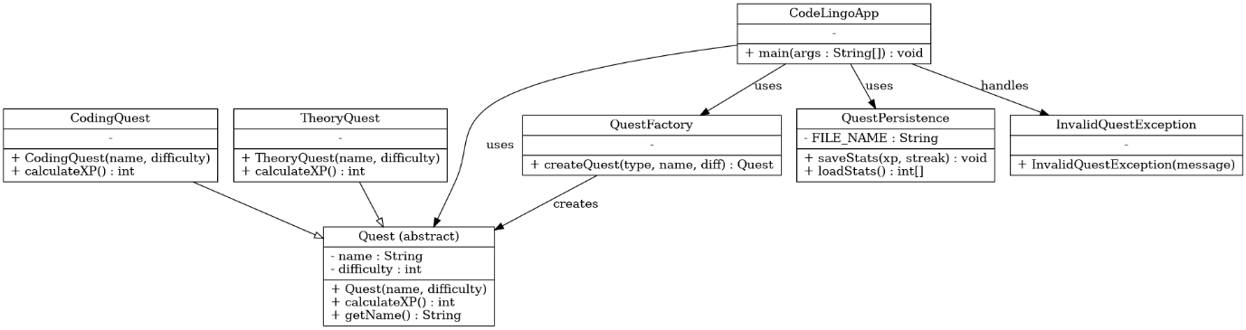
Description of Major Classes
- Quest (Abstract): Acts as the base template for all study activities, defining common properties like name and difficulty.
- CodingQuest & TheoryQuest: Specialized subclasses that implement unique XP calculation logic for different study modes.
- QuestFactory: A creational design pattern class that instantiates specific quest objects based on user input, ensuring the main application remains decoupled from subclass details.
- QuestPersistence: A dedicated Data Access Layer class responsible for saving and loading user progress (XP and Streaks) to a local text file.
Package and Interaction Flow
The system utilizes a Layered Architecture. The UI Layer (CodeLingoApp) interacts with the Factory to generate Models (Quest objects), while the Data Access Layer (QuestPersistence) ensures state remains consistent across sessions.

4. OOP Concepts Demonstrated
Abstraction
- Where it is used: In the Quest abstract class.
- Why it is used: To define a rigorous "contract" for all study activities, ensuring every task has a name and an XP calculation method while hiding specific implementation details at the base level.
- Code Snippet:
public abstract class Quest {
protected String name;
protected int difficulty;

public Quest(String name, int difficulty) {
this.name = name;
this.difficulty = difficulty;
}

public abstract int calculateXP();
}
- Explanation: The abstract keyword on the class prevents it from being instantiated directly. The abstract method calculateXP() acts as a placeholder that forces any subclass to provide its own specific logic, ensuring consistency across the system.
Inheritance
- Where it is used: In the CodingQuest and TheoryQuest subclasses.
- Why it is used: To promote code reusability by allowing specialized quest types to inherit common attributes (like name and difficulty) and behaviors from the base Quest class.
- Code Snippet:
public class CodingQuest extends Quest {
public CodingQuest(String name, int difficulty) {
super(name, difficulty);
}

@Override
public int calculateXP() {
return difficulty * 100;
}
}
- Explanation: The extends keyword establishes an "IS-A" relationship, meaning CodingQuest is a type of Quest. The super keyword is used to call the constructor of the parent class, reducing redundancy in attribute initialization.
Polymorphism
- Where it is used: During the execution of calculateXP() within the CodeLingoApp main loop.
- Why it is used: To allow the system to treat different quest objects uniformly while executing their unique logic dynamically at runtime based on the actual object type.
- Code Snippet:
Quest myQuest = QuestFactory.createQuest(type, name, diff);
int earned = myQuest.calculateXP();
- Explanation: Even though myQuest is declared as a generic Quest type, the JVM determines at runtime whether to execute the CodingQuest or TheoryQuest version of calculateXP(). This "Dynamic Method Binding" is the essence of polymorphism.
Exception Handling
- Where it is used: In the InvalidQuestException class and the try-catch blocks within CodeLingoApp.
- Why it is used: To create a custom exception hierarchy for graceful failure management, ensuring the program provides meaningful feedback instead of crashing when encountering invalid user inputs.
- Code Snippet:
public class InvalidQuestException extends Exception {
public InvalidQuestException(String message) {
super(message);
}
}
if (myQuest == null) {
throw new InvalidQuestException("Quest type not supported!");
}
- Explanation: By extending the base Exception class, InvalidQuestException becomes a "Checked Exception". The throw and catch mechanism allows the application to intercept errors and maintain a "High-Maturity" user experience.

5. Implementation Highlights
The Factory Design Pattern
- Justification: It provides high design maturity by centralizing object creation, making it easy to add a "ProjectQuest" later without changing the core loop.
public static Quest createQuest(String type, String name, int diff) {
if (type.equalsIgnoreCase("CODING")) return new CodingQuest(name, diff);
if (type.equalsIgnoreCase("THEORY")) return new TheoryQuest(name, diff);
return null;
}
Persistence Layer (File I/O)
- Justification: This addresses the instructor's feedback regarding local file persistence, ensuring user streaks are not lost when the program closes.
public static void saveStats(int xp, int streak) {
try (PrintWriter writer = new PrintWriter(new FileWriter("user_stats.txt"))) {
writer.println(xp);
writer.println(streak);
} catch (IOException e) { /* Error Handling */ }
}

6. Testing & Error Handling
Test Cases
- Polymorphism Check: Verified that a "Hard" Coding Quest (Difficulty 5) correctly awards 500 XP.
- Persistence Check: Verified that exiting the app and restarting successfully loads the previous XP from user_stats.txt.
- Boundary Check: Verified that entering a difficulty of 1 or 5 calculates XP accurately according to multipliers.
Error Handling
- Failure Scenario: User enters an invalid quest type.
- Handling: The system throws a custom InvalidQuestException, which is caught by the UI to display a friendly error message instead of crashing.

7. Git Workflow

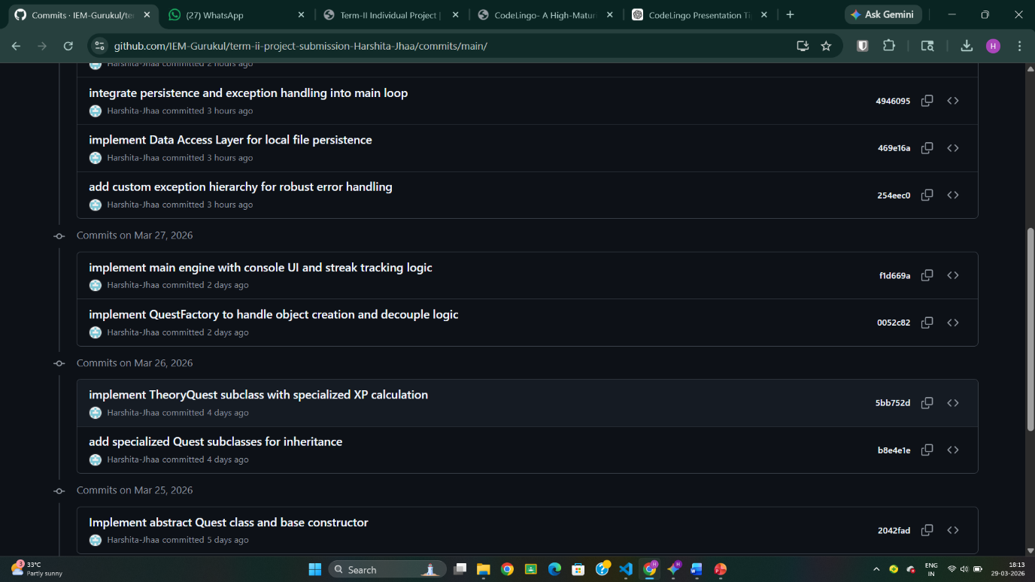

- Progression: Development followed a structured timeline, starting with the abstract base class, followed by inheritance-based subclasses, and finally the integration of the Factory and Persistence layers.

8. Conclusion & Future Scope
CodeLingo successfully demonstrates the application of Advanced OOP principles to solve a real-world student engagement problem. Future iterations could include a Swing GUI for better user interaction or JSON-based persistence for more complex data structures.

Appendix
Initial Proposal:

Project Title:

CodeLingo : A High-Maturity Gamified Study Engine

Target User:
Computer Science students seeking to gamify their coding consistency and track habit momentum.

Problem Statement
Modern productivity tools often fail to sustain long-term engagement because they lack meaningful feedback loops and specialized tracking for different task types. Most "To-Do" apps treat all tasks as equal strings, leading to "productivity fatigue." CodeLingo solves this by treating study sessions as "Quests" with varying difficulty and rewards. It addresses the "consistency gap" by implementing a Duolingo-inspired momentum engine that calculates streaks and XP (Experience Points) based on task complexity. The system provides a structured, extensible framework to turn abstract study goals into quantifiable, rewarding achievements, ensuring users stay motivated through gamified progression.

Core Features
- Dynamic Quest Creation: Categorize study sessions into "Coding," "Theory," or "Project" types via a Factory pattern.
- Momentum Engine: A streak-tracking algorithm that calculates daily consistency and applies XP multipliers.
- XP & Leveling System: Progress-based leveling where different task types yield polymorphic rewards.
- Persistence Layer: Automatic saving and loading of user profiles and quest history to local files.
- Robust Input Validation: Comprehensive error handling for date formats and invalid task parameters.

OOP Concepts to be Used
- Abstraction: Use of an abstract class Quest to define a rigorous contract for all study activities while hiding implementation details.
- Inheritance: Specialized subclasses (e.g., CodingQuest, TheoryQuest) inheriting from the base Quest class.
- Polymorphism: Method overriding in subclasses to calculate unique XP rewards and completion logic dynamically at runtime.
- Exception Handling: Custom exception hierarchy (e.g., StreakResetException, DataPersistenceException) for graceful failure management.
- Collections: Utilization of Map for user profiles and List for quest management to ensure efficient data manipulation.

Proposed Architecture Description
CodeLingo follows a Layered Architecture to ensure a strict separation of concerns. The Model
Layer defines the data entities; the Service Layer (Logic) contains the Momentum Engine and
XP calculation; and the Data Access Layer handles File I/O. By decoupling the logic from the
Console-based UI, the system remains extensible, allowing for a future migration to a Swing GUI without modifying the core business rules. The Factory Design Pattern will be intentionally used to manage object creation, demonstrating high design maturity.

- Review Mail:
Dear Harshita Jha ,

Project: CodeLingo : A High-Maturity Gamified Study Engine
Decision: APPROVED_MINOR
Score: 90

Strengths:
The proposal clearly articulates a real problem faced by students regarding engagement and consistency, offering a compelling gamified solution. It demonstrates a strong grasp of fundamental OOP concepts (Abstraction, Inheritance, Polymorphism, Exception Handling, Collections) by explicitly integrating them into the features and architectural design. The proposed Layered Architecture and the intentional use of the Factory Design Pattern showcase a high level of design maturity and foresight, particularly in planning for UI decoupling and future extensibility. The feature set is comprehensive, covering core gamification mechanics, persistence, and robust input validation, ensuring a functional and engaging application.

Improvements:
Consider outlining a basic testing strategy (e.g., unit tests for the Momentum Engine or XP calculation logic) to further enhance the robustness and development quality of the project. While implied by the Factory pattern, explicitly illustrating the inheritance hierarchy for 'Quest' types (e.g., a base Quest class with specialized subclasses like CodingQuest, TheoryQuest) would more overtly demonstrate the application of inheritance and polymorphism. Specifying the intended data format (e.g., JSON, CSV, Java Serialization) for the local file persistence layer would add a minor layer of detail.

Regards,
Course Instructor

