Advanced Programming Lab
[PCCCS495]

Hospital Management System

Name: -Rhitam Biswas
Semester: -IV
Class Roll: - 46
Enrolment Number: - 12024052004044
Date: - 29/03/2026

Instructor name: - Susovan Jana, Soumadip Biswas, Swagatam Basu

Department of Information Technology
2026

2. Problem Statement
Modern hospitals require efficient systems to manage patients and provide appropriate treatment based on their condition. Manual handling can lead to delays, especially in emergency situations.
This project aims to develop a console-based Hospital Management System using Java that:
- Accepts patient details (name, disease, priority)
- Assigns a doctor
- Determines treatment based on condition and priority
- Handles critical cases with emergency surgery
- Ensures robust execution using exception handling
The goal is to demonstrate core Object-Oriented Programming (OOP) concepts in a real-world scenario.

3. System Design
3.1 UML Class Diagram (Text Representation)
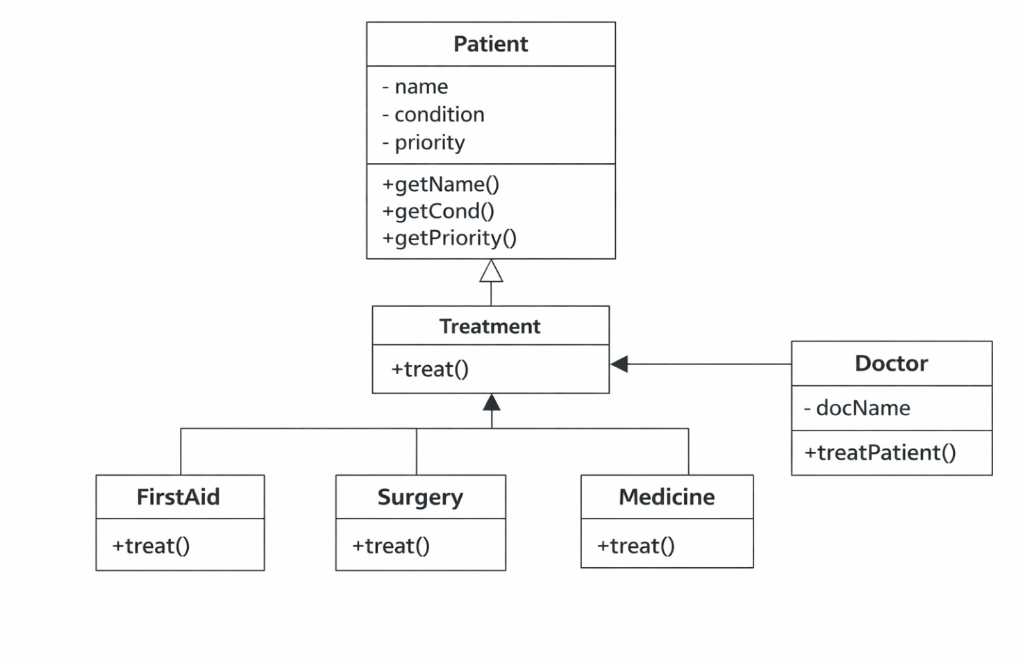

3.2 Description of Major Classes
Patient
Stores patient details such as name, condition, and priority.
Doctor
Handles treatment decisions based on patient condition and priority.
Treatment (Base Class)
Defines a general treatment method.
FirstAid, Surgery, Medicine
Derived classes implementing specific treatments.

3.3 Package Structure
All classes are placed in a single package (default package) for simplicity:
Hospital Project
- Hospital.java
- Patient.java
- Doctor.java
- Treatment.java
- FirstAid.java
- Surgery.java
- Medicine.java

3.4 Interaction Flow
- User enters patient details
- Selects doctor
- System creates Patient object
- Doctor evaluates condition
- Priority check:
  - Critical → Emergency Surgery
  - Normal → Medicine / First Aid
- Treatment executed
- Option to continue or exit

4. OOP Concepts Demonstrated
4.1 Encapsulation
Where used: Patient class
Why used: To protect data and allow controlled access

Code Snippet:
class Patient {
private String name;
private String cond;

public String getName() {
return name;
}
}
Explanation:
Data members are private and accessed via getter methods, ensuring data security.

4.2 Inheritance
Where used: Treatment → FirstAid, Surgery, Medicine
Why used: To reuse common logic and extend functionality
Code Snippet:
class FirstAid extends Treatment {
public void treat(Patient p) {
System.out.println("Providing First Aid");
}
}
Explanation:
Child classes inherit from Treatment and override behavior.

4.3 Polymorphism
Where used: Treatment reference
Why used: To call different methods using same reference
Code Snippet:
Treatment t;
t = new Surgery();
t.treat(p);
Explanation:
Same method behaves differently depending on object type.

4.4 Abstraction
Where used: Treatment class
Why used: To define a common interface for all treatments
Code Snippet:
class Treatment {
public void treat(Patient p) {
System.out.println("General treatment");
}
}
Explanation:
Provides a base structure for specialized treatments.

4.5 Exception Handling
Where used: Main method
Why used: To prevent program crash
Code Snippet:
try {
int choice = sc.nextInt();
} catch (Exception e) {
System.out.println("Invalid input");
}
Explanation:
Handles invalid inputs safely.

5. Implementation Highlights
Snippet 1: Doctor Selection
switch(choice) {
case 1: d = new Doctor("Dr.Arijit Deb"); break;
}
Justification: Ensures structured and readable selection logic.

Snippet 2: Priority Handling
if(p.getPriority().equalsIgnoreCase("critical")) {
t = new Surgery();
}
Justification: Critical patients are prioritized for emergency treatment.

Snippet 3: Condition-Based Treatment
if(cond.equals("fever")) {
t = new Medicine();
}
Justification: Enables dynamic treatment assignment.

Snippet 4: Loop Control
if(!again.equalsIgnoreCase("yes")) {
break;
}
Justification: Allows continuous execution until user exits.

6. Testing & Error Handling
Test Cases
Input | Expected Output
Fever + Normal | Medicine
Injury + Normal | First Aid
Heart + Critical | Surgery

Edge Cases
- Invalid doctor selection
- Empty input
- Wrong priority value

Failure Scenarios
- Non-integer doctor input → handled by try-catch
- Unexpected condition → default treatment

7. Git Workflow

Commit History
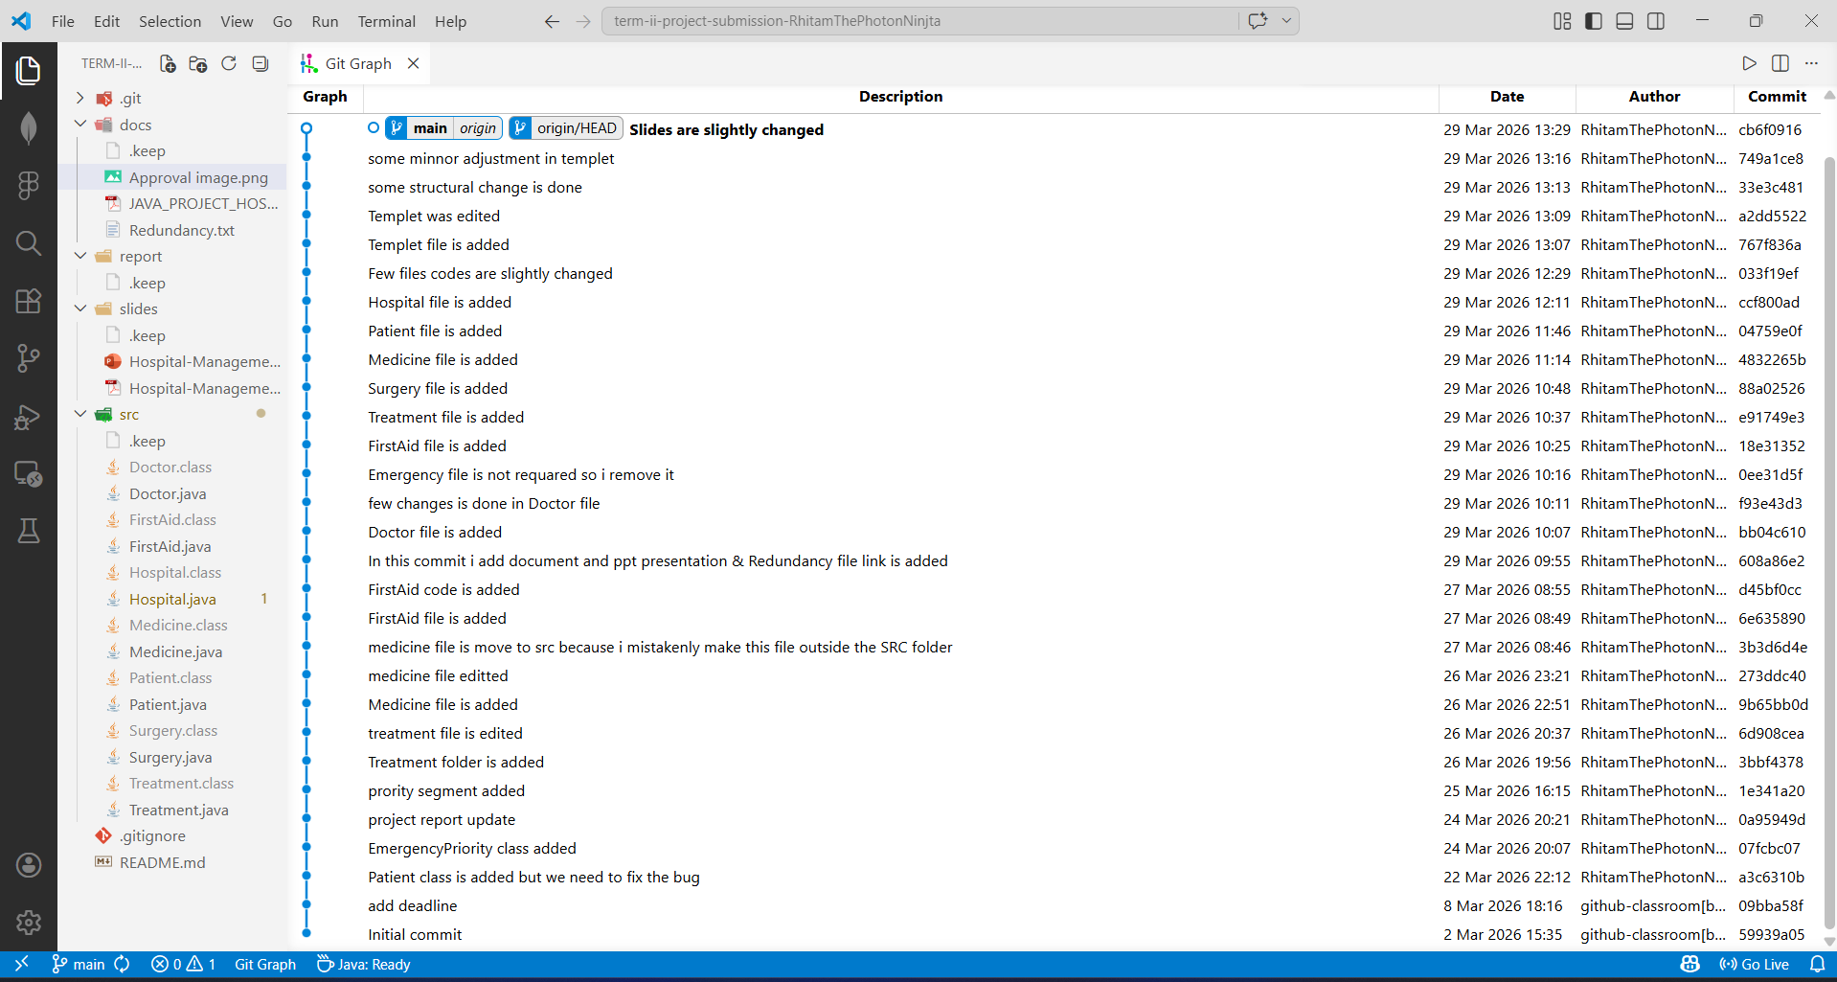

Development Progression
Project was developed incrementally:
- Basic structure
- OOP implementation
- Error handling
- Feature enhancement

8. Conclusion & Future Scope
Conclusion
The project successfully demonstrates OOP principles through a real-world hospital system. It efficiently handles patient data, prioritization, and treatment assignment.
Future Scope
- GUI using Java Swing
- Database integration
- Multi-doctor specialization
- Online appointment system
- AI-based diagnosis

9.Appendix
Initial Project Proposal
JAVA_PROJECT_HOSPITAL.pdf
Review Mail
approval email with APPROVED_MINOR
Approval image.png
Additional Submissions (if any)
N.A

