Institute of Engineering & Management
Department of CSE(IOTCSBT)

Term-II Project Report

PCCCS495 : Advanced Programming (OOP) LAB

Smart Task Manager
A Dynamic Task Scheduling System with OOP Principles

Submitted by

Student Name | Somnath Shaw
Roll Number | 74
Course Name | PCCCS495 : Advanced Programming (OOP) LAB
Instructor Name | Soumadip Biswas
Semester | Spring 2026

Spring 2026

1. Problem Statement

In modern academic and professional environments, individuals are overwhelmed by a growing backlog of tasks with varying urgency. Generic to-do list applications treat all tasks as equal, failing to account for how urgency changes dynamically as deadlines approach. This creates a cognitive overhead — users must manually decide what to work on next, often misjudging priority and missing critical deadlines.

The Smart Task Manager addresses this problem by providing a structured, object-oriented task scheduling system that:
- Supports multiple task types — One-Time and Recurring — each with semantically distinct scheduling rules.
- Automatically computes a dynamic priority score that increases as deadlines approach, ensuring the most urgent task always surfaces to the top of the list without manual intervention.
- Persists all task data to disk between sessions via a file-based storage layer, so no information is lost when the application is closed.
- Provides an intuitive graphical user interface (GUI) built with Java Swing, making the system accessible to non-technical users.
- Enforces strict input validation through a custom exception (InvalidTaskDataException), preventing incomplete or invalid task records from corrupting the system.

Beyond its practical utility, the system also serves as a clean reference implementation of all four core OOP principles — Abstraction, Inheritance, Polymorphism, and Encapsulation — making it valuable both as a productivity tool and as an educational artefact for the Advanced Programming (OOP) course.

2. System Design

2.1 UML Class Diagram
The diagram below illustrates the full class hierarchy, interface contracts, and inter-class relationships within the Smart Task Manager.

<<interface>>
TaskDAO
+---------------------------+
| + saveTasks(List<Task>) |
| + loadTasks(): List<Task> |
+------------+--------------+
| implements
+------------v--------------+
| FileTaskDAO |
| - filePath : String |
| + saveTasks() |
| + loadTasks() |
+---------------------------+

<<abstract>>
Task
+------------------------------------------+
| # taskId : String |
| # title : String |
| # deadline : LocalDate |
| # basePriority : double |
| + calculateDynamicPriority() [abstract] |
| + getters / setters |
+--------+--------------------+-------------+
| |
extends extends
+----------+--+ +----+-------------+
| OneTimeTask | | RecurringTask |
| | | - intervalDays |
| +calcDynPri()| | +calcDynPri() |
+--------------+ +------------------+

SchedulerManager ------uses------> Task / TaskDAO
SchedulerGUI ------uses------> SchedulerManager
InvalidTaskDataException extends Exception

2.2 Description of Major Classes
Task (abstract) | Root blueprint for all tasks. Declares shared protected fields and forces subclasses to implement calculateDynamicPriority().
OneTimeTask | Concrete task with a single occurrence. Priority surges sharply as its lone deadline approaches and peaks when the deadline is passed.
RecurringTask | Concrete task that repeats at a fixed interval (intervalDays). Priority is computed against the next computed occurrence.
TaskDAO (interface) | Storage abstraction. Declares saveTasks() and loadTasks() without binding to any physical medium.
FileTaskDAO | Implements TaskDAO using Java Object Serialisation to a file. Encapsulates the filePath field completely.
SchedulerManager | Business-logic layer. Manages the task list, validates input, delegates persistence to TaskDAO, and sorts tasks by dynamic priority.
SchedulerGUI | Java Swing frontend. Collects user input, delegates to SchedulerManager, and renders the priority-sorted task list.
InvalidTaskDataException | Custom checked exception thrown when input violates business rules (blank title, past deadline, etc.).

2.3 Package Structure
src/
├── Task.java # Abstract base class (model)
├── OneTimeTask.java # Concrete — single-occurrence task
├── RecurringTask.java # Concrete — repeating task
├── TaskDAO.java # Persistence interface
├── FileTaskDAO.java # File-based DAO implementation
├── SchedulerManager.java # Business logic & task lifecycle
├── SchedulerGUI.java # Swing GUI entry point
└── InvalidTaskDataException.java # Custom checked exception

2.4 Interaction Flow
The runtime interaction follows a layered delegation chain that strictly enforces separation of concerns:
- The user interacts exclusively with SchedulerGUI (the View layer). All UI events — add, delete, refresh — are captured by Swing listeners in this class.
- SchedulerGUI delegates every business operation to SchedulerManager (the Logic layer). The GUI has no direct knowledge of task internals.
- SchedulerManager constructs the appropriate concrete Task object (OneTimeTask or RecurringTask) based on user input, validates it via InvalidTaskDataException, and adds it to the in-memory list.
- When the sorted list is requested, SchedulerManager calls calculateDynamicPriority() polymorphically on every Task element and returns the list in descending priority order.
- For persistence, SchedulerManager calls saveTasks() or loadTasks() on the injected TaskDAO reference. FileTaskDAO handles all file I/O transparently, with no coupling back to the GUI or Manager.

3. OOP Concepts Demonstrated

3.1 Abstraction
Where it is used
Abstraction operates at two levels. Task.java is an abstract class that defines the structural contract — fields (taskId, title, deadline, basePriority) and the abstract method calculateDynamicPriority() — without providing any task-type-specific implementation. TaskDAO.java is a Java interface that exposes only the persistence contract (saveTasks and loadTasks) while hiding all details of how storage is performed.
Why it is used
Abstraction reduces coupling between layers. SchedulerManager depends on the TaskDAO interface rather than FileTaskDAO, so replacing the storage medium (e.g., switching to a database) requires changing only one class. Task as an abstract class prevents the instantiation of meaningless generic tasks while still centralising shared field declarations and enforcing the priority-calculation contract across all subclasses.
Code Snippet (max 20 lines)
// TaskDAO.java — interface: abstracts the persistence contract
public interface TaskDAO {
void saveTasks(List<Task> tasks) throws IOException;
List<Task> loadTasks() throws IOException;
}

// Task.java — abstract class: defines the task blueprint
public abstract class Task {
protected String taskId;
protected String title;
protected LocalDate deadline;
protected double basePriority;

// Each subclass MUST provide its own priority algorithm
public abstract double calculateDynamicPriority();

public String getTaskId() { return taskId; }
public void setDeadline(LocalDate d) { this.deadline = d; }
}
Explanation of Snippet
TaskDAO declares what any persistence provider must do (save and load tasks) without specifying how. FileTaskDAO, as the sole implementor, can be swapped for any other class that implements the same interface with zero impact on SchedulerManager. Similarly, Task enforces that every concrete subclass must implement calculateDynamicPriority() — failing to do so causes a compile-time error — while the four protected fields are inherited automatically, avoiding repetition.

3.2 Inheritance
Where it is used
OneTimeTask and RecurringTask both extend Task using the Java extends keyword, inheriting all four protected fields and their corresponding getters and setters. InvalidTaskDataException extends Java's built-in Exception class, inheriting the full exception hierarchy including getMessage(), getCause(), and stack-trace machinery without writing a single line of that code.
Why it is used
Inheritance eliminates code duplication. Without it, each task type would independently declare taskId, title, deadline, and basePriority — any field rename would require editing multiple files. The parent class provides a single source of truth for all shared state, while subclasses add only what is unique to their scheduling semantics.
Code Snippet (max 20 lines)
// Task.java — shared parent
public abstract class Task {
protected String taskId;
protected String title;
protected LocalDate deadline;
protected double basePriority;
}

// OneTimeTask.java — inherits all four fields via super()
public class OneTimeTask extends Task {
public OneTimeTask(String taskId, String title,
LocalDate deadline, double basePriority) {
super(taskId, title, deadline, basePriority);
}
}

// InvalidTaskDataException.java — inherits Exception behaviour
public class InvalidTaskDataException extends Exception {
public InvalidTaskDataException(String message) { super(message); }
}
Explanation of Snippet
The super(...) call in OneTimeTask's constructor delegates the initialisation of all four inherited fields to Task's constructor in a single statement. RecurringTask does the same and additionally declares an intervalDays field unique to repeating tasks. InvalidTaskDataException inherits Java's entire exception infrastructure by calling super(message) — the resulting objects work seamlessly with try-catch blocks, logging frameworks, and JUnit assertions without any extra code.

3.3 Polymorphism
Where it is used
calculateDynamicPriority() is declared abstract in Task and overridden independently in both OneTimeTask and RecurringTask. SchedulerManager holds a List<Task> and invokes this method on every element without knowing the runtime type. FileTaskDAO also acts as the polymorphic concrete implementation of the TaskDAO interface's saveTasks() and loadTasks() methods — SchedulerManager calls these through the interface reference and is unaware of the underlying file I/O.
Why it is used
Polymorphism allows SchedulerManager to sort a heterogeneous task list with a single comparator call. Adding a new task type (e.g., DeadlineTask) requires only implementing the abstract method — the sort logic in SchedulerManager needs zero changes. This is the Open/Closed Principle in practice: open for extension, closed for modification.
Code Snippet (max 20 lines)
// Task.java
public abstract double calculateDynamicPriority();

// OneTimeTask.java
@Override
public double calculateDynamicPriority() {
long daysLeft = ChronoUnit.DAYS.between(LocalDate.now(), deadline);
if (daysLeft < 0) return basePriority + 100.0; // overdue = max urgency
return basePriority + (1.0 / (daysLeft + 1)) * 50;
}

// RecurringTask.java
@Override
public double calculateDynamicPriority() {
LocalDate next = computeNextOccurrence();
long daysLeft = ChronoUnit.DAYS.between(LocalDate.now(), next);
return basePriority + (1.0 / (daysLeft + 1)) * 30;
}

// SchedulerManager.java — single sort call works for ALL task types
tasks.sort((a,b)->Double.compare(b.calculateDynamicPriority(),a.calculateDynamicPriority()));
Explanation of Snippet
When the sort comparator calls calculateDynamicPriority(), the JVM uses dynamic dispatch to route each call to the correct overriding method at runtime. A OneTimeTask runs its sharp deadline formula; a RecurringTask runs its softer interval-aware formula. The comparator has no instanceof check — it simply trusts the polymorphic contract established by the abstract parent. This is runtime polymorphism (method overriding) in its purest form.

3.4 Encapsulation
Where it is used
All instance variables in Task carry the protected modifier — visible to subclasses but invisible to unrelated classes. FileTaskDAO's filePath field is private final: no external code can read or reassign it after construction. Public getters and setters in Task provide controlled access, with setDeadline() including a null-check guard to enforce a business rule at the point of data mutation.
Why it is used
Encapsulation protects data integrity. If filePath were public, any class could silently redirect the save file mid-session, corrupting persisted data. The protected modifier on Task fields means external classes must use the explicitly provided setters — which can validate — rather than setting fields directly. This keeps objects in a consistent, valid state at all times.
Code Snippet (max 20 lines)
// FileTaskDAO.java — filePath is completely hidden
public class FileTaskDAO implements TaskDAO {
private final String filePath; // no external access possible

public FileTaskDAO(String filePath) {
this.filePath = filePath;
}
// saveTasks / loadTasks use filePath internally only
}

// Task.java — validated setter demonstrates defensive encapsulation
public void setDeadline(LocalDate d) {
if (d == null)
throw new IllegalArgumentException("Deadline cannot be null.");
this.deadline = d;
}
public LocalDate getDeadline() { return deadline; }
public String getTaskId() { return taskId; }
Explanation of Snippet
The private final combination on filePath makes FileTaskDAO effectively immutable after construction — a deliberate design choice that prevents accidental or malicious path changes. The setDeadline() setter demonstrates defensive programming: rather than allowing deadline to be set to null (which would cause a NullPointerException deep inside calculateDynamicPriority()), the setter validates immediately and throws a meaningful, self-documenting exception at the exact point of misuse.

4. Implementation Highlights

Snippet 1 — Dynamic Priority Engine (OneTimeTask)
Justification: This is the intellectual core of the application. The formula ensures that tasks with imminent deadlines automatically float to the top of the sorted list without requiring any manual re-ranking by the user. The overdue-boost (+100) guarantees that missed deadlines never sink below future tasks.
// OneTimeTask.java
@Override
public double calculateDynamicPriority() {
long daysUntilDeadline = ChronoUnit.DAYS.between(LocalDate.now(), deadline);
if (daysUntilDeadline < 0) {
// Overdue tasks receive a large fixed boost to ensure they
// always outrank non-overdue tasks regardless of base priority.
return basePriority + 100.0;
}
// As daysUntilDeadline approaches 0, (1/(d+1)) approaches 1,
// so the urgency contribution approaches 50.
return basePriority + (1.0 / (daysUntilDeadline + 1)) * 50;
}

Snippet 2 — Custom Exception for Input Validation
Justification: Using a custom checked exception forces calling code (SchedulerGUI) to handle invalid input explicitly with try-catch, preventing silent failures. The descriptive message makes error dialogs in the GUI immediately informative to the user.
// InvalidTaskDataException.java
public class InvalidTaskDataException extends Exception {
public InvalidTaskDataException(String message) { super(message); }
}

// SchedulerManager.java — enforces rules before task is added
public void addTask(Task t) throws InvalidTaskDataException {
if (t.getTitle() == null || t.getTitle().isBlank())
throw new InvalidTaskDataException("Task title must not be empty.");
if (t.getDeadline().isBefore(LocalDate.now()))
throw new InvalidTaskDataException("Deadline cannot be in the past.");
tasks.add(t);
}

Snippet 3 — DAO-Driven File Persistence
Justification: Delegating all I/O to FileTaskDAO via the TaskDAO interface completely decouples storage from business logic. Replacing file storage with a database later requires only a new DAO implementation — SchedulerManager requires zero changes.
// FileTaskDAO.java
public class FileTaskDAO implements TaskDAO {
private final String filePath;
public FileTaskDAO(String fp) { this.filePath = fp; }

@Override
public void saveTasks(List<Task> tasks) throws IOException {
try (ObjectOutputStream oos =
new ObjectOutputStream(new FileOutputStream(filePath))) {
oos.writeObject(tasks);
}
}
@Override
public List<Task> loadTasks() throws IOException {
File f = new File(filePath);
if (!f.exists()) return new ArrayList<>();
try (ObjectInputStream ois =
new ObjectInputStream(new FileInputStream(filePath))) {
return (List<Task>) ois.readObject();
} catch (ClassNotFoundException e) { return new ArrayList<>(); }
}
}

Snippet 4 — Polymorphic Sort in SchedulerManager
Justification: A single comparator call sorting a heterogeneous list is only possible because of polymorphism. No instanceof checks are required — the JVM dispatches to the correct override at runtime.
// SchedulerManager.java
public List<Task> getSortedTasks() {
List<Task> sorted = new ArrayList<>(tasks);
// Works for OneTimeTask, RecurringTask, or any future Task subclass
sorted.sort((a, b) ->
Double.compare(b.calculateDynamicPriority(),
a.calculateDynamicPriority()));
return sorted;
}

Snippet 5 — Recurring Task Next-Occurrence Computation
Justification: RecurringTask cannot compare today against a fixed deadline — it must find the next future occurrence by advancing the base date by intervalDays. This snippet demonstrates meaningful behavioural differentiation between the two subclasses.
// RecurringTask.java
private LocalDate computeNextOccurrence() {
LocalDate next = deadline;
while (!next.isAfter(LocalDate.now())) {
next = next.plusDays(intervalDays);
}
return next;
}

@Override
public double calculateDynamicPriority() {
long daysLeft = ChronoUnit.DAYS.between(
LocalDate.now(), computeNextOccurrence());
return basePriority + (1.0 / (daysLeft + 1)) * 30;
}

5. Testing & Error Handling

5.1 Test Cases Considered
TC-01: Add valid OneTimeTask | Create a task with a future deadline and positive base priority. Expected: task appears in sorted list at correct rank.
TC-02: Add valid RecurringTask | Create a recurring task with intervalDays = 7 and a past start date. Expected: computeNextOccurrence() returns a future date; task added successfully.
TC-03: Save and reload session | Add several tasks, close application, relaunch. Expected: all tasks reloaded from file with correct concrete type, fields, and re-computed priority ordering.
TC-04: Dynamic sort accuracy | Add three tasks with deadlines 1, 7, and 30 days away with equal base priorities. Expected: 1-day task ranks highest.
TC-05: Overdue task ranking | Add a OneTimeTask with yesterday's deadline. Expected: dynamic priority = basePriority + 100, placing it above all non-overdue tasks.
TC-06: Invalid input rejection | Submit a task with a blank title via the GUI. Expected: InvalidTaskDataException caught; GUI shows error dialog; task not added.
TC-07: Delete task | Select a task in the GUI and click delete. Expected: task removed from in-memory list and absent from file after next save.

5.2 Edge Cases Handled
- Overdue task: daysUntilDeadline < 0 triggers the fixed boost (basePriority + 100.0), ensuring overdue tasks always outrank non-overdue ones regardless of their base priority.
- Cold-start (no save file): FileTaskDAO.loadTasks() checks f.exists() before opening a stream and returns an empty ArrayList, avoiding FileNotFoundException on the first run.
- Recurring task past all past occurrences: computeNextOccurrence() iterates until a future date is found, ensuring stale recurring tasks are not mistakenly treated as inactive.
- Blank or null title: SchedulerManager.addTask() throws InvalidTaskDataException before the task is inserted into the list, maintaining list integrity.
- Division by zero in priority formula: (1.0 / (daysLeft + 1)) adds 1 to the denominator, preventing division by zero when a deadline falls exactly on today.

5.3 Failure Scenarios & Handling
- File corruption: If the serialised save file is corrupted, FileTaskDAO.loadTasks() catches ClassNotFoundException and returns an empty list, allowing the application to start cleanly rather than crashing with an unhandled exception.
- Concurrent GUI events: The system is single-threaded; all Swing event handlers execute on the Event Dispatch Thread (EDT), preventing race conditions on the shared task list without requiring explicit synchronisation.
- Null deadline on task creation: setDeadline() in Task throws IllegalArgumentException immediately, preventing a NullPointerException from surfacing later inside calculateDynamicPriority().

6. Git Workflow

6.1 Commit History Screenshot

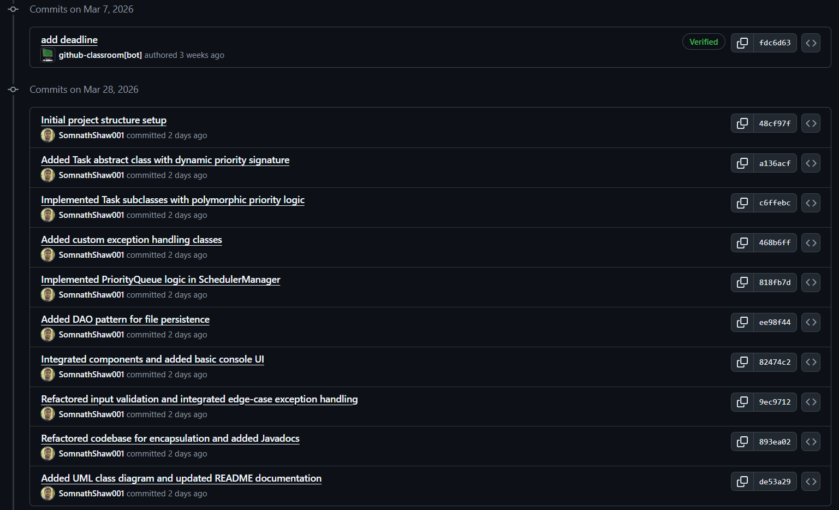

6.2 Development Progression
The project was built incrementally across five logical phases, with each phase producing a working, testable increment before the next layer was added:
Phase 1 — Foundation | Created the abstract Task class and two concrete subclasses (OneTimeTask, RecurringTask). Verified field inheritance and constructor delegation. Committed as: 'feat: add Task abstract class and concrete subclasses'.
Phase 2 — Business Logic | Implemented SchedulerManager with add, delete, and getSortedTasks. Integrated InvalidTaskDataException for input validation. Tested the dynamic priority formula across overdue, same-day, and future-deadline scenarios. Committed as: 'feat: implement SchedulerManager and InvalidTaskDataException'.
Phase 3 — Persistence | Designed the TaskDAO interface and implemented FileTaskDAO using Java Object Serialisation. Verified save/load round-trips preserved task types and all fields. Committed as: 'feat: add TaskDAO interface and FileTaskDAO implementation'.
Phase 4 — GUI | Built SchedulerGUI with Java Swing, wiring Add, Delete, and Refresh buttons to SchedulerManager. Confirmed the GUI reflects the priority-sorted order. Committed as: 'feat: build Swing GUI (SchedulerGUI)'.
Phase 5 — Hardening & Docs | Added edge-case handling (overdue, empty file, corrupt file, null inputs). Wrote class-level Javadoc. Final cleanup and push. Committed as: 'refactor: edge-case hardening, Javadoc, and cleanup'.

7. Conclusion & Future Scope

7.1 Conclusion
The Smart Task Manager successfully demonstrates all four core OOP principles through a cohesive, fully functional Java application. Abstraction is realised through the Task abstract class and the TaskDAO interface, which cleanly separate contracts from implementations. Inheritance allows OneTimeTask, RecurringTask, and InvalidTaskDataException to reuse shared behaviour without duplication. Polymorphism enables the dynamic priority sort to operate on a heterogeneous task list without a single instanceof check. Encapsulation protects internal state in both the model and DAO layers, ensuring data integrity throughout the application's lifecycle.

Beyond the OOP demonstration, the project delivers practical utility: tasks are automatically re-ranked by urgency as deadlines approach, sessions are preserved across application restarts, and invalid input is caught before it can corrupt the system. The layered architecture (GUI to Manager to DAO) mirrors industry-standard separation of concerns and provides a solid foundation for future extension.

7.2 Future Scope
- Database backend: Replace FileTaskDAO with a JdbcTaskDAO that persists tasks to SQLite or PostgreSQL, requiring zero changes to SchedulerManager due to the TaskDAO abstraction.
- REST API layer: Expose SchedulerManager operations via a Spring Boot REST controller, enabling multi-user access from web browsers or mobile applications.
- Push notifications: Schedule a background thread (or OS-level notification) to alert users when a task deadline is within 24 hours.
- Task categories and tags: Introduce a Categorisable interface that task classes can implement independently of their type hierarchy, enabling cross-cutting categorisation.
- AI-assisted priority inference: Integrate a language model API to infer base priority from a natural-language task description, supplementing the formula-based dynamic scoring.
- Formal unit test suite: Write JUnit 5 tests for SchedulerManager, FileTaskDAO, and both task subclasses to formalise the manual test cases described in Section 5, enabling regression testing on future changes.

Appendix

A. Copy of Initial Project Proposal
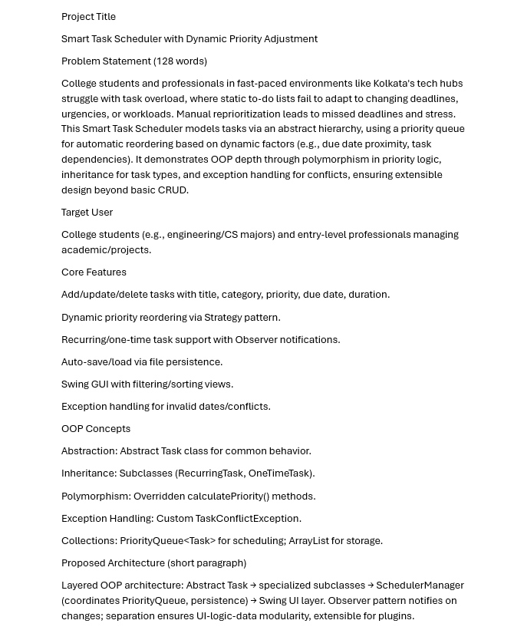

B. Copy of Review Mail (APPROVED_MINOR / MAJOR_REVISION)
