Course: PCCCS495: Advanced Programming (OOP) Lab
Term II Project Report
Project Title: Inventory Management System Using DAO Pattern with File Persistence
Submitted by: Subhashree Das
Github Username: das-subho06
Class Roll no.: 64
Enrollment no.: 12024052017066
Department: CSE(IOT CS BT)
Course Instructor: Soumadip Biswas Sir, Susovan Jana Sir, Swagatam Basu Sir.
Semester: 4th (Spring 2026)
IEM Gurukul GitHub: IEM-Gurukul / term-ii-project-submission-das-subho06

Problem Statement:
Small businesses – retail shops, pharmacies, general stores – typically manage their inventory through paper registers or spreadsheet files. This approach suffers from a range of operational problems: data is frequently lost due to accidental deletion or hardware failure; there is no built-in mechanism to search or filter records quickly; and, critically, there is no automated alert system to warn the owner when a product is running low and needs restocking.
This project addresses these problems by delivering a Java-based desktop application, InvenTrack, that allows a shopkeeper to digitally manage Products, Categories, and Suppliers from a single graphical interface. The system uses the Data Access Object (DAO) design pattern to cleanly separate data-access logic from business logic, and persists all records to local binary files using Java Object Serialization removing any dependency on an external database or internet connection.
The Service layer enforces business rules on every user action, validating inputs such as non-empty names, positive selling prices, non-negative quantities, and referential integrity between entities (a product must reference a valid category and supplier). Features include full CRUD operations for all three entity types, live dashboard statistics, a dedicated Low Stock Alert panel with one-click restock capability, name-based product search, category filtering, sortable table columns, and CSV export of the entire inventory – making the system both practical and maintainable for small-scale use.

System Design
UML Class Diagram
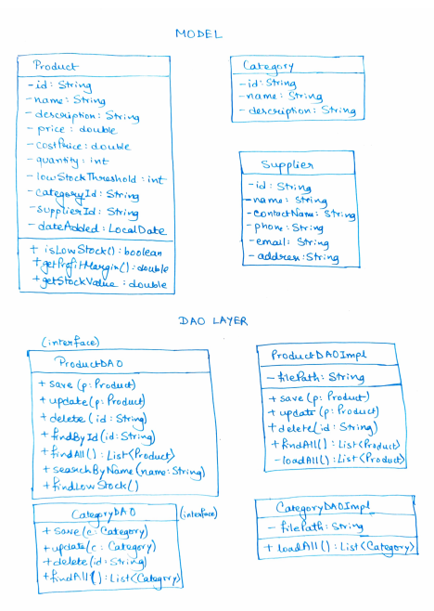
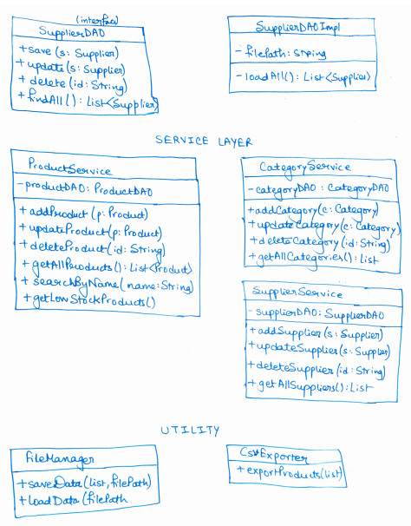
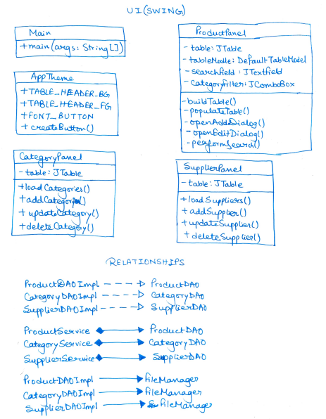
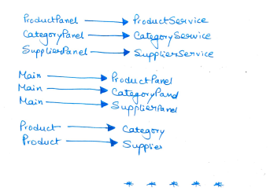
Description of Major Classes:
Class / Interface | Responsibility
Product | Model: stores all product fields; implements Serializable; provides isLowStock() and getProfitMargin() helpers.
Category / Supplier | Lightweight model classes holding reference data used by products.
ProductDAO (interface) | Declares the full CRUD contract: save, update, delete, findById, findAll, findByCategoryId, findLowStock, searchByName, generateNextId.
ProductDAOImpl | Implements ProductDAO using FileManager; loads the list on every operation, mutates it, and writes it back.
ProductService | Validates all business rules before delegating to the DAO; enforces referential integrity; the only layer the UI interacts with.
FileManager | Generic utility using Java Object Serialization to persist any List<T> to a .dat binary file; handles folder creation and I/O exceptions.
MainFrame | Root Swing window; owns a CardLayout container and a sidebar; switches panels and triggers data refresh on navigation.
DashboardPanel | Displays live summary statistics (total products, total value, low-stock count) and a table of low-stock items.
ProductPanel | Full CRUD panel for products; contains search field, category filter combo-box, sortable Jtable, and action buttons.
LowStockPanel | Dedicated alert panel showing quantity vs. threshold with a shortage column and one-click restock dialog.
CsvExporter | Static utility that writes all products to a timestamped CSV file in exports/; handles RFC 4180 comma-escaping.
ValidationException | Custom unchecked exception thrown by all service methods on rule violations; caught by UI panels to display JoptionPane error dialogs.

Package Structure:
com.inventory
├── Main.java ( Application entry point)
├── model/
│ ├── Product.java
│ ├── Category.java
│ └── Supplier.java
├── dao/
│ ├── interfaces/
│ │ ├── ProductDAO.java
│ │ ├── CategoryDAO.java
│ │ └── SupplierDAO.java
│ └── impl/
│ ├── ProductDAOImpl.java
│ ├── CategoryDAOImpl.java
│ └── SupplierDAOImpl.java
├── service/
│ ├── ProductService.java
│ ├── CategoryService.java
│ └── SupplierService.java
├── ui/
│ ├── AppTheme.java
│ ├── MainFrame.java
│ ├── DashboardPanel.java
│ ├── ProductPanel.java
│ ├── CategoryPanel.java
│ ├── SupplierPanel.java
│ └── LowStockPanel.java
├── util/
│ ├── FileManager.java
│ └── CsvExporter.java
└── exception/
└── ValidationException.java
Interaction Flow:
- The user performs an action in a UI panel (e.g., clicks Add Product after filling the form fields).
- The panel collects input values and calls the appropriate Service method (e.g., productService.addProduct(...)).
- The Service validates every field; if a rule is violated, a ValidationException is thrown and propagated to the UI, which displays an error dialog.
- If validation passes, the Service constructs the domain object and calls the DAO interface method (e.g., productDAO.save(product)).
- The DAO implementation delegates to FileManager.saveData(), which serializes the updated list to products.dat.
- Control returns to the UI, which calls refreshTable() to reload and redisplay the updated data.

OOP Concepts Demonstrated
Encapsulation
Where it is used: All three model classes — Product, Category, and Supplier — declare every field as private and expose them exclusively through public getter and setter methods.
Why it is used: This prevents other classes from directly modifying the internal state of a model object in an uncontrolled manner. For example, no external class can set a negative quantity directly; all mutations go through the Service layer, which validates first.
Code Snippet:
Product.java
public class Product implements Serializable {

private String id;
private String name;
private double price;
private int quantity;
private int lowStockThreshold;

// Derived behaviour encapsulated inside the class
public oolean isLowStock() {
return quantity <= lowStockThreshold;
}

public double getProfitMargin() {
if (costPrice == 0) return 0.0;
return ((price – costPrice) / price) * 100.0;
}

public int getQuantity() { return quantity; }
public void setQuantity(int qty) { this.quantity = qty; }
}

Explanation: All fields are private, so no other class reads or writes them directly. The helper methods isLowStock() and getProfitMargin() encapsulate derived logic: the LowStockPanel and DashboardPanel simply call these methods without re-implementing the threshold comparison or margin formula themselves, which eliminates code duplication and centralises business logic in the model.

Abstraction
Where it is used: The DAO interfaces ProductDAO, CategoryDAO, and SupplierDAO declare method signatures — save(), update(), delete(), findById(), findAll(), searchByName(), etc. — without specifying how the data is stored.
Why it is used: The Service layer and UI panels program against the interface contract, not against a specific storage mechanism. If the application were later upgraded from file serialization to a SQLite database, only the impl/ classes would change; every other layer of the system would remain untouched.
Code Snippet:
ProductDAO.java
public interface ProductDAO {
void save(Product product);
void update(Product product);
void delete(String id);
Optional<Product> findById(String id);
List<Product> findAll();
List<Product> findByCategoryId(String categoryId);
List<Product> findLowStock();
List<Product> searchByName(String keyword);
String generateNextId();
}
Explanation: This interface contains nine method signatures and zero implementation code. ProductService holds a reference of type ProductDAO, so it calls productDAO.save(product) without ever knowing whether data is going to a file, a database, or a network service. The abstraction boundary is clean and total.

Polymorphism
Where it is used: (a) The ProductService field productDAO is declared as type ProductDAO (interface) but instantiated as ProductDAOImpl at runtime. (b) A custom DefaultTableCellRenderer is overridden in each panel to provide different row-colouring behaviour from the same method signature.
Why it is used: It decouples the calling code from the concrete class. The Service never needs to know which DAO class it is using; it simply calls the interface methods and the JVM dispatches the call to the correct implementation.
Code Snippet:
ProductService.java
public class ProductService {

// Declared as the interface type — not the concrete class
private ProductDAO productDAO = new ProductDAOImpl();

public List<Product> getLowStockProducts() {
// productDAO.findLowStock() dispatches to ProductDAOImpl
// at runtime — the Service does not know or care which impl
return productDAO.findLowStock();
}
}
Explanation: Because productDAO is typed as ProductDAO (the interface), swapping new ProductDAOImpl() for a hypothetical new DatabaseProductDAOImpl() on the single instantiation line is the only change needed to switch the entire storage layer — no modifications to service logic are required. This directly demonstrates run-time polymorphism and the Open/Closed Principle.

Inheritance
Where it is used: (a) ValidationException extends RuntimeException, inheriting exception-handling infrastructure. (b) All five UI panels — DashboardPanel, ProductPanel, CategoryPanel, SupplierPanel, and LowStockPanel — extend Jpanel, inheriting Swing’s layout and painting mechanisms.
Why it is used: ValidationException inherits the message-storage, stack-trace capture, and propagation machinery of RuntimeException, requiring only a single constructor. Extending Jpanel allows each panel to be added directly to a CardLayout container in MainFrame without any adaptor code.
Code Snippet:
ValidationException.java
package com.inventory.exception;
// Extends RuntimeException — inherits getMessage(), printStackTrace(),
// getCause(), and all other exception infrastructure automatically.
Public class ValidationException extends RuntimeException {

private static final long serialVersionUID = 1L;

public ValidationException(String message) {
super(message); // passes message to RuntimeException
}
}
Explanation: The entire class body is just three lines of meaningful code, yet it gains the full RuntimeException behaviour through inheritance. Being unchecked (inheriting from RuntimeException rather than Exception) means callers are not forced to declare it in a throws clause, keeping the service-method signatures clean.

Exception Handling
Where it is used: Every service method validates input and throws ValidationException on rule violation. FileManager wraps all I/O operations in try-with-resources blocks and converts checked IOException to RuntimeException. Main.java registers a global uncaught-exception handler.
Why it is used: Separating validation from the UI layer means that no panel has to contain its own checking logic; the Service is the single source of truth for what is valid. Wrapping checked I/O exceptions prevents every calling site from having to handle them, since file-I/O failure is a non-recoverable runtime error in this context.
Code Snippet:
FileManager.java
public static <T> void saveData(List<T> list, String filePath) {
ensureDataFolderExists();
try (
FileOutputStream fos = new FileOutputStream(filePath);
ObjectOutputStream oos = new ObjectOutputStream(fos)
) {
oos.writeObject(list); // streams closed automatically
} catch (IOException e) {
// Rethrow as unchecked — callers don’t need to handle it
throw new RuntimeException(
“Error saving data to file: “ + filePath
+ “\nReason: “ + e.getMessage());
}
}
Explanation: The try-with-resources construct guarantees that FileOutputStream and ObjectOutputStream are closed whether or not an exception occurs, preventing resource leaks. Converting IOException to RuntimeException is a conscious design choice: since the application cannot sensibly continue if it cannot persist data, this is treated as a fatal condition and reported via the global handler in Main.java.

Collections and Java Streams
Where it is used: All data is held in List<T> collections. Java Streams are used in all three DAO implementations for search, filter, and ID-generation operations.
Why it is used: Collections provide dynamic sizing and convenient iteration. Streams allow declarative, readable transformations without manual loops, improving both correctness and clarity.
Code Snippet:
ProductDAOImpljava
@Override
public List<Product> searchByName(String keyword) {
String lower = keyword.toLowerCase();
return loadAll().stream()
.filter(p -> p.getName().toLowerCase().contains(lower))
.collect(Collectors.toList());
}

@Override
public String generateNextId() {
List<Product> list = loadAll();
if (list.isEmpty()) return “PRD001”;
int max = list.stream()
.mapToInt(p -> Integer.parseInt(p.getId().substring(3)))
.max().orElse(0);
return String.format(“PRD%03d”, max + 1);
}
Explanation: The first method pipelines three stream operations — stream(), filter(), collect() — to produce a filtered sublist without mutating the source. The second uses mapToInt() and max() to compute the highest numeric suffix and increments it, guaranteeing unique, sequential IDs (PRD001, PRD002, ...) even after deletions in the middle of the sequence.

Implementation Highlights
Generic FileManager Using Type Parameters
FileManager.saveData() and loadData() are declared as generic methods using the type parameter <T>, allowing the same I/O logic to persist Products, Categories, and Suppliers through identical method calls. This eliminates three separate persistence utility classes and demonstrates correct use of Java Generics.

// Works for List<Product>, List<Category>, List<Supplier> — same method
public static <T> void saveData(List<T> list, String filePath) {
try (ObjectOutputStream oos = new ObjectOutputStream(
new FileOutputStream(filePath))) {
oos.writeObject(list);
} catch (IOException e) {
throw new RuntimeException(“Save failed: “ + e.getMessage());
}
}

@SuppressWarnings(“unchecked”)
public static <T> List<T> loadData(String filePath) {
File f = new File(filePath);
if (!f.exists()) return new ArrayList<>();
try (ObjectInputStream ois = new ObjectInputStream(
new FileInputStream(f))) {
return (List<T>) ois.readObject();
} catch (IOException | ClassNotFoundException e) {
throw new RuntimeException(“Load failed: “ + e.getMessage());
}
}
Justification: The unchecked cast on readObject() is unavoidable because the JVM erases generic type information at runtime (type erasure). The @SuppressWarnings(“unchecked”) annotation documents this known, safe cast explicitly rather than silently suppressing the warning.

Input Validation with Referential Integrity
ProductService.addProduct() performs six validation checks before creating a product, including foreign-key-style lookups that ensure the referenced category and supplier actually exist. This prevents orphaned records without requiring a relational database.

Public void addProduct(String name, String description,
double price, double costPrice, int quantity, int threshold,
String categoryId, String supplierId) {

if (name == null || name.trim().isEmpty())
throw new ValidationException(“Name cannot be empty.”);
if (price <= 0)
throw new ValidationException(“Price must be > 0. Got: “ + price);
if (costPrice < 0)
throw new ValidationException(“Cost price cannot be negative.”);
if (quantity < 0)
throw new ValidationException(“Quantity cannot be negative.”);
if (!categoryDAO.findById(categoryId).isPresent())
throw new ValidationException(“Category ‘” + categoryId + “’ not found.”);
if (!supplierDAO.findById(supplierId).isPresent())
throw new ValidationException(“Supplier ‘” + supplierId + “’ not found.”);

productDAO.save(new Product(productDAO.generateNextId(), name.trim(), ...));
}
Justification: Guard-clause style validation is used: each rule is checked independently and throws immediately on failure, keeping the happy-path code at the bottom of the method and making the validation logic easy to audit one rule at a time.

Low Stock Detection Encapsulated in the Model
Rather than scattering threshold comparisons across multiple panels, the logic is encapsulated directly in the Product model. Every panel that needs to flag low stock simply calls product.isLowStock(), guaranteeing a single, consistent definition of “low stock” throughout the application.
// Product.java — single source of truth for the low-stock rule
public oolean isLowStock() {
return quantity <= lowStockThreshold;
}

// ProductDAOImpl.java — uses method reference for clarity
public List<Product> findLowStock() {
return loadAll().stream()
.filter(Product::isLowStock)
.collect(Collectors.toList());
}
Justification: The method reference Product::isLowStock is functionally equivalent to p -> p.isLowStock() but more concise and communicates intent clearly. The LowStockPanel computes the shortage column as (threshold – quantity) for each item, giving the shopkeeper a precise restock quantity at a glance.

CSV Export
CsvExporter generates a timestamped CSV file in the exports/ folder. It correctly handles the edge case where product names or descriptions contain commas or double-quote characters.
Private static String escape(String value) {
if (value == null) return “”;
// Step 1: double any embedded double-quote characters
String escaped = value.replace(“\””, “\”\””);
// Step 2: wrap in quotes if field contains delimiter or whitespace
if (escaped.contains(“,”) || escaped.contains(“\””)
|| escaped.contains(“\n”) || escaped.contains(“\r”)) {
return “\”” + escaped + “\””;
}
return escaped;
}
Justification: Without this two-step escape, a product named “Laptop, 15 inch” would corrupt the CSV column alignment, and a product description containing a double-quote character would produce invalid CSV. The standard approach of doubling embedded quotes before wrapping is implemented here exactly as specified in RFC 4180.

Testing and Error Handling
Test Cases Considered:
Scenario | Expected Outcome
Add product with valid inputs | Product saved; ID auto-generated as PRD00n; appears in table.
Add product with empty name | ValidationException thrown; dialog displays “Name cannot be empty”.
Add product with price = 0 or negative | ValidationException thrown; dialog displays “Price must be > 0”.
Add product with non-existent category ID | ValidationException thrown; dialog shows category not found.
Update existing product details | DAO updates record in-place; table refreshes with new values.
Delete a product that exists | Product removed from file; table reflects deletion immediately.
Search product by partial name | All matching products returned; non-matching products hidden.
Add product with quantity = 0 | Saved successfully; shown as LOW STOCK if threshold > 0.
Restock product via Low Stock panel | New quantity saved; item disappears from low-stock view.
Export inventory to CSV | File created in exports/ with correct column headers and data rows.
Delete category still referenced by products | ValidationException thrown; category not deleted; error shown.
Edge Cases Handled:
- Empty search keyword: Returns the full product list rather than an empty result, preventing a confusing blank screen for the user.
- Duplicate category name: CategoryService.addCategory() scans existing categories with a case-insensitive comparison before saving, preventing duplicates like “electronics” and “Electronics”.
- ID generation after deletion: generateNextId() always finds the current maximum ID and increments it, so IDs are never reused even if intermediate records are deleted.
- data/ folder not present: FileManager.ensureDataFolderExists() creates the folder automatically on first use; the application never crashes on a fresh install.
- Negative low-stock threshold: Validated as non-negative; a threshold of zero effectively disables the low-stock alert for that product.
- CSV fields containing commas or quotes: Handled by the RFC 4180-compliant escape() method in CsvExporter.
Failure Scenarios and Recovery:
- File I/O error on save: FileManager catches IOException and throws RuntimeException; Main.java’s global uncaught-exception handler intercepts it and displays an error dialog via JoptionPane, preventing a silent crash.
- Corrupted .dat file: If a .dat file is unreadable (e.g., due to an interrupted write), loadData() throws RuntimeException, which is caught by the global handler; the user is informed and the application continues with an empty list.
- Null or missing optional values: All findById() calls return Optional<T>; callers always check .isPresent() before accessing the value, so NullPointerExceptions on those paths are structurally impossible.
- Concurrent UI updates: All UI construction and updates are dispatched via SwingUtilities.invokeLater(), ensuring they execute on the Event Dispatch Thread and avoiding race conditions.

Git Workflow
Commit History:
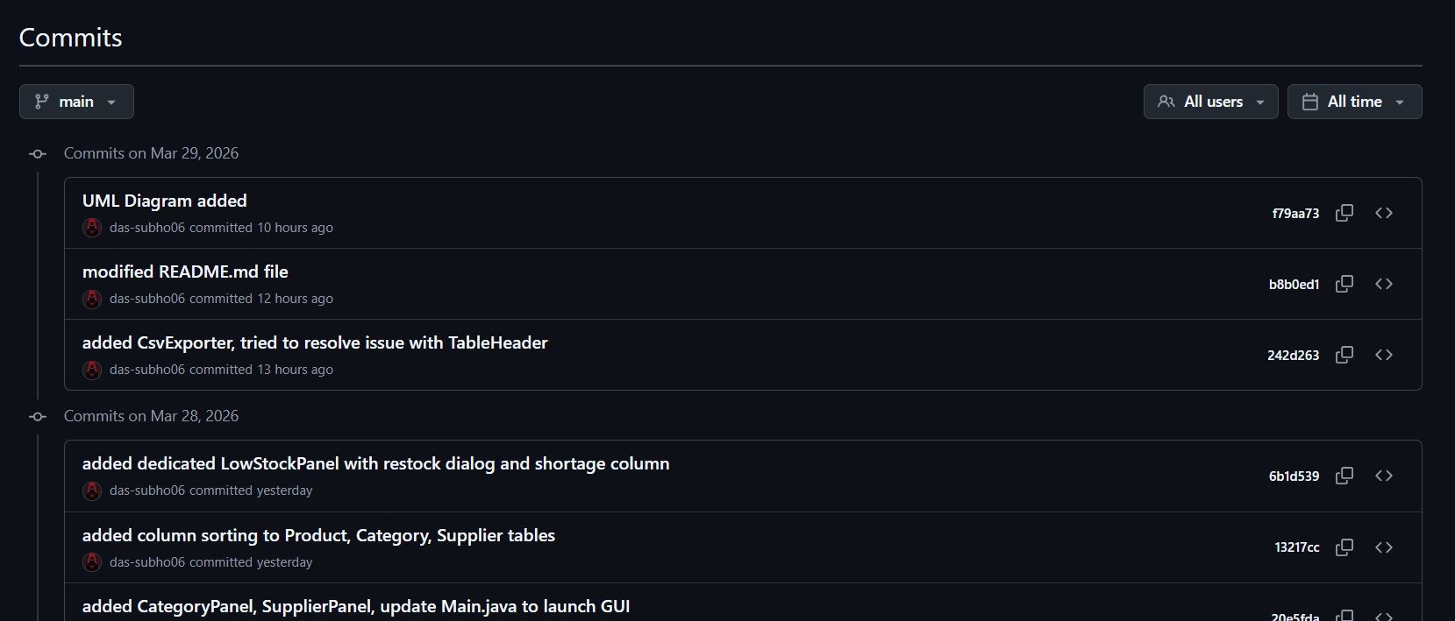
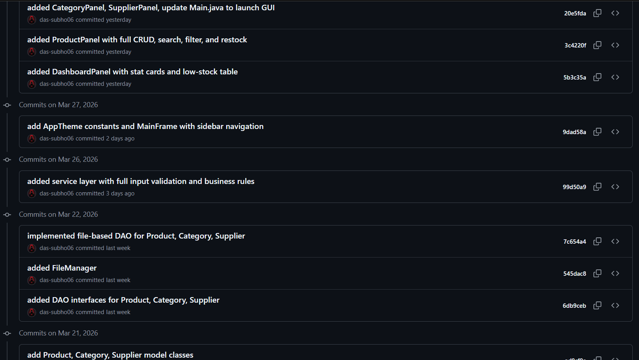
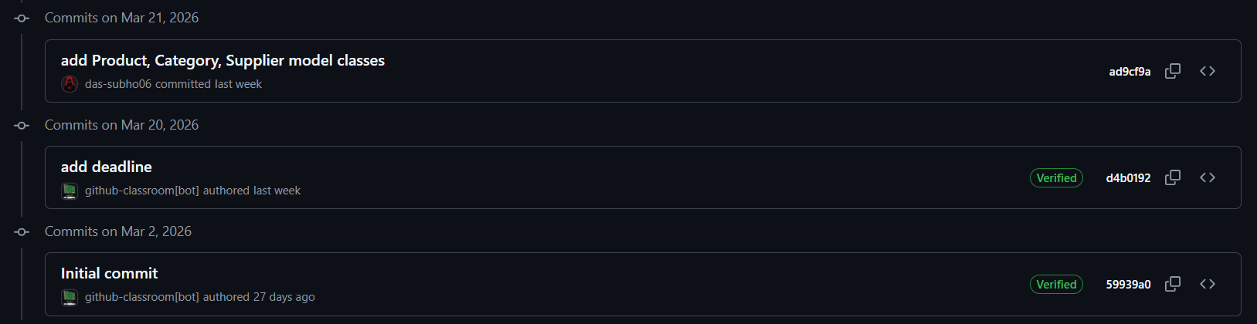
Development Progression
The commit history reflects a deliberate bottom-up development strategy aligned with the DAO pattern’s layered architecture:
- Phase 1 (Commits 2–3): The model and interface layers were established first, creating stable contracts for all subsequent work without any implementation dependency. This allowed each subsequent layer to be written against a known, fixed API.
- Phase 2 (Commits 4–5): Persistence infrastructure was built next. FileManager was isolated as its own commit to allow independent testing before the three DAO implementations were added on top of it.
- Phase 3 (Commit 6): The service layer was completed before any UI work began, ensuring that all business rules were functional and testable independently of the graphical interface. This separation made debugging straightforward.
- Phase 4 (Commits 7–12): UI panels were added incrementally — the visual framework first (MainFrame, AppTheme), then the Dashboard, then the most complex panel (Products with full CRUD and search), then the remaining entity panels, then the dedicated LowStock panel.
- Phase 5 (Commits 13–14): Refinements and bonus features — CSV export and column sorting — were added after the core system was stable. This kept the critical path risk-free and ensured that bonus work could not break the core functionality.

Conclusion and Future Scope
Conclusion:
The InvenTrack Inventory Management System successfully demonstrates all six OOP concepts stipulated in the project specification within a cohesive, functional desktop application. Encapsulation is enforced through private fields and public accessors in all model classes. Abstraction is achieved through the DAO interface contracts that completely hide file-I/O details from upper layers. Polymorphism is exercised both at the DAO level (interface references resolved to concrete implementations at runtime) and at the UI level (overridden DefaultTableCellRenderer). Inheritance is used for ValidationException and all five UI panels. Exception handling provides both user-facing validation feedback via JoptionPane dialogs and robust I/O error recovery via the global uncaught-exception handler. Java Collections and Streams power all data retrieval, search, and filtering operations throughout the application.
The DAO design pattern proved to be an excellent architectural choice for this scale of project, enforcing strict separation of concerns and enabling the entire storage mechanism to be replaced without touching any layer above the DAO implementations — a property that directly addresses the instructor’s feedback regarding extensibility. The system fully implements CRUD for all three entities, addresses all five improvement points raised in the APPROVED_MINOR feedback, and adds bonus features including a dedicated Low Stock Alert panel, column sorting, and CSV export.
Future Scope
- Database Integration: Replace FileManager with a JDBC-based DAO implementation targeting SQLite or H2 to support larger inventories without changing the Service or UI layers - directly demonstrating the DAO pattern’s extensibility.
- User Authentication: Implement a login screen with role-based access (Admin vs. Read-Only Viewer) to make the system suitable for multi-user environments.
- Advanced Reporting: Generate graphical reports (bar charts via JfreeChart) for inventory value trends, category distribution, and monthly restock activity.
- Automated Restock Alerts: Integrate JavaMail to send email notifications automatically when any product’s quantity drops below its threshold.
- Barcode / QR Scanning: Add support for scanning product barcodes via a webcam to speed up stock entry and lookup in a physical retail setting.
- Undo / Redo Mechanism: Implement a command-pattern-based undo stack so shopkeepers can reverse accidental deletions or edits without restarting the application.

Appendix A — Initial Project Proposal
Project Proposal Document
Project Title: Inventory Management System using DAO Pattern and File Handling in Java
Name: Subhashree Das
Department: CSE(IOT CS BT)
Year: 2nd
Section : A
Roll no.: 64
Enrollment no.: 12024052017066
Problem Statement (Max 150 words)
Managing product inventory efficiently is important for small businesses and shops to track available items, update stock levels, and maintain organized records. However, many small stores still rely on manual record-keeping methods such as notebooks or unstructured files, which can lead to errors, misplaced information, and difficulty in updating product data. To address this problem, an Inventory Management System will be developed using Java Object-Oriented Programming concepts and the DAO (Data Access Object) design pattern. The system will allow users to add, view, and delete product information such as product ID, name, quantity, and price. Product data will be stored using file handling instead of a database, making the application simple and lightweight. The use of the DAO pattern will separate data access logic from the application logic, improving maintainability, scalability, and code organization while demonstrating practical implementation of core Java programming concepts.

Target User
- Small shop owners and retail store managers
- Small businesses that need a simple inventory tracking system
- Students and beginner programmers learning Java OOP concepts
- Developers who want to understand the DAO design pattern with file storage

Core Features
- Add new products to the inventory
- View the list of available products
- Delete products from the inventory
- Store product information in a file for persistent storage
- Simple menu-driven console interface for user interaction
- Organized data management using Java classes and collections

OOP Concepts to be Used
Abstraction
- Implemented using the ProductDAO interface to define data operations without exposing implementation details.
Inheritance
- Future extensions can inherit base classes for expanding system functionality.
Polymorphism
- Achieved through implementing the ProductDAO interface with different DAO implementations.
Exception Handling
- Used to manage file input/output errors and prevent program crashes.
Collections / Threads (if applicable)
- Java Collections such as ArrayList will be used to store and manage product objects efficiently.

Proposed Architecture Description
The system will follow a layered architecture using the DAO design pattern. The Model layer contains the Product class representing product attributes such as ID, name, quantity, and price. The DAO layer includes the ProductDAO interface and ProductDAOImpl class that handle data operations like adding, retrieving, and deleting products. File handling will be used to store product data in a text file. The Main Application layer provides a console-based interface where users can interact with the system through menu options. This architecture separates data representation, data access, and user interaction, making the application more organized, maintainable, and scalable.

Appendix B — Instructor Review Response (APPROVED_MINOR)
From: Course Instructor To: Subhashree Das
Dear SUBHASHREE DAS,
Project: Inventory Management System using DAO Pattern + File Persistence Decision: APPROVED_MINOR Score: 90
Strengths: The proposal clearly identifies a practical problem for small businesses and provides a well-structured solution suitable for beginner Java OOP students. The architectural description, utilizing the DAO pattern with clear separation of Model, DAO, and Main Application layers, is excellent and demonstrates a strong understanding of object-oriented design principles. The explicit mention of core OOP concepts to be applied (Abstraction, Polymorphism, Encapsulation, Exception Handling, Collections, Design Pattern) aligns perfectly with university learning objectives. The choice of file persistence over a database is appropriately justified for a lightweight, beginner-friendly system, emphasizing file handling as a key learning outcome. The scope is well-defined and manageable for a project of this nature.
Improvements:
- Consider adding an ‘Update Product’ feature to provide full CRUD functionality, which is a common expectation for inventory management systems.
- Elaborate on specific input validation and error handling strategies beyond just ‘Exception Handling’ - for instance, how the system will ensure unique product IDs, positive quantities, valid prices, and graceful handling of file I/O errors.
- A ‘Search Product’ feature (e.g., by name or ID) would significantly enhance the system’s usability.
- Specify the intended format for the persistent data file (e.g., CSV, JSON, or a custom delimited format) for better clarity and to ensure robust data parsing and storage.
- While the DAO pattern promotes scalability, the ‘scalability’ claim for a file-persistent, console-based system might be slightly overstated; it would be more accurate to emphasize ‘maintainability’ and ‘extensibility’ for future upgrades to a database.
Regards, Course Instructor

Appendix C — Response to APPROVED_MINOR Feedback
All five improvement points raised by the instructor were addressed in the final implementation:
- Update Product: A full update dialog was implemented in ProductPanel, and ProductService.updateProduct() handles all validation for updates, providing complete CRUD functionality across all three entity types.
- Validation strategies: ProductService implements six guard clauses covering empty names, non-positive prices, negative quantities and thresholds, and referential integrity checks for both categoryId and supplierId. FileManager wraps all I/O in try-with-resources with explicit RuntimeException rethrow for graceful I/O error handling.
- Search Product: ProductPanel includes a live search field backed by ProductDAOImpl.searchByName() using Java Streams. A category filter combo-box provides additional drill-down capability without requiring a separate search operation.
- Persistent data format: Java Object Serialization is used, producing binary .dat files (products.dat, categories.dat, suppliers.dat). This format is documented in the README. CSV export was also added as a human-readable alternative via CsvExporter.
- Scalability vs. Maintainability: The report and README now correctly describe the benefit of the DAO pattern as “maintainability and extensibility”, and the Future Scope section describes the precise steps needed to upgrade to a JDBC/database backend - demonstrating exactly the extensibility the pattern is designed to enable.

*****

