Course Name: PCCCS495 – Object Oriented Programming (Java)

Project Title: Hospital Appointment Management System

Student Name: PARBONI MITRA

Roll Number: 4

Instructor Name: Dr. Prof. Susovan Jana and Dr. Prof. Soumadip Biswas

Spring 2026

2. Problem Statement

Hospitals and clinics often rely on manual systems or basic record-keeping methods to manage patient and doctor information. These systems are difficult to maintain, prone to errors, and inefficient when handling multiple patients and appointments. Issues such as duplicate records, missing information, and poor organization can lead to operational inefficiencies.
The Hospital Appointment Management System is designed to provide a simple and structured software-based solution to manage patient and doctor data. The system uses object-oriented programming principles to model real-world entities such as patients, doctors, and appointments. This approach ensures better organization, modularity, and maintainability of the system while demonstrating core OOP concepts in Java.

3. System Design
UML Class Diagram (MANDATORY)

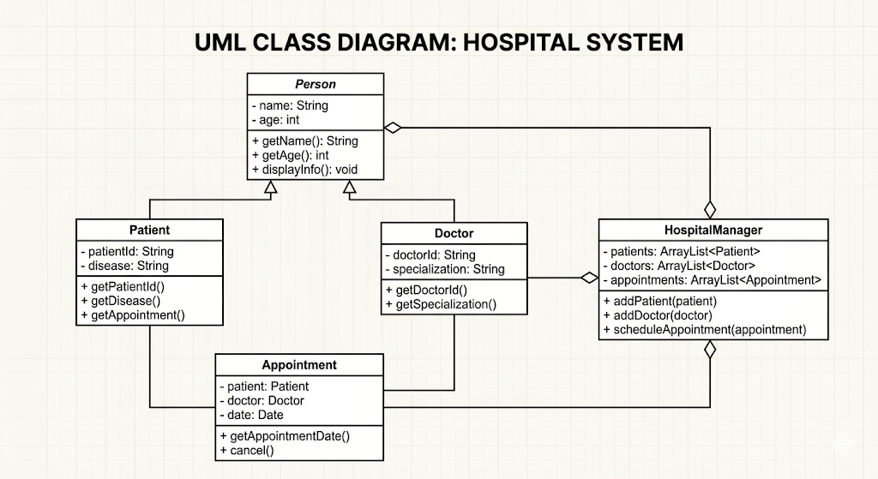

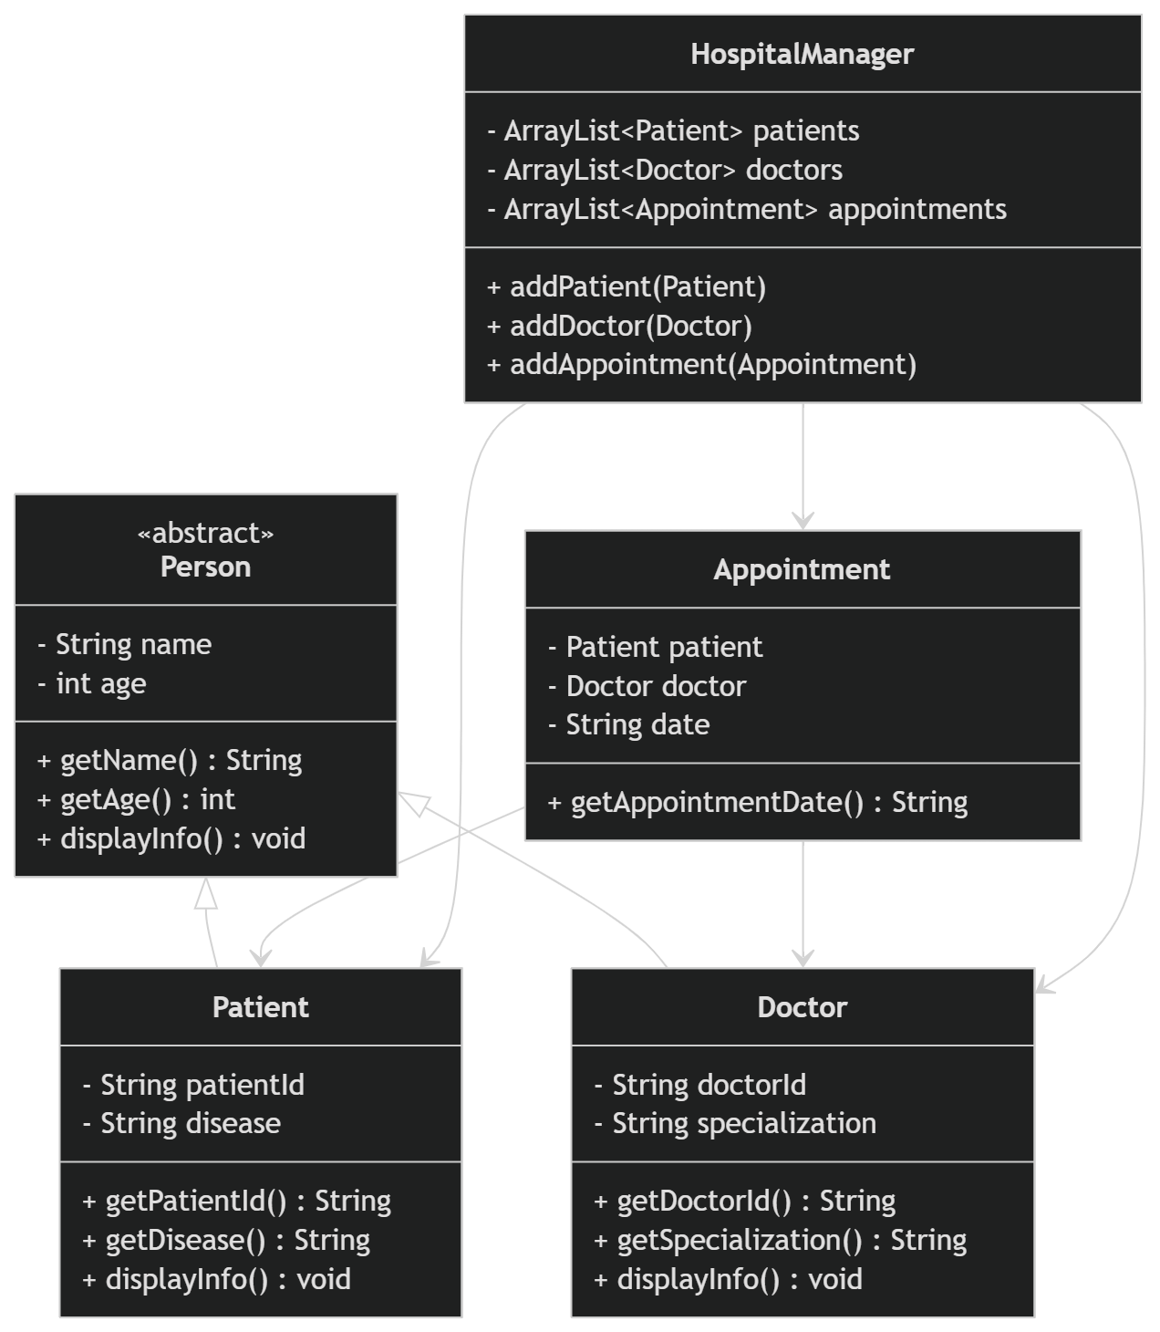

Description of Major Classes

- Person: Abstract base class containing common attributes like name and age.
- Patient: Inherits from Person and stores patient-specific details.
- Doctor: Inherits from Person and stores specialization details.
- Appointment: Represents relationship between patient and doctor.
- HospitalManager: Handles core logic and stores all data using ArrayList.
- Main: Provides menu-driven user interface

Package Structure
src/
model/
service/
Main.java

Interaction Flow
- User selects option from menu
- Input is taken via Scanner
- HospitalManager processes data
- Data is stored in ArrayList
- Output displayed to user

4. OOP Concepts Demonstrated

Abstraction
Where used: Person abstract class
Why: To define common structure without implementation details

public abstract class Person {
private String name;
private int age;
public abstract void displayInfo();
}

Explanation:
Abstract class ensures subclasses must implement displayInfo().

Inheritance
Where used: Patient and Doctor extend Person

public class Patient extends Person {

Explanation:
Allows reuse of common attributes and avoids duplication.

Polymorphism
Where used: Method overriding

@Override
public void displayInfo() {
System.out.println("Patient Details");
}

Explanation:
Same method behaves differently for different classes.

Encapsulation
Where used: Private variables + getters

private String name;

public String getName() {
return name;
}
Explanation:
Protects data and allows controlled access.

Collections
Where used: ArrayList

ArrayList<Patient> patients = new ArrayList<>();

Explanation:
Stores dynamic data efficiently.

5. Implementation Highlights
Snippet 1: Adding Patient

public void addPatient(Patient patient) {
patients.add(patient);
}

Justification: Stores patient dynamically.

Snippet 2: Display Patients

for (Patient p : patients) {
p.displayInfo();
}

Justification: Uses loop + polymorphism.

Snippet 3: Appointment Creation

Appointment a = new Appointment(patient, doctor, date);

Justification: Connects objects.

6. Testing & Error Handling
Test Cases
- Add multiple patients
- Add multiple doctors
- Display records
Edge Cases
- Empty lists
- Invalid input
- Duplicate entries
Failure Scenarios
- Wrong menu input
- Missing data

- Git Workflow
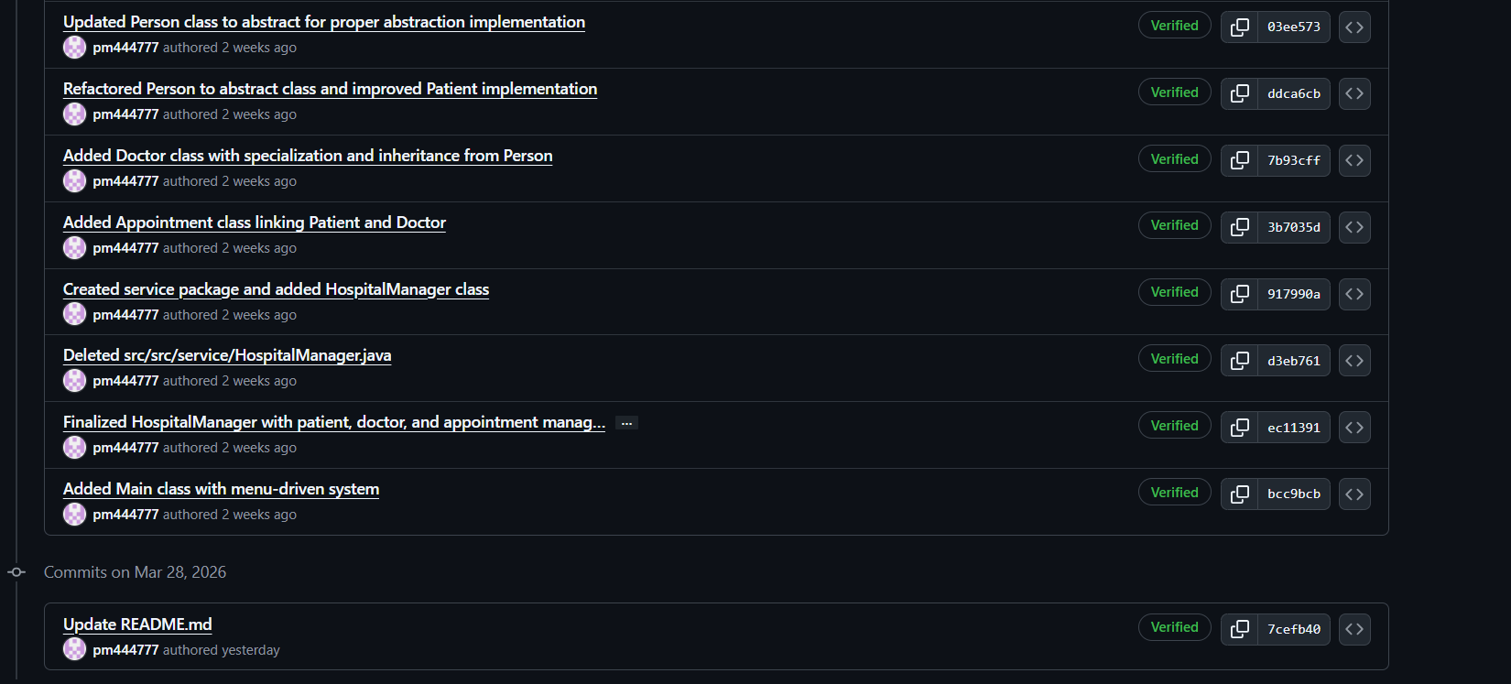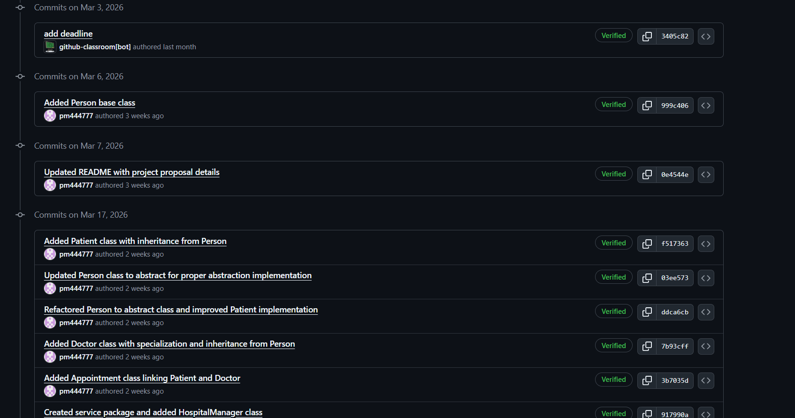
Explanation
The project was developed step-by-step using Git. Each major component such as model classes, service layer, and main interface was committed separately. This ensures version control and proper tracking of progress.

8. Conclusion & Future Scope
Conclusion
This project demonstrates how object-oriented programming can be used to build a simple real-world system. It highlights concepts like abstraction, inheritance, and modular design.

Future Scope
- Add database integration
- Improve UI (GUI)
- Add real appointment scheduling
- Add login system

Appendix
- Initial Proposal
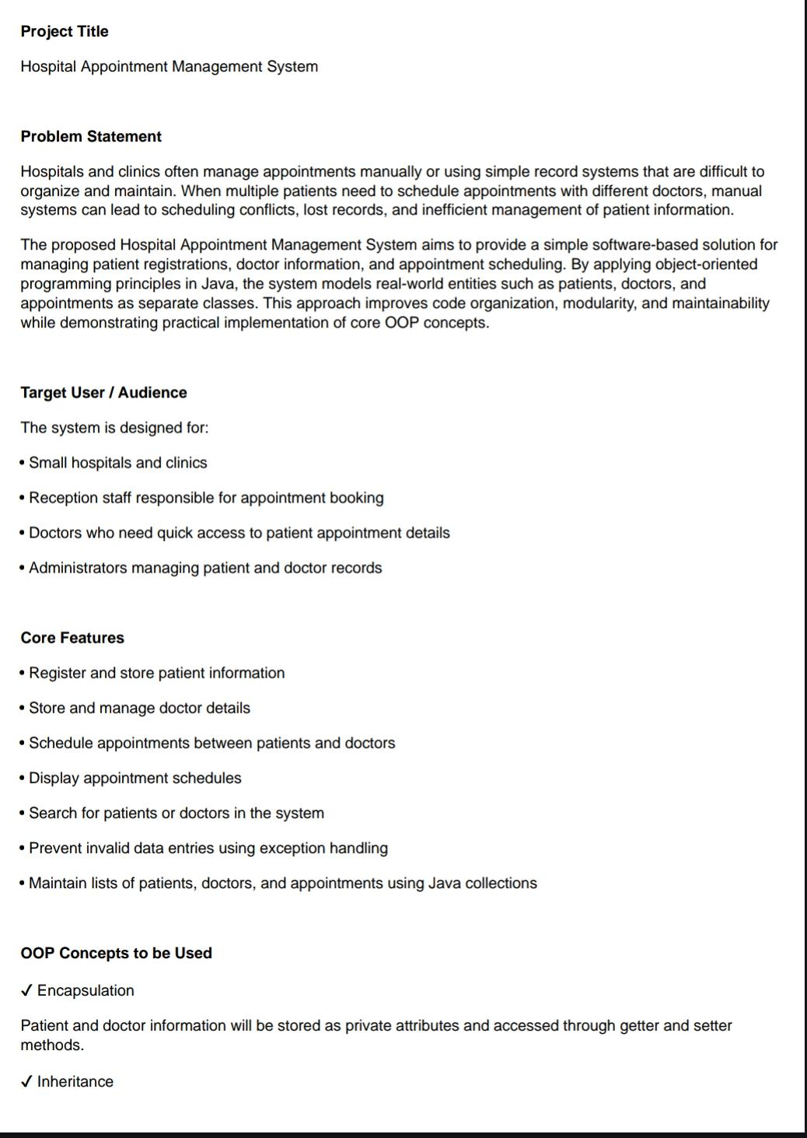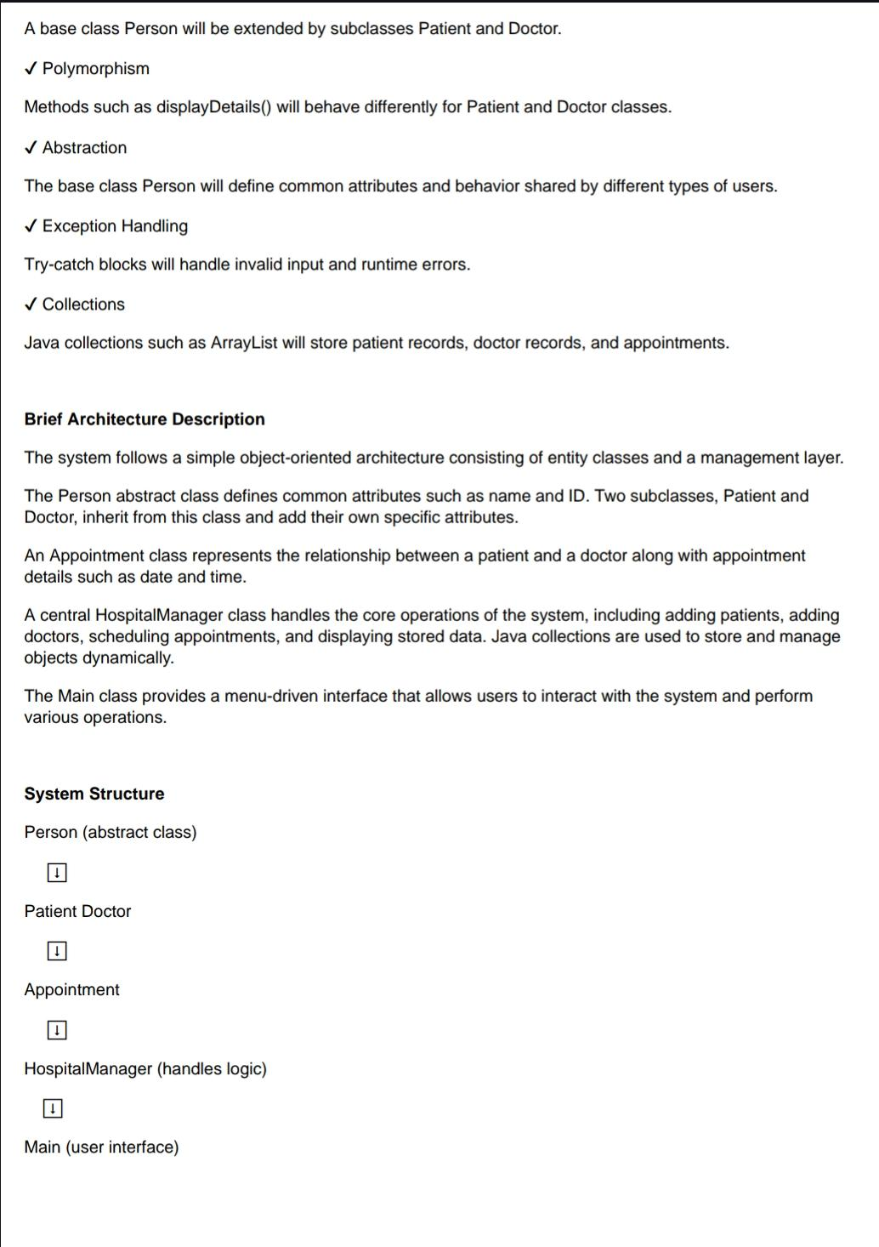
- Approval Mail Screenshot

