Institute of Engineering & Management
Department of CSE (IOTCSBT)

PROJECT REPORT
Advanced Programming (OOP)

Course Registration System
Using Composite Pattern for Course Modules

Submitted by
Srinistha Biswas
Roll Number: 9

Under the guidance of
Dr. Soumadip Biswas
Dr. Swagatam Basu
Dr. Susovan Jana

Spring 2026

1. Problem Statement

In many educational institutions, courses are structured hierarchically with modules, sub-modules, and elective groups. Traditional systems treat courses as flat structures, making nested module management difficult. This project implements a Course Registration System using the Composite Design Pattern, modeling hierarchical structures where administrators build Course to Module to Lesson trees and students register with full validation.

Applying core OOP principles — Abstraction, Encapsulation, Inheritance, Polymorphism — the system ensures modularity and maintainability. Custom exception handling manages registration errors, and File I/O persistence retains data across sessions, addressing all APPROVED_MINOR feedback.

Target Users & Core Features
- University students, academic administrators, educational institutions, OOP learners
- Hierarchical course structure: Course to Module to Lesson with recursive display
- Register/cancel enrollments with duplicate and invalid-course validation
- Calculate total credits per student; display all courses and students
- File I/O persistence: save/load students, courses, registrations to .txt files

2. System Design

2.1 UML Class Diagram
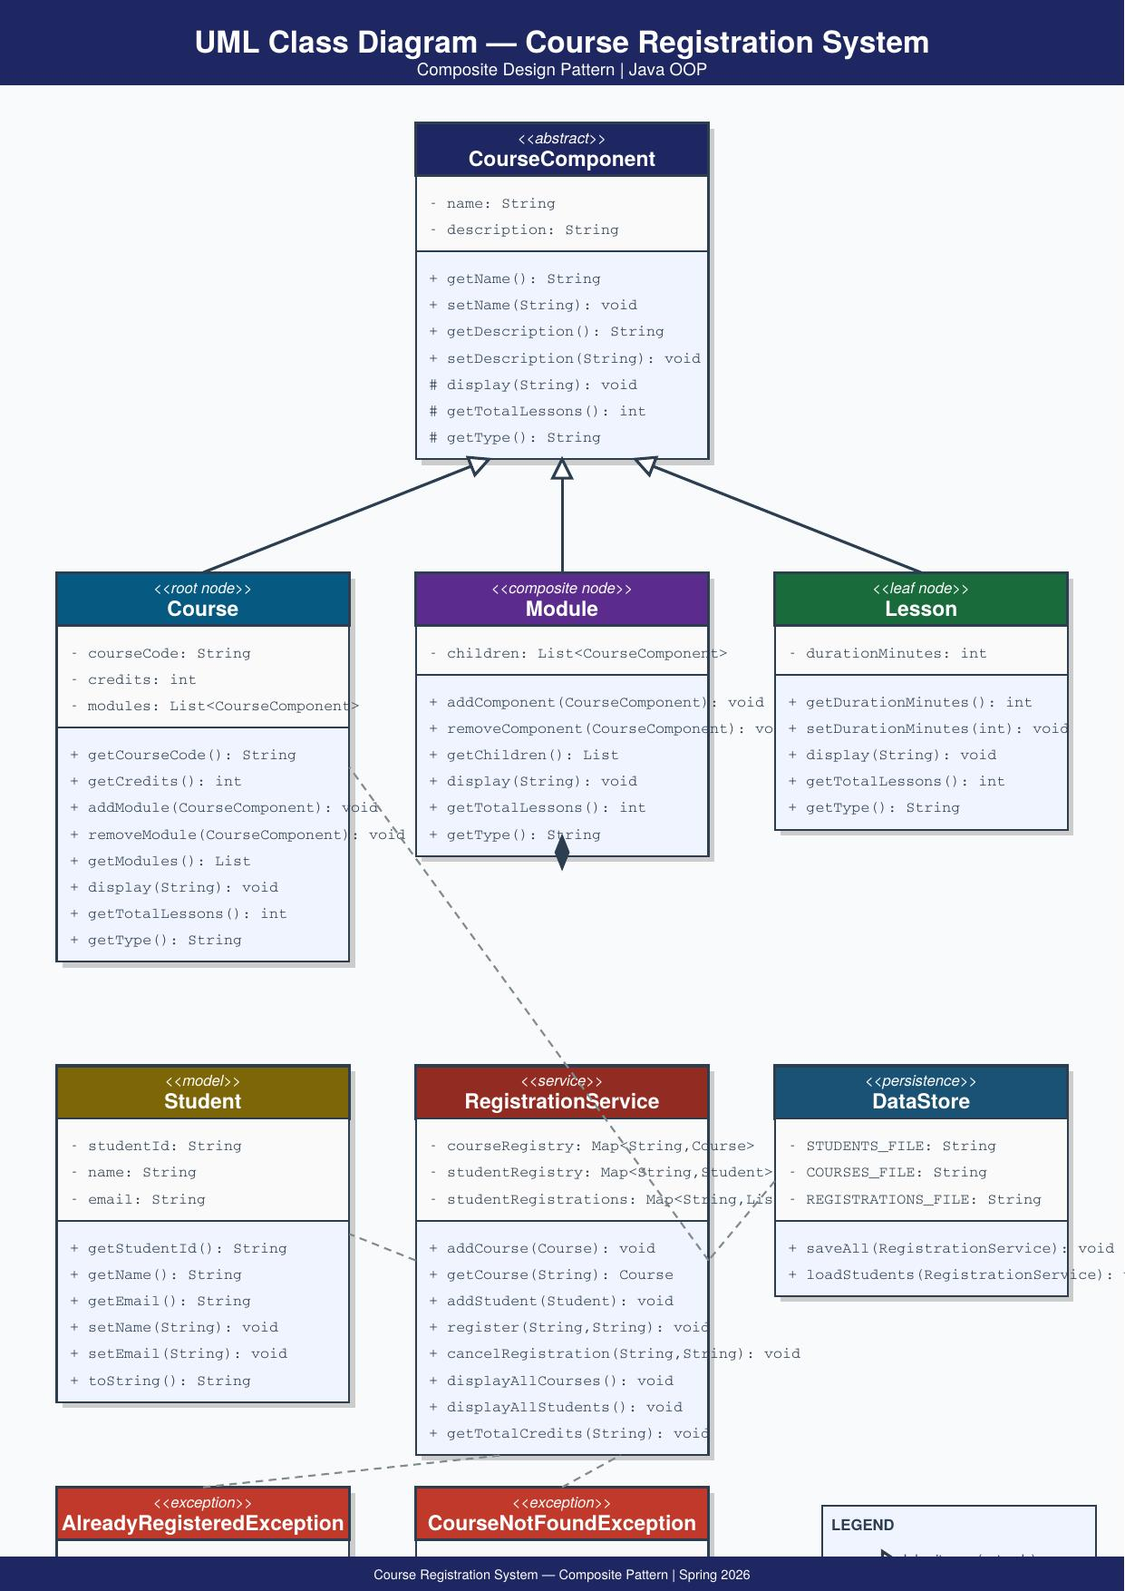
Figure 1: UML Class Diagram — Course Registration System
2.2 Major Classes
CourseComponent (Abstract)
Abstract root of the Composite Pattern. Declares display(), getTotalLessons(), getType() as abstract methods enforcing a uniform interface. Holds private name and description with encapsulated access.
Course / Module / Lesson
Course (root node) adds courseCode, credits, and List of modules. Module (composite node) holds children — Lessons or sub-Modules — and recurses in display(). Lesson (leaf node) adds durationMinutes, returns 1 from getTotalLessons(), no children.
RegistrationService
Business logic layer with three HashMaps: courseRegistry, studentRegistry, studentRegistrations. Provides register(), cancelRegistration(), displayAllCourses(), displayAllStudents(), getTotalCredits().
DataStore & Exceptions
DataStore uses BufferedWriter/Reader for File I/O persistence. AlreadyRegisteredException and CourseNotFoundException extend Exception with descriptive messages.

2.3 Package Structure & Interaction Flow
src/component/ CourseComponent.java, Course.java, Module.java, Lesson.java
src/model/ Student.java
src/exception/ AlreadyRegisteredException.java, CourseNotFoundException.java
src/service/ RegistrationService.java
src/persistence/ DataStore.java | src/ Main.java

- Main.java loads persisted students via DataStore.loadStudents() on startup.
- Course trees built: Lessons grouped into Modules, Modules attached to Courses.
- RegistrationService.register() validates course existence, checks duplicates, enrolls.
- Exceptions thrown for invalid operations; caught and displayed in Main.java.
- DataStore.saveAll() persists all data to .txt files at program end.

3. OOP Concepts Demonstrated

3.1 Abstraction
Where used: CourseComponent.java — abstract class with abstract methods display(), getTotalLessons(), getType().
Why used: Hides complexity by defining a contract. All course elements treated uniformly regardless of internal implementation.
Code Snippet:
public abstract class CourseComponent {
private String name, description;
public abstract void display(String indent);
public abstract int getTotalLessons();
public abstract String getType();
}
Explanation: Subclasses must implement all abstract methods. Client code calls them uniformly without knowing the concrete type.

3.2 Encapsulation
Where used: All fields in CourseComponent, Student, Course, Module, Lesson are private with public getters/setters.
Why used: Protects internal state. External classes cannot directly modify sensitive fields like studentId.
Code Snippet:
public class Student {
private String studentId, name, email;
public String getStudentId() { return studentId; }
public String getName() { return name; }
public void setName(String n){ this.name = n; }
}
Explanation: All data access is controlled. studentId cannot be changed after construction, ensuring identity integrity.

3.3 Inheritance
Where used: Course, Module, Lesson all extend CourseComponent, reusing name, description, and constructor logic.
Why used: Avoids duplication of shared fields and behavior across all three node types.
Code Snippet:
public class Course extends CourseComponent {
private String courseCode;
private int credits;
public Course(String code, String name, String desc, int cr) {
super(name, desc); // parent constructor handles common fields
this.courseCode = code; this.credits = cr;
}
}
Explanation: super() delegates common initialization. Course only declares unique fields, reducing code duplication.

3.4 Polymorphism
Where used: display() overridden in Course, Module, Lesson — each with different behavior, called uniformly.
Why used: Enables recursive tree rendering without type-checking — central to the Composite Pattern.
Code Snippet:
// Course: prints details and recurses into modules
public void display(String indent) {
System.out.println(indent + "Course [" + courseCode + "]: " + getName());
for (CourseComponent m : modules) m.display(indent + " ");
}
// Lesson: prints directly, no recursion needed
public void display(String indent) {
System.out.println(indent + "Lesson: " + getName());
}
Explanation: Same method call behaves differently at runtime based on actual object type — runtime polymorphism.

3.5 Exception Handling
Where used: AlreadyRegisteredException and CourseNotFoundException thrown by RegistrationService, caught in Main.
Why used: Custom exceptions provide precise context — exactly which student/course caused the failure.
Code Snippet:
public void register(String sid, String code)
throws AlreadyRegisteredException, CourseNotFoundException {
getCourse(code); // throws CourseNotFoundException if invalid
List<String> list = studentRegistrations.get(sid);
if (list.contains(code))
throw new AlreadyRegisteredException(sid, code);
list.add(code);
}
Explanation: Two distinct failure modes handled separately, enabling targeted user feedback and clean error recovery.

3.6 Collections
Where used: HashMap in RegistrationService for course/student registries; ArrayList for per-student course lists.
Why used: HashMap provides O(1) lookup. ArrayList gives dynamic, ordered storage of enrollments.
Code Snippet:
private Map<String, Course> courseRegistry = new HashMap<>();
private Map<String, Student> studentRegistry = new HashMap<>();
private Map<String, List<String>> studentRegistrations = new HashMap<>();

studentRegistrations.putIfAbsent(sid, new ArrayList<>());
studentRegistrations.get(sid).add(courseCode);
Explanation: Nested Map<String, List<String>> efficiently maps each student to their dynamic enrollment list.

4. Implementation Highlights

4.1 Recursive display() — Composite Pattern Core
Module.display() calls display() on each child with increased indentation. No type-checking required — polymorphism handles all node types uniformly.
public void display(String indent) {
System.out.println(indent + "Module: " + getName());
for (CourseComponent c : children) c.display(indent + " ");
}
Justification: Eliminates instanceof checks. Adding new node types requires zero changes to display logic.

4.2 File I/O Persistence — DataStore.java
BufferedWriter saves comma-separated records; try-with-resources ensures streams always close.
try (BufferedWriter bw = new BufferedWriter(new FileWriter(FILE))) {
for (Student s : service.getAllStudents().values())
bw.write(s.getStudentId() + "," + s.getName() + "," + s.getEmail());
} catch (IOException e) { System.out.println("Error: " + e.getMessage()); }
Justification: Addresses mentor improvement — data survives program restarts without a database.

4.3 getTotalCredits() — Collections + Exception Handling
List<String> courses = studentRegistrations.getOrDefault(sid, new ArrayList<>());
int total = 0;
for (String code : courses) total += getCourse(code).getCredits();
System.out.println("Total credits: " + total);
Justification: getOrDefault() prevents NullPointerException. getCourse() propagates CourseNotFoundException cleanly.

5. Testing & Error Handling

5.1 Test Cases
# | Test Case | Expected Result | Status
1 | Register student in valid course | Confirmed successfully | PASS
2 | Register same student twice | AlreadyRegisteredException | PASS
3 | Register in invalid course CS999 | CourseNotFoundException | PASS
4 | Display hierarchical course tree | Correct indented output | PASS
5 | Cancel existing registration | Removed successfully | PASS
6 | Cancel non-existent registration | Warning displayed | PASS
7 | Calculate total credits | Correct sum returned | PASS
8 | Save data to .txt files | All 3 files created | PASS
9 | Load students on startup | Previously saved data loaded | PASS
10 | Display all courses/students | All entries printed | PASS

5.2 Edge Cases & Failure Scenarios
- Student with no registrations: getOrDefault() returns empty list — no NullPointerException.
- File not found on load: DataStore checks file.exists() before reading — no crash.
- CourseNotFoundException: getCourse() throws with exact course code in message.
- AlreadyRegisteredException: Reports exact studentId and courseCode in message.
- IOException: Caught within DataStore methods — file failures do not crash the app.

6. Git Workflow

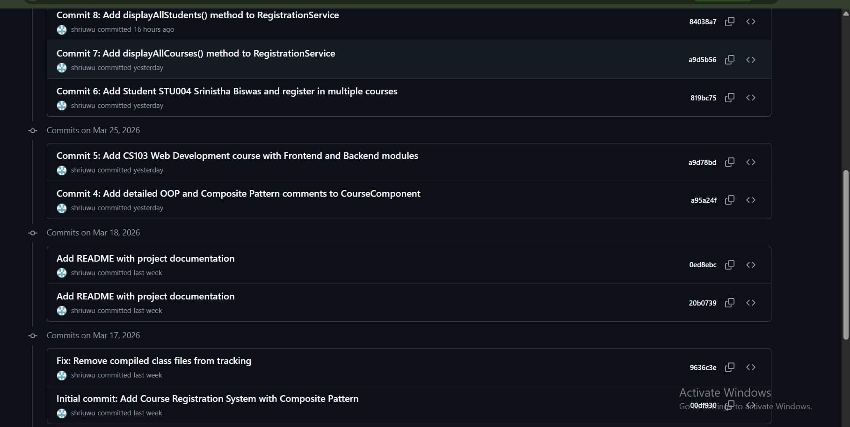


College Submission Repo — IEM-Gurukul/term-ii-project-submission-shriuwu

Development Progression
- Initial commit: Complete project with Composite Pattern, OOP, exceptions, collections, File I/O.
- Fix gitignore & README: Cleaned repo, added full architecture documentation.
- Commits 4-6: Added OOP comments, CS103 Web Development course, Student STU004.
- Commits 7-8: Added displayAllCourses() and displayAllStudents() utility methods.
- Commits 9-10: Integrated display methods in Main; added getTotalCredits().

7. Conclusion & Future Scope

This project successfully implements a Course Registration System using the Composite Design Pattern in Java, demonstrating all core OOP principles. The Composite Pattern proved ideal — treating Course, Module, and Lesson uniformly through CourseComponent eliminates type-checking and enables elegant recursive operations across arbitrarily deep hierarchies.

All three APPROVED_MINOR improvements have been addressed: Encapsulation is explicitly demonstrated across all classes; File I/O persistence is implemented in DataStore.java; Git is referenced as a project management practice. The project has 10 meaningful commits across a clean 5-package architecture.

Future Scope
- Database Integration: Replace File I/O with SQLite for concurrent, robust storage.
- Course Capacity Management: Implement enrollment limits with CourseFull exception.
- Menu-driven Console Interface: Add Scanner-based interactive runtime management.
- Multi-threading: Simulate concurrent registrations with synchronized methods.
- JavaFX GUI: Visualize the course hierarchy as an interactive tree structure.

A. Appendix

A.1 Initial Project Proposal
Project Title : Course Registration System Using Composite Design Pattern
Problem Statement
In many educational institutions, courses are structured hierarchically, consisting of modules, sub-modules, and elective groups. Traditional registration systems treat courses as flat structures, making it difficult to manage nested modules and specializations efficiently. This project aims to design and implement a Course Registration System using the Composite Design Pattern to model hierarchical course structures. The system will allow administrators to create courses and modules in a tree-like format and enable students to register while maintaining constraints such as course capacity. By applying Object-Oriented Programming principles, the system will ensure modularity, scalability, and maintainability. The project will also demonstrate real-world implementation of design patterns in academic software systems.
Target User
• University students
• Academic administrators
• Educational institutions
Core Features
• Create hierarchical course structures (Courses → Modules → Sub-modules)
• Student registration functionality
• Course capacity management
• Display course structure dynamically
• Custom exception handling for registration limits
• Menu-driven console interface
• Version control using Git for development tracking
OOP Concepts to be Used
• Abstraction : Abstract base class (CourseComponent) to define common structure for modules and courses.
• Inheritance : Module and Course classes inherit from the base component class.
• Polymorphism : Overriding display and registration methods to allow uniform treatment of individual modules and grouped modules.
• Exception Handling : Custom exception (e.g. CourseFullException) for handling registration limits.
Proposed Architecture Description
- The system will follow the Composite Design Pattern architecture. An abstract component class will define common operations such as add, remove, and display. Leaf nodes will represent individual modules, while composite nodes will represent courses that can contain multiple modules or sub-courses. Students will interact with course objects through a registration mechanism that enforces capacity constraints using custom exception handling. The system will be modular, object-oriented, and structured to allow future scalability.

A.2 Review Mail — APPROVED_MINOR
Dear Srinistha Biswas,
Project: Course Registration System Using Composite Design Pattern Decision: APPROVED_MINOR Score: 92 Strengths:
The proposal demonstrates an excellent understanding of the problem domain and a highly appropriate choice of the Composite Design Pattern to solve it. The problem statement is clear, highlighting the limitations of flat structures and the benefits of a hierarchical approach. The architectural description clearly outlines how the Composite pattern will be implemented, differentiating between abstract components, leaf nodes, and composite nodes. The proposed features are relevant, well-aligned with the chosen design pattern, and realistic for a university project. The inclusion of core OOP concepts, custom exception handling, and capacity management reflects good design principles.

Improvements:
1.**Explicit Encapsulation**: While implied by OOP, explicitly listing 'Encapsulation' alongside other OOP concepts (Abstraction, Inheritance, Polymorphism) would provide a more complete picture of the OOP principles being applied.
2.**Data Persistence**: The proposal currently doesn't specify how course structures, student data, or registration records will be persisted. For a more robust system, consider adding a plan for data storage (e.g., in-memory for simplicity, file I/O, or a simple database solution like SQLite).
3.**Refine 'Git' as a Feature**: 'Version control using Git for development tracking' is a project management practice rather than a system feature. It could be rephrased under 'Project Management' or as a development methodology point.
Regards, Course Instructor

