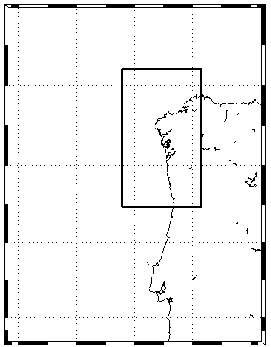
Atlantic Ocean
Lisboa

