Supporting PCS Adoption: A Database of Cooling and Heating Effects for Designers and Practitioners

Akihisa Nomoto ^{1,*}, Maíra André ² , Thomas Parkinson ²

¹ Takenaka Corporation, Chiba, Japan
² IEQ Lab, School of Architecture, Design and Planning, The University of Sydney, Australia
*Corresponding email: nomoto.akihisa@takenaka.co.jp

SUMMARY
This study developed an open-access database quantifying the cooling and heating effects of commercially available Personal Comfort Systems (PCS) based on thermal manikin experiments. The database is intended to support the integration of PCS into the design and operation of conventional room air conditioning systems by providing accessible and quantitative information on their thermal effects. We tested 17 different PCS devices in a climate-controlled chamber simulating typical office environments. Example results at an ambient temperature of 25°C indicate that small desk fans at mid-level speed settings provide limited whole-body cooling (< 1.0°C), while standing fans and evaporative coolers achieve stronger cooling effects of up to 3.0°C. Heating devices demonstrated warming effects ranging from approximately 0.5 °C to 3.5 °C. These findings demonstrate the potential of PCS to support building designers in relaxing ambient temperature setpoints while maintaining occupants’ thermal comfort. The database is publicly available at: https://github.com/IEQLab/pcs_database.

KEYWORDS
Personal Comfort Systems (PCS); Open-access; Database; Thermal Comfort; Thermal Manikin

1 INTRODUCTION
Personal Comfort Systems (PCS) offer a promising approach to heating and cooling individuals with significantly lower energy consumption compared to conventional air conditioning systems. Their proximity to the body and ability to be tailored to individual needs enable reduced power usage and enhanced occupant satisfaction. Despite a growing body of research demonstrating these advantages over the past two decades, PCS have yet to become commonplace in office environments. Practitioners rarely consider them in the design process, hindering their application. This is partly caused by the difficulty in integrating their effect into the design and dimensioning of the air conditioning system. To address this gap, we developed an open-access database of local and overall cooling and heating effects for a range of commercially available PCS products. This paper presents an overview of the experiment and an example result.

2 METHODS
A chamber experiment was conducted to quantify the sensible heat transfer of localized thermal stimuli provided by PCS using a thermal manikin in a climate-controlled chamber at The University of Sydney from January 2024 to March 2025. Seventeen PCS devices were tested, and each PCS was tested under still-air conditions at air and mean radiant temperatures of 22, 25, and 28 °C. Relative humidity was not controlled and varied between 40% and 60%. To represent typical office environments, the thermal manikin was maintained in a sitting posture. Cooling devices were evaluated with a typical summer clothing ensemble (0.4 clo: underwear, socks, short-sleeve dress shirt, trousers, and shoes), while heating devices were tested with heavier clothing (0.8 clo: summer clothing plus light knit cardigan and jacket). These clothing insulation values were measured with the thermal manikin in accordance with ISO standard 9920 (2007).
The manikin’s skin temperature was uniformly controlled at 34°C. The supplied power required to maintain this temperature was continuously recorded under identical environmental conditions with and without PCS operation, and the difference in the supplied power was defined as the PCS-induced thermal effect. The resulting effects were converted to equivalent delta temperatures (ΔTeq) [1], representing the thermal offset introduced by PCS and indicating the potential for relaxation of ambient system setpoints.

3 RESULTS
The device information (e.g., size, brand, and dimensions), experimental conditions (e.g., air temperature and relative humidity for each test), and measurement results (skin temperature and supplied electrical power) are included in the database. Each PCS is assigned a unique identifier. Users can access the results of individual PCS devices according to their interests and application needs. Figure 1 presents example results illustrating the overall cooling and heating effects of PCS at their mid-level settings on ΔTeq under an ambient operative temperature of 25 °C. Small fans (e.g., IDs 1–7) exhibited limited cooling effects of less than 1°C. In contrast, standing fans (IDs 8 and 9) and an evaporative cooler (ID 10) produced moderate cooling effects ranging from 1.8 to 3.0 °C. The heating effects of PCS at their mid-level settings in this study ranged from approximately 0.5 °C to 3.0 °C (IDs 11-17), with the heating pad (ID 11) applied to the back showing the strongest impact.

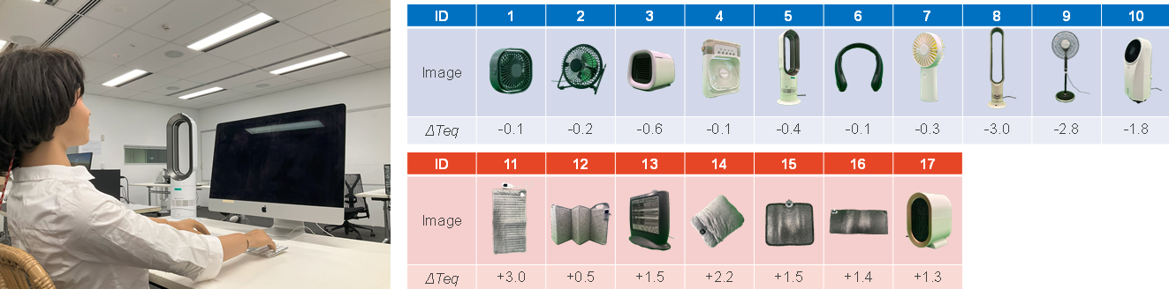
Figure 1. Example of the experimental setup and representative results for 17 PCS devices (ΔTeq for the overall body). The presented effects correspond to mid-level operation under an ambient temperature of 25 °C.

4 DISCUSSIONS
The database quantifies the extent to which setpoint temperatures may be relaxed according to the selected PCS, thereby facilitating its inclusion in air conditioning design strategies. However, this study has several limitations that should be considered when interpreting the results. First, latent heat effects associated with sweating were not included as the manikin only calculates dry heat losses. Under real conditions involving perspiration, the cooling effect of fans is expected to be greater; therefore, the present measurements may underestimate the actual cooling effect of PCS in hot environments. Second, this paper only showed changes in whole-body equivalent temperature (ΔTeq). Although the desk fans exhibited small whole-body cooling effects, they provided stronger localized cooling around the head and upper body. Please note that human thermal perception is more complex than the area-weighted averaging used in thermal manikin calculations [2]. Finally, convective heat loss by PCS depends on both the manikin surface temperature and the surrounding air temperature. Results vary under different temperature conditions, so we encourage users to access the database for additional results.

REFERENCES
[1] ISO 7726 (1998) [2] Hui Zhang, Human thermal sensation and comfort in transient and non-uniform thermal environments, University of California, Berkeley, (2003)

