GeoSPARQL – a minimal approach
version | date | comments
1 | 2025-07-30 | First draft issue for IES v4.4.0-rc1

Outline of the approach
The minimal approach to the addition of GeoSPARQL to IES has the following parts:
Additional classes: It is recognised that geo:SpatialObject, geo:Feature, and geo:Geometry are each equivalent to ies:Element in a 4D ontology, so no addition to IES is required for these.
The class geo:Point becomes ies:WorldLine in a 4D ontology, and this is proposed as useful subclass of ies:Element.
The class geo:BoundingBox exists solely to constrain the range of geo:hasBoundingBox, and so is superfluous.
Relationships and attributes: Most of the GeoSPARQL attributes are either:
- relationships between instances of ies:Element, which can be added; or
- instances of ies:Characteristic, which can be implemented using the existing IES capability.
There are a few attributes, such as geo:hasSpatialResolution and geo:hasSpatialAccuracy, which required further analysis.
Numeric representation: A model for the specification of a region of space with respect to a coordinate system is necessarily complicated, encompassing topology as well as geometry. The minimal approach does not attempt this, but instead references an external “representation”, such as that provided by Well Known Text (WKT) – see https://libgeos.org/specifications/wkt/ .

Scope of GeoSPARQL

GeoSPARQL as UML
The GeoSPARQL specification is small, and is shown as UML in Figure 1.
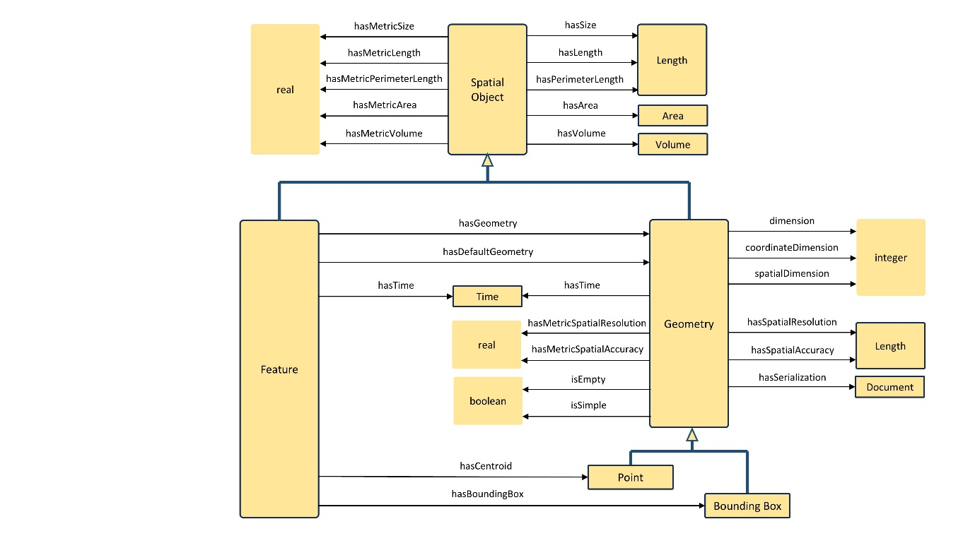
Figure 1 - GeoSPARQL classes and properties as UML
The definitions of the classes and their attributes follow.
The classes geo:SpartialObjectCollection, geo:FeatureCollection and geo:GeometryCollection are omitted because, IES already supports assemblies.
The GeoSPARQL “Topology vocabulary extension” is not addressed.

Spatial object
Anything spatial (being or having a shape, position or an extent).
hasSize | Subproperties of this property are used to indicate the size of a Spatial Object as a measurement or estimate of one or more dimensions of the Spatial Object's spatial presence.
hasMetricSize | Subproperties of this property are used to indicate the size of a Spatial Object, as a measurement or estimate of one or more dimensions of the Spatial Object's spatial presence. Units are always metric (meter, square meter or cubic meter).
hasLength | The length of a Spatial Object.
hasMetricLength | The length of a Spatial Object in meters.
hasPerimeterLength | The length of the perimeter of a Spatial Object.
hasMetricPerimeterLength | The length of the perimeter of a Spatial Object in meters.
hasArea | The area of a Spatial Object.
hasMetricArea | The area of a Spatial Object in square meters.
hasVolume | The volume of a three-dimensional Spatial Object.
hasMetricVolume | The volume of a Spatial Object in cubic meters.

Feature
A discrete spatial phenomenon in a universe of discourse.
NOTE A Feature represents a uniquely identifiable phenomenon, for example a river or an apple. While such phenomena (and therefore the Features used to represent them) are bounded, their boundaries may be crisp (e.g., the declared boundaries of a state), vague (e.g., the delineation of a valley versus its neighbouring mountains), and change with time (e.g., a storm front). While discrete in nature, Features may be created from continuous observations, such as an isochrone that determines the region that can be reached by ambulance within 5 minutes.
hasGeometry | A spatial representation for a given Feature.
hasDefaultGeometry | The default geometry to be used in spatial calculations, usually the most detailed geometry.
hasCentroid | The arithmetic mean position of all the geometry points of a given Feature.  The target geometry shall describe a point, e.g. sf:Point.
hasBoundingBox | The minimum or smallest bounding or enclosing box of a given Feature.  The target is a geometry that defines a rectilinear region whose edges are aligned with the axes of the coordinate reference system, which exactly contains the geometry or Feature e.g. sf:Envelope.
hasTime (an inherited attribute valid for all classes) | Stated by GeoSPARQL to be analogous to hasGeometry. It is when the Feature exists. It can be a point in time or a period of time.

Geometry
A coherent set of direct positions in space. The positions are held within a Spatial Reference System (SRS).
NOTE Geometry can be used as a representation of the shape, extent or location of a Feature and may exist as a self-contained entity.
dimension | The topological dimension of this geometric object, which must be less than or equal to the coordinate dimension. In non-homogeneous collections, this is the largest topological dimension of the contained objects.
coordinateDimension | The number of measurements or axes needed to describe the position of this Geometry in a coordinate system.
spatialDimension | The number of measurements or axes needed to describe the spatial position of this Geometry in a coordinate system.
hasSpatialResolution | The spatial resolution of a Geometry
hasMetricSpatialResolution | The spatial resolution of a Geometry in meters.
hasSpatialAccuracy | The positional accuracy of the coordinates of a Geometry.
hasMetricSpatialAccuracy | The positional accuracy of the coordinates of a Geometry in meters.
isEmpty | (true) if this geometric object is the empty Geometry. If true, then this geometric object represents the empty point set for the coordinate space.
isSimple | (true) if this geometric object has no anomalous geometric points, such as self intersection or self tangency.
hasSerialization | Connects a Geometry object with its text-based serialization.
hasTime (an inherited attribute valid for all classes) | Stated by GeoSPARQL to be analogous to hasGeometry. It is when the Geometry exists. It can be a point in time or a period of time.

Point
A point geometry corresponding with the centroid of the Feature’s geometry. The centroid is typically used to show location on a low-resolution image, and for some indexing and discovery functions.

BoundingBox
A simplified geometry-representation corresponding to the envelope of the Feature’s geometry. Bounding-boxes are typically used in indexing and discovery.

Moving to 4D
IES is 4D, therefore an instance of ies:Element can change with time. GeoSPARQL is 3D, and has an attribute geo:hasTime which specifies when an object exists. This does not cause a conflict. For any GeoSPARQL attribute, an ies:Element can have a state or temporal part during which the attribute has an unchanged value.
IES uses the principal of super substantivalism in which matter is a property of space-time and not separate from it. The GeoSPARQL does not use this principal and so has the attribute geo:isEmpty to specify that an object is an empty region of space-time. This attribute is not relevant to IES because a region of space-time can have different distributions of matter within in it at different times.

Additional classes
The only additional class is ies:WorldLine, which is defined as:
An Element that is a point in space, and can have start and end dates.
Other subclasses of ies:Element could be added with different spatial and temporal dimension, as described in section 6.1, but for a minimal approach an implementation of geo:dimension suffices.

Relationships and attributes

Relationship and attribute disposition
The relationships and attributes in GeoSPARQL are assimilated into IES according to the following table.
GeoSPARQL attribute | Approach
hasSize | IES characteristic
hasMetricSize | SI simplification
hasLength | IES characteristic
hasMetricLength | SI simplification
hasPerimeterLength | IES characteristic
hasMetricPerimeterLength | SI simplification
hasArea | IES characteristic
hasMetricArea | SI simplification
hasVolume | IES characteristic
hasMetricVolume | SI simplification
hasGeometry | Relationship between elements
hasDefaultGeometry | Relationship between elements
hasCentroid | Relationship between elements
hasBoundingBox | Relationship between Elements
hasTime | IES 4D approach
dimension | Dimension attribute
coordinateDimension | Dimension attribute
spatialDimension | Dimension attribute
hasSpatialResolution | Relationship between elements
hasMetricSpatialResolution | SI simplification
hasSpatialAccuracy | Relationship between elements
hasMetricSpatialAccuracy | SI simplification
isEmpty | IES 4D approach
isSimple | Dimension attribute
hasSerialization | Numeric representation

IES characteristic
These GeoSPARQL attributes are implemented in IES as ies:Characteristic. The attributes are of two types:
- classification of an ies:Element
For example, geo:hasVolume. A 3D ies:Element can be a member of the class 10m³.
- classification of an aspect of an ies:Element.
For example, geo:hasPerimeterLength. A 2D ies:Element can have an outer bound which is a closed curve and a member of the class 25m. This is discussed further in section 6.1.3
There are issues with the current handling of the two types of ies:Characteristic, but these issues are not addressed here.

SI simplification
GeoSPARQL provides simplified attributes where the unit of measure is encoded in the attribute name, such as geo:hasMetricLength (length in metres). This simplification is not required for IES, so these attributes can be omitted.

Relationship between elements

geo:hasGeometry
This relationship is between an ies:Element for which the region of space is unknown and another ies:Element for which the region of space is known, where the known region of space is an approximation to the unknown region of space.
GeoSPARQL constrains the known region of space to be defined with respect to a coordinate system. This is the usual case, but the constraint in unnecessary.
In GeoSPARQL the known region of space have spatial dimension lower than that of the unknown. This implies a method of generating a region of space of the same spatial dimension which is unstated.
The relationship is implemented in IES as ies:hasGeometricApproximation.

geo:hasDefaultGeometry
The GeoSPARQL relationship is implemented as as ies:hasDefaultGeometricApproximation, which is a subproperty of ies:hasGeometricApproximation.

geo:hasCentroid
The GeoSPARQL relationship is implemented as ies:hasCentroid. In IES, the range is ies:WorldLine.
The existing relationship ies:isCentroidOf is deprecated because it is restricted to centroids that are ies:PointOnEarthSurface and stationary with respect to WGS84.

geo:hasBoundingBox
The GeoSPARQL relationship is implemented as ies:hasBoundingBox, which is a subproperty of ies:isPartOf. The subproperty does not specialise the semantics of ies:isPartOf, but instead states the purpose of the relationship (semantically dubious, but done elsewhere in IES).
GeoSPARQL constrains the bounding box to be defined with respect to a coordinate system. This is the usual case, but the constraint in unnecessary.

geo:hasSpatialResolution
The definition or selection of one ies:Element that is an approximation to another is an ies:Event. The spatial resolution of the approximation is an ies:Characteristic possessed by the ies:Event. The approach in IES is shown in Figure 2.
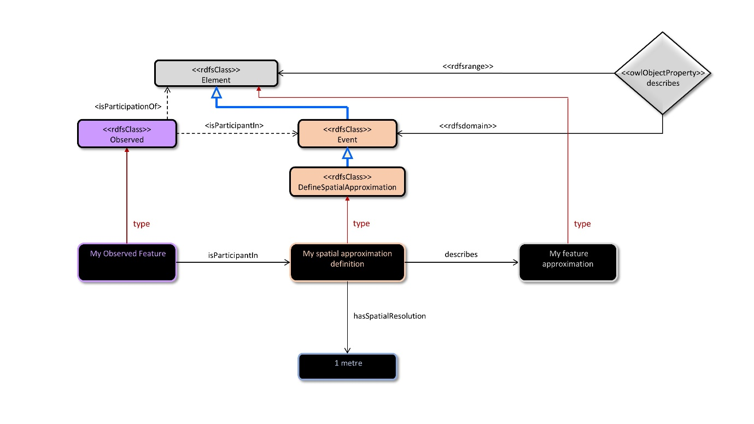
Figure 2 - Spatial resolution
The spatial resolution is an ies:Characteristic of the ies:DefineSpatialApproximation.

geo:hasSpatialAccuracy
The attribute geo:hasSpatialAccuracy could be regarded as an ies:Characteristic of either the ies:DefineSpatialApproximation that creates an approximation, or as an ies:Characteristic of an assessment of an approximation. The latter approach is shown in Figure 3.
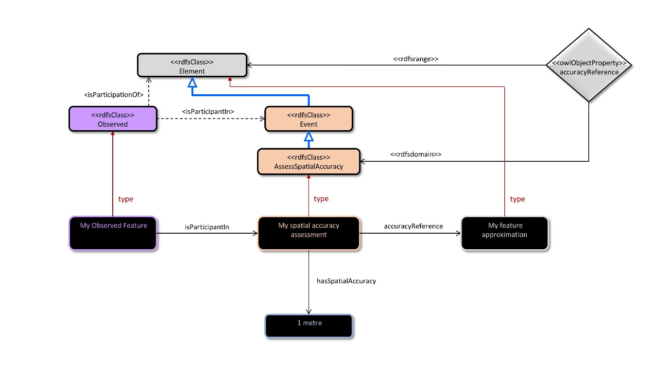
Figure 3 - Spatial accuracy

Dimension attribute
Dimensional statements are made in GeoSPARQL by attributes of geo:Geometry. A minimal approach to GeoSPARQL in IES would define equivalent attributes for ies:Element as follows:
- ies:topologicalDimension;
- ies:coordinateDimension;
- ies:spatialDimension.
This topic is discussed in section 6.1
The GeoSPARQL attribute geo:isSimple specifies that a geometry is not manifold. In a minimal approach, it may be sufficient to restrict IES to manifold geometry.

Numeric representation
GeoSPARQL does not provide a numeric representation of geometry. Instead it has the attribute geo:hasSerialization which references a numeric representation defined elsewhere. An example in the GeoSPARQL specification using Well Known Text (WKT) is shown in Figure 4.
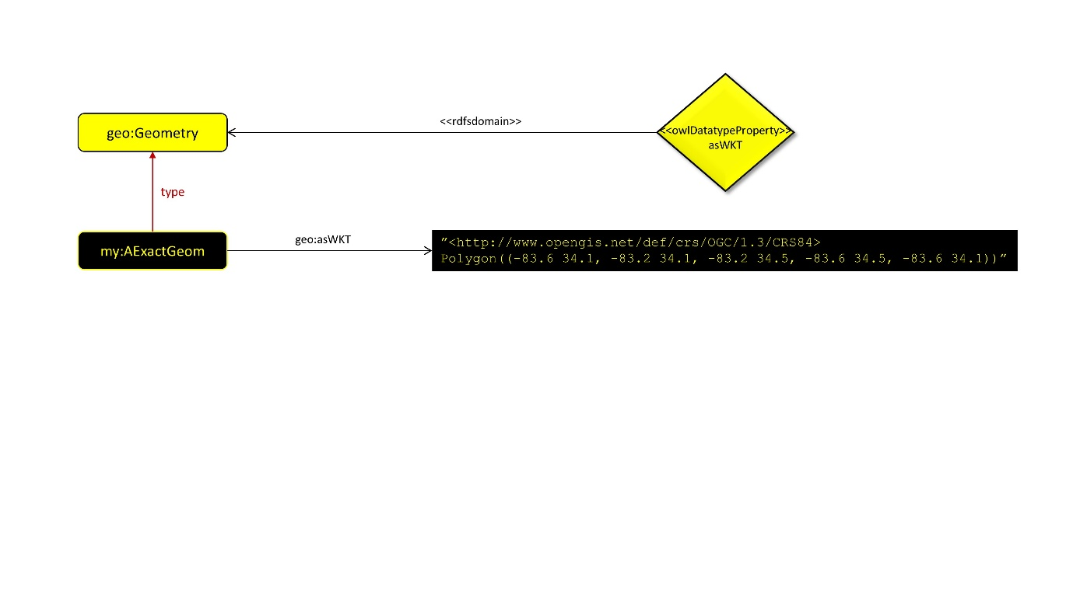
Figure 4 - GeoSPARQL WKT example
This approach could go directly into IES, however it requires parsing of a text literal to obtain:
- a reference to a coordinate system;
- a representation of the geometry with respect to the coordinate system.
Extracting the coordinate system as an object in IES, Figure 4 becomes Figure 5.
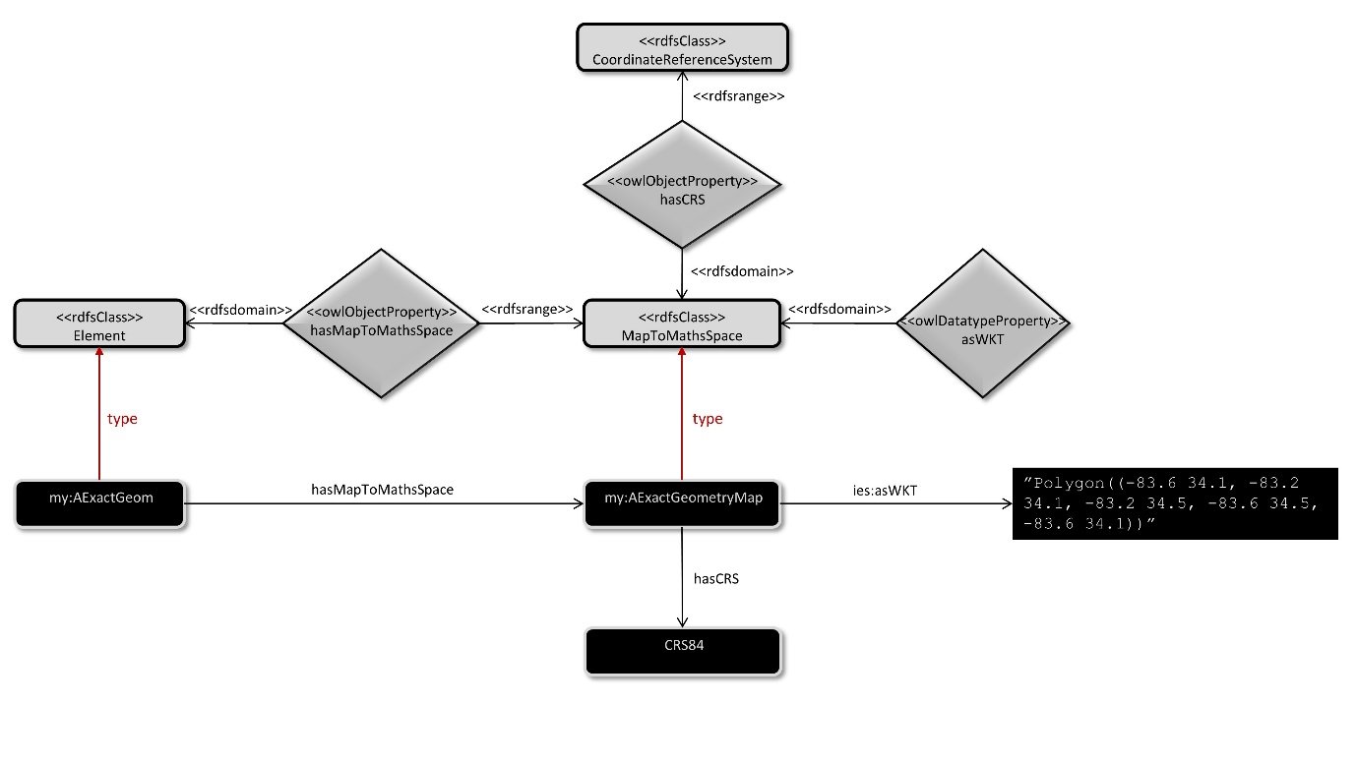
Figure 5 - WKT example in IES
This approach leads to a near serialization in TURTLE as follows:
my:AExactGeom ies:hasMapToMathsSpace
[ies:hasCRS my:CRS84 ;
ies:asWKT
“Polygon((-83.6 34.1, -83.2 34.1, -83.2 34.5, -83.6 34.5, -83.6 34.1))”
] .

This works as a minimal approach, but the underlying semantics is very difficult – see section 7.2

Further work
The minimal approach to GeoSPARQL leaves some loose ends as follows:
dimension: this is a simple integer attribute in GeoSPARQL, but a more formal approach would use subclasses.
This work can be a useful extension of IES, but belongs in “top” above “common” as an extension to ies-top:State.
geometry and maths space: Many approaches to geometry and topology, including WKT and ISO 10303 (the ubiquitous CAD standard), define geometry and topology in terms of a maths space, which is mapped to space-time by a Coordinate Reference System (CRS).
The mathematics of this is difficult, and is not currently addressed by IES, or any other widely used ontology. Going beyond the “work around” in the minimal approach may be unnecessary. This would be part of IES “top” if undertaken.
ontological approach to shape definition: This is the definition of a region of space time based upon:
- topological hierarchy – vertex, edge, face, volume
- interpolation functions on a parameterisation of the space.
The are existing data models in this area, but no widely used ontology. The task of developing an ontology in this area is huge, and should not be lightly undertaken.

Dimension

Attribute in GeoSPARQL – subclass in IES
GeoSPARQL has the attribute geo:dimension which is defined to be the topological dimension. Only manifolds have a well-defined topological dimension. A geo:Geometry Collection can be defined that has parts with different topological dimensions. Such part of space-time is not manifold.
It is probably appropriate to restrict IES to parts of space-time that are manifold.
A more formal approach in IES will be the definition of subclasses of ies:Element (in IES 5, or ies-top:State in IES 6) with different manifold dimension.

Manifold and boundary
A boundary is only well defined for manifolds. A boundary of a manifold of dimension n has dimension n-1. Hence a boundary of a 3D spatial object through time, which is 4D, has dimension 3. In many useful cases, this boundary can be divided into:
- 3D spatial object at two separate instants in time – start and finish;
- 2D spatial object through time.
Not all ies:Elements have this form. Consider a forest fire which starts at a point in space-time and grows radially outwards.
A 0D spatial object through time is a 1D ies:WorldLine. A boundary of an ies:WorldLine has 0 dimension. A boundary of a finite ies:WorldLine consists of two instances of 0D ies:SpaceTimePoint.

Perimeter
The outer boundary of a 2D spatial object through time is a 1D closed curve through time. The attribute geo:hasPerimeterLength is the length of this boundary. If the boundary is recognised as an ies:Element, then geo:hasPerimeterLength can be replaced by geo:hasLength as shown in Figure 2.
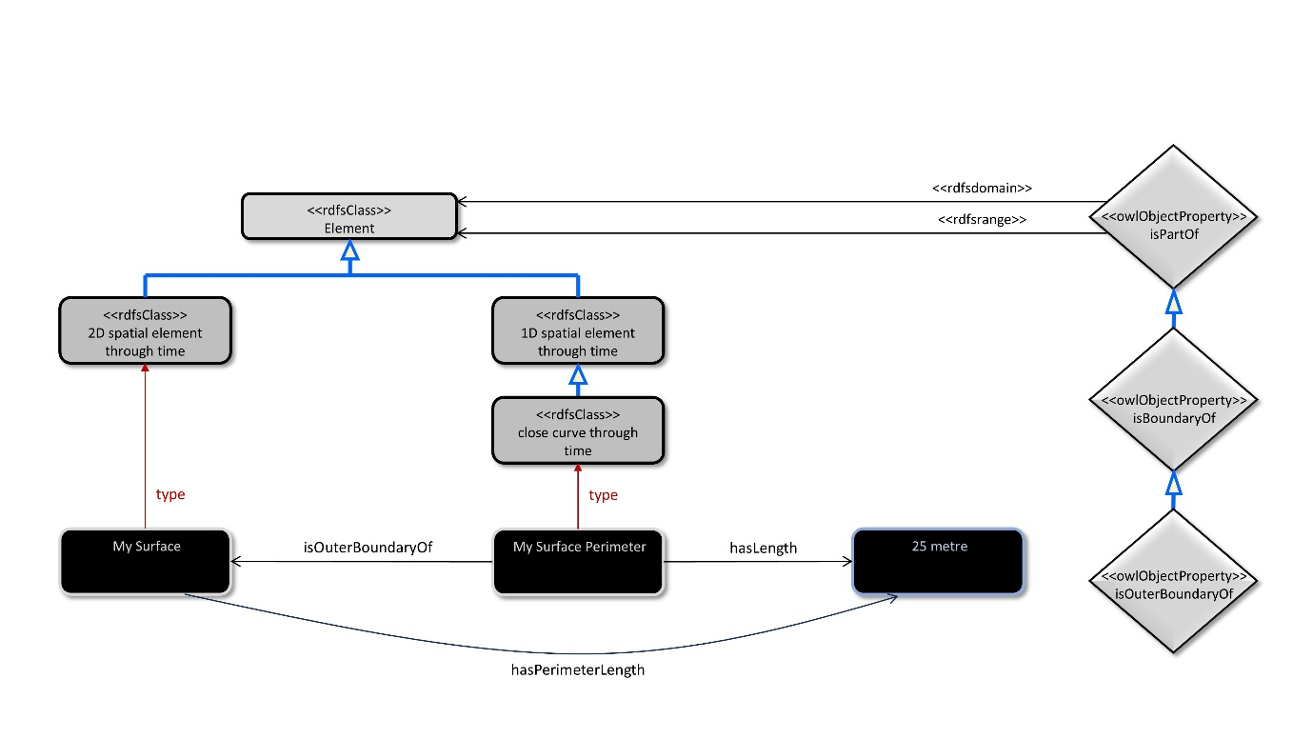
Figure 6 - Perimeter length

Geometry and maths space
The minimal approach to GeoSPARQL has the “work around” shown in Figure 5. In Figure 5, the text referenced by ies:asWKT describes a part of a maths space, but this object is not shown. A more formal equivalent to Figure 5 is shown in Figure 7.
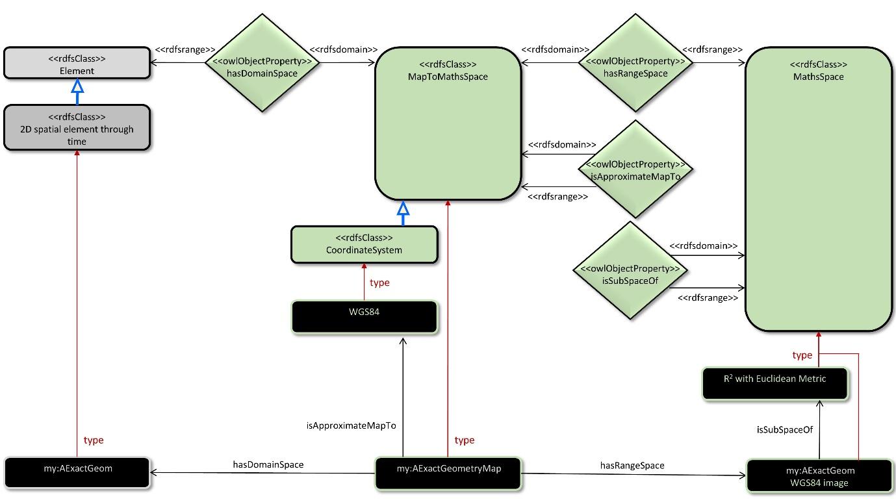
Figure 7 - Element and maths space
The maths space “my:AExactGeom WGS84 image” is described by the WKT text.
None of the classes and relationships shown in green in Figure 7 is currently in IES. If these classes were added to IES, they would be part of the “top”, but this may be unnecessary work with little benefit.

Ontological approach to shape definition
Most existing data models, such as WKT or ISO 10303 define parts of maths spaces rather than parts of space time. However the approach, which is based upon:
- topological hierarchy – vertex, edge, face, volume;
- interpolation functions on a parameterisation of the space,
can be implemented as statements about parts of space-time, i.e. about ies:Element.
An ontology could be developed that:
- converted existing informal data models into an ontology;
- interpreted the statements in these data models about parts of maths spaces as statements about parts of space-time.
However, the task is not trivial and may not belong within IES. For IES applications, external references to existing representations of shape may suffice.

