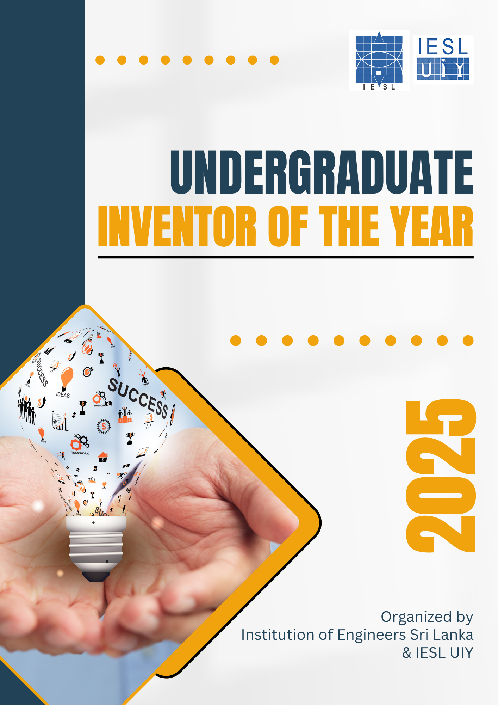

UIY GENERAL INSTRUCTIONS
“Fueling the Next Generation of Industry Innovators”

Welcome to UIY

The Undergraduate Inventor of the Year (UIY) competition, organized by the Institution of Engineers Sri Lanka (IESL), recognizes and inspires engineering undergraduates in Sri Lanka. UIY continues the legacy of the Junior Inventor of the Year (JIY) competition, which has supported young innovators for over 40 years. UIY encourages engineering students to use their creativity and technical skills to develop innovative solutions for real-world problems.
UIY was introduced as an extension of the JIY competition, providing a dedicated space for university-level innovators. It has grown into a nationally recognized event, attracting top engineering students from universities across Sri Lanka. The competition fosters collaboration, idea refinement, and interaction with industry experts and academic leaders. With a strong emphasis on research and engineering excellence, UIY continues to shape the next generation of engineers.

Organizers

The UIY competition is a prestigious event organized by the Institution of Engineers Sri Lanka (IESL). As the primary organizer, IESL is deeply committed to fostering a culture of innovation among university students by encouraging future engineers to think beyond conventional boundaries. Through IESL-UIY, it contributes to the overall advancement of next-generation engineering in Sri Lanka.

Eligibility

The UIY competition is exclusively open to the University of Peradeniya, University of Moratuwa, University of Ruhuna, South Eastern University of Sri Lanka, University of Jayawardhanapura, University of Jaffna, and the Open University of Sri Lanka engineering students in Sri Lanka.

Path to UIY

Group Consistency
UIY inventors can participate in group projects with a maximum of 6 members.

Application Process
To be eligible for participation, students must be registered undergraduates of one of the universities mentioned under the “Eligibility” title. Undergraduates who have already completed their degree may apply for UIY, provided that the degree’s effective date has not exceeded six months as of July 31, 2026.
Interested applicants must submit their applications through the IESL-UIY website (https://uiy.iesl.lk) by July 31, 2026. The following documents should be submitted during registration.
- Application
- A brief report (refer to ANNEX I for the format)
- A declaration letter from the department head (should be obtained through the supervisor). This verification letter should objectively detail the student’s level of independence and originality in their project, clarify the advisor’s (supervisor’s) role, include sponsors’ information (if applicable), and include information regarding the related publications (if applicable).

Preliminary competition
The following materials are required to be submitted prior to the preliminary competition (the submission dates will be announced after registration):
- Working prototype of the invention
- Competitors should be available for the Q&A session.

- The number of additional rounds will be decided accordingly by considering the total number of initial submissions. If there will be more than one preliminary round, the progress of the invention will be evaluated.

Final competition
The final competition will be a physical event held in October 2026.
The following materials should be submitted prior to the final competition (the submission dates will be announced after the preliminary competition):
- Working prototype of the invention
- A video clip that markets your invention/innovation
- A Q&A session will be held regarding the invention conducted by the judging panel.

Evaluation Process
Judges will evaluate projects based on originality and creativity; social, local, and global impact; execution of the idea into a working model; feasibility of implementation or commercialization; and innovation demonstration.

Reasons for unsuccessful application
- Innovation uses dangerous and unsafe materials and conditions, and is unsafe to handle.
- Innovation that can cause harm to humans and animals.
- Innovation violates research ethics
- Models of existing products and processes.
- Products/models that contain/use live specimens without obtaining ethical clearance.
- Products/models that contain/use firearms.

Awards

The UIY Competition plays a crucial role in connecting undergraduate inventions with industry demands. By offering a platform for students to pitch their innovative ideas, the competition not only recognizes young inventors but also provides them with expert guidance.
This initiative helps enhance the professional and personal skills of participants, ensuring their projects gain industry value and real-world applicability. Additionally, contestants benefit from workshops, networking opportunities, and even international exposure, further strengthening their potential to make a meaningful impact.
Competitors that participate become one step closer to turning their ideas into practical, marketable products, which contribute to technological and industrial growth.
In addition to island-wide recognition and the UIY award certificates, UIY winners will receive a financial award of 150 000 LKR for first place, 125 000 LKR and 100 000 LKR for second and third place, respectively.

Best proformance
Best potential for commercialization
Most popular
Multidisciplinary
Most Impact

