ABC DNSSEC Key Ceremony Scripts

Abbreviations
KMF= Key Management Facility
TEB = Tamper Evident Bag (large AMPAC stock #GCS1216 large, #GCS0912 small)
HSM = Hardware Security Module
FD = Flash Drive
SO = Security Officer
SA = System Administrator
SC = Safe Controller
IW= Internal Witness
EW= External Witness
MC= Master of Ceremonies

Participants
Instructions: At the end of the ceremony, participants print name, citizenship, signature, date, time, and time zone on SO’s copy.

Title | Printed Name | Signature | Date | Time
Sample | Bert Smith | Bert Smith | 12 Jul 2010 | 18:00 UTC
SA
SO
SC
IW
MC
EW1
EW2
EW3

Participants Arrive
Step | Activity | Initial | Time
1 | SA escorts SO, SC, IW and other authorized personnel into the KMF after starting cameras.

Sign into KMF
Step | Activity | Initial | Time
2 | SA has all participants sign into the KMF log.

Emergency Evacuation Procedures
Step | Activity | Initial | Time
3 | SA reviews emergency evacuation procedures with participants.

Verify Time and Date
Step | Activity | Initial | Time
4 | IW enters date (month/day/year), UTC time using a reasonably accurate wall clock visible to all here:  Date (UTC): ___________________Time (UTC): _____________________  All entries into this script or any logs should follow this common source of time.

Open KMF Safe
Step | Activity | Initial | Time
5 | SC, while shielding combination from camera, opens KMF Safe.
6 | SC takes out safe log and prints name, date, time, signature, and reason (i.e. “open safe”) in safe log. IW initials this entry.
Remove Equipment from KMF Safe
Step | Activity | Initial | Time
7 | SO removes blank smartcards (in TEB) from the safe and completes the next entry in the safe log indicating removal with “Blank Smartcard Removal,” TEB #, printed name, date, time, and signature. IW initials this entry.
8 | SA removes card reader (in TEB) from the safe and completes the next entry in the safe log indicating removal with “Card Reader Removal,” TEB #, printed name, date, time, and signature. SA places the item on KMF table. IW initials this entry.
9 | SA takes out the TEB with the O/S DVD from the safe and completes the next entry in the safe log indicating its removal with “DVD Removal,” TEB #, printed name, date, time, and signature. SA places the item on KMF table. IW initials this entry.
10 | SA takes out the TEB with blank, labeled (HSMFD), flash drives from the safe and completes the next entry in the safe log indicating its removal with “HSMFD Removal.” TEB #, printed name, date, time, and signature. SA places the item on KMF table. IW initials this entry.
11 | SA takes out the TEB with laptop from the safe and completes the next entry in the safe log indicating its removal with “Laptop Removal,” TEB #, printed name, date, time, and signature. SA places item on KMF table. IW initials this entry.
12 | SA removes any power supply units, cables and other equipment necessary from safe and places them on KMF table.

Close KMF Safe
Step | Activity | Initial | Time
13 | SC makes an entry including printed name, date, time and signature into the safe log indicating closing of the safe. IW initials this entry.
14 | SC places safe log back in safe and closes and locks safe.
15 | SO and SA verify that the safe is locked.

Set Up Laptop
Step | Activity | Initial | Time
16 | SA inspects the O/S DVD TEB for tamper evidence; reads out TEB # while participants match it with the prior script entry.  TEB# BB71822797
17 | SA inspects the laptop TEB for tamper evidence; reads out TEB # while participants match it with the prior script entry.  TEB# BB24707058
18 | SA takes O/S DVD and laptop out of TEBs placing them on KMF table; discards TEBs; connects laptop power, external display and (if used) printer and boots laptop from DVD.  [NOTE: The following steps may be skipped depending on facility configuration]
19 | SA logs in as root / dnssec.
20 | SA enters the command  startx  and ensures that external display works.
21 | SA configures printer as default and prints test page.
22 | SA opens a terminal window and maximizes its size for visibility. (CTRL++)
23 | SA opens a second window (e.g., using ALT-F2) and executes  sha256sum /dev/cdrom  To verify the authenticity of the DVD. The SA may continue with other elements while this computation is taking place by returning to the first window. The sha256 hash as created by the software development department should be: 27cbaeb7f0aef5b7c82360ae8a410bb0d74af2231c0462d751ee11cf8f3daa79
24 | SA verifies the time zone, date, and time on the laptop and synchronizes it if necessary. Display the current time and timezone:  date  If the timezone is not set to UTC:  cd /etc/  rm localtime  ln -s /usr/share/zoneinfo/UTC localtime  Set time to match the wall clock (mm=month dd=day):  date mmddHHMMYYYY  Verify:  Date
25 | SA inspects the HSMFD TEB for tamper evidence; reads out TEB # while participants match it with the prior script entry.  TEB# BB21880471
26 | SA takes HSMFDs out of TEB; discards TEB; and plugs it into free USB slot.  Note:If only unprepared FDs are available, the SA may follow the following steps to format and label:  - Plug FD in  - Unmount FD if auto mounted by O/S  - determine device name using dmesg (should be /dev/sdb1)  - execute mkfs.vfat –n HSMFD /dev/sdb1  - remove FD  - re-insert FD and wait for O/S to recognize as above  The O/S should recognize the FD as /media/HSMFD  If the FD is not recognized, SA mounts the HSMFD using:  mkdir /media/HSMFD  mount /dev/sda1 /media/HSMFD  Where /dev/sda1 should be the FD in dmesg output.  Then displays contents to participants using ls –lt /media/HSMFD
Start Logging Terminal Session
Step | Activity | Initial | Time
27 | SA executes  script /media/HSMFD/script–20160717.log  to start a capture of terminal output.
Connecting Card Reader
Step | Activity | Initial | Time
28 | SA inspects the card reader TEB for tamper evidence; reads out TEB # while participants match it with the prior script entry.  TEB# BB21880470
29 | SA removes reader from TEB; discards TEB; and connects smartcard reader to free USB slot on laptop or expander.

Initializing Smartcards
Step | Activity | Initial | Time
30 | SO inspects the TEB of smartcards for tamper evidence; reads out TEB # while SA matches it with a prior script entry.  TEB# BB71822796  and removes smartcards from TEB and discards TEB.
31 | SO takes a new smartcard and plugs it into card reader. Light on reader should flash.
32 | SO initializes the smartcard by running  hcarderase  SO enters new PIN (say 123456) while shielding from camera. If reusing a previously initialized card, you may be asked for “Security Officer PIN”. Respond with PIN used previously for this card. Note: For our configuration, PIN, PUK, and SO PIN are made equal.
33 | SO begins process of making 2 of 2 keys or “shares” needed to clone the smartcard HSM to other smartcards and thus make backups. SO executes:  hmakeshares  When asked for a password for share 1, the SO enters a password (say password1).  When asked for a password for the second share, have the SA (not SO) enter a password (say password2).
34 | SO now imports their share into the card by executing:  himportshare dkek-share-1.pbe  and entering their password from above.
35 | SA now imports their share into the card by executing:  himportshare dkek-share-2.pbe  and entering their password from above. Note “DKEK key check value”
36 | SA now sets the domain name by typing:  export DOMAIN=ietf  (and optionally “export TEST=yes” to generate short term signatures)

Generate a New KSK and put on Smartcards
Step | Activity | Initial | Time
37 | To generate KSK inside the card, SO runs  hgenkskec  SO notes CKA_LABEL of the form ksk.ietf.2016…
38 | SO then executes  hcardshow  To verify contents of card to see private key label ksk.ietf.2016….  Note that for these smartcards, the public key will be stored in a file of the form ksk.ietf.2016…pub
39 | The SO now exports an encrypted backup of the KSK by executing:  hwrapkey  and entering KEY REFERENCE: 1 and CKA_LABEL: ksk.ietf.2016… from above. This will generate a file of the form ksk.ietf.2016…wrap  SO may display directory contents using ls –lt
40 | SA copies permanent information to HSMFD by executing:  cp –p * /media/HSMFD/
41 | SO removes card physically labeling it with CKA_LABEL (e.g., ksk.ietf.2016…) and “KSK 1 of 2”.  SO then writes same information along with printed name and signature on a new TEB and places card in TEB and seals it. Finally, the SO writes TEB#, and CKA_LABEL here:  Description: KSK 1 of 2  TEB# _____________________________________________________  CKA_LABEL ksk.ietf.2016…  IW initials TEB and leaves on table.
42 | SO makes backup smartcards by inserting a new smartcard and executing:  hcarderase  and entering the same PIN as before (123456).  SO executes:  himportshare dkek-share-1.pbe  entering the password entered above (e.g., password1) when prompted.  The SA then executes  himportshare dkek-share-2.pbe  entering the password entered above (e.g., password2) when prompted.  Note “DKEK key check value”  The SO executes:  hunwrapkey  and responds with the encrypted backup of the key (e.g., ksk.ietf.2016…wrap) and NEW KEY REFERENCE: 1  The SO executes  hcardshow  to display and verify the smartcard contents.  (The above steps may be repeated for additional backup cards)
- KSK Generation Complete –
Start Hardware Random Number Generator (RNG)
Step | Activity | Initial | Time
43 | SA starts RNG by opening a new terminal window and executing  hcardrng  SO enters PIN when requested.
44 | SA tests RNG by returning to the script window and executing  rngtest < /dev/random  waiting at least 10 seconds; then hitting CTRL-C. The number of successful tests should greatly exceed any failures, if any. During the test, the RNG window should be displaying dots indicating the feeding of random numbers into the kernel.

Generate New ZSKs
Step | Activity | Initial | Time
45 | To generate ZSKs using the smartcard RNG, SA runs  hgenzskec  Note that cardrng window should show “…” indicating activity.  SA may display directory contents using ls –lt
46 | SA stops RNG by going to RNG terminal window and hitting CTRL-C then entering “exit”.

- DNSKEY RRset Signing -
Signing DNSKEY RRsets with KSK
Step | Activity | Initial | Time
47 | Leaving the smartcard in the reader the SA executes  hcardsignec  and the SA enters a passphrase (say “abc”) when prompted to do so. This will be used to encrypt the private ZSK material during transport to online signer.  The SA enters the CKA_LABEL that resulted from KSK generation above of the form ksk.ietf.2016… The SA may do a directory listing to see this again.  When prompted to do so, the SO enters their PIN (e.g., 123456).  This will generate KSK signed DNSKEY RRsets and corresponding ZSKs in passphrase encrypted files.
48 | Once complete SO removes card physically labeling it with CKA_LABEL (e.g., ksk.ietf.2016…) and “KSK 2 of 2”.  SO then writes same information along with printed name and signature on a new TEB and places card in TEB and seals it. Finally, the SO writes TEB#, and CKA_LABEL here:  Description: KSK 2 of 2  TEB# _____________________________________________________  CKA_LABEL ksk.ietf.2016…  IW initials TEB and leaves on table.
49 | SA puts stationery into printer and runs  /opt/dccom/bind/bin/dnssec/dnssec-dsfromkey *.key | tee dsset-ietf.  and then  enscript --copies=N [-p out.ps] dsset-ietf.  and hands printouts to participants. “N” is the number of copies.
50 | SA reads out the displayed DS record from terminal while participants match this to the printouts to ensure what is displayed is properly captured in the printouts that participants will take with them to verify and attest that the KSK generated in this ceremony is the one that will be deployed in the DNS.
51 | SA asks “does anyone object”?
 | IW attached a printout to his/her script.
52 | SA runs  tar --no-recursion -zcf /media/HSMFD/kc20160717.tar.gz *  to archive all results and ZSK+DNSKEY RRsets destined for signer and DS records for parent zone.
- DNSKEY RRset Signing Complete -

For Demonstration Only
Step | Activity | Initial | Time
XX | SA executes  hsignzoneec  and enters passphrase used to encrypt ZSKs from above (e.g., “abc”) when asked. This will create a test zone, add DNSKEY RRset, decrypt ZSKs above; start a local DNSSEC enabled nameserver; and show output from:  dig +dnssec –t DNSKEY ietf @127.0.0.1  SA may query other RRsets as well. The SA may also run “monitor” as an example of a script monitoring time to signature expiration.
Stop Logging Terminal Output
Step | Activity | Initial | Time
53 | SA stops logging terminal output by entering “exit” in terminal window

Backup HSM FD Contents
Step | Activity | Initial | Time
54 | SA displays contents of HSMFD by executing  ls –lt /media/HSMFD
55 | SA plugs a blank HSMFD into the laptop, then waits for it to be recognized by the O/S as /media/HSMFD_ and copies the contents of the original HSMFD to the blank drive for backup by executing  cp -Rp /media/HSMFD/* /media/HSMFD_  Note:If only unprepared FDs are available, the SA may follow the following steps to format and label:  - Plug FD in  - Unmount FD if auto mounted by O/S  - determine device name using dmesg (should be /dev/sdb1)  - execute mkfs.vfat –n HSMFD /dev/sdb1  - remove FD  - re-insert FD and wait for O/S to recognize as above
56 | SA displays contents of HSMFD_ by executing  ls –lt /media/HSMFD_
57 | SA unmounts new HSMFD using  umount /media/HSMFD_
58 | SA removes HSMFD_ and places on table.
59 | SA repeats steps above and creates 4 more copies.

Returning HSMFD to a TEB
Step | Activity | Initial | Time
60 | SA unmounts HSMFD by executing  umount /media/HSMFD
61 | SA removes HSMFD and places it in new TEB and seals; reads out TEB #; shows item to participants and IW records TEB # here  TEB # ______________________________________________________  and places it on KMF table.

Returning O/S DVD to a TEB
Step | Activity | Initial | Time
62 | After all print jobs are complete, SA executes  shutdown –hP now  removes DVD and turns off laptop.
63 | SA places DVDs in new TEB and seals; reads out TEB #; shows item to participants and IW records TEB # here.  TEB# _______________________________________________________  and places it on KMF table.

Returning Laptop to a TEB
Step | Activity | Initial | Time
64 | SA disconnects card reader, printer, display, power, and any other connections from laptop and puts laptop in new TEB and seals; reads out TEB #; shows item to participants and IW records TEB # here.  TEB# _______________________________________________________  and places it on KMF table.

Returning Card Reader to a TEB
Step | Activity | Initial | Time
65 | SA places card reader in new TEB and seals; reads out TEB #; shows item to participants and IW records TEB # here.  TEB# _______________________________________________________  and places it on KMF table.
Returning Equipment in TEBs to KMF Safe
Step | Activity | Initial | Time
66 | SC opens safe shielding combination from camera.
67 | SC removes the safe log and fills the next entry with printed name, date, time, and signature indicating the opening of the safe. IW initials the entry.
68 | SO records return of KSK 1 of 2 in next entry field of safe log with TEB #, printed name, date, time, and signature. Places item in safe. IW initials the entry.
69 | SO records return of KSK 2 of 2 in next entry field of safe log with TEB #, printed name, date, time, and signature. Places item in safe. IW initials the entry.
70 | SA records return of card reader in next entry field of safe log with TEB #, printed name, date, time, and signature; places the card reader into safe and IW initials the entry.
71 | SA records return of laptop in next entry field of safe log with TEB #, printed name, date, time, and signature; places the laptop into safe and IW initials the entry.
72 | SA records return of HSMFD in next entry field of safe log with TEB #, printed name, date, time, and signature; places the HSMFD into safe and IW initials the entry.
73 | SA records return of O/S DVD in next entry field of safe log with TEB #, printed name, date, time, and signature; places the O/S DVD into safe and IW initials the entry.
74 | SA returns remaining power supplies, adaptors, and cables to safe. No entry in log is necessary.

Closing KMF Safe
Step | Activity | Initial | Time
75 | SC makes an entry including printed name, date, time, signature and notes closing safe into the safe log. IW initials the entry.
76 | SC places log back in safe and locks safe.
77 | SO and SA verify safe is locked.

Participant Signing of IW’s Script
Step | Activity | Initial | Time
78 | All EWs enter printed name, date, time, and signature on IW’s script coversheet.
79 | SA, SC, SO review IW’s script and signs it.

Signing out of Ceremony Room
Step | Activity | Initial | Time
80 | SA ensures that all participants sign out of KMF (except IW who must remain) sign-in log and are escorted out of the KMF.

Filming Stops
Step | Activity | Initial | Time
81 | SA stops filming.

Copying and Storing the Script
Step | Activity | Initial | Time
82 | IW makes at least 5 copies of his or her script: one for off-site audit bundle, one for on-site audit bundle, one for IW, and copies for other participants, as requested.  Audit bundles each contain 1) output of signer system - HSMFD; 2) copy of IW’s key ceremony script; 3) audio-visual recording; 4) SA attestation (A.2 below); and 5) the IW attestation (A.1 below) - all in a TEB labeled “Key Ceremony”, dated and signed by IW and SA. One bundle will be stored by the SA at the KMF – typically in the same area as the safe. The second bundle will be kept securely by the IW at a bank safe deposit box.

All remaining participants sign out of ceremony room log and leave.

Appendix A.1:

Key Ceremony Script

(by IW)

I hereby attest that the Key Ceremony was conducted in accordance with this script and any exceptions which may have occurred were accurately and properly documented.

Printed Name: _________________________________________

Signature: _________________________________________

Date: _________________________________________
Appendix A.2:

Access Control System Configuration Review

(by SA)

I have reviewed the physical access control system and not found any discrepancies or anything else out of the ordinary.

Enclosed is the audited physical access log.

Printed Name: _________________________________________

Signature: _________________________________________

Date: _________________________________________

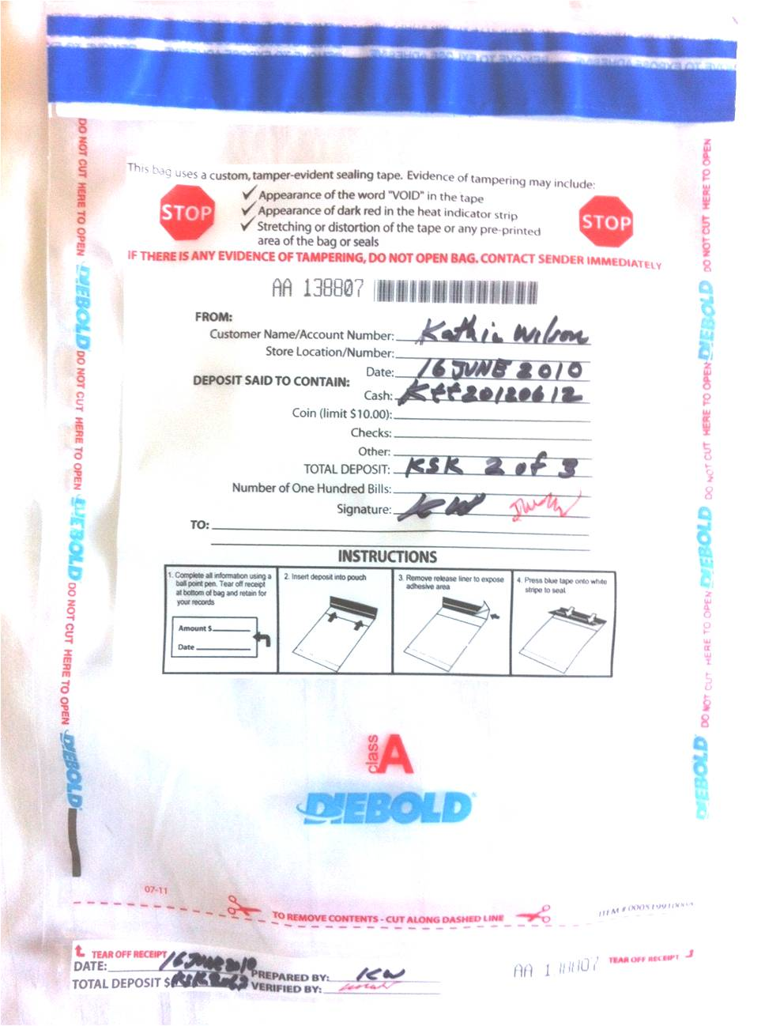

A | Alfa | AL-FAH
B | Bravo | BRAH-VOH
C | Charlie | CHAR-LEE
D | Delta | DELL-TAH
E | Echo | ECK-OH
F | Foxtrot | FOKS-TROT
G | Golf | GOLF
H | Hotel | HOH-TEL
I | India | IN-DEE-AH
J | Juliet | JEW-LEE-ETT
K | Kilo | KEY-LOH
L | Lima | LEE-MAH
M | Mike | MIKE
N | November | NO-VEM-BER
O | Oscar | OSS-CAH
P | Papa | PAH-PAH
Q | Quebec | KEH-BECK
R | Romeo | ROW-ME-OH
S | Sierra | SEE-AIR-RAH
T | Tango | TANG-GO
U | Uniform | YOU-NEE-FORM
V | Victor | VIK-TAH
W | Whiskey | WISS-KEY
X | Xray | ECKS-RAY
Y | Yankee | YANG-KEY
Z | Zulu | ZOO-LOO
1 | One | WUN
2 | Two | TOO
3 | Three | TREE
4 | Four | FOW-ER
5 | Five | FIFE
6 | Six | SIX
7 | Seven | SEV-EN
8 | Eight | AIT
9 | Nine | NIN-ER
0 | Zero | ZEE-RO

ABC DNSSEC Script Exception

Abbreviations
TEB = Tamper Evident Bag
HSM = Hardware Security Module
FD = Flash Drive
SO = Security Officer
IW = Internal Witness
EW= External Witness
SA = System Administrator
SC = Safe Controller
Instructions: Initial each step that has been completed below, e.g., BTS. Note time.
Note Exception Time
Step |  | Activity |  | Initial |  | Time
1 | IW notes date and time of key ceremony exception and signs here: ____________________________________________________
2 | IW Describes exception and action below

– End of DNSSEC Script Exception –
ABC DNSSEC Script Exception

Abbreviations
TEB = Tamper Evident Bag
HSM = Hardware Security Module
FD = Flash Drive
SO = Security Officer
IW = Internal Witness
EW= External Witness
SA = System Administrator
SC = Safe Controller
Instructions: Initial each step that has been completed below, e.g., BTS. Note time.
Note Exception Time
Step |  | Activity |  | Initial |  | Time
1 | IW notes date and time of key ceremony exception and signs here: ____________________________________________________
2 | IW Describes exception and action below

– End of DNSSEC Script Exception –

ABC DNSSEC Script Exception

Abbreviations
TEB = Tamper Evident Bag
HSM = Hardware Security Module
FD = Flash Drive
SO = Security Officer
IW = Internal Witness
EW= External Witness
SA = System Administrator
SC = Safe Controller
Instructions: Initial each step that has been completed below, e.g., BTS. Note time.
Note Exception Time
Step |  | Activity |  | Initial |  | Time
1 | IW notes date and time of key ceremony exception and signs here: ____________________________________________________
2 | IW Describes exception and action below

– End of DNSSEC Script Exception –

