This is my personal portfolio detailing the work I have done towards the completion of release 1.

## Artifact 1 - Sketches

Shanil and I (another group member) sketched the User Interface for the Media Vault. I designed the Home page, favorites page , video player and media player. The following image is evidence of the sketches I have done.

Home screen:

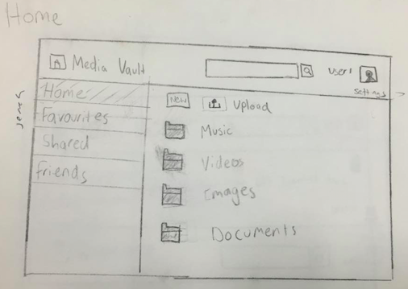

Favourites page 1:

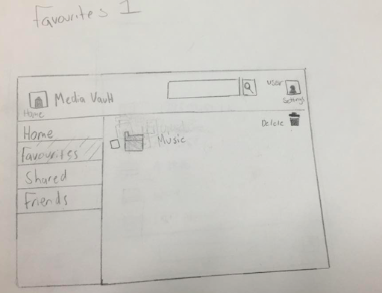

Favourites page 2:

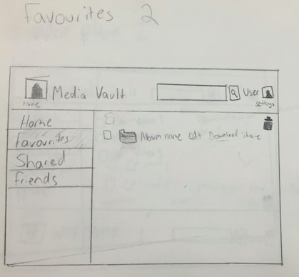

Favourites page 3:

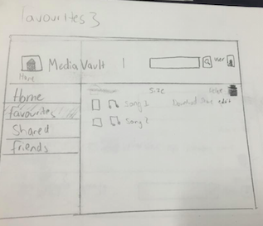

Video player 1:

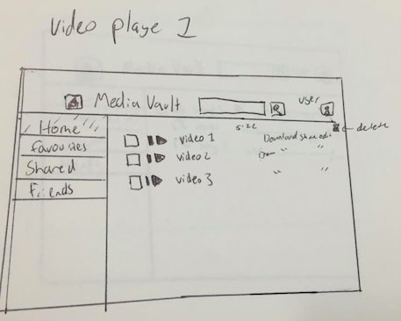

Music Player:

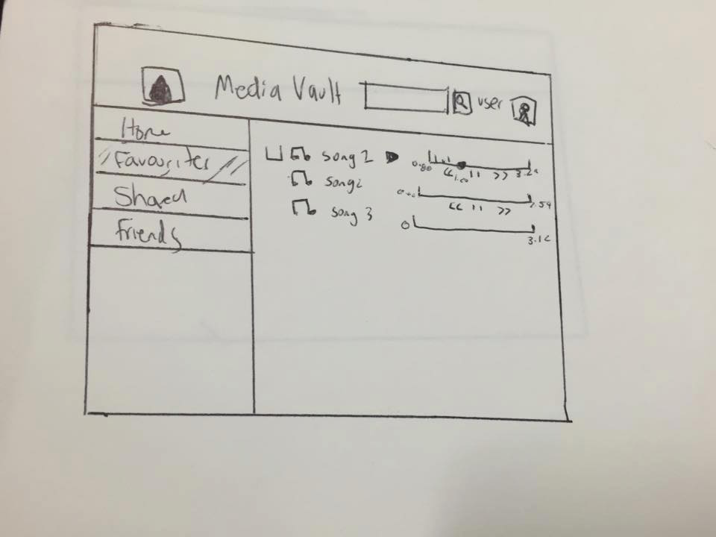

## Artifact 2 - Acceptance Criteria

During the meet up with the client team we were given the task of developing acceptance criteria for some of the Must Have stories. I also contributed to some of the user stories. This is a screenshot of the Must have stories developed by Nicola, Mal and I.

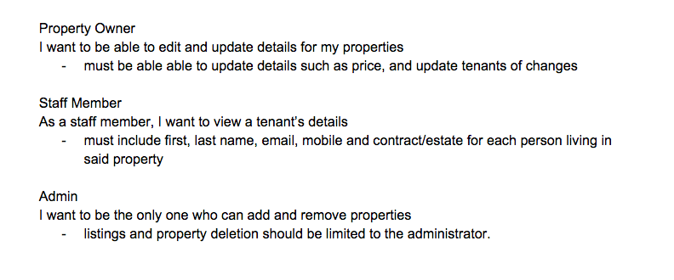

## Artifact 3 – Test Case

Shanil and I created a few test cases for different combinations of existing/non existing username and good/bad passwords. This is one test case we created:

**Assumption of requirements**

- Valid login and password combination

- Login is case sensitive

**Test Data:**  
2 user accounts were created to be used in testing:  
- User1 Attempt1!  
- User2 Attempt1234!

**Test Cases**

- Valid login/valid password User1/Attempt1! Logged in

- Invalid login/Valid password User22/Attempt1234!

- Valid login/ Valid password User2/Attempt1234!

## Artifact 4- Sketches 2

Whilst discussing with the client members they were after the colour scheme blue and other features added. They also suggested that we move the buttons to the top. So I decided to design new sketches of the User Interfaces. I designed the Home page, favorites page, video player and media player.

Home Page:

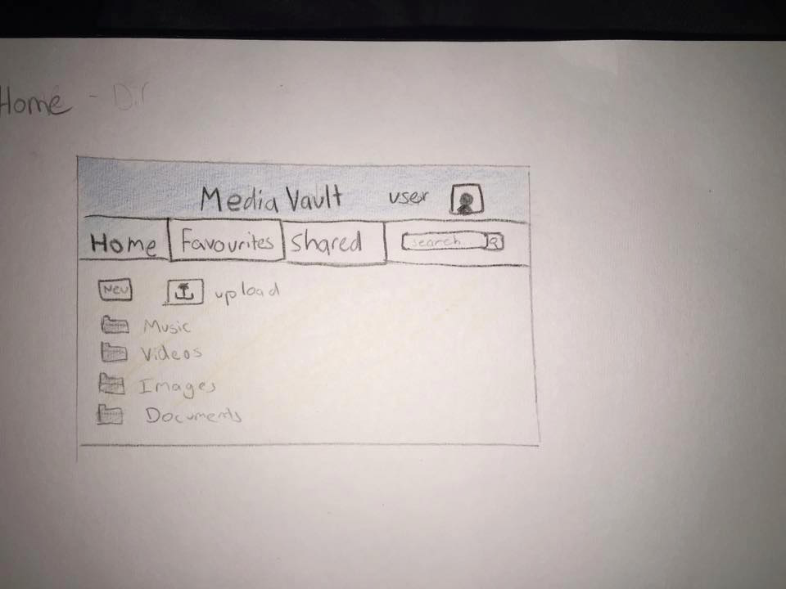

Favourites 1:

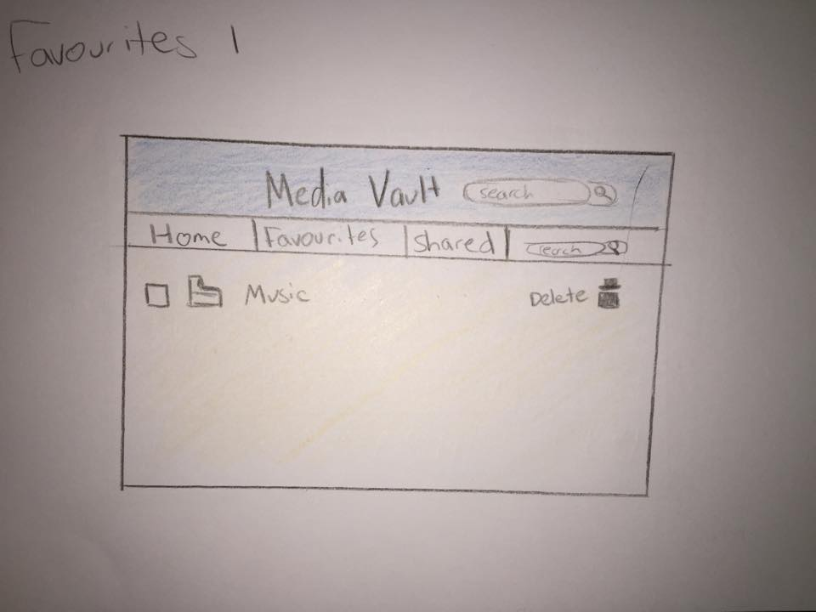

Favourites 2:

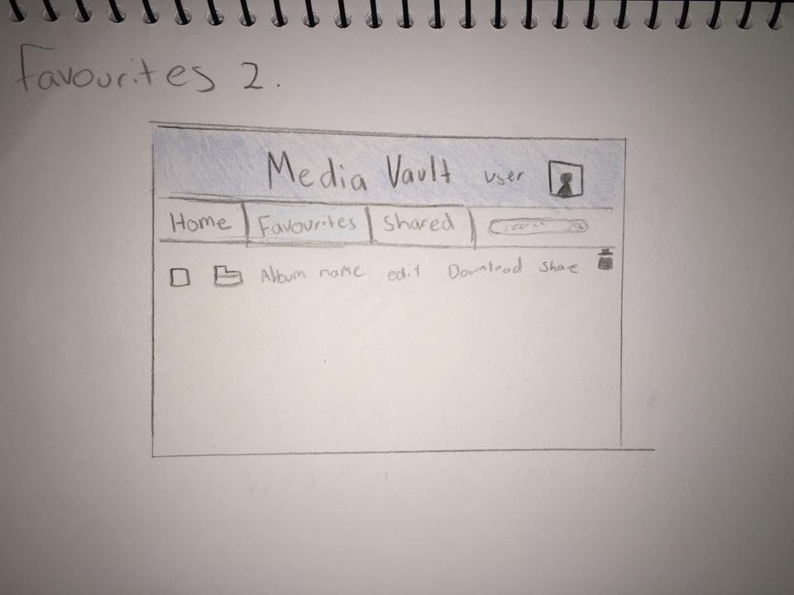

Favourites 3:

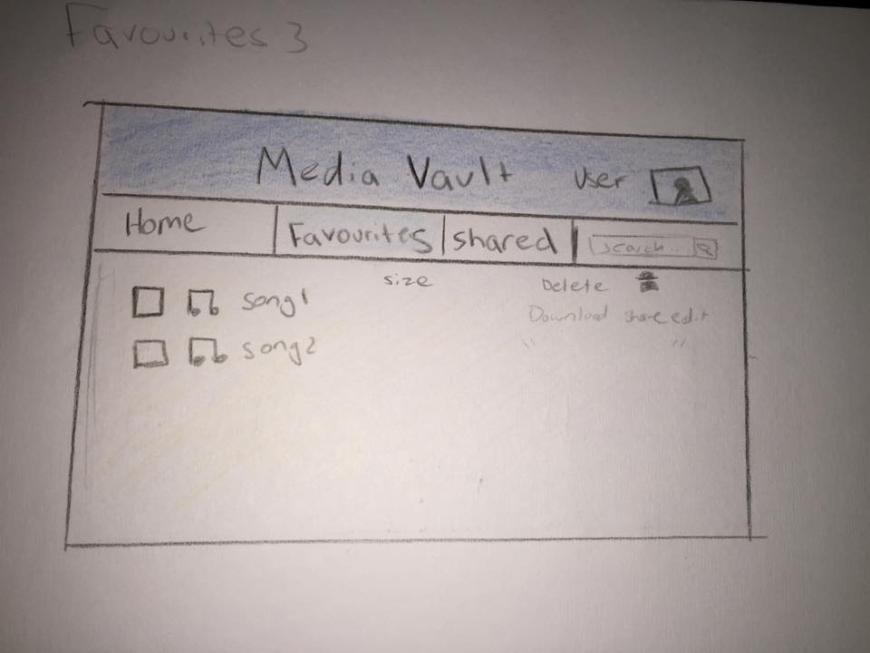

Video Player:

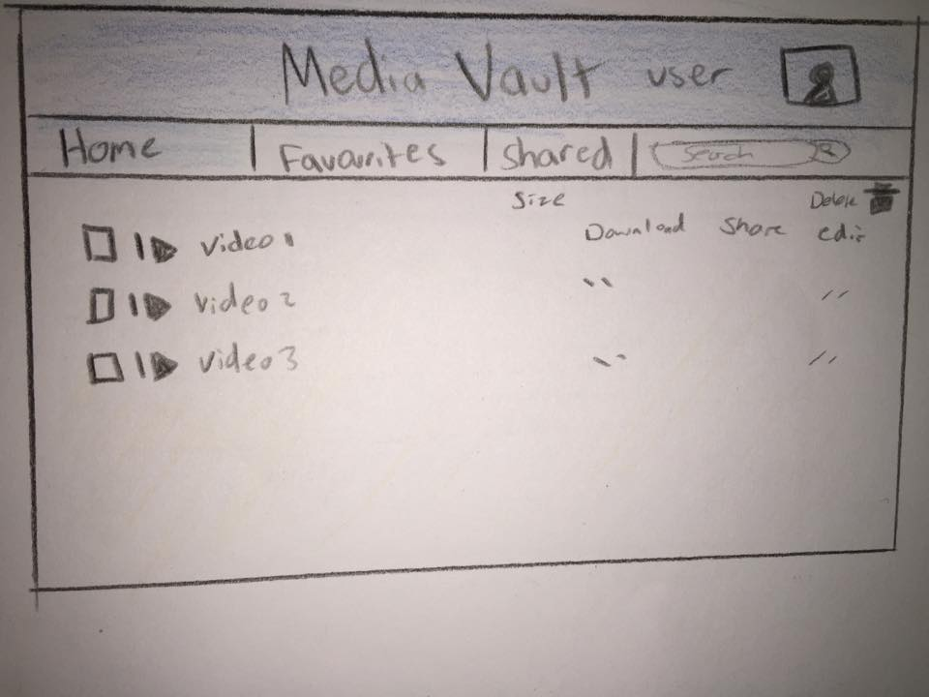

Music player:

