MailMagpie 
User guide
Prepare a CSV, personalise your emails and create Outlook drafts with confidence.
For desktop app users • Version 1.0.0 • 18 October 2026

What the app does
MailMagpie combines each row of a CSV file with an email template to produce personalised messages in bulk. You can review and edit the results, add shared or recipient-specific attachments, then create drafts in Outlook or export email files.
Drafts only. MailMagpie does not send emails. Outlook drafts are created in the Microsoft account used to sign in. Review and send them from Outlook when ready.
1 Upload files | 2 Create email template | 3 Preview emails
Choose a CSV and check its data. | Write the subject and body; insert CSV placeholders. | Review recipients and attachments, then create drafts or export.

Find what you need
Topic | Page
Quick start and Microsoft sign-in | 2
CSV layout and column reference | 3
Example CSV and saving your spreadsheet | 4
Uploading and checking the CSV | 5
Creating the email template | 6
Placeholders, CC, BCC and Reply To | 7
Adding attachments | 8
Previewing and editing emails | 9
Creating and interrupting Outlook drafts | 10
Exporting, keeping your work and shortcuts | 11

Examples and screenshots use fictional recipients. Replace example addresses with your own data before creating a real mail merge.

1. Quick start

Before you begin
- Have the MailMagpie desktop application, a Microsoft account with an Outlook mailbox, and an internet connection for sign-in and draft creation.
- Prepare a comma-separated .csv file and keep any recipient attachment files in the same folder structure as the CSV.
- Keep the original spreadsheet and a copy of your email template. The app does not provide a Save project command.

Complete your first mail merge
1. Open MailMagpie. On Windows, open the supplied MailMagpie executable. Use the desktop application for this workflow.
2. Select Sign in with Microsoft. Complete sign-in in the browser, using the account where you want the drafts to appear. Return to MailMagpie after the success message.
3. Select Choose CSV file. Open your CSV, check the total recipient count and the preview of the first three data rows, then select Next.
4. Create the template. Enter a meaningful Subject and write the email body. Place the cursor in the body and choose a field from Insert placeholders to personalise the message.
5. Set optional recipients. Add CC, BCC or Reply To if needed. CSV columns can control these values; see page 7.
6. Select Preview emails. Select each recipient to check their message. Add shared attachments, check any CSV attachment paths and make individual edits as needed.
7. Select Create all Outlook drafts. Check the confirmation count and attachments, then select Create drafts (or Create draft for a one-row CSV). Wait for the final status.
8. Open Outlook using the same account. Find the messages in Drafts, check their recipients, subject, formatting and attachments, then send from Outlook when ready.
Start with one row. For a first trial, use a separate CSV containing only your own email address and one example record. The current screen creates drafts for every loaded row; selecting a recipient does not limit the batch.

Choosing the right Microsoft account
The browser may already be signed in to a Microsoft account. Check the account shown during sign-in before continuing. Choosing CC, BCC or Reply To does not change which mailbox receives the drafts.

2. Set up your CSV
A CSV is a plain-text spreadsheet: the first row contains column names, and each subsequent non-empty row becomes one email. Start with Email and the fields needed by your message. Add optional columns only when needed.

Column reference
Header | Required? | What to put in the column
Email | Yes* | The main recipient address, for example alice@example.com. Use one address per row for a straightforward personalised mail merge.
RecipientEmail | Instead* | Accepted instead of Email. Use one of these two headers, rather than including both.
FirstName | No | A name to insert with {{FirstName}}, for example Alice.
Course / AppointmentDate / other fields | As needed | Any custom fields used in your body template. Each header must be unique and match its placeholder exactly.
CC | No | Addresses copied into this row’s email. Separate multiple addresses with commas within the cell.
BCC | No | Addresses copied without being shown to other recipients. Separate multiple addresses with commas within the cell.
ReplyTo | No | An address to receive replies to this row’s email. A non-empty row value overrides the template’s Reply To field.
Attachments | No | Local file paths for this recipient. Separate multiple paths with semicolons; leave blank for no row-specific attachments.

*Include either Email or RecipientEmail. Use the exact header spellings shown above for predictable results.

Rules for a reliable file
- Put headers in the first row. Do not add a report title, introductory text, merged cells or totals above or below the recipient data.
- Keep each person’s values on the same row and give every recipient a valid email address. Include each intended recipient once, with one data row for each email you want to create.
- Use clear, unique headers such as FirstName. Personalisation is case-sensitive: {{FirstName}} and {{firstname}} are different placeholders.
- Use plain values for dates, IDs and other fields. Check that the exported CSV contains the exact text you want to appear in each email, including any leading zeros in IDs.
- Save as a comma-separated CSV, preferably UTF-8. Excel workbooks (.xlsx), tab-separated files and semicolon-delimited spreadsheets are not supported as the CSV input format.
Optional columns have an effect. If CC or BCC is present, its entire column controls that field and disables manual entry. Omit an unused column if you want to enter a common value on the template screen.

3. Example CSV and saving the file

A simple three-recipient example
Create these four columns in your spreadsheet, or copy the text below into a plain-text file named sample-recipients.csv. Example addresses use example.com; replace them before a real mail merge.
Email,FirstName,Course,AppointmentDate
alice@example.com,Alice,CAB301,19 October 2026
bob@example.com,Bob,CAB301,20 October 2026
charlie@example.com,Charlie,CAB301,21 October 2026

Save from a spreadsheet
1. Check that the active worksheet contains only the headers and recipient rows you want to use.
2. Use your spreadsheet’s Save As, Export or Download command. In Excel, select CSV UTF-8 (Comma delimited) (*.csv) where available; CSV (Comma delimited) is also an option.
3. Choose a folder and save the file with a .csv extension. A CSV contains one worksheet, so export the intended sheet.
4. If prompted that some spreadsheet features will not be retained, keep the CSV format for the exported copy. Keep your original workbook separately if you need its formulas or formatting.
5. Open the CSV in a text editor or check MailMagpie’s upload preview. Confirm that fields are separated into the expected columns and that names, dates and addresses are correct.

Commas, quotes and multiple addresses
When a value contains a comma, the raw CSV must enclose the whole value in double quotes. Spreadsheet CSV exports normally do this automatically. A double quote inside a quoted value is written twice.
Email,FirstName,CC,Comment
alice@example.com,Alice,"tutor@example.com,admin@example.com","Bring notes, please"
bob@example.com,Bob,,"He said ""thank you""."
The CC cell above contains two addresses separated by a comma. The comma after notes stays inside one Comment cell. Enter those values normally in a spreadsheet; add CSV quotation marks yourself only when editing the raw CSV text.

Keep the separators straight
Use | Separator / example
Between CSV columns | Comma: Email,FirstName
Between email addresses in one cell or field | Comma: tutor@example.com,admin@example.com
Between paths in one Attachments cell | Semicolon: attachments/alice.pdf;attachments/guide.pdf

After making changes. Save the CSV and select it again in MailMagpie. The app does not automatically reread changes made in your spreadsheet or text editor.

4. Upload and check your data
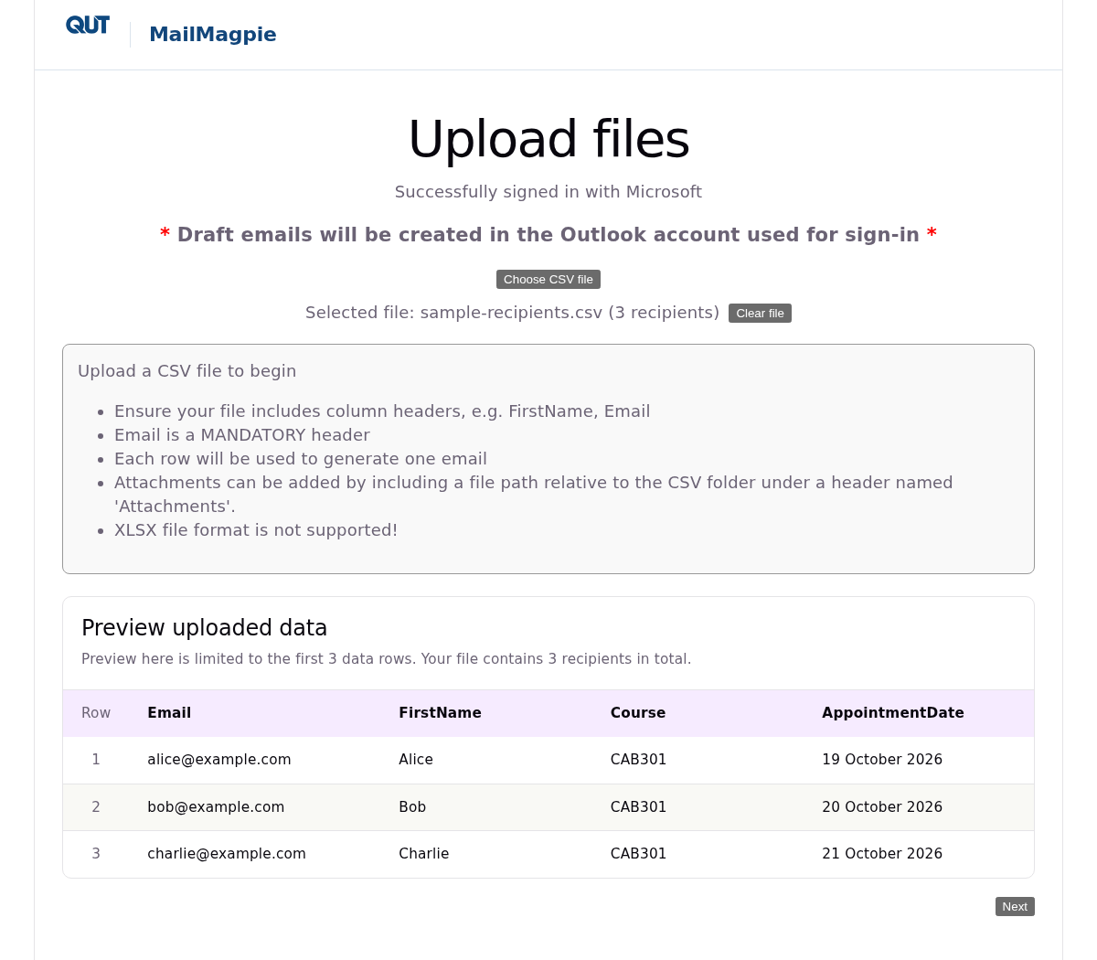
Figure 1. Upload files: a fictional CSV is selected and its first three data rows are shown.
1. Sign in, then select Choose CSV file and open the prepared .csv file.
2. Check the Selected file name and total recipient count. Review the headings and values under Preview uploaded data; only the first three data rows are shown.
3. Read any CC/BCC notice. Use Clear file to remove the selection, or choose a different CSV. Select Next when you are ready.
Complete your CSV setup before moving on to the template and individual email edits.

5. Create your email template
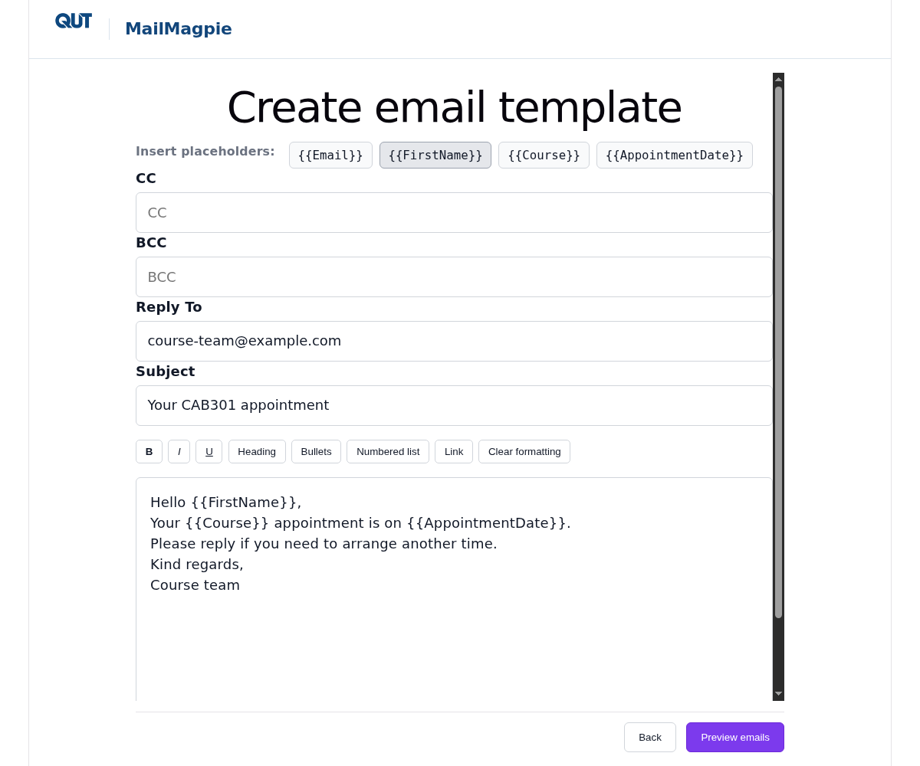
Figure 2. Choose a CSV field under Insert placeholders to add it to the message body.
1. Set a meaningful Subject and start writing the email body. Replace the default subject before creating your drafts.
2. Click in the email body where you want a personalised value. Under Insert placeholders, select a button such as {{FirstName}}. The app inserts it at the cursor.
3. Continue typing and add other fields the same way. To replace text, select it in the body before clicking a placeholder button.
4. Use the toolbar for bold, italics, underlining, headings or lists. To add a link, select the text, choose Link, enter the URL and select Insert link.
5. Set any optional recipient settings (page 7), then select Preview emails to review each personalised message. The body must contain text before you can continue.

6. Personalisation and recipient settings

Choose placeholders from your CSV
The buttons under Insert placeholders come from the uploaded CSV’s column headers. For the example CSV on page 4, choose {{FirstName}}, {{Course}} and {{AppointmentDate}} while writing the body below:
Subject: Your CAB301 appointment
Hello {{FirstName}},
Your {{Course}} appointment is on {{AppointmentDate}}.
Please reply if you need to arrange another time.
Kind regards,
Course team
For Alice, the opening becomes “Hello Alice,” and the next sentence becomes “Your CAB301 appointment is on 19 October 2026.” Bob and Charlie receive their own row’s values.
- Selecting a button adds the exact header and surrounding {{braces}} automatically; you do not need to type the placeholder.
- Fill in the fields used by your template for each recipient so the personalised sentences are complete.
- Keep each placeholder together when formatting. Apply formatting to the whole placeholder rather than parts of its name.
Subject line. Placeholder buttons insert into the body. Use the Subject field for one shared subject; it is not personalised.

CC, BCC and Reply To
Field | Purpose | Which value is used?
CC | Send a visible copy. | If a CC column exists, each row supplies its own CC value. Otherwise the manual template field applies to every email.
BCC | Send a copy whose address is hidden from other recipients. | If a BCC column exists, each row supplies its own BCC value. Otherwise the manual template field applies to every email.
Reply To | Direct replies to a different address. | A non-empty ReplyTo cell overrides the manual template field. A blank or absent cell uses the manual value. If both are blank, no custom Reply To is set.

Use comma-separated addresses when entering more than one address in a field. In raw CSV text, quote a cell containing commas as shown on page 4.
Leave a CC or BCC cell blank when that row should have no recipient for that field. To use one common manual value, prepare the CSV without that column and enter the value on the template screen.

7. Add attachments

Attach the same files to every email
1. On Preview emails, select Add attachments and choose one or more files.
2. Check the names under Global attachments. Each listed file will be attached to every generated draft or exported email.
3. Select Remove beside a file to stop including it. Recheck this list when preparing a different mail merge.

Attach different files to individual recipients
Add an Attachments column to the CSV. Each cell lists only the files for that row. Separate multiple paths with semicolons. Leave the cell blank when that person has no individual attachments.
Email,FirstName,Attachments
alice@example.com,Alice,attachments/alice.pdf;attachments/guide.pdf
bob@example.com,Bob,attachments/bob.pdf
charlie@example.com,Charlie,
Use a folder layout like this:
Mailout/
recipients.csv
attachments/
alice.pdf
bob.pdf
guide.pdf
Paths start from the CSV’s folder. If the CSV is F:\Mailout\recipients.csv, attachments/alice.pdf means F:\Mailout\attachments\alice.pdf. The location of the MailMagpie executable does not determine the attachment location. Both / and \ work as path separators on Windows.
Keep the CSV and attachment folder together when moving them to another computer or drive, then select the CSV from its new location. Relative paths continue to work even if the drive letter changes.

Attachment requirements
- Use non-empty files smaller than 3 MB each. Executable and script file types such as .exe, .bat and .js are not supported attachments.
- Select each recipient to inspect CSV attachments for this recipient. These are the row’s paths; the app checks the actual files when creating drafts or exporting.
- Global files and row-specific files are combined in each message. List each intended attachment once, using either the global list or the relevant CSV row.

8. Preview and edit individual emails
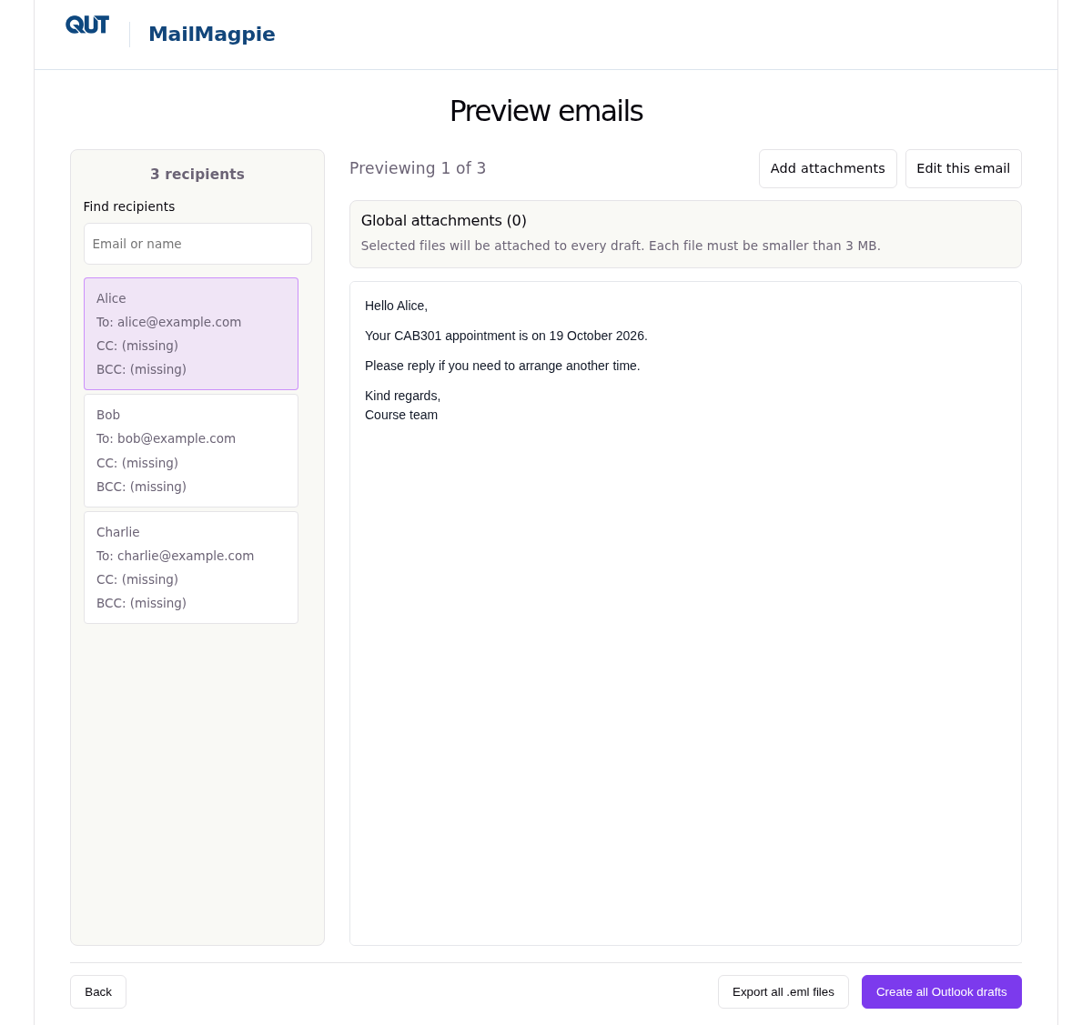
Figure 3. Preview emails: select a recipient on the left to inspect their personalised message.
Use Find recipients to locate a name or email address, then select that recipient. Review their personalised message and To, CC and BCC entries.
For a one-person body change, select Edit this email, make the change and select Save changes. Cancel keeps the previous content. An Edited badge identifies a customised message.
Batch actions. “Create all Outlook drafts” and “Export all .eml files” process every loaded CSV row. Use search and selection to navigate the preview.

9. Create Outlook drafts

Final checks
- Check the correct Microsoft account, recipient count and To/CC/BCC addresses. Check the Subject and Reply To on the template screen.
- Review the merged body for each recipient and check that personalised values and individual edits read as intended.
- Check global attachments and each recipient’s CSV paths. Use a one-row CSV addressed to yourself for an initial trial.

Create the batch
1. Select Create all Outlook drafts. The action applies to all loaded CSV rows, including rows outside the current search matches.
2. Read the confirmation: it shows the number of drafts and attachment counts. Select Cancel to return to the preview, or Create drafts to proceed. For a one-row CSV, the confirmation uses Create draft.
3. Wait while the app validates attachments and creates drafts. Follow the progress message and keep the app open until it finishes.
4. Open Drafts in Outlook using the same Microsoft account. Check recipients, subject, Reply To if used, message formatting and attached files before sending.
Each run creates a new set of Outlook drafts for the loaded CSV rows.

Interrupt a batch that is running
1. Select Interrupt draft creation below the progress message.
2. Read the progress shown in the popup. Creation continues while the popup is open.
3. Select Interrupt creation to stop starting further draft requests. A draft already being saved can still finish. Select Keep creating, or press Escape, to dismiss the popup and continue.
4. Read the final created/remaining counts. Already-created drafts stay in Outlook; interruption does not send or delete them.

10. Export emails and keep your work

Export .eml files
An .eml file stores an individual email message for opening in a compatible mail application. Exporting creates local files; it does not save drafts to Outlook or send messages.
1. On Preview emails, review the full recipient list, any individual edits and attachments.
2. Select Export all .eml files. The app validates the recipients and attachment files before export.
3. Choose a new or empty folder in the folder picker. Files with the same generated names in an existing folder can be overwritten.
4. Check the completion message for the exported count and folder. Files are numbered in CSV order, for example 001-alice@example.com.eml.
5. Open a sample file with a mail application that supports .eml and check its appearance and attachments. Opening or editing options vary by mail application.
Exported files include To, CC, BCC, the shared subject, the personalised body and the combined attachments. Reply To is supported when creating Outlook drafts; it is not included in .eml exports.

Keep a reusable copy of your work
- Save your source spreadsheet, exported CSV and template text in your own files. The app has no Save project or Save template command.
- For a new session, sign in, select your saved CSV, enter your template and add the shared files you want to attach.
- Store CSVs, attachment folders and exported emails appropriately for the personal information they contain. Keep the folder structure intact when moving a mailout.

Keyboard and display shortcuts
Shortcut | Action
Ctrl+F on Preview | Focus Find recipients.
Enter / Shift+Enter in the search box | Move to the next / previous match. Select a recipient to view their email.
Escape in the search box | Clear the search.
Ctrl + mouse wheel | Zoom the app in or out (50%–300%).
Ctrl+0 | Reset the app zoom to 100%.
Escape in the interruption popup | Keep creating drafts and dismiss the popup.

