PlantUML for OpenOffice.org and LibreOffice Writer

Version: 0.3
Release Date: 2011-01-02
Copyright © 2010 Poul Bondo e-mail: pba@mailme.dk
License: Public Documentation License Version 1.0

This document will allow you to install tools for assisting in using embedded PlantUML inside OpenOffice.org and LibreOffice Writer documents. PlantUML can be found at: http://plantuml.sourceforge.net/

Version | Date | Description
0.3 | 2012-09-19 | Add -charset UTF-8 in the command line
0.2 | 2011-01-02 | Added comments from “Gerhard”:  - Replace Paragraph Style “Default” with “Standard”  - Added TextWrap = com.sun.star.text.WrapTextMode.NONE  - Added HoriOrient = com.sun.star.text.HoriOrientation.CENTER  Additional:  - Check for IsNull( oParPrev )  - Attempt to calculate page size for max image size. Only for fixed header and footer.  Added test for LibreOffice  Added test for Danish version
0.1 | 2010-03-26 | Initial Release

Installation
Before installing the tools in this document make sure that you have installed java and plantuml and that they are working properly.

- Java must be available from the standard path
- plantuml.jar must be copied to HOME/plantuml/ where HOME refers to OOo's HOME (not unix $home)
- You must have loaded this document with macros enabled. After installation you can disable macros again
- All other OOo documents must be closed.

HOME is typically “c:\documents and settings\<username>\My Documents” on Windows XP, “c:\users\<username>\My Documents” on Windows 7 and “/home/<username>/Documents/” on Ubuntu. it is found in Tools / Options / OpenOffice.org / Paths / My Documents

To install simply select the menu: “PlantUML / Install PlantUML”.

After installation you should see an additional toolbar with two buttons:
UML.* : Perform the PlantUML operations
UML! : Show / Hide the PlantUML code

Uninstall
To remove again later open this document again (with macros enabled) and select “PlantUML / Remove PlantUML”

Testing
Open a new (or existing) document and insert the Following text

Text before
@startuml
Alice -> Bob: Authentication Request
Bob --> Alice: Authentication Response
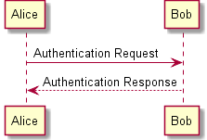
@enduml
Text after

Then press the UML.* button. You should now see a diagram within the code. Like this:

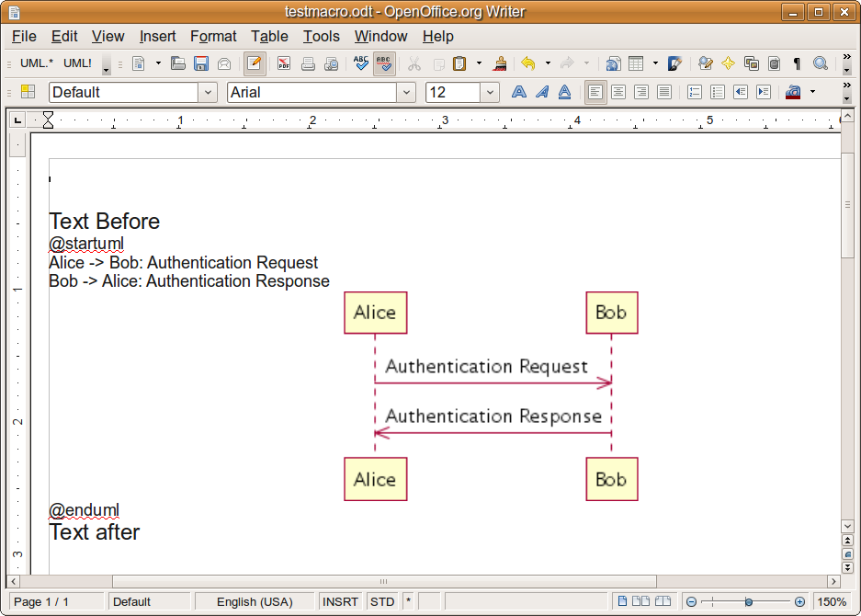
If the screen cursor is left inside a @startuml / @enduml section then only that diagram is updated. If the cursor is not inside a @startuml / @enduml section, then all diagrams are updated.

Now press the UML! Button. This should hide the code. Like this:

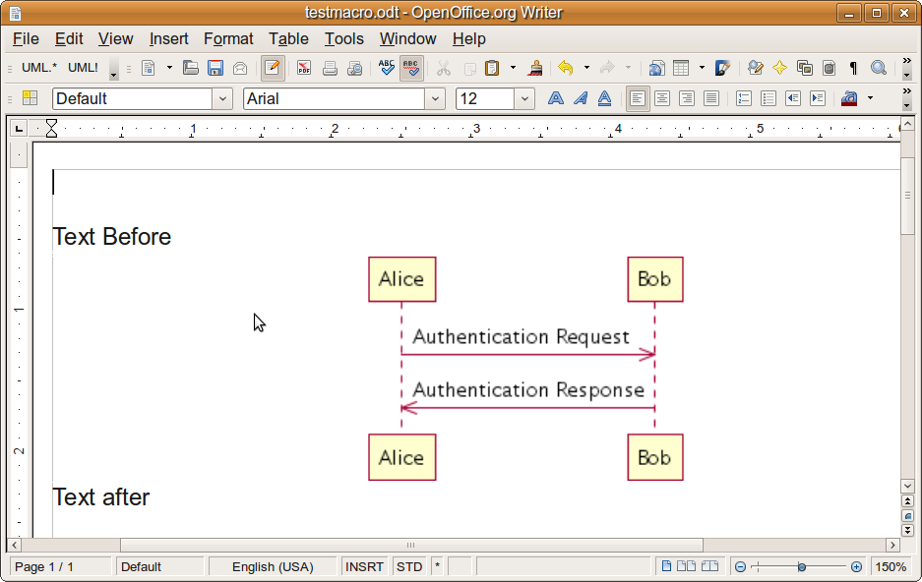
Pressing the UML! Button again will show the code again.

That's it.

Implementation details and notes
The following is a list of issues/details that needs to be worked out over time.

- Currently each diagram spawn a new java process. This should be optimized to just one java process. Performance related.
- The current edition of the diagram is deleted even if we are unable to generate a new diagram, e.g. in case of faulty Java installation. It has been improved, maybe it is ok now. Needs to be investigated.
- We should check for a read-only document before starting the update
- When there are syntax problems, it would be nice to leave the problem selected with the screen cursor.
- The newpage keyword is not currently supported.
- Captions for graphics will ruin the automatic update
- @startuml / @enduml inside a textbox (or any other context ?) does not work. Only as plain text.
- Pasting a string with @startuml / @enduml from a webpage generally does not work as it is apparently by default inserted as a single line / item. This also needs to be investigated

Tests performed
This document is “developed” and tested on a combination of Windows 7, Windows XP and Ubuntu on both 32 and 64 bit computers. Obviously this provides a large amount of combinations.

The release test consists of the testing the document “plantuml-test.odt”. As of release 0.2 this has been tested for the following combinations:

Windows XP32 bit with OpenOffice 3.2 32 bit English version
Windows 7 64 bit with LibreOffice 3.3 rc2 32 bit English version
Ubuntu 10.10 64 bit with LibreOffice 3.3 rc2 64 bit English version
Ubuntu 10.04 32 bit with OpenOffice 3.2 32 bit Danish version

