Black-Litterman Portfolio Optimization with Factor-Alpha Screening and Machine Learning Views

Introduction to Financial Engineering, Hanyang University

김도현 · 나근석 · 남현주 · 박진영 · 백상준 · 황도훈

Abstract
This study builds a monthly long-only portfolio that combines a Fama-French three-factor (FF3) security screen, machine-learning return forecasts, and the Black-Litterman (BL) model. Using CRSP monthly data for NYSE, AMEX and NASDAQ stocks, we run a time-series FF3 regression for each of the 2,426 stocks that were listed throughout January 2000 to December 2010, keep the 131 stocks that pass α > 0, t(α) ≥ 2 and a liquidity filter, and select the top 20 by t(α) without using any information after 2010. An XGBoost model trained on eight price and volume features with an expanding window and annual retraining forecasts next-month returns, and each forecast enters BL as an absolute view (P = I) with 50% Idzorek confidence.
Over the 2011–2020 out-of-sample period with monthly rebalancing, a 20% weight cap and a 0.2% transaction cost, the portfolio earns a net CAGR of 19.68% (Sharpe 1.15, MDD −19.55%), compared with 13.88% for the S&P 500 Total Return index and 13.02% for the equal-weighted portfolio of the same 20 stocks. Absolute views outperform factor-relative views for all five forecasting models. The advantage, however, depends on dynamic covariance updating, the risk-aversion coefficient and a large Apple weight, and the excess return over the S&P 500 (t = 2.26) is not significant at 5% once the 40 model–view combinations are taken into account (White's Reality Check p = 0.095). It also depends on the 20 stocks chosen in 2010: reselecting the stocks every year lowers the CAGR from 18.13% to 10.52% under an equal-weighted prior, and in an untouched 2021–2025 test the strategy earns 5.51% against 14.43% for the S&P 500 Total Return index.
Keywords: Black-Litterman Model, Fama-French Three-Factor Model, Security Selection, XGBoost, Machine-Learning Views, Portfolio Optimization

1. Overview
1.1 Background and Objectives
Mean-variance optimization[1] is the starting point of portfolio theory, but in practice its weights are extremely sensitive to expected-return estimates. Plugging in sample means concentrates weight in the stocks with the largest estimation errors, and small changes in the inputs produce large changes in the weights. Black and Litterman[2] eased this problem with a Bayesian structure that uses the implied expected returns reverse-engineered from market equilibrium as the prior and blends in investor views according to their confidence. The BL model, however, leaves open where the views should come from. Views were traditionally the subjective judgment of analysts, but a growing literature uses machine-learning forecasts instead. Gu, Kelly and Xiu[3] report that tree-based models and neural networks capture nonlinear interactions in stock returns and deliver higher out-of-sample predictive power than linear models.
This study connects three stages in a single reproducible pipeline. First, we estimate FF3[4] alphas using only 2000–2010 data and narrow the investment universe to 20 stocks. Second, machine-learning models trained on price and volume features forecast next-month returns, and the forecasts are converted into views. Third, the BL posterior gives long-only optimal weights that are rebalanced monthly over the ten years from 2011 to 2020. The research questions are: (i) within a stock set chosen by FF3 alpha up to 2010, does a BL portfolio with ML views beat both the market index and an equal-weighted portfolio of the same stocks after transaction costs? (ii) Which matters more for performance, the form of the views (the P matrix) or the forecasting model? (iii) How sensitive is any advantage to design choices such as covariance updating, the risk-aversion coefficient δ and the prior weights?
The scope was narrowed during the project. Because feeding every stock in the data into an optimizer is impractical, we cut the universe to 20 stocks and focused on ML-view-based BL. In addition, because the first results might reflect the selection of the top 20 stocks rather than BL itself, we added an equal-weighted portfolio of the same 20 stocks as a second benchmark and extended the backtest to ten years.
1.2 Related Literature
He and Litterman[5] set out the intuition and practical implementation of the BL model. Idzorek[6] addressed the difficulty of specifying the view uncertainty Ω directly by mapping a confidence level (0–100%) for each view into Ω. At 50% confidence, Idzorek's Ω equals τ·diag(PΣP^{T}), and the posterior expected return then does not depend on τ[7]. On the selection side, the intercept of the FF3 regression extends Jensen's[8] alpha to a factor model and measures excess return not explained by market, size and value exposures. Alpha divided by residual volatility, the appraisal ratio, is the quantity Treynor and Black[9] use to size active positions. For return forecasting, Gu, Kelly and Xiu[3] find that momentum, short-term reversal, volatility and volume characteristics account for most of the predictive power, and XGBoost[10], a regularized boosting method that adds shallow trees sequentially, performs strongly at low computational cost. Finally, testing many stocks at once inevitably produces some that look significant by chance, and Harvey, Liu and Zhu[11] stress the need for multiple-testing corrections in empirical finance.
1.3 Research Framework
<Figure 1> summarizes the pipeline in four stages. (1) Investment universe: an FF3 regression on 2000–2010 data selects 20 stocks. (2) Return forecast: XGBoost, trained on all 2,426 universe stocks, forecasts next-month returns μ̂ for the 20 stocks. (3) Black-Litterman: the market-cap-weighted prior is combined with the views (P = I, Q = μ̂, 50% confidence). (4) Optimization and backtest: weights are set under a no-short-sale constraint and a 20% cap per stock, rebalanced monthly from 2011 to 2020, net of a 0.2% transaction cost.
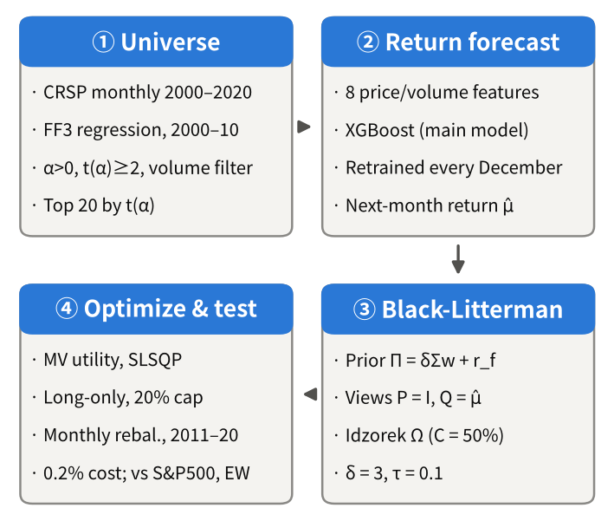
<Figure 1> Overall investment framework
1.4 Key Findings and Organization
The key findings are as follows. Over the ten-year backtest from 2011 to 2020, the main portfolio (XGBoost × P = I) earned a net CAGR of 19.68%, annualized volatility of 16.11%, a Sharpe ratio of 1.15 and an MDD of −19.55%, beating both the baseline benchmark, the S&P 500 TR (CAGR 13.88%, Sharpe 0.98), and the equal-weighted portfolio of the same 20 stocks (13.02%, 0.78). A starting $100 grew to $603, compared with $367 for the S&P 500 TR. The form of the views (P = I) mattered more than the forecasting model, and the advantage was sensitive to the monthly updating of covariances and views, the risk-aversion coefficient δ and the Apple weight. The monthly excess return over the S&P 500 TR has a t-statistic of 2.26, but it is not significant at 5% after correcting for the 40 combinations examined (Reality Check p = 0.095). Two additional tests show that the result depends on the 20 stocks chosen in 2010: reselecting the stocks every year lowers the CAGR from 18.13% to 10.52% under an equal-weighted prior, and in an out-of-sample test on 2021–2025 the strategy earned 5.51% against 14.43% for the S&P 500 TR.
The rest of the paper is organized as follows. Section 2 covers the investment universe (data and preprocessing, FF3 security selection and the data split), and Section 3 covers the forecasting models, view construction, Black-Litterman optimization, and the backtest design and benchmarks; together, Sections 2 and 3 form the portfolio management framework. Section 4 evaluates the portfolio value and performance metrics over the backtest period against the S&P 500 TR and reports two additional tests (annual reselection and a 2021–2025 out-of-sample test), and Section 5 concludes with limitations.

2. Investment Universe
2.1 Data and Preprocessing
The stock data are the CRSP monthly records provided for the course (IFE_term_stock_data.csv), covering NYSE, AMEX and NASDAQ stocks from January 2000 to December 2020. Stocks are identified by PERMNO rather than ticker, and duplicate stock-month rows and invalid prices were removed. Monthly returns are the ratio of adjusted prices (ADJ_PRC) in two consecutive months, computed from adjusted prices that reflect reinvested dividends. Trading volume (VOL) is used only in logs or as a relative rank.
Five external datasets are used. The FF3 factors (Mkt−RF, SMB, HML) and the risk-free rate RF (one-month T-bill) come from the Kenneth French Data Library. The security selection uses the July 2026 vintage, while the ML features and the rolling factor loadings of views M1–M3 use a file downloaded earlier (ff3_factors.csv). Because the library revises past values when it is updated, the two files have identical Mkt−RF and RF but SMB and HML values that differ by at most 0.09 percentage points. Market capitalization for the prior is computed from CRSP as the absolute unadjusted price times shares outstanding (|PRC|×SHROUT). The performance benchmark is the S&P 500 Total Return index from Yahoo Finance (ticker ^SP500TR), and the risk-free rate is the one-year Treasury constant-maturity yield from FRED (GS1, the monthly average of daily yields, annual %). The monthly risk-free rate is r_f = GS1/1,200 (converting percent to a decimal and dividing by 12, a simple-interest conversion) and is used in the BL prior and the Sharpe ratio. The difference from compound conversion is at most 0.003 percentage points per month over the sample and is negligible. The rate of the decision month is applied to the following holding month. Finally, the federal funds rate from FRED is used only to compute the sample-implied δ in Section 3.4.
2.2 FF3-Based Security Selection
2.2.1 Model and Estimation
Each stock's monthly excess return is regressed on the FF3 factors. The estimation window is the 131 months from February 2000 to December 2010 (January 2000 serves as the base price for the first return), and the intercept α_i in Eq. (1) is the average monthly excess return not explained by the three factors.
$$R_{i,t}-{RF}_{t}=α_{i}+b_{i}\left({Mkt}_{t}-{RF}_{t}\right)+s_{i}{SMB}_{t}+h_{i}{HML}_{t}+e_{i,t} (1)$$
SMB and HML are return series common to all stocks rather than stock-level characteristics, so differences across stocks appear in the loadings b_i, s_i, h_i and in α_i. The sample is restricted to stocks listed throughout 2000–2010 (a balanced panel). Every stock therefore shares the same 131 months and the same factor matrix X, and the 2,426 regressions are computed in a single matrix OLS. The residual variance has 131 − 4 = 127 degrees of freedom.
The universe is built as follows. Of the 10,046 stocks that appear at least once in the period, 2,456 have prices in all 132 months, and 2,451 also have 131 valid returns and are listed on NYSE, AMEX or NASDAQ (EXCHCD 1–3) in December 2010. For the 25 duplicate share classes of the same company we keep the class with the higher average volume (e.g., HEICO). The tracking stocks of APPLERA and LOEWS were not merged, because they track different business units. The final regression universe has 2,426 stocks.
2.2.2 Selection Rule and Ranking Criterion
The gate has four conditions: α_i > 0, t(α_i) ≥ 2, exclusion of the bottom 20% by average volume, and a sigma guard. The sigma guard removes stocks whose monthly standard deviation is below 1.5%, whose share of zero-return months exceeds 30% (suspected stale prices), or whose absolute Sharpe ratio exceeds 3 while their standard deviation is in the bottom 5% (inflation by a small denominator). Stocks that pass the gate are sorted in descending order of t(α) in Eq. (2).
$$t\left({\hat{α}}_{i}\right)=\frac{{\hat{α}}_{i}}{{\hat{σ}}_{e,i}\sqrt{{\left[{\left(X^{'}X\right)}^{-1}\right]}_{00}}} (2)$$
We rank by t(α) for two reasons. First, once the universe is defined by a factor model, it is consistent to rank by the excess return that the factors do not explain. The Sharpe ratio also rewards returns from market, size and value exposures and so does not fit the selection logic. Second, in a balanced panel √[(X′X)⁻¹]₀₀ is the same constant for every stock, so t(α) = (α̂/σ̂_e)/√[(X′X)⁻¹]₀₀ and the t(α) ranking is mathematically identical to the appraisal-ratio (α̂/σ̂_e)[9] ranking. t(α) thus reflects both the statistical reliability of alpha and its size relative to residual risk. Ranking by alpha alone tends to favor volatile stocks and picks stocks with large estimation errors.
2.2.3 Blocking Post-2010 Information
We kept post-2010 information out of the selection. First, right after loading the price and factor files we delete the 499,660 rows from January 2011 onward. Second, listing status, exchange code, ticker and company name are all taken as of December 2010. Attaching 2020 identifiers would change the tickers of 10 of the 131 selected stocks, so we treat them as ex-post information. Third, the volume filter and the share-class deduplication use only 2000–2010 average volume. The balanced-panel condition itself, however, keeps only stocks that survived to 2010, so survivorship bias remains; Section 2.3.4 discusses it.
2.3 Selection Results and Validation
2.3.1 Selection Results
Of the 2,426 stocks, 139 satisfy α > 0 and t(α) ≥ 2, and the volume filter removes 8, leaving 131. The median annualized alpha of the selected stocks is 26.7%, more than three times the universe median of 8.0%, and the median t(α) is 2.34 (universe 0.70). By exchange, 77 are on NYSE, 52 on NASDAQ and 2 on AMEX. The median market beta is 0.95, close to the universe (0.98), but the median SMB loading is 0.02, far below the universe (0.45), and the HML loading is also lower at 0.26 (universe 0.39). The selected stocks are thus mid- to large-cap stocks with market-level risk rather than small or value stocks, and their high t(α) comes from alpha rather than from factor exposure. The median standard error of alpha is 10.95% per year, below the universe (12.72%), showing that the t(α) criterion also favors stocks with low residual volatility.
<Figure 2>(b) shows the top 20 stocks by t(α), which form the investment set. The top five are OXY (3.41), APH (3.28), HANS (3.28), POT (3.21) and AAPL (3.19), and the 20th, SWN, still has 2.86. Sectors are diversified across energy (OXY, SWN, SCCO), technology (AAPL, ANSS, CTSH, APH), consumer (HANS, DECK, GMCR) and industrials (CMI, AME, CNI). Foreign companies listed on U.S. exchanges are also included in the universe; among the top 20, POT (Canada, 4th) and CNI (Canada, 12th) are such cases. For reference, the in-sample performance of the equal-weighted 131 stocks is an annual excess return of 29.5%, volatility of 20.0%, a Sharpe ratio of 1.48 and an FF3 alpha of 27.9% (t = 10.4), well above the equal-weighted universe (14.8%, 21.3%, 0.69) and the market (0.5%, 16.9%, 0.03). These figures come from the same period as the selection, so they only confirm that the screen works as intended and are not evidence of investment performance.
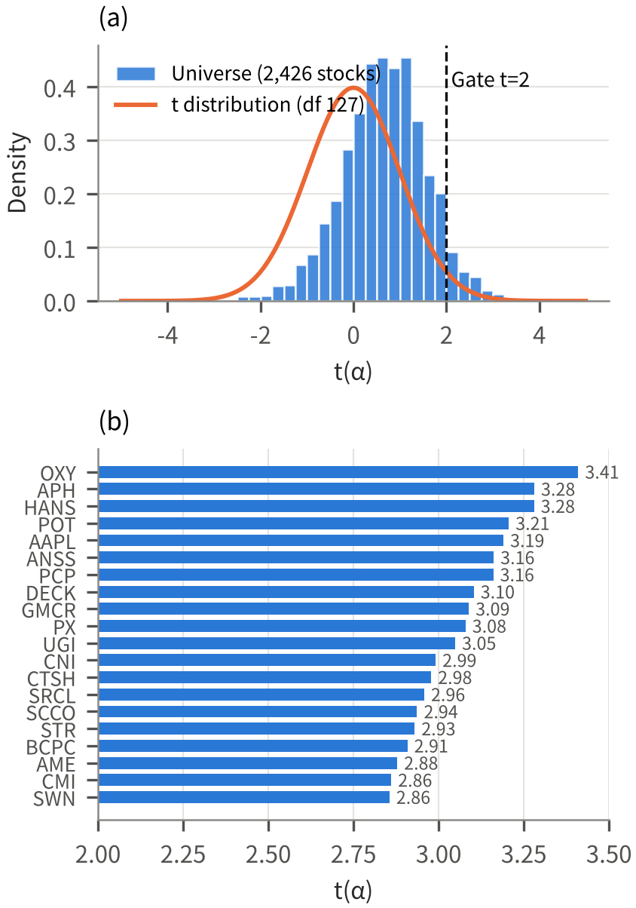
<Figure 2> (a) Distribution of t(α) for 2,426 stocks versus the null t distribution, (b) top 20 selected stocks by t(α)
2.3.2 Multiple Testing and Chance Expectation
When 2,426 stocks are tested at once, some will exceed t ≥ 2 by chance even if every alpha is zero. Under a t distribution with 127 degrees of freedom, the one-sided probability P(t ≥ 2) is about 2.38%, so 57.8 stocks are expected by chance; 139 actually pass, 2.41 times as many. At t ≥ 2.5 the counts are 50 versus 16.6 (3.01 times) and at t ≥ 3 they are 11 versus 3.9, so the ratio rises with the threshold. <Figure 2>(a) likewise shows the universe's t(α) distribution shifted to the right of the null t distribution. This may, however, reflect a sample-wide feature, namely positive average alphas in 2000–2010 for stocks with little small-cap or value tilt.
Applying multiple-testing corrections indeed changes the conclusion. The smallest one-sided p-value is 4.36×10⁻⁴, 21.2 times larger than the Bonferroni threshold (0.05/2,426 = 2.06×10⁻⁵). No stock survives the Benjamini-Hochberg FDR[12] at 5%, and 11 stocks have t ≤ −2 in the opposite direction. We therefore interpret the FF3 stage not as a test that finds stocks with significant alpha but as a screen that prioritizes stocks with high alpha and low residual risk. This reading is consistent with the concerns of Harvey, Liu and Zhu[11], and it motivates the ML views and the BL combination, so that later performance does not rely solely on alpha persistence from the selection period.
2.3.3 Linearity and Tail Diagnostics
FF3 is a linear model, so nonlinear responses in months with large market moves could distort alpha. We checked this in five ways. First, in a Treynor-Mazuy[13] regression that adds the squared market excess return to FF3, the share of stocks whose squared term has |t| above 2 is 2.3% for the selected stocks, lower than the universe (8.0%). Second, in a Henriksson-Merton[14] regression that adds the down-market term max(0, −(Mkt−RF)), the share with |t| above 2 on this term is only 1.5% (universe 6.8%). Third, the median residual kurtosis is 4.17 (3 for a normal distribution; universe 5.36), and the Jarque-Bera test rejects normality at 5% for 62.6% (83.2%), so the selected stocks have relatively thin tails. Because a majority still reject normality, fourth, we apply the residual bootstrap of [15] stock by stock. Resampling residuals 500 times per stock under the null of α = 0, the median one-sided 5% critical value is 1.62 (seed 0; 1.60–1.62 across seeds), almost equal to the t-distribution value of 1.657, so non-normal residuals do not materially change the t(α) verdict. Fifth, after dropping the five months with the largest absolute market excess return (2000-11, 2002-09, 2008-10, 2009-02, 2009-04) and re-estimating, 115 of the 131 stocks (87.8%) keep α > 0 and t ≥ 2. In addition, in the bottom 20% of market months (27 months, average market excess return −7.34%), the average residual of the selected stocks is +0.36% per month, higher than in the top 20% of months (−0.11%) and the middle 60% (−0.09%), so there is no systematic deterioration in down markets. Overall, the selection is unlikely to stem from a few extreme months or a violation of linearity.
2.3.4 Survivorship Bias
The balanced panel includes only stocks that remained listed through December 2010, so it carries survivorship bias[16]. The data contain no delisting returns (DLRET), so even if stocks delisted mid-period were included, their losses just before delisting could not be captured. Shumway[17] and Shumway and Warther[18] estimate average performance-related delisting returns of about −30% on NYSE and AMEX and about −55% on NASDAQ; ignoring them overstates the performance of survivors. A further reason for the balanced panel is that when a price stalls near zero before delisting, volatility approaches zero and the Sharpe ratio or t(α) can become abnormally large. This bias directly affects the in-sample figures of the selection period, but the 2011+ backtest uses only stocks observable at the end of 2010, so the choice is feasible at the time of investment. PCP, GMCR, STR and PX, which delisted during the backtest, earn their returns up to delisting, and their weight is then redistributed to the remaining stocks in proportion to their weights.
2.4 Data Split and Walk-Forward Design
The forecasting models are trained with an expanding-window walk-forward scheme. At the end of each December the model is retrained on all data to date, and the most recent 12 months serve as the validation set for choosing hyperparameters. The target is next-month total return, and only observations with at least 12 months of past returns, so that every feature can be computed, are used. The training sample is the full FF3 universe of 2,426 stocks, while forecasts are made only for the 20 investment stocks; training on the 20 stocks alone would give only 20 observations per month and a high risk of overfitting. There are 16 retrainings from December 2004 to December 2019, and the training sample grows from 114,022 to 493,941 rows. Forecasts from December 2004 to November 2010 are used only for diagnostics; actual investment decisions are made 120 times, from 31 December 2010 to 30 November 2020, each setting the weights for the following month (January 2011 to December 2020). This training sample also consists of stocks that survived to 2010, so the same period is used for both selection and training.

3. Portfolio Management Framework
3.1 Features
The eight features are built from prices and volume only and implement, with monthly data, the characteristic families that ranked high in Gu, Kelly and Xiu[3]. mom1m is the current-month return and captures short-term reversal[19]; mom6m and mom12m are cumulative returns over t−5 to t−1 and t−11 to t−1 and capture momentum[20]. chmom is the change in momentum, mom6m minus the cumulative return over t−11 to t−6. retvol is the 12-month standard deviation of returns, beta is the 12-month market beta, and idiovol is the residual standard deviation of that regression[21]. Finally, log_volume is log trading volume, used instead of price times volume because the volume unit is unclear. Each feature is converted every month to its cross-sectional rank scaled to [−1, 1], which removes outliers and differences in scale over time, and missing values are set to 0, the middle of the range.
3.2 Forecasting Models
The main model is XGBoost[10]. We compare four combinations of tree depth {1, 2} and learning rate {0.01, 0.1}, growing up to 1,000 trees and stopping when the validation loss fails to improve for 50 rounds. Across the 16 retrainings, 1 to 521 trees were selected, and depth 2 was chosen 11 times. Depth is capped at 2 because monthly returns have a very low signal-to-noise ratio, so deep trees easily fit noise, and because annual retraining calls for a light computational load. The comparison models are Elastic Net[22] (ρ = 0.5, λ chosen by validation MSE from 10 values between 10⁻⁴ and 10⁻¹ and then refit on the full sample), a three-layer neural network NN3 (8→32→16→8→1 with BatchNorm and ReLU, MSE+L1 loss, Adam, batch size 10,000, up to 100 epochs, early stopping after 5, and a 10-seed ensemble), RandomForest[23] (300 trees, a 10% bootstrap sample per tree, 3 or 5 split candidates, depth 1–6, minimum leaf size 100) and a Transformer[24] (inputs are the eight features over the latest 12 months; two encoder layers with model dimension 32, 4 attention heads, feed-forward dimension 64, dropout 0.1 and a learned positional embedding; Adam with a learning rate of 0.001 or 0.0001 chosen by validation, batch size 2,048, up to 30 epochs, early stopping after 3, seed 42).
In out-of-sample diagnostics (2011–2020), XGBoost has the highest OOS R² (0.60%) and mean information coefficient (IC, the cross-sectional rank correlation between forecasts and realized returns, 0.040) among the three main models. Elastic Net has an R² of 0.56% and IC of 0.031, and the ANN 0.19% and −0.006. The IC t-statistics, however, are 1.37 for XGBoost and 1.12 for Elastic Net and are not significant at 5%, and the share of months with a positive IC, 53.7% for XGBoost, 59.7% for Elastic Net and 47.5% for the ANN, is not far from chance. The share of months in which the top five forecasts beat the bottom five is 54.9%, 59.7% and 46.7%, respectively. RandomForest (R² 0.58%, IC 0.047, t = 1.98, positive IC in 56.7% of months) and the Transformer (0.48%, 0.032, 1.22, 60.8%) are similarly weak; RandomForest has the highest IC of the five, but it is only at the border of 5% significance. OOS R² is computed over the full 2,426-stock training universe as 1 − Σ(r − r̂)²/Σr², and the IC is the Spearman correlation across the 20 investment stocks. Months in which a model gives all 20 stocks the same forecast are excluded because the IC is undefined, so the XGBoost and Elastic Net ICs are based on 82 and 72 of the 120 months. Stock-level predictive power is therefore weak, in line with typical monthly return prediction[3].
The models also differ in clear ways. Elastic Net shrank every coefficient to zero in 7 of the 16 retrainings and gave all 20 stocks the same forecast, so for 48 months (holding years 2012, 2015, 2016 and 2019) its views carried no cross-sectional information. The surviving variables were most often log_volume (9 times, always negative) and mom1m (9 times, negative), favoring stocks with low volume and low last-month returns. The ANN chose the upper end of the learning-rate grid (10⁻²) in all 16 retrainings, a boundary solution, and its forecasts had about 2.5 times the cross-sectional dispersion of XGBoost, pushing monthly turnover to 57%. RandomForest preferred simple structures, choosing depth 1 in 10 of 16 retrainings, with variable importance of about 31% for short-term reversal, 31% for momentum, 4% for the change in momentum, 24% for risk (volatility and beta) and 11% for volume. XGBoost selected a single depth-1 tree in the December 2011, 2014 and 2018 retrainings and 18 depth-1 trees in December 2015, so in 38 of the months after these retrainings its forecasts were identical across the 20 stocks.
XGBoost is the main model for three reasons. First, as Gu, Kelly and Xiu[3] show, tree models capture nonlinear interactions among features without manual design. Second, shallow trees with early stopping control overfitting and retrain quickly every year. Third, as Sections 4.1 and 4.5 show, under the same BL setting it has the highest net CAGR and Sharpe ratio of the five models, and its turnover (39.2%) is lower than that of Elastic Net (51.3%), the ANN (56.7%) and the Transformer (81.5%). RandomForest has even lower turnover (27.7%) but a CAGR 0.83 percentage points lower (18.85%). XGBoost's difference from Elastic Net is not statistically significant (t = 0.16), so the accurate reading is not that XGBoost is clearly superior but that it matches Elastic Net's performance with lower turnover.
3.3 View Construction
A BL view is defined by three elements: P (which stocks the view is about), Q (the expected return the view states) and Ω (the uncertainty of the view). In every scheme Q is the forecast vector μ̂ multiplied by P, and Ω uses the closed form of Idzorek's[6] method at confidence C = 50%. In Eq. (3), (1−C)/C = 1, so Ω equals τ·diag(PΣP^{T}). Covariances between views are set to zero (a diagonal Ω).
$$Q=P\hat{μ}, Ω=\frac{1-C}{C}τ diag\left(PΣP^{⊤}\right) (3)$$
We compare five ways of building P. M4 (the main scheme) sets P = I, giving 20 absolute views of the form 'next month's return on stock i is μ̂_i'. M1–M3 are factor-relative views. M1 ranks all 20 stocks by their FF3 SMB loading s_i and M2 by their HML loading h_i, assigning weights linear in rank to form one long-short view (long side +1, short side −1, row sum 0; weights of ±0.01 to ±0.19 with 20 stocks); M3 uses both rows as two views. M1 thus states that small-cap-like stocks will outperform large-cap-like stocks by Q next month, and M2 that value-like stocks will outperform growth-like stocks by Q, with the sign and size of Q = Pμ̂ set by the ML forecasts. The base versions re-estimate s_i and h_i from the previous 60 months at each decision date (rolling), while the 'fixed' variants keep the s_i and h_i from the 2000–2010 selection regression for all 120 months. The weighting scheme is identical in both and only the estimation window differs; the average correlation between the two P rows is 0.06 for SMB and 0.31 for HML, so they are effectively different views. Under M4 the number of views falls to 16–19 as delisted stocks drop out. M5 combines the stocks with positive forecasts into a single view with weights proportional to the forecasts. In M5, P and Q come from the same forecast, so Q may be biased upward. Splitting training into even and odd years would not fully separate them because of 12-month momentum and would halve the training period, so we did not implement it and record it as a limitation.
3.4 Black-Litterman Combination and Optimization
The prior is the implied expected return reverse-engineered from market equilibrium. In Eq. (4), w_mkt is the market-cap weight of the 20 stocks at the decision date, Σ is the sample covariance of the previous 60 monthly returns, and r_f is the monthly GS1 rate for the decision month. In the original BL model Π is an excess return, but because Q forecasts total returns, we add r_f so that the units match. Section 4.4 reports the result without adding r_f.
$$Π=δΣw_{mkt}+r_{f} (4)$$
The posterior expected return and covariance follow Eqs. (5) and (6). K = τΣP^{T}(PτΣP^{T} + Ω)⁻¹ is the weight on the gap between the views and the prior (Q − PΠ). Because Ω = τ·diag(PΣP^{T}), τ cancels in K, so μ_BL does not depend on τ, and τ affects only Σ_BL[7].
$$μ_{BL}=Π+K\left(Q-PΠ\right) (5)$$
$$Σ_{BL}=Σ+τΣ-KPτΣ (6)$$
Optimal weights maximize the mean-variance utility in Eq. (7) subject to full investment, no short sales and a 20% cap per stock. The problem is solved with SLSQP[25], starting from w_mkt. The 20% cap prevents extreme concentration in a few stocks.
$$w^{*}={arg max}_{w} w^{⊤}μ_{BL}-\frac{δ}{2}w^{⊤}Σ_{BL}w (7)$$
$$s.t. 1^{⊤}w=1, 0≤w_{i}≤0.2$$
The parameters are set as follows. The risk-aversion coefficient δ is 3, within the conventional range of 2.0–4.0 and close to He and Litterman's[5] 2.5 and Idzorek's[6] 3.07. It is also consistent with the market's own risk premium: estimating δ = (E[r_m] − r_f)/σ_m² from the U.S. market factor gives 2.09 to 3.15 depending on the start year, and with the 1926–2010 estimate of 2.09 the main portfolio earns a CAGR of 21.14%. The δ computed directly from 2010 data was 8.84. It is obtained from δ = (E[r_m] − r_f)/σ_m², taking the equal-weighted portfolio of the 20 selected stocks as the market portfolio and using its February 2000–December 2010 average monthly return of 2.875%, variance of 0.003237, and the December 2010 federal funds rate (0.015% per month). Because the market proxy is a high-alpha stock set that earned 34.5% per year during the selection period, the expected return is large, which pushes δ above the conventional range. τ is set to 0.1 and, as explained above, barely affects the results. The covariance matrix is re-estimated from the previous 60 months at every decision date.
3.5 Backtest Design and Benchmarks
At each month-end decision date d, Σ, Π and the views are updated for stocks that have a return in that month (that is, are listed), and target weights are computed. Rebalancing starts from the weights that drifted with the previous month's returns, so turnover is the sum of absolute differences between target and drifted weights. The transaction cost is 0.2% per unit of turnover, the low end of a 0.2–0.25% range. If a stock delists during the holding month, its weight is sold and redistributed to the remaining stocks in proportion to their weights, and both the sale and the repurchase are added to turnover. This redistribution uses the fact that the stock has no return in the holding month, which is not known at the start of that month, so it is a simplification rather than a model of an actual delisting (Section 5.2). The net return is given by Eq. (8), where TO_t is turnover, w* the target weight, w̃ the drifted weight and c = 0.002.
$$R_{p,t}^{net}=\left(1-c·{TO}_{t}\right)\left(1+R_{p,t}^{gross}\right)-1 (8)$$
$${TO}_{t}=\sum_{i}{\left|w_{i,t}^{*}-{\tilde{w}}_{i,t}\right|}$$
There are two benchmarks. The S&P 500 TR is the U.S. large-cap market return including dividends and is measured on the same total-return basis as the portfolio. The equal-weighted portfolio of the 20 stocks (EW) rebalances the same 20 stocks to 1/n every month and pays the same transaction cost; it was added to separate the contribution of stock selection from that of the BL weighting. As DeMiguel, Garlappi and Uppal[26] show, equal weighting is also a benchmark that optimized portfolios find hard to beat. The performance metrics are total return, CAGR, annualized volatility (monthly standard deviation × √12), the Sharpe ratio (mean / standard deviation of monthly returns in excess of GS1 × √12), maximum drawdown (MDD) and average monthly turnover.

4. Performance Evaluation
4.1 Comparison of Models and View Schemes
<Table 1> reports the 2011–2020 net CAGR for the 40 combinations of five forecasting models and eight P schemes. The clearest result is that the P scheme matters more than the model. Decomposing the variation in CAGR across the 40 combinations by P scheme and model (a two-way decomposition without replication), the P scheme explains 85.3%, the model 4.5%, and the remaining 10.2% is their interaction. Within a model, CAGR differs by 6.0 percentage points on average across P schemes, whereas within a P scheme it differs by only 1.4 points on average across models. Under P = I, however, the gap across models widens to 4.6 points, so differences between forecasting models translate into performance only when views reach individual stocks. M4 (P = I) is best for all five models (15.1–19.7%), while the factor-relative views M1–M3 cluster in a narrow range regardless of the model (13.3–14.4% for the rolling versions and 11.6–13.7% for the fixed variants). M1–M3 are insensitive to the model because relative views adjust only the difference between groups of stocks relative to the prior, so the weights are driven mostly by the market-cap prior, especially Apple. Indeed, for Elastic Net and the ANN the average Q of M1–M3 is within ±0.11% per month, close to zero, so the posterior barely moves away from the prior. The fixed variants, which use 2000–2010 loadings, trail the rolling versions, which use loadings from the previous 60 months, by 1.3–2.6 percentage points for M2 and M3, while for M1 the gap is small (−0.2 to 0.7 points). This suggests that size and value tilts measured a decade earlier did not represent the stocks' later character well. M5, at 13.6–15.6%, sits between M4 and M1–M3 for four of the five models; for the ANN it is 13.6%, below its rolling M1–M3.

<Table 1> Net CAGR (%) by forecasting model and view scheme, 2011–2020
Model | M1 | M1 fixed | M2 | M2 fixed | M3 | M3 fixed | M4 | M5
Elastic Net | 14.0 | 13.6 | 14.3 | 12.8 | 14.3 | 12.4 | 19.5 | 15.5
ANN | 13.9 | 13.7 | 14.3 | 12.0 | 14.2 | 11.6 | 15.1 | 13.6
XGBoost | 13.7 | 13.6 | 14.4 | 12.8 | 14.2 | 12.2 | 19.7 | 15.5
RandomForest | 13.3 | 13.5 | 14.4 | 13.0 | 13.9 | 12.0 | 18.9 | 15.6
Transformer | 14.1 | 13.4 | 13.4 | 12.0 | 13.6 | 12.2 | 17.4 | 14.6
Note: net of 0.2% cost; δ = 3, τ = 0.1, market-cap prior. M1–M3: rank-weighted SMB/HML relative views (base: loadings from the previous 60 months; fixed: 2000–2010 selection-regression loadings); M4: P = I; M5: single view proportional to positive forecasts.

Within M4, XGBoost (19.68%) and Elastic Net (19.46%) are close, followed by RandomForest (18.9%), the Transformer (17.4%) and the ANN (15.1%). The ANN's forecasts, with an IC near zero, came with large dispersion and high turnover that eroded performance, whereas models with weak but low-dispersion, stable forecasts did better inside BL. This fits the view that because BL shrinks the views toward the prior, what matters is less the accuracy of the forecasts themselves than whether they tilt consistently away from the prior. XGBoost M4 also ranks first when the prior is equal-weighted.
4.2 Full-Period Performance
Panel A of <Table 2> reports the 2011–2020 performance of the main portfolio (XGBoost × M4) and the two benchmarks, and <Figure 3> shows their cumulative value. The net total return is 503.1%, turning $100 into $603. Over the same period the S&P 500 TR grew to $367 (267.0%) and the equal-weighted 20 stocks to $340 (240.1%). The net CAGR of 19.68% is 5.80 percentage points above the S&P 500 TR (13.88%) and 6.66 points above EW (13.02%). Annualized volatility of 16.11% is higher than the S&P 500 TR (13.54%) but similar to EW (16.48%), and the Sharpe ratio of 1.15 exceeds both the S&P 500 TR (0.98) and EW (0.78). The MDD of −19.55% (September to December 2018) is on par with the S&P 500 TR (−19.60%) and smaller than EW (−25.07%). <Figure 3>(a) shows that the main portfolio was ahead of the S&P 500 TR at the end of 2014 ($209 versus $178), but its weak 2015 brought it down to $178 by the end of that year, below the S&P 500 TR ($181). The gap reopened from 2016, reaching $414 versus $310 at the end of 2019 and $603 versus $367 at the end. Panel (b) shows deeper drawdowns than the S&P 500 TR in early 2016 and in the fourth quarter of 2018, but a shallower one in the 2020 COVID crisis (−18.2% versus −19.6% for the S&P 500 TR and −25.1% for EW).
Transaction costs have a limited effect. The gross CAGR is 20.82% (Sharpe 1.21), so costs take 1.13 percentage points per year. Average monthly turnover of 39.2% is far above EW (6.4%) but, as Panel B of <Table 2> shows, lower than Elastic Net (51.3%), the ANN (56.7%) and the Transformer (81.5%), though above RandomForest (27.7%). Notably, EW of the same 20 stocks trailed even the S&P 500 TR. Holding the same stocks in equal weights would not have beaten the market, so the main portfolio's excess performance can be attributed to the BL weighting rather than to the selection of the top 20 alone. As Section 4.5 shows, however, much of that weighting comes from the Apple weight delivered by the market-cap prior.

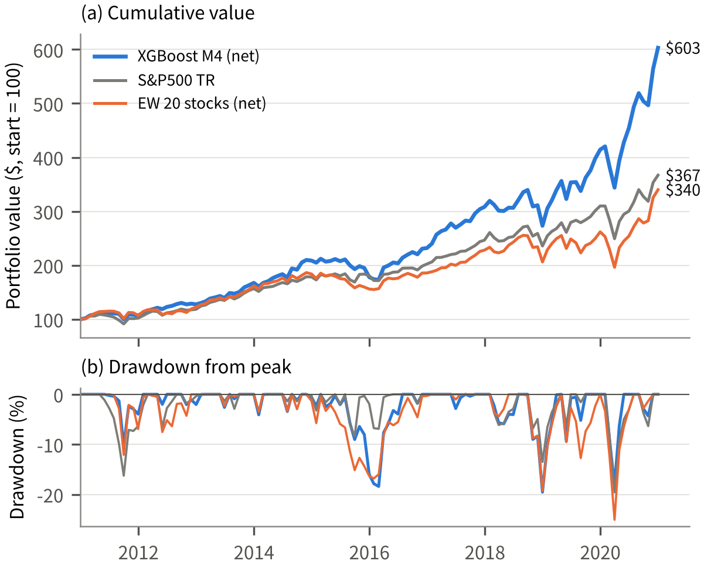
<Figure 3> (a) Cumulative portfolio value (start = $100) and (b) drawdown from peak, January 2011–December 2020
<Table 2> Full-period performance, January 2011–December 2020
Panel A. Main portfolio and benchmarks
Portfolio | Total return (%) | CAGR (%) | Volatility (%) | Sharpe | MDD (%)
XGBoost M4 (net) | 503.1 | 19.68 | 16.11 | 1.15 | −19.55
XGBoost M4 (gross) | 562.6 | 20.82 | 16.14 | 1.21 | −19.37
S&P500 TR | 267.0 | 13.88 | 13.54 | 0.98 | −19.60
EW 20 stocks (net) | 240.1 | 13.02 | 16.48 | 0.78 | −25.07
Panel B. Forecasting models (P = I, net of costs)
Model | CAGR (%) | Volatility (%) | Sharpe | MDD (%) | Turnover (%/month)
XGBoost | 19.68 | 16.11 | 1.15 | −19.55 | 39.2
Elastic Net | 19.46 | 16.47 | 1.12 | −19.36 | 51.3
RandomForest | 18.85 | 16.93 | 1.06 | −20.87 | 27.7
Transformer | 17.40 | 17.80 | 0.95 | −26.40 | 81.5
ANN | 15.07 | 17.21 | 0.86 | −26.08 | 56.7
Note: based on monthly returns from January 2011 to December 2020. CAGR is the annualized geometric return; volatility is the annualized standard deviation (monthly SD × √12); Sharpe ratios use returns in excess of GS1.

4.3 Performance by Regime and Episode
Market regimes are defined on the S&P 500 TR. A decline of 10% or more from a peak is a crisis, the period from that trough until the previous peak is regained is a recovery, January 2015 to June 2016 is designated as sideways, and the remaining months are rising. The 120 months split into 78 rising, 13 recovery, 18 sideways and 11 crisis months. In <Figure 4>(a), the main portfolio's annualized return is 27.0% in rising markets (S&P 500 TR 19.9%), 105.1% in recoveries (75.2%), −42.8% in crises (−44.6%) and −1.6% in the sideways market (3.5%). Excess performance is largest in recoveries (+29.9 points), followed by rising markets (+7.1) and crises (+1.8), and the portfolio lags only in the sideways market (−5.1). Monthly win rates are 62% in recoveries, 56% in rising markets, 55% in crises and 44% in the sideways market.
<Figure 4>(b) shows cumulative returns in seven representative episodes. In the 2011 European debt crisis (May–September 2011) the main portfolio fell 10.2%, less than the S&P 500 TR (−16.3%) and EW (−11.3%), and in the COVID crisis (January–March 2020) it lost 17.0%, less than the S&P 500 TR (−19.6%) and EW (−25.1%). In the fourth quarter of 2018 (October–December), however, it fell 19.6%, well below the S&P 500 TR (−13.5%). Since EW of the same 20 stocks also fell 19.1%, this loss appears to come from the decline of the stock set itself rather than from the BL weights, although we did not decompose contributions by stock. Rebounds were large in recoveries: 30.4% in January–April 2019 (S&P 500 TR 18.2%) and 43.6% in April–July 2020 (27.3%). By year, the portfolio beat the S&P 500 TR in 7 of 10 years, and the weakest years were 2015 (−16.0 points) and 2018 (−7.0 points). In short, the strategy is procyclical, strong in rising and recovering markets and weak in the sideways market, and its downside protection is mixed across episodes.
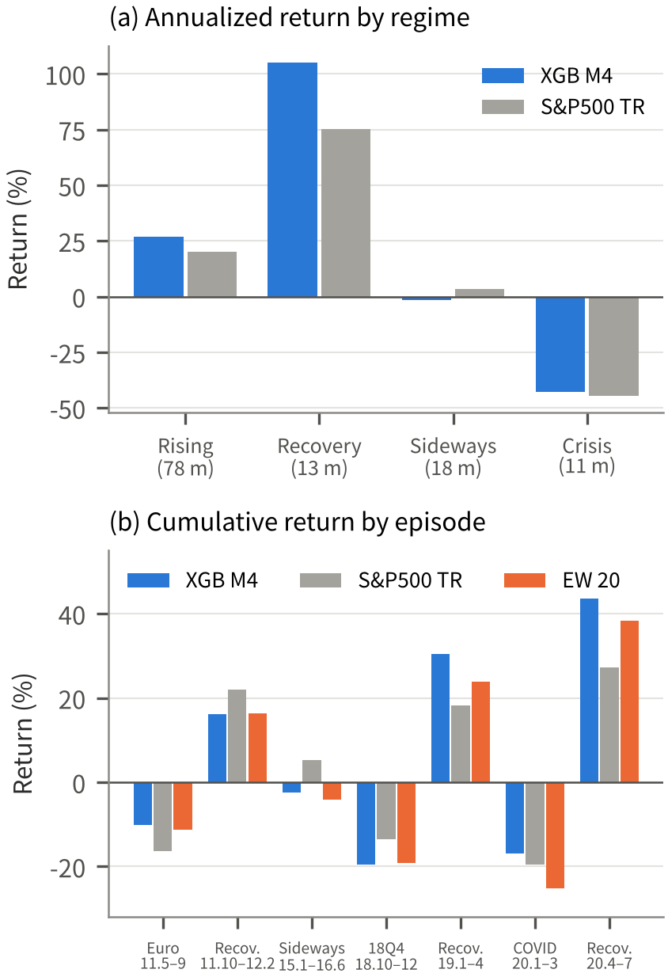
<Figure 4> Performance by market regime and episode: (a) annualized return by regime, (b) cumulative return by episode
4.4 Robustness and Sensitivity
<Figure 5> shows the net CAGR of the main setting and of nine settings that each change one element of it. The risk-aversion coefficient δ and covariance updating changed performance the most. At δ = 2.5 the CAGR rises to 20.40%, but at the computed value of 8.84 it falls to 13.77% and at δ = 10 to 13.27%, below the S&P 500 TR (13.88%) (−5.91 and −6.41 percentage points versus the main setting). As δ increases, the prior Π = δΣw_mkt grows proportionally while the views Q stay the same, so the view-driven tilt in the optimal weights shrinks in proportion to 1/δ and the weights move back toward the market-cap prior. The fall in monthly turnover from 39.2% to 20.6% and 18.8% reflects this. The effect holds regardless of the model: at δ = 8.84 and 10, the M4 portfolios of all five models trail the S&P 500 TR, and the number of the 40 combinations that beat the S&P 500 TR falls from 18 to 11 and 9. δ is therefore a key assumption that can reverse the conclusion. Fixing Σ at the 60 months of 2006–2010 lowers the CAGR to 13.40% (Sharpe 0.79, −6.28 points), below the S&P 500 TR. Keeping the end-2010 weights and restoring them only each December, which stops both view and covariance updating, yields 14.47% (Sharpe 0.91, −5.22 points).
τ, by contrast, has almost no effect. The CAGR is 19.72% at τ = 0.05 and 19.61% at τ = 0.2, within 0.07 points of the main setting, because τ cancels in μ_BL and only slightly affects Σ_BL, as explained in Section 3.4. Replacing the market-cap prior with an equal-weighted prior lowers the CAGR by 1.55 points to 18.13% (Sharpe 1.04) and cuts Apple's average weight from 17.9% to 3.4%. Since the equal-weighted prior still beats the S&P 500 TR by more than 4 points, the contribution of the ML views is not explained by the Apple effect alone. The earlier specification, which used the excess-return Π without adding r_f, yields 20.07%, only 0.39 points away from the main setting that corrects the unit mismatch. A tenth variant, which runs the main engine with the settings of the basic BL implementation (equal-weighted prior, excess-return Π and Σ in the optimizer), earns 18.79%; it serves the implementation check in Section 4.6 and is not shown in <Figure 5>.
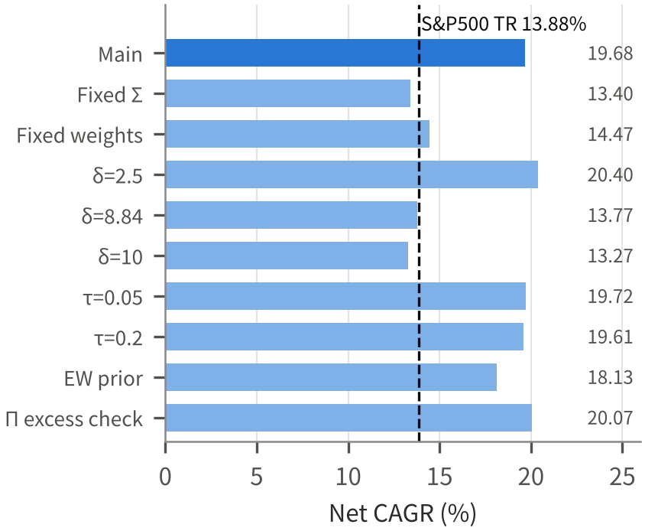
<Figure 5> Robustness and sensitivity: net CAGR under alternative settings (dashed line: S&P500 TR)
4.5 Holdings and Model Comparison
The stock with the largest average weight is Apple (17.9%), held in all 120 months and at the 20% cap in 72.5% of months. This is because Apple accounts for 46–86% of the 20 stocks' market capitalization, which tilts the prior Π heavily toward it. Next come CNI (12.1%, held 93% of months, at the cap 13.3%), UGI (10.8%, 82%, 29.2%), CMI (8.2%, 76%, 15.0%), ANSS (7.4%, 67%, 15.8%) and SRCL (7.3%, 63%, 10.0%). On average 10.2 stocks (7–14) have weights above 1%, so the portfolio concentrates on about ten stocks with strong views rather than spreading evenly across all 20. PCP and GMCR have average weights of only 0.35% and 0.36%.
Comparing XGBoost, Elastic Net and the ANN within M4 (Panel B of <Table 2>), Elastic Net has a CAGR of 19.46%, volatility of 16.47%, Sharpe 1.12 and MDD −19.36%, almost the same as XGBoost, but its 51.3% turnover costs 1.48 points per year. The ANN is weakest, with a CAGR of 15.07%, volatility of 17.21%, Sharpe 0.86, MDD −26.08% and turnover of 56.7% (costs of 1.58 points per year). RandomForest (CAGR 18.85%, Sharpe 1.06) has the lowest turnover (27.7%) but a deeper MDD (−20.87%), and the Transformer (17.40%) has the highest turnover (81.5%). The t-statistics of the monthly return differences are 0.16 for XGBoost−Elastic Net and 1.86 for XGBoost−ANN. XGBoost is thus statistically indistinguishable from Elastic Net but has an operational advantage in achieving the same performance with lower turnover.
4.6 Verification and Statistical Significance
Four checks guard against implementation errors. First, assert statements confirm that the Ω computed in the backtest equals the Ω saved by the view modules for all 40 combinations × 120 decision dates. Second, the separately written basic BL implementation (5_BL_Fin) and the main engine run with the same settings (equal-weighted prior, excess-return Π and Σ in the optimizer) give monthly gross returns that agree for all 40 combinations to within 2.2×10⁻¹⁰, except in four months with a delisting (February, March and September 2016 and October 2018), where the basic implementation sets the missing return to zero instead of redistributing the weight. Third, retraining reproduces the XGBoost forecasts exactly and the Elastic Net forecasts to within 10⁻¹⁴. Fourth, the performance metrics were recomputed separately to confirm that return units (decimals and percent) are not mixed.
Statistical significance is assessed with t-tests on monthly return differences. The difference from the S&P 500 TR has t = 2.26 (the main portfolio is higher in 55% of months) and the difference from EW has t = 2.47 (59%), both significant at 5%. These figures should be read with caution. We tested 5 models × 8 P schemes × 11 settings, and the main combination was chosen from among the best results. Correcting for multiple comparisons confirms this. Of the 40 model–view combinations, only two beat the S&P 500 TR at a nominal 5% level (XGBoost × M4, p = 0.026, and Elastic Net × M4, p = 0.039). For XGBoost × M4 the Bonferroni and Holm[27] adjusted p-values are 1.00 and the Benjamini-Hochberg[12] q-value is 0.77. White's Reality Check[28], which tests whether the best of the 40 truly beats the market using a stationary bootstrap[29] (mean block length 6 months, 5,000 draws), gives p = 0.095. The advantage is therefore suggestive at the 10% level but not significant at 5% once the search is taken into account, and the fact that 2011–2020 was a long bull market further limits generalization.
4.7 Additional Tests: Annual Reselection and 2021–2025
Peer questions asked how much the result depends on the 20 stocks fixed at the end of 2010, so we ran two further tests with the same XGBoost model, view scheme and BL engine (7_QA_Analysis in the code). First, we re-ran the FF3 selection every December from 2011 to 2019 using only the preceding 11 years of data and held each year's new top 20. Because the project data have no shares outstanding for the newly selected stocks, both portfolios in this comparison use an equal-weighted prior. With annual reselection the CAGR is 10.52% (Sharpe 0.65, MDD −24.12%), 7.6 percentage points below the fixed 20 under the same prior (18.13%; t = −1.72 for the monthly difference) and 3.4 points below the S&P 500 TR. The forecasts did not rank the new stocks well (mean IC −0.024 in 2012–2020), and the strategy also trailed an equal-weighted portfolio of the reselected stocks (11.50%).
Second, we ran an untouched out-of-sample test on 2021–2025 with CRSP monthly data for December 2020 to December 2025 downloaded from WRDS. Every choice was fixed as of December 2020. The same FF3 rule applied to 2010–2020 (2,153 stocks) selected a new top 20, none of which was in our original 20; XGBoost was trained on 2010–2020 data and refitted each December; and the portfolio used the main setting (M4, δ = 3, 20% cap, 0.2% cost, market-cap prior). The strategy earned a CAGR of 5.51% (Sharpe 0.21) against 14.43% (0.76) for the S&P 500 TR, a gap of −8.92 percentage points (t = −1.39). The equal-weighted portfolio of the new 20 stocks earned 6.28% and the market-cap prior without views 6.60%, so almost all of the shortfall came from the selected stocks rather than from the BL step or the forecasts. Many of the new picks were utilities and regional banks, which did poorly when interest rates rose. Together with the multiple-testing result in Section 4.6, these tests indicate that the 2011–2020 margin depended on the stocks chosen in 2010 and should not be read as an expected excess return.

5. Conclusion
5.1 Summary of Findings
This study combined an FF3 alpha screen, XGBoost return forecasts and the Black-Litterman model in one pipeline and tested it out of sample over the ten years from 2011 to 2020. Using only 2000–2010 data, we selected the top 20 of 2,426 stocks by t(α). About 2.4 times as many stocks passed t(α) ≥ 2 as chance would predict, but none remained significant after multiple-testing correction, so we treat the stage as a screen. The answers to the three research questions are as follows.
First (i), the BL portfolio with ML views beat both benchmarks after transaction costs. The main portfolio (XGBoost × P = I) earned a CAGR of 19.68%, a Sharpe ratio of 1.15 and an MDD of −19.55%, ahead of the S&P 500 TR (13.88%, 0.98) and the equal-weighted portfolio of the same 20 stocks (13.02%, 0.78). Because equal weighting of the same stocks did not beat the market, the margin within these 20 stocks came from the BL weighting. The t-statistics of the monthly excess returns (2.26 and 2.47), however, come from testing many combinations; after correction the advantage over the S&P 500 TR is not significant at 5% (Reality Check p = 0.095). The advantage also did not hold when the stocks were reselected every year (10.52%) or out of sample in 2021–2025 (5.51% against 14.43% for the S&P 500 TR).
Second (ii), the form of the views, not the forecasting model, mattered more. The P scheme explains 85.3% of the variation in CAGR across the 40 combinations and the model 4.5%, and absolute views (P = I) beat factor-relative views for all five models. Differences between models were meaningful only under P = I, at 4.6 percentage points.
Third (iii), the advantage was highly sensitive to some design choices. Fixing Σ or the weights at the end of 2010 lowered the CAGR to 13.40% and 14.47%, close to the S&P 500 TR, and raising δ to 8.84 or 10 lowered it to 13.77% and 13.27%, below the S&P 500 TR. In contrast, switching to an equal-weighted prior kept the advantage (CAGR 18.13%), and τ had almost no effect. Monthly updating and a low δ were therefore necessary conditions for the advantage. By regime, the strategy was strong in rising and recovering markets and weak in the sideways market.
5.2 Limitations and Future Work
First, the 20 investment stocks were fixed once at the end of 2010 and never reselected over ten years, and the same 2000–2010 survivors were used for both selection and model training. Delisting returns (DLRET) are not reflected either, and the weight of a stock that delists during a holding month is redistributed within that month, which uses information not available at the start of the month. This is the main limitation: as Section 4.7 shows, reselecting the stocks every year lowered the CAGR to 10.52%, and the stocks selected for 2021–2025 trailed the market by a wide margin. Improving the selection rule, including stocks listed or delisted mid-period, therefore matters more than refining the BL step. Second, there are only eight price- and volume-based features, and retvol and idiovol are computed from monthly rather than daily data as in the original paper. Adding accounting characteristics and daily volatility could improve predictive power. Third, performance depends heavily on the Apple weight and on δ. Methods that reduce the concentration of the market-cap prior, such as a weight cap relative to market cap, and a systematic estimate of δ are needed. The cap of 1% of each stock's market capitalization suggested by the instructor was not imposed because no fund size was assumed; with the main weights it would never have bound for a fund starting below about $30 million (tightest case: BCPC at 20% in August 2020).
Fourth, the diagonal Ω ignores correlations between views, and XGBoost and Elastic Net produced views with no cross-sectional differences for 38 and 48 months, respectively. A full Ω based on the covariance of forecast errors, and confidence levels that reflect forecast uncertainty, are left for future work. Fifth, monthly turnover of 39% could be a burden in practice, and only linear transaction costs were considered. Adding a turnover penalty to the objective could improve the balance between cost and performance. Finally, 2011–2020 was mostly a bull market and the regime samples are short (11 crisis and 13 recovery months). The single out-of-sample test on 2021–2025 did not confirm the advantage, so further validation over other periods and markets is needed.

References
[1] Markowitz, H. (1952). Portfolio selection. The Journal of Finance, 7(1), 77–91.
[2] Black, F., & Litterman, R. (1992). Global portfolio optimization. Financial Analysts Journal, 48(5), 28–43.
[3] Gu, S., Kelly, B., & Xiu, D. (2020). Empirical asset pricing via machine learning. The Review of Financial Studies, 33(5), 2223–2273.
[4] Fama, E. F., & French, K. R. (1993). Common risk factors in the returns on stocks and bonds. Journal of Financial Economics, 33(1), 3–56.
[5] He, G., & Litterman, R. (1999). The intuition behind Black-Litterman model portfolios. Goldman Sachs Investment Management Research.
[6] Idzorek, T. M. (2005). A step-by-step guide to the Black-Litterman model: Incorporating user-specified confidence levels. Working paper, Zephyr Associates.
[7] Walters, J. (2014). The Black-Litterman model in detail. SSRN Working Paper No. 1314585.
[8] Jensen, M. C. (1968). The performance of mutual funds in the period 1945–1964. The Journal of Finance, 23(2), 389–416.
[9] Treynor, J. L., & Black, F. (1973). How to use security analysis to improve portfolio selection. The Journal of Business, 46(1), 66–86.
[10] Chen, T., & Guestrin, C. (2016). XGBoost: A scalable tree boosting system. Proceedings of the 22nd ACM SIGKDD International Conference on Knowledge Discovery and Data Mining, 785–794.
[11] Harvey, C. R., Liu, Y., & Zhu, H. (2016). … and the cross-section of expected returns. The Review of Financial Studies, 29(1), 5–68.
[12] Benjamini, Y., & Hochberg, Y. (1995). Controlling the false discovery rate: A practical and powerful approach to multiple testing. Journal of the Royal Statistical Society: Series B, 57(1), 289–300.
[13] Treynor, J., & Mazuy, K. (1966). Can mutual funds outguess the market? Harvard Business Review, 44(4), 131–136.
[14] Henriksson, R. D., & Merton, R. C. (1981). On market timing and investment performance. II. Statistical procedures for evaluating forecasting skills. The Journal of Business, 54(4), 513–533.
[15] Fama, E. F., & French, K. R. (2010). Luck versus skill in the cross-section of mutual fund returns. The Journal of Finance, 65(5), 1915–1947.
[16] Brown, S. J., Goetzmann, W., Ibbotson, R. G., & Ross, S. A. (1992). Survivorship bias in performance studies. The Review of Financial Studies, 5(4), 553–580.
[17] Shumway, T. (1997). The delisting bias in CRSP data. The Journal of Finance, 52(1), 327–340.
[18] Shumway, T., & Warther, V. A. (1999). The delisting bias in CRSP's Nasdaq data and its implications for the size effect. The Journal of Finance, 54(6), 2361–2379.
[19] Jegadeesh, N. (1990). Evidence of predictable behavior of security returns. The Journal of Finance, 45(3), 881–898.
[20] Jegadeesh, N., & Titman, S. (1993). Returns to buying winners and selling losers: Implications for stock market efficiency. The Journal of Finance, 48(1), 65–91.
[21] Ang, A., Hodrick, R. J., Xing, Y., & Zhang, X. (2006). The cross-section of volatility and expected returns. The Journal of Finance, 61(1), 259–299.
[22] Zou, H., & Hastie, T. (2005). Regularization and variable selection via the elastic net. Journal of the Royal Statistical Society: Series B, 67(2), 301–320.
[23] Breiman, L. (2001). Random forests. Machine Learning, 45(1), 5–32.
[24] Vaswani, A., Shazeer, N., Parmar, N., Uszkoreit, J., Jones, L., Gomez, A. N., Kaiser, Ł., & Polosukhin, I. (2017). Attention is all you need. Advances in Neural Information Processing Systems, 30, 5998–6008.
[25] Kraft, D. (1988). A software package for sequential quadratic programming. Technical Report DFVLR-FB 88-28, DLR German Aerospace Center.
[26] DeMiguel, V., Garlappi, L., & Uppal, R. (2009). Optimal versus naive diversification: How inefficient is the 1/N portfolio strategy? The Review of Financial Studies, 22(5), 1915–1953.
[27] Holm, S. (1979). A simple sequentially rejective multiple test procedure. Scandinavian Journal of Statistics, 6(2), 65–70.
[28] White, H. (2000). A reality check for data snooping. Econometrica, 68(5), 1097–1126.
[29] Politis, D. N., & Romano, J. P. (1994). The stationary bootstrap. Journal of the American Statistical Association, 89(428), 1303–1313.

