**Proyecto final**

COA-501 Herramientas de cómputo para investigadores (R y Python)

[1]

19 de noviembre de 2022



### **0) Estudio de caso**

Se cuenta con la base de datos de un experimento realizado en Puebla, dónde se evaluaron los efectos de fertilizantes y plaguicidas contra una enfermedad foliar conocida como tizón suizo en árboles de navidad de la especie Douglas-fir. Se tomaron variables como transparencia de copa, severidad, incidencia, longitud de brotes, área de áciculas, etc. El objetivo del análisis es determinar la mejor técnica de machine learning o aprendizaje automático (Naive Bayes, K-NN y Random Forest) para clasificar la transparencia de copa en Douglas-fir.

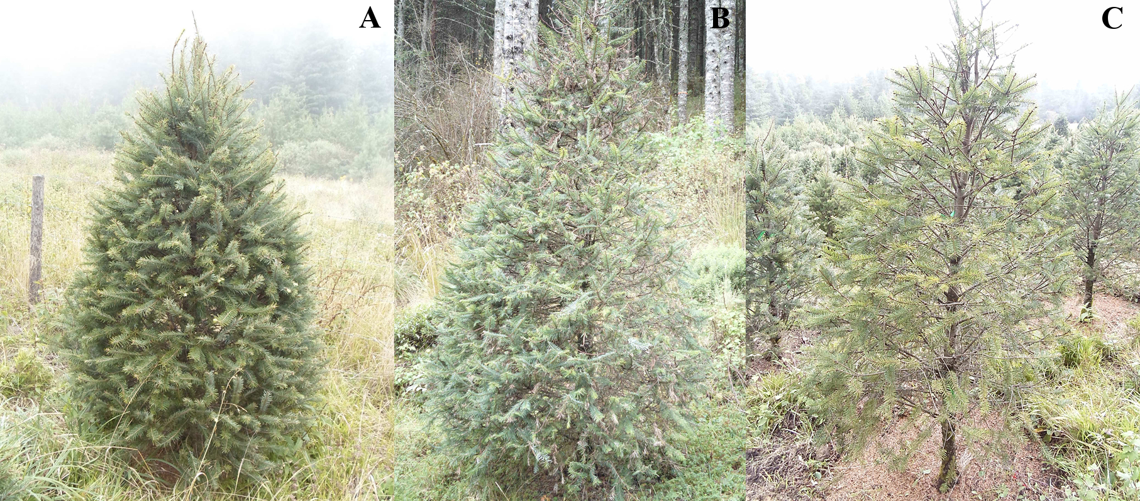

**Variables:**

* Arbol= unidad experimental (UE)
* Bloque= Transparencia de copa asignada como baja,media y alta
* Longitud= distancia en grados, minutos y segundos que hay con respecto al meridiano principal, que es el meridiano de Greenwich (0º) de la UE
* Latitud= distancia en grados, minutos y segundos que hay con respecto al paralelo principal, que es el ecuador (0º)
* X_UTM= coordenada X en el sistema de coordenadas universal transversal de Mercator
* Y_UTM= coordenada Y en el sistema de coordenadas universal transversal de Mercator
* Altitud= distancia vertical de la UE respecto al nivel del mar
* AltRan= Rango de Altitud de las UE en dos categorías: Alta y Baja
* Fungicida= Tratamiento fungicida (Procloraz, Propiconazol o sin fungicida)
* Nutrimento= Tratamiento fertilizante (Urea, Sulfato de potasio o sin fertilizante)
* Rep= repetición de la UE por tratamiento en un diseño experimental factorial en bloques generalizados
* Muestreo= número de muestreo de follaje (se realizaron 6)
* DDA= días despúes de la aplicación o del establecimiento del experimento
* Anio= edad del follaje o muestra
* AcicR= número de acículas retenidas de rama o muestra
* Abs= Número de cicatrices de acículas de la rama o muestra
* TotalAc= Total de acículas (AcicR + Abs)
* Inc= Incidencia del tizón suizo
* Sevmed= Severidad media del tizón suizo
* Sevmed= Severidad mínima del tizón suizo
* Sevmax= Severidad máxima del tizón suizo
* LonBrot= Longitud de la rama o muestea en centímetros
* indcol= Índice de colonización (Inc * Sevmed)
* Afmed= Área media de acícula (Área de acículas en centímetros cuadrados por muestra)
* Afmax= Área máxima de acícula por muestra
* Afmin= Área mínima de acícula por muestra
* Aftotal= Suma de área de acículas por muestra
* CA= Abs expresada en porcentaje (Abs*100/TotalAC)
* RA= RA expresada en porcentaje (RA*100/TotalAC)
* Color= Categorías de color por cada muestra (Verde claro, verde oscuro y rojizo)
* trat= Interacción de tratamientos (Fungicida*Nutrimento)
* ABCPEIC= Área bajo la curva progreso de la enfermedad con el índice de colonización

### **1) Base de datos y AED**

#base de datos  
summary(base)

## Arbol Bloque Longitud Latitud X_UTM   
## 1 : 12 Alta :216 Min. :-97.99 Min. :19.72 Min. :605708   
## 2 : 12 Baja :216 1st Qu.:-97.99 1st Qu.:19.72 1st Qu.:605724   
## 3 : 12 Media:216 Median :-97.99 Median :19.72 Median :605732   
## 4 : 12 Mean :-97.99 Mean :19.72 Mean :605732   
## 5 : 12 3rd Qu.:-97.99 3rd Qu.:19.72 3rd Qu.:605741   
## 6 : 12 Max. :-97.99 Max. :19.72 Max. :605759   
## (Other):576   
## Y_UTM Altitud AltRan Fungicida Nutrimento Rep   
## Min. :2180985 Min. :2973 Alta:312 1:216 1:216 Min. :1.0   
## 1st Qu.:2181009 1st Qu.:2979 Baja:336 2:216 2:216 1st Qu.:1.0   
## Median :2181025 Median :2982 3:216 3:216 Median :1.5   
## Mean :2181027 Mean :2985 Mean :1.5   
## 3rd Qu.:2181039 3rd Qu.:2991 3rd Qu.:2.0   
## Max. :2181087 Max. :2994 Max. :2.0   
##   
## Muestreo DDA Anio AcicR Abs   
## 1:108 0 :108 2016:324 Min. : 30.00 Min. : 0.00   
## 2:108 63 :108 2017:324 1st Qu.: 83.75 1st Qu.: 0.00   
## 3:108 91 :108 Median :101.00 Median : 2.00   
## 4:108 119:108 Mean :103.14 Mean : 6.91   
## 5:108 147:108 3rd Qu.:121.00 3rd Qu.: 8.00   
## 6:108 175:108 Max. :225.00 Max. :104.00   
## NA's :24 NA's :24   
## TotalAc Inc Sevmed Sevmin   
## Min. : 36.0 Min. :0.0000 Min. :0.00000 Min. :0.00000   
## 1st Qu.: 91.0 1st Qu.:0.0000 1st Qu.:0.00000 1st Qu.:0.00000   
## Median :108.0 Median :0.2667 Median :0.01483 Median :0.00000   
## Mean :110.1 Mean :0.4584 Mean :0.12498 Mean :0.06102   
## 3rd Qu.:128.0 3rd Qu.:0.9667 3rd Qu.:0.24258 3rd Qu.:0.10333   
## Max. :225.0 Max. :1.0000 Max. :0.61900 Max. :0.50667   
## NA's :24 NA's :24 NA's :24 NA's :24   
## Sevmax LonBrot indcol Afmed   
## Min. :0.00000 Min. : 3.300 Min. : 0.00 Min. :0.1322   
## 1st Qu.:0.00000 1st Qu.: 7.000 1st Qu.: 0.00 1st Qu.:0.2610   
## Median :0.07333 Median : 8.450 Median : 0.46 Median :0.3096   
## Mean :0.20214 Mean : 8.629 Mean :11.72 Mean :0.3117   
## 3rd Qu.:0.40083 3rd Qu.: 9.963 3rd Qu.:22.85 3rd Qu.:0.3577   
## Max. :0.90667 Max. :23.400 Max. :61.90 Max. :0.6133   
## NA's :24 NA's :24 NA's :24 NA's :24   
## Afmax Afmin Aftotal CA   
## Min. :0.152 Min. :0.0910 Min. : 3.966 Min. : 0.000   
## 1st Qu.:0.300 1st Qu.:0.2087 1st Qu.: 7.831 1st Qu.: 0.000   
## Median :0.352 Median :0.2470 Median : 9.287 Median : 1.646   
## Mean :0.358 Mean :0.2486 Mean : 9.350 Mean : 6.178   
## 3rd Qu.:0.411 3rd Qu.:0.2870 3rd Qu.:10.730 3rd Qu.: 7.692   
## Max. :0.849 Max. :0.4440 Max. :18.398 Max. :64.662   
## NA's :24 NA's :24 NA's :24 NA's :24   
## RA Color trat ABCPEIC   
## Min. : 35.34 Min. :1.000 11 : 72 Min. : 0.0000   
## 1st Qu.: 92.31 1st Qu.:1.000 12 : 72 1st Qu.: 0.0000   
## Median : 98.35 Median :2.000 13 : 72 Median : 0.1925   
## Mean : 93.82 Mean :1.694 21 : 72 Mean : 326.8269   
## 3rd Qu.:100.00 3rd Qu.:2.000 22 : 72 3rd Qu.: 683.7950   
## Max. :100.00 Max. :3.000 23 : 72 Max. :2850.9250   
## NA's :24 NA's :24 (Other):216

class(base)

## [1] "data.frame"

str(base)

## 'data.frame': 648 obs. of 32 variables:  
## $ Arbol : Factor w/ 54 levels "1","2","3","4",..: 1 2 3 4 5 6 7 8 9 10 ...  
## $ Bloque : Factor w/ 3 levels "Alta","Baja",..: 1 1 1 1 1 1 1 1 1 1 ...  
## $ Longitud : num -98 -98 -98 -98 -98 ...  
## $ Latitud : num 19.7 19.7 19.7 19.7 19.7 ...  
## $ X_UTM : num 605748 605744 605740 605754 605742 ...  
## $ Y_UTM : num 2181070 2181057 2181039 2181034 2181026 ...  
## $ Altitud : num 2979 2979 2980 2980 2984 ...  
## $ AltRan : Factor w/ 2 levels "Alta","Baja": 2 2 2 2 2 1 1 1 1 1 ...  
## $ Fungicida : Factor w/ 3 levels "1","2","3": 1 1 2 1 2 1 1 2 2 3 ...  
## $ Nutrimento: Factor w/ 3 levels "1","2","3": 1 2 2 2 1 3 3 3 2 1 ...  
## $ Rep : int 1 1 1 2 1 1 2 1 2 1 ...  
## $ Muestreo : Factor w/ 6 levels "1","2","3","4",..: 1 1 1 1 1 1 1 1 1 1 ...  
## $ DDA : Factor w/ 6 levels "0","63","91",..: 1 1 1 1 1 1 1 1 1 1 ...  
## $ Anio : Factor w/ 2 levels "2016","2017": 1 1 1 1 1 1 1 1 1 1 ...  
## $ AcicR : int 74 129 69 33 98 71 68 44 92 92 ...  
## $ Abs : int 25 2 2 6 20 15 3 5 4 15 ...  
## $ TotalAc : int 99 131 71 39 118 86 71 49 96 107 ...  
## $ Inc : num 0.9 1 0.767 1 1 ...  
## $ Sevmed : num 0.15 0.331 0.347 0.351 0.384 ...  
## $ Sevmin : num 0 0.137 0 0.21 0.197 ...  
## $ Sevmax : num 0.4 0.667 0.583 0.573 0.56 ...  
## $ LonBrot : num 7.25 12.9 5.1 3.9 9.25 5 6.8 4.5 7.7 9.55 ...  
## $ indcol : num 13.5 33.1 26.6 35.1 38.4 ...  
## $ Afmed : num 0.239 0.374 0.196 0.37 0.362 ...  
## $ Afmax : num 0.275 0.436 0.217 0.411 0.482 ...  
## $ Afmin : num 0.194 0.308 0.163 0.286 0.29 ...  
## $ Aftotal : num 7.18 11.23 5.88 11.1 10.87 ...  
## $ CA : num 25.25 1.53 2.82 15.38 16.95 ...  
## $ RA : num 74.7 98.5 97.2 84.6 83.1 ...  
## $ Color : int 1 1 1 1 1 1 1 1 1 1 ...  
## $ trat : Factor w/ 9 levels "11","12","13",..: 1 2 5 2 4 3 3 6 5 7 ...  
## $ ABCPEIC : num 0 0 0 0 0 0 0 0 0 0 ...

#matriz de diagramas de dispersion  
pairs(base[,c(5,6,7,9,10,12,18,19,22,24,28:30,32)])  
  
library(GGally)

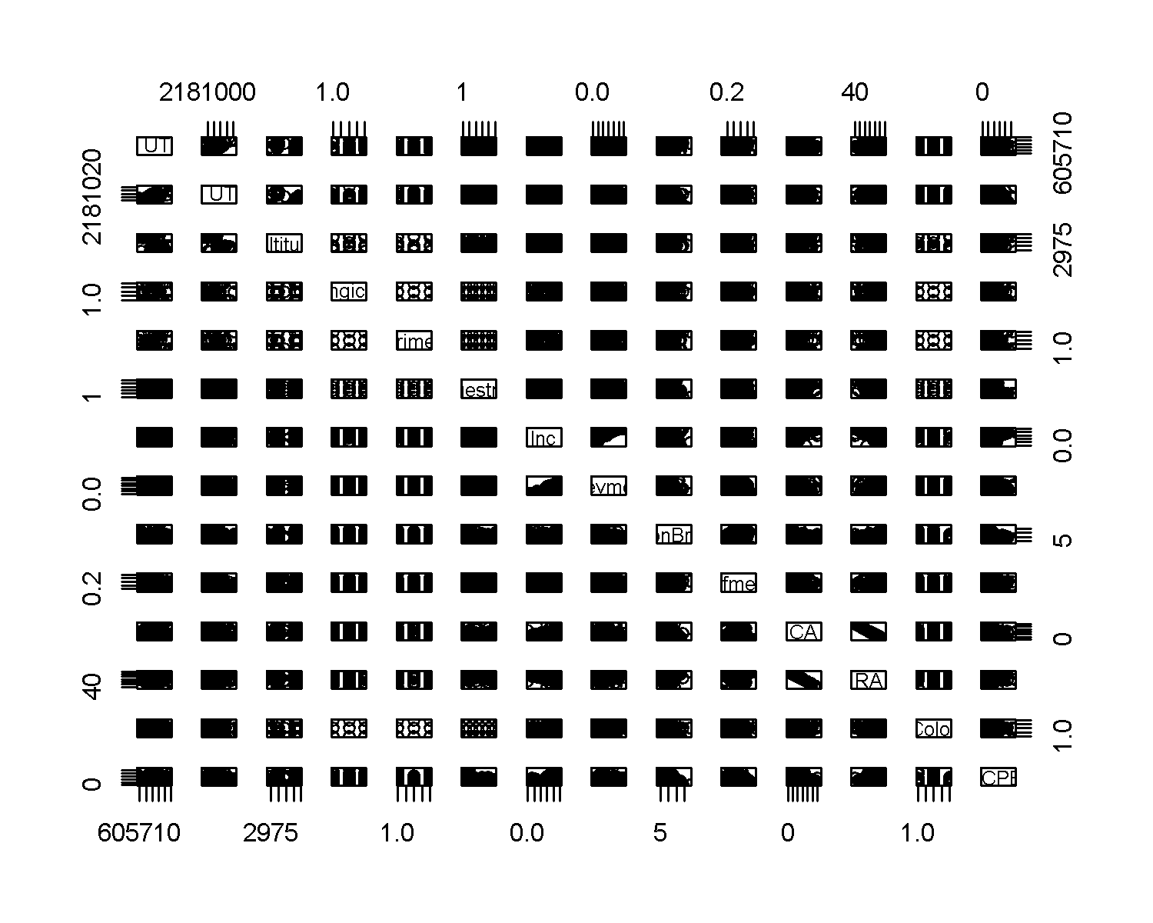

ggpairs(base[,c(5,6,7,18,19,22,24,28:30)],   
 title="correlograma con ggpairs")

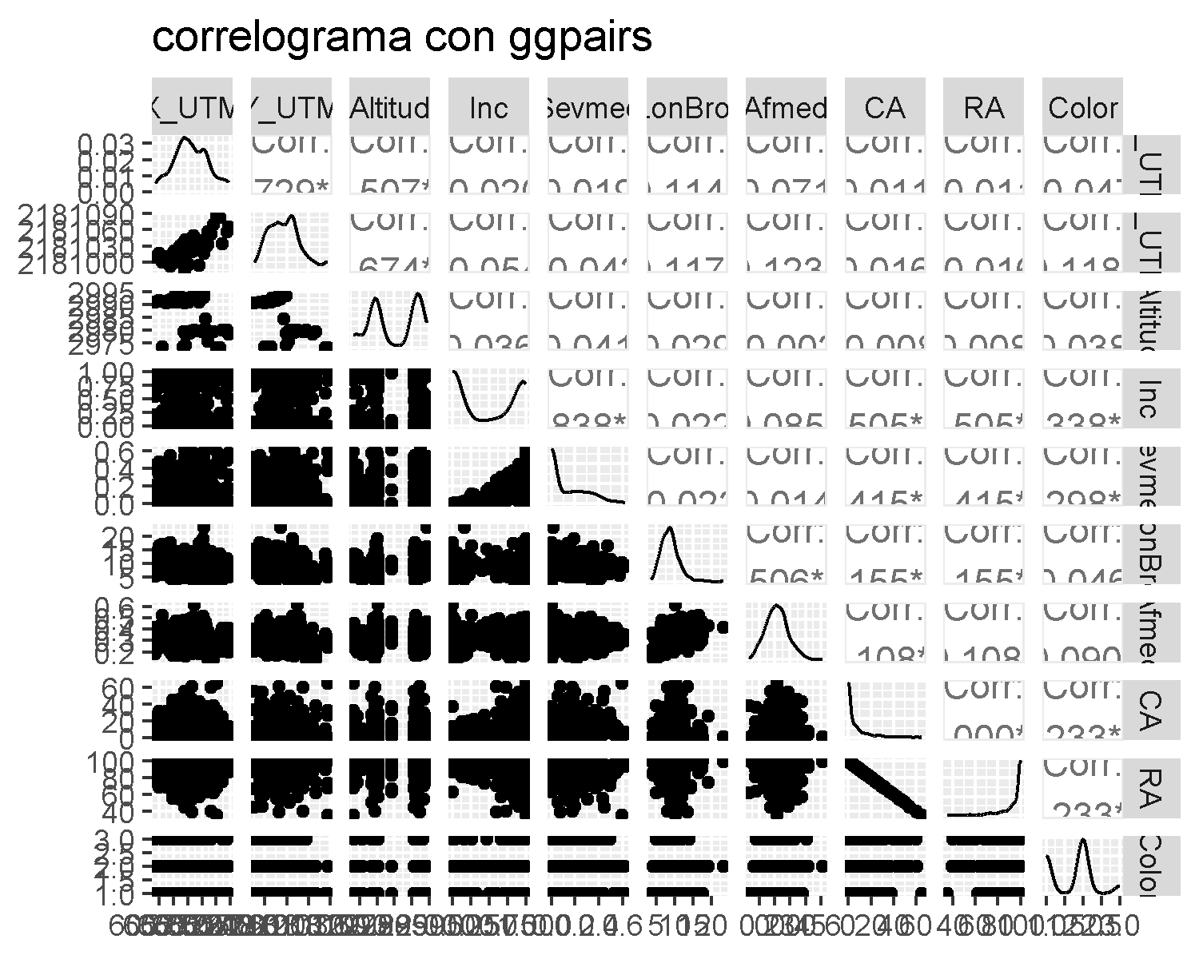

psych::pairs.panels(base[,c(5,6,7,18,19,22,24,28:30)])

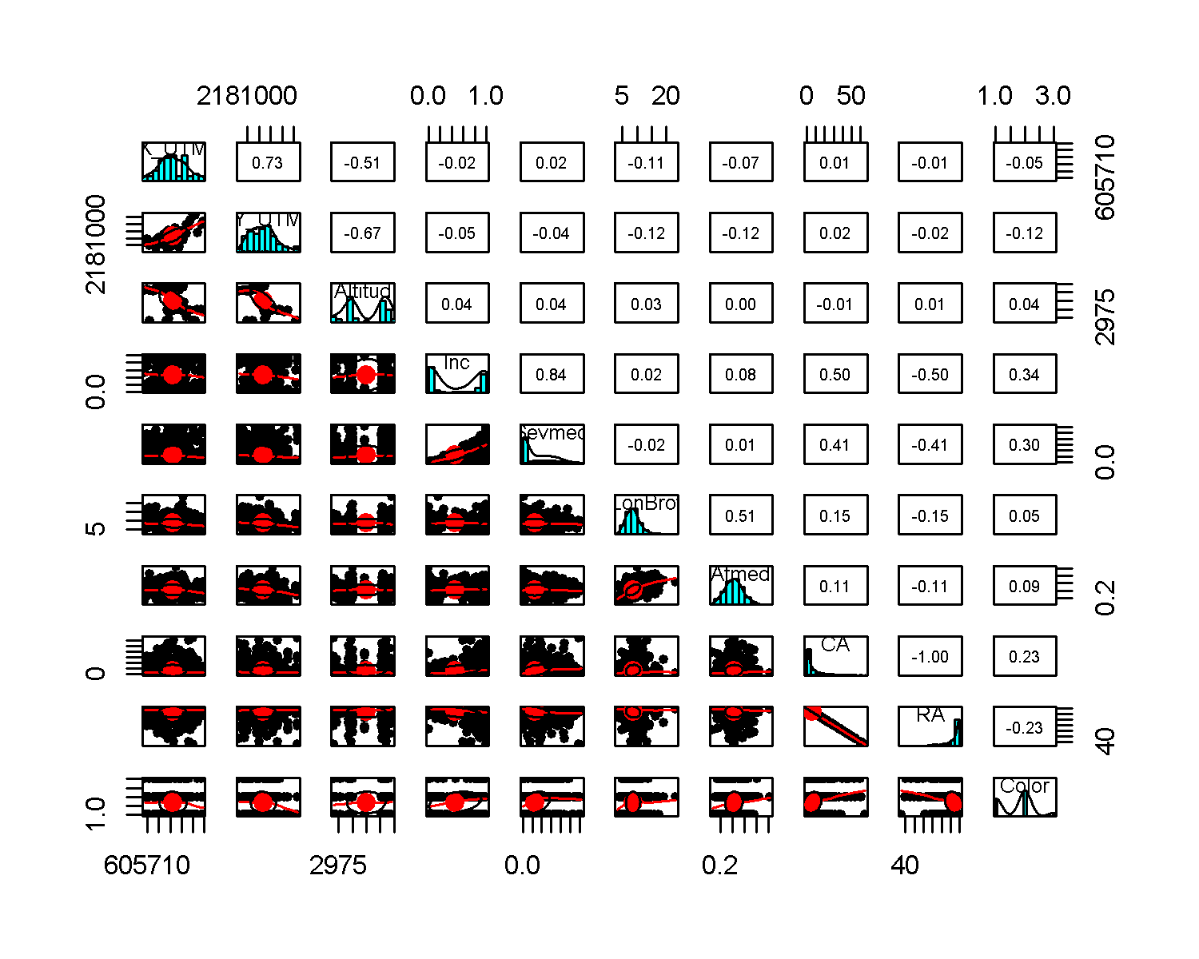

base.pc<- na.omit(base[,c(14,2,5,6,7,18,19,22,24,28:30)])  
  
#Análisis de componentes principales   
pca <- prcomp(base.pc[,-c(1,2)], scale = T, center=T)  
summary(pca)

## Importance of components:  
## PC1 PC2 PC3 PC4 PC5 PC6 PC7  
## Standard deviation 1.7451 1.5196 1.2216 1.0107 0.88496 0.70241 0.69614  
## Proportion of Variance 0.3045 0.2309 0.1492 0.1021 0.07832 0.04934 0.04846  
## Cumulative Proportion 0.3045 0.5354 0.6847 0.7868 0.86512 0.91446 0.96292  
## PC8 PC9 PC10  
## Standard deviation 0.46896 0.38840 1.265e-10  
## Proportion of Variance 0.02199 0.01509 0.000e+00  
## Cumulative Proportion 0.98491 1.00000 1.000e+00

#biplot  
library(ggplot2)  
Edad <- as.factor(base.pc$Anio)  
plot4 <- ggplot(base.pc, aes(x = pca$x[,1], y = pca$x[,2], colour = Edad)) +  
 geom_point(size=3) + xlab("PC1") + ylab("PC2")+  
 ggtitle("PCA por Edad del follaje")  
plot4

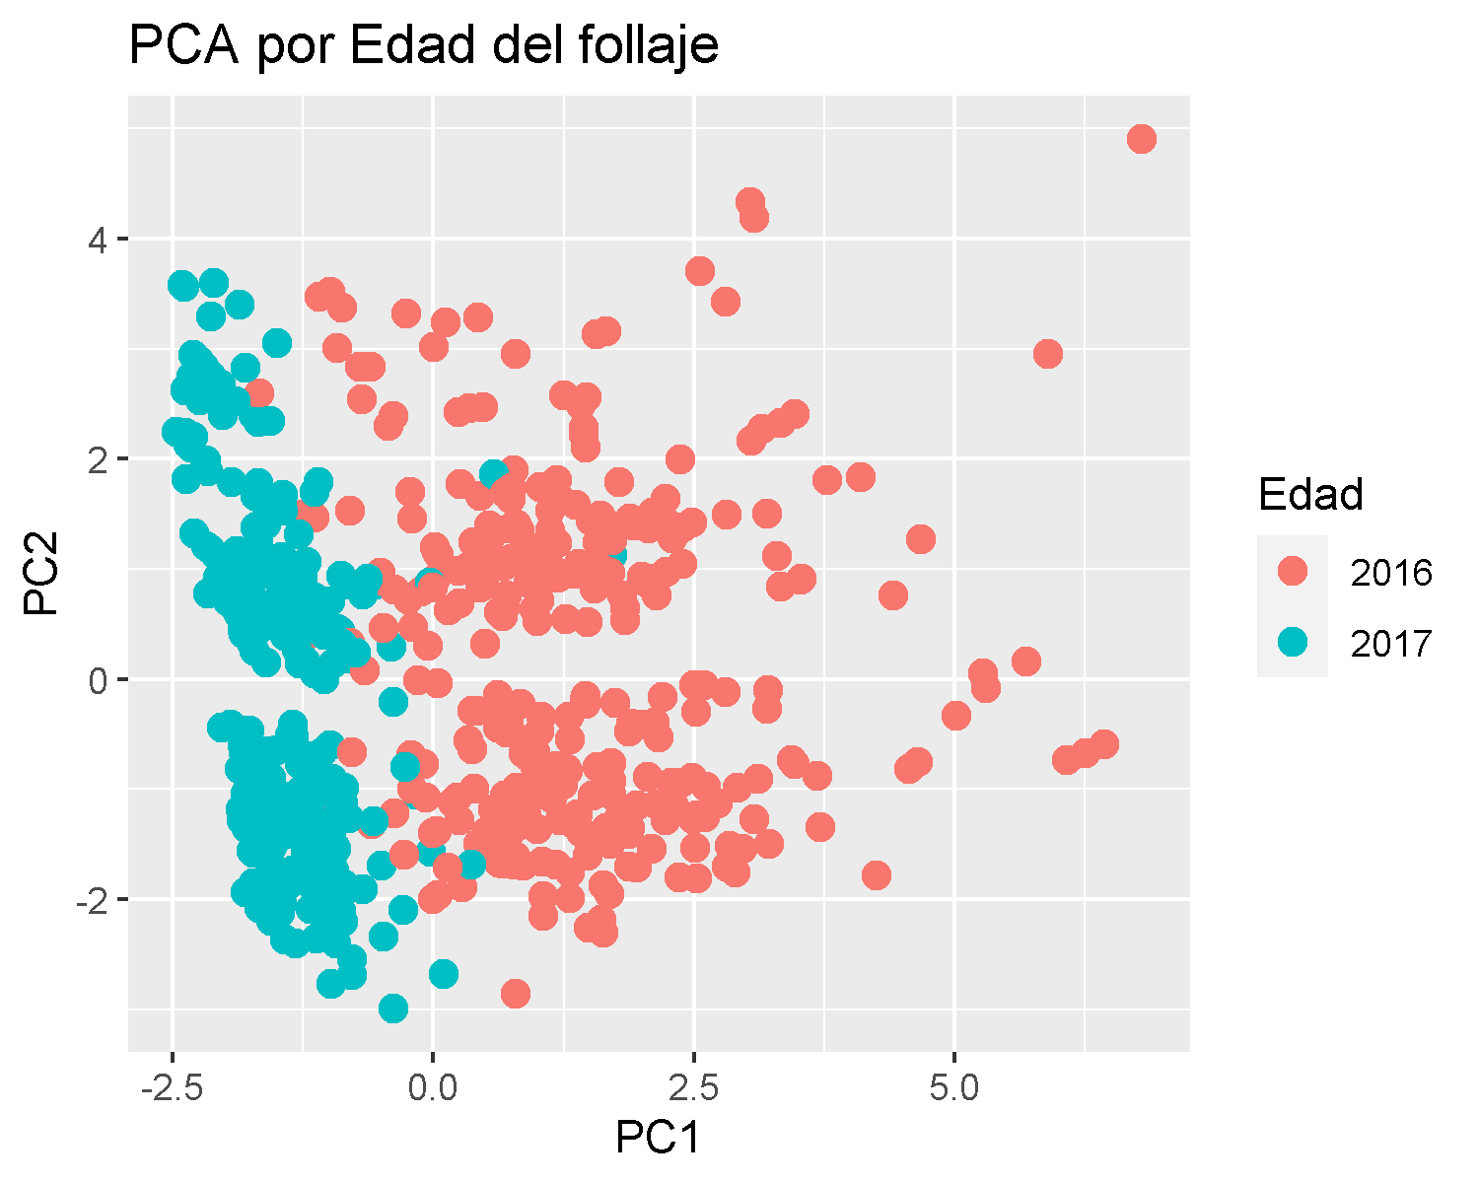

biplot(pca, main="PCA biplot")

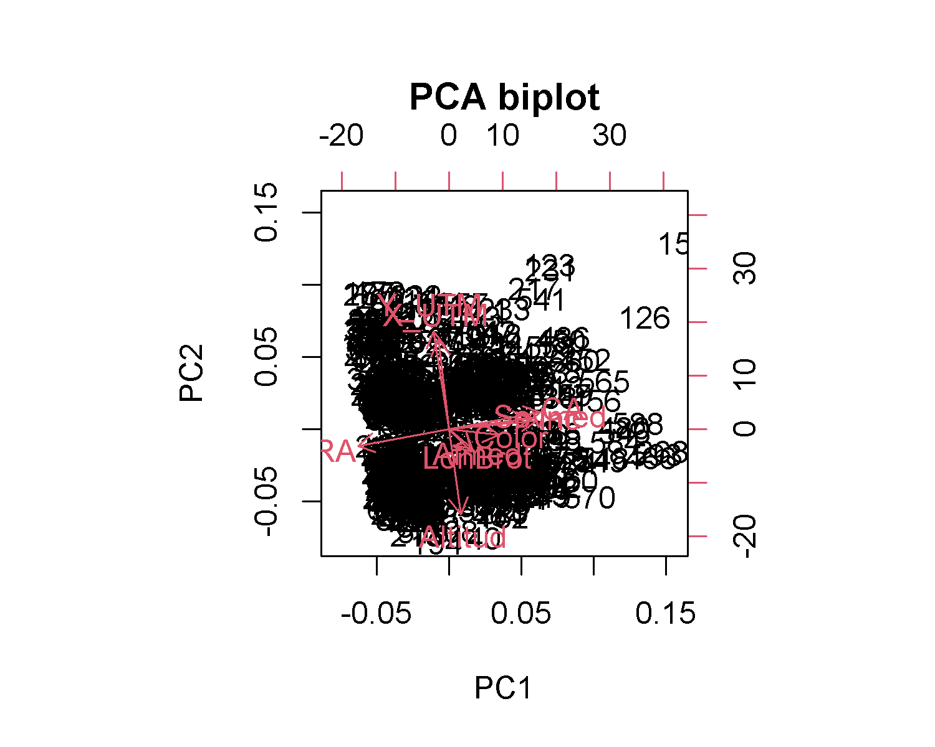

par(mfrow = c(1,2))  
plot(pca, main="Sedimentación")  
  
colores <- function(vec){  
 # la funci?n rainbow() devuelve un vector que contiene el n?mero de colores distintos  
 col <- rainbow(length(unique(vec)))  
 return(col[as.numeric(as.factor(vec))])  
}  
  
plot(pca$x[,c(1, 2)], col = colores(base.pc$Bloque),  
 pch = 19,   
 xlab = "PC1",   
 ylab = "PC2", main="PCA por Transparencia")

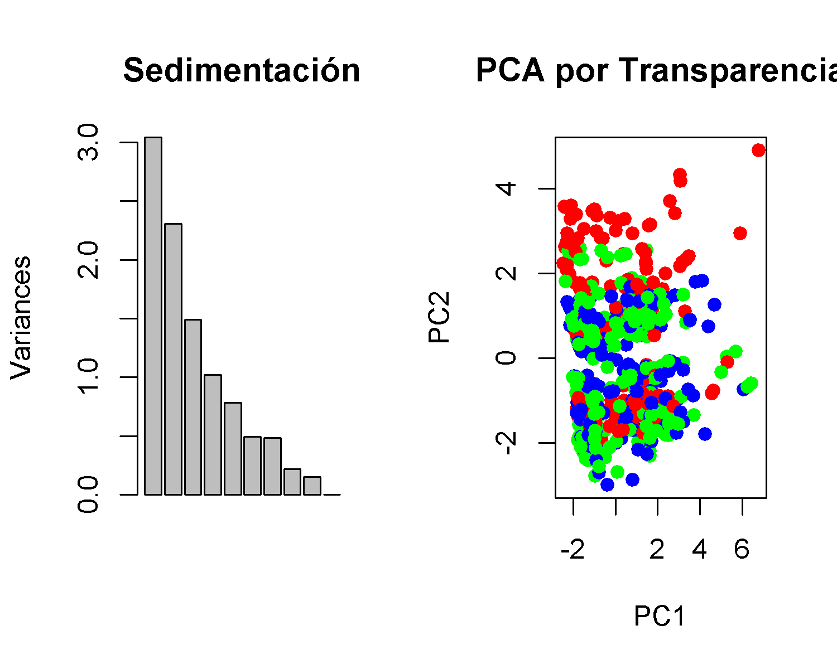

dev.off()

## null device   
## 1

**Interpretación:** De acuerdo con el AED y ACP se seleccionaron las variables transparencia de copa, coordenadas UTM (X y Y), altitud, incidencia, severidad, longitud de brote, área de acícula, acículas caidas, acículas retenidas y color de acícula, para implementar las técnicas de ML.

### **2) Random Forest**

library(randomForest)  
library(caret)  
  
#Getting Data  
base_rf <- na.omit(base[,c(2,5,6,7,18,19,22,24,28:30)])  
  
base_rf$Bloque <- as.factor(base_rf$Bloque)  
table(base_rf$Bloque)

##   
## Alta Baja Media   
## 200 216 208

#Data Partition  
set.seed(123)  
ind <- sample(2, nrow(base_rf), replace = TRUE, prob = c(0.7, 0.3))  
train <- base_rf[ind==1,]  
test <- base_rf[ind==2,]  
  
#Random Forest in R  
rf <- randomForest(Bloque~., data=train, proximity=TRUE)   
rf

##   
## Call:  
## randomForest(formula = Bloque ~ ., data = train, proximity = TRUE)   
## Type of random forest: classification  
## Number of trees: 500  
## No. of variables tried at each split: 3  
##   
## OOB estimate of error rate: 2.28%  
## Confusion matrix:  
## Alta Baja Media class.error  
## Alta 132 4 1 0.03649635  
## Baja 0 160 0 0.00000000  
## Media 4 1 136 0.03546099

#Confusion Matrix and Statistics  
p1 <- predict(rf, train)  
confusionMatrix(p1, train$Bloque)

## Confusion Matrix and Statistics  
##   
## Reference  
## Prediction Alta Baja Media  
## Alta 137 0 0  
## Baja 0 160 0  
## Media 0 0 141  
##   
## Overall Statistics  
##   
## Accuracy : 1   
## 95% CI : (0.9916, 1)  
## No Information Rate : 0.3653   
## P-Value [Acc > NIR] : < 2.2e-16   
##   
## Kappa : 1   
##   
## Mcnemar's Test P-Value : NA   
##   
## Statistics by Class:  
##   
## Class: Alta Class: Baja Class: Media  
## Sensitivity 1.0000 1.0000 1.0000  
## Specificity 1.0000 1.0000 1.0000  
## Pos Pred Value 1.0000 1.0000 1.0000  
## Neg Pred Value 1.0000 1.0000 1.0000  
## Prevalence 0.3128 0.3653 0.3219  
## Detection Rate 0.3128 0.3653 0.3219  
## Detection Prevalence 0.3128 0.3653 0.3219  
## Balanced Accuracy 1.0000 1.0000 1.0000

(tab1 <- table(p1, train$Bloque))

##   
## p1 Alta Baja Media  
## Alta 137 0 0  
## Baja 0 160 0  
## Media 0 0 141

1 - sum(diag(tab1)) / sum(tab1)

## [1] 0

#error del 0%  
  
  
p2 <- predict(rf, test)  
confusionMatrix(p2, test$Bloque)

## Confusion Matrix and Statistics  
##   
## Reference  
## Prediction Alta Baja Media  
## Alta 60 0 0  
## Baja 2 56 0  
## Media 1 0 67  
##   
## Overall Statistics  
##   
## Accuracy : 0.9839   
## 95% CI : (0.9536, 0.9967)  
## No Information Rate : 0.3602   
## P-Value [Acc > NIR] : < 2.2e-16   
##   
## Kappa : 0.9758   
##   
## Mcnemar's Test P-Value : NA   
##   
## Statistics by Class:  
##   
## Class: Alta Class: Baja Class: Media  
## Sensitivity 0.9524 1.0000 1.0000  
## Specificity 1.0000 0.9846 0.9916  
## Pos Pred Value 1.0000 0.9655 0.9853  
## Neg Pred Value 0.9762 1.0000 1.0000  
## Prevalence 0.3387 0.3011 0.3602  
## Detection Rate 0.3226 0.3011 0.3602  
## Detection Prevalence 0.3226 0.3118 0.3656  
## Balanced Accuracy 0.9762 0.9923 0.9958

(tab2 <- table(p2, test$Bloque))

##   
## p2 Alta Baja Media  
## Alta 60 0 0  
## Baja 2 56 0  
## Media 1 0 67

1 - sum(diag(tab2)) / sum(tab2)

## [1] 0.01612903

#error del 0%  
  
  
  
#Error rate of Random Forest  
plot(rf)

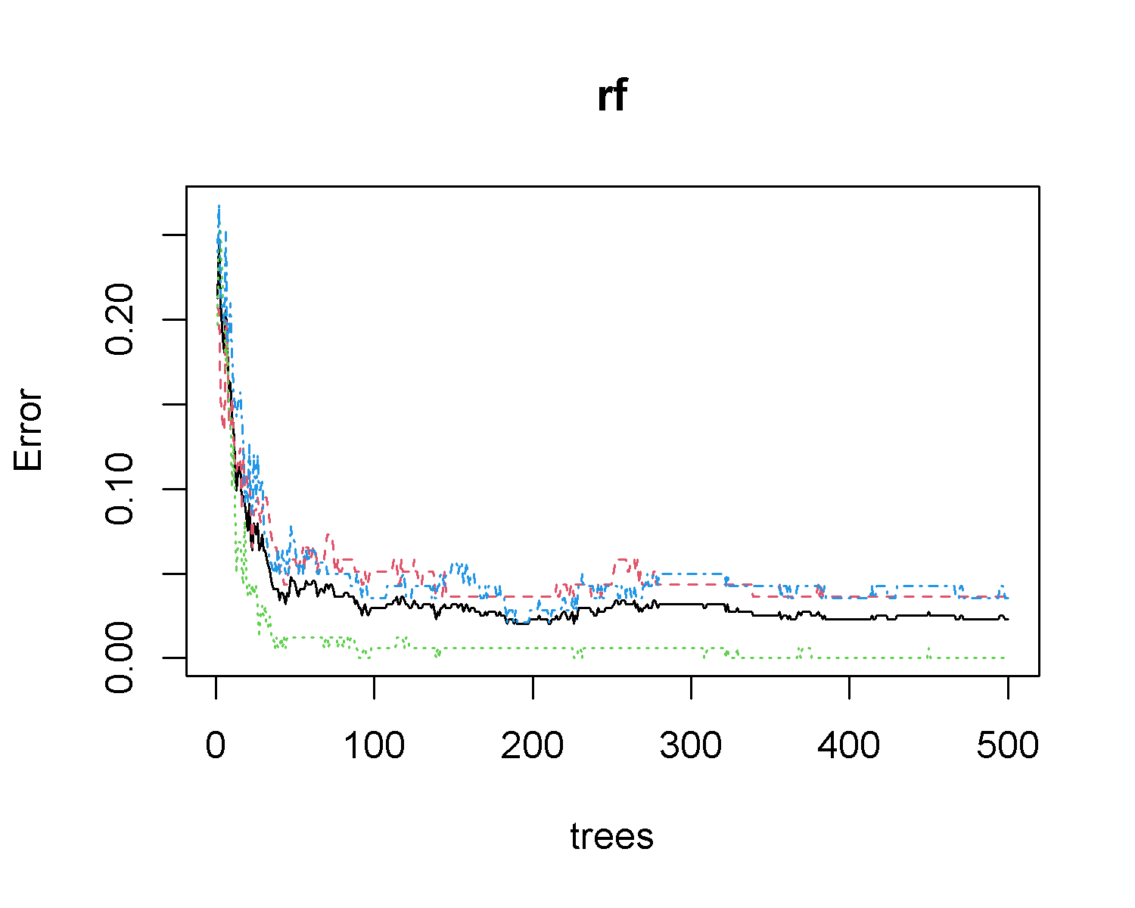

#Tune mtry (Número de variables aleatorias utilizadas en cada árbol)  
t <- tuneRF(train[,-1], train[,1],  
 stepFactor = 0.5,  
 plot = TRUE,  
 ntreeTry = 5,  
 trace = TRUE,  
 improve = 0.05)

## mtry = 3 OOB error = 17.53%   
## Searching left ...  
## mtry = 6 OOB error = 8.42%   
## 0.519802 0.05   
## mtry = 12 OOB error = 3.04%   
## 0.6390171 0.05   
## mtry = 24 OOB error = 2.36%   
## 0.2224409 0.05   
## mtry = 48 OOB error = 4.83%   
## -1.04665 0.05   
## Searching right ...  
## mtry = 1 OOB error = 47.96%   
## -19.30272 0.05

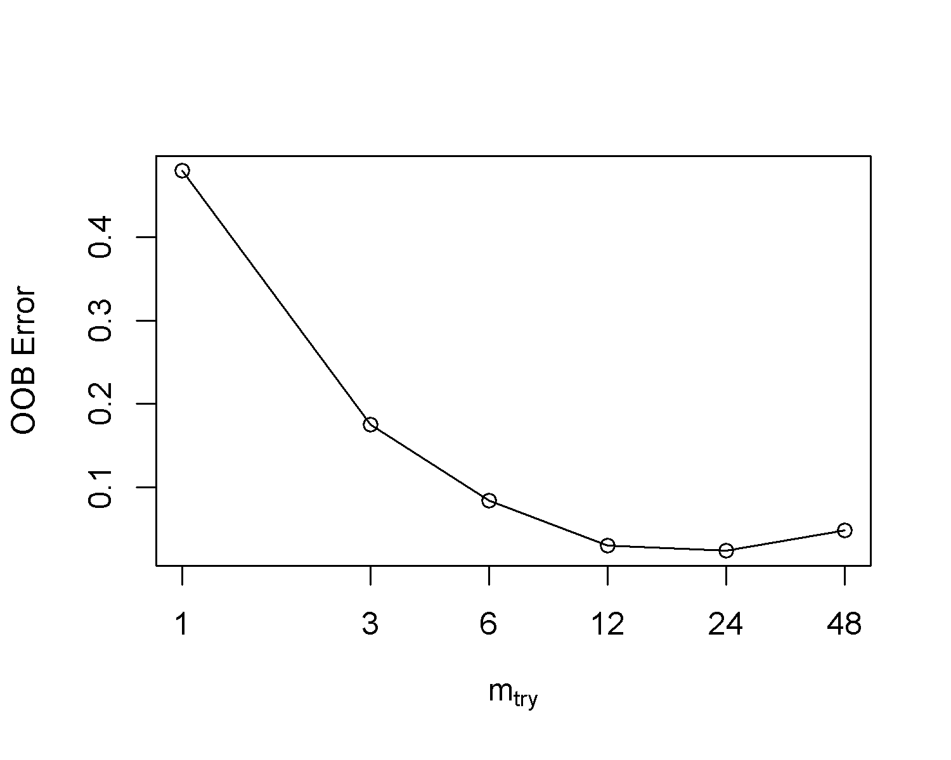

#mtry=6  
  
#No. of nodes for the trees  
hist(treesize(rf),  
 main = "No. of Nodes for the Trees",  
 col = "blue")

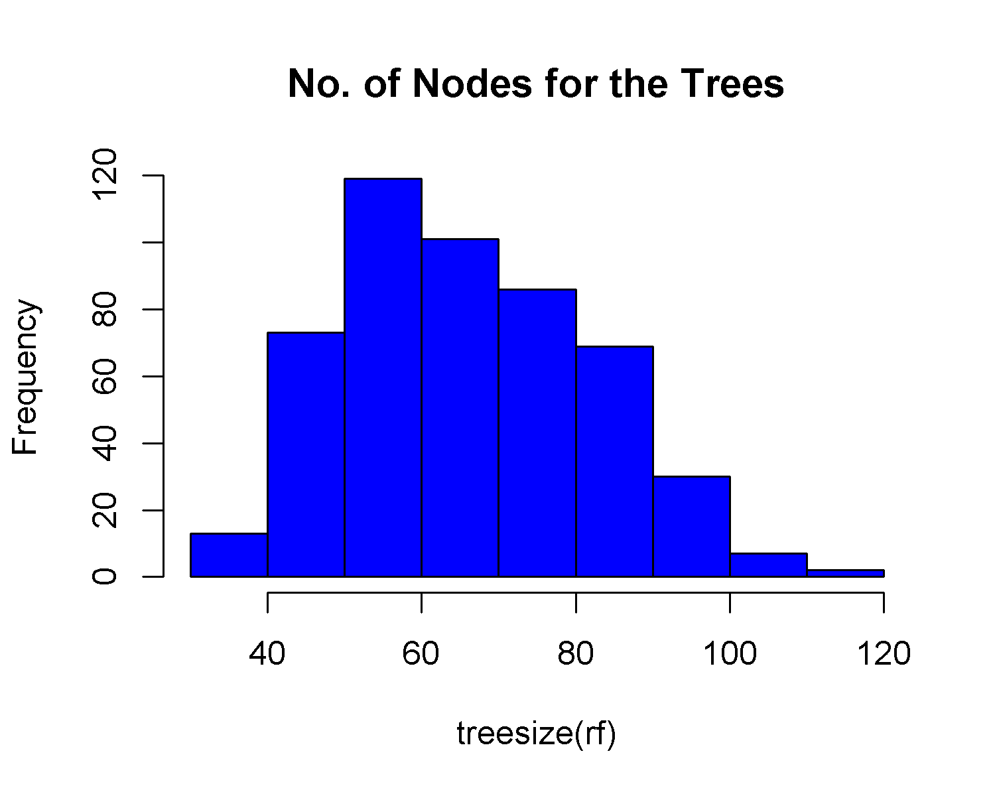

#media de 60 árboles  
  
#Variable Importance  
varImpPlot(rf,  
 sort = T,  
 n.var = 10,  
 main = "Top 10 - Importancia de Variables")

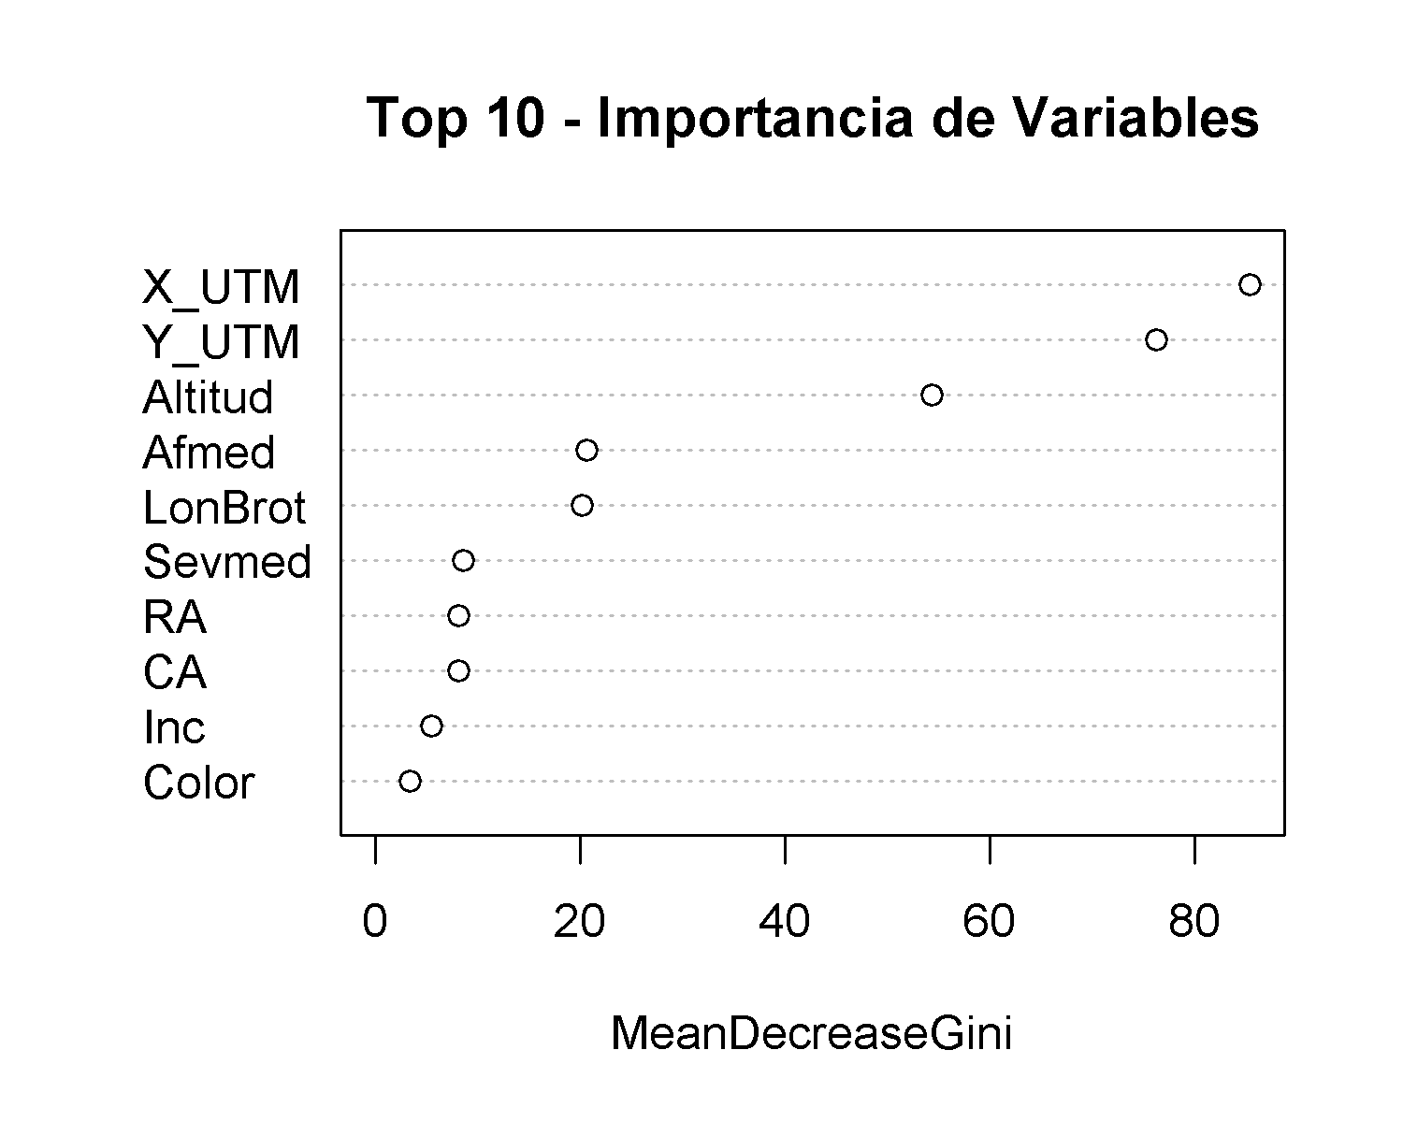

importance(rf)

## MeanDecreaseGini  
## X_UTM 85.378578  
## Y_UTM 76.219320  
## Altitud 54.328330  
## Inc 5.457896  
## Sevmed 8.613401  
## LonBrot 20.168919  
## Afmed 20.634459  
## CA 8.147649  
## RA 8.153187  
## Color 3.360461

#Partial Dependence Plot  
partialPlot(rf, train, Y_UTM, "Alta")

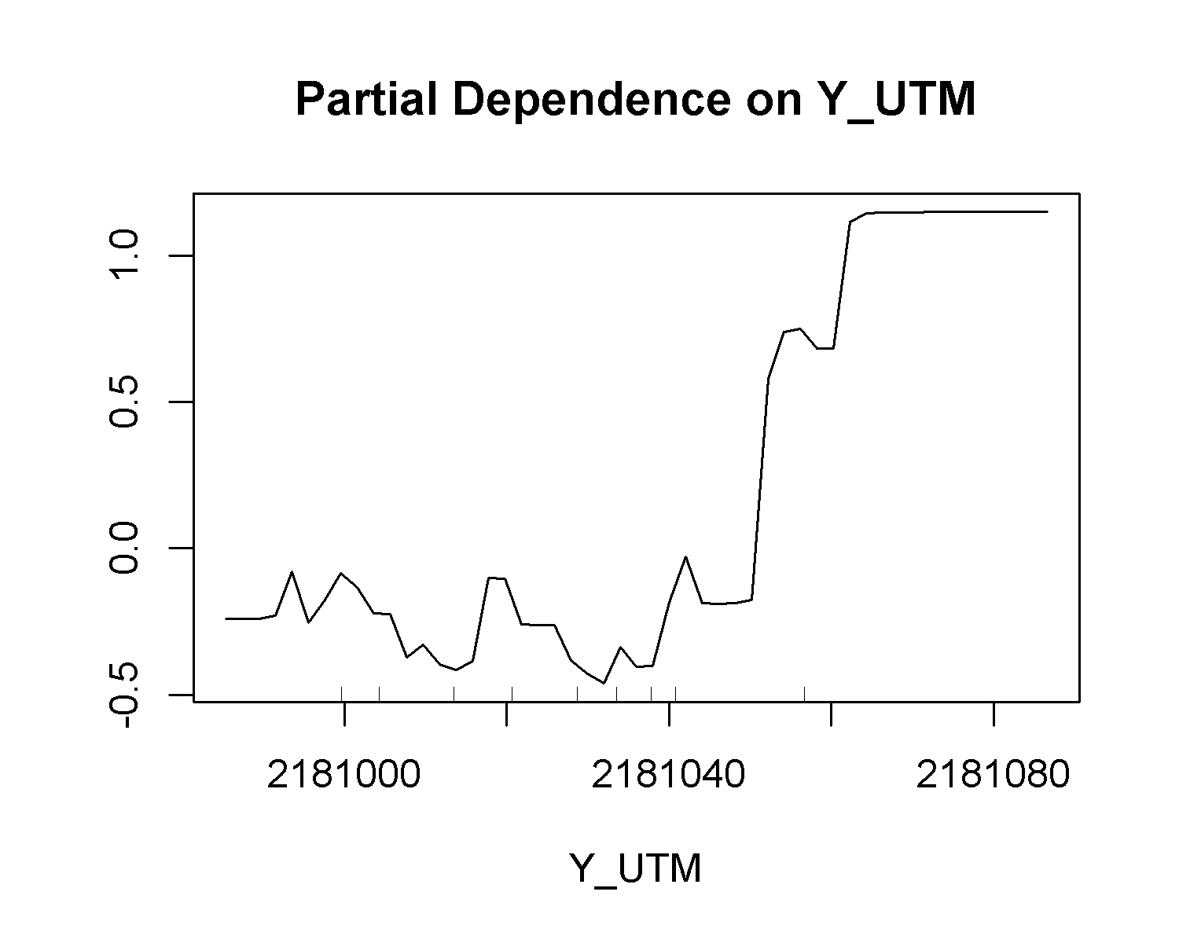 **Interpretación:** se obtuvo una precisión del 98% y un valor = 0.98, una mtry (Número de variables aleatorias utilizadas en cada árbol) de 6, 60 nodos promedio por árbol, las variables de mayor peso son las coordenadas UTM (X y Y).

### **3) Naive Bayes**

#clasificacion en datos poco correlacionados  
#https://www.r-bloggers.com/2021/04/naive-bayes-classification-in-r/  
#Para segmentar imagenes (severidad)  
#https://plantcv.readthedocs.io/en/latest/tutorials/machine_learning_tutorial/  
library(naivebayes)  
library(dplyr)  
library(ggplot2)  
  
  
base_nb <- na.omit(base[,c(2,5,6,7,18,19,22,24,28:30)])  
  
#Dplyr  
base_nb$Bloque <- as.factor(base_nb$Bloque)  
table(base_nb$Bloque)

##   
## Alta Baja Media   
## 200 216 208

base_nb %>%  
 ggplot(aes(x=base_nb$Bloque,  
 y=base_nb$Sevmed, fill = base_nb$Bloque)) +  
 geom_boxplot() +theme_bw()+stat_summary(fun="mean")+  
 ggtitle("Box Plot: Severidad por Transparencia")+  
 xlab("Transparencia de copa") + ylab("Severidad")+  
 theme(legend.position="none")

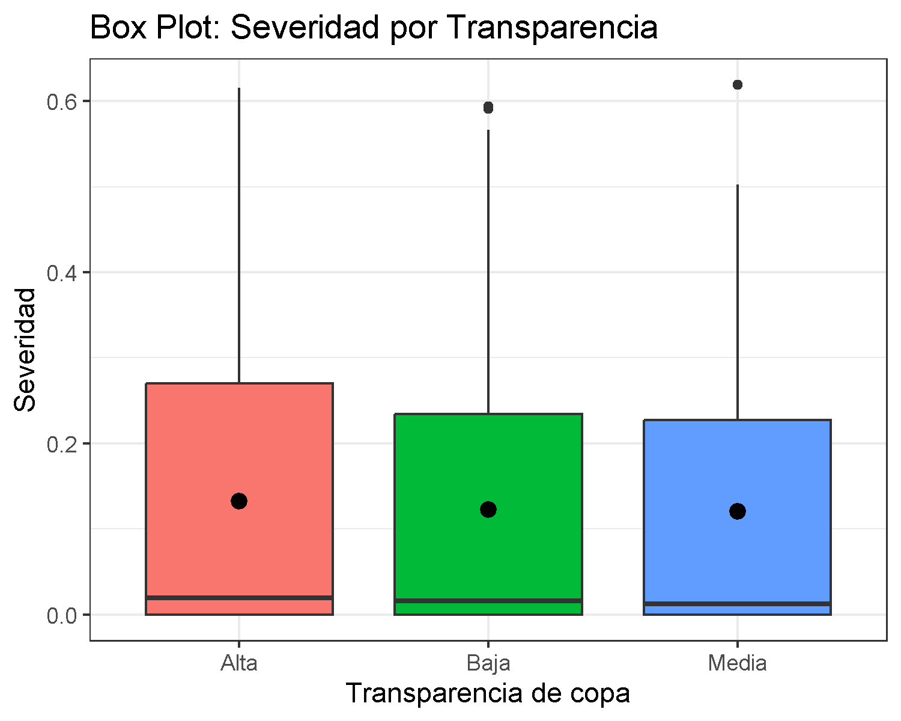

#particion de datos  
set.seed(1234)  
ind <- sample(2, nrow(base_nb), replace = T, prob = c(0.7, 0.3))  
train_nb <- base_nb[ind == 1,]  
test_nb <- base_nb[ind == 2,]  
  
  
  
nb <- naive_bayes(Bloque ~ ., data = train_nb, usekernel = T)   
nb

##   
## ================================== Naive Bayes ==================================   
##   
## Call:   
## naive_bayes.formula(formula = Bloque ~ ., data = train_nb, usekernel = T)  
##   
## ---------------------------------------------------------------------------------   
##   
## Laplace smoothing: 0  
##   
## ---------------------------------------------------------------------------------   
##   
## A priori probabilities:   
##   
## Alta Baja Media   
## 0.3294931 0.3525346 0.3179724   
##   
## ---------------------------------------------------------------------------------   
##   
## Tables:   
##   
## ---------------------------------------------------------------------------------   
## ::: X_UTM::Alta (KDE)  
## ---------------------------------------------------------------------------------   
##   
## Call:  
## density.default(x = x, na.rm = TRUE)  
##   
## Data: x (143 obs.); Bandwidth 'bw' = 4.234  
##   
## x y   
## Min. :605708 Min. :6.845e-05   
## 1st Qu.:605724 1st Qu.:5.646e-03   
## Median :605740 Median :1.531e-02   
## Mean :605740 Mean :1.563e-02   
## 3rd Qu.:605756 3rd Qu.:2.251e-02   
## Max. :605772 Max. :3.999e-02   
##   
## ---------------------------------------------------------------------------------   
## ::: X_UTM::Baja (KDE)  
## ---------------------------------------------------------------------------------   
##   
## Call:  
## density.default(x = x, na.rm = TRUE)  
##   
## Data: x (153 obs.); Bandwidth 'bw' = 3.012  
##   
## x y   
## Min. :605698 Min. :0.0000586   
## 1st Qu.:605716 1st Qu.:0.0035397   
## Median :605733 Median :0.0080609   
## Mean :605733 Mean :0.0145803   
## 3rd Qu.:605750 3rd Qu.:0.0230454   
## Max. :605767 Max. :0.0516069   
##   
## ---------------------------------------------------------------------------------   
## ::: X_UTM::Media (KDE)  
## ---------------------------------------------------------------------------------   
##   
## Call:  
## density.default(x = x, na.rm = TRUE)  
##   
## Data: x (138 obs.); Bandwidth 'bw' = 3.566  
##   
## x y   
## Min. :605699 Min. :7.663e-05   
## 1st Qu.:605713 1st Qu.:7.099e-03   
## Median :605727 Median :2.061e-02   
## Mean :605727 Mean :1.823e-02   
## 3rd Qu.:605740 3rd Qu.:2.765e-02   
## Max. :605754 Max. :3.286e-02   
##   
## ---------------------------------------------------------------------------------   
## ::: Y_UTM::Alta (KDE)  
## ---------------------------------------------------------------------------------   
##   
## Call:  
## density.default(x = x, na.rm = TRUE)  
##   
## Data: x (143 obs.); Bandwidth 'bw' = 8.552  
##   
## x y   
## Min. :2180968 Min. :1.452e-05   
## 1st Qu.:2181004 1st Qu.:1.747e-03   
## Median :2181040 Median :7.805e-03   
## Mean :2181040 Mean :6.930e-03   
## 3rd Qu.:2181076 3rd Qu.:1.125e-02   
## Max. :2181112 Max. :1.466e-02   
##   
## ---------------------------------------------------------------------------------   
## ::: Y_UTM::Baja (KDE)  
## ---------------------------------------------------------------------------------   
##   
## Call:  
## density.default(x = x, na.rm = TRUE)  
##   
## Data: x (153 obs.); Bandwidth 'bw' = 6.059  
##   
## x y   
## Min. :2180967 Min. :2.968e-05   
## 1st Qu.:2180994 1st Qu.:2.931e-03   
## Median :2181021 Median :7.321e-03   
## Mean :2181021 Mean :9.275e-03   
## 3rd Qu.:2181048 3rd Qu.:1.296e-02   
## Max. :2181075 Max. :2.738e-02   
##   
## ---------------------------------------------------------------------------------   
## ::: Y_UTM::Media (KDE)  
## ---------------------------------------------------------------------------------   
##   
## Call:  
## density.default(x = x, na.rm = TRUE)  
##   
## Data: x (138 obs.); Bandwidth 'bw' = 5.663  
##   
## x y   
## Min. :2180983 Min. :5.218e-05   
## 1st Qu.:2181003 1st Qu.:4.901e-03   
## Median :2181024 Median :1.382e-02   
## Mean :2181024 Mean :1.195e-02   
## 3rd Qu.:2181045 3rd Qu.:1.862e-02   
## Max. :2181066 Max. :2.012e-02   
##   
## ---------------------------------------------------------------------------------   
## ::: Altitud::Alta (KDE)  
## ---------------------------------------------------------------------------------   
##   
## Call:  
## density.default(x = x, na.rm = TRUE)  
##   
## Data: x (143 obs.); Bandwidth 'bw' = 2.165  
##   
## x y   
## Min. :2967 Min. :8.123e-05   
## 1st Qu.:2975 1st Qu.:7.206e-03   
## Median :2983 Median :1.904e-02   
## Mean :2983 Mean :3.037e-02   
## 3rd Qu.:2991 3rd Qu.:5.454e-02   
## Max. :3000 Max. :8.754e-02   
##   
## ---------------------------------------------------------------------------------   
## ::: Altitud::Baja (KDE)  
## ---------------------------------------------------------------------------------   
##   
## Call:  
## density.default(x = x, na.rm = TRUE)  
##   
## Data: x (153 obs.); Bandwidth 'bw' = 2.301  
##   
## x y   
## Min. :2967 Min. :0.0001377   
## 1st Qu.:2976 1st Qu.:0.0068304   
## Median :2984 Median :0.0229024   
## Mean :2984 Mean :0.0295464   
## 3rd Qu.:2993 3rd Qu.:0.0524126   
## Max. :3001 Max. :0.0725437   
##   
## ---------------------------------------------------------------------------------   
## ::: Altitud::Media (KDE)  
## ---------------------------------------------------------------------------------   
##   
## Call:  
## density.default(x = x, na.rm = TRUE)  
##   
## Data: x (138 obs.); Bandwidth 'bw' = 2.332  
##   
## x y   
## Min. :2966 Min. :0.0001916   
## 1st Qu.:2975 1st Qu.:0.0078593   
## Median :2983 Median :0.0223586   
## Mean :2983 Mean :0.0298194   
## 3rd Qu.:2992 3rd Qu.:0.0515802   
## Max. :3000 Max. :0.0763652   
##   
## ---------------------------------------------------------------------------------   
## ::: Inc::Alta (KDE)  
## ---------------------------------------------------------------------------------   
##   
## Call:  
## density.default(x = x, na.rm = TRUE)  
##   
## Data: x (143 obs.); Bandwidth 'bw' = 0.1516  
##   
## x y   
## Min. :-0.45489 Min. :0.007724   
## 1st Qu.: 0.02255 1st Qu.:0.184333   
## Median : 0.50000 Median :0.430753   
## Mean : 0.50000 Mean :0.522644   
## 3rd Qu.: 0.97745 3rd Qu.:0.877189   
## Max. : 1.45489 Max. :1.250835   
##   
## ---------------------------------------------------------------------------------   
## ::: Inc::Baja (KDE)  
## ---------------------------------------------------------------------------------   
##   
## Call:  
## density.default(x = x, na.rm = TRUE)  
##   
## Data: x (153 obs.); Bandwidth 'bw' = 0.147  
##   
## x y   
## Min. :-0.44114 Min. :0.008662   
## 1st Qu.: 0.02943 1st Qu.:0.234846   
## Median : 0.50000 Median :0.439232   
## Mean : 0.50000 Mean :0.530306   
## 3rd Qu.: 0.97057 3rd Qu.:0.877922   
## Max. : 1.44114 Max. :1.208382   
##   
## ---------------------------------------------------------------------------------   
## ::: Inc::Media (KDE)  
## ---------------------------------------------------------------------------------   
##   
## Call:  
## density.default(x = x, na.rm = TRUE)  
##   
## Data: x (138 obs.); Bandwidth 'bw' = 0.1492  
##   
## x y   
## Min. :-0.44755 Min. :0.00673   
## 1st Qu.: 0.02622 1st Qu.:0.17381   
## Median : 0.50000 Median :0.42338   
## Mean : 0.50000 Mean :0.52670   
## 3rd Qu.: 0.97378 3rd Qu.:0.84646   
## Max. : 1.44755 Max. :1.41405   
##   
## ---------------------------------------------------------------------------------   
## ::: Sevmed::Alta (KDE)  
## ---------------------------------------------------------------------------------   
##   
## Call:  
## density.default(x = x, na.rm = TRUE)  
##   
## Data: x (143 obs.); Bandwidth 'bw' = 0.05544  
##   
## x y   
## Min. :-0.16632 Min. :0.00084   
## 1st Qu.: 0.07067 1st Qu.:0.21204   
## Median : 0.30767 Median :1.00329   
## Mean : 0.30767 Mean :1.05316   
## 3rd Qu.: 0.54466 3rd Qu.:1.22723   
## Max. : 0.78166 Max. :3.88998   
##   
## ---------------------------------------------------------------------------------   
## ::: Sevmed::Baja (KDE)  
## ---------------------------------------------------------------------------------   
##   
## Call:  
## density.default(x = x, na.rm = TRUE)  
##   
## Data: x (153 obs.); Bandwidth 'bw' = 0.05547  
##   
## x y   
## Min. :-0.16640 Min. :0.001247   
## 1st Qu.: 0.06522 1st Qu.:0.321627   
## Median : 0.29683 Median :0.890326   
## Mean : 0.29683 Mean :1.077629   
## 3rd Qu.: 0.52845 3rd Qu.:1.361567   
## Max. : 0.76007 Max. :3.893333   
##   
## ---------------------------------------------------------------------------------   
## ::: Sevmed::Media (KDE)  
## ---------------------------------------------------------------------------------   
##   
## Call:  
## density.default(x = x, na.rm = TRUE)  
##   
## Data: x (138 obs.); Bandwidth 'bw' = 0.0524  
##   
## x y   
## Min. :-0.15720 Min. :0.00182   
## 1st Qu.: 0.04698 1st Qu.:0.42085   
## Median : 0.25117 Median :0.97273   
## Mean : 0.25117 Mean :1.22230   
## 3rd Qu.: 0.45535 3rd Qu.:1.23741   
## Max. : 0.65953 Max. :4.53500   
##   
## ---------------------------------------------------------------------------------  
##   
## # ... and 5 more tables  
##   
## ---------------------------------------------------------------------------------

plot(nb)

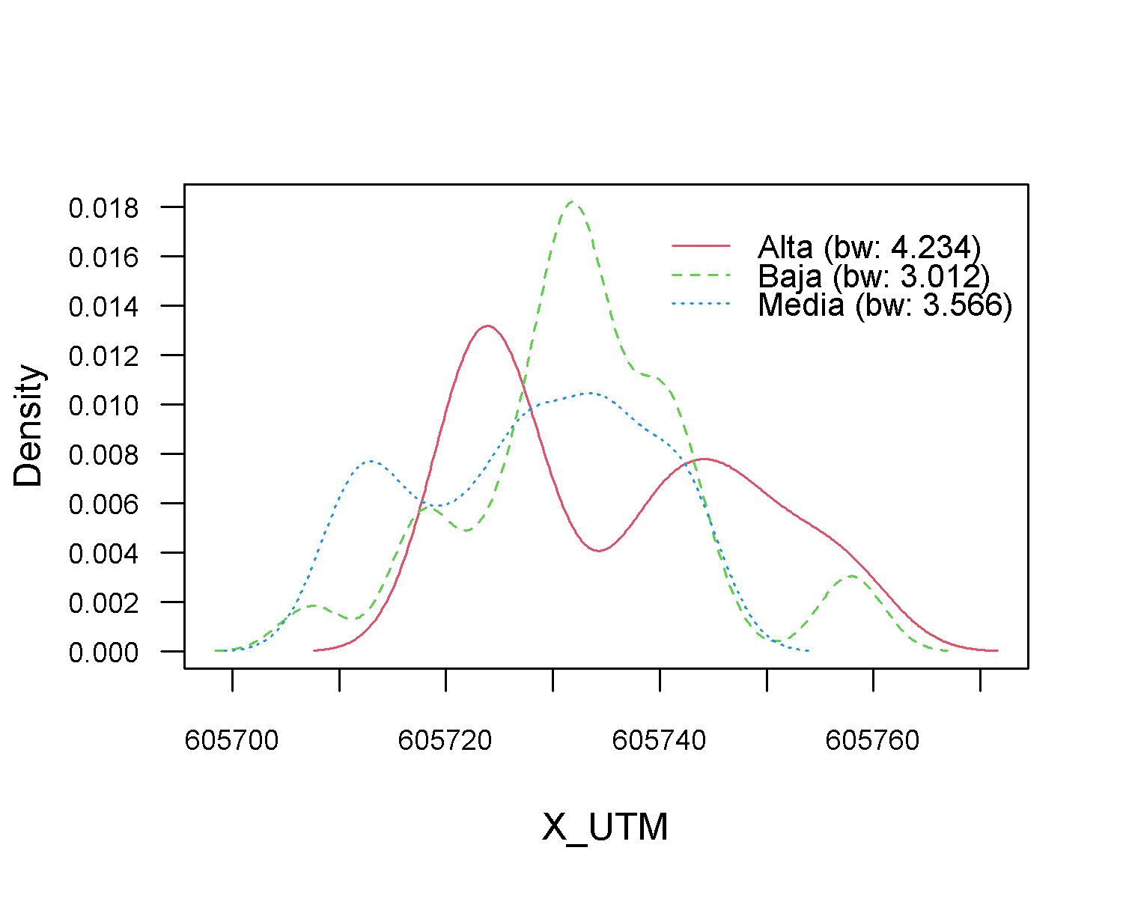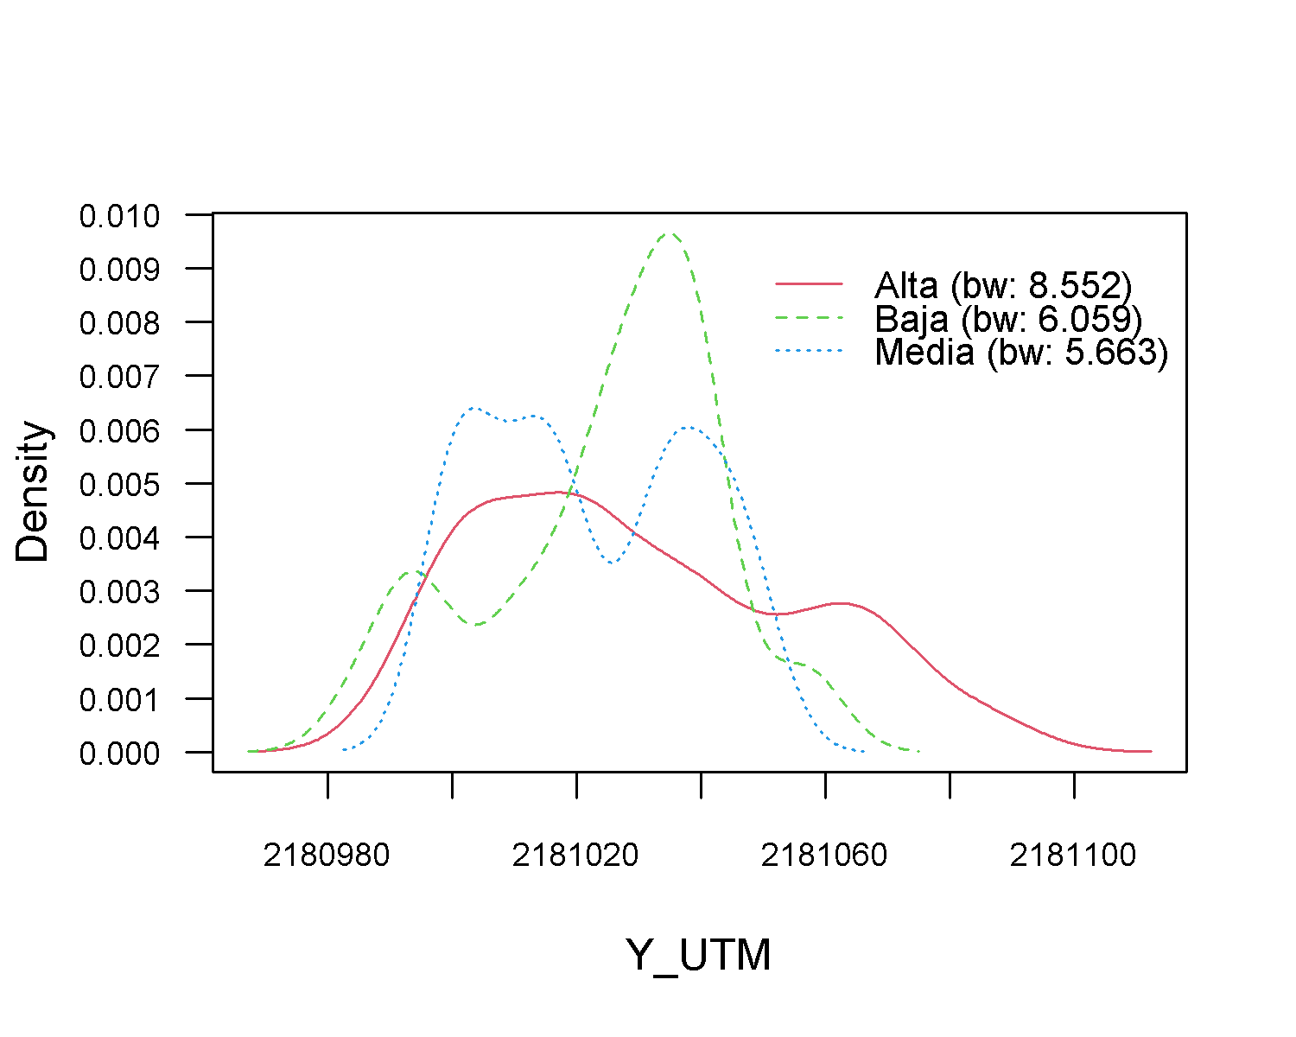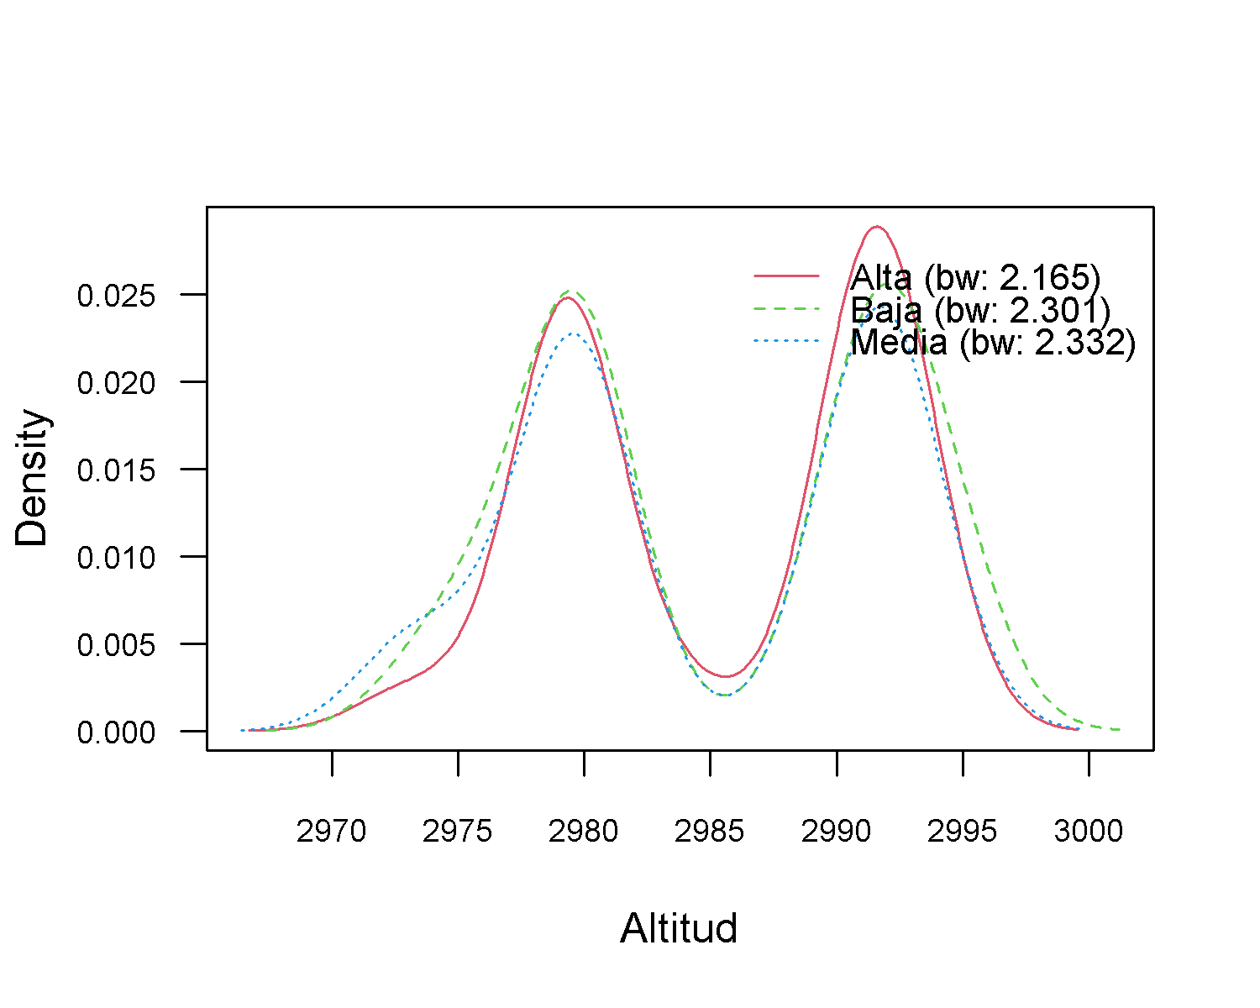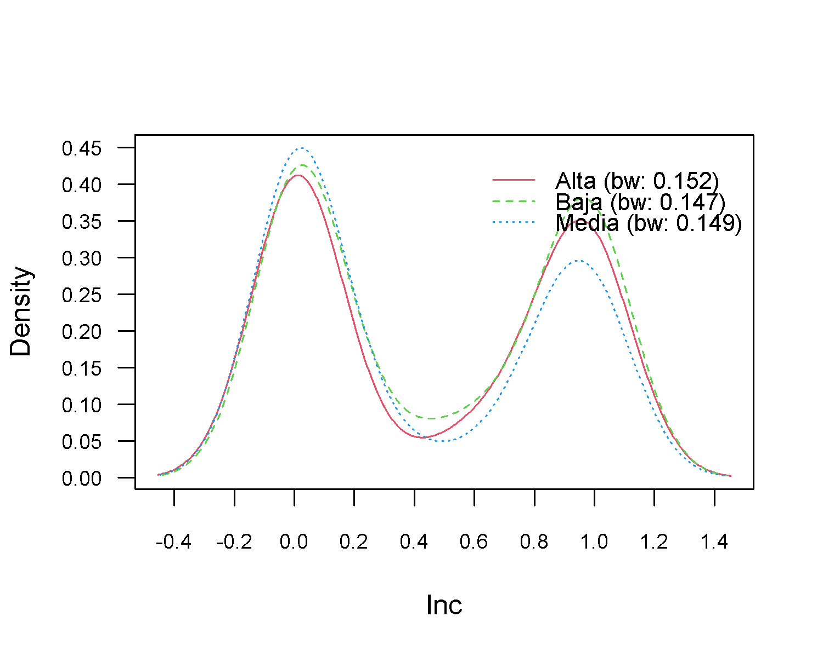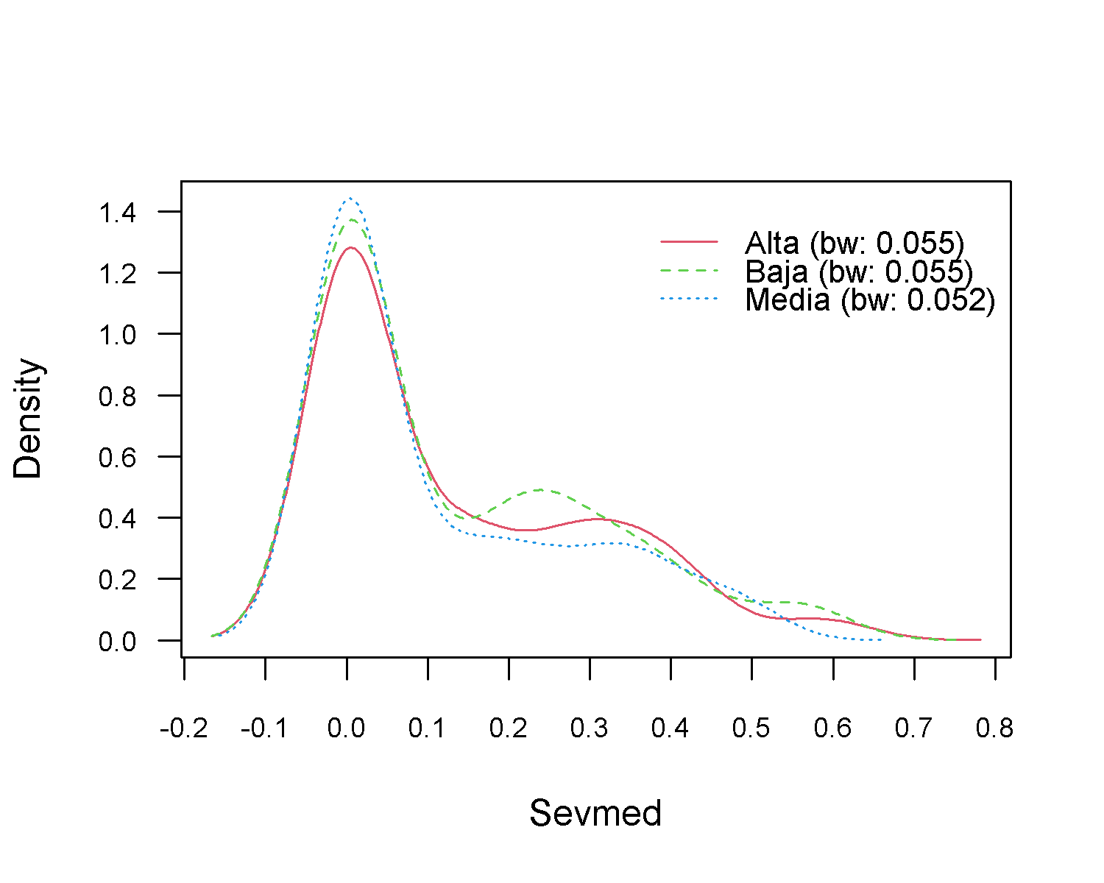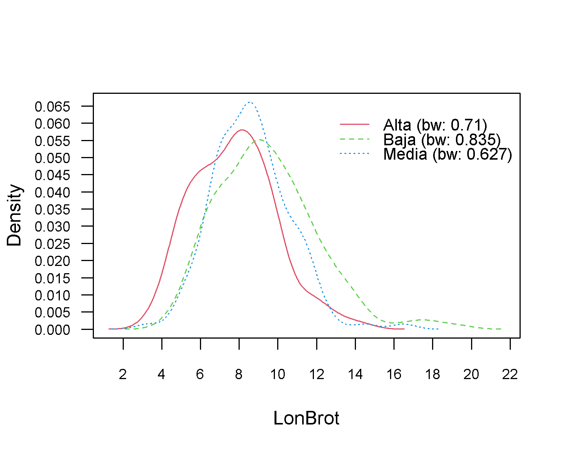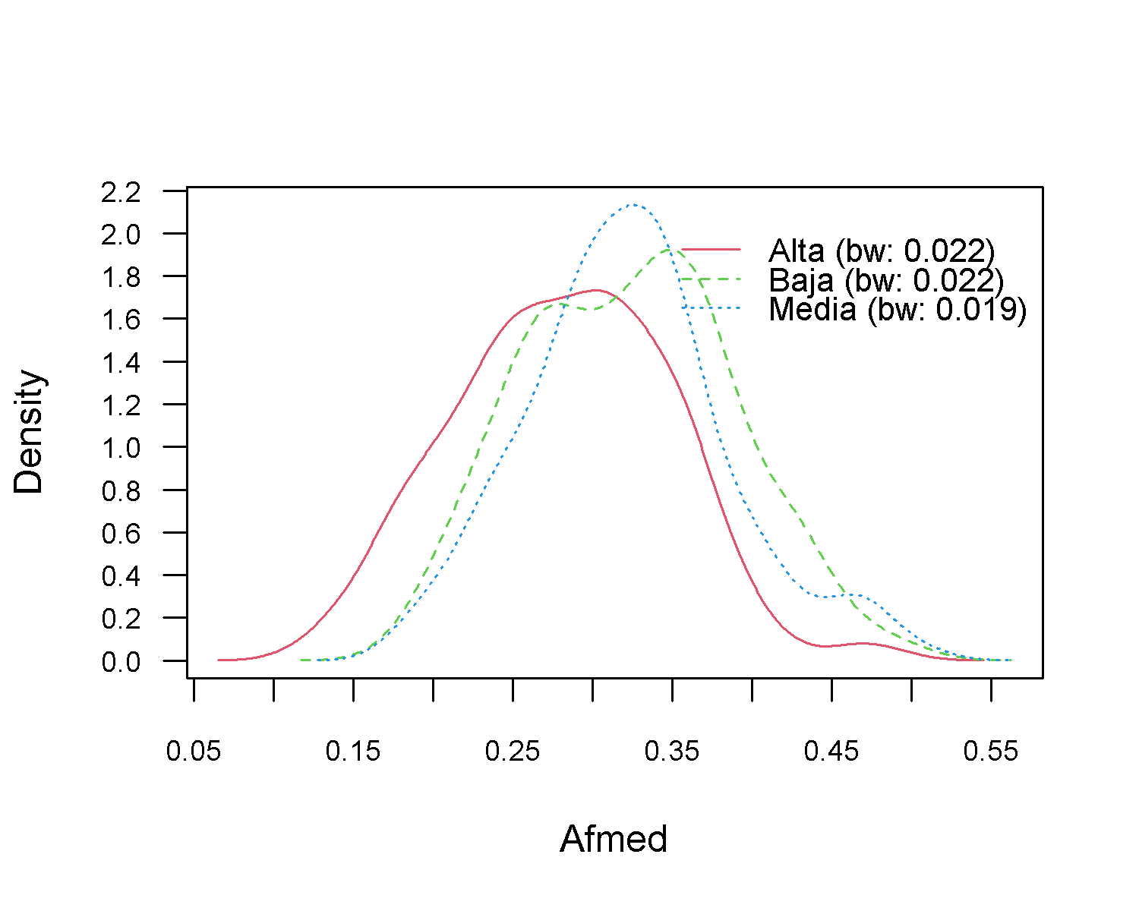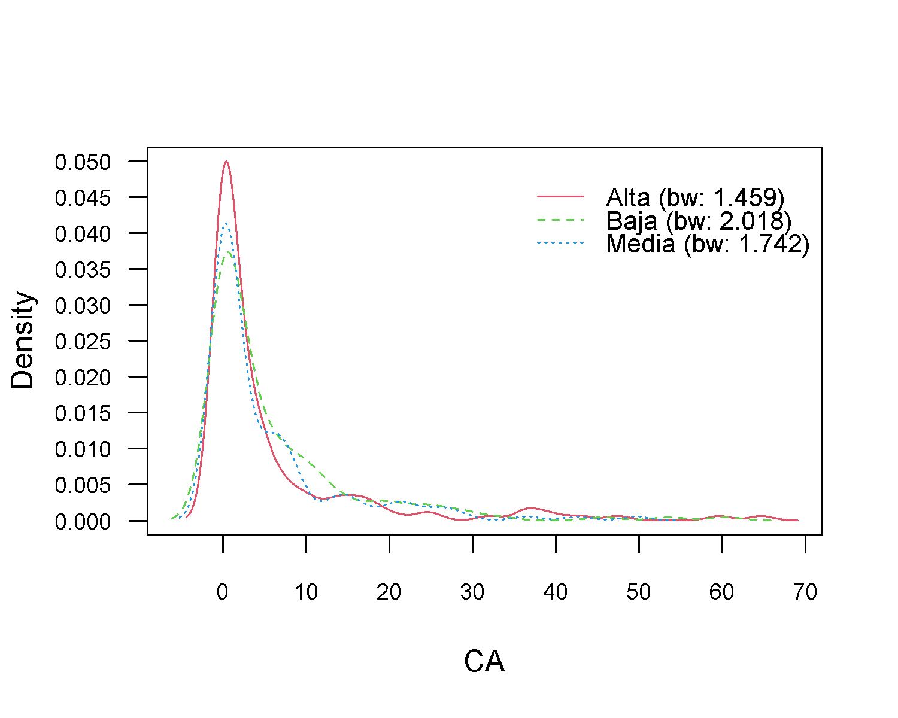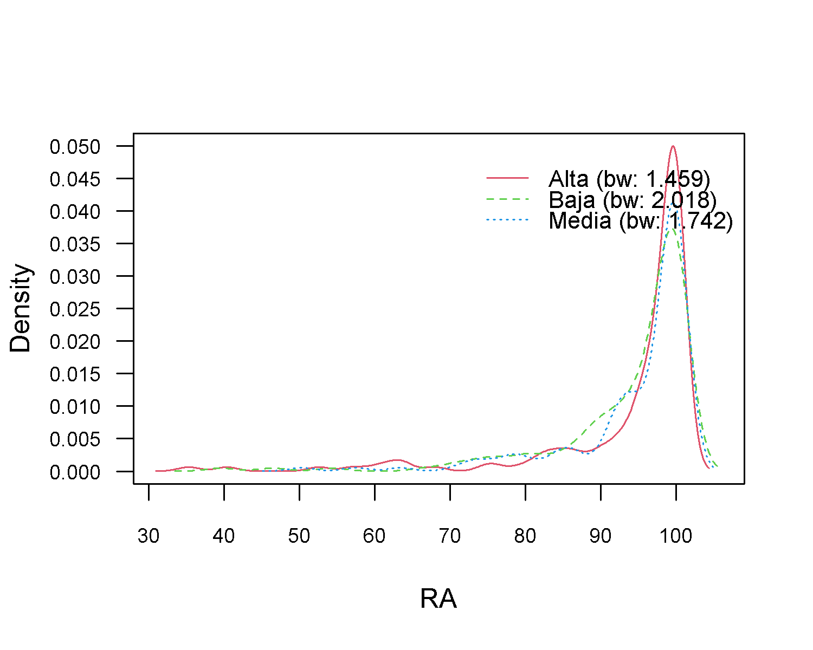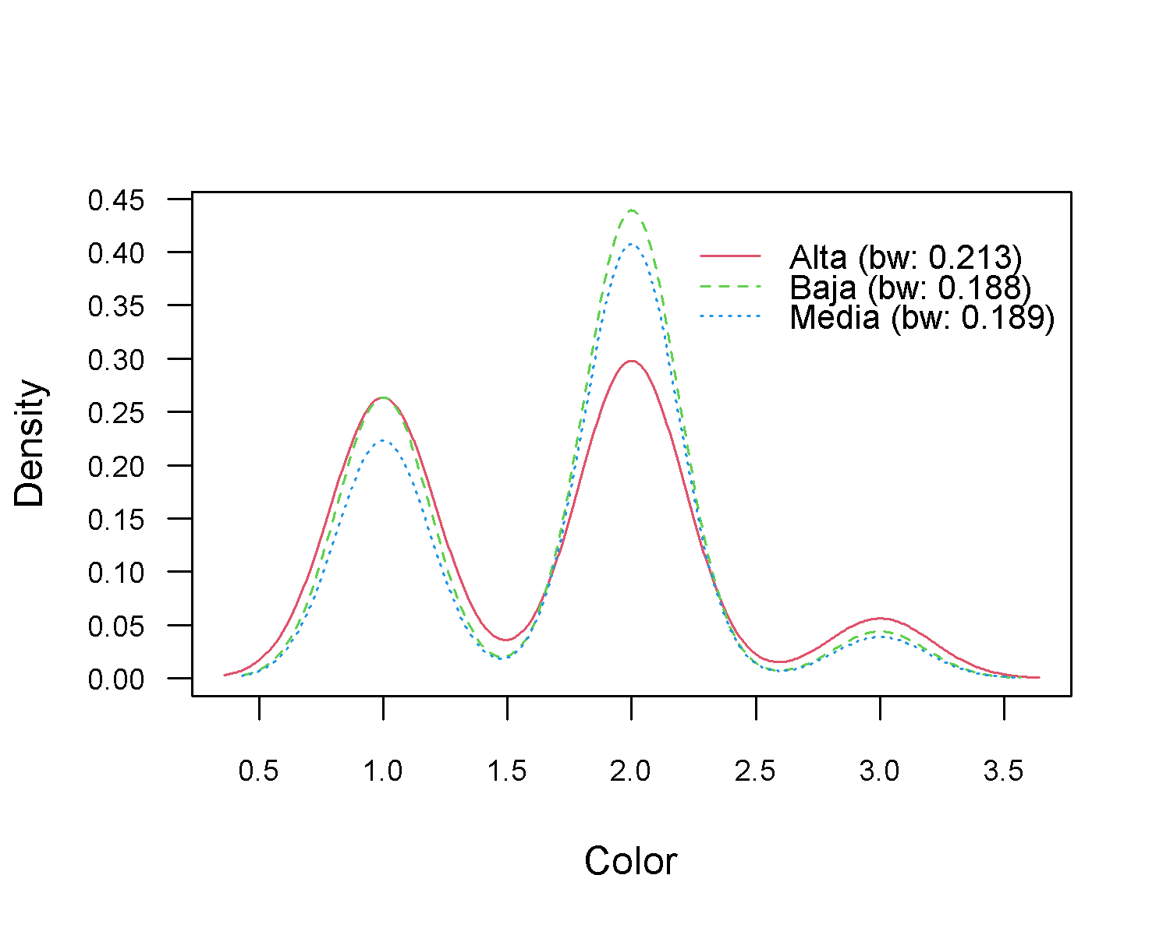

#Prediccion  
p <- predict(nb, train_nb, type = 'prob')  
head(cbind(p, train_nb))

## Alta Baja Media Bloque X_UTM Y_UTM Altitud Inc  
## 1 0.9787447 0.01850964 0.002745704 Alta 605747.9 2181070 2979.3 0.9000000  
## 2 0.4113505 0.53406359 0.054585864 Alta 605744.3 2181057 2979.3 1.0000000  
## 3 0.6491587 0.25629479 0.094546554 Alta 605740.2 2181039 2979.5 0.7666667  
## 4 0.8842636 0.11442525 0.001311104 Alta 605754.5 2181034 2980.0 1.0000000  
## 6 0.8065772 0.14937314 0.044049685 Alta 605727.7 2181021 2992.3 1.0000000  
## 7 0.7160262 0.07648249 0.207491317 Alta 605724.3 2181003 2990.8 1.0000000  
## Sevmed LonBrot Afmed CA RA Color  
## 1 0.1503333 7.25 0.2393667 25.252525 74.74747 1  
## 2 0.3310000 12.90 0.3744867 1.526718 98.47328 1  
## 3 0.3466667 5.10 0.1960667 2.816901 97.18310 1  
## 4 0.3510000 3.90 0.3699000 15.384615 84.61538 1  
## 6 0.2486667 5.00 0.2253667 17.441860 82.55814 1  
## 7 0.4033333 6.80 0.2549333 4.225352 95.77465 1

#Confusion Matrix – train data  
p1 <- predict(nb, train_nb)  
(tab1 <- table(p1, train_nb$Bloque))

##   
## p1 Alta Baja Media  
## Alta 91 19 20  
## Baja 19 97 26  
## Media 33 37 92

1 - sum(diag(tab1)) / sum(tab1) #error del 35%

## [1] 0.3548387

#Confusion Matrix – test data  
p2 <- predict(nb, test_nb)  
(tab2 <- table(p2, test_nb$Bloque))

##   
## p2 Alta Baja Media  
## Alta 28 14 13  
## Baja 12 30 22  
## Media 17 19 35

p2

## [1] Baja Baja Alta Baja Media Media Baja Media Alta Alta Baja Alta   
## [13] Media Alta Media Baja Media Media Media Media Baja Media Baja Baja   
## [25] Baja Baja Alta Media Baja Alta Alta Baja Alta Alta Media Baja   
## [37] Baja Baja Baja Baja Media Alta Media Alta Media Alta Media Media  
## [49] Media Media Media Alta Media Alta Baja Baja Media Alta Baja Media  
## [61] Alta Baja Media Alta Media Media Baja Media Media Alta Alta Baja   
## [73] Baja Alta Media Baja Media Baja Alta Alta Media Media Media Alta   
## [85] Media Media Baja Media Alta Baja Baja Media Media Alta Baja Baja   
## [97] Baja Media Media Media Alta Alta Baja Baja Media Alta Media Alta   
## [109] Baja Media Alta Alta Alta Media Media Alta Media Alta Alta Baja   
## [121] Media Baja Media Media Alta Alta Media Alta Alta Media Baja Baja   
## [133] Baja Baja Baja Media Media Baja Media Baja Baja Alta Media Media  
## [145] Alta Alta Baja Media Media Media Alta Alta Baja Alta Baja Media  
## [157] Alta Alta Media Alta Alta Alta Media Baja Baja Baja Baja Media  
## [169] Baja Media Baja Baja Baja Baja Baja Baja Alta Baja Alta Media  
## [181] Alta Alta Media Media Media Baja Baja Media Baja Media  
## Levels: Alta Baja Media

1 - sum(diag(tab2)) / sum(tab2) #error del 51%

## [1] 0.5105263

library(caret)  
confusionMatrix(p2,test_nb$Bloque)

## Confusion Matrix and Statistics  
##   
## Reference  
## Prediction Alta Baja Media  
## Alta 28 14 13  
## Baja 12 30 22  
## Media 17 19 35  
##   
## Overall Statistics  
##   
## Accuracy : 0.4895   
## 95% CI : (0.4164, 0.5629)  
## No Information Rate : 0.3684   
## P-Value [Acc > NIR] : 0.0004302   
##   
## Kappa : 0.2309   
##   
## Mcnemar's Test P-Value : 0.8238127   
##   
## Statistics by Class:  
##   
## Class: Alta Class: Baja Class: Media  
## Sensitivity 0.4912 0.4762 0.5000  
## Specificity 0.7970 0.7323 0.7000  
## Pos Pred Value 0.5091 0.4688 0.4930  
## Neg Pred Value 0.7852 0.7381 0.7059  
## Prevalence 0.3000 0.3316 0.3684  
## Detection Rate 0.1474 0.1579 0.1842  
## Detection Prevalence 0.2895 0.3368 0.3737  
## Balanced Accuracy 0.6441 0.6042 0.6000

**Interpretación:** se obtuvo una precisión de 49% y un valor de =0.23. En general esta técnica no fue tan buena para clasificar la transparencia de copa.

### **4) K-NN**

#https://rpubs.com/JairoAyala/601703  
  
library(kknn)  
  
base_knn <- na.omit(base[,c(2,5,6,7,9,10,12,18,19,22,24,28:30,32)])  
  
base_knn$Bloque <- as.factor(base_knn$Bloque)  
table(base_knn$Bloque)

##   
## Alta Baja Media   
## 200 216 208

set.seed(2020)  
muestra <- sample(1:624, 437)  
train_knn <- base_knn[muestra,]#70%  
test_knn<- base_knn[-muestra,]#30%  
dim(train_knn)[1]

## [1] 437

dim(test_knn)[1]

## [1] 187

knn <- train.kknn(Bloque~ ., data = train_knn, kmax = 9)  
knn

##   
## Call:  
## train.kknn(formula = Bloque ~ ., data = train_knn, kmax = 9)  
##   
## Type of response variable: nominal  
## Minimal misclassification: 0.5102975  
## Best kernel: optimal  
## Best k: 9

entre <- predict(knn, train_knn[,-1])  
tt <- table(train_knn[,1],entre)  
tt

## entre  
## Alta Baja Media  
## Alta 129 5 5  
## Baja 16 122 15  
## Media 7 7 131

precision <- (sum(diag(tt)))/sum(tt)  
precision

## [1] 0.8741419

#precisión del 100 % en datos de entrenamiento  
  
  
#Precisión test de prueba  
pred <- predict(knn, test_knn[,-1])  
table <- table(test_knn[,1],pred)  
table

## pred  
## Alta Baja Media  
## Alta 35 13 13  
## Baja 13 29 21  
## Media 12 16 35

clas <- (sum(diag(table)))/sum(table)  
clas

## [1] 0.5294118

#Precisión del 53% de datos de prueba  
  
#matriz de confusion con la prueba  
  
library(caret)  
confusionMatrix(pred,test_knn$Bloque)

## Confusion Matrix and Statistics  
##   
## Reference  
## Prediction Alta Baja Media  
## Alta 35 13 12  
## Baja 13 29 16  
## Media 13 21 35  
##   
## Overall Statistics  
##   
## Accuracy : 0.5294   
## 95% CI : (0.4552, 0.6026)  
## No Information Rate : 0.3369   
## P-Value [Acc > NIR] : 4.914e-08   
##   
## Kappa : 0.294   
##   
## Mcnemar's Test P-Value : 0.8695   
##   
## Statistics by Class:  
##   
## Class: Alta Class: Baja Class: Media  
## Sensitivity 0.5738 0.4603 0.5556  
## Specificity 0.8016 0.7661 0.7258  
## Pos Pred Value 0.5833 0.5000 0.5072  
## Neg Pred Value 0.7953 0.7364 0.7627  
## Prevalence 0.3262 0.3369 0.3369  
## Detection Rate 0.1872 0.1551 0.1872  
## Detection Prevalence 0.3209 0.3102 0.3690  
## Balanced Accuracy 0.6877 0.6132 0.6407

**Interpretación:** se obtuvo una precisión de 53% y un valor de =0.30. En general esta técnica no fue tan buena para clasificar la transparencia de copa.

### **5) Curvas Receiver Operating Characteristic (ROC)**

par(mfrow = c(1,3))  
#Random forest  
  
# Validation set assessment #2: ROC curves and AUC  
# Needs to import ROCR package for ROC curve plotting:  
library(ROCR)  
# Calculate the probability of new observations belonging to each class  
# prediction_for_roc_curve will be a matrix with dimensions data_set_size x number_of_classes  
prediction_for_roc_curve <- predict(rf,test[,-1],type="prob")  
# Use pretty colours:  
pretty_colours <- c("#F8766D","#00BA38","#619CFF")  
# Specify the different classes   
test$Bloque <- as.factor(test$Bloque)  
classes <- levels(test$Bloque)  
# For each class  
for (i in 1:3)  
{  
 # Define which observations belong to class[i]  
 true_values <- ifelse(test[,1]==classes[i],1,0)  
 # Assess the performance of classifier for class[i]  
 pred <- prediction(prediction_for_roc_curve[,i],true_values)  
 perf <- performance(pred, "tpr", "fpr")  
 if (i==1)  
 {  
 plot(perf,main="ROC Curve-Random Forest",col=pretty_colours[i])   
 }  
 else  
 {  
 plot(perf,main="ROC Curve- Random Forest",col=pretty_colours[i],add=TRUE)  
 abline (a = 0, b = 1, lty="dotted", lwd=2)   
 }  
 # Calculate the AUC and print it to screen  
 auc.perf <- performance(pred, measure = "auc")  
 print(auc.perf@y.values)  
}

## [[1]]  
## [1] 0.9993548  
##   
## [[1]]  
## [1] 1  
##   
## [[1]]  
## [1] 1

#Naive Bayes (ROC)  
  
# Validation set assessment #2: ROC curves and AUC  
# Needs to import ROCR package for ROC curve plotting:  
library(ROCR)  
# Calculate the probability of new observations belonging to each class  
# prediction_for_roc_curve will be a matrix with dimensions data_set_size x number_of_classes  
prediction_for_roc_curve <- predict(nb,test_nb[,-1],type="prob")  
# Use pretty colours:  
pretty_colours <- c("#F8766D","#00BA38","#619CFF")  
# Specify the different classes   
test_nb$Bloque <- as.factor(test_nb$Bloque)  
classes <- levels(test_nb$Bloque)  
# For each class  
for (i in 1:3)  
{  
 # Define which observations belong to class[i]  
 true_values <- ifelse(test_nb[,1]==classes[i],1,0)  
 # Assess the performance of classifier for class[i]  
 pred <- prediction(prediction_for_roc_curve[,i],true_values)  
 perf <- performance(pred, "tpr", "fpr")  
 if (i==1)  
 {  
 plot(perf,main="ROC Curve-Naive Bayes",col=pretty_colours[i])   
 }  
 else  
 {  
 plot(perf,main="ROC Curve-Naive Bayes",col=pretty_colours[i],add=TRUE)  
 abline (a = 0, b = 1, lty="dotted", lwd=2)   
 }  
 # Calculate the AUC and print it to screen  
 auc.perf <- performance(pred, measure = "auc")  
 print(auc.perf@y.values)  
}

## [[1]]  
## [1] 0.7632238  
##   
## [[1]]  
## [1] 0.6860392  
##   
## [[1]]  
## [1] 0.702381

#KNN (ROC)  
  
# Validation set assessment #2: ROC curves and AUC  
# Needs to import ROCR package for ROC curve plotting:  
library(ROCR)  
# Calculate the probability of new observations belonging to each class  
# prediction_for_roc_curve will be a matrix with dimensions data_set_size x number_of_classes  
prediction_for_roc_curve <- predict(knn,test_knn[,-1],type="prob")  
# Use pretty colours:  
pretty_colours <- c("#F8766D","#00BA38","#619CFF")  
# Specify the different classes   
test_knn$Bloque <- as.factor(test_knn$Bloque)  
classes <- levels(test_knn$Bloque)  
# For each class  
for (i in 1:3)  
{  
 # Define which observations belong to class[i]  
 true_values <- ifelse(test_knn[,1]==classes[i],1,0)  
 # Assess the performance of classifier for class[i]  
 pred <- prediction(prediction_for_roc_curve[,i],true_values)  
 perf <- performance(pred, "tpr", "fpr")  
 if (i==1)  
 {  
 plot(perf,main="ROC Curve - KNN",col=pretty_colours[i])   
 }  
 else  
 {  
 plot(perf,main="ROC Curve -KNN",col=pretty_colours[i],add=TRUE)  
 abline (a = 0, b = 1, lty="dotted", lwd=2)   
 }  
 # Calculate the AUC and print it to screen  
 auc.perf<- performance(pred, measure = "auc")  
 print(auc.perf@y.values)  
}

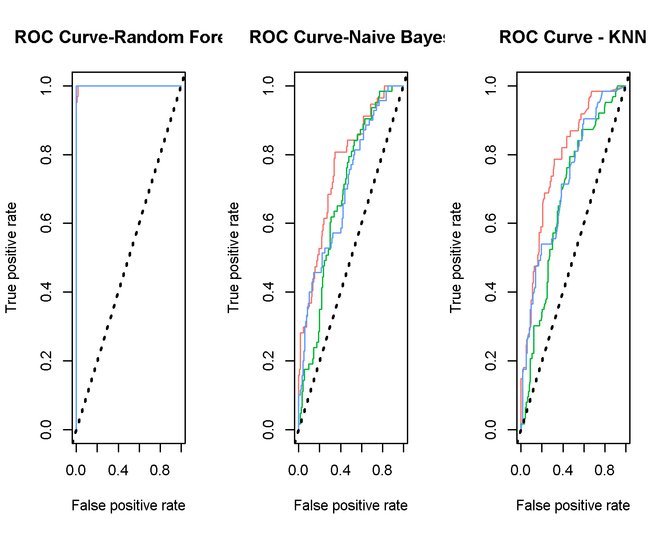

## [[1]]  
## [1] 0.7848686  
##   
## [[1]]  
## [1] 0.6751792  
##   
## [[1]]  
## [1] 0.7210061

dev.off()

## null device   
## 1

#cuadro con valores de precision  
p <-rbind(c(0.98,0.49,0.53))   
k <- rbind(c(0.98,0.23,0.30))  
r <- rbind(c(1.00, 0.70, 0.72))  
pres <- rbind(p,k,r)  
pres <- as.data.frame(pres)  
colnames(pres) <- c("Random Forest","Naive Bayes", "K-NN")  
pres <- cbind(Métrica=c("Precisión(%)","Kappa", "AUC-ROC"),pres)  
  
library(gt)  
pres %>% gt()

| Métrica | Random Forest | Naive Bayes | K-NN |
| --- | --- | --- | --- |
| Precisión(%) | 0.98 | 0.49 | 0.53 |
| Kappa | 0.98 | 0.23 | 0.30 |
| AUC-ROC | 1.00 | 0.70 | 0.72 |

**Interpretación:** De acuerdo la evaluación de las curvas ROC, es evidente qu el mejor modelo para clasificar a la transparencia de copa de Douglas-fir fue el Random Forest, ya que tuvo mayor cantidad de positivos verdaderos en comparación de Naive Bayes y K-NN, donde se pueden considerar que son modelos de regulares a malos.

1. IFIT-CP, [quiroz.ivan@colpos.mx](mailto:quiroz.ivan@colpos.mx)