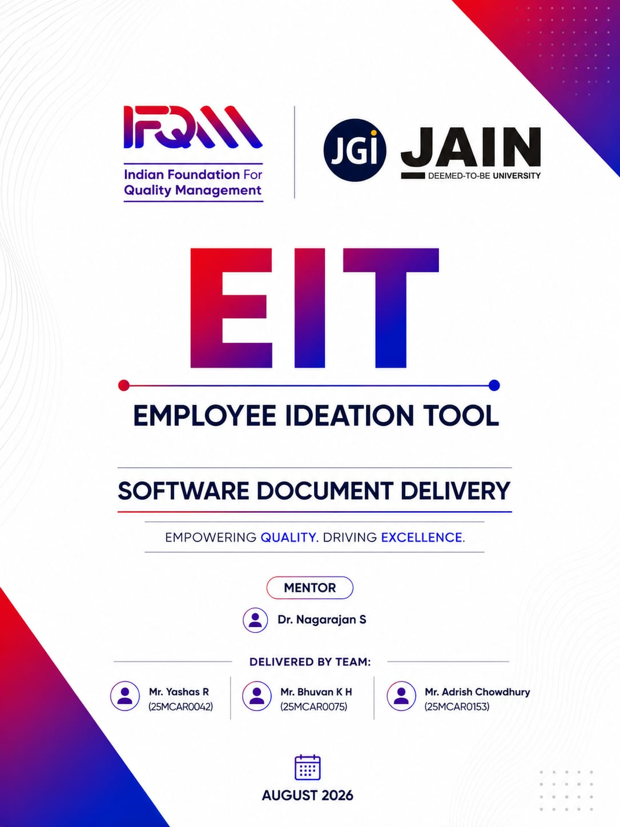
IFQM Project 2
Employee Ideation Tool – Requirement Document (Draft)
The Employee Ideation Tool shall serve as a structured digital platform to capture, evaluate, approve, and track improvement ideas submitted by employees across the organization. The objective is to promote a culture of continuous improvement, innovation, and employee engagement through a transparent and gamified system.
The system shall automatically capture employee details at the time of idea submission by integrating with the existing Employee Database. Pull Emp Name, Employee ID (if applicable), Department, Email ID, Phone Number, Reporting Manager, and Business Unit/Location from DB. These details shall be auto-populated to ensure data accuracy and reduce manual entry. The tool shall also allow the submitting employee to add up to two additional co-suggesters for collaborative ideas.
The platform shall enable structured registration of ideas throughout the year and show them in a dashboard.
For each idea submission, the employee must provide:
- Present Situation (description in English along with optional document upload)
- Proposed Idea/Solution (description in English along with optional document upload)
The system shall allow uploading of supporting documents (e.g., PDFs, images, spreadsheets) to substantiate both the current state and proposed improvements.
Each submitted idea shall follow a predefined approval workflow. The workflow shall include review and approval by the immediate manager or designated leaders based on department hierarchy or impact level. The system shall track approval statuses (e.g., Submitted, Under Review, Approved, Rejected, Implemented) and maintain an audit trail of actions taken.
The tool shall categorize and assess the impact of each idea across key organizational dimensions such as Production, Quality, Cost, Delivery, Safety, Environment, and Morale. Multiple impact areas may be selected per idea. Provision may also be included for quantifying tangible and intangible benefits where applicable.
To encourage participation, the system shall include a leaderboard and gamification features. Points shall be awarded based on criteria such as idea submission, approval, implementation, and measurable impact. The leaderboard shall display rankings of individuals, departments, and/or business units over defined time periods (monthly, quarterly, yearly).
The platform shall provide reporting and analytics capabilities, including the total number of ideas submitted during the year, status tracking, distribution, and participation metrics. Historical data shall be retained to enable year-wise comparison and continuous improvement analysis.
Overall, the Employee Ideation Tool shall ensure transparency, ease of submission, structured evaluation, and recognition, thereby strengthening the organization’s innovation ecosystem.

ACKNOWLEDGEMENT
We would like to express our sincere gratitude to everyone who supported, guided, and encouraged us throughout our internship at the International Foundation for Quality Management (IFQM).
First and foremost, we would like to express our sincere gratitude to Dr. Sagar Gulati, Director, School of Computer Science and IT, JAIN (Deemed-to-be University), for providing us with the opportunity and institutional support to undertake this internship as part of the MCA Programme.
We are deeply grateful to Mr. Samapth, IFQM In-charge, for providing us with the opportunity to work with IFQM and for his guidance and support throughout the internship. His direction and encouragement provided us with valuable exposure to a professional working environment.
We would also like to express our heartfelt thanks to our academic mentor, Dr. Nagarajan S, for his continuous guidance, encouragement, and support throughout the internship. His valuable feedback and regular guidance helped us remain focused on our objectives and ensured that our work was properly reviewed and documented.
We are especially thankful to Mr. Nikhil Kadam and Ms. Upasana Rath from the IFQM Digital Department for their valuable feedback throughout the internship. Their assistance and insights helped us understand the practical aspects of working on real-world digital projects and contributed significantly to our learning and professional development.
We would also like to acknowledge our fellow team members working on the QCMS tool – Harshith D, Shubham Pandey and Himnish Kumar R for their cooperation, collaboration, and support throughout the internship. Working together as a team provided us with valuable experience in collaborative problem-solving, project development, communication, and working within a professional environment.
Finally, we would like to express our deepest gratitude to our families for their constant support, encouragement, and motivation throughout this internship.
We are sincerely grateful to everyone who contributed to making this internship a valuable and enriching learning experience.
TABLE OF CONTENTS
Part A | Software Requirements Specification | 6
Part B | Software Architecture and Design | 19

PART A — SOFTWARE REQUIREMENTS SPECIFICATION
IFQM Employee Ideation Tool (EIT)

Introduction

Purpose
This document states what the Employee Ideation Tool is required to do, and how well it is required to do it. It is written to be read by people who will use, buy, build or test the system, which means requirements are stated in plain language and a technical term is explained in the sentence that introduces it.
It is deliberately separate from the Software Architecture document. This one says what must be true; that one says how it is achieved. Where a requirement exists because of a specific failure or a specific attack, the reason is given - a requirement whose purpose is unknown is the first one somebody removes.

Scope
The system collects improvement ideas from employees, routes them to the right reviewers, records the decision, and hands approved ideas to a separate implementation system. It serves many member organisations at once, each with its own users, data and settings, and each unable to see any other.
In scope:
    - Submission, review, approval and tracking of ideas, including drafts, attachments, co-suggesters, categories and time-bound challenges.
    - Participation: voting, comments, points and leaderboards.
    - Organisation administration: users, reporting lines, categories, approval stages, branding and email settings.
    - Authentication by password and by one-time code sent as a text message or an email.
    - Platform administration: creating and suspending organisations, subscription and billing, delivery configuration, and putting the whole platform on hold for maintenance.
    - Reporting, export and an audit trail.
    - Out of scope:
    - Implementing the approved idea. That is done in QCMS, a separate system, to which approved ideas are pushed.
    - Payroll, HR records and any authoritative employee master data. Users are imported.
    - Anonymous public submission from outside a member organisation.

Definitions
Term | Meaning
Tenant / organisation | One member organisation. Each has its own database, so no query can reach another organisation's data even if the code asking is wrong.
Platform administrator | IFQM staff. Administers organisations; cannot read
 | the ideas inside them.
Organisation administrator | Runs one organisation: its people, settings and categories.
One-time code (OTP) | A six-digit secret sent to a mobile number or email address and exchanged for a session. Valid once, for a few minutes.
DLT | The registration regime Indian mobile operators require before they will carry commercial text messages. An unregistered message is discarded by the carrier.
Sender ID / header | The six-character name a recipient sees instead of a phone number.
Content template | Wording approved in advance by the operator, with placeholders. The text sent must match it.
SLA | The number of days a reviewer has before an idea is flagged overdue.
QCMS | The Quality and Continuous improvement Management System where approved ideas are implemented and tracked.
Maintenance mode | A platform-wide hold during which no member organisation can sign in and IFQM staff still can.

References
    - Software Architecture document - how these requirements are realised, with diagrams.
    - User Guide - the same system described as tasks, for the people who operate it.
    - Test Cases document - the 248 executed cases and their recorded results.

Overall description

Product perspective
The system is a browser application backed by an HTTP API and a set of MySQL databases. It holds one registry database recording which organisations exist, and one separate database per organisation holding that organisation's people and ideas. Separation is physical rather than a column in a shared table, because a missing filter in a shared table is a data breach whereas a missing filter against a separate database returns nothing.
It integrates outward only. Nothing external calls into it. Four outbound integrations exist - an SMS gateway, a mail sender, QCMS and an optional AI scorer - and all four are optional in the sense that the system continues to work, with reduced function, when any is absent.

User classes
Class | Characteristics | What they need most
Employee | Any member of a member organisation. Not assumed to be a confident computer user; may be working on a phone on a shop floor. | To submit an idea in a few minutes without training, in their own language.
Reviewer / | Decides on ideas from the people who report to | A queue that makes overdue work obvious.
manager | them.
Organisation administrator | Runs the scheme for one organisation. | Bulk user import, reporting lines, categories, and settings that do
 |  | not need IFQM.
Platform | IFQM staff, small in number. | To create and support organisations without
administrator |  | ever reading their ideas.

Operating environment
    - Client: any current browser on desktop, tablet or phone. No installation, no plug-in.
    - Server: Node.js running an Express application, behind HTTPS.
    - Data: MySQL 8. The registry and every organisation database live on the same server instance in the current deployment.
    - Delivery: an Indian DLT-registered SMS gateway for text, and SMTP or the mail provider's HTTPS API for email.

Constraints
    - Indian mobile operators discard commercial text that is not registered in advance, so message wording is configuration rather than source code and must match the approved template exactly.
    - Some hosting providers block outbound SMTP entirely. Email delivery must therefore not depend on SMTP alone.
    - The free hosting tier used for the current deployment sleeps when idle and has an ephemeral disk, so uploaded files do not survive a restart.
    - Money is held as a whole number of paise. A price is an exact quantity and floating point is not.

Assumptions and dependencies
    - Employee records are created by an organisation administrator, by import or individually. Nobody self-registers as an employee.
    - An organisation applying to join can receive both an email and a text message, since it must prove it holds both before its application is accepted.
    - The sending domain stays verified with the mail provider. If it lapses, every message is rejected regardless of anything in this system.

External interface requirements

User interface
    - Every screen must work at phone width. The idea form runs one step to a screen on a small display.
    - The entire interface must be available in English, Hindi, Kannada, Malayalam, Marathi, Tamil and Telugu. The choice is remembered per device and changes labels, not content other people have written.
    - No screen may report failure without saying what to do next. "Something went wrong" is not an acceptable message.

Software interfaces
Interface | Direction | Requirement
SMS gateway | Outbound | Sends a one-time code by text. Must carry the entity, sender and content-template registrations the operator requires. Must record every attempt without storing the message body.
Mail - SMTP | Outbound | Sends codes, reset links and notifications. TLS required; a server presenting an unverifiable certificate must be refused, not accepted.
Mail - HTTPS API | Outbound | The same messages over port 443, used where the host blocks outbound SMTP. Must be usable without changing any other setting.
QCMS | Outbound | Receives approved ideas. A duplicate must be treated as success - the idea has arrived, and retrying would create a second.
AI scorer | Outbound | Optional. With none configured, no idea text may leave the system at all and scoring runs locally.

Communications
    - All client traffic over HTTPS.
    - The API is stateless and authenticated by a signed token carried in a header.
    - Cross-origin requests are permitted only from an explicit list of front-end addresses.

Functional requirements
Requirements are numbered FR-n.m and grouped by area. The right-hand column names the module in the Test Cases document that exercises the requirement; every requirement here is covered by at least one executed case.

Authentication and sessions
ID | Requirement | Verified by
FR-1.1 | A user signs in with an email address or a registered mobile number and a password. The organisation code is optional where the identifier belongs to only one organisation. | Authentication
FR-1.2 | A failed sign-in must not reveal whether the account exists. The message and the time taken must be the same for an unknown account as for a wrong password. | Authentication, Safety & Data Protection
FR-1.3 | Five consecutive failures lock the account for fifteen minutes. The counter must survive a server restart and be shared across servers. | Authentication
FR-1.4 | A session expires after a period of | Authentication
 | inactivity, and immediately when the password changes or the account is deactivated - on every device.
FR-1.5 | A user on a temporary password may reach nothing except the change-password screen and support, enforced by the server. | Authentication
FR-1.6 | A user may reset a forgotten password by an emailed link valid for one hour and usable once, or by a one-time code where the mailbox cannot be reached. | Authentication, One-Time Codes

One-time codes, by text and by email
A one-time code is a six-digit secret sent to something the person already holds and exchanged for a session, or for proof that they own an address or a number. The same rules apply wherever a code is used.
ID | Requirement | Verified by
FR-2.1 | A user may sign in with a code instead of a password. The resulting session must be indistinguishable from a password session - no downstream feature may behave differently. | One-Time Codes
FR-2.2 | A code is sent by text when the person supplied a mobile number and by email when they supplied an address. The other channel may be used only when the first cannot deliver at all, and the substitution must be recorded. | One-Time Codes
FR-2.3 | Codes are stored hashed. No column anywhere may hold the digits, and the message body must never be written to any log. | One-Time Codes, Safety & Data Protection
FR-2.4 | A code is drawn from a cryptographic random source, is valid for a configurable window defaulting to five minutes, and may be redeemed exactly once. | One-Time Codes
FR-2.5 | Wrong guesses are counted against the individual code. Reaching the limit (default five) destroys that code rather than leaving it live with the counter pinned. | One-Time Codes
FR-2.6 | Issuing a new code expires any code still outstanding for the same identifier, so resending never widens the range an attacker may guess within. | One-Time Codes
FR-2.7 | Requesting a code must answer identically whether or not the identifier is registered, and must write no record for an | One-Time Codes
 | unregistered one.
FR-2.8 | A further request within the resend interval is refused, and the reply states how long remains. | One-Time Codes
FR-2.9 | The sign-in screen offers the code option only when a code can actually be delivered. | One-Time Codes
FR-2.10 | Every send attempt is recorded with the outcome, the purpose, the template used and the recipient masked to its last four digits. | One-Time Codes, Observability
FR-2.11 | The text sent must match the wording registered with the operator for the template it claims, placeholder for placeholder. | One-Time Codes
FR-2.12 | An organisation applying to join must verify both its contact email address and its contact mobile number by code before the application can be submitted, and the outcome is recorded on the application. | One-Time Codes
FR-2.13 | The registration form - unlike sign-in - reports honestly whether a code was sent, because the applicant is typing their own details. | One-Time Codes
Why requesting a code must say nothing
Anything that answers differently for a registered number than for an unregistered one turns the sign-in page
into a directory: type numbers, learn who works there. FR-2.7 is the reason the reply is deliberately unhelpful,
and the reason no row is written for an unknown identifier - a timing difference would leak the same fact.

Ideas
ID | Requirement | Verified by
FR-3.1 | An employee submits an idea with, at minimum, a title, the present situation and a proposed solution. Everything else is optional. | Ideas
FR-3.2 | An idea may be saved as a draft, visible only to its author and their administrator. | Ideas
FR-3.3 | Input is validated before it reaches the database. A field longer than its column must be refused with a message naming the limit, never a | Ideas
 | server error.
FR-3.4 | Attachments are restricted by real type and size, checked on the server. Renaming a file must not change what it is taken to be. | Ideas, Safety & Data Protection
FR-3.5 | Similar existing titles are shown as a warning at submission. It must never block submission. | Ideas
FR-3.6 | Each submitted idea receives a permanent identifier. | Ideas
FR-3.7 | Browse and list responses must not carry full idea text; truncating on screen is not privacy. | Safety & Data Protection

Review and approval
ID | Requirement | Verified by
FR-4.1 | An idea is routed to the reviewer configured for its author, and passes through the approval stages the organisation has defined. | Review & Approval
FR-4.2 | Nobody may decide on their own idea. | Review & Approval
FR-4.3 | An organisation administrator may not approve or otherwise act on a submitted idea; administration and adjudication are separate. | Review & Approval
FR-4.4 | A rejection requires a comment. | Review & Approval
FR-4.5 | A decision writes the status and the audit entry together, or neither. A decision is never half-recorded. | Data Integrity & Recovery
FR-4.6 | Concurrent decisions on the same idea result in exactly one recorded approval. | Reliability & Fault Tolerance
FR-4.7 | An idea not decided within the configured SLA is flagged overdue. | Review & Approval

Participation
ID | Requirement | Verified by
FR-5.1 | Users may vote on ideas, once each, and may withdraw a vote. | Voting & Community
FR-5.2 | Users may comment on ideas visible to them. | Comments
FR-5.3 | Points are awarded for submission, approval and implementation, at rates the platform sets, and are shown on a leaderboard. | Voting & Community
FR-5.4 | A user may not alter their own role, points or reporting line; attempts from the browser are refused by the server. | Safety & Data Protection

Organisation administration
ID | Requirement | Verified by
FR-6.1 | An administrator creates users individually or by spreadsheet import, with a derived temporary password that must be changed at first sign-in. | Org Admin / Users
FR-6.2 | A mobile number is required for every user, so that a code can always reach them. | Org Admin / Users
FR-6.3 | An administrator defines categories, approval stages, the review SLA, branding and the organisation's own mail settings. | Branding & Settings
FR-6.4 | Deactivating a user ends their access immediately, without deleting their ideas. | Org Admin / Users

Platform administration
ID | Requirement | Verified by
FR-7.1 | Platform staff create an organisation, which provisions its database and first administrator, and may rename, suspend, reactivate or remove it. | Platform Admin
FR-7.2 | Removing an organisation requires typing its code to confirm. | Platform Admin
FR-7.3 | Platform staff may not read the ideas, comments or personal data inside any organisation. | Security & Multi-Tenancy
FR-7.4 | Platform staff configure the SMS gateway and the one-time-code policy, and may send a real test message to prove the settings before anybody depends on them. | One-Time Codes, Observability
FR-7.5 | Code sign-in cannot be switched on while the chosen provider could not actually deliver. | One-Time Codes
FR-7.6 | Platform staff can put the entire platform on hold for maintenance. See 4.8. | One-Time Codes, Platform Admin

Maintenance mode
ID | Requirement | Verified by
FR-8.1 | When maintenance is on, no member organisation may obtain a session - by password or by one-time code. | One-Time Codes
FR-8.2 | Sessions opened before maintenance began stop working on their next request. | One-Time Codes
FR-8.3 | IFQM platform staff are unaffected and retain full access to the console, so the switch can always be reached to turn it off. | One-Time Codes
FR-8.4 | Signing out remains available to a member organisation user, so they can clear a refused session and see the notice. | One-Time Codes
FR-8.5 | The sign-in screen displays the notice, which the operator may write, defaulting to standard wording. | One-Time Codes
FR-8.6 | If the registry cannot be read, the system must behave as though maintenance is off. It must never be possible for a database fault to create a lockout nobody can clear. | Reliability & Fault Tolerance

Integration, reporting and billing
ID | Requirement | Verified by
FR-9.1 | An approved idea may be pushed to QCMS. Failure is recorded against the idea and may be retried; a duplicate counts as success. | QCMS Integration
FR-9.2 | Each organisation holds its own QCMS credentials; they are never shared or returned to the browser. | QCMS Integration, Safety & Data Protection
FR-9.3 | Dashboards and reports summarise submissions, decisions, timeliness and participation, and may be exported. | Analytics & Reports, Reports & Export
FR-9.4 | An audit trail records who did what and when. | Observability & Operations
FR-9.5 | Subscriptions carry a plan, a period, a grace window and reminders; an organisation past its grace window is put on hold and can still pay. | Platform Admin

Non-functional requirements

Security
ID | Requirement | Verified by
NFR-1.1 | Passwords are stored using a deliberately slow one-way hash, never reversibly. | Safety & Data Protection
NFR-1.2 | One-time codes are stored to the same standard as passwords. | One-Time Codes
NFR-1.3 | Authorisation is decided from the database on every request, not from the session token, so removing a user or changing a | Security & Multi-Tenancy
 | role takes effect at once.
NFR-1.4 | One organisation must never be able to read another's data, including by altering identifiers in a request. | Security & Multi-Tenancy
NFR-1.5 | Secrets - mail passwords, gateway keys, integration tokens - are never returned by any endpoint. A caller may learn only whether one is set. | Safety & Data Protection
NFR-1.6 | Saving an unrelated setting must never clear a stored secret. A secret changes only on an explicit new value or an explicit instruction to clear it. | Safety & Data Protection
NFR-1.7 | Outbound mail requires TLS and a verifiable certificate. | Safety & Data Protection
NFR-1.8 | A provider that writes codes to a log instead of sending them is refused outright in production. | One-Time Codes
NFR-1.9 | Uploads are checked by real content type on the server, and are never served in a way that lets them execute. | Safety & Data Protection

Performance and capacity
ID | Requirement | Verified by
NFR-2.1 | Ordinary screens respond within about two seconds on a dataset of several thousand ideas. | Scalability - Vertical & Performance
NFR-2.2 | List endpoints page their results; no endpoint may return an unbounded set. | Scalability - Vertical & Performance
NFR-2.3 | Adding an organisation must not degrade any other organisation. | Scalability - Horizontal
NFR-2.4 | Database connections are pooled within a bound, so that the number of organisations cannot exhaust the server's connection limit. | Scalability - Horizontal
NFR-2.5 | Request rates are limited per address, and per organisation against its plan allowance, with a grace band so that reaching a limit cannot take a workspace fully offline. | Scalability - Horizontal

Reliability and availability
ID | Requirement | Verified by
NFR-3.1 | A failure in an outbound integration must not fail the action that triggered it. An approval is recorded even when notification cannot be sent. | Reliability & Fault Tolerance
NFR-3.2 | A failure to write a log or an audit | Reliability & Fault Tolerance
 | convenience record must never fail the operation it describes.
NFR-3.3 | Where a transport is unreachable, the system falls back to an alternative if one is configured and stops retrying the dead route for a period, so a user is not made to wait out a timeout on every attempt. | Reliability & Fault Tolerance
NFR-3.4 | Concurrent identical requests must not produce duplicate records. | Reliability & Fault Tolerance
NFR-3.5 | Schema changes are applied by recorded, forward-only migrations, and a newly created database must be identical to a fully migrated one. | Data Integrity & Recovery

Usability, accessibility and operability
ID | Requirement | Verified by
NFR-4.1 | The interface is available in seven languages, complete in each; a missing translation falls back to English rather than showing a key. | Extensibility & Future Scope
NFR-4.2 | Every failure message names the cause and the next action. | Observability & Operations
NFR-4.3 | Configuration that an operator must change is reachable from a screen, not only from a deployment. | Observability & Operations
NFR-4.4 | A status panel must never report success for a route it has not proved. "Accepted by the gateway" is reported as such and not as "delivered". | Observability & Operations
NFR-4.5 | Logs record what happened without recording the contents of any message, code or password. | Observability & Operations

Privacy
ID | Requirement | Verified by
NFR-5.1 | Personal data stays inside the organisation that owns it.  Platform-level views count rows; they never list their contents. | Security & Multi-Tenancy
NFR-5.2 | Recipients are masked wherever a delivery is recorded, so no operational table can become a contact directory. | One-Time Codes
NFR-5.3 | With no AI provider configured - the default - no idea text leaves the system. | Safety & Data Protection

Data requirements
The registry holds 15 tables describing which organisations exist, the platform's own staff, subscription and payment records, one-time codes, and the delivery log. Each organisation database holds 17 tables covering its people, ideas, votes, comments, workflow, categories, challenges, notifications and settings.
Data | Requirement
One-time codes | Identifier, purpose, channel actually used, hashed code, attempt count, expiry and consumption time. Retained briefly after use as evidence that an address or number was verified, then pruned.
Delivery log | Provider, purpose, masked recipient, template, outcome, gateway reference. Never the message body.
Money | Whole paise. Never a decimal - 2500.10 has no exact binary form and the error compounds through tax and refund.
Audit | Who, what, when, for every decision and administrative action.
Attachments | Stored outside the database; the current hosting tier does not preserve them across a restart, which is recorded in section 8 as a limitation.

Verification
Requirements are verified by an executable suite that drives the real application over HTTP against scratch databases, and records for every case what was expected, what happened and when. The current run is 248 cases, all passing. The suite is deliberately prevented from reaching any external service: the text gateway is replaced by a mock that writes the message to a log, and no mail account is configured, so a test run can neither bill a gateway nor send a message to a real person.
Area | Cases
One-Time Codes (SMS & Email) | 19
Authentication | 12
Safety & Data Protection | 40
Reliability & Fault Tolerance | 24
Scalability - Vertical & Performance | 21
Extensibility & Future Scope | 18
Data Integrity & Recovery | 18
Scalability - Horizontal | 16
Platform Admin | 10
Observability & Operations | 8
Ideas | 8
QCMS Integration | 7
Org Admin / Users, Voting & Community | 6 each
Comments, Review & Approval, Security & Multi-Tenancy | 5 each
Categories & Challenges, Analytics & Reports | 4 each
Notifications, Reports & Export, Branding & Settings, Support | 3 each
A separate developer suite of 46 cases runs on every change and covers the same security properties at unit level.

Requirements not fully met
Listed rather than omitted. A specification that records only what works is not a specification, and each of these is a decision somebody should be able to revisit.
Item | Position
Uploaded files do not survive a restart | The current hosting tier has an ephemeral disk. Attachment rows persist while the files do not. Resolved by object storage or a persistent volume.
Outbound SMTP is blocked | Mail is therefore sent over the provider's HTTPS API. Requires the API credential to
on the current host | be configured; without it, email cannot be delivered from that host at all.
Only one text template registration is in use | Every purpose is sent under the activation registration, so a sign-in code reads as an activation message. Correct when the remaining approved wordings are supplied.
The service sleeps when | The first request after a period of inactivity is slow. A consequence of the hosting tier,
idle | not of the application.
No automated restore drill | Backups are taken; restoring one has not been exercised on a schedule. A backup that has never been restored is a hypothesis.
End of specification. Where this document and the running system disagree, the system is the fact and this document is the defect - raise it so that one of the two is corrected.

PART B — SOFTWARE ARCHITECTURE AND DESIGN

Software Architecture and Design Document
IFQM Employee Ideation Tool (EIT)
Field | Detail
Document title | Software Architecture and Design Document
Product | IFQM Employee Ideation Tool (EIT)
Version | 1.1
Status | Reviewed and verified against the code - for final review
Date of issue | 15 August 2026
Prepared by | Development team
Classification | Internal - for IFQM and project stakeholders
Revision history
Version | Date | Author | Summary of change
1.0 | 02 August  2026 | Development team | First complete version. Covered all 25 requested deliverables and described the system as built.
1.1 | 15 August  2026 | Development team | Review pass. Section 10 rewritten with per-endpoint request, response, authentication and error detail.  Section 13 restated as module structure rather than a class diagram, since the codebase has no classes.  New section 26 covering work not yet done. Every diagram, count and traceability row checked against the code: endpoint, table, module, screen and test figures corrected, and the requirements matrix extended to cover subscriptions and billing, which the previous version listed as out of scope after it had been built.

How to read this document
This document describes how the IFQM Employee Ideation Tool is built. It is written for a mixed audience, so it avoids jargon wherever it can and explains it where it cannot. If you only need the shape of the system, sections 1 to 6 are enough. If you are going to work on it, read the whole thing.

The way it is organised
Part | What it covers | Who it is mainly for
A | Overview and requirements (sections 1-2) | Everybody
B | Architecture diagrams (sections 3-6) - what the system is made of and where each part runs | Anyone reviewing the design
C | Detailed design diagrams (sections 7-14) - how it behaves, step by step | Developers and testers
D | Running it (sections 15-23) - deployment, security, failure, monitoring, testing, release | Operations and QA
E | Decisions, traceability and outstanding work (sections 24-26) | Reviewers and auditors

Architecture diagrams and design diagrams
The two are kept apart deliberately, because they answer different questions. An architecture diagram shows the pieces and how they are arranged; it would still be true if nobody ever pressed a button. A design diagram shows what actually happens when somebody does. Mixing the two is the usual reason architecture documents become unreadable.
The separation is carried in the figure number itself, so it holds wherever a figure appears:
Prefix | Kind | Answers | Figures
A-n | Architecture - structure | What is the system made of, and where does each piece run? | A-1 to A-7
D-n | Detailed design - behaviour | What happens, step by step, when somebody does something? | D-1 to D-15
Part B holds the architecture set and Part C the design set. Three architecture figures (A-5 deployment, A-6 security, A-7 integrations) and one design figure (D-15 failure handling) appear later, in Part D, because each belongs beside the operational discussion that uses it - a deployment diagram is of little use eleven pages away from the environment table. The prefix still says which kind each one is, and the list of figures below names the kind and the part for every figure in the document.

Conventions used in the diagrams
- Every diagram is a drawing, generated from a script rather than placed by hand, so a diagram and the thing it describes are changed in one action.
- Colour carries meaning and is consistent across every figure: indigo for the system and the path through it, teal for stored data, amber for a decision, green for a wanted outcome, red for a refusal, slate for anything outside our control.
- Colour is never the only signal. Every diagram reads correctly in black and white, and each one carries a legend directly beneath it.
- A solid box is something that exists. A solid arrow is something that happens now.
- Anything marked optional works only if that organisation has configured it. The product runs without any of them.
- Where a number is quoted - tables, endpoints, modules, screens, tests - it was counted from the code for this version, not estimated.

Assumptions this document rests on
# | Assumption | If it turns out to be wrong
A1 | Customers are small and medium businesses, mostly manufacturing, of roughly 20 to 500 staff. | Scale figures in section 20 would need revisiting, though nothing structural changes.
A2 | Each customer wants their data kept physically separate from other customers. | The separate-database design could be simplified, but this is a common condition of sale.
A3 | Ideas are typed by people. There is no bulk import of ideas and no machine feed. | The submission path would need a different entry point.
A4 | Traffic is bursty and modest - busy at the start of a campaign, quiet between. | Sustained heavy traffic would need the caching described in section 20.
A5 | IFQM operates the platform and holds the customer relationship. | The platform console assumes exactly this separation.
A6 | Email and SMS are optional per customer. Many will run without either. | Nothing breaks; the features they power simply stay off.
A7 | Idea text is commercially sensitive to the customer. | The visibility rules in section 16 could be relaxed, and are already a setting.

What this document does not cover
- Taking payment. Plans, GST pricing, trials and holds are all built and are described in sections 2.1, 10.6.10 and 25. Connecting a payment gateway and issuing invoices is not, and is not designed here. See section 26.3.
- Commercial terms - what IFQM actually charges a given customer. The system records whichever figure the platform team sets.
- Single sign-on with the QCMS, DWM and Skills tools. Agreed in principle, blocked on an Azure tenant that does not exist yet. See ADR-011.
- The manual test case catalogue and the user guide, which are separate documents.
Section 26 lists everything that is not yet done, including the items above. It is deliberately the last section rather than a footnote, because it is the part of a handover most likely to be needed.

PART A - OVERVIEW AND REQUIREMENTS
- System Overview and Objectives

What the system is
The IFQM Employee Ideation Tool is a web application that lets the staff of a business put forward ideas for improving how that business works, and then makes sure those ideas are actually looked at, decided on and followed through.
Most businesses already have some version of this. It is usually a suggestion box on a wall, a messaging group, or a form somebody filled in once. They almost always stop working, and they stop for the same three reasons. Nobody hears back, so people give up after the second try. Everything lands on one person's desk unsorted, so nothing gets read properly. And when an improvement does happen, nothing connects it back to whoever suggested it, so the whole scheme feels like goodwill rather than a result.
This system is built to fix those three things specifically. Every idea has a status the person who submitted it can see. Every idea is scored and sent to whoever should actually decide. When an idea is implemented, the saving is recorded against it and the person who raised it is credited.

Objectives
# | Objective | How we would know it worked
O1 | Make it easy enough that shop-floor staff actually use it | Ideas arriving from people who are not office-based
O2 | Make sure no idea sits without an answer | Very few ideas past their review date
O3 | Send each idea to the right person automatically | Reviewers see only what is theirs to decide
O4 | Make the value visible | Savings recorded against implemented ideas, and reportable
O5 | Keep each customer's data completely separate | No path exists by which one customer can read another's data
O6 | Protect the idea itself until it has been reviewed | Full proposal text not readable by uninvolved colleagues
O7 | Be runnable by a business with no IT department | Setup is a working day, with no software to install
O8 | Work in the languages people actually speak | Seven languages, chosen per person

Scope
In scope: capturing ideas, scoring them, routing them for approval, tracking implementation and savings, rewarding contributors, reporting, running many customer organisations from one platform, handing approved ideas to the QCMS tool, and the subscription side of the platform - plans, free trials, and putting an organisation on hold when its period lapses.
Out of scope for this version: taking payment. The system records which plan an organisation is on, prices it including GST, runs the trial clock and holds the account when the period ends, but no payment gateway is connected and no invoice is issued - money changes hands outside the product
and a member of the platform team marks the account paid. Also out of scope: single sign-on with other IFQM tools; a native mobile application, since the screens already work in a phone browser; and any automatic feed of ideas from another system.

Who uses it
Who | What they need from it | Roughly how many
Employee | Put forward an idea and see what happened to it | Most of the headcount
Reviewer or manager | See what is waiting on them, decide, give a reason | Perhaps one in eight
Organisation administrator | Run the scheme: people, rules, reports | One or two per business
IFQM platform administrator | Run the product across all customers | A handful, capped at five
MSME applicant | Apply for a workspace. Has no account yet | Occasional

Functional and Non-Functional Requirements
Each requirement has an identifier so it can be traced through to the module that implements it and the test that covers it. Section 25 does that mapping.

Functional requirements - what it has to do
Table 2.1 Functional requirements
ID | Requirement | Priority
FR-01 | A person signs in with an email address or phone number and a password. Five wrong attempts locks the account for fifteen minutes. | Must
FR-02 | A person can sign in instead with a one-time code sent to their phone. | Should
FR-03 | Somebody who forgets their password can reset it by email. | Must
FR-04 | Staff imported in bulk get a temporary password and must change it on first use. | Must
FR-05 | An employee submits an idea through a guided form covering the situation, the proposed fix, the business case, attachments and colleagues who helped. | Must
FR-06 | The form warns about similar ideas that already exist. | Should
FR-07 | An idea can be saved as a draft, visible only to its author. | Must
FR-08 | Every submitted idea is scored out of 100 automatically. | Must
FR-09 | Ideas are sent to a reviewer, either up the reporting line or to a committee. | Must
FR-10 | An idea with no answer inside the agreed time moves up to the next approver. | Must
FR-11 | A reviewer approves, rejects or passes an idea onward, with a reason. | Must
FR-12 | Anyone looking at an idea can see whose desk it is on. | Should
FR-13 | Approved ideas get an owner and a target date, and their saving is recorded. | Must
FR-14 | Contributors earn points; a leaderboard shows the top contributors. | Must
FR-15 | Employees can vote and comment on each other's ideas. | Should
FR-16 | Time-limited challenges can be run to ask for ideas on one problem. | Could
FR-17 | Browse screens show a one-line summary of a solution, never the full text. | Must
FR-18 | Each organisation decides who may read the full text. | Must
FR-19 | An administrator can archive old ideas without deleting them. | Should
FR-20 | An idea can be marked for patentability, separately from its approval. | Should
FR-21 | Ideas export to spreadsheet and PDF, honouring the filters on screen. | Must
FR-22 | Rejected ideas have their own screen so they can be read as a set. | Should
FR-23 | Staff can be added in bulk from a spreadsheet. | Must
FR-24 | The reporting structure can be corrected from a downloadable spreadsheet. | Should
FR-25 | The user list can be filtered by role, department, status or manager. | Should
FR-26 | A business can apply for a workspace itself, from a work email address. | Must
FR-27 | Free and disposable email domains are refused at application. | Must
FR-28 | No workspace is created until IFQM approves the application. | Must
FR-29 | IFQM can create, pause and remove organisations. | Must
FR-30 | IFQM sees counts and totals only, never idea content. | Must
FR-31 | Sign-in activity is recorded and viewable by IFQM. | Should
FR-32 | Approved ideas can be handed to the QCMS tool. | Should
FR-33 | Each organisation sets its own branding, categories and approval chain. | Must
FR-34 | The interface is available in seven languages. | Must
FR-35 | Support tickets can be raised by a customer and answered by IFQM. | Should
FR-36 | IFQM holds a catalogue of subscription plans, priced in whole paise with GST either included or added. | Must
FR-37 | The plan and the free-trial length are chosen by IFQM at the moment an application is approved, and either can be changed at any time afterwards. | Must
FR-38 | A new organisation gets a free trial, 14 days by default, adjustable per organisation. | Must
FR-39 | When a trial or paid period lapses the organisation is put on hold and cannot use the platform until IFQM records payment. | Must
FR-40 | IFQM sees one screen per organisation carrying its registration details, headcount, idea counts, implemented and pushed totals, and its billing state. | Should
FR-41 | The monthly request allowance follows the organisation's plan, and can never lock a workspace out of signing in or raising a ticket. | Should
FR-42 | An unknown web address shows a helpful page with working links rather than a browser error, and the public pages carry breadcrumbs, FAQs and page descriptions. | Could

Non-functional requirements - how well it has to do it
Table 2.2 Non-functional requirements
ID | Area | Requirement | How it is met
NFR-01 | Separation | One customer must never reach another's data | A separate database per organisation. The connection is chosen from the signed-in session, so reaching another would mean opening the wrong database on purpose
NFR-02 | Confidentia lity | Idea text must not be readable by uninvolved colleagues | Browse lists never carry the full text. The detail screen filters by role and relationship. The rule is enforced by the server, not the screen
NFR-03 | Access control | Access ends at once when somebody is removed or demoted | The user is read back from the database on every request rather than trusted from the session token
NFR-04 | Passwords | Passwords must not be recoverable | Stored as bcrypt hashes. Resetting is the only route, by design
NFR-05 | Transport | Nothing sensitive travels in the clear | HTTPS enforced, plain HTTP redirected, HSTS sent, database connections use TLS
NFR-06 | Abuse | One machine or one customer cannot exhaust the platform | Rate limits per address, plus a request quota per organisation
NFR-07 | Performanc e | Screens should feel immediate at normal size | Indexed queries, pagination, and lists capped at 100 rows
NFR-08 | Scale | Must cope with several thousand staff in one organisation | Search, filtering and paging happen in the database. No screen loads a whole table
NFR-09 | Availability | A fault in a minor feature must not take the system down | Logging, notifications and usage counting fail quietly and the request continues
NFR-10 | Recoverabi lity | Data must survive a mistake or a failure | Managed database with automatic backups and point-in-time recovery, plus a backup script for self-hosting
NFR-11 | Auditabilit y | It must be possible to reconstruct what happened to an idea | An append-only history on every idea, and a separate sign-in record
NFR-12 | Usability | Runnable by a business with no IT staff | Everything is a screen in the app. 74 plain-English explanations sit beside the technical settings
NFR-13 | Accessibilit y | Usable by keyboard and readable on a phone | Visible focus outlines, keyboard-reachable controls, layouts that reflow
NFR-14 | Language | Seven Indian languages | All interface text is looked up by key. English carries 1,116 keys and each of the six other languages 822, so 294 strings fall back to English rather than breaking the screen. Partial - see section 26
NFR-15 | Portability | Not tied to one hosting company | Standard Node and MySQL. Which host is used is configuration, not code
NFR-16 | Maintainab ility | A new team must be able to take it over | Rules live in one layer. A technical manual records the non-obvious decisions and why they were made
NFR- | Privacy | Collect only what is needed | Aadhaar, bank details and full dates of
17 |  |  | birth are deliberately not collected
NFR-18 | Safe defaults | An insecure configuration must not start | The server refuses to boot with a weak signing key, a blank database password, or developer settings left in production

PART B - ARCHITECTURE DIAGRAMS
This part answers one question: what is the system made of, and where does each piece run. It does not describe behaviour - that is Part C. The two are kept apart on purpose, because mixing them is the usual reason architecture documents stop being readable.

Overall System Architecture

The system in its surroundings
The first diagram shows the system as a single box, with the people who use it and the outside services it talks to. It is the right place to start because it makes the boundary obvious: everything inside the box is ours to build and run, everything outside it is somebody else's.
Figure A-1 System context
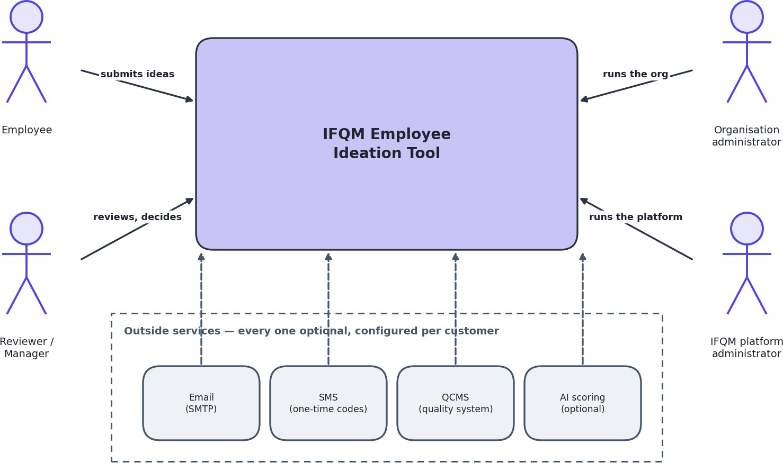
Legend: Boxes are systems. Arrows show who talks to whom. Dashed edges elsewhere in this document mean optional or not yet built.
Note the four outside services at the bottom. Every one of them is optional and is configured per customer. A customer can run the whole product with none of them connected, and many will.

The system opened up
The second diagram opens the box. There are three places where code or data lives: the visitor's browser, the application server, and the database.
Figure A-2 Containers - what runs where
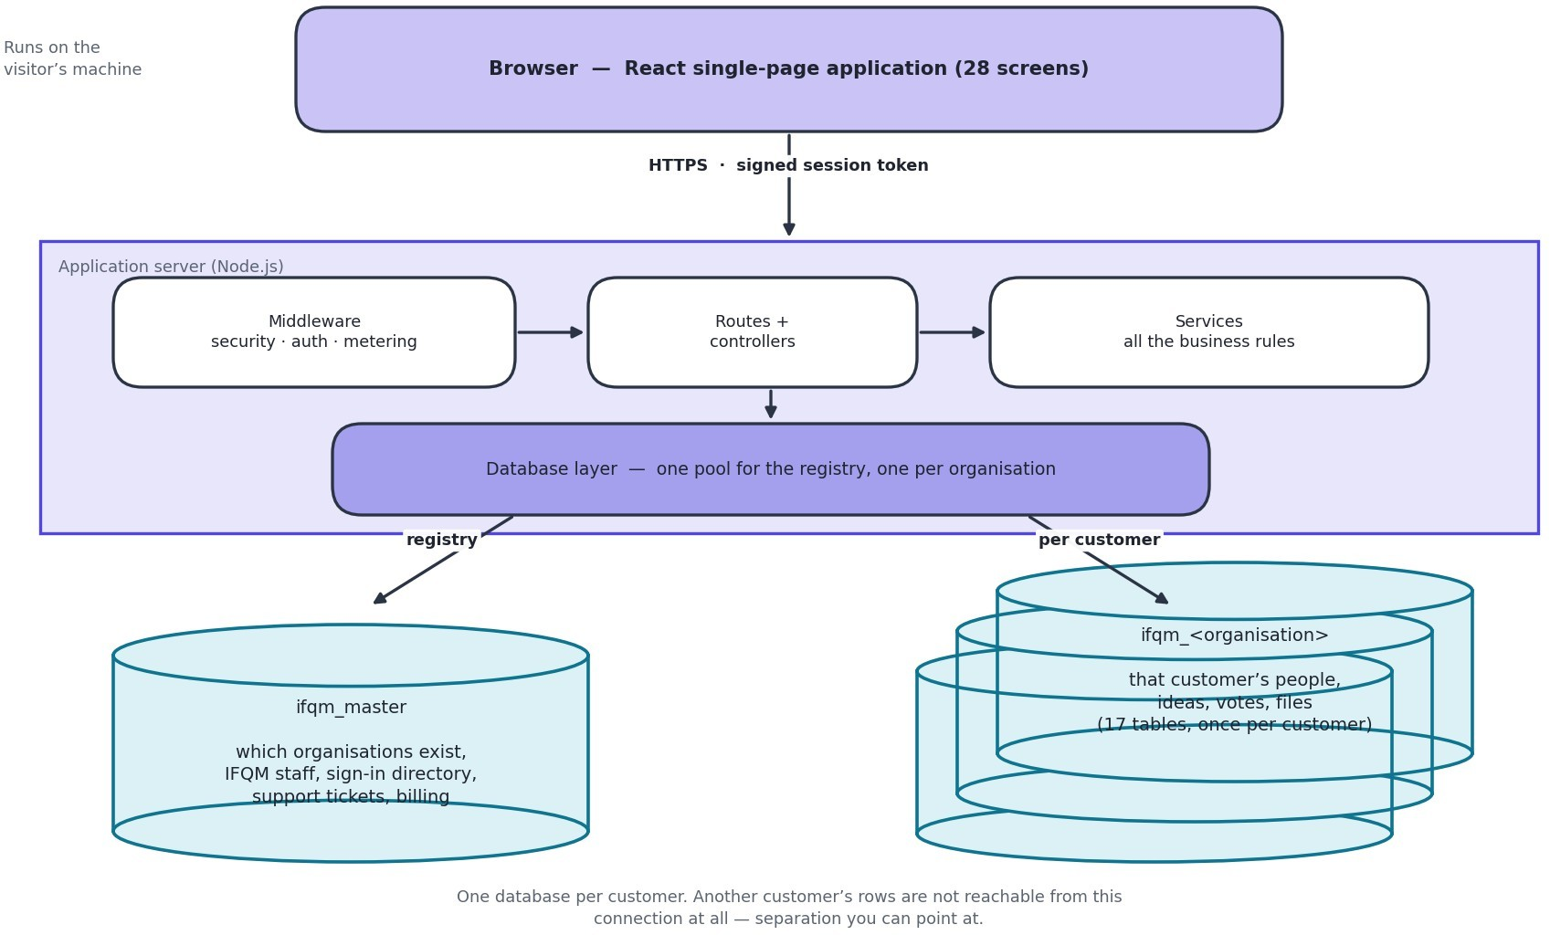
Legend: Vertical lines separate the three places code and data live. Every arrow is HTTPS or a database connection over TLS.
The single most important thing on this diagram is on the right: one database for the registry, and then a completely separate database for every customer organisation. That is what makes it impossible for one customer to see another's information.

Why it is built this way
Principle | What it means in practice | Why
One database per customer | Each organisation's people, ideas and files live in their own database. The registry only records which organisations exist and where each one lives. | Separation you can point at. A mistake in a query cannot leak across customers, because the wrong data is not in the connection at all.
Rules in one layer | All the business rules sit in the service layer. The web layer above only handles requests; the database layer below only fetches rows. | The rules can be tested directly, and a new way of reaching the system cannot accidentally bypass them.
Never trust the session alone | The signed-in user is read back from the database on every single request. | Removing someone, changing their role or resetting their password takes effect immediately rather than up to eight hours later.
Decide on the server | What a person may see is decided by the server. The screen is never the thing enforcing a rule. | A restriction that only exists in the screen is not a restriction. Anyone can read what was sent to their own browser.
Fail closed on setup, fail open on measurement | An unsafe configuration stops the server. A fault in logging or usage counting is written down and ignored. | Running insecurely is worse than not running. But a fault in counting should never become an outage for the customer.
Schema changes are deliberate | Deploying new code does not change the database. That is a separate, human step. | Automatic schema changes on deploy are how data gets lost.

Architecture Description
What each part is responsible for, and just as usefully, what it is not.

The screens
Component | Responsible for | Not responsible for
Single-page application | Drawing 28 screens, collecting input, showing results, holding the signed-in session in the browser, and switching language. | Deciding what anybody is allowed to see or do. It draws what it is given.
One API client file | Every call to the server goes through a single file, which attaches the session token and the organisation to each request. | Business rules. It is plumbing.

The server
Component | Responsible for | Not responsible for
Middleware chain | Security headers, allowed origins, rate limiting, identifying the user, choosing the organisation's database, and counting usage. Runs before everything else. | Anything specific to ideas, users or approvals.
Routes | Mapping a web address to a piece of code, and naming which roles may reach it. | Any rule beyond the role check.
Controllers | Reading the request, calling one service, sending the reply. | Business rules. A controller with an 'if' in it about ideas is a mistake.
Services | All the actual rules: what a valid idea is, who reviews it next, who may read the text, what a score means, when to award points. | Anything to do with HTTP. A service never sees the web request, which is why it can be tested on its own.
Database layer | Holding one connection pool for the registry and one per organisation, and handing back the right one. | Deciding who is allowed to use it.

The data
Component | Responsible for | Not responsible for
The registry | Which organisations exist, which database each uses, IFQM staff accounts, the sign-in directory, one-time codes, support tickets, sign-in history and usage counters. | Anything about an individual employee, or any idea. It is deliberately thin.
One database per organisation | That organisation's people, ideas, votes, comments, approval history, files and settings. 17 tables, repeated per customer. | Knowing that any other organisation exists.
Uploaded files | Attachments on disk, one folder per organisation, served only through a checked download. | Being reachable by a web address. There is no public link to a file.

Technology Stack
What the system is built from, and why each choice was made. Versions are the ones in the project files today.
Figure A-3 Technology stack
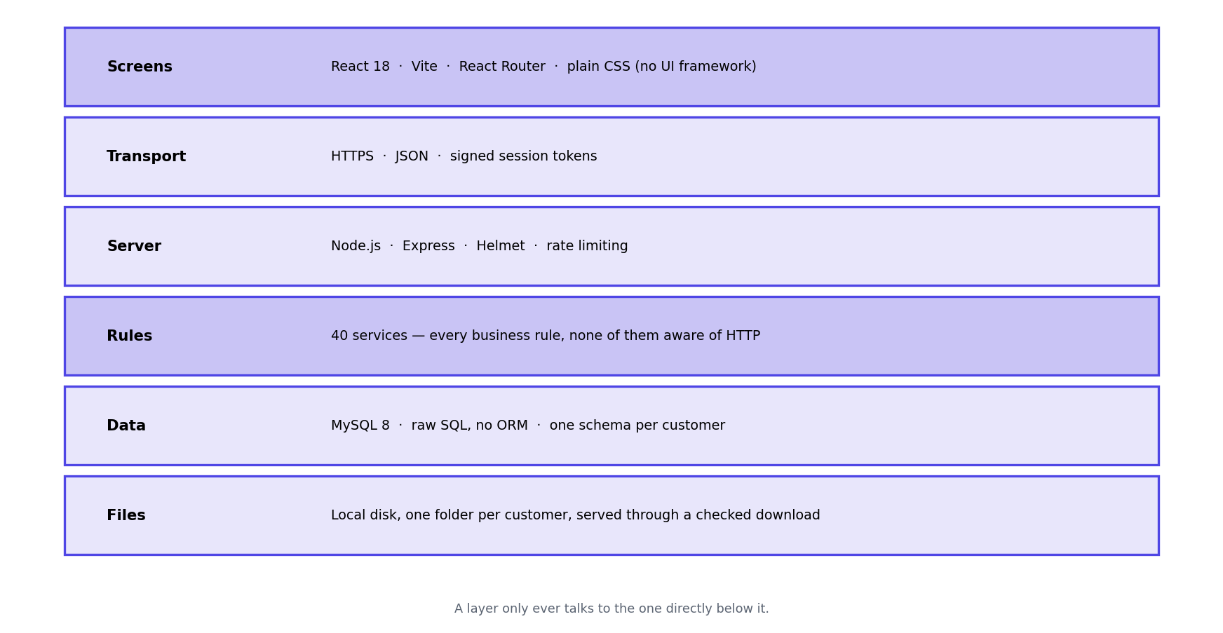
Legend: Each band is a layer. A layer only talks to the one directly below it.
Choice | Why this one
React with Vite | The screens are highly interactive - wizards, live filtering, overlays - which is what React is good at. Vite builds plain static files, so hosting the screens costs nothing and needs no server.
No UI framework | The design is a small set of CSS tokens and 18 shared components. A framework would have added a large dependency and a house style that would then need overriding everywhere.
Node.js with Express | The work is mostly waiting - on the database, on mail, on QCMS - which is exactly what Node is efficient at. Express is small enough that the whole request path can be read in one sitting.
MySQL | The data is strongly relational: people report to people, ideas belong to people, approvals reference both. It is also the database Indian hosting providers support best and the one most local administrators already know.
Raw SQL, no ORM | Multi-tenancy means picking a connection per request. An ORM would have added a layer between us and exactly the thing that matters most here, and hidden the queries that most need reviewing.
Signed tokens for sessions | The API holds no session state, so it can be restarted or run on two machines without logging anybody out. The security cost - a token that stays valid after a change - is removed by re-reading the user on every request.
Scoring built in by default | It works with no account, no API key and no cost, and no idea text leaves the system. An external provider is available but is off unless chosen.

Module and Component Structure
The server is organised in four layers plus a set of cross-cutting concerns. A request travels down the layers and the answer comes back up. No layer reaches past the one below it.
This section is the outside view - which layers exist and what belongs in each. Section 13 is the inside view of one of those layers: what a single module actually exports, what it keeps private, and which other modules it may call. The two are deliberately in different parts, because the first is a structural question and the second is a design one.
Figure A-4 Modules and their dependencies
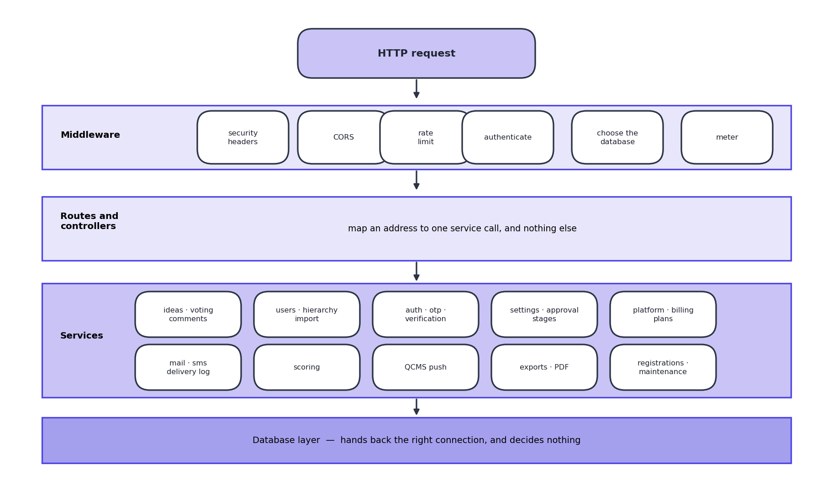
Legend: Top to bottom is the path of a request. A layer never reaches past the one below it; services never touch the web request directly.
There are 35 services. They are grouped here by what they are about rather than alphabetically, because that is how somebody looking for one would think about it. Section 13.2 names all 35.

The rule that keeps this honest
Every service takes a database connection as its first argument and never touches the web request. That one rule is what makes the services testable directly, and it is why a service cannot accidentally depend on who is calling it.
The clearest example is idea visibility. The rule about who may read a full proposal lives in one service function. The browse list, the detail screen and the idea board all call it. When the board was found to be bypassing it, the fix was to route it through the same function rather than to write the rule a second time.

Screens
Table 6.1 All 28 screens, grouped by who reaches them
Group | No. | Screens
Public | 3 | Landing page, sign in, apply for a workspace
Employee | 11 | Dashboard, my ideas, submit, challenges, all ideas, rejected ideas, idea board, leaderboard, profile, support, help
Reviewer | 1 | Review queue
Organisation admin | 4 | Admin panel (eight tabs: overview, ideas, users, hierarchy, categories, system, approved ideas, integration), analytics, audit trail, super admin
IFQM platform | 7 | Organisations, one organisation in detail, registrations, plans and billing, support tickets, sign-in activity, platform settings
Everywhere else | 2 | The forced password change screen, and the page shown for an address that does not exist
Alongside those sit 18 shared components that are not screens in their own right: the idea detail overlay, assign reviewers, review action, bulk import, bulk archive, the reporting-line lookup, the charts, the billing banner, breadcrumbs and the rest.

PART C - DETAILED DESIGN DIAGRAMS
Part B showed what the system is made of. This part shows what it does - the steps that happen when somebody presses a button, the shape of the data, and the screens themselves.

System Workflow
The life of an idea, from somebody having a thought to the saving being recorded. Everything else in the product exists to keep an idea moving along this path.
Figure D-1 Idea lifecycle
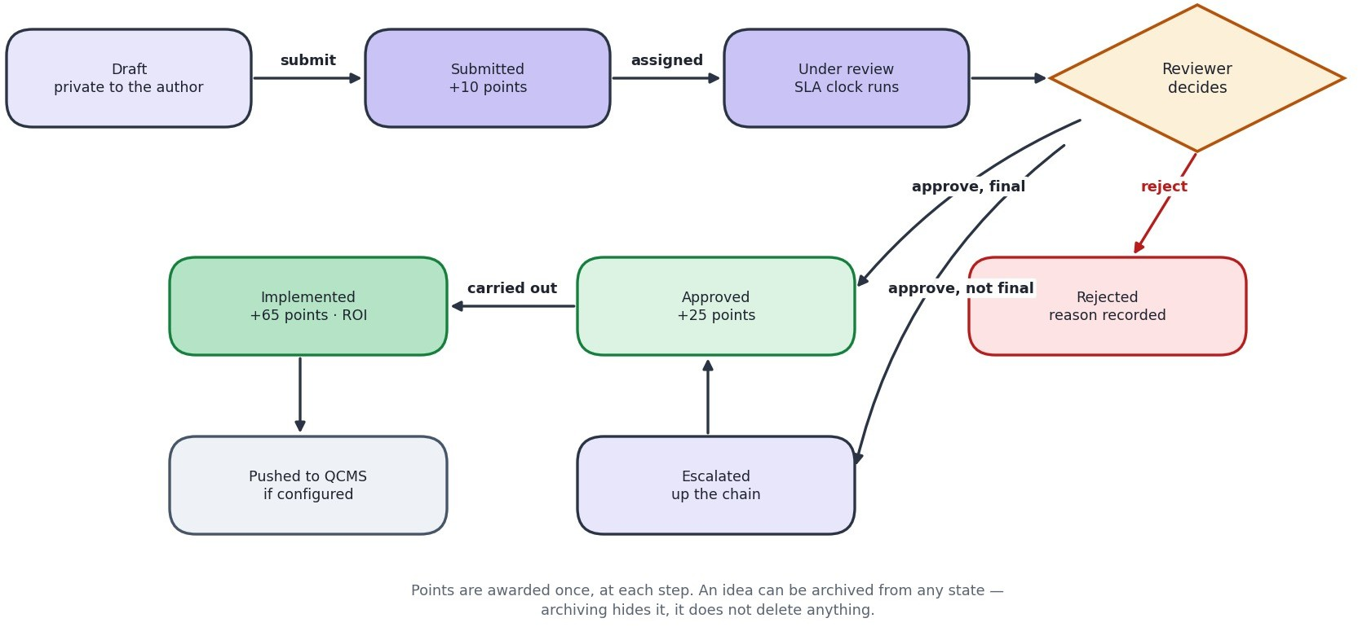
Legend: Rounded outcomes are the six states an idea can be in. Points are awarded once, at each step.
Points are awarded once at each step: 10 for submitting, 25 when approved, 65 when implemented. The larger number at the end is deliberate
- it rewards ideas that were actually carried out, not ideas that merely sounded good.

The two ways an idea can be approved
 | One reviewer at a time | A committee together
How it moves | Up the reporting line, one manager at a time | Everyone assigned sees it at the same time
Who decides | Each person in turn passes it on or closes it | A set share must agree, for example 75 per cent
Best for | Everyday improvements with a clear owner | Ideas that cross departments, or need several opinions
If nobody answers | Moves up a level automatically after the escalation period | Same

Two things worth being clear about
    - The review period and the escalation period are different. The first flags an idea as late so somebody chases it, and changes nothing. The second actually moves the idea to the next person. The escalation period should always be the longer of the two.
    - Rejection is not a dead end. The reason is kept, and rejected ideas have their own screen, because the reason an idea was turned down is one of the most reusable things in the system.

Data Flow
Where information comes from, what is done with it, and where it ends up. Two levels: the whole system as one process, then the same thing opened up.
Figure D-2 Data flow, level 0 (context)
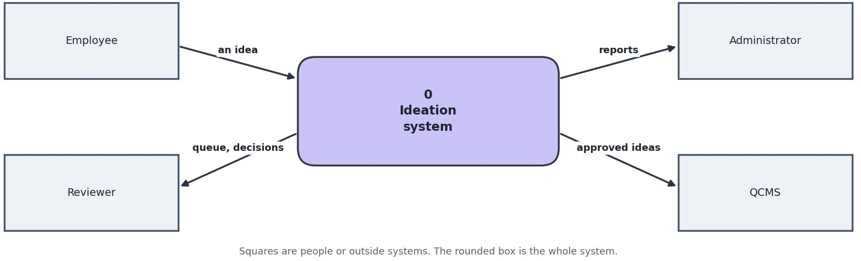
Legend: Squares are people or outside systems. The rounded box is the system. Arrows are data.
Figure D-3 Data flow, level 1 (inside the system)
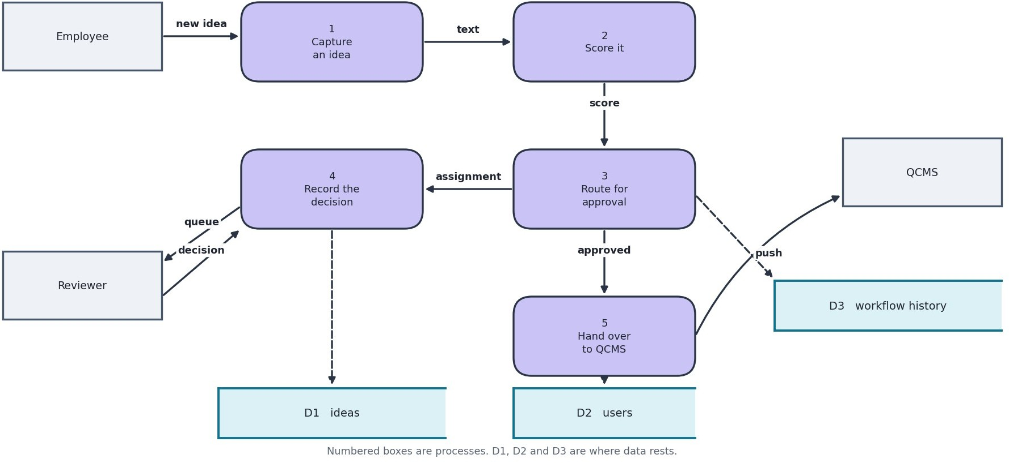
Legend: Numbered boxes are processes. D1, D2, D3 are stores of data. Arrows are named with what flows.
The two stores are worth noticing. D1 is shared by everybody and holds almost nothing about individuals. D2 exists once per customer and holds everything about their people and ideas. No process ever reads D2 for an organisation other than the one the signed-in user belongs to.

Database Design
There are two kinds of database. One registry, shared, holding as little as possible. Then one database per customer, holding everything about that customer.

The registry
Figure D-4 Registry tables and relationships
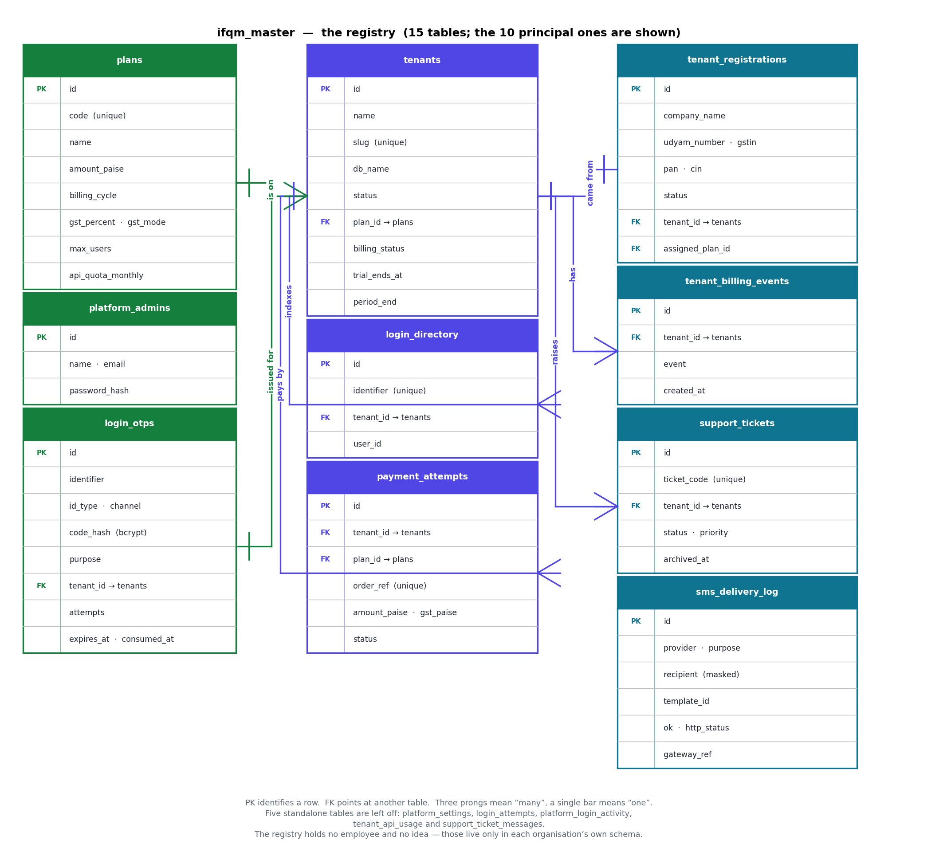
Legend: PK = the column that identifies a row. FK = a pointer to another table. Three prongs on a line mean 'many', a single bar means 'one'. 13 tables in the registry; the 7 principal ones are drawn.

One customer organisation
Figure D-5 Per-organisation tables and relationships
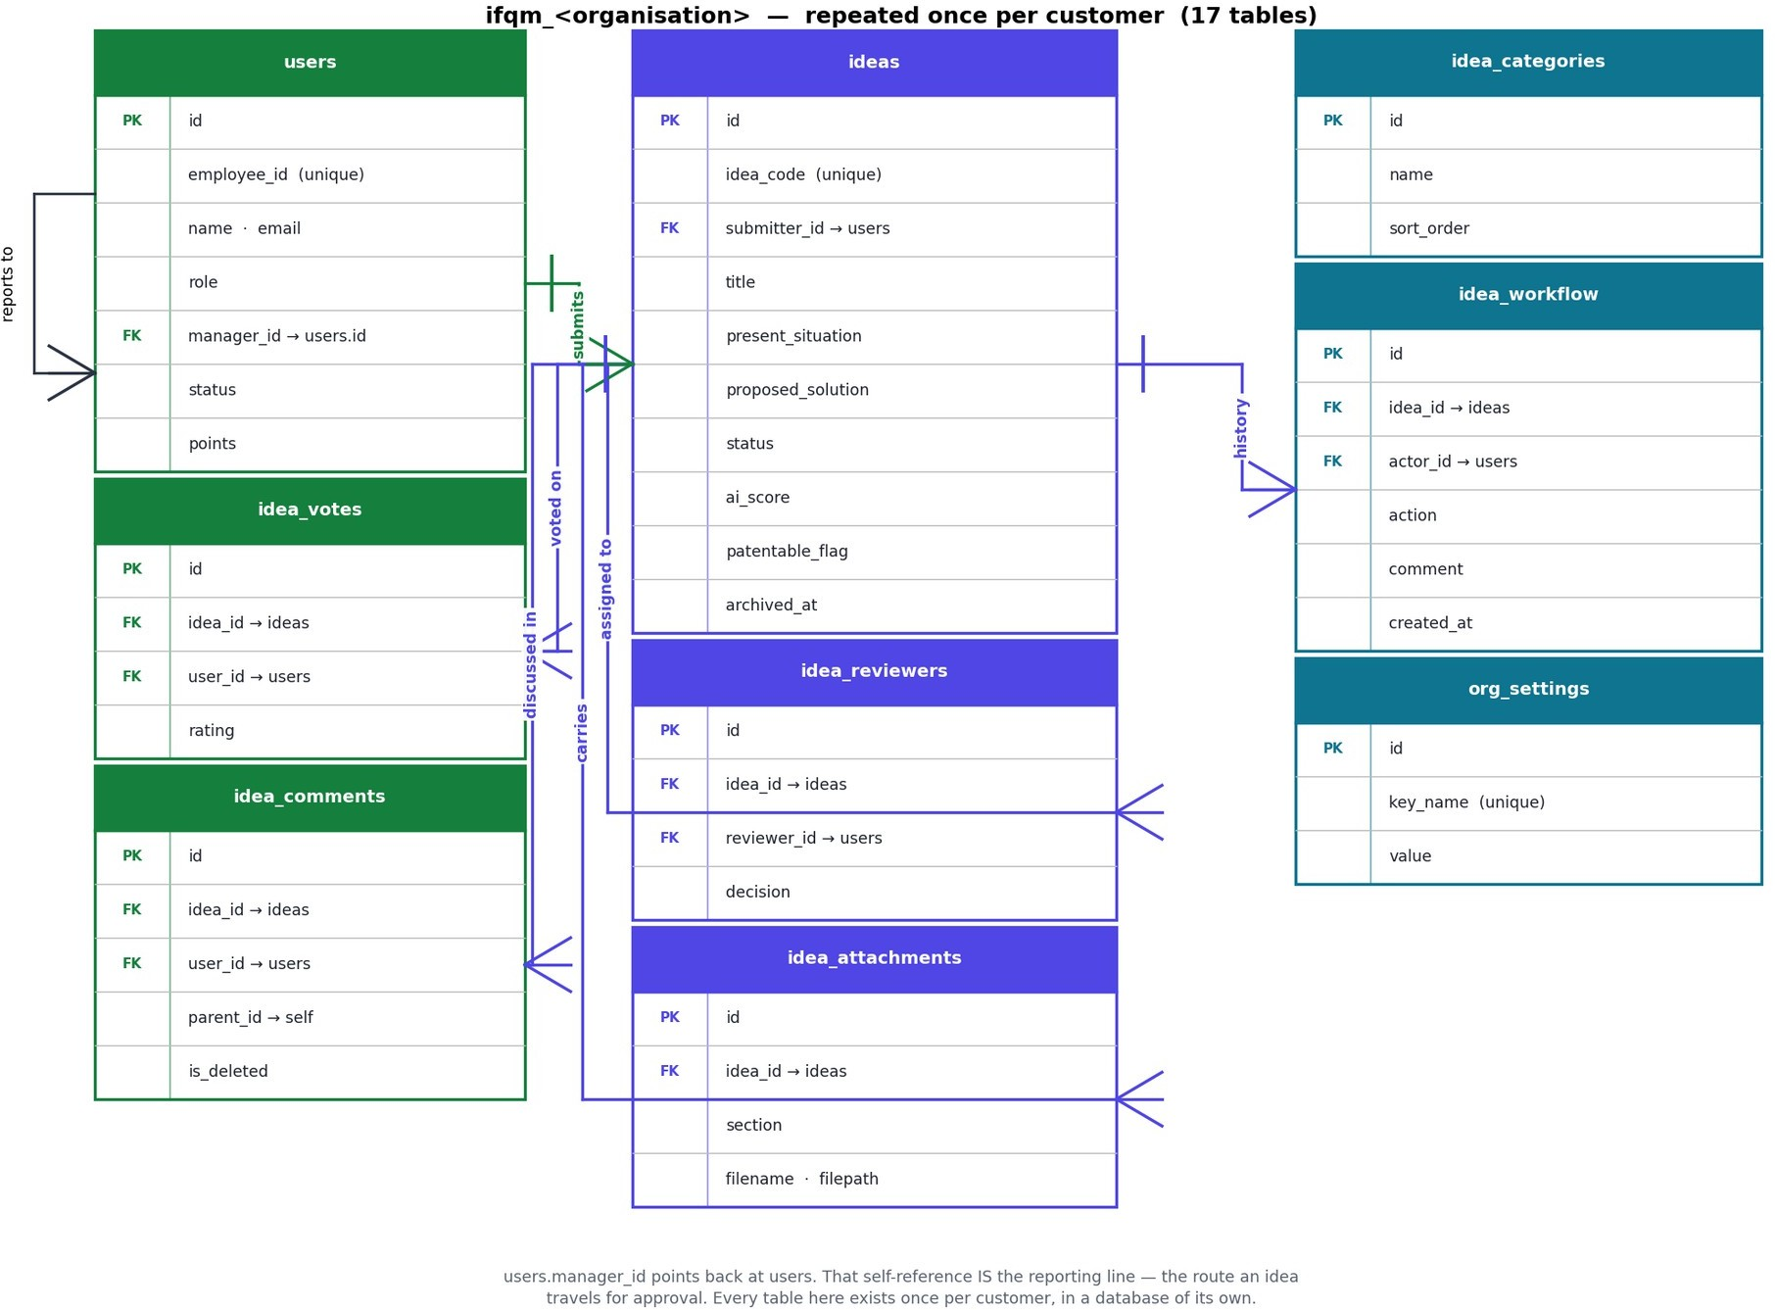
Legend: 17 tables per organisation, every one of them existing once per customer in a separate database. The 9 that carry the idea path are drawn; the remaining 8 (notifications, email_queue, password_reset_tokens, user_import_jobs, user_import_errors, idea_co_suggesters, idea_community_votes, challenges) hang off users or ideas without adding a relationship worth drawing.
The users table points at itself - that is the reporting line, and it is what ideas travel along when they escalate.

Design decisions in the data
Decision | Reason
Approval history is append-only | Every status change is written as a new row and nothing is ever edited. It is the audit trail, and an audit trail you can edit is not one.
Archiving is a date, not a delete | An archived idea keeps its points, its history and its recorded saving. It just leaves the working lists. Deleting would destroy exactly the evidence the scheme is measured on.
Patentability is its own column | An idea can be approved and not patentable, or turned down on cost and still worth filing. Folding it into the status would lose precisely those cases.
Both an estimate and a commitment for dates | One column is what the submitter guessed; another is what the owner committed to after approval. Keeping one column would lose the comparison.
Year of birth, not date of birth | The temporary first password uses only the year, so the day and month were personal data collected for nothing.
Settings are key and value | Each organisation has its own settings and new ones are added
rows | constantly. A column per setting would mean a schema change every time.
Tags stored as a short list in one column | The set of tags is fixed and small and is never queried relationally. A separate table would be ceremony with no benefit.

API Architecture and Specification
One HTTP interface, used by the screens and by nothing else at present. Everything lives under /api. There are 133 endpoints across 19 groups. Those figures, and the per-group counts in 10.5, are read out of the route files by a script rather than maintained by hand, because a hand-counted endpoint table is correct on the day it is typed and wrong a fortnight later.

Conventions
Aspect | Convention
Base path | /api. There is no version prefix - the only caller is the product's own screens, which are deployed together with the server. A version prefix would be added the day an outside party is given access.
Format | JSON in, JSON out, UTF-8. Uploads are multipart form data. Two endpoints answer with bytes rather than JSON: the attachment download and the idea PDF.
Success | An object with success set to true, plus named data. There is no generic "data" wrapper; the key says what it holds - ideas, user, subscription.
Failure | An object with success false and error set to one plain-English sentence, suitable for showing to a person unaltered. Some errors carry an extra field, such as retry_after on a lockout.
Authentication | A signed token in the Authorization header, as a Bearer token.
Organisation | Taken from the token, never from anything the caller can set freely. There is no tenant parameter on any endpoint.
Naming | Paths are lower case with hyphens; JSON fields are lower case with underscores, matching the column names they mostly come from.
Dates | Sent as strings. Timestamps are MySQL DATETIME in the server's zone; plain dates are YYYY-MM-DD. Anything that is not exactly YYYY-MM-DD is stored as empty rather than guessed at.
Paging | page and limit as query parameters where a list can grow. Lists are capped at 100 rows and the cap is applied by the server, not requested by the caller.
Idempotency | There are no idempotency keys. Where repeating a call would do harm - a second approval on one idea - the endpoint takes a named database lock and the repeat is refused with 409 rather than silently applied twice.

Authentication and authorisation
Every request carries the same header, and every guarded endpoint runs the same three checks in the same order. Nothing endpoint-specific happens before them.
Step | What is checked | Refusal
1 Token | Authorization: Bearer <token>. The signature and expiry are verified. | 401 with 'Not authenticated'
2 Freshness | The account is read back from the database and its password-change stamp compared with the one inside the token. | 401 - the session was opened before a password change, or the account is gone or deactivated
3 Role | The route names the roles allowed to reach it. Where the rule depends on the row rather than the | 403 with 'Insufficient permissions'
 | role - your own idea, your report's idea - the service checks again after loading it.
Ten endpoints have no token check, and they are exactly the ones that cannot: the eight sign-in and password-reset calls under /auth, and the two under /registrations. Every other endpoint in the system is guarded. Of the ten, only the two registration endpoints are reachable by somebody who has no account at all, which is what makes them the pair worth watching.

Status codes
Code | Means | Typical cause
200 | Done | Everything, including creations - the API does not use 201
400 | The request is wrong | A required field is missing, a value is not in the allowed set, an organisation code is the wrong length
401 | Not signed in, or no longer signed in | No token, a tampered or expired token, a wrong password, a session opened before a password change
403 | Signed in, but not allowed | The role does not reach this route, or the row belongs to somebody else
404 | No such thing | An unknown id, or an unknown path - which answers 'Unknown action' rather than an HTML page
409 | Conflicts with the current state | The application was already approved, the organisation code is taken, the idea is being decided by somebody else right now
413 | Too large | The upload exceeds the organisation's own limit, or its storage allowance is full
429 | Too many | Rate limited by address, locked out after five wrong passwords, or over the plan's monthly request allowance
500 | A fault on our side | Always the generic sentence. The detail - table names, file paths, stack - goes to the log, never to the caller

Rate limits and quotas
Limit | Applies to | Allowance | On breach
Global | Each calling address | 300 requests per minute, configurable | 429 'Too many requests. Please slow down.'
Sign-in | Each calling address, on /auth | 30 attempts per 15 minutes, configurable | 429 'Too many authentication attempts.'
Heavy operations | Each calling address, on bulk import and similar | 10 per hour | 429
Account lockout | One account | 5 wrong passwords, then 15 minutes | 429 carrying retry_after in seconds
Plan allowance | One organisation | The monthly figure on its plan | 429 - but sign-in, support, notifications, branding, settings and the health checks are always let through, so an organisation  over its allowance can still
 |  |  | get in and raise a ticket

The endpoint map
All 19 groups. Counts are from the route files as they stand.
Table 10.1 Every route group, with its endpoint count
Group | No  . | What it covers | Who may call it
/platform | 35 | Organisations and their detail, the registration queue, plans and billing, support tickets, platform settings, sign-in activity | IFQM platform staff only - a blanket guard on the whole group
/users | 18 | People, bulk import, the reporting line, the hierarchy template, role and department filters | Organisation admin, except the lookups every signed-in user needs
/ideas | 18 | Submit and draft, list, read, duplicate check, review actions, committee assignment, savings, implementation, archive, patentability | Signed-in, then narrowed per route: reviewer roles to decide, admin to archive
/auth | 10 | Sign in, sign out, one-time codes, password reset and change | Eight are open by necessity; change-password needs a session
/votes | 8 | Ratings, up and down votes, the idea board | Signed-in
/challenges | 5 | Time-limited campaigns | Signed-in to read, admin to run
/support | 5 | Tickets raised by a customer and their messages | Signed-in
/settings | 4 | One organisation's own settings, an email test, and its subscription | Reading is open to the organisation; writing is admin
/export | 4 | Ideas and leaderboard spreadsheets, analytics, single-idea PDF | Signed-in; analytics is restricted to senior roles
/branding | 4 | Logo and colours | Anyone reads, admin writes
/integrations | 4 | The QCMS key, the approved-ideas list, and the push | Organisation admin
/comments | 3 | Threaded comments on an idea | Signed-in
/categories | 3 | The organisation's own idea categories | Signed-in reads, admin writes
/upload | 3 | Attach a file, download one through a check, remove one | Signed-in
/registrations | 2 | A business applying for a workspace, and the live email check | Open. The only pair reachable without an account
/score | 2 | Re-score an idea, and explain a score | Signed-in
/notifications | 2 | The unread list, and marking them read | Signed-in
/reports | 2 | Analytics figures behind the charts | Signed-in, scoped by role
/leaderboard | 1 | The ranked contributor list | Signed-in

Endpoint specifications
Ten endpoints in full. They were chosen to cover every shape the API takes: an open call, a guarded write, a redacted read, a role-guarded state change, a file in, a file out, a provisioning call, an outbound integration, and a billing read.
10.6.1
POST
/api/auth/logi n
Purpose | Exchange an email address or phone number and a password for a session.
Auth | None. This is the call that creates one.
Request | { "email": "priya@acme.co.in", "password": "...", "org_slug": "acme", "client_timezone": "Asia/Kolkata" }
Fields | email accepts an email address, a registered phone number, or an employee number. org_slug is optional - left out, the organisation is resolved from the sign-in directory. client_timezone is optional and is used only to describe roughly where a platform-admin sign-in came from.
200 | { "success": true, "user": { "id": 41, "name": "Priya S", "role": "employee", "points": 120, "must_change_password": false }, "token": "eyJ..." }
400 | "Email and password are required."
401 | "Invalid email/phone or password. 3 attempt(s) remaining."
429 | "Too many failed attempts. Please try again in 15 minute(s)." - plus retry_after in seconds
Notes | A wrong password, an unknown account and a deactivated account all answer the same way and take the same time, because a password check runs against a dummy hash even when nothing matched. Every attempt, successful or not, is written to the sign-in record.
10.6.2
POST
/api/ideas/sub mit
Purpose |  | Submit an idea, or convert one of the author's own drafts into a submission. POST  /api/ideas/draft is the same call with the same body and saves a draft instead.
Auth |  | Any signed-in user.
Request |  | { "title": "...", "present_situation": "...", "proposed_solution": "...", "impact_areas": "Quality,Cost", "impact_level": "High", "tangible_benefit": "...", "investment_required": "Under Rs 50,000", "feasibility": "High", "time_required": "3_6m", "solution_tags": ["quality","cost"], "co_suggester_ids": [12, 19, 24], "is_anonymous": false, "id": 142 }
Required |  | title, present_situation, proposed_solution. Everything else is optional - a half-formed idea is still worth capturing, and a reviewer can ask for the rest. id is present only when editing an existing draft.
Validated |  | feasibility must be Low, Medium or High; time_required one of three bands; solution_tags are filtered against a fixed set. An unrecognised value is stored as empty rather than creating a fourth band or a one-off tag that every filter would then miss.  The author is dropped from their own co-suggester list, as are duplicates.
200 |  | { "success": true, "idea_id": 142, "idea_code": "EIT-0142", "ai_score": 78, "points_added": 10 }
400 |  | "Title, present situation and proposed solution are required."
Side effects |  | Scores the idea, sets the review due date from the organisation's SLA, routes it to the author's line manager, writes a workflow entry, awards 10 points, and queues an email. Points are awarded once: re-submitting an already-submitted idea returns points_added 0.
Notes |  | Two submissions in the same instant can collide on the generated idea code. The insert is retried with a fresh code rather than surfacing a 500 on a perfectly valid submission.
10.6.3
GET
/api/ideas
Purpose | The list of ideas this person is allowed to see.
Auth | Any signed-in user. The scope is worked out from the role, not requested.
Query | search, status, impact, archived, tag, time_required - all optional
200 | { "success": true, "ideas": [ { "id": 142, "idea_code": "EIT-0142", "title": "...", "solution_summary": "First sentence only.", "solution_redacted": true, "ai_score": 78, "status": "Under Review", "submitter_name": "Priya S", "created_at": "2026-07-02 11:04:19" } ] }
Guaranteed absent | proposed_solution and present_situation are set to empty on every row of this response, for every caller including an administrator. The full text is only ever served by 10.6.4. Where the organisation has closed the solution section altogether, solution_summary is emptied too and solution_hidden_by_policy is set.
Scope | An employee sees their own ideas in full and everybody else's as title and status. A manager additionally sees their reports'. A plant head, executive or administrator sees all of them.
Notes | This endpoint used to select every column, so the whole text of every idea reached every employee's browser while the screen showed only a snippet. Truncating on screen is not privacy - see ADR-005.
10.6.4
GET
/api/ideas/:id
Purpose | One idea, with as much of it as this reader is entitled to.
Auth | Any signed-in user. Entitlement is decided per row.
200 | { "success": true, "idea": { "id": 142, ..., "proposed_solution": "...", "solution_redacted": false, "viewer_inside": true, "workflow": [ ... ], "attachments": [ ... ], "comments": [ ... ] } }
Redaction | The author, the co-suggesters and anybody in the approval chain always read the full text - viewer_inside is true. For everybody else the organisation's own setting decides: the full text, a preview of a set length, or nothing. solution_redacted says which happened, so the screen can explain rather than appear broken.
403 | "Insufficient permissions." - the idea belongs to another part of the organisation this reader has no line to
404 | "Not found." - and the same answer for an id in another organisation, which is
 | unreachable from this connection in any case
10.6.5
POST
/api/ideas/revi ew-action
Purpose |  |  | Approve, reject or pass an idea onward, with a reason.
Auth |  |  | Reviewer roles: team lead, project lead, manager, department manager, senior manager, plant head, executive, admin, super admin. The service then checks that this particular reviewer is the one the idea is waiting on.
Request |  |  | { "idea_id": 142, "decision": "approve", "comment": "Costed and worth doing." }
200 (passed on) |  |  | { "success": true, "decision": "Escalated", "escalated_to": "R Kulkarni", "points_awarded": 0 }
200 (final) |  |  | { "success": true, "decision": "Approved", "points_awarded": 25 }
403 |  |  | This person is not the reviewer this idea is waiting on
409 |  |  | "This idea is being updated by someone else. Please try again."
Concurrency |  |  | The whole decision is taken under a named database lock keyed on the idea. A double-tapped Approve button used to read 'no recent action' twice and write two, so an idea could be approved five times with five audit entries. The lock lives in MySQL rather than in the process, so it holds across two servers.
Side effects |  |  | Appends to the idea's history, awards points, notifies the next reviewer or the author, and queues an email.
10.6.6
POST
/api/upload
Purpose | Attach a file to one section of an idea.
Auth | Any signed-in user, who must own the idea being attached to.
Request | multipart/form-data with file, idea_id and section. section is one of situation, solution, benefits, support.
200 | { "success": true, "filename": "EIT-0142-1722512345-plan.pdf" }
Accepted | pdf, png, jpg, jpeg, gif, xlsx, xls, csv, docx, doc
400 | "File type not allowed.", "No file uploaded.", or "File exceeds this organisation's 5 MB limit."
403 | "Unauthorized or idea not found."
413 | The organisation's total storage allowance would be exceeded
Notes | The size limit is the organisation's own setting, not a fixed 10 MB. No public URL is returned and none exists - the file is only reachable through 10.6.7.
10.6.7 GET
/api/upload/:id/down load
Purpose |  |  |  |  |  | Fetch an attachment, after checking that this reader may have it.
Auth |  |  |  |  |  | Any signed-in user. The attachment must belong to an idea in this organisation that this reader may see.
200 |  |  |  |  |  | The file itself, as bytes. Not JSON.
Headers sent |  |  |  |  |  | Content-Disposition: attachment - never inline, so an uploaded file cannot execute in the application's own origin. Plus X-Content-Type-Options: nosniff, a sandboxing Content-Security-Policy, and Cache-Control: private, no-store so it stays out of shared caches.
403 |  |  |  |  |  | "This attachment is not available." or "Invalid attachment path."
404 |  |  |  |  |  | "Attachment not found." or "File missing on disk." - the second is what a lost file on the current hosting looks like; see section 21.2
10.6.8 POST
/api/platform/registrations/:id/a pprove
Purpose |  |  |  |  |  |  | Approve an MSME application, which provisions their workspace.
Auth |  |  |  |  |  |  | IFQM platform staff only.
Request |  |  |  |  |  |  | { "slug": "acme", "plan_id": 3, "trial_days": 14, "billing_note": "Rate agreed with the regional office." }
Fields |  |  |  |  |  |  | slug is the organisation code and defaults to the one proposed on the application. plan_id and trial_days are chosen by the approver, who has the company's headcount and turnover in front of them at that moment. Left out, trial_days falls back to the platform default of 14.
What it does |  |  |  |  |  |  | Creates the database, builds all 17 tables, creates the first administrator, registers the organisation, assigns the plan and starts the trial clock - as one sequence.
200 |  |  |  |  |  |  | { "success": true, "tenant_id": 12, "slug": "acme", "admin_email":  "ops@acme.co.in", "temp_password": "..." }
400 |  |  |  |  |  |  | "Organisation code must be 2-30 characters."
409 |  |  |  |  |  |  | "This application has already been approved." or "Organisation code \"acme\" is taken. Approve with a different code."
Notes |  |  |  |  |  |  | The temporary password is returned exactly once and is never retrievable again - it is not stored in readable form anywhere. The operator relays it out of band and the new administrator must change it at first sign-in.
10.6.9 POST
/api/integrations/ push
Purpose |  |  |  | Hand approved ideas to the QCMS quality system.
Auth |  |  |  | Organisation admin.
Request |  |  |  | { "idea_ids": [142, 155], "only_pending": true }
200 |  |  |  | { "success": true, "attempted": 2, "imported": 1, "duplicate": 1, "failed": 0, "results":  [ { "id": 142, "idea_code": "EIT-0142", "status": "imported", "message": "..." } ] }
400 |  |  |  | "QCMS integration is turned off. Enable it and save your API key first." or "No QCMS API key saved."
Partial success |  |  |  | The call answers 200 even when some ideas failed. Each idea carries its own status, because refusing the whole batch over one bad row would mean redoing the ones that worked.
Duplicates |  |  |  | A duplicate is counted as success, not failure. The idea has arrived; retrying would create a second copy in the customer's quality system.
10.6.10 GET
/api/settings/subscri ption
Purpose |  |  |  |  | Where this organisation's account stands, and how long is left. This is what the banner across the top of the screen reads.
Auth |  |  |  |  | Any signed-in user of the organisation. It carries no other organisation's figures and no price the caller is not already paying.
200 |  |  |  |  | { "success": true, "subscription": { "billing_status": "trial", "state": "trial", "days_left": 6, "blocked": false, "trial_ends_at": "2026-08-16", "label": "Trial - 6 day(s) left" },  "plan": { "code": "STARTER", "name": "Starter", "amount_paise": 250000, "billing_cycle": "monthly", "gst_percent": 18, "gst_mode": "included", "max_users": 100 }, "quota": { "monthly": 60000, "used_month": 4120, "percent": 7, "source": "plan", "enforced": true } }
Money |  |  |  |  | Always whole paise, never rupees as a decimal. Rounding errors on money are the kind of bug that gets found by a customer.
blocked |  |  |  |  | True once a trial or paid period has lapsed. The screens read this to put the workspace on hold. An organisation with no end date on file is never blocked - locking somebody out because a field was left empty is the wrong way round.

Use Cases
Who can do what. The important line on this diagram is the one around the IFQM platform administrator: they sit outside the organisation and can never reach idea content, however senior they are.
Figure D-6 Use case overview
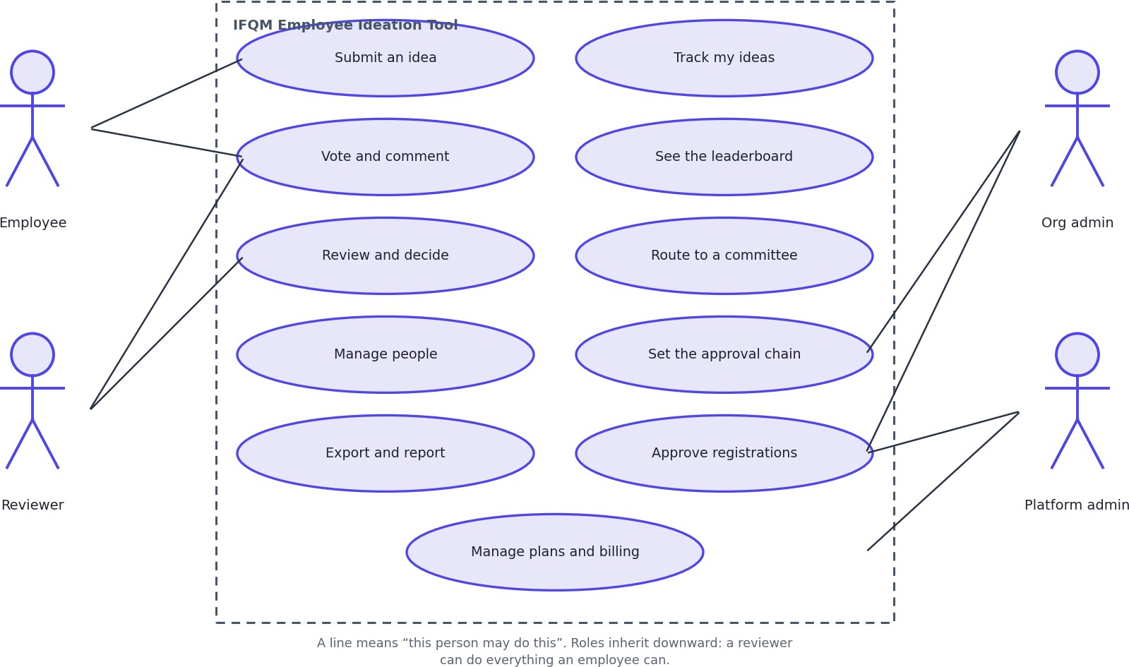
Legend: Stick-figure equivalents are on the left. Round brackets are things the system does.

Sequence Diagrams
Five journeys, chosen because each one shows something that is not obvious from the structure alone.

Signing in
Figure D-7 Sign in with a password
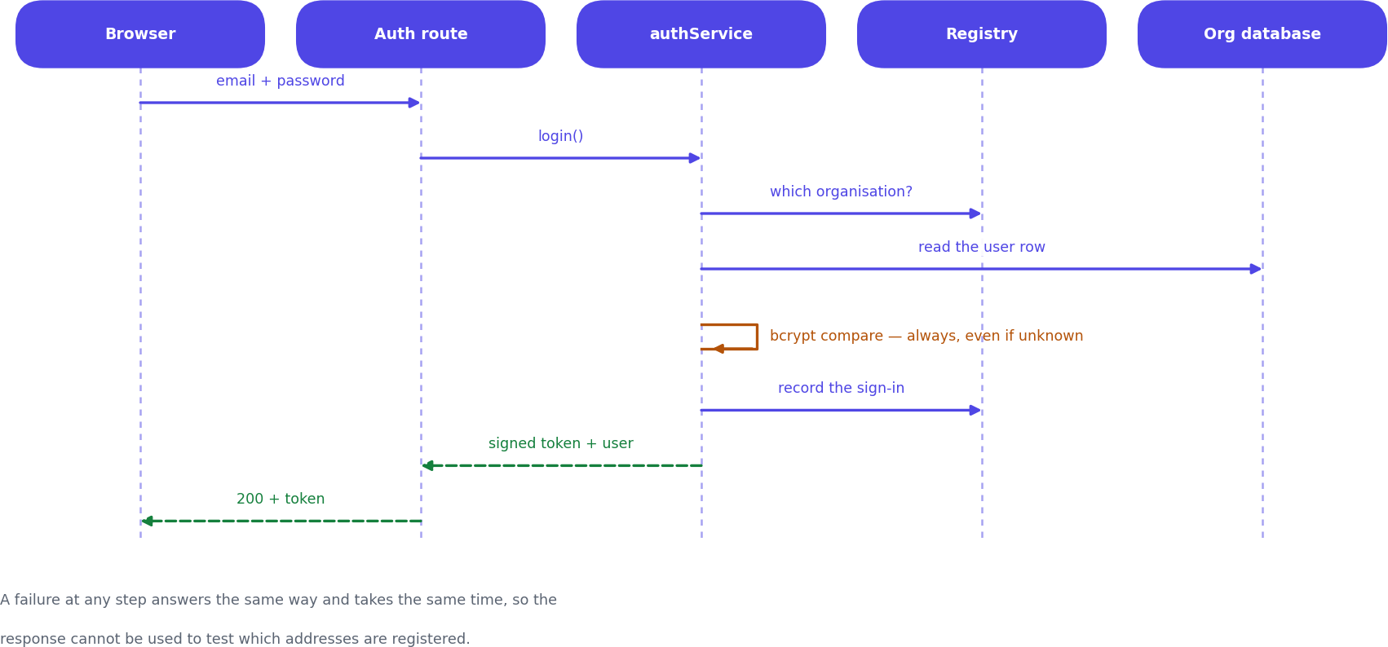
Legend: Each column is a participant and time runs downward. A solid arrow is a call, a dashed arrow is the answer to it, and a box across a column is that participant doing work. The database read on the far right is the per-request re-check that makes a removal or a demotion take effect immediately.

Submitting an idea
Figure D-8 Submit an idea
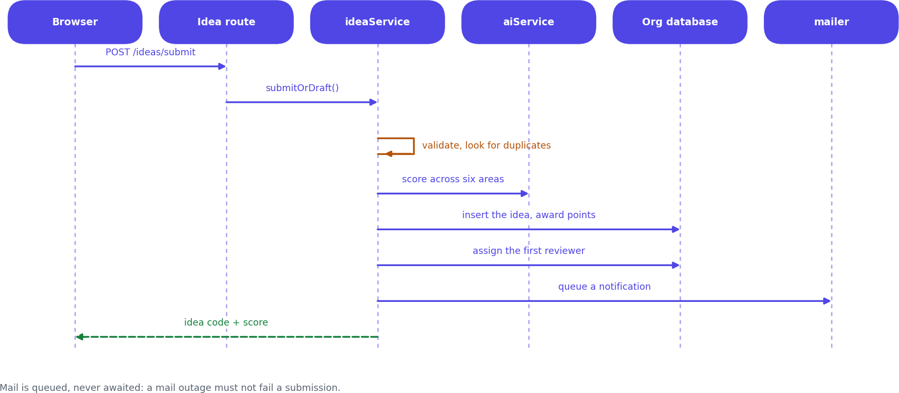
Legend: Each column is a participant and time runs downward. A solid arrow is a call, a dashed arrow is the answer to it, and a box across a column is that participant doing work. Scoring, the workflow entry, the points award and the email all happen before the submitter is answered, except the email, which is queued.

Reviewing and escalating
Figure D-9 A decision, and what happens when nobody decides
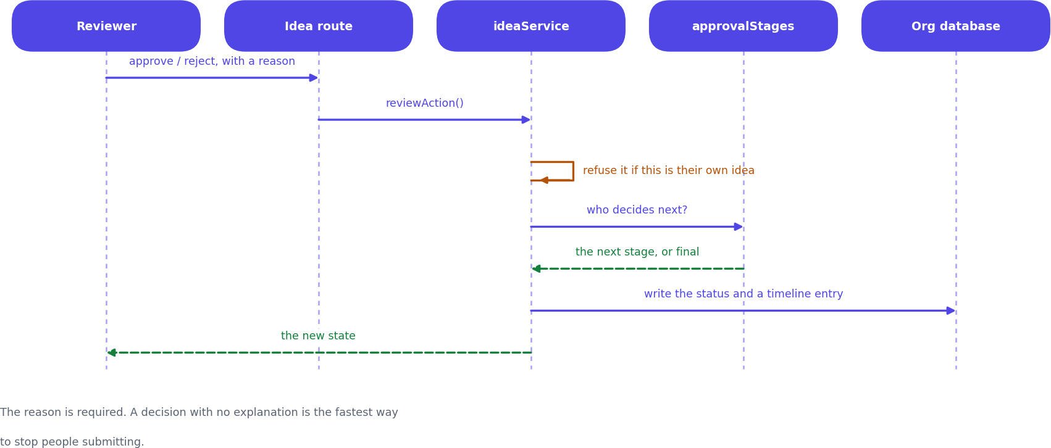
Legend: Each column is a participant and time runs downward. A solid arrow is a call, a dashed arrow is the answer to it, and a box across a column is that participant doing work. The whole decision runs inside a named database lock, so two clicks in the same instant cannot both be recorded.

A business applying for a workspace
Figure D-10 MSME registration and approval
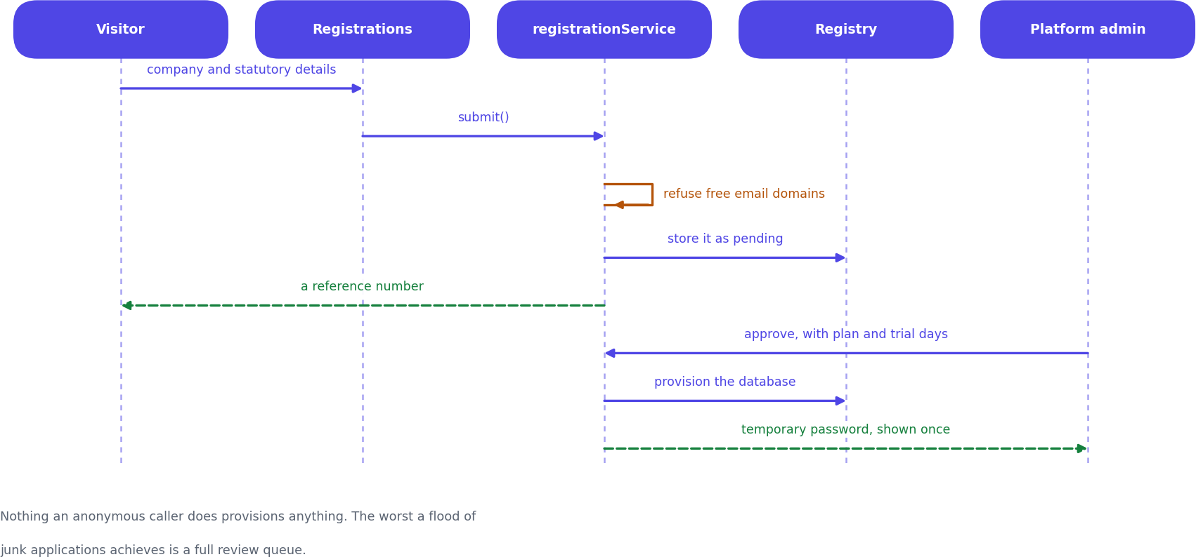
Legend: Each column is a participant and time runs downward. A solid arrow is a call, a dashed arrow is the answer to it, and a box across a column is that participant doing work. Nothing on the left half of this diagram creates anything. The database is not built until a human on the right approves.

Handing an idea to QCMS
Figure D-11 Push an approved idea to QCMS
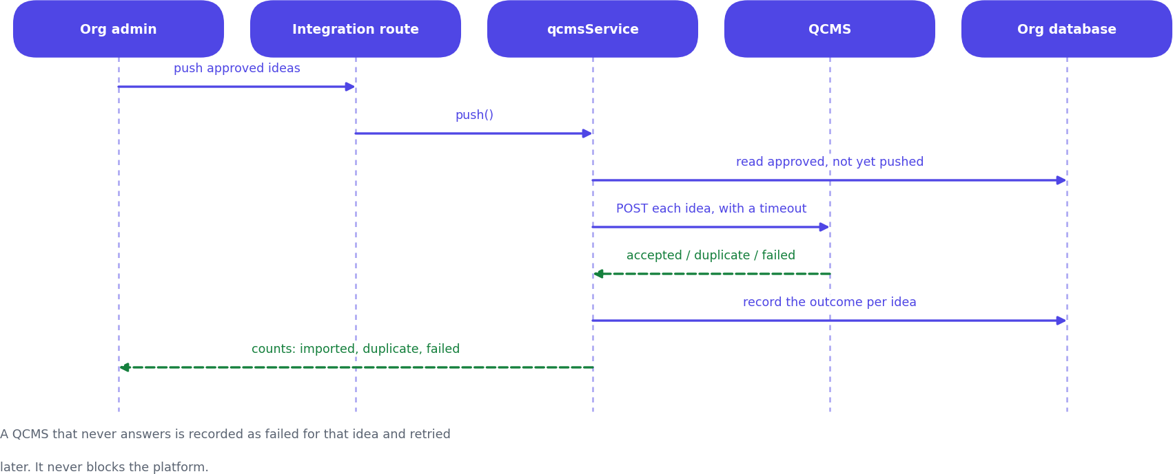
Legend: Each column is a participant and time runs downward. A solid arrow is a call, a dashed arrow is the answer to it, and a box across a column is that participant doing work. A duplicate answer from QCMS is recorded as success, not failure - the idea has arrived, and retrying would create a second copy.

Module and Service Structure
There is no class diagram in this document, and this section explains why rather than leaving a reader to notice the absence.
The server is not written in classes. It is written as ES modules that export plain functions - 35 service modules, none of which declares a class, holds instance state or takes part in an inheritance hierarchy. Drawing boxes labelled IdeaService with a compartment of methods would describe a design nobody wrote, and would suggest objects being constructed and held that do not exist anywhere in the codebase.
So the unit of structure here is the module, and that is what is drawn: each module, the functions it exports, the ones it keeps to itself, and which modules it is allowed to call. The notation is the familiar one - a plus sign is exported and callable from elsewhere, a minus sign is private to the file - because it is the meaning people already have for those symbols, not because a class is implied.
Figure D-12 Module structure, taking the idea path as the example
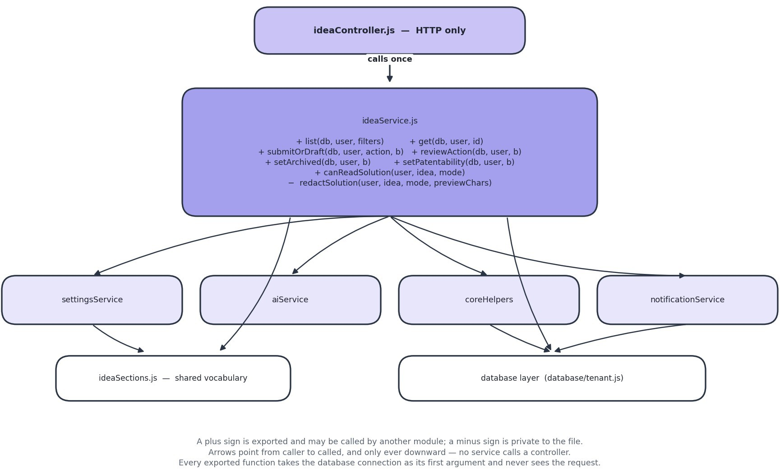
Legend: Boxes are modules, not classes - there are no classes in this codebase. A plus sign is an exported function; a minus sign is private to the file. Arrows point from caller to called and only ever travel downward.
One path through the system, drawn in full. There are 35 service modules; every one of them follows this same shape - a controller above it that only handles HTTP, the database connection passed in as the first argument, and calls that only ever travel downward.

What holds the structure together
Rule | What it means | Why it matters
A service never sees the request | Every exported function takes the database connection first and plain values after. There is no req, res or session object inside the services folder. | The rules can be called directly from a test, and a service cannot come to depend on who is calling it or how.
Calls only go | Controllers call services; services call | The dependency graph has no
downward | other services, helpers and the database layer. No service calls a controller. | cycles, so any module can be read on its own.
Shared vocabulary lives in its own module | ideaSections.js holds the list of idea section names and the rule for which of them an employee may see. It imports nothing. | Without it, settingsService and ideaService would each need the other, which is a circular import - the concrete reason that module exists.
The role check happens twice | The route names the roles that may reach it; the service checks again once it has loaded the row. | The route check cannot know whether this idea is yours. Only the service, holding the row, can decide that.

The modules, grouped by what they are about
Table 13.1 All 35 service modules
Group | Modules
Ideas | ideaService, ideaSections, ideaPdfService, votingService, commentService, challengeService, categoryService, approvalStages
People | userService, userImportService, hierarchyTemplateService, directoryService, leaderboardService
Access | authService, otpService, smsService, hashPool
Organisation | settingsService, brandingService, notificationService, supportService, activityService
Platform | platformService, platformSettingsService, registrationService, planService, subscriptionService
Outward | qcmsService, integrationService, mailerService, aiService
Output | exportService, reportService, uploadService
Shared | coreHelpers

User Interface and Screen Flow
How somebody moves through the product, and roughly what the main screens look like. These are layouts, not final visuals.
Figure D-13 Screen flow
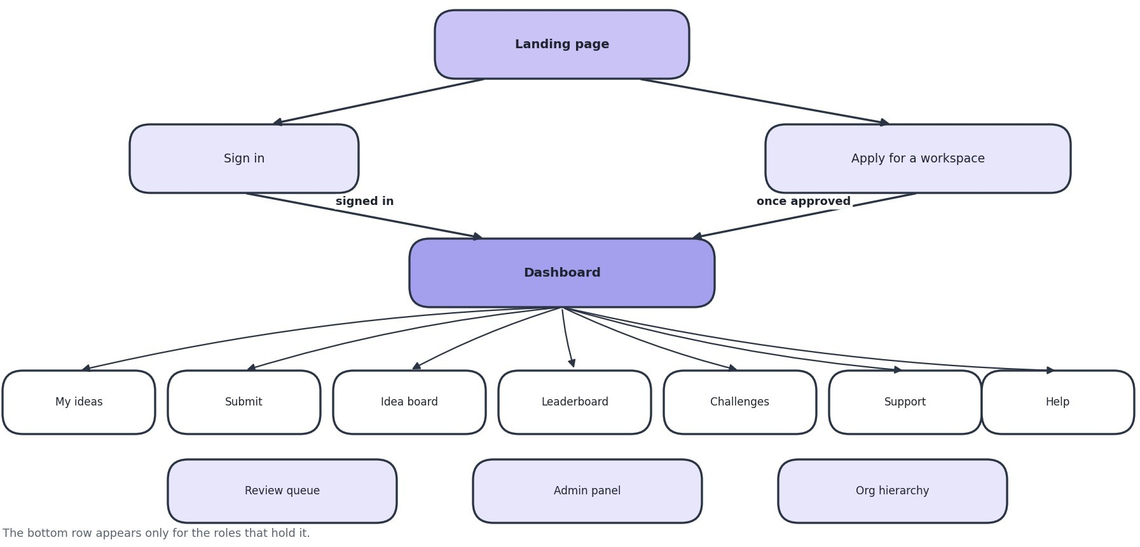
Legend: Boxes are screens. The path from the landing page to a signed-in screen is the same for everybody.
Figure D-14 Wireframes of the main screens
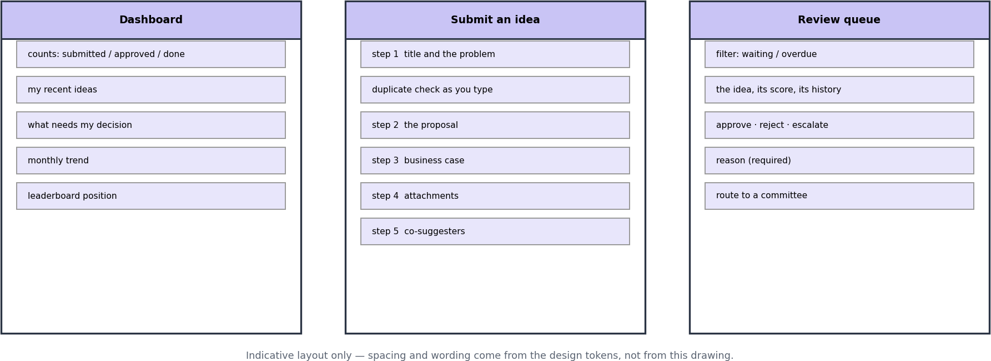
Legend: Rough layouts, not final visuals. Square brackets are controls.

Interface principles
Principle | What it means
The landing page explains before it asks | A business arriving for the first time gets an explanation of the product, not a password box. Signing in is one click away for people who already have an account.
Long forms are broken into steps | The submission form is six short steps rather than one long page, so nothing is abandoned halfway.
Jargon is explained where it appears | 60 small information buttons sit beside technical terms. They open on hover for a mouse, on tap for a phone, and on keyboard focus. A phone user gets the same help as everybody else.
Required fields are obvious before the error | Marked with a red asterisk. Previously they were the same colour as the label and read as punctuation.
Detail opens over the list | Reading an idea does not lose your place in the list you were working through.
Colour is never the only signal | Feasibility is red, amber and green, but always with the word as well.
Everything works in seven languages | Chosen per person, not per organisation, because a shop floor and an office rarely share one language.

PART D - RUNNING THE SYSTEM
- Deployment Architecture
Where the system runs today, and how a change gets from a developer's machine to the live site.
Figure A-5 Deployment
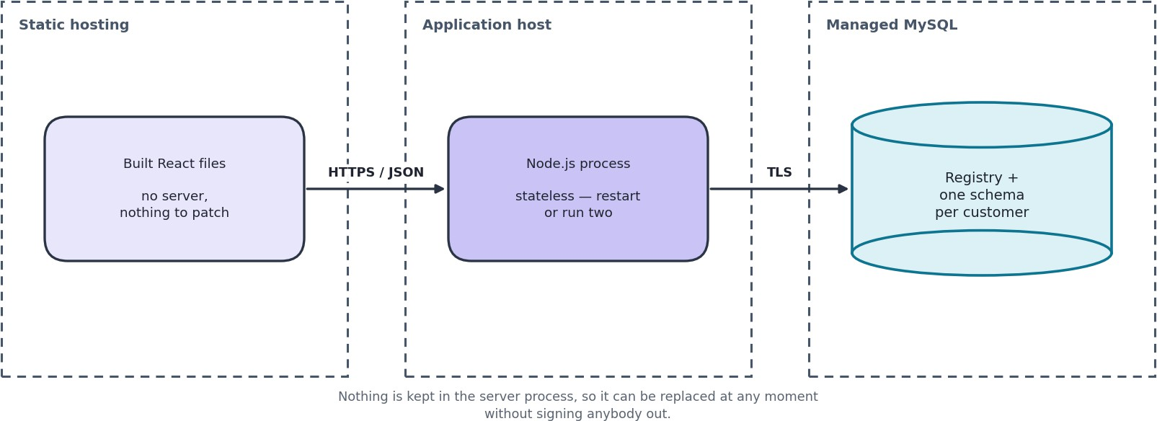
Legend: Arrows are automatic unless labelled otherwise.

Environments
Environment | Screens | API | Database | Purpose
Development | Local, port 5173 | Local, port 4000 | Local MySQL or XAMPP | Day-to-day work
Live (current) | Vercel | Render | Aiven managed MySQL | Demonstratio ns and user acceptance testing
Production (planned) | Azure Static Web Apps | Azure App Service | Azure Database for MySQL | Paying customers - see ADR-009

Known limitations of the current hosting
Limitation | Effect | What fixes it
The API sleeps after 15 minutes idle | The first request after a quiet period takes about a minute | A paid tier, or the move to Azure
The disk is temporary | Uploaded files vanish when the API restarts, while their database records survive. An attachment appears in a list and then fails to open. | Move files to object storage. This is the first task in the production plan
The database is capped at 1 GB | Fine for demonstrations, not for several real customers | A paid database tier
Email is not configured | Password resets and notifications are | Configure an SMTP server per
 | silently not delivered | organisation

Security Architecture
Security is arranged as six layers. A request has to clear all six, and each layer assumes the ones above it were passed.
Figure A-6 Security layers
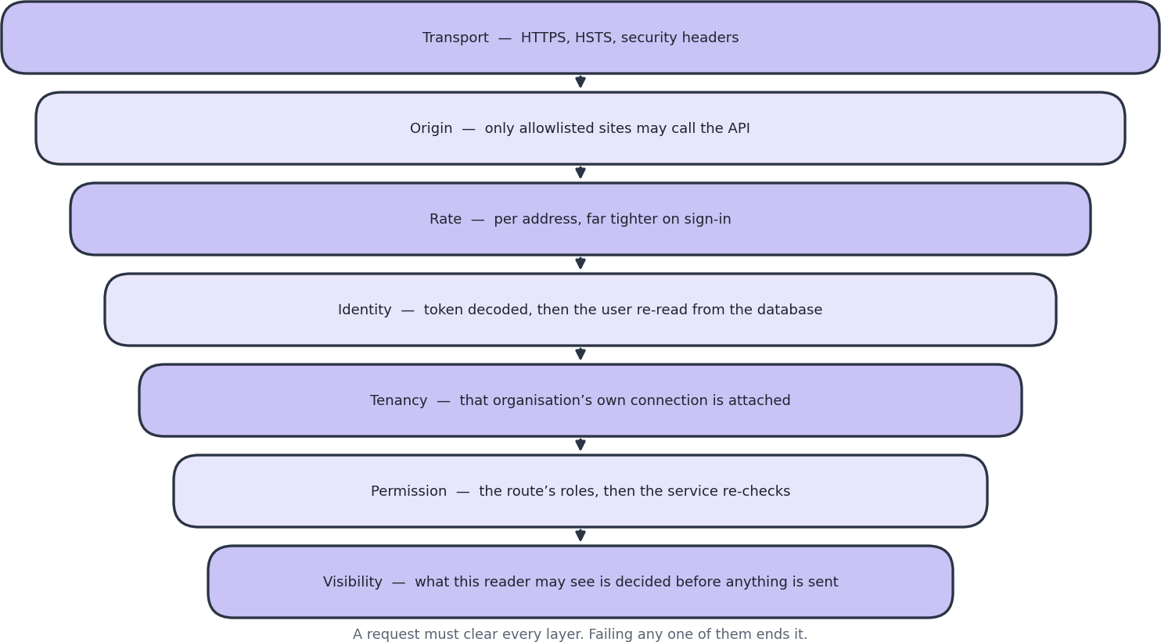
Legend: Each layer assumes the ones above it were passed. A request must clear all six.

Roles and what they can reach
Role | Can see | Can do
Trainee, Employee | Their own ideas in full; titles and summaries of others | Submit, vote, comment
Team lead, Project lead | Their team's ideas | The above, plus review
Manager, Department manager, Senior manager | Their reports' ideas, in full | Review and pass onward
Plant head | Every idea in the organisation | Final approval
Executive | Every idea in the organisation | Review
Organisation admin | Everything in their own organisation | All of the above, plus people, settings, archiving, exports
Super admin | Everything in their own organisation | As organisation admin. Deliberately removed from the approval chain
IFQM platform admin | Counts and totals for every organisation. No idea content, ever | Create and pause organisations, approve applications, handle tickets

Decisions worth explaining
Decision | Why
The user is re-read from the database on every request | A session token stays valid for eight hours. Trusting it meant that removing an employee did not end their access, demoting someone left their old powers in place, and resetting a password did not close sessions opened with the old one.
A password check runs even when the account does not exist | Skipping it answered 'no such account' in about five milliseconds and 'wrong password' in about 250. That difference alone let anyone work out who works at a company.
Lockout counters are stored in the database | They used to be held in memory, which meant they reset on every restart, did not exist across two servers, and grew without limit.
Browse lists never carry full idea text | The screen only showed a snippet, but the whole text was in the response and readable by anyone who opened the browser's network tab. Truncating on screen is not privacy.
Super admin is not in the approval chain | Whoever holds that password is usually somebody in IT, not the person qualified to judge a shop-floor improvement.
Content protection is offered but described honestly | It blocks right-click, selection and copying, and stamps the reader's name across the text. It cannot stop a screenshot or a phone camera and the help text says so. Its real value is that a leaked screenshot carries a name.
One-time codes are bcrypt-hashed like passwords | A six-digit code in a plain column would let anyone with read access to the registry sign in as any user with a code outstanding - an easier secret to use than a password hash, and outstanding for exactly as long as somebody is trying to sign in.
Codes are drawn from a cryptographic random source | Math.random() is predictable from previous output, so an attacker who had seen one code could compute the next. The digits are rejection-sampled so the modulo does not bias the low ones.
The code option is hidden unless a code can actually be delivered | Offering it while the gateway is misconfigured is worse than not offering it: the user abandons a password that works for a code that never arrives, and the sign-in screen has no way to explain itself.
The mock SMS provider is refused under NODE_ENV=production | It writes the code to the server log instead of sending it, which is what makes testing possible before a gateway contract exists. In a live system that is a credential leak and a silent failure at once, so it fails closed rather than pretending.
Maintenance mode is enforced after the platform-admin branch, not by a role check | The gate sits at a point in the sign-in path that IFQM staff never reach, so they are exempt by the shape of the function. A role check could be got wrong later, and getting it wrong means nobody can sign in to switch maintenance back off.
Maintenance mode fails open if the registry cannot be read | The console used to switch it off reads the same database. A blip that was treated as 'assume on' would be a platform-wide lockout that nobody could clear.

Putting the platform on hold
Maintenance mode stops every organisation using the system while an update is carried out, and leaves IFQM's own staff able to work. That asymmetry is the whole feature: somebody has to be able to see the platform in order to decide it is safe to turn back on.
It is enforced in three places, because any one of them alone leaves a door open:
    - At password sign-in, so no new session can be obtained.
    - At the one-time-code routes, on both request and redemption - the login screen offers a code as an alternative to a password, so the two are the same door and both have to be shut. A code issued a minute before the switch must not still buy a session after it.
    - On every authenticated request, so a session opened before the switch stops working. Without this, 'on hold' would mean nothing to anybody already signed in, which is most people during a working day.
Signing out is deliberately still allowed. A tenant whose session is being refused should be able to clear it and land on the sign-in screen, which is where the notice is; leaving them holding a token that every other endpoint rejects is a worse dead end than the one being prevented. The flag is cached for a few seconds and dropped on write, because it is read on every authenticated request and changes roughly never.

Integration Architecture
Four outside services, all optional, all configured per customer, and all outbound. Nothing external can call into the system.
Figure A-7 Integrations
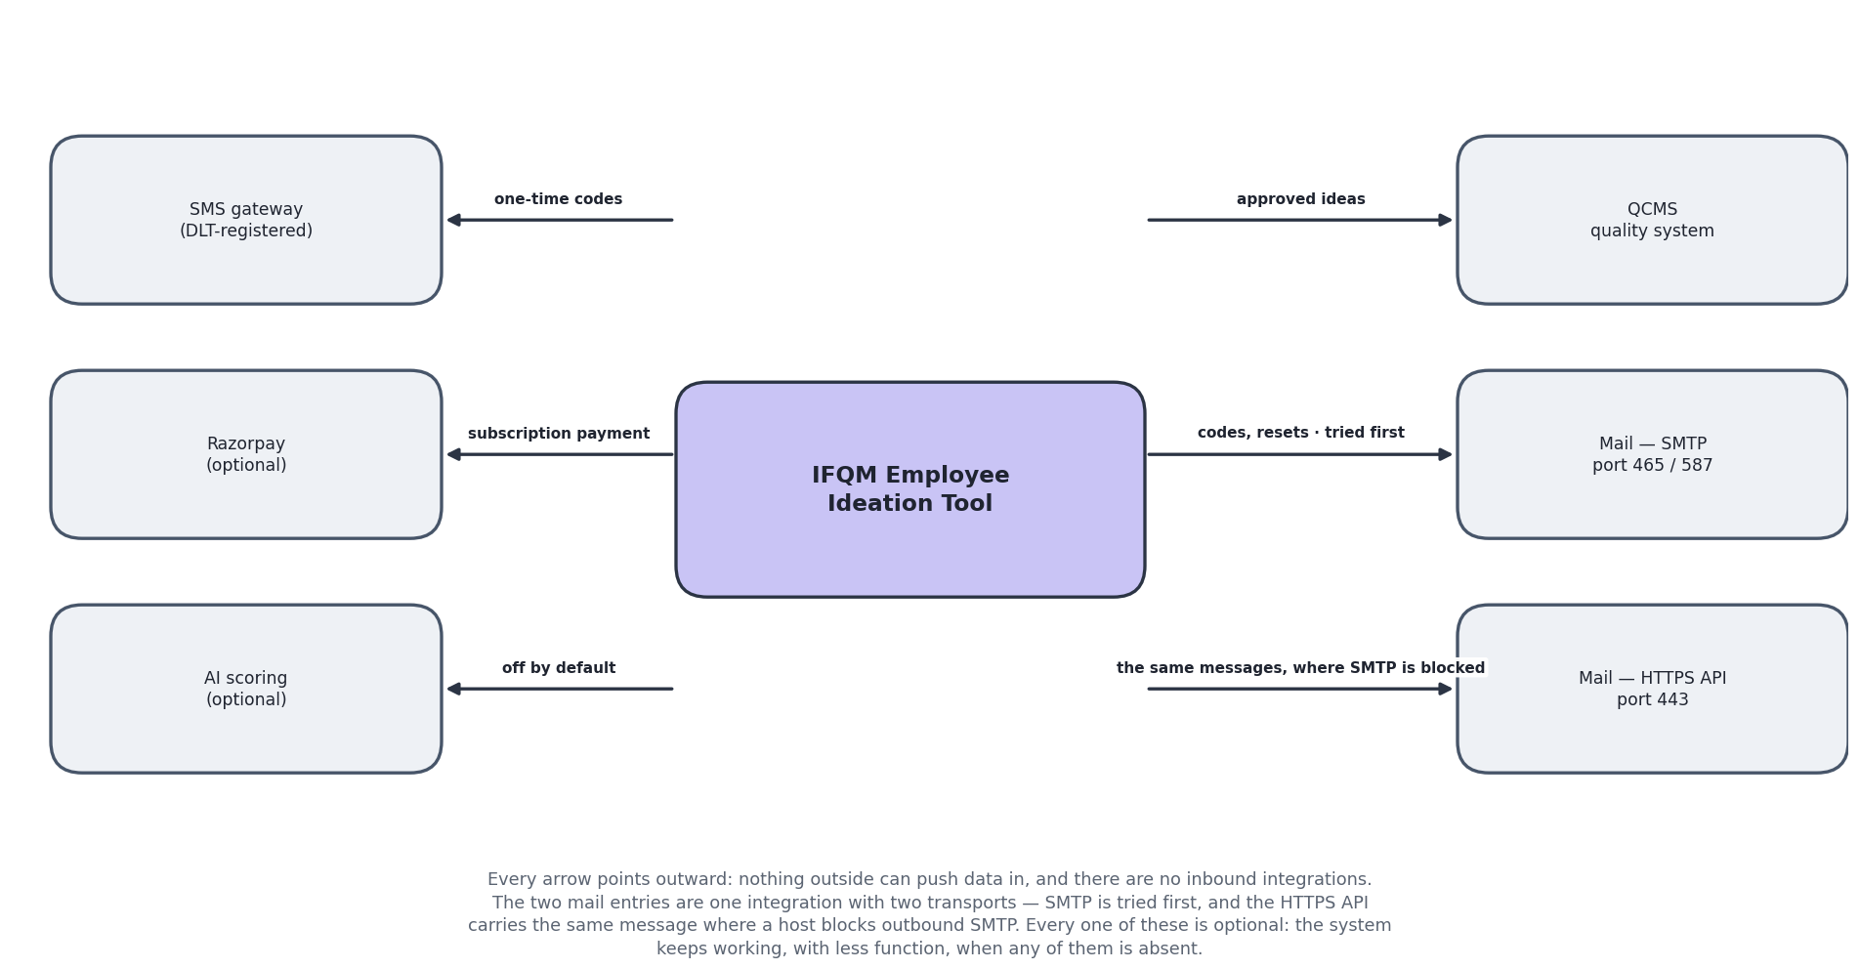
Legend: Arrows point the way data travels. There are no inbound integrations.
Integration | Directio n | Trigger | If it fails
QCMS | Out | An administrator pushes an approved idea | The failure is recorded against the idea and it can be retried. A duplicate is treated as success, because the idea has arrived and retrying would create a second
Email (SMTP) | Out | Password reset, notifications, one-time codes | Queued and retried. Where the host blocks outbound SMTP the sender falls through to the provider's HTTPS API instead, then stops attempting SMTP for a few minutes
Email (HTTPS API) | Out | Same messages, when SMTP cannot be reached | The caller is told the code could not be sent. Nothing is queued behind it
SMS gateway | Out | A one-time code, by text | The code is sent by email instead where an address is on file, and the fallback is logged. Password sign-in is unaffected
AI scoring | Out | An idea is submitted, only if a provider is configured | Falls back to the built-in scorer. The submission still succeeds
Worth stating plainly for customer conversations: with no AI provider configured, which is the default, no idea text leaves the system at all. Scoring runs inside the application.

One-time codes, by text and by email
A one-time code is a six-digit secret sent to something the person already holds - a mobile number or an email address - and exchanged for the same session a password would have produced. It is used in five places, and the same service issues and checks the code in all of them.
Purpose | Where it is used | Channel
login | Signing in with a code instead of a password | Text, or email if the person typed an address
registration_verify | An organisation applying to join proves it holds the address | Email
registration_phone | The same application proves it holds the mobile number | Text
password_reset | Resetting a password without reaching the emailed link | Either
phone_verify | Confirming a number somebody has just added or changed | Text
Codes are stored bcrypt-hashed, never in clear. A plain six-digit column would let anyone with read access to the registry sign in as any user with a code outstanding - the same mistake as storing passwords in clear, and a far easier secret to use than a password hash. The digits exist in memory for the length of one request and are never written down, which is also why the delivery log records that a message was sent and never what it said.
Four rules bound what a code can do, and each exists because of a specific attack:
    - It expires in five minutes and can be redeemed exactly once. Marking it consumed happens before the session is minted, so two requests arriving together cannot both succeed.
    - Wrong guesses are counted per code, and the fifth destroys it. Six digits is a million possibilities, which sounds like a lot until you notice an attacker has the whole validity window and can guess as fast as the network allows.
    - Issuing a new code expires the previous one. Otherwise every resend adds another live code and the guessing space shrinks with each click.
    - Requesting a code says nothing about whether the identifier is registered. The reply is identical either way, and no row is written for an unknown one - otherwise the endpoint becomes a way to type numbers and learn who works there.
The registration form is the deliberate exception to that last rule: it reports honestly whether the code was sent. The applicant is typing their own details into a form they are filling in, so there is nothing to give away, and a form that cannot say "that did not send" leaves somebody waiting for a code that is never coming.

What the mobile operator requires
Indian operators will not carry commercial text unless it is registered in advance, and an unregistered message is dropped by the carrier with no error and no delivery report - which looks exactly like a bug in this application. Three registrations travel with every message:
Registration | What it is | Consequence if wrong
Principal Entity ID | The business, registered once on the operator's portal | Message rejected at the gateway
Header / Sender ID | The six-character name the recipient sees instead of a number | Rejected; a header of any other length is a transcription slip
Content Template ID | The exact approved wording, one per purpose | Accepted by the gateway
 |  | and then dropped by the carrier, silently
The last row is the one that costs time. The carrier compares the text against the template the id claims, placeholder for placeholder, so the wording is configuration rather than a string in the source: if the two ever drift - because somebody edited the sentence to read better - every message starts being dropped and the cause is invisible from inside the application. The gateway answering "accepted" is not evidence of delivery, and the console says so rather than reporting success.
Where only one template registration is available, every purpose is sent under that one - its id and its wording together, because the carrier checks the two against each other. Sending approved wording under a different purpose's id fails just as surely as sending unregistered text.

Error Handling and Exception Flow
Two kinds of problem, handled differently on purpose.
Figure D-15 How a failure is handled
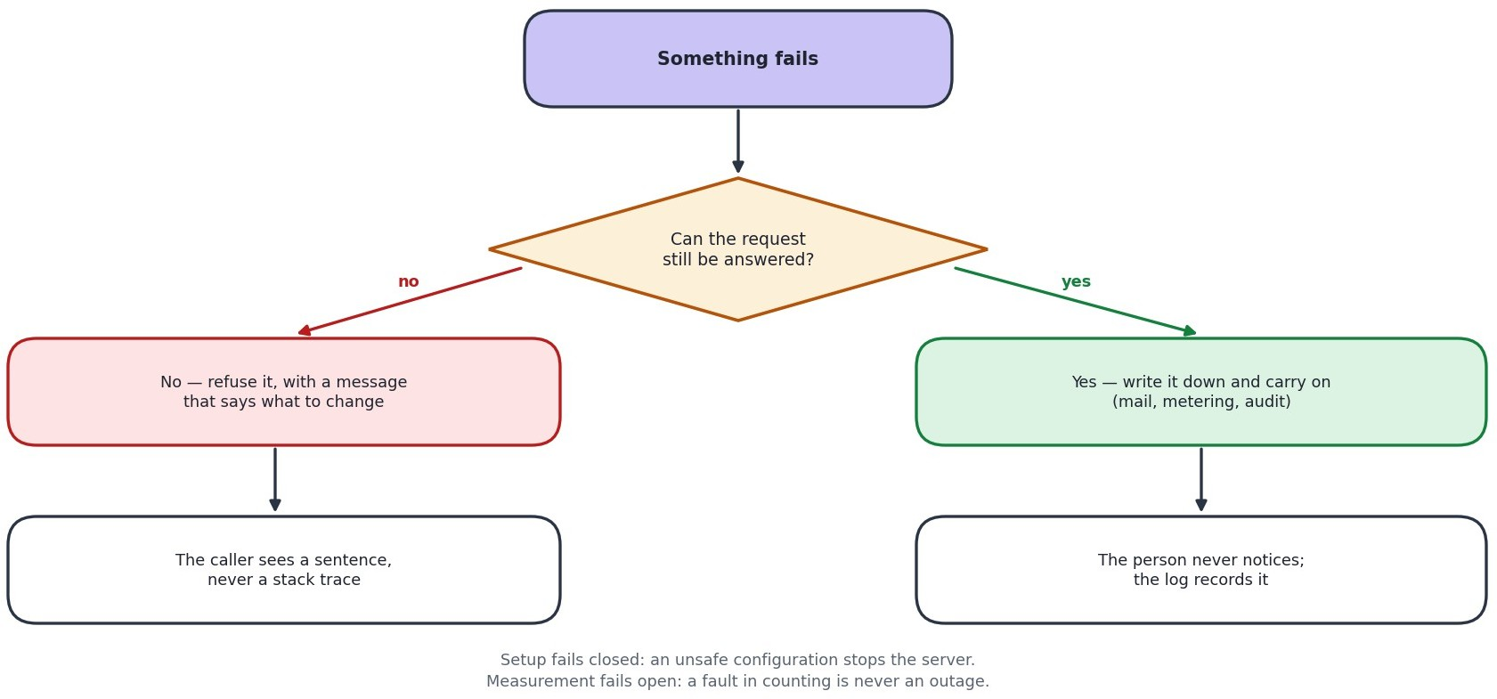
Legend: Numbers are the standard web status codes the API returns.

The principle
A problem we anticipated gets a specific, useful message: which field was wrong, how many sign-in attempts remain, which limit was reached. A problem we did not anticipate gets a generic message and a full entry in the log.
The reason for the difference is that raw database errors name tables, columns and file paths. Showing one to a user hands an attacker a map of the system. So the detail goes to the log, where the people who need it can find it, and the user gets a sentence.

Things that fail quietly, and why
Operation | Why a failure is swallowed
Writing a sign-in record | An audit trail that can stop a sign-in turns a logging outage into an outage
Sending a notification | A mail server being slow must not make submitting an idea fail
Counting API usage | A fault in measuring must never become an outage for the customer
Updating the sign-in directory | It repairs itself on the next sign-in

Things that fail loudly, and why
Situation | What happens
Weak or missing session signing key | The server refuses to start and says so
Blank database password, or the root account in use | The server refuses to start
Settings still pointing at a developer | The server refuses to start
machine
The registry cannot be reached, in production | Sign-in is refused rather than falling back to a default organisation, which would authenticate somebody against the wrong customer's data

Logging and Monitoring

What is written down
Kind | Where | Kept | Contains
Application log | Standard output, collected by the host | Host's retention | Start-up, requests, warnings, errors with stack traces
Request log | Same | Same | Method, path, status, time taken
Sign-in activity | Registry table | 180 days | Who, when, from what address and browser, success or failure
Idea history | Per organisation, in the database | Life of the idea | Every status change, who made it, when, and the comment
Import errors | Per organisation | Life of the job | Row number and reason
API usage | Registry table | Rolling | Requests per organisation per month

What is never logged
    - Passwords, in any form.
    - One-time codes, except in the deliberate test-only mode, which refuses to run in production for exactly this reason.
    - The QCMS key.
    - Full phone numbers - the last four digits only.
    - Idea content.

Health checks
Check | Answers | Use
/api/health | The process is running | A load balancer's basic check. Deliberately does not touch the database
/api/ready | The process can reach the registry | The check to point orchestration at. A server that is up but cannot reach its database is worse than one that is down, because it answers every request with an error

Gaps to close before production
    - No alerting. Somebody has to look at the logs. An uptime check with an email alert is the cheapest first step, and both health endpoints already exist for it to call.
    - No error aggregation. A tool that groups repeated errors would make patterns visible that a flat log hides.
    - No dashboard for sign-in failures, which is the signal that matters most for abuse. The data is already recorded; nothing displays it as a trend.
These three are carried forward into section 26.2, which is the single consolidated list of everything not yet done.

Performance and Scalability

What has already been done
Measure | Reason
Indexes on the columns lists are sorted and filtered by | Under load testing, the ideas list was scanning the whole table and sorting it on every request. At a few thousand rows that is cheap; at hundreds of thousands it consumed the connection pool and requests started failing. With the index the database reads in order and stops at 100 rows
Every list is capped and paged | The user list used to return every employee in one response. Bulk import can put several thousand people in there, and sending all of them would hang the very screen an administrator lands on after importing
Searching and filtering happen in the database | So the browser never receives rows it is only going to hide
Password checks do not block the server | The synchronous version occupies the process for the full quarter-second of hashing, during which nobody else is served. A morning sign-in rush made login latency into everybody's latency
One connection pool per organisation, reused | Opening a connection per request is the most expensive thing a small application usually does
Usage counting is buffered | Writing a counter on every request would put a database round trip in front of every call, to protect against something that happens once a month

Where it would strain first
Growth | First thing to give way | Answer
More organisations | Database connections. Each organisation holds its own pool | Reduce the pool size per organisation, or close idle pools. Both are settings
Many more staff in one organisation | The org chart screen, which loads the whole tree | Load one level at a time
Many more ideas | The idea board, which is an unfiltered wall of cards | Add filters and paging to the board
Sustained heavy traffic | The API is a single process | Run several. The design already allows it - sessions hold no server-side state
Many attachments | Local disk | Object storage. Needed anyway for the current hosting
For the size of customer this is sold to - 20 to 500 staff - the current design has considerable headroom. The strain points above are worth knowing, not worth pre-emptively engineering.

Backup and Disaster Recovery

What is backed up
What | How | How often | Kept
Registry database | Managed provider snapshots | Daily, plus point-in-time | Per the provider's plan
Each organisation's database | Same | Daily, plus point-in-time | Same
Uploaded files | NOT BACKED UP on  the current hosting | - | This is the biggest gap. See below
Code and schema | Git history | Every change | Indefinitely
Configuration | Host's settings store | On change | Current values only

The gap that needs closing first
Uploaded files sit on the application server's own disk. On the current hosting that disk is wiped whenever the server restarts, and it is not backed up at all. The database records describing those files survive, so the result is an attachment that appears in a list and fails to open.
Moving files to object storage fixes the backup gap and the disappearing-files problem in one change, and it has to happen before any customer stores anything they would miss. It is the first item in the production plan.

Recovery targets
Scenario | Target time to recover | Expected data loss | How
Application server fails | Under 15 minutes | None | Redeploy. The API holds no state of its own
Database corrupted or wrong data written | 1 to 4 hours | Up to 5 minutes | Point-in-time restore to just before the problem
One organisation's data damaged | 1 to 2 hours | Up to 5 minutes | Restore that one database. Others are untouched, which is a direct benefit of the separate-database design
Whole hosting region lost | 4 to 24 hours | Up to 24 hours | Restore into another region from the latest snapshot
Files lost | Not currently recoverable | All files | Until object storage is in place, this cannot be recovered. Stated plainly rather than glossed over
These targets have not been rehearsed. A restore that has never been tested is an assumption, not a plan, and a rehearsal should be scheduled before the first paying customer.

Testing Strategy

What exists today
Level | What it covers | How many | How it runs
Integration tests | The API end to end against a real database - sign-in, roles, tenant separation, lockout arithmetic, anonymity, approvals, QCMS, billing | 37, all passing | npm test
Assurance suite | One scripted case per requirement across 22 areas, from authentication to fault tolerance and scalability. Writes a results file and a printable test-case document | 229 cases, 228 passing | node test/tc_runner.mjs
Migration checks | Every schema file applied twice under strict database settings | All 20 migrations | Script
Targeted verification | Written for each risky change - quotas, one-time codes, visibility rules, the hierarchy template | As needed | Scripts, run during development
The one failing case is deliberate and is left failing rather than skipped: it compares the interface strings across the seven languages and reports the 294 that exist in English and not in the other six. It will pass when the translation work in section 26.3 is done, and until then it is the thing that stops that gap being forgotten.

What the integration tests deliberately cover
They are not there for coverage figures. Each one exists because the thing it checks either broke once or would be severe if it broke.
    - One organisation cannot read another's data.
    - A role cannot reach an endpoint it should not.
    - Lockout counts correctly - an off-by-one here locks people out a try early.
    - An anonymous idea stays anonymous everywhere, including in the approval history.
    - The approval chain routes and escalates correctly.
    - A password change ends sessions opened with the old password.

Gaps
Gap | Risk | Suggested answer
No automated screen tests | A screen can break without a test noticing | A handful of browser tests over the critical paths: sign in, submit, approve
No load testing since the indexing work | Performance could regress unnoticed | A scripted run before each release
No penetration test | Requested in the minutes, not yet done | Commission one before the first paying customer
No user acceptance testing | Also requested, and not yet run | Run it on the current live deployment, which exists for this purpose
Tests need a real database | Cannot run on a machine without MySQL | Acceptable, and deliberate - the things being tested are database behaviour
All of these except the last are carried forward into section 26.1, with what closing each one would actually take.

Deployment and Release Plan

How a change reaches the live site
Step | What happens | Who
1 | Write the change and run the tests locally | Developer
2 | If the database changes, write a numbered migration file and apply it locally | Developer
3 | Commit and push to the main branch | Developer
4 | The screens and the API rebuild automatically | Automatic
5 | Run the migration against the live database, deliberately | Developer
6 | Check the health endpoint and try the changed feature | Developer

The rule about database changes
Migrations are forward-only. Fixing a bad migration means writing a new one, never editing a file that has already been applied - copies that already ran cannot be retro-edited. A ledger records which migration has been applied to which database, so re-running applies only what is missing.
Order matters when a change is not backwards-compatible. A migration that adds something goes before the code that needs it; one that removes something goes after. Getting this the wrong way round causes a short outage.

Rollback
Problem | How to undo it
Code is faulty | Both hosts keep previous deployments; roll back with one click
A migration is faulty | Write and apply a new migration that corrects it. Never edit the original
Data is wrong | Point-in-time restore of that organisation's database

Before the first paying customer
# | Task | Why it blocks
1 | Move uploaded files to object storage | Files are currently lost on restart and are not backed up
2 | Configure an SMTP server | No password reset or notification email is delivered
3 | Move to paid hosting | Cold starts and a 1 GB database cap
4 | Rehearse a restore | The recovery plan is untested
5 | Run user acceptance testing | Requested in the minutes
6 | Commission a penetration test | Requested in the minutes
7 | Set up uptime alerting | Nobody is currently told when something breaks
Section 26.4 puts these in the order they should actually be done, alongside the items that do not block a first customer but still need doing.

PART E - DECISIONS, TRACEABILITY AND OUTSTANDING WORK
- Architecture Decision Records
The decisions that shaped the system, each with the reason and what it cost. The point of writing these down is that in a year somebody will look at one of these choices, think it is odd, and change it. This is so they can see what it was for before they do.
ADR-001 A separate database for every customer
Status | Accepted
Context | Customers are businesses who expect their staff list and their ideas to be nobody else's business. Sharing tables and filtering by a customer column is the common approach, but it means one missing WHERE clause leaks between customers.
Decision | One database per organisation, plus a small shared registry recording which organisations exist.
Consequences | Separation you can point at in a sales conversation. A restore affects one customer. The cost is more databases to migrate, and a connection pool per customer, which is the first thing that will strain as the number of customers grows.
ADR-002 Sessions as signed tokens, but the user re-read every time
Status | Accepted
Context | Server-held sessions would tie a user to one server and complicate restarts. Tokens solve that, but a token stays valid until it expires - so removing an employee did not end their access.
Decision | Use a signed token for identity, but read the user back from the database on every request and check the role and password timestamp.
Consequences | Removals, demotions and password resets take effect immediately. The cost is one small indexed query per request, which is a fair price for correct access control.
ADR-003 Raw SQL rather than an object-relational mapper
Status | Accepted
Context | An ORM saves work on simple applications. Here the central concern is choosing which database a request talks to, which is exactly what an ORM abstracts away.
Decision | Use the MySQL driver directly with prepared statements.
Consequences | The queries that matter most are visible and reviewable. The cost is more code, and discipline about parameter binding - helped by prepared statements being the default.
ADR-004 Scoring built in, external providers optional
Status | Accepted
Context | Sending idea text to an outside company is a real concern for customers, and an API key is a barrier for a small business.
Decision | A scorer inside the application is the default. OpenAI or Gemini can be configured but are off unless chosen.
Consequences | The product works with no account and no cost, and by default no idea text leaves the system. The built-in scorer is less nuanced, which is an acceptable trade for a sorting aid.
ADR-005 Full idea text is never sent to a browse list
Status | Accepted
Context | The list query originally selected every column, so the full text of every idea was delivered to every employee's browser. The screen showed a snippet, which hid it from the reader but not from the page.
Decision | Browse endpoints send a one-line summary and nothing more. The full text comes only from the single-idea endpoint, and only to people entitled to it.
Consequences | The protection is real rather than cosmetic. The cost is a second request to read an idea in full, which is what a person does anyway.
ADR-006 Archiving instead of deleting
Status | Accepted
Context | Administrators need old ideas out of the way. Deleting them would destroy the points awarded, the approval history and the recorded savings - the very evidence the scheme is judged on.
Decision | Archiving sets a date. Everything is retained and it can be reversed.
Consequences | Nothing is lost and reports stay correct. The cost is that every list has to filter on it, which is why the column is indexed.
ADR-007 One-time codes stored hashed, with a provider interface
Status | Accepted
Context | A six-digit code in plain text would let anyone reading the table sign in as that user. And no SMS provider had been chosen when the feature was asked for.
Decision | Hash the code exactly as a password. Send it through a provider interface with three implementations, one of which writes to the log for testing and refuses to run in production.
Consequences | The feature could be built and tested before a supplier existed, and changing supplier is a setting. The cost is a hash comparison per attempt, which is negligible.
ADR-008 Approval chain expressed as ordered stages
Status | Accepted
Context | Organisations describe approval as an order - originator, then manager, then department head - not as two unordered lists of roles.
Decision | Store the ordered list. Derive the reviewer and final-approver sets from it, so the engine underneath never learns that stages exist.
Consequences | The admin screen can add, remove and reorder steps, and the preview is honest. The cost is two ways of expressing the same chain, which is why both are derived from one definition.
ADR-009 Target Microsoft Azure for production
Status | Proposed
Context | The system runs on a free-tier arrangement that is fine for demonstrations and wrong for customers. Azure, AWS and a plain virtual server were compared.
Decision | Recommend Azure App Service with Azure Database for MySQL and Blob Storage.
Consequences | Not chosen on price - the three are close at this size. Chosen because single sign-on is already committed to Microsoft Entra ID, and federating a different cloud's identity system to it is the expensive part. A plain virtual server is cheapest and was rejected because patching, upgrades, backups and certificates all become a named person's recurring job, which is the opposite of what a handover needs.
ADR-010 Move uploaded files to object storage
Status | Proposed
Context | Files sit on the application server's disk. That is fine on one permanent machine and wrong the moment there are two, or the platform replaces the machine - which is exactly what the current hosting does.
Decision | Move attachments to object storage before production.
Consequences | Fixes disappearing attachments and the backup gap in one change. Contained: three modules write files. Must happen before any customer stores anything they would miss.
ADR-011 Defer single sign-on
Status | Deferred
Context | Requested in the minutes, across QCMS, DWM and Skills.
Decision | Not built. The sign-in path was structured so that a new method returns the same session as any other, which one-time codes have now demonstrated.
Consequences | Adding single sign-on later is an addition rather than a rewrite. Blocked on an Azure
 | tenant and agreement from two other tools.
ADR-012 Free email domains blocked at registration
Status | Accepted, with a conflict
Context | An ideation platform is sold to a business. An address anyone can create in a minute is no evidence the applicant speaks for a company.
Decision | Refuse consumer and disposable email domains, and require a human to approve every application anyway.
Consequences | Keeps the review queue readable. But the same minutes also ask to accept a personal address for businesses with no domain of their own. Both cannot be true. Free mail is blocked today, so a sole trader cannot register. This needs a decision - it is the one genuinely open question in this document.

Requirements Traceability Matrix
Every requirement mapped to the part of the system that implements it, the diagrams that describe it, and how it is verified. This is the table to use when asking whether something was actually built.

Functional requirements
Table 25.1 All 42 functional requirements, mapped to code, diagram and check
Req | Implemented in | Diagrams | Verified by | State
FR-01 | authService, auth middleware | D-7, A-6 | Integration tests | Done
FR-02 | otpService, smsService | A-6 | Six scripted security checks | Done
FR-03 | authService | A-6 | Integration tests | Done
FR-04 | userImportService | A-4 | Integration tests | Done
FR-05 | ideaService, submit screen | D-1, D-8, D-14 | Integration tests, manual | Done
FR-06 | ideaService.checkDuplicate | D-8 | Manual | Done
FR-07 | ideaService.submitOrDraft | D-1 | Integration tests | Done
FR-08 | aiService | D-8 | Integration tests | Done
FR-09 | approvalStages, ideaService | D-1, D-9 | Integration tests | Done
FR-10 | ideaService escalation | D-9 | Integration tests | Done
FR-11 | ideaService.reviewAction | D-9 | Integration tests | Done
FR-12 | ideaService review stage | D-1 | Scripted check | Done
FR-13 | ideaService ROI and implementation | D-1 | Integration tests | Done
FR-14 | leaderboardService, coreHelpers | D-1 | Integration tests | Done
FR-15 | votingService, commentService | D-1 | Integration tests | Done
FR-16 | challengeService | A-4 | Manual | Done
FR-17 | ideaService.redactSolution | A-6, D-3 | Scripted, three modes | Done
FR-18 | settingsService, org settings | A-6 | Scripted, three modes | Done
FR-19 | ideaService.setArchived | D-5 | Scripted check | Done
FR-20 | ideaService.setPatentability | D-5 | Scripted check | Done
FR-21 | exportService, screen export | D-14 | Manual | Done
FR-22 | Rejected ideas screen | D-13 | Manual | Done
FR-23 | userImportService | A-4 | Integration tests, 500-row sample | Done
FR-24 | hierarchyTemplateService | A-4 | Round-trip script incl. refusals | Done
FR-25 | userService.adminUsers | A-4 | Scripted check | Done
FR-26 | registrationService | D-10 | End-to-end script | Done
FR-27 | registrationService domain check | D-10 | End-to-end script | Done
FR-28 | registrationService.approve | D-10 | End-to-end script | Done
FR-29 | platformService | A-1, D-6 | Integration tests | Done
FR-30 | platformService privacy | A-1, D-6 | Integration tests | Done
 | contract
FR-31 | activityService | A-6 | Scripted check | Done
FR-32 | qcmsService, integrationService | A-7, D-11 | Integration tests | Done
FR-33 | settingsService, brandingService | A-4 | Manual | Done
FR-34 | Language files | A-3 | Automated key check | Partial - 294 keys short in six languages
FR-35 | supportService | A-4 | Manual | Done
FR-36 | planService (priceBreakdown, decoratePlan) | D-4, D-6 | Integration tests | Done
FR-37 | registrationService.approveRe gistration, subscriptionService.assignPlan | D-4, D-10 | Integration tests | Done
FR-38 | subscriptionService.setTrialDa ys, defaultTrialDays | D-4 | Integration tests | Done
FR-39 | subscriptionService (billingState, sweepLapsed) | D-4 | Integration tests | Done
FR-40 | platformService.tenantDetail | A-1, D-6 | Manual | Done
FR-41 | tenantQuota middleware, migration 018 | A-6 | Integration test incl. the lock-out guard | Done
FR-42 | NotFoundPage, Breadcrumbs, PageMeta, HelpPage | D-13 | Browser check | Done

Non-functional requirements
Table 25.2 All 18 non-functional requirements
Req | Implemented in | Diagrams | Verified by | State
NFR-01 | database/tenant.js, auth middleware | A-2, D-4, D-5 | Integration tests | Done
NFR-02 | ideaService redaction | A-6 | Scripted, all modes and roles | Done
NFR-03 | auth middleware re-read | A-6, D-7 | Integration tests | Done
NFR-04 | bcrypt in authService | A-6 | Integration tests | Done
NFR-05 | app.js, config | A-6 | Live check | Done
NFR-06 | rateLimiter, tenantQuota | A-6 | Scripted quota test | Done
NFR-07 | Indexes, paging | - | Load testing | Done
NFR-08 | Server-side search and paging | - | Manual with 500 users | Done
NFR- | Best-effort writes | D-15 | Code review | Done
09
NFR-10 | Managed backups, backup script | - | Not yet rehearsed | Partial
NFR-11 | idea_workflow, login activity | D-5 | Integration tests | Done
NFR-12 | Information buttons, glossary | D-14 | Browser check | Done
NFR-13 | Focus outlines, responsive layout | D-14 | Manual | Partial
NFR-14 | Seven language files | A-3 | Automated key check | Partial - 294 keys short
NFR-15 | Standard Node and MySQL | A-3, A-5 | Runs on three hosts | Done
NFR-16 | Layered services, technical manual | A-4 | Review | Done
NFR-17 | Registration and import field sets | D-4 | Review | Done
NFR-18 | config.assertConfigOrExit | D-15 | Integration tests | Done

Requirements not fully met
Two of the sixty rows above say Partial rather than Done. Both are listed again in section 26 with what it would take to close them. Every other requirement in this matrix has working code behind it and a way of checking it.
Req | What is short | What would close it
FR-34 / NFR-14 | English carries 1,116 interface strings; each of the six other languages carries 822. The 294 newest strings fall back to English rather than breaking the screen. | A translation pass over the newer screens. The mechanism is finished - this is content
NFR-13 | Focus outlines, keyboard reach and reflow are in place and were checked by hand. No assistive technology has been used against the product and no standard has been claimed. | An accessibility review against a named standard, if one is going to be claimed

Work Not Yet Done
Everything above describes what exists. This section is the other half of an honest handover: the things a reader might reasonably assume are in place and which are not. Nothing here is a defect. They are pieces of work that have not been started, or have been done but never exercised - and the difference between those two matters, because an untested backup is more dangerous than an absent one, since somebody is relying on it.

Assurance not yet carried out
Item | Where it stands | Risk of leaving it | What closing it takes
User acceptance testing | Not run. The live deployment exists for exactly this and is working. | The people who will use the product every day have not yet said whether it fits how they actually work. That is the feedback most likely to change a screen. | Scheduling with a customer, and someone to sit with them. No engineering work
Penetration testing | Not commissioned. Requested in the minutes of 29 July 2026. | The security work in section 16 was designed and reviewed by the people who wrote it. That is not the same as being tested by somebody trying to break it. | A budget and a firm. Should be done before the first paying customer
Backup restore rehearsal | Backups are being taken. No restore has ever been performed from them. | The single largest one here. The recovery targets in section 21.3 are estimates, not measurements. A backup nobody has restored from is an assumption. | Half a day: restore a snapshot into a scratch database and confirm an organisation comes back whole. Repeat quarterly
Automated screen tests | None. The 37 integration tests and the 229-case assurance run both work against the API, not the interface. | A screen can break without anything failing. | A handful of browser tests over sign in, submit and approve
Load testing since the indexing work | Done once, before the indexes were added; not repeated since. | Performance could regress without anybody noticing. | A scripted run before each release

Operational gaps
Item | Where it stands | Risk of leaving it | What closing it takes
Monitoring and alerting | Nothing. Logs are written and health checks answer, but nobody and nothing is watching them. | The first person to know the site is down is a customer. Both health endpoints already exist and are unused by any monitor. | An uptime service pointed at /api/ready with an email alert. An hour's work and a small monthly cost
Error aggregation | Errors go to a flat log on the host. | A fault that happens forty  times in an hour looks the same as one that happened | A hosted error tracker, or a scheduled digest of
 |  | once. | the log
A view of sign-in failures | The data is recorded in the registry; nothing displays it as a trend. | Repeated failed sign-ins are the clearest signal of abuse, and it is currently only visible by reading rows. | One chart on the platform console over data that is already there
Object storage for attachments | Files are on the application server's own disk. On the current hosting that disk is wiped on restart and is not backed up. | Attachments already disappear while their database records survive, so a file appears in a list and fails to open. This is a live defect, not a future one. | Three modules write files, so the change is contained. It is the first task in the production plan and must happen before a customer stores anything they would miss
SMTP in production | Not configured. The queue works; nothing delivers from it. | Password resets and notification emails are silently not sent. | Credentials for a mail service, set per organisation

Content and feature work
Item | Where it stands | Risk of leaving it | What closing it takes
Translation completeness | English 1,116 strings; Hindi, Kannada, Malayalam, Marathi, Tamil and Telugu 822 each. The gap is the 294 newest strings. | A shop-floor user on a Tamil interface meets English text on the newer screens. It works, but it undercuts the claim that the product speaks seven languages. | A translation pass. The lookup mechanism, the fallback and the automated key check are all finished - this is content, not code
Single sign-on with Entra ID | Not built. The sign-in path was deliberately shaped so a new method returns the same session as any other, which the one-time-code route has already demonstrated. | Nothing breaks; it stays a separate password. | An Azure tenant, plus agreement from QCMS, DWM and  Skills. An addition rather than a rewrite - see ADR-011
Taking payment | Plans, pricing with GST, trials, holds and the billing history are all built. No payment gateway is connected and no invoice is generated. | None operationally - money is collected outside the product today and a member of the platform team records it. It is only a gap if self-service payment is wanted. | A gateway integration and invoice generation. The plan and period data it would need is already recorded
Registration for a business with no domain | Blocked on a decision, not on work. Free email domains are refused, so a sole trader cannot apply. | A segment of the intended market cannot register at all. | A decision. The minutes ask for both this and the domain rule, and both cannot be true - see ADR-012. This is the one genuinely open question in this document

The order they should be done in
# | Item | Why it goes here
1 | Object storage for attachments | It is the only item on this list that is losing data right now
2 | Configure SMTP | Password reset does not work without it
3 | Uptime alerting | An hour of work, and it changes who finds out first
4 | Rehearse a restore | Turns section 21.3 from estimates into measurements
5 | User acceptance testing | Feedback is cheapest before more is built on top
6 | Penetration test | Wants a stable target, so after the four above
7 | Translation pass | Content work, and it can run alongside anything else
8 | Decide the free-email question | Needs a person, not a sprint. See ADR-012

PART D — COMPLETE USER GUIDE
IFQM Employee Ideation Tool — Turn great ideas into real improvements

About this guide
This guide explains how to use the Employee Ideation Tool from end to end. It assumes nothing: not that you have used a system like this before, and not that you know what any of the words on the screen mean. Where a word has a specific meaning here - "escalation", "co-suggester", "challenge" - it is explained the first time it appears and again in the glossary at the end.

Conventions used here
    - Things you click or type are written in bold: click Submit Idea.
    - Screens are named as they appear in the left-hand menu: Dashboard, My Ideas, Review Queue.
    - Boxed notes are the things people most often get wrong, or that cannot be undone. They are worth reading even if you skim everything else.
    - Where behaviour depends on how your organisation has set the tool up, it says so. Your administrator can change quite a lot - the approval chain, the categories, the review deadline, even the name and logo at the top of the page.

What you need
    - A modern web browser. Nothing to install.
    - An account, created for you by your organisation's administrator. You cannot sign yourself up - see 3.1.
    - Your organisation code, if your organisation uses one. Ask your administrator, or see 3.2.

How the platform works
The tool exists to make one thing easy: getting a good idea from the person who had it to the person who can approve it, without the idea being lost, forgotten, or quietly ignored. Everything else in the product supports that single journey.

The journey of an idea
Stage | What happens | Who does it
Draft | You start filling in the idea and save it without submitting. Only you (and your administrator) can see a draft. | You
Submitted | You submit. The idea gets a permanent code (for example IDA-2026-014), your reviewer is notified, and a review deadline is set. | You
Under Review | A reviewer has picked it up, or it has been escalated to a more senior manager for a decision. | Your manager or a committee
Approved | The idea is accepted. You earn points, and it becomes eligible to | A reviewer with approval authority
 | be handed to the QCMS tool for implementation.
Rejected | The idea is not being taken forward. The reviewer's comment tells you why - and a rejected idea can be reworked and submitted again as a new idea. | A reviewer
Implemented | The change has actually been made. This is the stage worth the most points, because it is the stage that saved the money or removed the risk. | A manager tracking delivery

What you get out of it
    - Your idea is on the record. Every decision, comment and escalation is stored against the idea with the name of the person who made it and the time they made it. Nothing disappears into a mailbox.
    - You are told what happened. A notification arrives when the idea moves, and the reviewer is asked to leave a comment with the decision.
    - You earn recognition. Points are awarded for submitting, for approval and for implementation, and the leaderboard shows the most active people and departments.
    - Your colleagues can help. Anyone in your organisation can vote, rate and comment on ideas, and you can name the colleagues who worked on it with you so they get the credit too.

Three ordinary days
The same week, from three points of view. If you only want to know what the tool feels like in use, this is it.
Who | What their week looks like
Ravi, machine operator | Notices on Monday that line 3 keeps draining coolant. Opens Submit Idea on his phone during the break, types the situation with the figure he already knows (about 40 litres a shift), photographs the capped return line, adds the maintenance engineer as a co-suggester and submits. He gets 10 points and a notification that his manager has it. On Thursday a notification says it was approved and escalated for the spend, with a comment agreeing with his numbers. He can watch the timeline from there.
Priya, production manager | Opens Review Queue on Tuesday morning: six ideas, one overdue. She reads Ravi's, checks the figures against the coolant purchase report he attached, approves it with a comment about the March rebuild, and rejects a duplicate with a note pointing at the original. The overdue one she routes to committee because it crosses into maintenance. Ten minutes, and everyone involved knows where they stand.
Anil, organisation | Checks the dashboard on Monday: submissions up, two reviews overdue in one
administrator | department. He messages that manager. Mid-week he imports the new intake of trainees from a spreadsheet, fixes two reporting lines the import flagged, and adds a category for the new energy
 | programme. On Friday he opens Approved Ideas and pushes the week's approvals to QCMS, where implementation is tracked.

Who can see what
This matters, so it is worth being precise. Your organisation is separate from every other organisation on the platform: nobody outside it can see your ideas, your files, your comments or your people. Inside your organisation:
Item | Who can see it
A draft | Only you, and your organisation administrator.
A submitted idea | Everyone in your organisation, on the idea board and in the lists.
An anonymous idea | Everyone can see the idea; nobody except senior reviewers and administrators can see who submitted it. Your name is hidden from the idea, from the approval timeline and from the co-suggester list.
An attachment | Anyone signed in to your organisation who can see the idea, and only through the app - files are never public links. A draft's attachments stay private to you.
Your email and phone | Your administrator, and colleagues searching for you as a co-suggester (by name and employee ID).
Analytics and the audit trail | Managers and administrators, depending on their role.
The IFQM platform team cannot read your ideas
The vendor team that creates and supports organisations sees only counts and administrator contact details.
They cannot open your ideas, your files or your user list. If you raise a support ticket they see what you write
in that ticket, and nothing else.

Roles: what each person can do
Your role decides which menu items you see and which buttons you get. Your administrator sets it. If you think yours is wrong - you can see the Review Queue but you are not a reviewer, or you cannot see it and you should - ask your administrator rather than working around it.
Role | Can do | Cannot do
Employee / Trainee | Submit ideas, save drafts, attach documents, name co-suggesters, submit anonymously, vote, rate, comment, earn points, see the leaderboard, raise support tickets. | Review or approve anything, including their own idea. See other people's drafts. Reach admin screens.
Team Lead / Project Lead | Everything an employee can, plus the Review Queue for their own team's ideas and the ability to approve, reject or escalate them. | Approve their own idea. See ideas outside their reporting line.
Manager / Department Manager / Senior Manager | Everything a team lead can, plus recording ROI and implementation progress, seeing the identity behind an anonymous | Administer users, branding or integrations.
 | idea, bulk review, and analytics for their area.
Plant Head / Executive | Organisation-wide visibility of ideas and analytics, and final approval authority at the top of the escalation chain. | Administer users or integrations.
Admin / Super Admin | Everything above for their organisation, plus users and bulk import, the reporting hierarchy, the approval chain, categories, challenges, branding, email settings, the audit trail, exports, approved-idea push and the QCMS integration settings. | See any other organisation. Reach the IFQM platform console.
Platform Admin (IFQM) | Create, rename, suspend and remove organisations, manage platform administrators, answer support tickets, set platform-wide defaults. | Read any organisation's ideas, users, files or analytics.

Getting started

Getting an account
Accounts are created by your organisation's administrator - either one at a time or by importing a spreadsheet of the whole department. You cannot register yourself. If you have no account, open the sign-in page and use Request access: fill in your name, your email and your organisation, and the request is passed to the people who can create your account.
An organisation that wants to join the platform applies on the registration form instead. That form asks you to prove two things before it will accept the application: that you hold the email address you gave, and that you hold the mobile number. Each has a Send OTP button beside it that sends a six-digit code, and a Verify OTP button to enter it. Both must show as verified before the form can be submitted.
Why an application asks for two codes The address and the number become the contact route for the organisation's first administrator account, so an application with a mistyped address would be approved and then be unreachable. Unlike the sign-in page, this form tells you honestly whether the code was sent - you are typing your own details into a form you are filling in, so there is nothing to give away, and a form that cannot say "that did not send" leaves you waiting for a code that is never coming.

Signing in
The sign-in page asks for three things, and one of them is often optional:
1. Organization Code - your organisation's short code, for example "acme". Many organisations do not need you to type it: if your email or phone number is registered with only one organisation, leave it blank and the tool will find you. Leave it blank as well if you are an IFQM platform administrator. 2. Email or phone number - whichever your administrator registered for you. Both work; switch between the Email and Phone tabs. 3. Password - use the eye icon to check what you typed before you submit. Tick Keep me signed in on a device that only you use.
Your session ends automatically after a period of inactivity, and it also ends immediately if your password is changed or your account is deactivated.
Wrong password five times locks the account for 15 minutes This protects you: it is what stops somebody guessing their way in. The correct password will not open the account during those 15 minutes either, so wait it out or ask your administrator to reset your password. The error message never reveals whether an email address exists on the platform - that is deliberate.
Signing in with a one-time code instead of a password. If the option is offered, the sign-in page carries a link reading Sign in with a code instead. Type the email address or the mobile number your organisation registered for you, and a six-digit code is sent to it - by text if you typed a number, by email if you typed an address. Enter the code and you are signed in exactly as a password would have signed you in; nothing afterwards behaves differently.
The code is valid for five minutes and can be used once. Five wrong attempts destroy it, and asking for a new one cancels the previous one - so if two codes arrive, only the newer will work. There is a short wait before the tool will send another, and the screen counts it down for you.
The link only appears when the platform can actually deliver a code. That is deliberate: offering a sign-in route where nothing ever arrives is worse than not offering it, because you would abandon a password that works for a code that never comes.
The reply is the same whether or not the number is registered Asking for a code always answers "if that number belongs to an account, a code has been sent to it", and it says so just as readily for a number nobody has ever used. Anything else would turn the sign-in page into a way of discovering who works at your organisation.

Your first sign-in and the temporary password
If your account was created for you, your first password is temporary and predictable: the first four letters of your name, in lower case, followed by your year of birth. Asha Rao, born in 1994, starts with asha1994.
Because a colleague could guess that, the tool will not let you do anything else until you have replaced it. Sign in, and you are taken straight to the change-password screen. Every other screen is blocked until you choose a new password - and that is enforced by the server, so there is no way around it. Choose something at least twelve characters long that you do not use anywhere else; a short phrase is easier to remember and harder to guess than a mangled word.

If you forget your password
1. On the sign-in page, click Forgot your password? A small panel opens on the page itself. 2. Enter your registered email address and click Send reset link. For your safety the reply is always the same whether or not that address has an account - it never confirms who is registered. 3. Open the emailed link. It takes you to a page where you type the new password twice, with an eye icon to check what you typed. The link is valid for one hour and can be used once. 4. Choose the new password and you are returned to the sign-in page. Setting a new password immediately ends every session that was opened with the old one, on every device. 5. If no email arrives, check junk mail, then ask your administrator. An administrator can reset your password directly. There is a second route for anyone who cannot reach the mailbox the link would go to - somebody whose work address is the very account they are locked out of, or who is on a phone
away from their desk. Ask for a reset code instead: a six-digit code is sent to the registered email address or mobile number, and once you have entered it you set a new password on the spot. The code follows the same rules as a sign-in code - five minutes, one use, five wrong attempts and it is destroyed.

Finding your way around
Where | What it is
Left-hand menu | Every screen you have access to: Dashboard, Submit Idea, My Ideas, Idea Board, All Ideas, Challenges, Review Queue, Leaderboard, Analytics, Audit Trail, Org Hierarchy, Admin Panel, Support and My Profile. You only see the ones your role allows. The menu collapses to icons if you want more room.
Top bar | The bell icon with your unread notifications, the language selector, and your own name and points.
Dashboard | Your starting point: total ideas, how many are approved and implemented, how many are waiting for review, anything overdue, the spread of statuses and the most recent activity.
Support | Raise a ticket with the IFQM team when something is broken. Reachable even when your account is stuck on a temporary password, because that is exactly when you need it.

Two-minute quick starts
If you read nothing else, read the row for your role.
If you are... | Do this first
An employee | Sign in, change your temporary password, open Submit Idea, and write down the one thing about your work that has annoyed you most this month. Fill in the situation with a number in it, the solution, and submit. Everything else on the form is optional.
A reviewer or manager | Open Review Queue and sort out anything marked Overdue. Decide, and leave a comment on every rejection. Then check that the people who report to you are correctly listed under you - if they are not, their ideas are not reaching you.
An organisation | Import your people, fix the reporting lines, add your categories, set the review
administrator | deadline, upload your logo, and configure email. Then submit one idea yourself and take it all the way through - it is the fastest way to find anything you have set up wrongly.
A platform administrator | Create the organisation, hand its first administrator their credentials, and point them at section 9 of this guide.

Your profile
Open My Profile to see your details - name, employee ID, department, business unit, location, email, phone, who you report to - and your total points. You can update your own contact details. You cannot change your own role, your points or your reporting line; those belong to your administrator, and attempts to set them from the browser are refused by the server.

On a phone or tablet
There is nothing to install and no separate app: open the same address in the phone's browser and sign in. The layout adapts - the left-hand menu collapses behind a button, and the idea form runs one step to a screen. Photographs taken on the phone can be attached directly, which is usually the fastest way to capture a problem while you are standing in front of it. Your language choice is remembered per device, so you may need to set it again on the phone.

Working in your own language
The whole interface is available in seven languages: English, Hindi, Kannada, Malayalam, Marathi, Tamil and Telugu. Use the language selector in the top bar; the choice is remembered on that device. It changes the labels and messages, not the content other people have typed - an idea written in English stays in English.

Submitting an idea
This is the heart of the tool. The form is a six-step wizard: you can move back and forth, and you can save a draft at any point and come back to it. Nothing is visible to anyone else until you press submit on the last step.

Before you start: what makes a good idea
The reviewers are busy people reading a queue. The ideas that get approved are almost always the ones that made the reviewer's job easy. Three habits do most of that work:
    - Describe the situation with a number. "Paint rejection has gone from 2% to 6% on line 3 since March" is a case. "Quality is poor" is an opinion.
    - Propose something specific enough to cost. "Install automatic viscosity monitoring on the paint line" can be quoted. "Improve the process" cannot.
    - Say what it is worth, even roughly. An estimate you can explain beats a blank field. If you genuinely do not know, leave it blank - the reviewer can ask.

Step 1 - The situation
Field | What to put in it
Situation Title | One line that a manager could read in a queue of forty and understand. "Recirculate coolant on line 3", not "Coolant".
Current Situation Description | What is happening today, and why it is a problem. At least 20 characters, but write a paragraph: how often it happens, who it affects, what it costs in time, money, quality or safety. This is the field reviewers quote back when they approve.
As you type the title, the tool quietly checks for ideas that already exist with a similar title. If it finds any it lists them under Similar ideas already exist. Open them before you carry on: if somebody has already raised yours, it is usually better to add a comment and your vote to theirs than to file a duplicate. If yours is genuinely different, say so in the description and continue - the warning never blocks you.

Step 2 - The solution and its impact
Field | What to put in it
Proposed Solution | What you want done, in enough detail that somebody else could act on it. Include what you have already tried, if anything.
Select Categories | The areas your idea improves - quality, cost, delivery, safety, environment, morale and whatever else your organisation has added. Choose all that genuinely apply; these drive the analytics and the category the idea carries into the implementation system.
Overall Impact Level | Low, Medium or High - your honest assessment of the size of the benefit. Reviewers sort by this, and inflating it is quickly noticed.

Step 3 - The business case
Every field on this step is optional, and the form says so: fill in what you know and leave the rest. A partly filled business case is normal and is not held against you - the reviewer will ask for the rest if they need it.
Field | What to put in it
Tangible Benefit | The measurable gain, with a number where you can: "Rs. 50,000 savings a year", "40 minutes saved per shift".
Intangible Benefit | The gain you cannot put a figure on: better audit scores, less rework frustration, safer working, improved customer confidence.
Investment required | What it would cost to do - money, tooling, or people's time. "Rs. 2,00,000 for tooling plus 3 man-days" is a perfect answer.
Feasibility | How easy you think it is to actually do, from your own knowledge of the area.
Time required to implement | A duration ("about 6 weeks"), a target date, or both.
Benefits expected | What improves, and by how much. This is where you turn the two benefit fields into a sentence a manager can act on.
Support required | The teams, approvals or skills you would need. Naming them here is often what turns a good idea into a scheduled one.

Step 4 - Attachments
You can attach supporting documents to four places: the situation, the solution, the support required and the benefits. A photograph of the problem is often worth more than a paragraph describing it.
    - Accepted file types: PDF, Word, Excel, CSV, and images (PNG, JPG, GIF).
    - Maximum 10 MB per file (your administrator can change this).
    - Files are stored privately. They are never public links: they can only be downloaded through the app, by somebody signed in to your organisation who is allowed to see that idea.
    - While the idea is still a draft, its attachments are visible only to you and your administrator.
Do not attach personal or confidential records Attach what is needed to explain the idea. Payroll data, medical information, customer contracts and personal identity documents do not belong on an improvement suggestion, however relevant they feel at the time.

Step 5 - Co-suggesters
If colleagues worked on this with you, name them. Search by name or employee ID and add as many as apply - there is no limit of two. They appear on the idea, and the credit is shared: co-suggesters are listed when the idea goes to the implementation system, and they show up on the idea for everyone to see.
Two things to know. You cannot add somebody who is not in your organisation - only colleagues appear in the search. And on an anonymous idea the co-suggester list is hidden from colleagues along with your own name, because a list of names is an excellent clue to who filed it.

Step 6 - Review and submit
The last step shows you everything you have entered, in one place, before it goes anywhere. Read it as a reviewer would. Three more choices live on this step:
Option | What it does
Idea Template | Tags the idea as a Cost Reduction, Quality Improvement, Safety Enhancement or Process Optimization idea. Optional, and used for grouping and reporting.
Link to Challenge | Attaches the idea to a campaign your organisation is running - for example a quarterly safety drive. Only open challenges appear.
Submit anonymously | Your name is hidden from colleagues everywhere the idea appears: the idea itself, the approval timeline, and the co-suggester list. Senior reviewers and administrators can still see who you are - an idea has to be accountable to somebody - and you can always see your own idea unmasked. Use this when the point of the idea is uncomfortable for somebody; do not use it to avoid getting the credit.
Press Submit New Idea. The idea is given its permanent code, your points are added, your reviewer is notified, and a review deadline is set from your organisation's service-level setting.

Drafts
Save Draft stores everything without submitting. Drafts appear in My Ideas marked as drafts, and only you and your administrator can see them. Reopen a draft to carry on where you left off; when you finally submit, it becomes the same idea rather than a second one. There is no limit on how long a draft can sit there, but an idea in draft is an idea nobody is acting on.

A worked example
Field | Filled in
Situation Title | Recirculate coolant on line 3
Current Situation | Line 3 discards roughly 40 litres of coolant every shift because the return line was capped during the 2023 rebuild and never reinstated. At three shifts a day that is about 120 litres a day, plus the disposal cost and the time the operator spends refilling.
Proposed Solution | Reinstate the return line with an inline filter and a level sensor, so coolant is filtered and returned to the tank instead of being drained. Maintenance
 | confirmed the original pipework is still in place.
Categories / Impact | Cost, Environment / Medium
Tangible benefit | Rs. 4,20,000 a year in coolant and disposal
Investment required | Rs. 85,000 for the filter and sensor, plus 2 maintenance days
Time to implement | About 3 weeks, target end of next month
Support required | Maintenance team for two days; EHS sign-off on the disposal change
Attachments | Photo of the capped return line; last quarter's coolant purchase report
Co-suggesters | The line operator who noticed it and the maintenance engineer who confirmed the pipework

The eight mistakes that get ideas rejected
Mistake | What to do instead
A title nobody can act on ("Improve line 3") | Name the change: "Recirculate coolant on line 3".
A situation with no measurement | Add the number you already know: how often, how long, how much, since when.
A solution that is really a complaint | Say what should be done and by whom, not only what is wrong.
An impact level set to High on every idea | Rate it honestly. Reviewers read hundreds of these and calibrate quickly.
An empty business case on an expensive idea | Even a rough figure you can defend beats a blank field. Say it is an estimate.
A photograph attached with no explanation | Say in the text what the reviewer is looking at and why it matters.
Ignoring the duplicate warning | Open the similar ideas. Adding your vote and a comment to an existing idea is often more effective than a second idea.
Naming colleagues who did not contribute | Co-suggester is credit, and it is visible to everyone. Keep it accurate.

After you submit

Following your idea
My Ideas lists everything you have submitted with its current status, its code, its votes and its review deadline. Open an idea to see the full record: what you wrote, the attachments, the co-suggesters, the comments, the votes, and the timeline of every action taken on it.

The timeline
Every idea carries an approval timeline: who did what, when, and what they said about it. A submission, each review decision, each escalation to a more senior manager, and the final outcome all appear there in order. It is the answer to "what is happening with my idea", and it cannot be quietly edited - it is also the audit trail your administrator sees.
On an anonymous idea the timeline hides your name from colleagues in the same way the idea itself does, so the trail does not become the leak.

Notifications
The bell in the top bar collects everything that concerns you: your idea has been reviewed, escalated, approved, rejected or marked implemented; somebody has commented on it; a reviewer has asked for something. Click a notification to go straight to the idea, and use mark read to clear the list. If your organisation has configured email, the important ones arrive by email too - and if email is not working, nothing is lost: the in-app notification and the idea itself are unaffected.

What reviewers are looking at
It helps to know how your idea appears on the other side. A reviewer's queue is sorted by deadline first, then by the quality score, then by age - so an idea with a clear situation, a specific solution and a filled-in business case surfaces earlier and reads better. Ideas past their deadline are flagged as Overdue on the reviewer's screen and on the administrator's dashboard, so a forgotten idea becomes visible rather than invisible.

The quality score
Each submitted idea carries a quality score, used to order the review queue so that well-made cases surface first. It is calculated from what you wrote - whether the situation is specific, whether the solution is actionable, whether the benefit and the investment are stated - and it is an aid to sequencing, never a decision. A low score does not reject anything and a high score does not approve anything; a human makes every decision, and the comment they leave is the one that counts. If your organisation has connected an AI provider the scoring uses it; if not, a built-in rule-based version does the same job.

If your idea is rejected
You will get a notification and, on the idea, the reviewer's comment explaining why. Read it as information rather than a verdict: the most common reasons are that the cost outweighs the benefit as described, that the work is already scheduled, or that the situation was not specific enough to act on. All three are answerable. Rework the idea and submit it again as a new idea, referring to the earlier code, and say what changed.

Taking part: voting, comments and points

Browsing ideas
Idea Board and All Ideas show what your colleagues have submitted. Filter by status, by impact level, or search by title or idea code. Employees see their own ideas and the ones they are named on; managers see their team's; administrators and executives see the whole organisation. Lists show the most recently updated ideas first and are capped at a hundred at a time, so use the filters rather than scrolling.

Voting and rating
    - Community vote - a simple up vote. Clicking again removes your vote; you cannot vote twice on the same idea, however fast you click.
    - Rating - one to five, for how strong you think the idea is. The average appears on the idea.
    - Votes are a signal to reviewers, not a decision. A popular idea still needs an approval; an unpopular one can still be approved if the case is good.

Commenting well
Anyone in your organisation can comment on a submitted idea. Comments are limited to a thousand characters, which is about two paragraphs - long enough to be useful, short enough to be read. The comments that help most are the ones that add information the submitter did not have: that the same thing was tried in 2022, that another line has the part in stock, that the maintenance window is in three weeks.
Your name is attached to your comment and stays in the record. Comments on an anonymous idea are not anonymous - only the submitter's identity is protected.

Points and the leaderboard
When | Points
You submit an idea | +10
Your idea is approved | +25
Your idea is implemented | +65
The weighting is deliberate: the tool rewards ideas that actually get done far more than ideas that merely get filed. Your administrator can change these values for your organisation. Leaderboard ranks people and departments over all time, or by month, quarter or year, and also lists the highest-scoring ideas.

Challenges
A challenge is a campaign your organisation runs for a period - a safety drive, a cost-reduction month, a push on a particular line. Open Challenges to see what is running and what each one is asking for, then link your idea to it on the last step of the form. Ideas raised under a challenge are grouped together for reporting, which is how the organisation sees whether the campaign worked.

Reviewing ideas (managers and reviewers)
If your role includes review, you have a Review Queue. This section is about using it well; the mechanics take five minutes to learn, and the judgement takes longer.

The queue
The queue holds the ideas waiting on you: submitted ideas from the people who report to you, ideas escalated to you by a reviewer below you, and ideas where you have been named on a review committee. It is ordered by deadline, then by quality score, then by age. Overdue items are flagged, and they also appear on your administrator's dashboard - a queue that is quietly ignored does not stay quiet.
You can never review your own idea The button is disabled and the server refuses the action even if the request is sent directly. If your own idea is sitting in your queue because you are also the manager of the person who raised it, it will route to the level above you instead.

Making a decision
Open the idea, read it, and choose one of four actions:
Decision | What it means | What happens next
Approve | The idea is sound and should go ahead. | If there is a more senior reviewer above you in the chain, the idea moves to them for the final decision and the step is recorded. If you are the final approver, the idea becomes Approved, the submitter earns points, and it becomes eligible for the implementation system.
Reject | The idea is not being taken forward. | The idea is closed as Rejected and the submitter is notified with your comment. Write the comment as if you were explaining it to them in person - because you are.
Move to Under | You have picked it up and are | The status changes so the submitter can see
Review | looking into it. | somebody has it, and it stays with you.
Mark as Implemented | The change has actually been made. | The idea is closed as Implemented and the submitter earns the largest points award. Only use it when the work is genuinely done.
Every decision asks for a comment. It is optional for approvals and effectively compulsory for rejections: it is the only thing the submitter gets to learn from. Decisions are confirmed before they are applied, and are then written to the audit trail with your name and the time.

Escalation
Approval walks up the reporting line. When you approve an idea and there is a reviewer above you, the idea is escalated to them rather than closed, they are notified, and the timeline records the level. This is what stops a single approval committing an organisation to a cost, and it is also why an approved idea sometimes shows as Under Review again - it has moved up a level, not gone backwards. Your administrator configures how many levels are required and which roles count as final approvers.

Committee review
Some ideas are routed to several reviewers at once instead of up a chain. Each named reviewer records their own decision, the idea shows how many have responded, and it closes when the committee has. Use Route to Committee when an idea crosses departments and one manager's opinion is not enough.

Bulk review
When a queue has built up, select several ideas and apply the same decision with one comment. Use it for the genuinely routine cases - duplicates of an idea already approved, or a batch from a campaign that has been agreed as a whole. A bulk rejection with a generic comment is the fastest way to teach people not to submit ideas.

Recording ROI and implementation
Managers can record what an approved idea actually returned, and track its implementation status. Do it when the numbers are known rather than when the idea is approved: the gap
between the estimated benefit and the realised one is the most useful number the whole system produces, and it is what makes next year's business cases credible.

Writing a comment people learn from
The comment is the part of a decision that changes what happens next. Two examples, on the same idea:
Weak | Strong
"Not feasible." | "Good catch on the coolant loss - the figures match what maintenance reported. We cannot do it this quarter because line 3 is down for the rebuild in March and the return line is part of that scope. I have added it to the rebuild list and asked maintenance to confirm the filter spec. Resubmit if it is not in the rebuild plan by April."
"Approved." | "Approved. Escalating to the plant head for the spend approval on the sensor. The Rs. 4.2 lakh saving looks right at three shifts; even at two it pays back inside a year."
The strong versions take a minute longer and do three things the weak ones do not: they tell the submitter their work was read, they say what would change the answer, and they leave a record that makes sense to somebody reading the audit trail a year later.

The closure summary
Reviewers and administrators can export a single idea as a closure summary PDF - the situation, the solution, the business case, the decisions and the timeline in one document. It is the thing to attach to a management review pack or hand to an auditor. It is available to the review hierarchy, not to submitters.

Running an organisation (administrators)
The Admin Panel is where an organisation is configured. It has eight tabs, described one at a time below. Everything here affects only your organisation.

Overview
Counts and trends for the whole organisation: how many ideas, where they are in the pipeline, how many are overdue, and how activity is moving. Start here; it usually tells you which of the other tabs you need.

User List: creating people
To add one person, use Add User and fill in:
Field | Notes
Name | Required. The first four letters also form their temporary password.
Email | Required and unique. This is one of the two things they can sign in with.
Employee ID | Required and unique. Colleagues search on this when adding co-suggesters.
Date of birth | Required. The year forms the second half of the temporary password.
Role | Defaults to employee. This decides everything they can see and do - see section 3.
Department / Business unit / Location | Optional, and worth filling in: the analytics group by them.
Phone | Optional. Lets them sign in with a phone number instead of an email address.
Reports to | Their manager. This is what routes their ideas to the right reviewer, so it matters more than it looks.
The new account starts on the derived temporary password (name plus birth year) and is forced to change it at first sign-in. You never set somebody's real password for them.

User List: importing a spreadsheet
For a department or a whole site, import instead of typing. The flow is deliberately cautious:
1. Download the template from the import screen. It arrives as a spreadsheet with the correct headers, an example row, a dropdown of valid roles and a sheet of instructions. 2. Fill it in. Common column names are recognised automatically, so an export from your HR system usually needs little editing - "emp id", "empid" and "employee code" all map to employee_id, "dob" maps to date_of_birth. 3. Upload it and review the preview. Every row is validated before anything is created, and each problem is reported with its row number. 4. Confirm the import. Rows whose employee ID or email already exists are skipped, never overwritten
    - so re-uploading the same file is safe. 5. Download the errors file if some rows were rejected, fix those rows, and upload just those.
Column | Required | Notes
employee_id | Yes | Unique. The key the import de-duplicates on.
name | Yes | Full name.
email | Yes | Unique work email.
date_of_birth | Yes | YYYY-MM-DD, or just the four-digit year. The first-login password is built from it.
role | No | Blank means employee. Use the dropdown in the template.
department, business_unit, | No | Optional, but they drive the analytics and phone sign-in.
location, phone
manager_employee_id | No | The employee ID of their manager - either somebody who already exists or another row in the same sheet. Circular reporting lines are rejected.
Tell people their first password before you import
Everybody in the file will be able to sign in with "first four letters of the name plus year of birth" until they
change it. Send the note that explains this at the same time as you run the import, not a week later.

Hierarchy
The reporting line is what routes ideas. Use the Hierarchy tab to see the organisation as a tree and to set who reports to whom. An employee with no manager has nobody obvious to review their ideas, so this screen is the first place to look when somebody says their idea has not been picked up.

System settings
Setting | What it does
Approval chain | Which roles may review, which roles may give final approval, and how many approvals an idea needs.  Use the default unless your organisation has a specific governance requirement.
Review deadline (SLA) | How many days a reviewer has before an idea is flagged as overdue.
Points | The values awarded for submission, approval and implementation.
Email (SMTP) | The mail server used for notifications and password-reset links. The password is stored securely and is never shown again once saved - leaving the field blank keeps the stored one.

Categories and challenges
Categories are the improvement areas people tag ideas with. Start with the defaults - quality, cost, delivery, safety, environment, morale - and add only what your organisation genuinely reports on; a long list makes tagging meaningless. Challenges are the campaigns described in
7.5: give each one a clear title, a description of what you want and a closing date.

Branding
Set your organisation's name and upload a logo, and the tool looks like your own. Logos are stored inside the app rather than on a public address, so they are visible to your people and to nobody else.

Analytics, exports and the audit trail
    - Analytics - submissions over time, status distribution, activity by department and category, and the realised versus estimated benefit.
    - Exports - the full idea list as CSV for your own analysis, an analytics export, and the per-idea closure summary PDF.
    - Audit Trail - who did what, and when, across the organisation. This is the record to consult when a decision is questioned, and the one to show an auditor.

A new administrator's first week
In the order that saves the most rework. Each step assumes the one before it.
Day | Do this | Why in this order
1 | Change your own password. Set your organisation name and logo (Branding). | Everything after this is easier to demonstrate to colleagues when the tool already looks like yours.
1 | Set the review deadline and confirm the approval chain | These decide when ideas go overdue and who has to approve
 | (System). | them. Changing them after a hundred ideas exist is confusing for everyone.
2 | Agree your categories with whoever reports on improvement, then enter them (Categories). | Ideas submitted before the categories exist are tagged with whatever was available at the time.
2-3 | Import your people, starting with one small department as a trial. | The preview catches format problems before you commit thousands of rows, and a trial import teaches you the error report while it is still small.
3 | Fix the reporting lines (Hierarchy). | This is what routes ideas. An import with missing managers produces ideas that reach nobody, and that is the single most common cause of "nothing happens when I submit".
4 | Configure email (System), then test it with a password reset to yourself. | Notifications and reset links depend on it. Everything still works without it, but people have to come and look.
4 | Submit one idea as yourself and take it through review to approval. | Ten minutes here finds more configuration mistakes than an hour of checking screens.
5 | If you use QCMS, paste the API key and set the base URL, then push that test idea. | Prove the connection with one idea you do not mind seeing in QCMS, rather than with a real batch.
5 | Announce it: what the tool is for, the temporary-password rule, and where to get help. | A launch note that explains the first password prevents most of the first week's support tickets.

Keeping it healthy
    - Watch the overdue count on the dashboard. It is the earliest sign that a manager is drowning or that the reporting line is wrong. A queue people trust is a queue people submit to.
    - Deactivate leavers promptly. Their access ends on their next click, and their ideas stay with the organisation.
    - Read the rejection comments occasionally. They are the clearest picture you will get of how the scheme is being run, and of who needs a word about the tone.
    - Publish what got implemented. The implementation points and the leaderboard help, but nothing drives submissions like a colleague's idea visibly happening.
    - Review the categories once a quarter. Retire the ones nobody uses.

Approved ideas and the QCMS integration
An approved idea still has to be implemented, and implementation is tracked in a separate tool: QCMS, the Quality and Continuous Improvement Management System. This platform hands approved ideas across so nobody re-types them. Two Admin Panel tabs cover it: Approved Ideas and API & Integration.

What gets sent
Only ideas your organisation has approved, and only when an administrator sends them. What travels is the idea itself: its code, title, situation, solution, category, department, who submitted it, the co-suggesters, the tangible and intangible benefit, the investment, the implementation time and the impact level. Nothing else about your organisation leaves the platform, and the connection is one-way.

Setting it up
Open Admin Panel and then API & Integration. There are three controls:
Control | What to do with it
Enable | Turn the integration on. Nothing is ever sent while it is off.
API key | Paste the key QCMS issued to your organisation (it starts with qcms_live_). It is stored securely on the server and never shown again - the field displays dots once a key is saved. Leave it blank when you change another setting and the stored key is kept.
QCMS Base URL | The address of your QCMS installation's integration API. The field is pre-filled with the default your operator configured, shown as placeholder text.  Type your own address to override it for your organisation, or clear the field to go back to the default. The endpoint that ideas will actually be sent to is shown underneath as you type, so you can check it before saving.
The address must be a full web address beginning with http:// or https:// - anything else is refused when you save, rather than being accepted and silently failing later. Each organisation holds its own key and its own address, so two organisations on the same platform can point at completely different QCMS installations.
Only administrators can change these The API key and the address are administrator-only, and the key is never sent back to the browser once saved. If an ordinary user reaches this screen, something is wrong with their role - fix the role, and tell support.

Sending ideas across
The Approved Ideas tab lists everything your organisation has approved, with a push status against each one. Send them individually with Push, or send everything outstanding with Push all - which skips anything already sent. Each idea comes back with one of three outcomes:
Status | Meaning | What to do
Imported | QCMS accepted the idea and created it. | Nothing. Track it in QCMS from here.
Duplicate | QCMS already had an idea with that code. | Nothing - this is the safe outcome of sending the same idea twice. Pushing is deliberately safe to repeat.
Failed | QCMS refused it or could not be reached. | Read the message on the row. The usual causes are a wrong or disabled API key, an incorrect base URL, or QCMS being down. Fix it and push again - nothing was sent, and nothing was lost.

If pushing does not work
Symptom | Most likely cause
"QCMS integration is turned off" | The Enable box is not ticked. Tick it and save.
"No QCMS API key saved" | The key field is empty. Paste the key from QCMS and save.
Every idea comes back Failed with an authorisation message | The key is wrong, has been rotated, or has been disabled in QCMS. Get a fresh key.
Every idea comes back Failed with a | The base URL is wrong, or QCMS is unreachable from the server.
connection message | Check the address shown under the field.
Failures mentioning a rate limit | You are sending faster than QCMS accepts. Wait a minute and push again; already-imported ideas will come back as duplicates and be skipped.

Getting help

Raising a support ticket
Open Support, describe what happened, and attach a screenshot if you have one. Say what you were trying to do, what you expected, and what you saw instead - those three sentences save a day of correspondence. You can reply on the ticket and close it when it is sorted.
Support is deliberately reachable even when your account is stuck on a temporary password, because that is exactly when people need it. Your ticket is visible to the IFQM support team and to your own organisation - and to nobody else. Internal notes the IFQM team write to each other are never shown to you.

What to tell your administrator instead
    - Wrong role, wrong department, or the wrong manager on your account.
    - A colleague who needs an account, or one who has left and needs deactivating.
    - Categories or challenges you would like added.
    - Password resets, if email is not working for you.

For the IFQM platform team
Platform administrators sign in without an organisation code and land on the Platform Dashboard. Their console covers the organisations on the platform - never the contents of any of them.
Screen | What it is for
Platform Dashboard | Every organisation with its user and idea counts, status and admin contact.
Organisations | Create an organisation (name, short code, and the first administrator's name, email and password - the database and the schema are created automatically and it is usable immediately), rename it, suspend or reactivate it, reset its administrator's password, or remove it. Removal requires typing the
 | organisation's code to confirm, because it takes the data with it.
Support Tickets | Every ticket from every organisation, with internal notes that the customer never sees.
Settings | Platform-wide defaults for new organisations, and the platform administrator accounts. An administrator cannot delete their own account. Also holds the Messaging and Maintenance tabs below.
Settings > Messaging | The text-message gateway and the one-time-code policy: how long a code lasts, how many wrong attempts are allowed, how long before another may be requested, and the registered sender and template details the mobile operator requires. It shows the last twenty delivery attempts, and a Test Connection button that sends a real message so the settings are proved before anybody depends on them. Code sign-in cannot be switched on while the gateway could not actually deliver.
Settings > Maintenance | Puts the whole platform on hold while an update is carried out. See below.
Suspending an organisation blocks sign-in, it does not delete anything
Everybody in that organisation is refused at the sign-in page until it is reactivated, and all of its data is exactly
as it was when it comes back.

Maintenance mode
Maintenance mode puts the entire platform on hold so that developers can work on an update without anybody using the tool underneath them. Switch it on from Settings > Maintenance. While it is on:
    - Nobody from any organisation can sign in - by password or by one-time code.
    - Sessions that were already open stop working on their next action, so a person part-way through a screen is stopped rather than left to save into a system being changed.
    - The sign-in page shows a notice explaining that the platform is under maintenance and to check with the platform administrator. You can write your own wording; leave it blank for the standard sentence.
    - IFQM platform administrators are unaffected. They can still sign in and use the whole console. That last point is the reason the feature is safe to use: the screen you would need in order to turn it off keeps working. Turning it on asks you to confirm, because it interrupts every customer at once; turning it off does not, because it restores service. The panel shows how long the platform has been on hold, so a window somebody forgot to close is visible rather than something to remember.
Signing out still works during maintenance Somebody whose session is being refused can still sign out cleanly and land on the sign-in screen, where the notice is. Leaving them holding a session that every other screen rejects would be a worse dead end than the one being prevented.

Your privacy and security
Most of this is handled for you. These are the parts that depend on what you do.
- Your password is yours. Nobody at IFQM and nobody in your organisation can read it. An administrator can reset it, which is different - and if they do, your existing sessions stop working immediately.
- Signing out on a shared machine. Use Keep me signed in only on a device that is yours.
- Anonymous means anonymous to colleagues. Your name is hidden from the idea, the timeline and the co-suggester list. Senior reviewers and administrators can still see it, because an idea has to be accountable to somebody. Do not mention identifying details in the text if you want to stay unidentified - the tool cannot hide what you write about yourself.
- Attachments are not public. They can only be downloaded through the app by somebody signed in and entitled to see the idea, and they always download rather than opening inside the page.
- Leaving the organisation. When your account is deactivated your access ends on your very next click, not whenever your session happens to expire. Your ideas stay with the organisation.
- Nothing crosses between organisations. Each organisation's data lives in its own database. There is no screen, address or trick that shows one organisation another's ideas.

What happens to your data
Question | Answer
Where is my organisation's data stored? | In a database that belongs to your organisation alone, separate from every other organisation on the platform.
What happens when I leave? | Your account is deactivated and access ends immediately. The ideas you submitted stay with the organisation - removing them would break the audit trail and the analytics that justified the improvements.
Can an idea be deleted? | Not through the app, by design. A submitted idea is closed by a decision, and the record of that decision is what makes the scheme auditable.
Who can export my ideas? | People whose role already lets them see those ideas: your manager for their line, an administrator for the organisation. An export never contains more than the person could see on screen.
What leaves the platform? | Only what an administrator sends to your organisation's own QCMS installation, and only for approved ideas. Section 10.1 lists exactly which fields travel.
What if the organisation is | Sign-in is blocked and nothing is deleted. Everything is exactly as it was
suspended? | when it is reactivated.

Troubleshooting and frequently asked questions
Question | Answer
I cannot sign in and I am sure the password is right. | Check whether you are typing an organisation code that you do not need - if your email is registered with only one organisation, leave it blank. If you have had five failed attempts, the account is locked for 15 minutes. If it still fails, ask your administrator to reset the password.
It says my account has been | Your administrator has switched the account off,
 | usually because of a role
deactivated. | change or an exit process. Only they can switch it back on.
The sign-in page says the platform is under maintenance. | IFQM is working on an update and has put the platform on hold deliberately. Nobody in any organisation can sign in until it is finished. Nothing has been lost and nothing is broken - wait, or check with the platform administrator for how long it is expected to last.
My one-time code has not arrived. | Give it a minute; a text can take longer than an email. Check that the number or address you typed is the one your organisation registered - a code goes only to what is on file. If you asked twice, only the newest code works, because requesting a new one cancels the previous one. If nothing arrives at all, sign in with your password instead and tell your administrator, who can ask IFQM to check the gateway.
My code is refused even though I typed it correctly. | Codes last five minutes and can be used once. If you have requested another since, the earlier one stopped working the moment the new one was issued - use the most recent message. After five wrong attempts the code is destroyed and you need a fresh one.
The registration form will not let | Both the email address and the mobile number have to be verified first: use
me submit. | Send OTP beside each, then Verify OTP with the code. The form tells you honestly if a code could not be sent, so if it says so, check the address or number for a typo and try again.
It keeps sending me to the change-password screen. | You are still on the temporary password. Nothing else will open until you set a new one of at least twelve characters.
I was signed out in the middle of | Either your session reached its time limit, or your password was changed -
working. | a password change ends every session that was opened with the old one. Sign in again; a draft you saved is safe.
My idea does not appear in the list. | If it is still a draft, only you can see it - open My Ideas and look for the draft marker. If you submitted it, check the filters at the top of the list; they persist between visits.
I attached a file and it was refused. | Check the type (PDF, Word, Excel, CSV, PNG, JPG, GIF) and the size (10 MB by default).  Renaming a file does not change what it is - the tool checks the real extension.
The duplicate warning showed ideas that are not the same as mine. | It matches on similar titles only, and it never blocks you. Read them, then carry on.
Nobody has looked at my idea. | Check who you report to on My Profile. An empty reporting line is the usual cause: ideas route to the manager, so with no manager there is nobody to route to. Ask your administrator to set it.
My idea was approved but the status says Under Review again. | It has been escalated to a more senior reviewer for the final decision. The timeline shows the level and who it went to. It has moved forward, not backward.
I cannot review an idea that is in | You cannot review your own idea, including one you are named on as a
my queue. | co-suggester. It will route to the level above you.
I clicked Approve twice. Have I approved it twice? | No. The tool records one decision no matter how many times the button is pressed, and only one entry
 | appears in the audit trail.
I rejected an idea by mistake. | The decision is in the audit trail and cannot be erased, which is the point of an audit trail. Add a comment explaining the error, and ask the submitter to resubmit so it can be decided properly.
Points look wrong. | Points are awarded on submission, approval and implementation. If your organisation changed the values, ideas decided earlier keep what they were awarded at the time.
Emails are not arriving. | Email is configured per organisation. Ask your administrator to check the mail settings. Nothing is lost when email fails - notifications still appear in the app and every action is still recorded.
The interface is in the wrong language. | Use the language selector in the top bar. It is remembered per device, so it may need setting again on your phone.
An export or a report is missing | Exports respect your role: you get what you are allowed to see. An
data I expected. | employee's export covers their own ideas; a manager's covers their line; an administrator's covers the organisation.
Can I delete an idea? | No, and deliberately so. Ideas are part of the record. A draft you never submitted can simply be left; a submitted idea is closed by a decision, not by deletion.
Can I change an idea after | Add the new information as a comment so the reviewer sees it in context. If
submitting it? | it has changed fundamentally, ask the reviewer to reject it and submit the reworked version.
Somebody left and their ideas are still listed. | That is correct: the idea belongs to the organisation, and removing it would break the audit trail and the analytics. Their account no longer has access.
Approved ideas are not reaching | See 10.4. Almost always it is the enable switch, the API key, or the base
QCMS. | URL.
The page is slow, or something looks broken. | Refresh first. If it persists, raise a support ticket with the screen name, what you were doing and the time - the team can find the matching entry in the logs from that.

Launching the tool in your organisation
This section is for whoever owns the improvement scheme - usually the organisation administrator together with a quality or operations lead. The software is the easy part; what decides whether the scheme works is how the first six weeks are handled.

Before you announce anything
    - Decide who reviews what, and tell them. A reviewer who discovers the queue by accident three weeks in will not clear it. Walk each manager through their Review Queue before launch.
    - Agree the deadline you can actually meet. Setting the review SLA to three days and then missing it teaches people the tool is decorative. Start with a number you can hold and tighten it later.
    - Decide what happens to an approved idea. Who schedules the work, who funds it, and how it is tracked - through QCMS or otherwise. An approval that leads nowhere is worse than a rejection with a reason.
    - Pick the first campaign. A challenge with a clear theme ("energy waste on the shop floor, closing 30 April") gets far more submissions than an open invitation to suggest anything.

The announcement
Whatever form it takes, it needs to answer five questions in this order:
Question | What to say
What is it for? | One sentence about the kind of problem you want raised, with an example from your own site.  Abstract invitations produce abstract ideas.
How do I get in? | The address, and the temporary-password rule - first four letters of the name plus year of birth - with the instruction to change it immediately.
What happens to my idea? | Who reviews it, in how many days, and that they will get a written reason either way.
What do I get? | The points, the leaderboard, and whatever recognition your organisation attaches to them. Say plainly that implementation is worth the most.
Who do I ask? | The administrator's name for accounts and roles, and the Support screen for anything broken.

The first six weeks
    - Week 1 - watch for people stuck on the temporary password and for ideas that reach nobody because a reporting line is missing. Both are visible from the dashboard and the hierarchy screen.
    - Week 2 - read every rejection comment yourself. This is the moment the tone of the scheme is set, and it is much easier to correct in week two than in month six.
    - Week 3-4 - close the loop publicly on the first implemented idea. Name the submitter (unless it was anonymous), say what changed and what it saved.
    - Week 5-6 - look at the analytics by department. A department with no submissions is almost never a department with no problems; it is usually one whose manager has not mentioned the tool.

What good looks like after a quarter
Signal | What it tells you
Overdue reviews near zero | The scheme is credible. This is the single most important number.
Rejections carry real comments | People are learning what a fundable idea looks like.
Implemented ideas exist, and people know about them | The loop closes; submissions sustain themselves.
Submissions spread across departments | It is an organisation-wide scheme rather than one keen team.
Realised benefit recorded against approved ideas | You can prove the value of the scheme with numbers rather than enthusiasm.

Quick reference

Where things are
I want to... | Go to
Raise an idea | Submit Idea
See what happened to my ideas | My Ideas
Read what colleagues have suggested | Idea Board or All Ideas
See what is waiting on me | Review Queue
See the campaigns running now | Challenges
Check my points and the rankings | Leaderboard
See trends for the organisation | Analytics
Check who did what | Audit Trail
Add or import people | Admin Panel > User List
Fix a reporting line | Admin Panel > Hierarchy
Change categories, the approval chain or email | Admin Panel > Categories / System
Send approved ideas for implementation | Admin Panel > Approved Ideas
Set the QCMS key or address | Admin Panel > API & Integration
Report a problem | Support

Limits and defaults
Thing | Default
Attachment size | 10 MB per file
Attachment types | PDF, Word, Excel, CSV, PNG, JPG, GIF
Comment length | 1,000 characters
Situation description | At least 20 characters
Co-suggesters | No limit
Failed sign-ins before lockout | 5, then 15 minutes
Minimum password length | 12 characters
Points | +10 submitted, +25 approved, +65 implemented
Ideas shown in a list at once | 100 - use the filters and search
Languages | English, Hindi, Kannada, Malayalam, Marathi, Tamil, Telugu
Your administrator can change several of these for your organisation.

Glossary
Anonymous idea | An idea submitted without your name being shown to colleagues. Senior reviewers and administrators can still see who submitted it.
Approval chain | The sequence of roles an idea must pass through before it is finally approved.
Audit trail | The permanent record of who did what and when, across the organisation.
Challenge | A campaign inviting ideas on a particular theme for a period.
Co-suggester | A colleague who worked on the idea with you and shares the credit.
Draft | A saved but unsubmitted idea, visible only to you and your administrator.
Escalation | Passing an approved idea up to a more senior reviewer for the final decision.
Idea code | The permanent identifier an idea gets when submitted, for example IDA-2026-014.
Impact level | Your assessment of how big the benefit is: Low, Medium or High.
Organisation code | The short code identifying your organisation at sign-in, for example "acme".
QCMS | The separate Quality and Continuous Improvement Management System where approved ideas are implemented and tracked.
Review deadline (SLA) | The number of days a reviewer has before an idea is flagged as overdue.
Role | What you are allowed to see and do. Set by your administrator.
Temporary password | The first-login password derived from your name and year of birth, which must be changed before anything else can be used.
Timeline | The list of actions taken on one idea, in order.
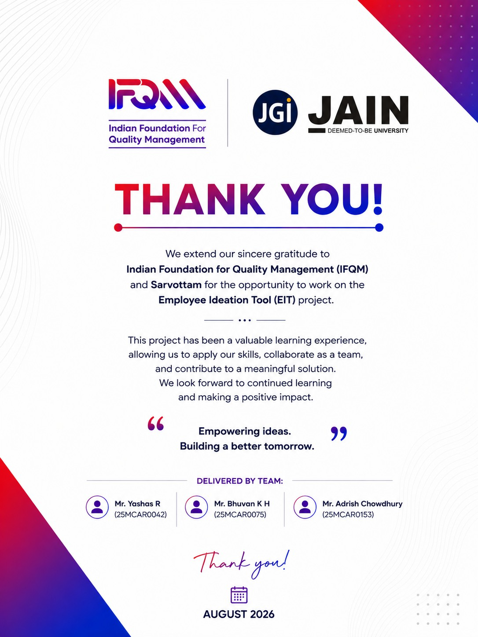

PART E — TECHNICAL MANUAL
Written for whoever inherits this codebase. It assumes you can read JavaScript and SQL, and nothing else about the project.
Covers MOM 29 Jul 2026 §1.2, §1.3, §2.1, §3.1, §3.2 and §13.7.
File | For
README.md | What the product does, quick start
docs/USER_GUIDE.md | End users (employees, org admins)
docs/DEPLOYMENT.md | Production deployment on your own server
docs/FREE_DEPLOY.md | Zero-cost deployment (Vercel + Render + Aiven)
MOM_29Jul2026_Implementation_Status.md | Every MOM item and its state
Companion documents
---

1. System shape
Browser ──HTTPS──▶ React SPA (Vite build, static files)
│
│ XHR, Bearer JWT
▼
Express API ──▶ ifqm_master (registry: tenants, platform
│ admins, tickets, login
│ activity, registrations)
│
└────────▶ ifqm_<slug> (one schema PER ORGANISATION:
users, ideas, votes, files)
The single most important structural fact: each organisation has its own database schema. ifqm_master records which organisation exists and which schema it lives in; nothing else. A query in the app is always scoped to one tenant's pool, so cross-tenant leakage would require a code path that deliberately opens the wrong pool.

Request lifecycle
1. src/app.js — helmet, CORS allow-list, HTTPS redirect, body parsing, the global per-IP rate limiter. 2. src/routes/index.js — mounts each route group under /api. 3. src/middleware/auth.js — decodes the JWT, re-reads the user from the database on every request (so deactivation, demotion and password reset take effect immediately rather than at token expiry), resolves the tenant, attaches req.db and req.tenant, and meters the request against the organisation's API quota. 4. Controller — HTTP shape only. Never contains business rules. 5. Service — all business logic; takes db as its first argument and never touches req/res. This is why services are directly testable. 6. src/middleware/errorHandler.js — turns ApiError into a JSON response and anything else into a generic 500 (raw driver errors disclose schema names and paths, so they are logged, never returned).

Layout
backend/
├── server.js boot, graceful shutdown, port-clash diagnostics
├── schema/tenant_schema.sql ← a new organisation is built from THIS FILE ALONE
├── scripts/ setup · migrate · backup · provision-tenant
└── src/
├── config/ all env vars land here, plus the production guard
├── database/ master.js (registry) · tenant.js (per-tenant pools)
├── middleware/ auth · rateLimiter · tenantQuota · errorHandler
├── routes/ thin; one file per resource
├── controllers/ thin; HTTP only
└── services/ the actual product
frontend/src/
├── pages/ one file per route
├── components/ shared UI, Layout/ holds the shell
├── context/ Auth · Branding · Lang · Toast · Notif
├── i18n/ en + 6 Indian languages
└── services/api.js every server call in the app
db/
├── master.sql registry schema + seeds
└── migrations/ NNN_name.sql, forward-only, ledgered
---

2. The rules that are not obvious
Each of these exists because the alternative failed in production. Change them only with the reason in hand.
`tenant_schema.sql` must stay in step with `db/migrations/`. createTenant() provisions a new organisation from that file alone — it never runs the migrations. Anything a migration adds must also be born there, or every organisation created from the UI starts life missing it. This has already caused one outage ("Create New Organisation" died on Unknown column 'password_changed_at').
Migrations are forward-only and ledgered. ifqm_master.schema_migrations records (db_name, filename). Fixing a bad migration means writing a new one — never editing an applied file, because copies that already ran cannot be retro-edited. Files ending _master.sql target the registry; everything else is applied to every tenant schema.
MySQL, not MariaDB. XAMPP ships MariaDB, which accepts ADD COLUMN IF NOT EXISTS and CREATE INDEX IF NOT EXISTS. Real MySQL 8 does not. Every guarded DDL statement in db/migrations/ uses the information_schema + PREPARE idiom for that reason. Managed MySQL also defaults to sql_mode=ANSI, where "double quotes" are identifiers — so SQL string literals must use single quotes.
Never `SELECT i.*` into a list response. That is how the full text of every idea's proposed solution ended up in every employee's browser. ideaService redacts on the way out; see §4 below.
Passwords are compared asynchronously. bcryptjs's sync variant pins the event loop for the full ~250 ms of key stretching, during which the process serves nobody. A 9 a.m. sign-in surge made login latency the whole API's latency.
Login always burns a bcrypt compare, even for an unknown account (DUMMY_HASH). Short-circuiting answered "no such user" in 5 ms and "wrong password" in 250 ms, so response time alone enumerated who worked there.
The platform console cannot see inside a tenant. platformService has a written privacy contract at the top of the file: aggregate counts and the org's own admin contact, never an employee row, an idea's content, or a file. Two endpoints were removed for violating it.
---

3. Data model, in brief
Registry — `ifqm_master`
Table | Holds
tenants | One row per organisation: slug, domain, schema name, status, last_login_at, quota overrides
platform_admins | IFQM staff. Soft-capped at 5 (§12.11)
tenant_registrations | MSME self-signup queue (§9)
platform_login_activity | Append-only sign-in record (§12.12)
tenant_api_usage | Per-tenant request counters (§8.3)
login_attempts | Brute-force lockout state (cleared on success — not an audit trail)
support_tickets | Every org's tickets, plus archived_at (§12.3)
platform_settings | Platform-wide defaults
Per organisation — `ifqm_<slug>`
users · ideas · idea_attachments · idea_co_suggesters · idea_workflow (append-only audit) · idea_reviewers · idea_votes · idea_community_votes · idea_comments · challenges · idea_categories · notifications · org_settings · email_queue · password_reset_tokens · user_import_jobs.
ideas is the centre of gravity. Note that several columns are deliberately separate rather than merged:
• expected_implementation_date (submitter's estimate) vs
implementation_target_date (what the owner commits to after approval)
• implementation_duration (free text, legacy) vs time_required (fixed bands,
MOM §14.5) — the free-text column holds real data on older ideas and cannot be coerced
• patentability is its own axis, not a status: an idea can be approved and
unpatentable, or rejected and still worth filing
• archived_at is a filter, not a delete — points, audit trail and ROI survive
---

4. Two rules worth understanding before changing anything

Solution visibility (§13.1, §11.4)
The proposal text is the intellectual contribution. Publishing it to the whole organisation on filing lets anyone restate it as their own before the original is even reviewed.
• The list endpoint never sends a full solution to anyone. It sends
solution_summary (first sentence) and solution_redacted.
• The detail endpoint redacts unless the viewer is the author, a
co-suggester, an assigned or current reviewer, or a manager and above.
• The org admin chooses the mode: authors_reviewers (default), managers_only,
everyone.
Enforced server-side, so it holds against a crafted API call — not a UI restriction.

The approval chain
Two modes. getApprovalConfig() resolves both into the same { reviewer_roles, final_roles } shape, so the escalation engine never learns which one an org uses.
• stages — an ordered list (`originator → immediate_manager →
department_manager → plant_head`). Order is the thing being stored.
• default / custom — two role lists.
Per MOM §13.11/§13.12: super_admin is no longer an approver anywhere, and the built-in chain ends at Plant Head. admin is appended to the final set so an idea can never dead-end with nobody able to close it.
---

5. Running it
# One command, idempotent, also repairs a half-built database
cd backend && npm install && npm run setup && npm run dev # :4000
cd frontend && npm install && npm run dev # :5173
npm run setup creates backend/.env, builds ifqm_master, creates every tenant schema in the registry, and applies all migrations.
Tests: cd backend && npm test — 33 HTTP integration tests against a real database. They cover the invariants that have broken before (tenant isolation, role gates, lockout arithmetic, anonymity masking). The 285/288 figure in the MOM refers to the separate manual test-case document, not this suite.
Adding an organisation: platform console → New Organisation, or node scripts/provision-tenant.js --name="Acme" --slug="acme" --domain="acme.com".
---

6. Where the bodies are buried
Symptom | Cause
Server exits at boot with a numbered list | The production config guard. Fix what it names in .env.
Unknown column … on Create Organisation | tenant_schema.sql drifted from db/migrations/.
SQL syntax error on a managed MySQL | MariaDB-only DDL, or "double quotes" under ANSI_QUOTES.
Opaque 500 on a browser API call | Origin missing from CORS_ORIGIN. The cors middleware passes an Error, which becomes a 500 — this misleads reliably.
Uploads vanish after a deploy | Ephemeral disk (Render free tier). Files are on disk, rows are in the DB.
429 with a quota message | Per-tenant API quota (§8.3). Raise it on the tenant row or in platform settings.
Login works, everything else 401s | Password changed, role changed, or account deactivated — every request re-reads the user.
---

7. Phases completed (§3.1)
Phase | Delivered
1 | PHP/MySQL prototype — idea capture, basic review
2 | Multi-tenancy: registry + schema per organisation, platform console
3 | Migration to React + Node/Express; JWT replaces PHP sessions
4 | Workflow depth: configurable approval chains, SLA/escalation, multi-reviewer committees
5 | Engagement: points, leaderboard, challenges, community voting
6 | Outcomes: implementation tracking, ROI, analytics, exports, audit log
7 | Hardening: brute-force lockout, per-request re-auth, privacy contract on the console, load-driven indexing
8 | Reach: 7-language i18n, bulk user import, email/phone login without an org code
9 | Integration: QCMS push for approved ideas
10 | This MOM — MSME self-registration with approval, solution privacy, podium leaderboard, on-hold vs inactive, per-tenant quotas, patentability, archiving

8. Roadmap (§3.2)
Not started; recorded so the sequence is not re-derived later.
Near term — SMTP configured in production (nothing emails until then) · OTP/SMS login (§4) · Azure OAuth + SSO with QCMS, DWM and Skills (§12.6, §12.7) · billing and GST invoicing (§10).
Then — text-to-voice idea capture, aimed squarely at shop-floor staff who will speak an idea but not type one · a mobile app (the SPA is responsive today, which may be enough — worth testing before committing) · richer analytics.
Open questions blocking work are listed in MOM_29Jul2026_Implementation_Status.md. The live one is §9.6 vs §9.3: the MOM asks both to block free email domains and to accept Gmail for businesses without a domain. Free mail is currently blocked.
---

9. QCMS API key — operator guide (§13.7)
The key is write-only through the API. GET /api/integrations/settings returns qcms_api_key_set: true|false and never the value, so a compromised admin session cannot read it back out.
To set one: Admin → API & Integration → paste → Save. To rotate: paste the new one; leaving the field blank keeps the existing key rather than wiping it. To remove: contact IFQM. The key is stored per tenant in org_settings; there is no screen, export or log line anywhere that prints it.
Base URL comes from QCMS_BASE_URL in the environment, and an org admin can override it per tenant.

PART F — PROJECT FLOWS, PHASES AND TIMELINE
How an idea travels, how an organisation joins, who can see what, and when each part was built.
<table> <tr> <td><b>Audience</b></td> <td>Anyone who needs to understand how the product behaves without reading the code — a new engineer, a reviewer of the design, or IFQM staff answering a customer.</td> </tr> <tr> <td><b>How to read it</b></td> <td>Each flow is visually illustrated below with diagrams and structured execution paths.</td> </tr> <tr> <td><b>Source</b></td> <td>MOM 29 July 2026, §2.1. System Workflow and Process Specifications.</td> </tr> </table>
---

System Overview Diagram
![System Overview Diagram](file:///c:/xampp/htdocs/ifqm/docs/diagrams/F0_overview.png)
flowchart TD
subgraph Overview["IFQM Employee Ideation Tool — System Overview"]
A[1. Employee / Submitter] -->|Submits Idea| B[Idea Lifecycle & AI Scoring]
B -->|Workflow Routing| C[Line Manager / Plant Head Approval]
C -->|Approved| D[Implementation & ROI Tracking]
D -->|Integration| E[QCMS Enterprise Push]
F[2. MSME Organisation] -->|Registers Workspace| G[Platform Admin Approval & Tenant Provisioning]
H[3. Authentication] -->|OTP / Password| I[Role-Based Authorization & Session Hardening]
end

Contents
 | Flow | What it answers
1 | [Idea lifecycle](#1-idea-lifecycle) | What happens between somebody noticing a problem and the saving being recorded
2 | [MSME registration and approval](#2-msme-registration-and-approval) | How an organisation gets a workspace, and what stops anybody helping themselves to one
3 | [Authentication](#3-authentication) | How somebody signs in, and what happens when they get it wrong
4 | [Who sees what](#4-who-sees-what) | Which parts of an idea reach which people
5 | [Timeline](#5-timeline) | When each part of the product was built
---

1. Idea lifecycle
The core loop. Everything else in the product exists to keep an idea moving along this path.
![The Idea Lifecycle Diagram](file:///c:/xampp/htdocs/ifqm/docs/diagrams/F1_idea_lifecycle.png)
flowchart TD
A[Employee opens Submit] --> B[Step 1: title + present situation]
B --> C{Duplicate detected?}
C -- yes --> C1[Similar ideas shown<br/>submitter decides] --> D
C -- no --> D[Step 2: proposed solution,<br/>impact areas, tags]
D --> E[Step 3: business case<br/>feasibility · time required · investment]
E --> F[Step 4: attachments]
F --> G[Step 5: co-suggesters]
G --> H{Submit or save draft?}
H -- draft --> H1[(Status: Draft)]
H1 --> B
H -- submit --> I[AI / heuristic scores 0-100<br/>across six dimensions]
I --> J[(Status: Submitted)<br/>+10 points · SLA clock starts]
J --> K{Workflow type}
K -- hierarchical --> L[Routed to line manager]
K -- multi-reviewer --> M[Committee assigned<br/>approval threshold applies]
L --> N{Reviewer decision}
M --> N
N -- reject --> O[(Status: Rejected)<br/>reason recorded in timeline]
N -- approve, not final --> P[Escalates to next role in chain]
P --> N
N -- approve, final role --> Q[(Status: Approved)<br/>+25 points]
Q --> R[Implementation owner + target date]
R --> S[(Status: Implemented)<br/>+65 points · ROI captured]
S --> T{QCMS configured?}
T -- yes --> U[Pushed to QCMS<br/>counted in the platform console]
T -- no --> V[Ends here]
O --> W[Visible in Rejected Ideas<br/>with its reason]
Starts when | An employee opens Submit
Ends in | Implemented and measured, rejected with a reason, or archived
Points | +10 submitted · +25 approved · +65 implemented, each awarded once
Who decides | The line manager, or a committee where the organisation routes it that way
Settings that bite | review_sla_days, escalation_days, approval_threshold
> [!IMPORTANT] > An overdue idea and an escalated idea are different things. > review_sla_days marks an idea as late so somebody chases it — nothing moves > and nobody is reassigned. escalation_days is what actually moves it up the > chain. Both are per organisation, and confusing the two is why those fields > carry information buttons in the admin panel.
> [!NOTE] > A draft is private to its author, has not entered the process, and can be > resumed at any time. Nothing happens to it until it is submitted.
---

2. MSME registration and approval
![MSME Registration and Approval Diagram](file:///c:/xampp/htdocs/ifqm/docs/diagrams/F2_registration.png)
flowchart TD
A[MSME visits the landing page] --> B[Register your organisation]
B --> C[Step 1: company + applicant]
C --> D{Work email domain?}
D -- gmail / outlook / disposable --> D1[Rejected inline<br/>before the long form] --> C
D -- corporate domain --> E[Step 2: Udyam, GSTIN, PAN,<br/>entity type, MSME category,<br/>NIC, headcount, turnover]
E --> F[Step 3: address + confirm authority]
F --> G[(tenant_registrations: pending)]
G --> H[Reference REG-n shown]
G --> I[Platform → Registrations<br/>badge appears]
I --> J{Platform admin decision}
J -- reject --> K[(rejected, note kept internally)]
J -- approve --> L[Org code confirmed]
L --> M[Tenant database provisioned<br/>from tenant_schema.sql]
M --> N[First admin created<br/>one-time password shown ONCE]
N --> O[Operator relays it out of band]
O --> P[Admin signs in,<br/>forced password change]
P --> Q[Bulk-import staff · configure<br/>categories and approval chain]
Q --> R[Organisation live]
Starts when | A business fills in the form on the landing page
Ends in | A provisioned workspace with a first administrator, or a rejection with a reason
Decided by | IFQM platform staff, who also set the plan and the trial length
Checked | Corporate email domain, then Udyam, GSTIN, PAN, CIN, NIC and PIN formats
> [!WARNING] > Nothing an anonymous caller does provisions anything. > The worst a flood of junk applications achieves is a full review queue. No > database is created, no account exists, and no email is sent to anybody but > the applicant until a human approves it.
> [!TIP] > A duplicate application returns exactly the same response as a new one. > Telling an anonymous caller "this company already has an account" would be a > free customer-list lookup for anybody who wanted one.
---

3. Authentication
![Authentication Diagram](file:///c:/xampp/htdocs/ifqm/docs/diagrams/F3_authentication.png)
flowchart TD
A[Sign in: email or phone + password] --> B{Account locked?}
B -- yes --> B1[429, minutes remaining<br/>recorded as a lockout]
B -- no --> C{Matches a platform admin?}
C -- yes --> D[Platform console session]
C -- no --> E{Org code supplied?}
E -- yes --> F[Open exactly that organisation]
E -- no --> G[Resolve org from the login directory<br/>email or phone]
F --> H{Password correct?}
G --> H
H -- no --> I[Failure counted · generic message<br/>5 strikes = 15-minute lock]
H -- yes --> J[JWT issued · sign-in recorded ·<br/>tenants.last_login_at stamped]
J --> K{Must change password?}
K -- yes --> L[Forced change screen<br/>only Support reachable]
K -- no --> M[Dashboard for their role]
Sign in with | Email, registered phone number, or employee number
Organisation code | Optional — the sign-in directory resolves it when it is left out
Wrong passwords | Five, then a 15-minute lock. The right password does not open it early
Session | A signed token that carries the account's password-change stamp
> [!IMPORTANT] > The token is a claim, not a source of truth. > Every request re-reads the user from the database, so deactivating somebody, > changing their role, or resetting their password takes effect on their very > next request rather than whenever the token happens to expire.
> [!NOTE] > Every failure — unknown account, wrong password, deactivated account — answers > the same way and takes the same time. A response that differs is a way to test > which addresses are registered.
---

4. Who sees what
![Who Sees What Diagram](file:///c:/xampp/htdocs/ifqm/docs/diagrams/F4_visibility.png)
flowchart LR
subgraph Platform["IFQM platform admin"]
P1[Organisations + aggregate counts]
P2[Registration queue]
P3[Support tickets]
P4[Sign-in activity]
P5["NEVER: employee rows,<br/>idea content, files"]
end
subgraph Org["Organisation"]
A1[Org admin: everything in their org]
A2[Plant head / executive: all ideas]
A3[Manager: their reports' ideas]
A4[Employee: own ideas + titles of all]
end
Platform -.->|provisions, never reads| Org
Who | Sees
Employee | Their own ideas in full. For everybody else's: the title, the status, and whatever their organisation has opened up
Manager | The ideas of the people who report to them
Plant head / executive | Every idea in the organisation
Organisation admin | Everything in their organisation, plus the settings that govern it
IFQM platform staff | Which organisations exist, how many people and ideas each has, the registration queue, support tickets and sign-in activity
> [!CAUTION] > IFQM staff never see the content of an idea, an employee record, or a file. > The platform console provisions organisations and counts them. It does not read > them, and there is no screen anywhere in it that could.
> [!NOTE] > On top of the role scoping above, each organisation chooses how much of a > proposal a colleague outside an idea may read — the one-line gist by default. > Authors and reviewers are never restricted by that setting.
---

5. Timeline
![Timeline Diagram](file:///c:/xampp/htdocs/ifqm/docs/diagrams/F5_timeline.png)
flowchart TD
T1[Prototype Phase<br/>Basic Idea Submission & Review] --> T2[Multi-Tenancy Architecture<br/>Schema Per Organisation & Master Registry]
T2 --> T3[React + Express Re-architecture<br/>Stateless JWT Authentication & Security Hardening]
T3 --> T4[Hierarchical Approval Chains<br/>Plant Head Final Reviewer & SLA Clock]
T4 --> T5[Gamification & Analytics<br/>Points, Leaderboard, Challenges & Audit Logs]
T5 --> T6[Security & Compliance Hardening<br/>Lockout Guards, Privacy Contracts & Activity Logs]
T6 --> T7[Multi-language & Integrations<br/>7-Language i18n, Bulk User Import & QCMS Integration]
T7 --> T8[MSME Self-Registration & OTP Verification<br/>ZeptoMail Email OTP, Subscription Plans & Dedicated Reset Flow]
When | Milestone
Early 2026 | PHP prototype: capture and basic review
— | Multi-tenancy: registry + schema per organisation
— | Rewrite to React + Node/Express; JWT replaces sessions
— | Configurable approval chains, SLA/escalation, committees
— | Points, leaderboard, challenges, community voting
— | Implementation tracking, ROI, analytics, audit log
— | Security hardening: lockout, per-request re-auth, console privacy contract
— | 7-language i18n, bulk import, email/phone login
— | QCMS integration
29 Jul 2026 | Review meeting — this MOM
Aug 2026 | MSME self-registration, solution privacy, podium leaderboard, on-hold vs inactive, quotas, patentability, archiving
Aug 2026 | Free-tier deployment live (Vercel + Render + Aiven)
Aug 2026 | Subscription plans, trials and billing; organisation profile dashboard
Next | SMTP in production · OTP login · UAT · Azure OAuth + SSO
> [!NOTE] > Dates before the review meeting are deliberately unanchored. The repository > history carries the commit dates, and inventing precise milestones for a > handover document would be worse than saying so.
---
<sub>Colour coding is consistent across every diagram in this project — indigo for the path through the system, teal for stored data, amber for a decision, green for an outcome somebody wanted, red for a refusal, slate for anything outside our control.</sub>

Minutes of Meeting — 29 July 2026, and what was implemented
Tracks every action item in IFQM_EIT_MOM_29Jul2026.docx (in this folder) against what is now in the codebase.
Status as of 7 August 2026 (second round).
Each item carries one of three states, and the distinction matters when reading the totals:
State | Meaning
✅ Done | Built and verified in response to this MOM
⏸️ Pre-existing | Already satisfied before this MOM; no work was needed
❌ Not started | No code exists for it yet
🟡 Partial | Some of the item is covered; the gap is stated
Summary of 75 action items: 52 done · 9 pre-existing · 2 partial · 12 not started.
The 12 remaining are, with two exceptions, not code. They are commercial decisions (§1.4 support scope, §5.1 trial period, §6.1 branding, §10.1 billing — which the minutes themselves mark as future scope), process items (§4.3 UAT, §7.1 penetration testing, §3.3 IFQM taking ownership), a question for a vendor (§8.2), and a figure only its owner can confirm (§1.1).
The two genuine engineering items left are §12.6 SSO across QCMS, DWM and Skills and §12.7 Azure OAuth, which need an Azure tenant and app registration that do not exist yet, plus agreement from the other two tools.
§9.6 is a decision, not a task. It contradicts §9.3 — see Open questions.
---

1. Project Handover & Documentation
# | Expected | State | Notes
1.1 | Confirm test case count (285 vs 288) | ❌ | The automated suite is 33 HTTP integration tests; the 285/288 figure refers to the manual test-case document. Needs reconciling by whoever owns that sheet.
1.2 | Handover package: source, user manual, technical manual | ✅ | Source, docs/USER_GUIDE.md, and now docs/TECHNICAL_MANUAL.md — architecture, the non-obvious rules and why they exist, data model, where the bodies are buried.
1.3 | Documentation for project continuity | ✅ | TECHNICAL_MANUAL.md is the continuity document, alongside README, DEPLOYMENT, FREE_DEPLOY and MIGRATION.
1.4 | Define scope of extended post-deployment support | ❌ | Commercial decision, not a code change.

2. Project Flowchart & Timeline
# | Expected | State | Notes
2.1 | Complete flowchart + full project timeline | ✅ | docs/PROJECT_FLOWCHART.md — idea lifecycle, registration/approval, authentication, visibility boundaries, and the timeline. Mermaid, renders on GitHub.

3. Multiple Phases & Future Roadmap
# | Expected | State | Notes
3.1 | Document phases completed so far | ✅ | Ten phases recorded in TECHNICAL_MANUAL.md §7.
3.2 | Roadmap: text-to-voice, mobile app, others | ✅ | Roadmap in TECHNICAL_MANUAL.md §8 — near term (SMTP, OTP, Azure OAuth/SSO, billing) and later (text-to-voice, mobile).
3.3 | IFQM takes ownership of sustaining + training | ❌ | Organisational, not code.

4. OTP / Login Testing
# | Expected | State | Notes
4.1 | Mock OTP test on login with SMS-tag integration | ✅ | One-time-code sign-in built end to end, with a pluggable SMS provider so the mock test the minutes asked for works today without an SMS contract. Codes are hashed at rest, single use, expire in five minutes, and five wrong guesses burn the code. Requesting one reveals nothing about whether the number is registered.
4.2 | Developer/test access via OTP | ✅ | Same flow, with a dev_access purpose recorded against the code so a developer or tester sign-in is distinguishable from a normal one in the activity log.
4.3 | UAT before final deployment | ❌ | Process item.

5. Trial Period
# | Expected | State | Notes
5.1 | Define website trial period | ❌ | Open item in the MOM itself. The public landing page currently says "free while in preview" — that wording is a placeholder pending this decision.

6. Tool Branding
# | Expected | State | Notes
6.1 | Finalise tool name and logo | ❌ | Still using the IFQM mark.
6.2 | Integrate logo/branding with IFQM identity | ⏸️ | Per-tenant branding (logo upload, primary colour) already exists in Admin → Branding.

7. Security & System Testing
# | Expected | State | Notes
7.1 | Stress / penetration-style testing | ❌ | Load testing informed the ideas.updated_at index, but no penetration test has been run.
7.2 | Disable screenshots and right-click | ✅ | Content protection as an org setting, off by default: right-click, selection, copy and drag suppressed on idea text, plus a watermark carrying the reader's own name. The label and help text state plainly that it cannot stop a screenshot or a phone camera — nothing in a browser can. Its real value is that a leaked screenshot is attributable.

8. API & Data Privacy
# | Expected | State | Notes
8.1 | Clarify API key privacy and what the API stores | ✅ | docs/DATA_AND_API_PRIVACY.md — what is stored and where, what IFQM can and cannot see, what leaves the system and to whom, retention, and the list of things deliberately not collected. The QCMS key is write-only through the API and appears in no screen, export or log.
8.2 | Confirm enterprise edition does not leak private info | ❌ | Vendor question.
8.3 | API rate limits: 10,000 total, 2,000/month | ✅ | Per-tenant quota: 10,000 lifetime / 2,000 monthly, counted in tenant_api_usage, enforced in middleware/tenantQuota.js. Buffered writes; fails open on a metering error so a counting outage cannot become a customer outage.
8.4 | File upload limit 10 MB, listed under expected benefits | ⏸️ | Enforced via MAX_FILE_MB=10, both in multer and in the upload service. Not yet surfaced as a "benefit".
8.5 | Upper limit per organisation + per-file size limit | ✅ | Per-organisation storage cap now enforced on upload, measured from the directory on disk rather than a running total — a counter drifts the moment a file is removed by hand.
8.6 | Evaluate DDoS prevention at tenant level | ✅ | Abuse protection is now per tenant as well as per IP. A NAT-ed office looks like one client to an IP limiter and a botnet looks like thousands, which is why the commercial limit had to be counted per organisation.

9. Self-Service & Tenant Registration
# | Expected | State | Notes
9.1 | "Register" option for new tenants | ✅ | Public /signup, three-step form, POST /api/registrations.
9.2 | MSMEs approved/whitelisted by IFQM on the backend | ✅ | Applications queue in ifqm_master.tenant_registrations as pending. Nothing is provisioned until a platform admin approves; approval creates the tenant DB and issues a one-time admin password. Platform → Registrations.
9.3 | Detect and block free/disposable email-domain generators | ✅ | 30+ consumer providers and 18 disposable services blocked, server-side on submit and live as the applicant types.
9.4 | Explore corporate mail detection during sign-up | ✅ | GET /api/registrations/check-email validates the domain on blur before the applicant fills the rest of the form.
9.5 | GST number + email if a company domain exists | ✅ | GSTIN captured (format-validated, optional since MSMEs below the threshold have none) alongside Udyam number, PAN, CIN, entity type, MSME category, NIC code, headcount, turnover band and registered address.
9.6 | Mobile number / Gmail route when no company domain exists | ❌ | Deliberate gap. §9.3 and §9.6 pull in opposite directions: one says block free mail, the other says accept Gmail when there is no domain. Free mail is currently blocked outright. Needs a decision — see "Open questions" below.
9.7 | Admin-only registration channels by approval method | 🟡 | Approval is admin-only as required. Gmail/Outlook and phone as approval channels are not implemented, pending 9.6.

10. Billing
# | Expected | State | Notes
10.1 | Invoice generation → GST | ❌ | Marked "future scope" in the MOM.

11. Leaderboard
# | Expected | State | Notes
11.1 | Attractive leaderboard: Top Contributors, Top 5, podium | ✅ | Top three on a 2-1-3 podium (winner centre and tallest) with 🏆/🥈/🥉, gold/silver/bronze tinting, ranks 4+ continuing as rows. Collapses to one column on narrow screens.
11.2 | Shareable via social media | ✅ | Share button on the leaderboard: Web Share API where the device offers it, clipboard fallback. Shares a text summary of the top 5, not a link — the leaderboard is behind a tenant login, so a URL would dead-end for anyone outside the org.
11.3 | Compare "All Ideas" view against an "Idea Board" view | ✅ | docs/VIEW_COMPARISON.md. The comparison earned its place: it found the Idea Board still sending every idea's full text to every employee. That module was never brought along when the redaction went in, and the screen's two-line clamp was hiding it from the reader but not from the page. Fixed, along with the board showing archived ideas.
11.4 | Biocon-style: problem, business case, solution as one-line summary; full details hidden until expanded | ✅ | The list endpoint no longer sends any full solution text, and the detail endpoint redacts it unless the viewer is the author, a co-suggester, an assigned or current reviewer, or a manager and above. All Ideas shows a one-line gist with a 🔒 and an explanation. Title, impact, score and status stay public.

12. IFQM Super Admin Login
# | Expected | State | Notes
12.1 | Rename "Suspended" to "On-Hold" | ✅ | Renamed across the console (status badge, KPI tile, filter, menu action, toasts). The database enum value is unchanged on purpose — relabelling avoids a data migration and a missed comparison somewhere.
12.2 | Clarify On-Hold vs Inactive | ✅ | Now two independent columns. Status = what an operator did (Active / On Hold / Pending). Activity = what the org did, derived from a new tenants.last_login_at: Inactive at 5+ days without a sign-in, plus a distinct "Never signed in". Reported only — nothing is switched off.
12.3 | Archive option for tickets under Support | ✅ | archived_at on support_tickets, hidden from the list unless asked for. Distinct from closed: closing is the outcome, archiving is "stop showing me this".
12.4 | Nomenclature: "Active Orgs" | ✅ | KPI tile now reads "Active Orgs".
12.5 | Count of ideas sent to QCMS, shown as a total | ✅ | Per-organisation QCMS column in the tenant table, plus a platform-wide total tile.
12.6 | SSO across QCMS, DWM and Skills on a shared database | ❌
12.7 | Azure for OAuth | ❌
12.8 | "Ideas Implemented" on home page (Orgs → Ideas → Implemented) | ✅ | Ideas Implemented and Sent to QCMS as headline tiles, summed from the same per-tenant figures the table shows, so the headline cannot disagree with the rows.
12.9 | Nomenclature: "Organisation Admin" | ✅ | Role label is now "Organisation Admin", including the platform console column and the contacts panel.
12.10 | Top-right: "Superadmin signed in as [username]" | ✅ | Platform admins now see "Superadmin signed in as <name>" instead of a name plus a role pill.
12.11 | Create another superadmin (soft limit 5) | ✅ | Soft cap of 5, stored in platform_settings so an operator who genuinely needs a sixth can raise it — soft because the MOM said soft.
12.12 | Notifications should display login activity | ✅ | platform_login_activity, append-only, recording successes, failures and lockouts with IP and user agent. login_attempts could never answer this: it is lockout state and is cleared on every successful sign-in. Endpoint: GET /api/platform/activity.
12.13 | "i" info button next to SLA and Escalation Days | ✅ | Info buttons on SLA and Escalation Days. Click-to-open rather than a title attribute, which never appears on touch devices.
12.14 | Define an approval-threshold setting | ⏸️ | approval_threshold already exists per tenant and is seeded at provisioning.
12.15 | SMTP integration not yet set up | ⏸️ | SMTP is configurable per tenant; it is simply not configured on the deployed instance, so password-reset and notification emails are silent until it is.

13. Organisation Admin Login
# | Expected | State | Notes
13.1 | Restrict which sections employees can view (one-line solution) | ✅ | Fully configurable by the organisation admin: author and reviewers (default), managers only, or everyone. Server-enforced and verified in all three modes.
13.2 | Org Admin control over ideas, including archiving old ideas | ✅ | Archive/restore on an idea, org-admin only, logged to the workflow timeline. Not a delete: points, audit trail and ROI survive.
13.3 | All Ideas: add filter and export to CSV/PDF | ✅ | CSV and PDF export from All Ideas, honouring the active filters. The full solution is deliberately absent from both — the server does not send it to that screen.
13.4 | Bulk import fields: Salutation, First Name, Last Name, Year of Birth only | ✅ | Import sheet is now Salutation / First name / Last name / year_of_birth. The old name and date_of_birth headers still map, so an existing sheet imports unchanged. The temporary password only ever used the year, so the day and month were personal data collected for no purpose.
13.5 | Dashboard: Rejected Ideas view | ✅ | Dedicated Rejected Ideas page. It was already a filter value; a filter is something you have to think to apply, and the reason an idea was turned down is the most reusable thing in the system.
13.6 | Rate limit 10 MB listed under expected benefits | ⏸️ | Same as 8.4.
13.7 | QCMS API key: user guide only, no key exposure | ⏸️ | The key is write-only in the API — it is never returned to a client. A user guide is still to be written.
13.8 | Hierarchy: typing a user shows their full reporting chain via dropdown | ✅ | GET /api/users/:id/chain returns the full line upward plus direct reports. Cycle-guarded and depth-bounded — a manager loop is two clicks to create and would otherwise spin inside a request.
13.9 | User list: filter by Manager, Executive etc. without pulling the whole DB | ✅ | Filter by role, department, status or manager, all applied in SQL. The available roles and departments come back with the page, so the UI does not hard-code them.
13.10 | Idea Management: "Patentability" decision option | ✅ | Not assessed / not patentable / possibly / filing recommended / filed, recorded against the idea and logged to its timeline. Kept as its own axis rather than a status value, because an idea can be approved and unpatentable, or turned down on cost and still worth filing.
13.11 | Remove Super Admin from the approval chain | ✅ | super_admin removed from the approval chain and from the selectable role list. A stored chain that still names it is filtered out on read.
13.12 | Final approval authority: Plant Head (replacing Executive) | ✅ | Built-in chain now ends at Plant Head. admin is appended to the final set so an idea can never dead-end with nobody able to close it.
13.13 | Show current review stage ("Under review by ___") | ✅ | review_stage on the idea detail: "Under review by <names>", or unassigned/draft/closed. Multi-reviewer ideas name everyone still outstanding.
13.14 | Customisable hierarchy per org via Excel template (Year of Birth, not DOB) | ✅ | Reporting-structure template, separate from the employee import: it can rewire who reports to whom and cannot create, rename or remove anybody. Downloads pre-filled with the organisation as it stands. Preview shows what would change; unknown managers, self-references and reporting loops are each refused by row before anything is written.

14. Employee Login
# | Expected | State | Notes
14.1 | Dashboard: Rejected Ideas view | ✅ | Same dedicated page as 13.5.
14.2 | Export idea to PDF including attachment file names | ✅ | PDF now has a dedicated attachments section listing file names, sizes and which part of the idea they belong to. Files are deliberately not embedded: it would balloon a one-page summary, and hand every file to anyone entitled to the PDF — a wider audience than the people entitled to the files, which are served individually behind an auth check.
14.3 | Employees can only view idea title and part of the solution | ✅ | See 11.4. Enforced server-side, so it holds even against a crafted API call.
14.4 | Mark mandatory fields with a red asterisk | ✅ | Title, Present Situation and Proposed Solution in the submit wizard. Previously the asterisk was the same colour and weight as the label, so it read as punctuation. Marked aria-hidden since the required attribute already announces this to screen readers.
14.5 | Form fields: Situation Title, Description, Solution, Business Case (colour-coded feasibility), Time Required dropdown (<3 / 3–6 / 6–12 months) | 🟡 | Time Required is a three-band dropdown and feasibility is colour-coded (red/amber/green buttons rather than a dropdown, so it reads at a glance). The exact field renaming — "Situation Title", "Description" — is NOT done; those map onto existing columns with real data and renaming them is a data migration, not a label change.
14.6 | Solution category tags: Process Improvement, QCD | ✅ | Process Improvement, Quality, Cost and Delivery as toggles. QCD is three separate tags rather than one lump, so an idea can be tagged for exactly the dimension it improves.
14.7 | Remove the Idea Template section | ⏸️ | No idea-template section exists in the current UI.
14.8 | Remove "Submit Idea Anonymously" | ✅ | Removed from the submit form. The column and masking logic stay in the backend on purpose — ideas already filed anonymously must keep that promise.
14.9 | Capture a timestamp for every idea submitted | ⏸️ | submitted_at, created_at and updated_at are all recorded.
14.10 | Upvote/downvote for all employees; predictions possibly restricted to seniors | ✅ | Voting is open to everyone and always was. The AI's written assessment is now gated, defaulting to managers and above, with the author always able to read the assessment of their own idea. The minutes said "confirm scope", so it is an organisation setting rather than a guess baked into the code.
14.11 | Team Lead sits within the Employee hierarchy | ⏸️ | team_lead is already a role in the hierarchy chain.

15. Infrastructure & Hosting
# | Expected | State | Notes
15.1 | Compare Azure, AWS, Hostinger on cost and reliability | ✅ | docs/HOSTING_COMPARISON.md. Recommends Azure, primarily because §12.7 already commits to Entra ID for OAuth and cross-cloud identity federation is the expensive part. Flags that uploads must move to object storage regardless of provider.
---

Open questions blocking further work
1. §9.6 contradicts §9.3. Blocking free mail and accepting Gmail-based registration for domain-less businesses cannot both be true. Current behaviour blocks free mail. If sole traders must be able to register, the likely shape is a second route: phone + Gmail, flagged in the queue as unverified, with the reviewer doing the diligence. Needs a decision.
2. §1.1 test case count. 285 or 288 — whoever owns the manual test-case sheet needs to confirm. The automated suite is a separate figure (33).
3. §7.2 screenshot/right-click blocking. Recommend discussing before building; it is bypassed trivially and the server-side redaction already shipped is the control that holds.
4. §13.1 configurability. Solution visibility is currently a fixed rule. Making it an Org Admin setting is a small piece of work, but the default and the available levels need deciding.

Also delivered, outside the MOM
• Public marketing landing page at / aimed at MSMEs, with sign-in moved to
/login — the site previously opened on a password prompt.
• Zero-cost deployment now live: Vercel + Render + Aiven, documented end to end.
• SQL portability fixes — the schema only ever ran on MariaDB (XAMPP) and failed
on real MySQL 8 over MariaDB-only DDL and ANSI_QUOTES.
• Password-reset links were dead (/reset-password had no route and the token
parameter name did not match what the email built); fixed.
• Platform console row-actions menu was invisible (var(--card) is not a
defined token) and clipped on the bottom rows; fixed.

