Englisch Mündlich

1st Years

Small talk 

Make up a dialogue with your partner using the following prompts:

A conference is taking place in a hotel (you may choose the place and hotel name).

All conference participants are staying at the same hotel and many of them meet in the hotel bar after the first day of the conference and start getting to know each other.   
You and your partner are meeting for the first time in this business context (you may choose your mutual field of business).

Get to know your partner by using your small talk skills and remembering which topics are acceptable and which are not!

Remember to use suitable interjections and responses to make your small talk flow and avoid uncomfortable silences.

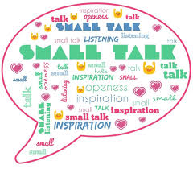Ideally your small talk should last 5 minutes.

