1. What is the common internet domain address for Britain?

* .br
* .gb
* .uk

1. What is the official name for the part of Europe that left the EU on 31 January 2020?

* United Kingdom of Britain and Northern Ireland
* United Kingdom of Great Britain and Northern Ireland
* United Kingdom of Great Britain and Ireland

1. Which one is the smallest of the nations that make up the UK?

* Scotland
* 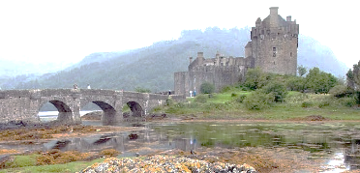Wales
* Northern Ireland

1. Which city is no capital in the UK?

* Dublin
* Cardiff
* Edinburgh

1. What is the name of the current Prime Minister?

* Theresa May
* David Cameron
* Boris Johnson

1. By convention, what is the British sovereign not supposed to do?

* declare war on another country
* appoint the Prime Minister
* cast a vote in general elections

1. 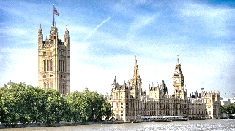Where does the British parliament meet?

* Downing Street
* the Palace of Westminster
* Whitehall

1. The British finance minister is also called …

* Finance Officer
* Chancellor of the Exchequer
* Secretary of the Treasury

1. The content of which newspaper should not be taken too seriously?

* The Times
* The Sun
* The Guardian

1. 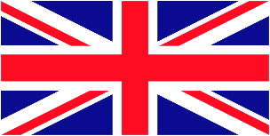The UK flag is also known as …

* The Britannia
* John Bull
* The Union Jack