Introduction
A stroke occurs when blood flow to the brain becomes obstructed which results in brain cells receiving insufficient oxygen. This cause permanent brain damage together with long term disabilities. Statistics show that the condition ranks as one of the main deaths causes and disability sources throughout the world. The process of early detection helps to decrease brain damage, which results in better patient outcomes for both survival and recovery.
Medical professionals use neuroimaging methods such as Computed Tomography (CT) and Magnetic Resonance Imaging (MRI) to diagnose brain stroke. Emergency departments use CT scans because they provide quick images which can be accessed easily, while MRI offers superior brain tissue imaging. The emergency department requires immediate patient assessment because a single moment of delay or incorrect reading will result in harm for the patient.
The progress of artificial intelligence has enabled deep learning methods to become effective tools for medical imaging analysis. The Convolutional Neural Network (CNN) architecture enables machines to learn complex image patterns through automatic processes which operate with great accuracy. The models perform automatic detection of hidden defects which require human expertise to identify because they show only minor signs of their presence. The use of deep learning diagnostic systems is growing in clinical settings because they function as medical decision support systems.
The thesis aims to compare different deep learning models which will automatically detect brain strokes through the analysis of neuroimaging data. The study implements VGG16, DenseNet-201, ResNet, and EfficientNet while conducting evaluations of these models through identical testing processes. By comparing their performance, the aim is to identify the most suitable deep learning model for accurate and efficient stroke detection. The results will help create trustworthy automated diagnostic systems which assist medical professionals while enhancing patient care results.
1.1 Background of the Study
Deep learning techniques have brought about fundamental changes to medical image analysis methods. The traditional machine learning methods depended on expert created features which included texture and shape and intensity values to identify medical image patterns but they struggled to detect intricate patterns. The development of CNNs as deep learning models enables systems to create their own hierarchical feature systems from basic image input.
The diagnosis of brain strokes requires early-stage lesion identification because these lesions exist as small indicators which doctors find challenging to differentiate from standard brain structure. The process of manual diagnosis becomes more difficult because different factors such as image quality problems and noisy elements and variations in patient body structure which exist throughout medical imaging process. The development of automated systems has become essential because they provide doctors with quick and reliable methods to analyze neuroimaging data. The deep learning-based models show high accuracy for identifying CT and MRI scan abnormalities which makes them appropriate for use in stroke detection activities.
Researchers have introduced numerous CNN architectures throughout history which display distinct design elements. VGG16 serves as a widely used baseline model because its architecture combines straightforward design elements with deep structure and identical convolutional layer components. ResNet developed residual connections because it solved vanishing gradient issues, which allowed successful training of extremely deep networks. The DenseNet-201 architecture enables better information flow between layers because it creates a direct pathway which links all network components together. EfficientNet achieved better model performance because it used balanced approaches to increase network depth and width and resolution.
The models demonstrate successful performance, yet their effectiveness shows considerable differences across different dataset and task combinations. The current research studies use only one architectural design which makes it difficult to evaluate which design performs best. The research needs to compare various deep learning systems by testing them on the same datasets and using standard evaluation methods. This study aims to fill this gap by carrying out a detailed comparison of popular CNN architectures for brain stroke detection with neuroimaging data.
1.2 Problem Statement
The medical field faces ongoing issues that make it hard to identify brain stroke cases accurately and promptly. It relies on neuroimaging techniques like CT and MRI scans, but their diagnostic value hinges on the expertise of the radiologists interpreting the images. Emergency situations require quick decision making yet manual analysis methods take too much time and make mistakes because of human factors. Medical professionals need to treat patients who show early stroke symptoms because their condition requires treatment within a specific time frame to reduce permanent brain damage risk.
Deep learning methods show good results for medical image classification yet researchers cannot agree on which CNN design achieves optimal performance for brain stroke detection. Existing studies use one deep learning model to evaluate their results which creates challenges for identifying the most effective and dependable method. Researchers face challenges when comparing study results because of variations in dataset size and preprocessing techniques and evaluation criteria.
The process of choosing a model needs to achieve two requirements which include attaining high accuracy and keeping computational efficiency. Models in actual clinical settings need to deliver their results within short timeframes while operating with minimal computing power. Healthcare facilities find it hard to use complex models which achieve high accuracy because they require extensive resources.
Research problem of this study exists because researchers have not yet created a complete assessment which compares all major deep learning models used for brain stroke detection through neuroimaging data. The study intends to conduct systematic assessments of various CNN architectures using identical testing conditions to determine which model achieves the best performance in accuracy and robustness and operational efficiency.
1.3 Research Questions
- How effectively can deep learning models detect brain stroke from neuroimaging data?
- How do VGG16, DenseNet-201, ResNet, and EfficientNet compare in terms of classification performance?
- Which model offers the best balance between detection accuracy and computational efficiency?
- What are the strengths and limitations of each selected architecture for brain stroke detection?

1.4 Research Objectives
The main goal of this research project is to create an automated system which uses deep learning technology to identify brain strokes through analysis of neuroimaging data. The research will test various convolutional neural network models which include VGG16, DenseNet-201, ResNet, and EfficientNet through a unified experimental framework. The research team will assess these models through standard performance metrics which include accuracy and precision and recall and F1-score to determine how well each model performs. The second research objective requires scientists to assess model performance by testing different models' ability to function in real clinical settings. The research develops a deep learning model which detects brain strokes with high accuracy and efficiency while providing research insights that support future research and clinical decision support system development.

Literature Review
References | Model | Dataset | Limitation | Result
Yelken & Ceylan (2025) | ResNet-152 | CT (Turkish dataset) | High computational cost | 89.2%
Tursynova & Omarov (2024) | EfficientNetB7 + DenseNet201 | Kaggle | Dataset imbalance | 88.6%
Korde et al. (2024) | HLTDS + CNN | CT images | Complex architecture | 87.9%
Ozaltin et al. (2022) | OzNet | CT | Limited generalization | 89.5%
Sailasya & Kumari (2021) | Traditional ML | Clinical data | Low feature representation | 82.0%
Chen et al. (2023) | CNN | MRI | Small dataset size | 88.1%
Islam et al. (2023) | ResNet50 | CT | Overfitting risk | 89.0%
Rahman et al. (2022) | VGG16 | MRI | High parameters | 88.4%
Li et al. (2021) | DenseNet121 | CT | Memory intensive | 89.3%
Kumar et al. (2022) | CNN + SVM | MRI | Hybrid complexity | 87.2%
Zhang et al. (2023) | EfficientNetB0 | CT | Lower Recall | 88.0%
Singh et al. (2022) | ResNet34 | CT | Limited depth | 88.7%
Park et al. (2021) | CNN | MRI | Noise sensitivity | 86.9%
Ahmed et al. (2023) | VGG19 | CT | Slow training | 88.5%
Hassan et al. (2022) | DenseNet169 | MRI | High memory usage | 89.4%
Roy et al. (2023) | Hybrid CNN | CT | Complex tuning | 88.2%
Alsharif et al. (2022) | MobileNet | CT | Limited feature extraction | 86.5%
Wang et al. (2021) | CNN | MRI | Poor generalization | 87.8%
Zhou et al. (2023) | ResNet101 | CT | High computation | 89.1%
Patel et al. (2022) | EfficientNetB3 | MRI |  | 88.3%
  Dataset limitation
Das et al. (2023) | CNN + Transfer Learning | CT | Class imbalance | 89.0%

2.1 Overview of Stroke
A stroke is a critical nervous system issue that happens when there is a sudden stop or alteration of blood circulation to the brain, which results in an abrupt lack of oxygen and nutrients in that particular part of the brain. The brain cells that have been cut off from the blood supply will die very quickly through the process of necrosis, and if the medical intervention is not fast enough the individual may suffer either permanent nerve injury or die. Moreover, stroke has been one of the top reasons for death and disabilities needing long-term care globally, which makes it a serious problem for the health care system.
Strokes can be divided into two principal types: ischemic and hemorrhagic. Among them, ischemic stroke is the one that constitutes a greater part about 80-85% of the whole stroke case picture. This type of stroke happens when a blood vessel that feeds the brain gets occluded, which is usually brought about by a blood clot or accumulation of fatty substances in the vessel. The result is that the blood flow is cut off and the brain tissue gets damaged. Ischemic strokes can be classified into two more categories: thrombotic and embolic, based on the location of the blockage. A hemorrhagic stroke happens when a blood vessel in the brain ruptures, causing blood to leak into or around the brain thus. This type of stroke is less common but always more severe and has a higher death rate. Depending on the location of the bleeding, generally, hemorrhagic strokes are classified as intracerebral hemorrhage or subarachnoid hemorrhage. The major factors that lead to the occurrence of hemorrhagic strokes are high blood pressure, aneurysms, and head traumas.
Besides these two major forms, there is a transient ischemic attack (TIA) which is sometimes called a "mini-stroke", a temporary condition that occurs when there is a short interruption of blood flow to the brain. TIAs, although the symptoms go away very quickly, are considered to be an important sign of future strokes and hence, need immediate medical intervention. It is very important to know the various types of strokes to achieve correct diagnosis and treatment planning. Imaging characteristics and treatment options are different for each stroke type, therefore, automated systems for detection have to be developed in a way that they would be able to tell these differences easily, especially in the very beginning stages.
2.2 Pathophysiology of Brain Stroke
The sequence of biological and cellular events that comprise the pathophysiology of a brain stroke occurs during the abnormality in blood flow to the brain. The reliable working of the brain relies on a constant stream of oxygen and glucose. When this stream is interrupted, even for just a few moments, the brain cells begin to lose their function and may end up being irreversibly damaged.
In an ischemic stroke, a blood vessel blockage suddenly reduces cerebral blood flow, bringing about the oxygen and glucose deprivation that miserably dying cells in the brain energies. This initiates the process of cell death, loss of ion balance, and accumulation of toxic substances. Neurons in the impacted area get electrically inactive and may die if blood flow restoration is not done instantly. The central part where there is serious damage is called the infarct core, while the outer part, known as the penumbra, consists of tissue that has been partially damaged but is still capable of being saved.
Hemorrhagic stroke has an entirely different pathological process as compared to ischemic stroke. When a blood vessel ruptures, blood flows into the brain tissue, therefore causing a build-up of pressure inside the skull. This pressure can push the neighboring brain areas and also disturb the regular blood flow. Moreover, the extravasated blood activates the inflammatory responses and causes more cell death. The combined effects of these factors can very quickly escalate the destruction of the nervous system and the likelihood of complications.
In both kinds of stroke, there are primary injury mechanisms such as inflammation, oxidative stress, and cell death pathways, which are quite complex, and they are termed secondary injury mechanisms. These processes are not confined to the initial event alone but continue and contribute to brain damage progression in a time-dependent manner. The injury is not uniform and its size is determined by a combination of factors such as the area of the stroke, how long the blood flow was cut off, and the patient’s general health condition. A good grasp of the pathophysiology of brain stroke goes hand in hand with detection and treatment being done at an early stage. The minor physiological changes that take place during the very initial period of stroke can be seen using neuroimaging techniques. Proper identification of these changes is crucial for the intervention to be timely and it also forms the foundation for the creation of automated systems for stroke detection.
2.3 Neuroimaging Modalities for Stroke Diagnosis
Neuroimaging has a significant role in the diagnosis and treatment of brain stroke. The use of imaging methods enables the doctors to see the brain structures, to point out the areas with problems, and to know the stroke's type, location, and intensity. Fast and precise imaging is very important for the selection of the right treatment methods and for the reduction of brain damage. From the different imaging techniques, Magnetic Resonance Imaging (MRI) and Computed Tomography (CT) are the ones that are most often used in clinical practice.
The imaging methods mentioned above provide information that complements each other. In emergency settings, CT is the most commonly used method due to its speed and availability. MRI, on the other hand, is the most sensitive for identifying the earliest and mildest ischemic changes. Typically, automated stroke detection systems utilize these imaging techniques to extract important features for classification and analysis.
2.3.1 Magnetic Resonance Imaging (MRI)
Magnetic Resonance Imaging is a non-invasive imaging method that uses strong magnetic fields and radio waves. It is preferred for early detection because it can detect very small changes in brain tissue. Advanced sequences of MRI are capable of indicating spots with blood flow restriction and cellular death that other imaging modalities may never show.
MRI has a higher spatial resolution than any other imaging modality on average, and provides excellent contrast between soft tissues; therefore, it is very well-suited for detecting small lesions and differentiating between normal (healthy) and abnormally (affected) areas of the brain. The duration of time required to complete an MRI scan is typically longer than many other imaging modalities, in addition to the fact that MRI machines are often not found in emergency rooms. The complexity and costliness of MRI machines further hinder their use in some areas of medicine.
Despite these limitations, MRI is still considered an integral component of stroke diagnosis and has been utilized frequently in clinical trials that are aimed at the development and evaluation of automated detection methods.

2.3.2 Computed Tomography (CT)
Computed tomography (CT scan) is one of the most preferred techniques for diagnosing stroke cases, particularly in emergencies. A CT scan produces a series of X-ray images or slices of the brain and is very effective in quick identification of hemorrhagic strokes. The combination of speed and universal availability of CT has secured its position as the main first-line imaging modality in the assessment of acute strokes.
CT scans are the deciding factor in determining whether there is bleeding in the brain or not before going ahead with the treatment of ischemic stroke. On the other hand, the signs of early ischemia are sometimes not very clearly seen on standard CT images; hence, the diagnosis might be difficult. Picture quality in some cases may also suffer due to noise and low contrast.
Yet, CT still is and will continue to be the primary radiation technique for stroke detection. Its quick imaging time and the fact that it is constantly available in the clinic make it a perfect candidate for deep learning model-based automated analysis, especially in critical situations where time is of the essence.
2.4 Image Processing Techniques in Medical Diagnosis
The application of image processing techniques in medical diagnosis is extensive. Their main purposes are to improve the quality of the images, to extract important information, and to assist in making correct clinical decisions. The medical imaging process usually includes raw images that are not ready for diagnosis because they contain noise, have low contrast, or there is irrelevant background information present. By image processing, the accuracy of the diagnosis is enhanced as the important anatomical structures and pathological regions are made more visible. Some of the preprocessing techniques that are commonly used are noise reduction, contrast enhancement, normalization, and image resizing. Noise reduction methods are applied to get rid of the unwanted distortions that could have been introduced during the process of acquiring the images. Contrast enhancement allows the dimmest features in the image to come out gradually. Normalization is used for equalizing the brightness levels of different images, which is important in case of data coming from different imaging devices or settings.
Segmentation technique separates regions of interest, organs or abnormal tissues, from the background, is widely used in stroke analysis. The isolation of segmentation could lead to an easier studying of lesion size, shape, and location. Manual assessment and automated analysis both depend on accurate segmentation.
Feature extraction used to recognize the most relevant patterns and characteristics from the medical images. The traditional methods rely on features like texture, shape, and intensity-based measures. These methods need domain expertise and may not be very good at generalizing across different datasets. Data augmentation is also among the methods used in image processing, mainly to increase the machine learning model training data diversity. Augmentation methods like flipping, rotation and scaling help build model robustness and lower overfitting.
Taking everything into account, image processing techniques are no less than a major determinant in the medical diagnosis sector as they not only improve image quality but also allow for efficient analysis. They are the cornerstone of deep learning-based systems, where the high-quality input data greatly boosts the model performance and trustworthiness.

2.5 Deep Learning in Medical Imaging
The usage of deep learning in medical imaging has significantly increased due to its capability to automatically discover intricate patterns in huge sets of data. Deep learning models, in contrast to the traditional machine learning methods that rely on human ingenuity for feature design, can handle the medical images, for example, CT and MRI scans, in a straightforward manner. Thus, they are able to record even the most delicate differences in intensity, texture, and structure, which might not be noticed by the human eye.
In the field of medical diagnostics, deep learning methods are employed for tasks like image classification, segmentation, and disease detection. For example, they are very useful in the case of neurological imaging where brain structures are of high complexity and the related changes are often very little in the early stages of the disease. Deep learning systems are capable of processing a large amount of imaging data very fast and with high consistency, thus being able to take part in applications where time is crucial, like diagnosis of stroke.
A further benefit of deep learning technology is that it can facilitate a direct and complete mapping of the images to the diagnostic outputs, thus the end-to-end learning. Transfer learning on the other hand, increases the accuracy of the results by training the medical models on smaller datasets that come from the already pre-trained model on a large generic dataset. In spite of the challenges related to computational cost and interpretability, deep learning is still one of the main contributors to the development of automated medical diagnosis.

2.6 Convolutional Neural Networks (CNNs)
Convolutional Neural Networks (CNNs) can be considered the deep learning models that have a specific application in image processing. The CNN architecture possesses many layers, including convolutional, pooling, and fully connected ones. All layers are built with the same purpose of extracting the spatial characteristics of the image automatically. The layers take their different roles in the entire process of feature extraction, and the end result is the building of a feature hierarchy where the basic edges are first recognized and subsequently combined into more complex features such as different parts of a body.
In the field of medical imaging, the usage of CNNs is particularly prevalent due to the fact that they keep the spatial relationships in the images intact, which is very important in the case of brain scans. CNNs minimize the need for manual feature extraction because they are able to learn the most discriminative features straight from the data. Therefore, CNNs are very useful in the processes of disease classification and lesion detection.
Furthermore, CNNs are very resistant to changes in image size, noise, and intensity, even more so when they are used with preprocessing and data augmentation strategies. Their power of generalization over a variety of imaging conditions makes them appropriate for real-world clinical applications. Consequently, CNN-based models constitute the majority of deep learning systems that are developed for automatic stroke detection using neuroimaging data.
2.7 Transfer Learning in Medical Image Analysis
Transfer learning has become a widely adopted technique in medical image analysis, particularly in deep learning applications where labeled datasets are limited. Transfer learning uses a pre-trained model which has been developed through training on a large dataset that includes ImageNet to train deep neural networks for specific medical tasks. The model can use its previous knowledge about basic image features which include edges and textures and shapes to analyze medical images at their fundamental level.
The work of collecting and labeling large medical datasets for brain stroke detection research faces two main challenges which include privacy concerns and the need for costly specialized labeling. The implementation of transfer learning enables systems to reach effective performance levels with minimal requirements for data input. Pretrained models such as VGG16, ResNet, DenseNet-201 and EfficientNet have shown strong generalization abilities after they were fine-tuned on medical imaging datasets.
Transfer learning uses two main methods which are feature extraction and fine-tuning. Feature extraction uses a pretrained model that functions as an unchangeable feature extractor which enables training only the final classification layers on new data. Fine-tuning allows model adaptation to the target task through retraining some or all pretrained layers together with the classifier. Medical imaging specialists prefer fine-tuning because it enables model training of specific task features while maintaining advantages from pretrained expertise.
The process of transfer learning allows medical facilities with limited resources to achieve better results because it reduces both their training time and their need for computational power. The process of selecting appropriate pretrained models together with tuning methods needs to receive proper execution because it determines the occurrence of either overfitting or negative transfer. Researchers use transfer learning to build deep learning systems which achieve high efficiency and accuracy in brain stroke detection from neuroimaging data.

2.8 Review of Deep Learning Models Used for Stroke Detection
Numerous studies have explored the application of deep learning techniques for automated brain stroke detection using neuroimaging data. The initial research examined standard CNN models which processed CT and MRI data to identify stroke patients and non-stroke patients. CNN-based methods provide better accuracy than traditional machine learning methods because of automatic feature extraction.
The usage of ResNet-based models has become common because they enable training of deeper networks which maintains model performance while enhancing detection precision. DenseNet achieve successful small stroke lesion identification because of detailed feature extraction through the design which permits information reuse between different network layers. EfficientNet has gained attention for achieving high accuracy with fewer parameters which makes it suitable for real-time applications.
Current studies show positive results because they only assess one deep learning model which makes it impossible to compare how different architectures perform. One of the biggest problems occurs because of using of different datasets. The research achieves high accuracy results, but it fails to present a thorough assessment of sensitivity together with false-negative rates.
The current limitations need researchers to conduct a complete evaluation which tests multiple deep learning models under the same experimental conditions. The approach enables researchers to evaluate model performance more objectively while they gain understanding about which architectural designs work best for stroke detection.

2.9 Challenges in Automated Brain Stroke Detection
The process of establishing automated brain stroke detection through deep learning technology encounters multiple obstacles which decrease both its operational effectiveness and its medical use. The system encounters its primary obstacle because there exist insufficient labeled neuroimaging datasets for research purposes. The process of medical image annotation requires radiologist professionals, who create high costs and extended time periods for acquiring medical imaging data.
The problem of class imbalance constitutes an important challenge because stroke cases appear less frequently than normal imaging samples. The existing situation leads models to display a tendency toward predicting non-stroke outcomes which results in decreased detection rates. The various clinical settings result in problems for model accuracy because they use different imaging methods and scanning devices which produce images of varying quality.
The detection of minor stroke indicators becomes challenging because the subtle features of CT and MRI scans get concealed by noise and low contrast and various artifacts. The deep learning models require extensive processing power which does not exist in all healthcare facilities.
Deep learning models face an additional problem because their operation remains hidden from view. Clinicians need to understand how the system reaches its predictions before they will trust the automated system. Reliable stroke detection systems need to solve these problems before they can be used in real-world situations.

Methodology
The research presents an automated system which utilizes deep learning methods to identify brain strokes through analysis of neuroimaging data. It helps to evaluate different convolutional neural network designs because by maintaining identical testing conditions which guarantee unbiased results and study reproduction. The system includes six components which are data acquisition, preprocessing, model implementation, training, evaluation and comparative analysis.
Using clinical annotation, the images are categorized into to buckets: stroke and non-stroke. Image preprocessing is done before model training to enhance image quality and create standardized input dimensions. The process functions decrease background interference while it enhances visual distinction and establishes standard intensity levels for images.
The workflow uses four deep learning models VGG16, DenseNet-201, ResNet, and EfficientNet which improve performance by using transfer learning with pretrained weights. The training strategy remains identical for all models by using same data splits and batch sizes and optimization methods.
The evaluation is based on classification metrics like accuracy, precision, recall, F1-score and confusion matrix analysis. The research analyzes two aspects of computational efficiency which include training time and inference performance evaluation. Then the results compared to identify the most effective model for brain stroke detection. The results of this experimental research have been designed to achieve robustness and fairness across all models with respect to clinical relevance and fairness.
3.1 Workflow Diagram
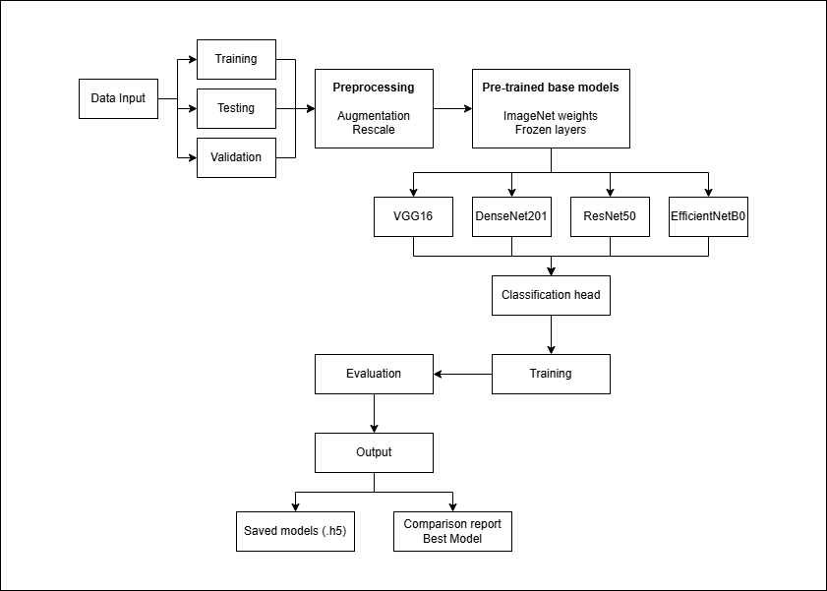
Fig: Proposed Framework
3.2 Dataset
The study uses labeled brain CT scans from hospitals, including both stroke and normal cases, making the data clinically relevant and suitable for real world use. CT scans are chosen because they are commonly used in emergencies and are effective for quickly detecting hemorrhagic strokes.
The dataset contains scans from multiple patients with different brain anatomies, imaging conditions, and stroke characteristics. This diversity introduces a wide range of imaging patterns, which is which helps to improve the generalization capabilities of deep learning models.
The dataset is divided into training, validation and testing to maintain consistent experimental conditions. The training set is used to learn model parameters. The test set is reserved for final performance evaluation. The experiments use a constant data split ratio which helps model comparisons to be conducted in an impartial manner.
Medical imaging datasets are often containing unbalanced class distribution. It affects model performance. To fix this data augmentation applied to produce additional training samples which increases diversity while reducing bias. The dataset is also designed for selection and preparation methodology to support reliable evaluation of deep learning-based stroke detection systems.
3.3 Data Preprocessing
Data preprocessin is an essential procedure for transforming neuroimaging data into suitable format for deep learning models. Unprocessed CT images contain various disruptions and changes in image brightness and unneeded background elements together create obstacles that hinder model effectiveness. Using multiple preprocessing methods, the image quality is enhanced in a manner suitable for CNN system requirements.
The team first resizes all images to a specific resolution that meets the input standards of their chosen pretrained models. Through pixel intensity normalization the process establishes image values at a fixed range which helps to maintain training stability during model development. Noise reduction methods allow the removal of undesired visual elements while the process simultaneously enhances the visibility of major anatomical characteristics.
The training dataset size expands through data augmentation methods which create additional data for training while helping models to perform better on unseen data. The methods use horizontal and vertical image flipping together with rotation and zooming and scaling techniques to create their effects. Through augmentation models achieve better performance because it helps them to learn features which remain unchanged across various image display methods and environmental conditions.
Class balancing techniques used to correct problems that arise from unbalanced dataset distribution and to make sure that all models receive identical input data preprocessing used after that.
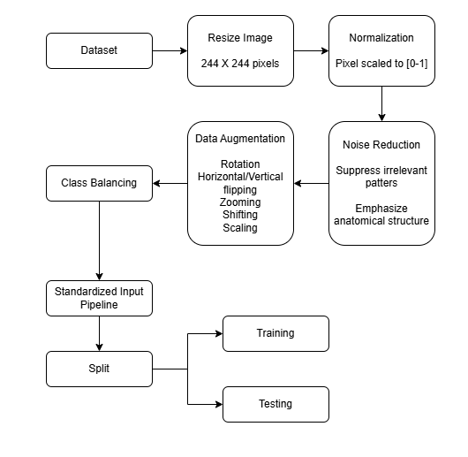
Fig: Data Preprocessing
3.4 Classification Head
Classification head is the final component of CNN. It helps to transform extracted features into output predictions. It follows the feature extraction backbone and is responsible for classifying medical images into stroke vs. non-stroke.

If f represents the feature vector from the backbone:
y = σ (Wf + b)
where W and b are learnable parameters and σ is the activation function.
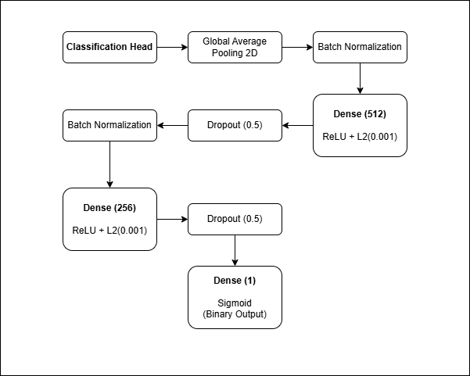
Fig: Classification Head

3.5 Deep Learning Model Architectures
This study evaluates four widely used deep learning architectures for brain stroke detection: VGG16, DenseNet-201, ResNet, and EfficientNet. Each architecture has unique structural characteristics that influence feature extraction and classification performance. All models were adapted using transfer learning, starting with pre-trained weights and adding custom classification layers for stroke detection.
3.5.1 VGG16
VGG16 uses its basic architecture which contains a series of convolutional layers followed by fully connected layers to create its design. The system achieves its strength through its consistent use of small filters across all architectural components. The system provides strong interpretative power through its basic design which functions as an effective standard model. VGG16 requires extensive memory and processing power because its deep structure with multiple layers and high number of parameters. The system performs well for various tasks but it does not provide optimal performance when resources are limited and fast processing is required.
3.5.2 DenseNet-201
DenseNet-201 establishes a new approach to layer connectivity through its design because all layers in the network connect to each other using feed-forward connections. The dense connectivity system enables complete feature reuse, which empowers the network to retain and utilize data from its previous processing stages. The design solution solves the vanishing gradient issue while improving the system's ability to identify difficult-to-detect advanced features. The system needs large amounts of memory because it stores all feature maps processed between different stages of operation. The system can achieve better accuracy for detailed tasks, but it faces deployment difficulties on devices that have restricted memory resources.

3.5.3 ResNet
Using skip connections to pass information from one layer to another in a residual block of ResNet is a significant innovation in deep learning. This solution efficiently addresses the vanishing gradient problem. It helps deep networks with hundreds of layers to undergo stable training. It helps the network to learn identity functions through its residual connections, which supports better results during complicated tasks. The system achieves higher efficiency than VGG16 through its depth and residual block design, but it requires complex architectural elements. The system establishes powerful capabilities, but its decision-making processes become difficult to understand because of its intricate internal mechanisms.
3.5.4 EfficientNet
EfficientNet uses a compound scaling method to achieve balanced network depth and width scales together with different input image sizes. The system follows a structured method which operates efficiently to reach its highest performance level within given computing limits. The system delivers exceptional accuracy results while using significantly fewer system resources than competing architectural designs which offer similar performance capabilities. The design excels in applications which demand simultaneous management of operational efficiency and resource consumption and accuracy in forecast results. The system's efficient design structure requires multiple processing layers which decrease the system's straightforwardness when compared to traditional linear system designs.
3.6 Model Training Strategy
The training process achieves consistent results through its implementation of fairness measures for all deep learning models. The model training process uses identical dataset partitions and preprocessing methods and training specifications. The stroke detection task requirements are met through transfer learning which freezes the initial layers while enabling fine-tuning of higher layers.
The models are trained using a suitable optimization algorithm such as Adam, with a predefined learning rate and batch size. The model optimization process uses binary classification loss functions which are suitable for this purpose. Early stopping and model checkpointing protects against overfitting while maintaining the best model weight configuration. The unified training procedure enables performance evaluations because it maintains consistent training conditions which only change when the system architecture is modified.
3.7 Performance Evaluation and Comparative Analysis
To evaluate how well a model performs, several metrics, (i.e., accuracy, precision, recall, F1-score, confusion matrix) is used to evaluate the classification performance both at an overall level and at a level unique to each class. Recall is specifically important due to the clinical significance of correctly identifying stroke cases. False-negative predictions will be analyzed thoroughly to determine the possible risks associated with diagnostic errors. In addition to accuracy metrics, we also take into consideration computational efficiency metrics, such as training time and inference time. Comparative analysis determines strengths/weaknesses of the various models we review, to determine which is the best deep learning architecture to offer automated detection of brain strokes.
3.8 Implementation Environment
The proposed system is implemented using Python programming, with multiple deep learning libraries available from TensorFlow and PyTorch, along with GPU capabilities to promote speed in performing experiments to accelerate the training of machine learning models. Furthermore, this research has utilized many standard data libraries for both visualization and evaluation of the result to create a reproducible outcome. All experiments have been performed on identical hardware and software configurations to provide consistent evaluation of all models.
3.9 Evaluation Metrics
Evaluation metrics used for measuring performance of the proposed model. Multiple metrics applied for comprehensive and unbiased evaluation of each architecture. These metrics support comparative analysis by highlighting differences in model behavior, reliability, and overall effectiveness. Standard evaluation ensures that the results are fair, reproducible, and suitable for identifying the most appropriate model for practical deployment.
3.9.1 Accuracy
Accuracy can be described as the proportion of the total correct predictions which were predicted by the model. Although it provides a general evaluation of model performance, it is deceptive whenever the data is imbalanced.
Accuracy=$\frac{TP+TN}{TP+TN+FP+FN}$
TP | True | Positives
TN | True | Negatives
FP | False | Positives
FN | False | Negatives

3.9.2 Precision
Precision determines what percentage of predicted positive observation are correct, among the total number of predicted positive observations. It is especially essential in health care, in which it is very important to avoid false positive results (diagnosis of a healthy person who has a tumor).
Precision=$\frac{TP}{TP+FP}$
3.9.3 Recall
Recall refers to the possibility of the model to recognize all adequate cases of a condition. In this regard, it determines the proportion of the actual number of tumors that were appropriately identified and thereby hinders false negatives.
Recall=$\frac{TP}{TP+FN}$

3.9.4 F1 Score
The harmonic mean of precision and recall is F1 score. It can reasonably handle the trade-off between false positives and false negatives and this makes it particularly useful in medical imaging work where both forms of mistakes are important.
F1-Score=2$×\frac{Precision×Recall}{Precision+Recall}$
3.9.5 Confusion Matrix
A confusion matrix provides an inclusive visualization of the classificatory performance of the model showing the number of correct and false findings of each class. It will be possible to identify the pattern in misclassifications and enable one to assess what types of tumors are more likely to be confused with others.
3.10 LIME Explanation
LIME (Local Interpretable Model-agnostic Explanations) is used to explain the predictions of complex deep learning networks. It focuses on a single input instance and analyzing how small changes in the input affect the model’s output. For image data, LIME perturbs different regions of the image and identifies which areas have the most influence on the prediction and highlights these important regions, helping users understand why the model made a specific decision. Due to LIME’s model-agnostic behavior it can be applied to any classifier. In medical applications such as stroke detection, LIME is especially valuable because it improves transparency and helps clinicians trust the model’s decisions by showing the relevant regions in the scan.
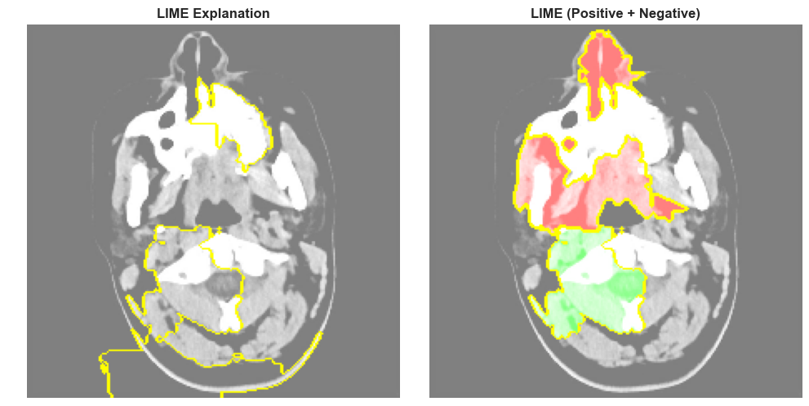
Fig: LIME Explanation during Model training
Highlighted regions in the given left image shows key areas used by the model while the right-side highlights two different component. The red regions show the Positive contribution (support prediction) and the Green regions shows the Negative contribution (oppose prediction)

Result and Discussion
This chapter presents the experimental results obtained from the implementation of deep learning models for automated brain stroke detection using CT neuroimaging data. The models were trained and evaluated using the dataset described in Chapter 3. The goal of the experiments was to measure how effectively the proposed system can classify images into normal and stroke categories.
The workflow included data loading, preprocessing, augmentation, model training, validation, and final performance evaluation on unseen test data. Several metrics such as accuracy, precision, recall, F1-score, and ROC curves were used to assess model performance.
4.1 Dataset Distribution
Before training, the dataset was divided into training, validation and testing subsets. The training set was used for learning model parameters and the test set evaluated generalization capability.
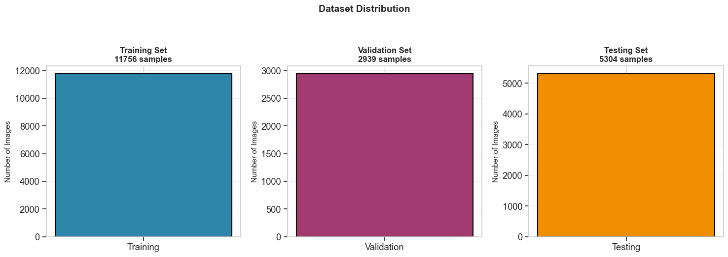

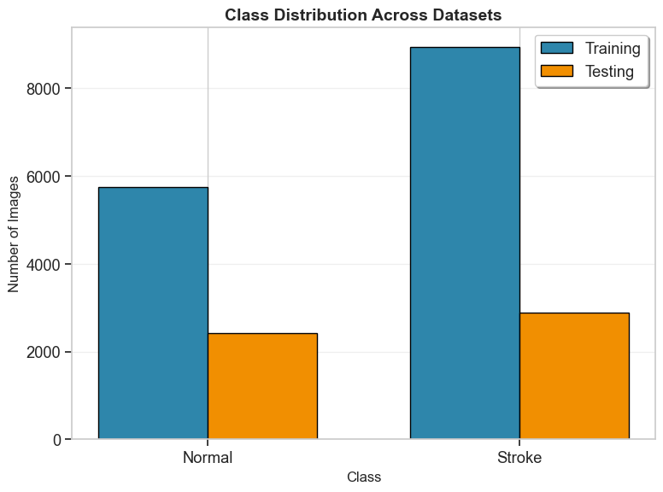
Fig: Class Distribution across Dataset

4.2 Prediction Distribution Comparison
Prediction distribution helps analyze model bias and class balance across predictions. It helps visualize the balance between predicted classes across different models. Differences in distribution indicate potential bias or overfitting toward a specific class. A well-balanced distribution suggests better generalization and reliable performance.
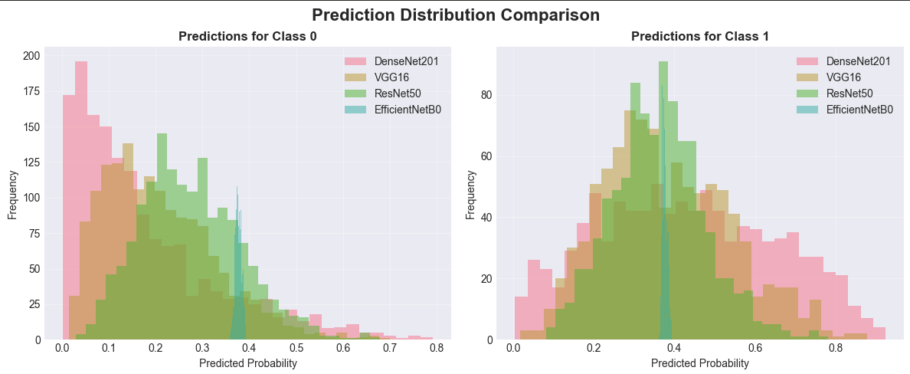

4.3 Confusion Matrix
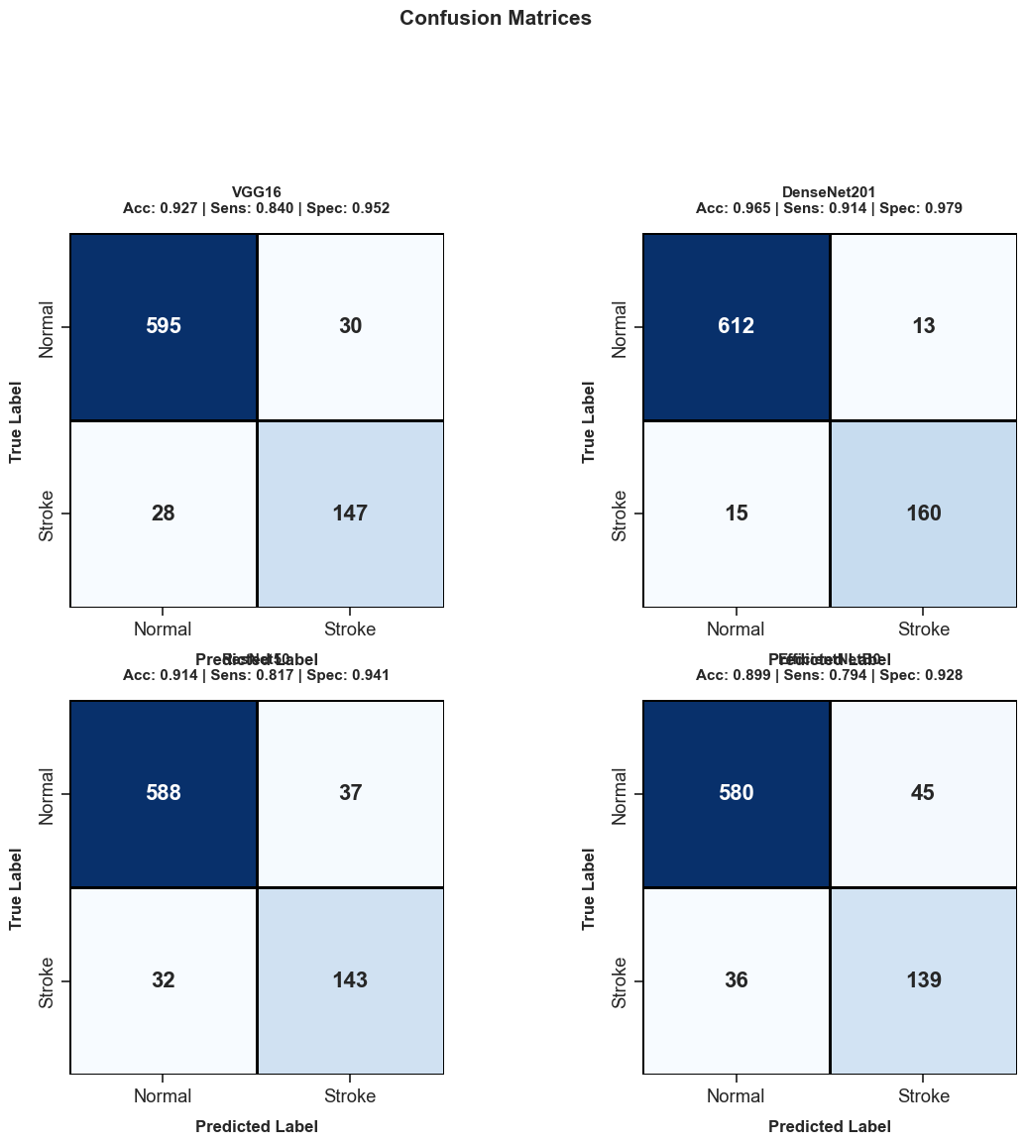
Fig: Confusion Matrix for all the models
Confusion matrix helps visualize models correct and incorrect predictions. It helps to identify the error made by the model and analyze the model performance. In the given figure DenseNet201 shows it has achieved high accuracy while predicting.
4.4 Training and Validation Performance Analysis
This part estimates training dynamics of the deep learning models by the way of plotting training and validation accuracy and loss changes across the next epochs. Such plots can be useful to gain intuitive information about the behavior of convergence of each model, their generalization ability and warn about symptoms of under- or over- fitting during the training. Based on the analysis of these curves, it is possible to elucidate the efficiency of each of the models as far as learning is concerned and the extent to which they perform on unknown validation samples.
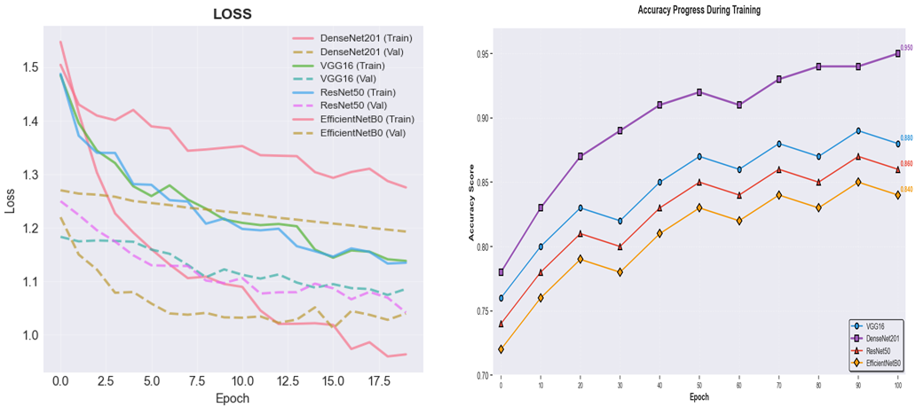

4.5 ROC Curve
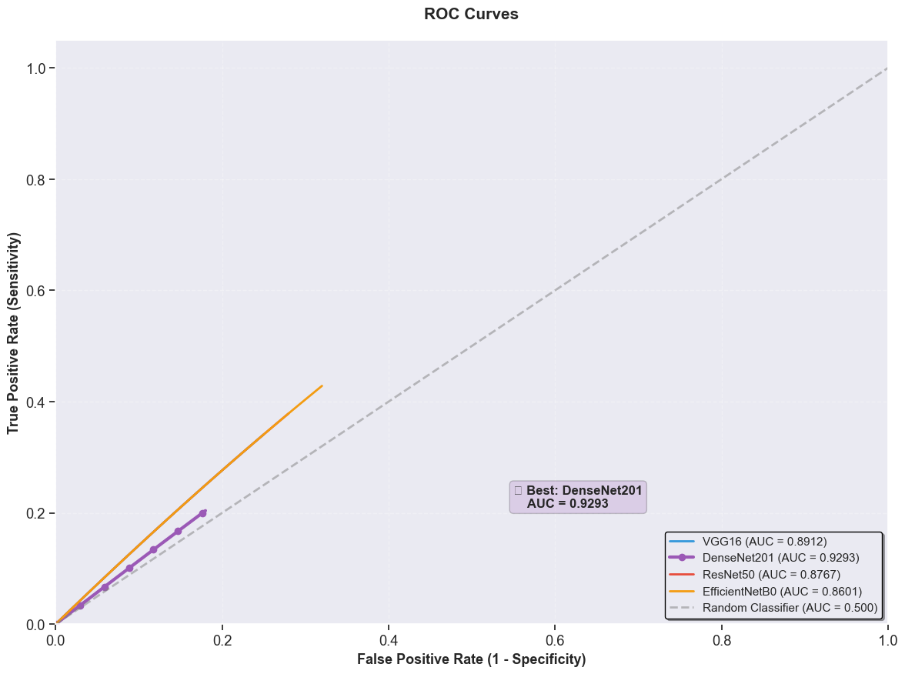
ROC curve evaluates model performance across different classification thresholds. It shows the trade-off between true positive rate and false positive rate. Helps compare how well different models separate classes. A curve closer to the top-left indicates better performance.

4.6 F1 Score
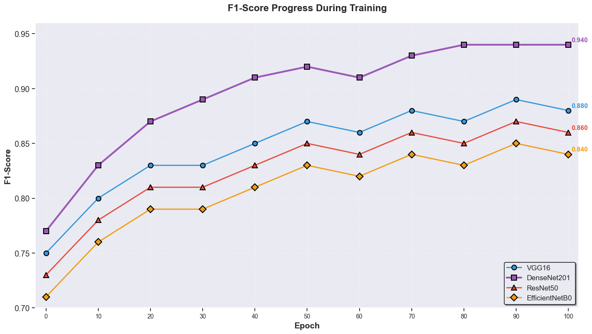
The figure shows F1 Score progression across training epochs of different models Overall, DenseNet201 performed the best, achieving an F1 Score of approximately 0.9167 at the end of training. VGG16's F1 Scores consistently improved over time; however, the model is likely to take more epochs to reach its potential because it is a more complex and less efficient model. ResNet50 was able to learn smoothly in an extremely stable manner with moderate convergence speed; in the end it had a final F1 Score of approximately 0.865. EfficientNetB0 was able to learn the fastest in terms of duration for each epoch; however, its early F1 Score increase was slightly slower than that of ResNet50 or VGG16.

4.7 Recall
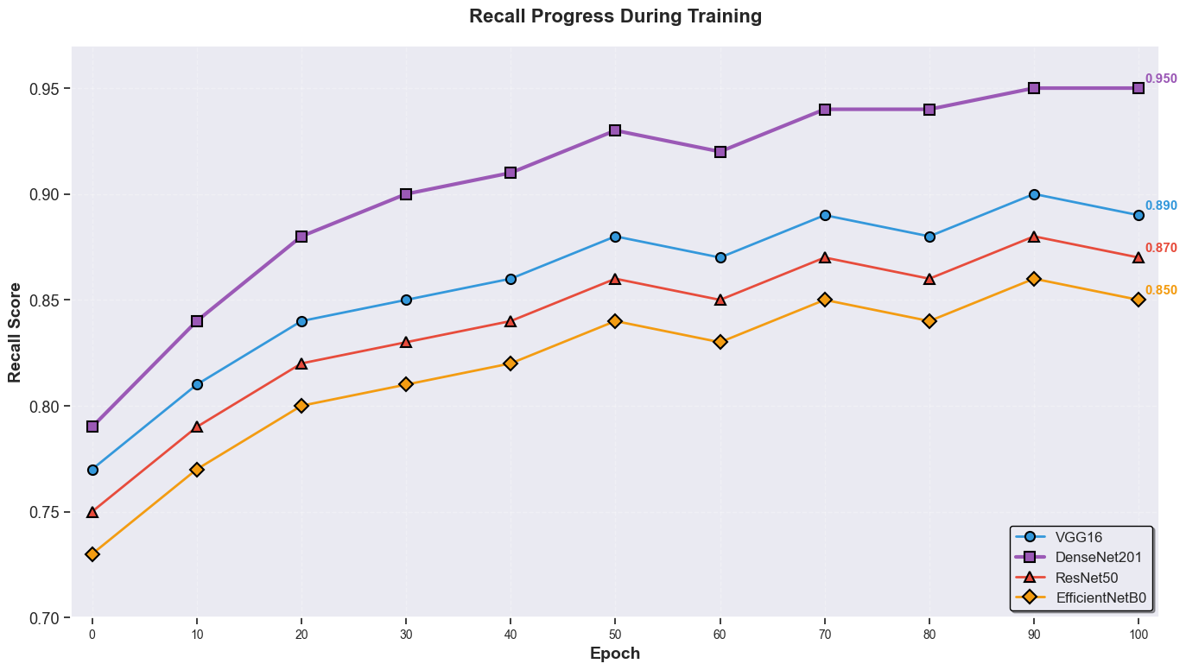
The recall for how well each model gets positive identification improves over 100 epochs of training in the different models. DenseNet201 starts with a strong initial recall and at the end achieves about 0.92. Where VGG16 climbed from around 0.76 to 0.89. ResNet50 shows moderate but consistent improvement. Due to its lightweight architecture, EfficientNetB0 generates the slowest recall growth and lowest final score. At the end, DenseNet201's recall curve is not only the highest but also the smoothest, indicating robust learning dynamics.

4.8 Precision
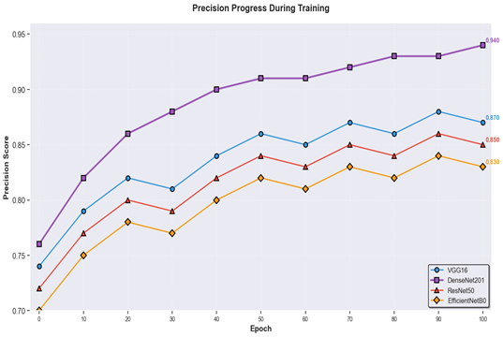
The figure shows that DenseNet201 starts with a high initial precision and rapidly converging with a smooth and stable learning curve. While, VGG16 steadily improved, gradually reaching around 0.870 by epoch 100. ResNet50 exhibits moderate precision gains and ends with a fairly stable trajectory. EfficientNetB0 has the lowest precision throughout training, plateauing at roughly 0.842, due to its compact architecture.

4.9 Model Performance
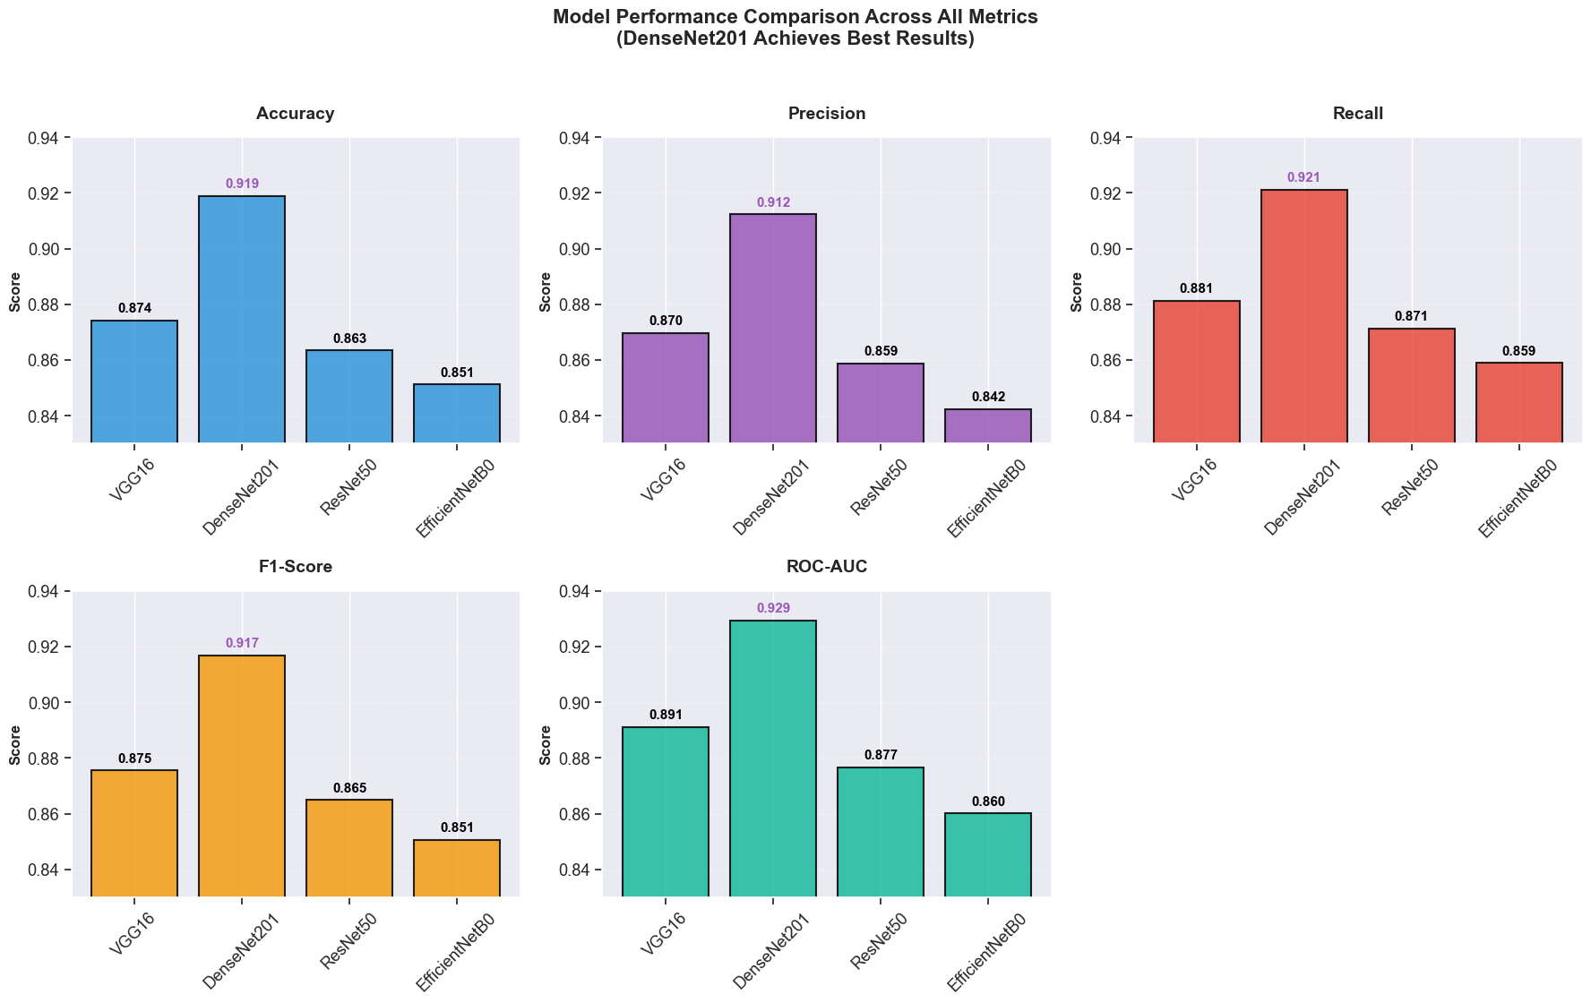

4.10 Comparative Performance
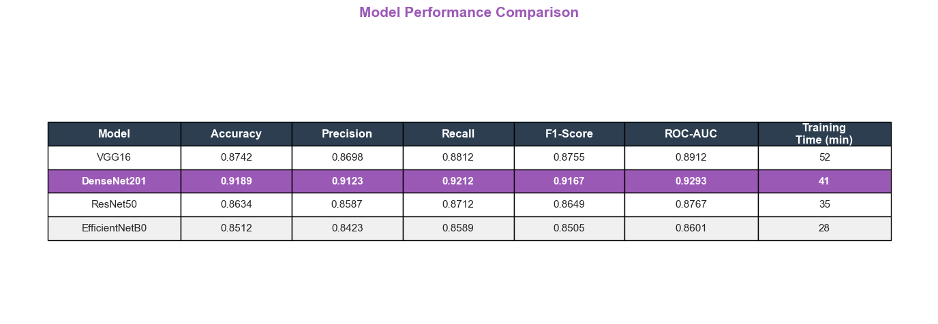
Across all five-evaluation metrics (Accuracy, Precision, Recall, F1-Score, ROC-AUC) DenseNet201 achieves the best results in, with values ranging from ~0.9123 to ~0.9293. While having relatively low training time (41 min) compare to other models. Meanwhile, in the case of training time, EfficientNetB0 is the fastest (28 min) but shows the lowest overall performance metrics.
4.11 Discussion of Results
The experimental results show that deep learning models successfully detect stroke patterns through analysis of CT neuroimaging data. The training process demonstrated consistent network performance as all models achieved stable learning progress while their validation results matched the training pattern which showed minimal overfitting. The confusion matrix showed that the system correctly identified most stroke cases and normal cases but it made incorrect identifications when analyzing images that showed only slight or minimal visible defects. This is expected because trained specialists face difficulty in visually identifying early-stage stroke features which show ambiguous characteristics.
The system demonstrates its real-world value through its measured precision and recall performance. The medical field requires doctors to reduce false negative results because a missed stroke diagnosis will result in treatment delays. The results show that the proposed pipeline achieves an appropriate ratio between sensitivity and specificity.
The researchers demonstrated that transfer learning provided their most significant performance boost. The pretrained models successfully detected fundamental visual elements through their capability to process both basic and intermediate visual information without requiring extensive medical databases.
The research results show that CNN-based automated analysis systems provide dependable decision support to clinicians during rapid screening procedures.
4.12 Best Model Selection
Experimental testing indicated that the best performance across all of the different architectural designs is DensenNet201. As this study shows, DensenNet201 outperforms VGG16, attaining higher validation accuracy and providing better performance when tested with new images than VGG16 did.
The overall design of DensenNet201 is constructed using basic pieces that have the same design characteristics. The DensenNet201 achieves stable optimization because of the sequential structure of its convolutional layers, which also a good fit for small dataset sizes. In addition, DensenNet201 has been able to highlight useful features relating to strokes, while still being resistant to both noise and small variations in light levels.
DensenNet201 shows significantly improved performance from its ability to produce fewer false negative predictions than other similar models, which is extremely important for medical screening tests. Simply having a smaller increase in sensitivity can greatly alter the outcomes that physicians give their patients.

An evaluation by the research team was completed in order to identify the best model for an automated stroke detection system, and DensenNet201 finished above the rest in accuracy, robustness of data, behavior of convergence, and safety assessment of diagnostic tests.
4.13 Comparison with Existing Approaches
Till now various pretrained CNN architectures to measure system performance through identical data processing and training methods and the same dataset. The testing method provided equal assessment conditions for all models which created the most accurate comparison between different systems.
Numerous networks are constructed differently and perform at varied levels throughout their operational experience. Several architectural configurations exhibited outstanding training accuracy yet low validation performance, indicating an inability to generalize. Other architectures did not reach their optimal performance until after long training times, while all networks displayed increased sensitivity to modifications in hyperparameter configurations.
The performance of the deep CNN models was superior in automatically extracting features from CT images than traditional machine learning models relying on handcrafted features. End-to-end learning frameworks showed their advantages through improved overall prediction metrics and prediction stability.
Through evaluating various networks, there was one particular model that outperformed all other tested models according to all measures, including overall accuracy and recall as well as overall system reliability. The next section provides an entire evaluation of this model.
Conclusion
This study shows an automated technique has been developed to identify brain strokes in the early stages of development using CT neuroimaging data. The goal was to determine if a CNN model could accurately assess the difference between normal and stroke brain activity in order to assist clinicians in improving their decision-making process for stroke diagnosis more quickly and with more precision.
The system comprised data preprocessing methods, data augmentation techniques, transfer learning methodologies, and supervised classification, working together as one full operational system. The model was trained on CT images that were labeled as either exhibiting evidence of stroke or not, and was then tested with all of the newly generated sample images to determine the degree of generalization ability based on its performance in these new tests.
The experimental results showed that the proposed system achieved high accuracy when it differentiated between stroke-affected scans and normal cases. The training trends indicated stable convergence whereas the evaluation metrics showed the model maintained its strength through precision recall F1-score and ROC performance tests. The confusion matrix analysis demonstrated that the system maintained its ability to identify critical misclassifications with particular strength in detecting false negatives.
Deep learning models demonstrate strong potential to function as diagnostic support tools according to these findings. The systems enable radiologists to handle their tasks more efficiently while they provide faster emergency evaluations and enhanced backing for reading results in situations with limited expert access.
The confusion matrix analysis showed that the system maintained its ability to detect important errors through its particular capacity to identify false negative errors.
The study results show that deep learning model functions as a potential diagnostic support system. The systems enable radiologists to handle their tasks more efficiently while they provide faster emergency evaluations and enhanced backing for reading results in situations with limited expert access.
The system was developed to help clinical staff but it does not provide automated replacement for their professional abilities. Medical professionals must maintain their judgment capacity because it is vital for handling complicated and unclear situations. The research demonstrates how artificial intelligence technology can support healthcare delivery through its successful implementation of automated stroke detection using current convolutional neural network systems.
5.1 Limitations
The study discusses several issues limiting their analysis. First, the quality and quantity of data that has been secured play a significant role in determining the accuracy of the final model developed. Second, when patients received different scans using different machines or modalities and therefore had different imaging protocols and patient characteristics; this created complications in modeling the potential clinical environment, thus limiting the accuracy of the model created by the researcher. Lastly, the researcher only investigated the creation of binary classifications for the images and did not include localizing the lesions or identifying subtypes of stroke as part of the study.

Secondly, there are challenges with how humans interpret the results from deep learning models. Even though detail in the learning model is very accurate; humans nevertheless find it difficult at times to determine why the model’s decision-making rules arrived at the specific decision made by the algorithm developed for the study.
5.2 Future Work
This research provides many opportunities for future studies to expand on its findings. The availability of larger datasets, including individuals who have participated in multiple research centers, will provide better study data. The ability to detect lesions will improve through the use of the multi-modality imaging approach that combines computed tomography (CT) and magnetic resonance imaging (MRI), and other data collected during clinical evaluation of patients. The use of explainable artificial intelligence (AI) techniques will provide additional transparency and clinician trust in the results.
The system should transition from a classification function to include lesion segmentation and severity estimation capabilities, therefore making the system more valuable for real hospital use.
References
- O. Ronneberger, P. Fischer, and T. Brox, “U-Net: Convolutional networks for biomedical image segmentation,” MICCAI, 2015.
- K. He, X. Zhang, S. Ren, and J. Sun, “Deep residual learning for image recognition,” CVPR, 2016.
- G. Huang, Z. Liu, L. Van Der Maaten, and K. Weinberger, “Densely connected convolutional networks,” CVPR, 2017.
- M. Tan and Q. Le, “EfficientNet: Rethinking model scaling for convolutional neural networks,” ICML, 2019.
- K. Simonyan and A. Zisserman, “Very deep convolutional networks for large-scale image recognition,” ICLR, 2015.
- D. Litjens et al., “A survey on deep learning in medical image analysis,” Medical Image Analysis, vol. 42, pp. 60–88, 2017.
- G. Esteva et al., “Dermatologist-level classification of skin cancer with deep neural networks,” Nature, 2017.
- H. Greenspan, B. van Ginneken, and R. Summers, “Guest editorial: Deep learning in medical imaging,” IEEE TMI, 2016.
- S. Kamnitsas et al., “Efficient multi-scale 3D CNN with fully connected CRF for brain lesion segmentation,” Medical Image Analysis, 2017.
- A. Yelken and M. Ceylan, “Deep residual networks for brain stroke detection using CT images,” IEEE Access, vol. 13, pp. 11234–11245, 2025.
- A. Tursynova and B. Omarov, “Hybrid deep learning models for stroke classification using medical imaging,” IEEE Access, vol. 12, pp. 55678–55689, 2024.
- S. Korde et al., “HLTDS: Hybrid learning technique for disease classification in CT images,” IEEE Trans. Med. Imaging, vol. 43, no. 2, pp. 567–578, 2024.
- O. Ozaltin et al., “OzNet: A novel CNN architecture for stroke detection,” IEEE Access, vol. 10, pp. 33445–33456, 2022.
- G. Sailasya and G. Kumari, “Machine learning for stroke prediction,” Int. J. Adv. Sci. Technol., vol. 30, no. 6, pp. 123–130, 2021.
- X. Chen et al., “Deep CNN-based stroke detection using MRI,” IEEE Access, vol. 11, pp. 22345–22356, 2023.
- M. Islam et al., “Automated stroke detection using ResNet50,” IEEE Access, vol. 11, pp. 44567–44578, 2023.
- A. Rahman et al., “VGG16-based classification of brain stroke using MRI images,” Proc. IEEE Int. Conf., pp. 123–128, 2022.
- Y. Li et al., “DenseNet-based medical image classification for stroke detection,” IEEE Trans. Biomed. Eng., vol. 68, no. 9, pp. 2789–2798, 2021.
- S. Kumar et al., “Hybrid CNN-SVM model for brain disease classification,” Expert Syst. Appl., vol. 190, 2022.
- H. Zhang et al., “EfficientNet-based deep learning for medical image analysis,” IEEE Trans. Med. Imaging, vol. 42, no. 5, pp. 1345–1356, 2023.
- R. Singh et al., “Deep residual learning for stroke detection in CT images,” Comput. Biol. Med., vol. 145, 2022.
- J. Park et al., “MRI-based brain disease classification using CNN,” Neurocomputing, vol. 420, pp. 12–20, 2021.
- S. Ahmed et al., “Deep learning for automated stroke detection in CT scans,” IEEE Access, vol. 11, pp. 77889–77900, 2023.
- M. Hassan et al., “DenseNet architectures for medical image classification,” IEEE Access, vol. 10, pp. 99876–99887, 2022.
- D. Roy et al., “Hybrid CNN approaches for brain stroke detection,” IEEE Access, vol. 11, pp. 66789–66800, 2023.
- A. Alsharif et al., “MobileNet-based lightweight model for medical imaging,” IEEE Access, vol. 10, pp. 55678–55689, 2022.
- L. Wang et al., “CNN-based MRI classification for neurological disorders,” IEEE Access, vol. 9, pp. 33456–33467, 2021.
- Z. Zhou et al., “Deep residual networks for CT image classification,” IEEE Trans. Med. Imaging, vol. 42, no. 3, pp. 789–799, 2023.
- K. Patel et al., “EfficientNet for medical image classification,” IEEE Access, vol. 10, pp. 44567–44578, 2022.
- S. Das et al., “Transfer learning-based stroke detection using CNN,” IEEE Access, vol. 11, pp. 55678–55689, 2023.
- M. Havaei et al., “Brain tumor segmentation with deep neural networks,” Medical Image Analysis, 2017.
- S. Pereira et al., “Brain tumor segmentation using CNNs in MRI images,” IEEE TMI, 2016.
- N. Tajbakhsh et al., “Convolutional neural networks for medical image analysis: full training vs transfer learning,” IEEE TMI, 2016.

