**Internet FinTech Chain (IFTC)**

**Global Business Restructuring**

**V 1.0**

Content

I. About the Project 3

1. Project Backgrounds 3

2. Project Highlights 3

3. Project Visions 4

4. Smart Contracts 5

II. Business Model 6

1. About the Business Model 6

2. Design Schemes 7

2.1. Issuance of Digital Cryptocurrencies as Subcurrencies 7

2.2. Payment and Clearing Systems 8

2.3. Account Systems 8

2.4. Decentralized Digital Asset Exchanges 9

2.5. Descriptions of Cases 9

III. Technical Architecture 10

1. Consensus Mechanisms 10

2. Voting 11

3. Slots 11

4. Delegates’ Round 12

5. Milestones 12

6. Underlying Architecture 12

6.1. SDK and BaaS 13

7. Worldwide Distributed Project Development 13

IV. Plan for Issuing Tokens 14

V. About the Team 15

VI. Risk Control 21

1. Governance Mechanism of Internet FinTech (IFT) 21

2. Audit 22

VII. Project Plan 23

VIII. Statement about Legal Affairs and Risks 24

IX. Contact Us 25

# I. About the Project

## 1. Project Backgrounds

As a new type of technologies, blockchains integrate technologies such as distributed data storage, point-to-point transfer, consensus mechanisms and encryption algorithms for creating trusted trading environment and building a trusted society. Their applications have been extended from finance to several fields, including internet of things（IOT）, smart manufacturing, supply chain management, data storage and transactions. Blockchains will provide new opportunities for the development of new-generation information technologies such as cloud computing, big data and hosted network. The trusted mechanisms constructed with these technologies will contribute to transformation of current business models, thereby initiating a new round of technological innovations and industrial transformations.

During their development, Ethereum that aroused extensive discussion came into being. As next-generation smart contract and platform for decentralized applications, it permits everyone to develop and utilize their applications operated through blockchains on the platform. Nevertheless, blockchain applications was greatly hinder from widespread dissemination by expensive usage fees of Ethereum platform, limited performances, vertical industries and limitations of applications for guaranteed payments.The DPOS-based platform put forward by EOS in 2017 claims that it doesn’t have problems such as extremely high usage fees and limited performances like Ethereum. We look forward to its technological innovations and breakthroughs. Besides, this platform will provide better platform architectures for future projects and create new approaches to business changes.

Having been devoting to science and technology innovations of finance for banking, the predecessor played dominant roles in developing and maintaining payment, clearing and account systems of banks, especially the former two systems. Up till now, IFTC has gained support from 20 banks, more than 1,000 channels, over one million merchants and 200 million users. After investigating the entire financial market, it has found that with the application of blockchains and tokens, unprecedented innovations will be made in financial sciences and technologies of the whole consumer market. Therefore, it has built an underlying Ethereum and EOS-based platform at the bottom of the blockchain for vertical sectors, which is named Internet FinTech Chain(IFTC).

## 2. Project Highlights

After the launch of IFTC, blockchains will approach commerce more closely via four designed schemes as follows:

A. Digital cryptocurrencies will be flexibly issued as sub-currencies through unique models of blockchains;

B. IFTC will develop payment and clearing systems by algorithms for practical Byzantine fault-tolerant (PBFT) state machine replication and hyperledgers, in order that a circulatory financial ecosystem can be constructed among consumers, merchants and commercial organizations.

C. Safe and high-performance account systems will be helpful for recording, paying, spending, depositing or transferring personal digital currencies.

D. IFTC will break the dominance of centralized digital asset exchanges to really realize the essence of transactions between dealmakers and favour all commercial or industrial organization to create, develop and maintain their own decentralized digital asset exchanges at the minimum costs.

The practical applications of smart contracts and transactions of cryptocurrencies will be standardized, so that routine users can smoothly experience distributed ledgers. Likewise, through demonstrating the actual application of blockchains in different vertical fields, we hope to enrich people’s knowledge about these technologies and their potential applications while helping different commercial and industrial organizations reconstruct their own commercial systems.

## 3. Project Visions

Exchanges, namely the exchanges among people, are essential for commerce. With the swift development of internet, various forms of online transaction have gradually become mainstream. However, online transactions are characterized by low transaction costs, diverse transaction methods, virtual transaction environment, instantaneousness and concealment. As a result, trust crises have become more and more frequent in different parts of the world. For instance, trust crises occurred in several brands that took the lead in the world last year, including Amazon, Facebook and Microsoft. Consequently, there has been a drastic increase in transaction costs of the whole society, which warns that consumers’ trust in businessmen is becoming increasingly weaker. In addition, the financing difficulties of small and medium-sized enterprises have not been handled effectively. Owing to their lack of collaterals recognized by banks, entrepreneurs can’t employ different products for direct financing. Thus, they are often exposed to risks of capital chain rupture.

At present, it has been urgent to update business model, which is also one of our visions.

In order to rebuild trust between consumers and merchants, promote reform of financing models and restructure global commerce, we launch IFTC (Internet FinTech Chain) for global users, which is a worldwide blockchain-based payment and clearing platform.

Based on IFTC, we have planned our visions about blockchains. We believe that blockchains will exert fundamental impacts upon many aspects of realities, ranging from commerce to data storage and other things. In view of this, we think that it is necessary to develop robust and open standards for blockchains and distributed ledgers, because this can promote the application of blockchains in mainstream commercial fields. We hope that IFTC is a blank white canvas, on which all individuals, commercial and industrial organizations are allowed to develop different blockchain applications as they wish. The purpose of IFTC protocols is restructuring of worldwide commercial systems for the purpose that their core features can be combined in any way. Under ideal conditions, solutions will be developed for programs of IFTC for data acquisition and processing using the blockchain IFTC. By virtue of these solutions, unprecedented new products and services will be provided upon decentralized consistency.

## 4. Smart Contracts

The smart contracts of IFTC are not only cost-effective and efficient, but also avoids the interference of malicious behaviours during the normal execution of contracts. These smart contracts are written into the blockchain in digital forms, in order that the whole process of storage, reading and execution can be transparent, traceable and immutable based on extraordinary characteristics of blockchain. Besides, a set of systems based on state machines are constructed via consensus algorithms of the blockchain, so that smart contracts can be executed efficiently. Smart contract systems automatically release presetting data resources and events containing triggering requirements according to these requirements included in event descriptions when such requirements are met. Concerning the entire smart contract system of IFTC, the key lies in coping with affairs and events through the module of smart contract, and the results of affairs and events still come out in groups. The smart contract is merely a system composed of a module for coping with affairs and a state machine. Indeed, it neither generates new nor modifies old smart contracts. It exists just for the purpose that a group of complicated digital commitments that contain triggering requirements can be fulfilled correctly dependent upon participants’ wills.

**Applications**

Here, some instances are given to represent what can be realized by the contract of IFTC, and we will write the exemplified codes in high-level language like C. Variables such as *tx.sender, tx.value, tx.fee, tx.data* and *tx.datan* are attributes to be entered for transactions. *Contract.storage* and *contract.address* are intrinsic attributes of the contract, while *block.contract_storage, block.account_balance, block.number, block.difficulty, block.parenthash, block.basefee* and *block.timestamp* are attributes of blocks. *Block.basefee* is base fee(benchmark cost), all transaction costs within IFTC are an integer multiple of the benchmark cost.

# II. Business Model

## 1. Brief Introduction of Business Model

IFTC provides standard underlying operating systems that can be used as infrastructure, on which different ecological environment can be created, and various commercial application scenarios are extended. It establishes account systems for commercial organizations based on guaranteed payments, issues digital cryptocurrencies, creates payment/clearing systems for transactions and develops open-source codes and solutions for decentralized digital asset exchanges, in order that these organizations can possess their own business models and architectures.

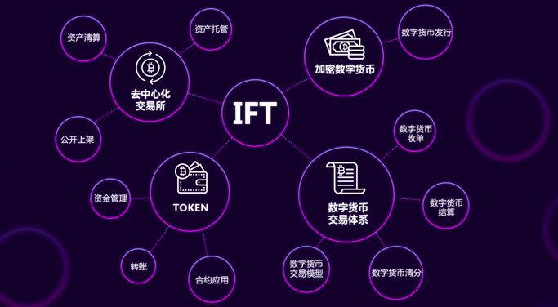

资产清算：Asset Liquidation；公开上架：Public Launch；资金管理：Asset Management；转账：Transfer；合约应用：Contract Application；数字货币交易模型：Trading Models for Digital Currencies；数字货币清分：Digital Asset Clearing,数字货币交易体系：Trading System for Digital Currencies；数字货币结算：Digital Asset Settlement；数字货币收单：Digital Asset Billing；加密数字货币：Digital Cryptocurrencies；数字货币发行：Issuance of Digital Currencies；资产托管：Assets under Trusteeship；去 中心化交易所：Decentralized Exchange

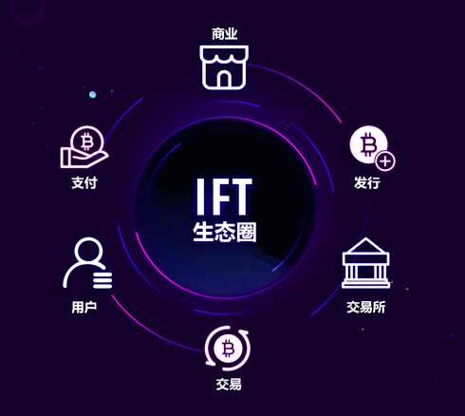

Ecosphere

Commerce

Issue

Exchange

Trading

User

Payment

## 2. Design Schemes

### 2.1. Issuance of Digital Cryptocurrencies as Sub-currencies

First of all, IFTC can be understood as a tool that can forecast the price of market consensuses by pledging project assets and aiming at outside assets. Based on IFTC, commercial organizations can issue their own sub-currencies easily. In general, anchoring mechanisms make ERC as valuable as real sub-currencies by pledging assets issued by a project through designs of some financial derivatives and technologies. A corresponding distributed autonomous company can be established accordingly through a digital public ledger. In consideration that IFTC issues many advanced financial protocols for special purposes and organizations expect to have their own internal currencies, we build a decentralized and autonomous commercial trading organization. We write fair and open rules in open-source programs, in order that an autonomous organization can be constructed without human intervention and management.

## 2.2. Payment and Clearing Systems

At present, velocity of transactions is critical for blockchain-based payment systems, especially for the small transactions. The payment and clearing systems of IFTC adopt algorithms for PBFT state machine replication and hyperledgers to minimize payment time to seconds. Amount of all consumers’ transactions is instantly recorded by the backend blockchain system in an encrypted manner, where merchants can look up the blockchain ledgers to check complete trading records. Furthermore, IFTC has created trading models named “open payments” and “fixed payments”, so that preliminarily deposited by consumers, digital currencies marketing and digital currencies financing for sub-merchants can be carried out on guaranteed payments.

IFTC will make interfaces of these payment and clearing systems accessible, so it will be easy for commercial organizations to develop their own commercial billing tools. In this way, sub-merchants of these organizations will be more capable of completing transactions by the digital currencies they issued.

**Open payments:** These payments are made based on the smart contract of IFTC particularly in line with following procedures. At first, users input information about their transactions. Then, they send funds to the smart contract. At last, transactions are executed via the contract. The contract will directly send the funds to all stakeholders once it receives trading information of both parties.

**Fixed payments:** Based on the smart contract of IFTC, the amount of fixed payments for transactions is directly determined for specific merchants ahead of time for subsequent consumption. Such amount may be directly used in exchange for equivalent digital currencies, in order that consumers can develop their own account system for digital currencies. Fixed payments realized the construction of financial ecology consist of preliminarily deposited by consumers, digital currencies marketing and digital currencies financing for sub-merchants and etc.

### 2.3. Account Systems

IFTC has established its own account systems based on its years of technological experiences for guaranteeing security of transaction data. In this set of systems, a range of mnemonic phrases will be generated according to generated private keys and documents once a user creates an account. While guaranteeing the broadcasting of transactions with algorithms and encryption technology, these systems also ensure security of sensitive information about private keys. In addition, the important role of mnemonic phrases is also a functional highlight of these account systems. Moreover, performances are technologically guaranteed. At the time of user registration, only a correlation is created among data of databases without spending much time in generating private keys and documents with encryption algorithms.

We create decentralized digital wallets and make their interfaces accessible to commercial organizations, in order that these organizations can easily create their own wallets based on IFTC or public IFTC wallets, and help participants record, consume, withdraw or transfer their digital currencies and assets. Moreover, digital assets can be exchanged through these account systems in digit asset exchanges. Decentralized account systems free users from worrying about their asset losses resulting from platforms’ creation of difficulties or hackers’ attacks.

### 2.4. Decentralized Digital Asset Exchanges

All standardized external assets can create “assets” within the IFTC system, and numerous assets can be exchanged in decentralized exchanges, thus forming trading markets. The most distinct features of the IFTC exchange is fixed payments build with blockchain in clearing chain, guaranteeing the direct trading assets secure and controllable without the unnecessary intermediary between nodes.

Besides, this set of interfaces are available to all commercial and industrial organizations, in order that they can create their own decentralized exchange and

Realizing real-time transections directly across districts and currencies among holders of digital assets or tokens. IFTC will break the dominance of exiting centralized digital asset exchange to really realize the essence of transactions between dealmakers (In the past, investors transferred their tokens to centralized exchanges and placed themselves at the mercy of exchanges without any safety guarantee). With decentralized exchanges, commercial organizations don’t have to pay high entry fees to enter the centralized exchange for trading.On the contrary, they can simply realize the exchange on the shelf and having the transaction function by issuing their digital currencies via IFTC.

### 2.5. Descriptions of Cases

As a commercial complex, ASHOP adopts ASPC (i.e. the digital currency issued by IFTC) and the clearing system of IFTC for its consumptions and guarantees. When they do shopping inside ASHOP, consumers can pre-deposit security deposit for target shops in the form of ATOKEN, obtain digital currencies with equal value to their deposits in bank cards, and get more discounts from merchant or shopping malls and pay for their consumptions via AWALLET of ASHOP. Merchants can finance digital currencies through the function of fixed payments. Meanwhile, the ASPC held by merchants and consumers can be traded through the IFTC digital currency Exchange.

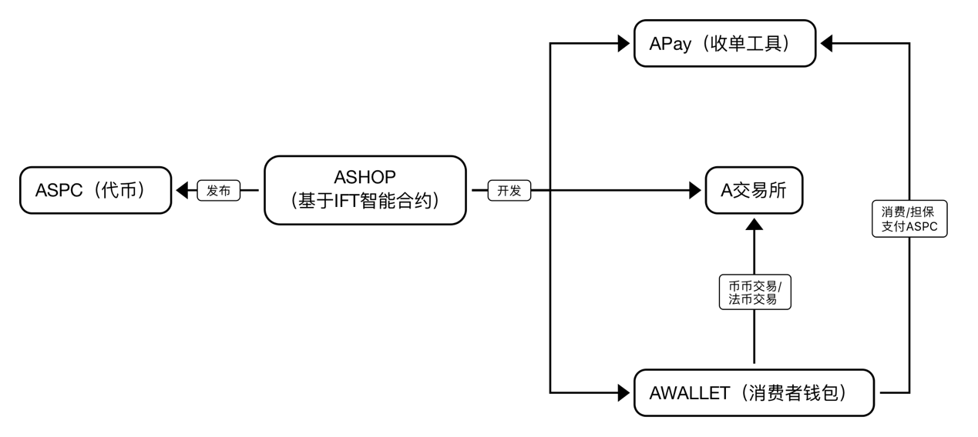

Token-to-Token Exchange

Legal tender-Token Exchange

Consumption/ Guaranteed Payment (ASPC)

AWALLET (Consumer Wallet)

A Exchange

Apay(Acquiring Tool)

Development

ASHOP

(Based on IFTC)

Issuance

ASPC (Token)

# III. Technical Architecture

## 1. Consensus Mechanisms

Concerning DPOS (Delegated Proof of Stake), blocks are created by delegates, who come from ordinary user nodes. First of all, the delegates are required to register. Next, they are expected to seek community trust and win votes through publicity and promotion. Only when they get enough votes into TOP 101 can they be accepted by systems as nodes that can really manage blocks, minted coins will be reward to them.

For bitcoins, voting is based on the computing power of computers. Computers with strong computing power can naturally get more votes and are more likely to win. As to DPOS mechanism, votes are cast based on the ratio of assets, namely equity, and consider more about the forces of people within the community. To maximize their own benefits, more reliable nodes are chosen, so this mechanism is safer and more decentralized. Following procedures must be completed for the whole mechanism:

(1) Register delegates and accept votes

• Users register as delegates;

• Accept votes (users who are ranked TOP 101 in number of votes);

(2) Maintain cycling and change delegates

• Slot: The slot of each block lasts 10 seconds;

• Delegate cycle or round: Every 101 blocks make up a round. All these blocks are generated at random by 101 representatives, while each representative generates a block. A complete round approximately lasts 1,010 seconds (101 x 10), approximately 16 minutes. At the end of each round, all TOP 101 representatives shall be replaced.

• Reward cycle: Milestone is set dependent upon blockchain height and blockchain rewards are adjusted at certain time point.

## (1) Register delegates

Delegates must be registered with software at the client, so this function has to interact with node. In other words, the node Api must be utilized at the client. *Modules/delegates.js* is the module for managing delegates. Based on the experiences mentioned above, we can easily find the Api in this module:

*“put /”: “addDelegate”*

The final information about Api is as follows:

*put /api/delegates*

For corresponding method, refer to *addDelegate()* of *modules/delegates.js.* This method doesn’t differ from functional transactions of registered users’ IP alias. Delegate registration is also a kind of transaction and categorized as “DELEGATE”.

## 2. Voting

This function is available to ordinary users, all of whom possess rights to vote, so it is logical to put them in the account management module, namely the file of *“modules/accounts.js”.*

## 3. Slots

(1) Time Coordination

Start time and finish time are defined by *beginEpochTime()* and *getEpochTime(time)*, which are two private method calculated for all other methods, so time inconsistency never exists.

(2) Coding Risks

Nonetheless, *getEpochTime(time)* might be the sole area where errors might occur. Look at Row 16 of the following codes. Through the *new Date()*, time of the operating system can be acquired. Time can be changed manually without any impact, whereas bifurcation behaviours might be caused in some cases.

*// helpers/slots.js*

*function getEpochTime(time) {*

*if (time === undefined) {*

*// Row 16*

*time = (new Date()).getTime();*

*}*

*var d = beginEpochTime();*

*var t = d.getTime();*

*return Math.floor((time - t) / 1000);*

*}*

(3) Slots

There is an interval time between the current time point and start time, which is assumed to be t. Take the value of t/10 to be an integral as current slot *[getSlotNumber()]*, where 10 is set by *constants.slots.interval.*

To be exact, the slot that delegates handle separately is expected to differ by their total number, which is set by *constants.delegates*. Here, the slot varies by 101. Hence, what are returned by the *(helpers/slots.js)* is delegates’ latest slot in adopting *getLastSlot().*

## 4. Delegates’ Round

For security, delegates must be replaced in every round in order to make sure that unstable nodes or those which doing bad things are promptly eliminated. Although the system looks for delegates randomly in order to generate new blocks, each delegate has chance to generate and broadcast a new block in each round with rewards. In this respect, it is much simpler than bitcoins, where each node is required to strive for the broadcasting rights through the POW mechanism.

## 5. Milestones

Milestones are mainly set for block rewards. Like the block rewards of bitcoins that are reduced by half every 4 years, those of IFTC are also granted according to certain rules. In general, the rewards are given as follow: 5IFTC/block for the first stage (about 1 year), 4IFTC/block for the second year, 1IFTC/block 4 years later and remain 1IFTC/block for the periods thereafter, so coins are issued slowly.

The quantity of increased issuances can be easily calculated. The slot in the first stage = *rewards.distance* 10s/(24 60 60) = 342.7 days; the quantity of increased issuances = *rewards.distance* 5 = 3000000 * 5 = 15,000,000. The issuances increase by 12,000,000, 9,000,000, 6,000,000 and 3,000,000 respectively in the second stage, the third stage, the fourth stage and subsequent periods respectively. Such appropriate inflation, which is a characteristic of DPoS mechanisms, is for rewarding notes so that more users can make contributions to internet.

## 6. Underlying Architecture

The underlying architecture of IFTC is as follows.

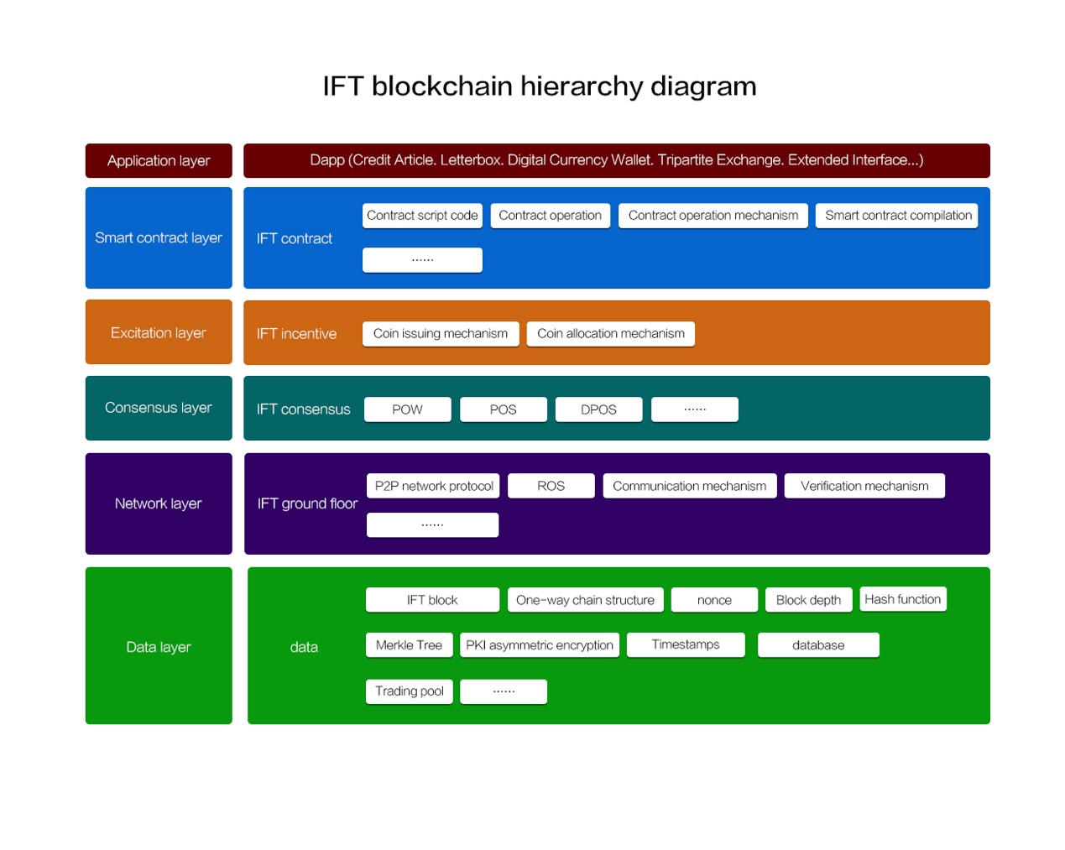

Fig 6-1: Underlying Architecture of IFTC

### 6.1. SDK and BaaS

IFTC provides gPRC API for upper-layer applications, and SDK encapsulated with API is available for application. Users can access multiple types of resources of IFTC through SDK, including IFTC account, transactions, ledgers, smart contract and monitored events sent by the smart contract or generated by blocks. Besides, IFTC SDK encapsulates special functions such as IFTC wallet, queries and accesses about IP content under more scenarios of IFTC. In the early stage, there will be two versions of IFTC SDK, namely NodeJs and Python. IFTC will launch the fully open BaaS platform online, which will be helpful for constructing one-stop test networks, visually representing content of distributed ledgers, developing/testing the smart contract, monitoring and analysing networks. The blockchain simulation environment of the BaaS platform will be similar to practical application scenarios, in order that developers can easily migrate and release the proven business models to the master chain of IFTC.

## 7. Worldwide Distributed Project Development

IFTC will build its platform with the accumulated efforts of developers from different parts of the world. With open-source codes, worldwide programmers can rebuild and submit bugs. The core for the global distributed development system of IFTC consists in its rewarding mechanism for developers’ participation in development. In this system, operators will assign development tasks, which will be undertaken by global developers through competitions. According to rules of the platform, IFTC tokens will be given as rewards to all task codes which are included in the thread of GitHub, in an attempt to encourage more excellent developers to get involved in improving IFTC.

# IV. Plan for Issuing Tokens

**Internet FinTech Coin**

[Project Name]: Internet FinTech Coin

[Name of Tokens]: IFTC

[Type of Tokens]: ERC20

[Total Amount of Tokens]: 1.2 billion

**Token Distribution**

Shareholders of the team will hold 0.1 billion coins for one year.

IFTC Marketing: 0.1 Billion, Marketing and Airdrop for IFTC (a Community Platform)

Rewards for developers: 0.05 billion coins will be available for rewarding developers. Project development will be performed with centralized distributed development strategies. Competent developers will be assembled for joint development from different part of the world, and 0.05 billion IFTCs will be used for rewarding developers who get involved in the joint development via POW mechanism.

Private placement: a total amount of 0.05 billion to be raised in fixed quantity.

Crowd-funding via whitelisting: A total amount of 0.1 billion coins will be issued. The issuance will be performed for 5 consecutive days from 00:00 CST UTC+8 on 27th August 2018 to 24:00 CST UTC+8 on 31st August 2018. For the purpose of donations at unfixed prices and average weighted distribution, an underwriter mechanism will be constructed by Ethereum through an invitation system.

Public crowd-funding: A total amount of 0.1 billion coins will be issued. The issuance will be performed for 10 consecutive days from 00:00 CST UTC+8 on 2nd September 2018 to 24:00 CST UTC+8 on 11th September 2018. The coins will be donated at unfixed prices and distributed based on weighted average.

Global crowd-funding: A total amount of 0.7 billion coins will be issued and 2 million coins will be issued per batch every 23 hours. They will be issued for 350 consecutive days from 00:00 CST UTC+8 on 13th September 2018 to 24:00 CST UTC+8 on 28th August 2019. The coins will be donated at unfixed prices and distributed based on weighted average.

Type of Raised Currencies: ETH

Raising rules: At the end of each stage, IFTCs will be allocated to all buyers proportionally dependent upon the total quantity of ETH they contribute at that stage. In particular, these coins will be allocated as follows:

* the value of ETH that you release.

Total quantity of tokens released per batch

Total value of all raised ETH

Uses of Raised ETH: Team Building and Project Development.

# V. About the Team

**1. Core Team**

**DOGI LI**



Senior Business Model Architect

He holds the Bachelor’s Degree in Chinese Language & Literature from Shenzhen University, the Bachelor’s Degree in Business Administration from Sichuan University and the MBA of Southwestern University of Finance and Economics.

He is an independent investor, leader of the Blockchain Research Group in the China Academy of Management Science and vice president of the Enterprise Innovation and Development Association of Guangdong Province.

Having established several science and technology companies, he has engaged in internet, real estate, financial technology for more than 15 years.

In 2013, he began to devote himself to explore the business models of blockchains.

**Edwin C Lun,**

**Zhijing Lun**



With the Bachelor’s Degree of Science in international commerce, he undertook courses about CEO management in the Harvard University.

Twenty years of strategic business development and operation experience in Asia and North America.

Having established several enterprises, including IDS, Mission 3-D and Pharos Medical Device, he is the leader of family enterprises and several transnational enterprises.

**Jason Hung**



Specializing in blockchain ecosystems, digital marketing, artificial intelligence and ERP-related businesses, he is a serial entrepreneur. He is also the co-founder of Treascovery, Chidopi and TimeBox.

Furthermore, he has founded EXSmart and more than 35 advisory committees of ICO, including SportsFix, CyClean, ICOMax, BitRewards, DateCoin, BlockLancer, eCoinomic, FaxPort, USAT, EVENFOUND, CoinArt, Kepler, PokerSports, EiraCube and SuchApp.

He has accumulated two decades of successful experiences in managing RD, IT, sales and advisory services;

He owns 9 technological patents related to over 2,000 application programs.

He is the person in charge of PeopleSoft and JDE in China.

In addition, he is a top expert of ICOBench and UBI Blockchain Internet.

**Marco**

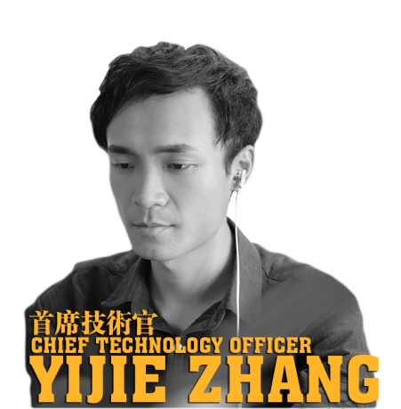

Domestic expert in internet technologies;

As full-stack architect, he is proficient with frontend/backend architectures, design and development. Having designed and developed large-scale mobile payment and clearing systems for supporting mobile payments of several banks such as Pudong Development Bank and China Merchants Bank, he has accumulated abundant experiences in designing and developing internet systems for vertical financial fields.

In 2016, he began to devote himself to explore the technology of blockchains

**Kiky**



She worked in the R&D Management Department of TENCENT TECH. In 2015, she embarked on financial sciences and technologies, with rich experiences in gathering, clearing and mining derivative data of vertical financial fields. In 2017, she began to study blockchain products and technologies, assisting in developing blockchain products and building communities.

**Joshua**



Independent Investor;

As co-founder of Urban-rural Reciprocal Assistance Project of Assisting Manor (NGO), associated director of United Hotel Management Co., Ltd and entrepreneur of self-media, he is adept in creative planning and marketing for brands. In 2015, he began to devote himself to blockchain research and community planning.

**Robo**



As former product manager of AI-based big data in Huawei Group, he guided on how to put AI SaaS into practices, including its applications in businesses and product digitization. He is able to closely keep up with news about academic circle and industries. In addition, he clearly knows evolution trends of technologies and considers application scenarios of businesses.

**YOUSEF AL-HANDARISH**



As researcher of Shenzhen Institute of Advanced Technology, he focuses on studying blockchains and internet of things, with rich experiences in data and control of credit risks.

He has attended several international science conferences and published related papers.

**Menson Pak**



With 3 years of experiences in internet finance, he got involved in the financial cooperation of a domestic leading mobile payment service provider (ULINE) with banks, up till now ULINE have cooperation with 27 banks. He has rich experiences in internet marketing and brand planning.

**Charming**



Graduating from Shenzhen University with double degrees in Biotechnologies and Chinese Language & Literature, she got involved in new media advertising strategies and development of well-known projects such as the project of The Beijing News for seeking Chinese makers, world internet conferences, My New Swag and cross-strait world internet conferences. She leads her team to track project schedules, marketing, advertising and promotion.

**Xavier**



He graduated from the University of North Texas with a degree in computer sciences of software in 1999.

He was employed by Nortel Network, worked as R&D Manager of SUSE Linux in Beijing and Taiwan, and CTO of Symbio Mobile. He has worked as SUSE’s consultant for distributed file systems of Ceph, and blockchain consultant of WeBank and 5miles.

**Caleb**



He is Ph.D of UCL, senior Java full-stack developer, participant of projects in UCL’s Blockchain Center and project architect of the Big Data Research Center of Alan Turing Institute.

He served as architect and higher posts in the Citibank, the Bank of America and the American Express.

During his employment for UCL, he was responsible for collaborating with central banks, investment banks, hedge funds, clearance centers and science & technology enterprises in terms of project research and development.

**Atticus**



Graduating from the London Business Collage with MBA and the Master’s Degree in Computer Sciences, he came from the HQ of the Barclays Bank. With 8 years of experience in business strategies and formulation in retail banking, he has accumulated 6 years of experiences in developing applications for real-time transactions of investment banks.

# VI. Risk Control

## 1. Governance Mechanism of Internet FinTech Chain (IFTC)

As a decentralized international blockchain community, IFTC will set up the overseas IFTC Foundation to guarantee its management and operations as well as management and safety of raised funds. In terms of structure, the IFTC Foundation will be made up of the IFTC Community Conference, Autonomous Committee and Executive Committee.

As the highest authority of IFTC, the Community Conference will all be composed of IFTC coin holders, who can exercise their rights to vote in the community conference, thus participating in major decisions of the community.

The Autonomous Committee, which is responsible for Community Conference, and will manage and supervise the Executive Committee. The members will be re-elected every two years dependent upon quantity of held coins and how many years the coins have been held. The Executive Committee, which is responsible for the Autonomous Committee, will be responsible for normal operations and maintenance of IFTC. It manages groups for technology development, business operations, financial management, risk control and quality assurance, which shall fulfil their respective tasks.

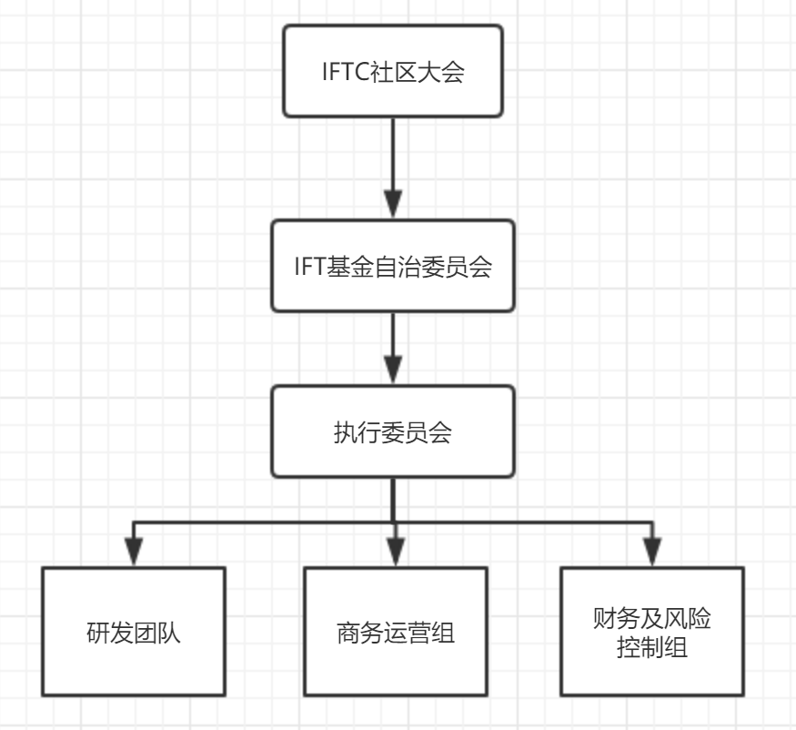

Financial & Risk Control Groups

Business Operations Team

R&D Team

Executive Committee

IFTC Conference

Autonomous Committee of IFT Foundation

## 2. Audit

The Autonomous Committee of the IFTC Foundation must conform to standard business practices for integrity and morality.

It shall also abide by related laws, regulations and self-discipline principles within the industry.

Furthermore, the financial management shall be transparent.

IFTC (Internet FinTech Chian) will annually invite international well-known third-party auditing organization to audit and evaluate the IFTC Foundation’s use of funds, expenditures and profit distribution.

It will completely public the evaluation and audit results made by the third-party organization.

# VII. Project Plan

|  |  |
| --- | --- |
| **Phases** | **Plan** |
| **Startup Phase** | IFTC Project Initiation |
| **Planning Phase** | IFTC will release its project white paper to footstone crowd-funding users. |
| **Announcement** | The project and corresponding white paper will be announced to global users on the official website of IFTC. |
| **Preparation for ICO** | Issue IFTCs based on ERC-20 of ETH. |
| **Whitelisting** | Raise funds from crowds through whitelisting and release 0.1 billion IFTCs. The raised ETH will be used for building technical teams of IFTC |
| **External Crowd-funding** | Raise funds through the Foundation and release 0.1 billion IFTCs. The raised ETH will be employed for project research and development of IFTC |
| **Long-term Crowd-funding** | Perform crowd-funding in public and release 0.7 billion IFTCs all over the world. The raised ETH will be used for running teams and creating super nodes. |
| **Project Launch** | Make the underlying public blockchain of IFTC accessible to the public and announce the open-source codes. |

# VIII. Statement about Legal Affairs and Risks

This statement doesn’t cover risks about tendering for securities and management of *iftc.io* and risks related to *iftc.io*. It doesn’t involve products governed by judicial laws. This is only a conceptual document about project descriptions.

[The white paper] doesn’t intend to sell, collect or bid products about *iftc.io*, related companies, shares, securities or other controlled products. This document shall not be used as manual for investment promotions or standardized contractual document in any form. It shall not constitute any advice or investment suggestion concerning securities or other controlled products within any judicial jurisdiction either. It shall not be deemed as connection, contract or commitment for selling, subscribing or inviting others to buy and subscribe any securities, or based on such content. This white paper has not been examined or reviewed by any judicial regulatory agency of any country or area.

It shall not be employed as suggestion for participation in investments: Any information or analysis in this document shall not constitute any suggestion concerning whether to make investments in the tokens or not. Besides, no inclined specific recommendation is made in this document. You must take all necessary advices from professionals such as tax and accounting firms.

This document shall not constitute any statement and undertaking. Although it is used for describing *iftc.io*, the platform put forward by us, the foundation of this platform clearly states that:

(1) No statement or representation is made regarding accuracy or integrity of any content described in this document, or the content related to this project released in other ways;

(2) If premises are not met, statements and undertakings must not be made concerning prospective or conceptual statements of accomplishments or reasonable content;

(3) The content of this document must not be regarded as basis for future undertakings or statements;

(4) The foundation shall not be liable for any loss caused to related personnel or other aspects because of the white paper;

(5) If not exempted, the legal responsibilities shall be only confined to those permitted by applicable laws.

Not all people are allowed to take part in the project, namely the network system and platform of *iftc.io*. For participation, the applicants might have to complete a range of steps, including providing information and documents indicating identity.

The unauthorized companies are unrelated to this project: Except for the foundation of *iftc.io,* the use of any other companies’ or organizations’ names or trademarks shall not indicate any party is connected with them or they are recognized. Such names and trademarks are only used for describing related content.

Notes about *iftc.io* tokens: “Internet FinTech Coins” are virtual cryptographic tokens of blockchain networks rather than products to be invested.

No one can assure or have any reason to believe that the Internet Fintech Coins that you hold will definitely appreciate, but might be even exposed to risks of depreciation.

These coins are not ownership certificates or indicate possession of control power. Holders of *iftc.io* are not granted the ownership and equity of the network system. They are not authorized to directly control the *iftc.io* network system or granted any right to make any decision concerning the network system.

# IX. Contact Us

Website: IFTC.IO

email：ift@iftc.io

Facebook：IFTC.IO / Twitter：IFTC.IO / Github：IFTC.IO / telegram：IFTC.IO/ medium：IFTC.IO/weibo：IFTC.IO