WCS Logger
automation tool to assist end-user in WCS PC host application

About this document
Scope and purpose
This automation tool assists users in collecting all necessary information / data through Saleae Logic Analysers.
Intended audience
Users who adapt Infineon WCS USB Type-C solutions in PC HOST applications and frequently communicate with Infineon WCS support teams in issue debugging discussions.

Table of Contents
About this document 1
1 Introduction 3
1.1 Prerequisites 3
1.2 Installation 4
2 Infineon Automation Tool Package 5
2.1 HPI Analyser 5
2.2 CC Analyser 7
2.3 Infineon PD Logger 7
3 How to use 9
3.1 Scenario A 9
3.2 Scenario B 10
4 Limitations of Infineon PD Logger 11
Self Service 12
Revision history 13

Introduction
Infineon WCS CCG devices are commonly used in PD port controller applications in systems like Notebook and Desktop computers, tablets, mobiles etc. In such cases, the system design typically includes a Host Processor or Embedded Controller (EC) that is responsible for the system policy decisions. The CCG controller can be connected to the EC and the CCG firmware allows the EC to monitor the status of the USB-PD ports, change configurations, perform firmware updates, and transparently interact with other USB-PD devices connected to CCG. All the capabilities are exercised through commands/responses transferred across the Host Processor Interface (HPI).
As results, it is mandatory to inspect HPI activities when working in issue analysis and debugging, apart from checking CC logs alone. This tool is aimed to facilitate users to collect all necessary trace logs through Saleae Logic Analyser, a 3rd party logic analyser supports up to 16 logical channels, as the standard debug procedures in collaborating with Infineon WCS support teams.

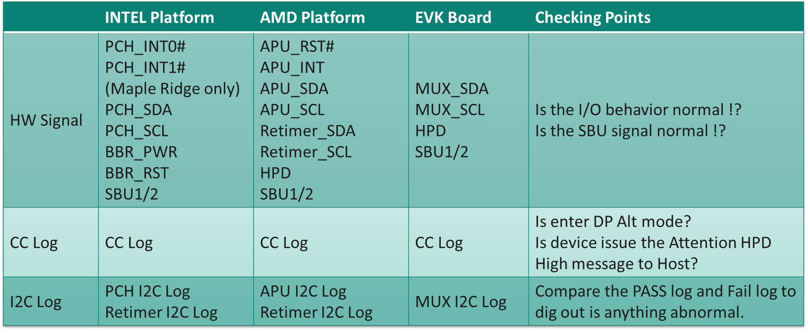
- WCS PD Host E2 training

Prerequisites
Infineon WCS support teams heavily rely on communication logs for issue analysis and debug, so a comprehensive log with accurate data is mandatory to accelerate solutions delivery. Saleae Logic Analyser is recommended as one of the prerequisites:
- Saleae Logic Pro 16
- Saleae Logic 2 application v2.4.0 or above
- Infineon CYPD4500 PD3.0 CC Sniffer (optional)
- Infineon CYPD4500 EZ-PD Protocol Analyser Utility (optional)

Infineon WCS support team creates a tool package to facilitate and standardise log collection activities. It includes:
- HPI Analyser: a specialised I²C analyser dedicated to Infineon HPI protocol.
- CC Analyser: USB Type-C vendor define message analyser.
- Infineon PD Logger: a python-base GUI tool to generate SALEAE logs with all necessary information described as WCS PD Host E2 training table in Figure 1.

Installation
Few things ahead:
- Install Saleae Logic 2 application and enable “Automation” via Preference -> Automation -> Enable Automation Server.
- Copy “HPI_regs.xml”, “i2c_analyzer_for_HPI.dll” and “Manchester_analyzer.dist.dll” to the folder assigned in Custom Low Level Analysers.
- Copy “main_auto_logger.exe” to arbitrary folder except root directory, which might need additional access permission for file creation later.

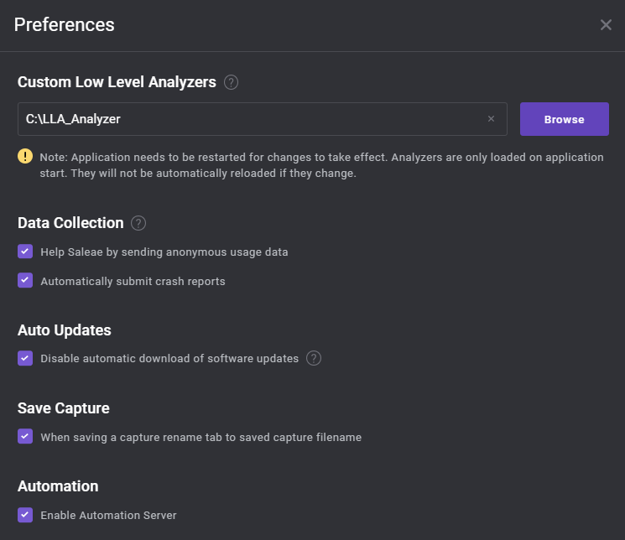
1
2
- Saleae Logic 2 Preferences

Infineon Automation Tool Package

HPI Analyser
The native I²C Analysers in Saleae Logic 2 application can decode and list bus messages to its terminal-like window and tabular-format table for search usage. It decodes I²C commands in BYTE format basis and is useful in generic use cases.
However, Infineon HPI protocol usually conducts a WORD or longer data length as a single command and responses, and it is not intuitive to translate decoded messages through native I²C analyser. Worse, it is hard to do HPI command search. Sometimes it causes additional efforts and inconveniences to users, especially for engineers who are dealing with HPI activities in daily basis.
Hence, Infineon WCS support team creates a customised Saleae I²C analyser alternative. It can re-synthesise standard I²C byte packets to scalable-length message format, allows users to change significant byte order and capable to translate HPI raw data. In addition, it is easier to do HPI command analysis by introducing timestamp ahead of every HPI messages.
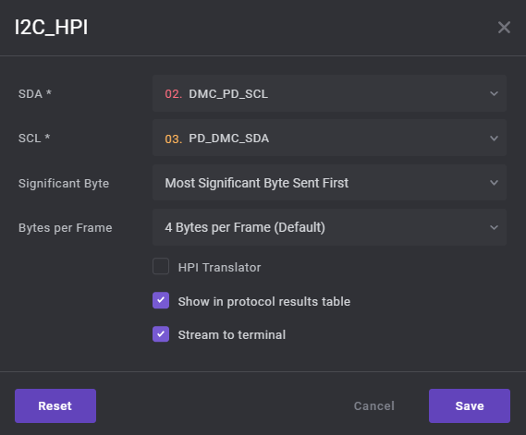
- Additional options in Infineon “I2C_HPI” analyser
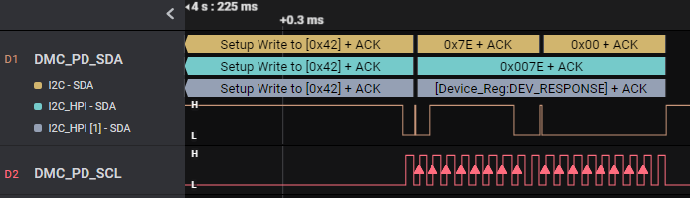
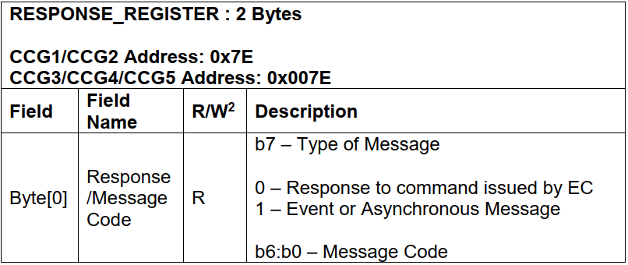
- HPI register address is decoded in raw (green) and translated (grey)
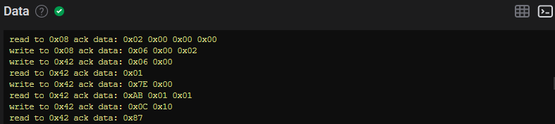
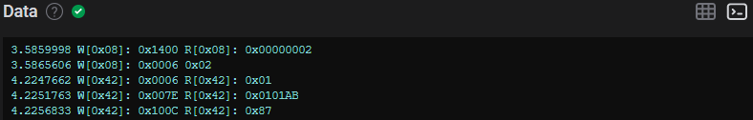
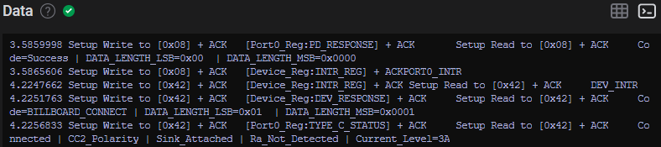
- Side-by-side comparison

CC Analyser
USB CC and HPI logs are mandatory information WCS support team usually need while dealing with issues. In the past, they were provided by CPYD4500 CC sniffer and Saleae Logic Analyser separately, and always was difficult to understand command sequences among CC and HPI activities because these logs are not referring the same timeline.
By introducing Infineon CC Analyser with a proper configuration, users can capture and decode both USB CC and HPI logs through Saleae Logic 2 application alone. It is extremely useful to check relevant command sequences across different protocols and accelerate debugging progress.
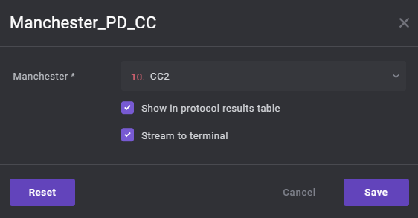
- Infineon “Manchester_PD_CC” Analyser

Infineon PD Logger
This is a portable Python application that supports Microsoft Windows 10 and above. It is highly recommended to use it with Saleae Logic Analyser Pro 16. The application pre-defines all necessary trace pins that users are required to provide while reporting issues for both AMD and INTEL design cases, along with project-relevant information, such as PD firmware revision. All numbers in pulldown menus are selectable but cannot be duplicated.
A folder named by current date will be created with all generated files, includes SALEAE logs and issue tracker form. A SALEAE log file is also generated based on channel number settings, associated with corresponding bus analysers respectively. The file will be named beginning with DATE_TIME as a prefix and appended with all data in the Version Information section. In addition, a text file named by the current date will be outputted under the same folder as the log files.
The Main window splits in following sections (refer to Figure 7):
- Version Information: it is mandatory to fill all information to blanks correspondingly, whereas OEM Ticket# as optional. It also covers both AMD and INTEL design trace needs.
- Generic:
  - USB-C: it defines SALEAE channel numbers to basic USB Type-C pins. All channels are recorded in both digital and analogue mode, and can be set to higher bitrate setting by enabling the “High Resolution” option.
  - PD/PD to EC: it defines HPI bus to EC and PD UART.
- AMD/INTEL Platform: it defines all necessary trace pins need for AMD and INTEL designs respectively. In AMD designs, MUX power pin SALEAE channel is shared with HPD pin. Please connect either one based on issue category.
- Start Recording: the main button to control Saleae Logic 2 application. It will be grey-out if lack of data in Version Information section, or channel selection duplication. Use this button to start / stop log capturing in Saleae Logic 2 application without save.

- Pass / Fail Case: the main buttons to save recorded logs for pass and fail cases. By clicking either buttons, it will save the current logs as pass or fail cases and export to an issue tracker form with all data described in Version Information section. It will be grey-out before log capturing.

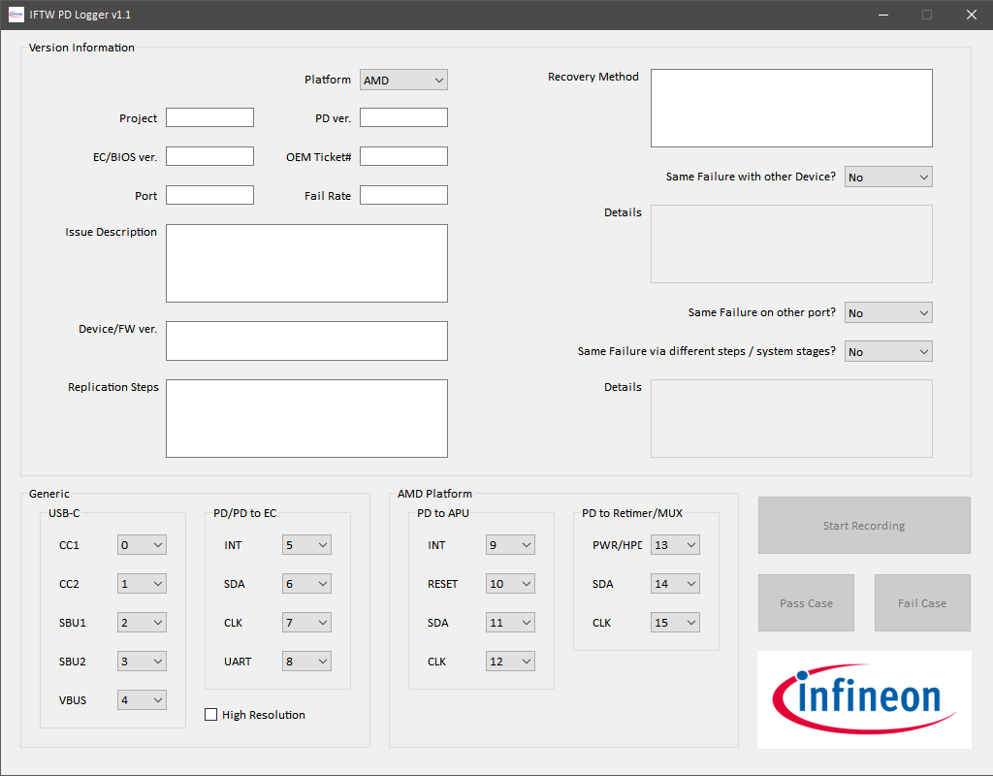
32
5
4
2
1
- Infineon PD Logger

How to use
Here is functional flow chart and there are 2 possible approaches in Infineon PD Logger usage:
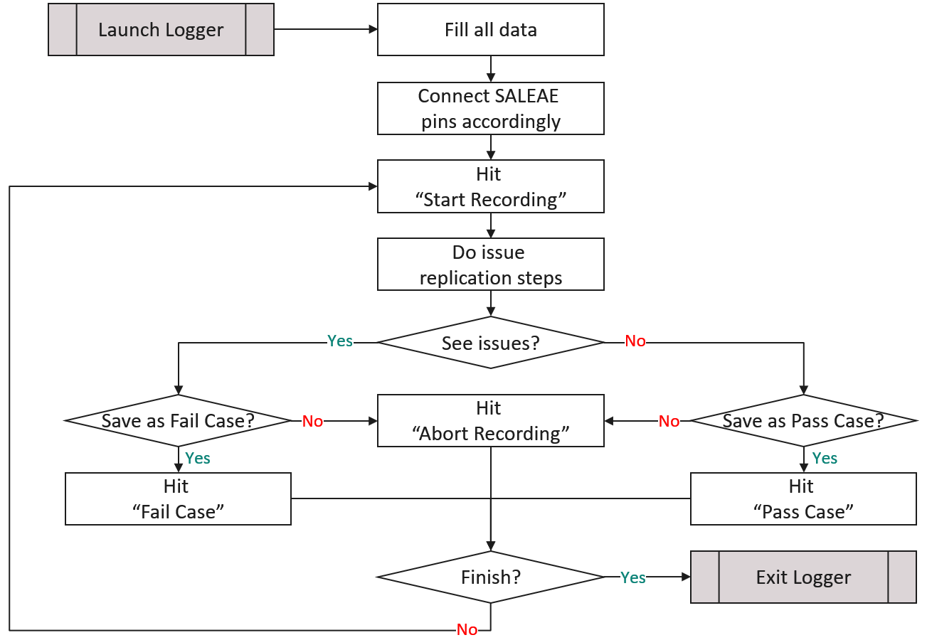
- Infineon PD Logger functional flow

Scenario A
This user scenario presumes Saleae Logic 2 application is not running in the background while starting Infineon PD Logger application. The benefit is users do not need to enable Saleae Automation option beforehand.
- Start Infineon PD Logger.
- Fill all information and platform type in Version Information and mapping SALEAE pins with pre-defined channels or preferred ones.
- Click “Start Recording” to start log capturing per setup.
- Infineon PD Logger launches Saleae Logic 2 application with automation supportive.
- Do issue replication steps. (e.g., shutdown and reboot to S0, re-plugging devices again, etc.)
- Click “Abort Recording”, “Pass Case” or “Fail Case” while replication steps finished.
- Infineon PD Logger assigns bus analysers to generated SALEAE log, and record capture settings in the text configuration file if necessary.
- Repeat step 3 to 7 for another log capture round.
- Close Infineon PD Logger while finished, and Saleae Logic 2 application will be shut down.

Scenario B
This user scenario only works while automation option is enabled in Saleae Logic 2 application as pre-requisites. In this case, it is presumed users launch Saleae Logic 2 application already.
- Start Infineon PD Logger.
- Fill all information and platform type in Version Information and mapping SALEAE pins with pre-defined channels or preferred ones.
- Click “Start Recording” to start log capturing per setup.
- Do issue replication steps. (e.g., shutdown and reboot to S0, re-plugging devices again, etc.)
- Click “Abort Recording”, “Pass Case” or “Fail Case” while replication steps finished.
- Infineon PD Logger assigns bus analysers to generated SALEAE log, and record capture settings in the text configuration file if necessary.
- Repeat step 3 to 6 for another log capture round.
- Close Infineon PD Logger while finished, and Saleae Logic 2 application will ***NOT*** be shut down.

Limitations of Infineon PD Logger
There are several limitations of Infineon PD Logger, including:
- It supports Microsoft Windows 10 and above only.
- It might crash if Saleae Logic 2 application does not enable automation option while working at Scenario B.
- Controlling Saleae Logic 2 application directly might cause Infineon PD Logger crash.
- It does not support Saleae Logic Analyser 8 / Pro 8 due to insufficient channel numbers.
- Channel renaming is not supported due to limitation of Saleae Automation library.

Self Service

CATEGORY | SYMPTOM | BASIC GUIDELINE
CHARGING | Charing icon is still ON after disconnecting USBC power source / no charging icon after connecting USBC power source | - Transfer to EC if relevant HPI commands (connect / disconnect) are sent from PD.
 | System shows “PC isn’t charging” message while attaching USBC power source devices | - Transfer to power source devices if no source PDOs or insufficient power profile capability are broadcasted.
 | System shows “charging slowly” in battery setting dialog while attaching USBC power source
DISPLAY | No display | - Transfer to graphic driver if EDID is shown in display setting.  - Transfer to external monitor / dongle if no HPD high or IRQ on CC log.
 | Display flicking / blur / flake on screen | - Transfer to graphic driver.
 | System shows “Display connection might be limited” message while attaching USBC display accessory | - Transfer to display accessory.
USB | No device is shown in device manager | NEED  USB MP310Q
 | System shows “USB device not recognized” message while attaching USBC device
 | Device is enumerated but yellow bang in device manager
THUNDERBOLT | No Thunderbolt function | - Check if INTEL ALT MODE is entered properly or not.

Revision history

Document version | Date of release | Description of changes
1.00 | 2023-07-20 | First release.

