Installation & Configuration Manual
A complete step-by-step standalone guide for provisioning bare-metal hardware, configuring enterprise hardware RAID storage, and deploying a secured operating system.

Phase 1: Physical Setup & Initial Boot Sequence

Power On & Hardware Readiness
  - Secure the server in the server rack.
  - Connect the dual power cables to independent Power Distribution Units (PDUs) for power redundancy.
  - Ensure the keyboard, monitor (VGA/DisplayPort), and network interface card (NIC) cables are firmly connected.
  - Press the Power Button on the front control panel.
  - Allow the server to execute its POST (Power-On Self-Test) routine.

Enter System Setup
  - During the boot process, monitor the blue Dell EMC splash screen.(May varies depends on servers)
  - Tap the F2 key as soon as it appears on the screen (you will see Entering System Setup
populate in the top-left corner).(May varies depends on servers)
  - Once loaded, you will be presented with the System Setup Main Menu displaying three primary options:
System BIOS
iDRAC Settings Device Settings
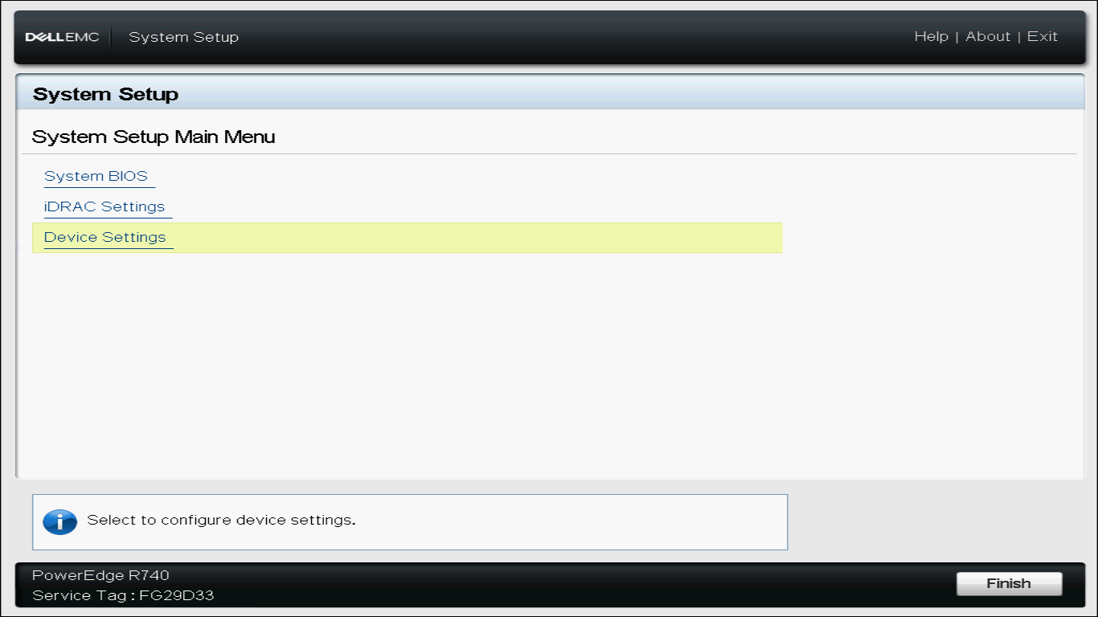

Phase 2: RAID Controller Configuration (Dell PERC H730P)
This section maps directly to the user interface flow of the PERC H730P configuration utility.

System Setup Main Menu
│
▼
Device Settings
│
▼
RAID Controller in Slot 4 (PERC H730P)

┌───────┴────────────────────────┐
▼ ▼
Configuration Management Virtual Disk Management (Clear, Select Disks, Create) (Verify final RAID volumes)

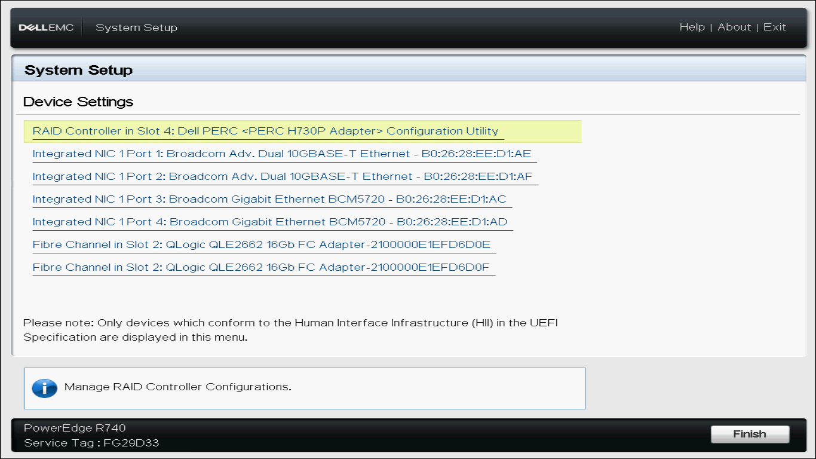

Navigating to the RAID Controller Interface
  - From the System Setup Main Menu, click on Device Settings.
  - Select RAID Controller in Slot 4: Dell PERC Configuration Utility.(May varies depends on servers)
  - You will arrive at the controller's Main Menu showcasing: Configuration Management
Controller Management Virtual Disk Management
Physical Disk Management Hardware Components

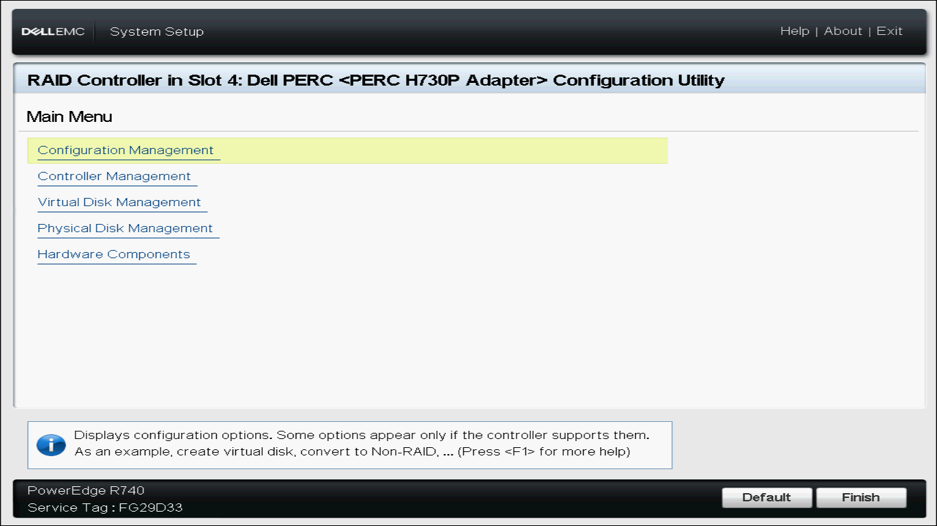

Purging Existing Configurations
CRITICAL WARNING: Cleaning configuration metadata permanently destroys any data currently mapped to the hard drives. Ensure any critical legacy data has been backed up before executing this step.
  - Navigate to Configuration Management.
  - Click on Clear Configuration.
  - Check the Confirm checkbox.
  - Select Yes.
  - Once the screen displays "The operation has been performed successfully," click OK.

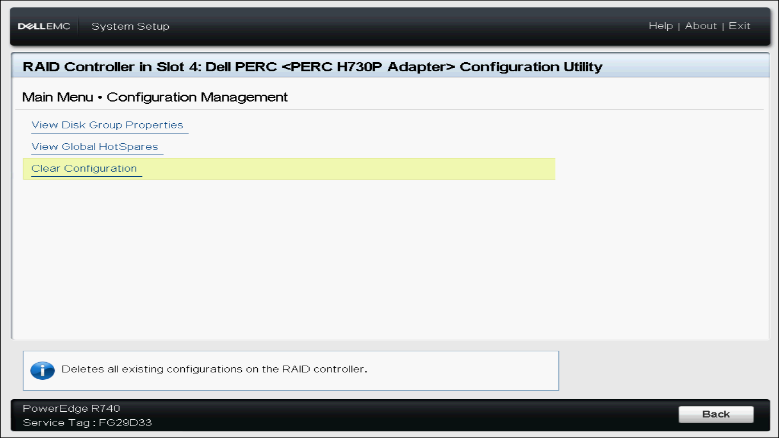

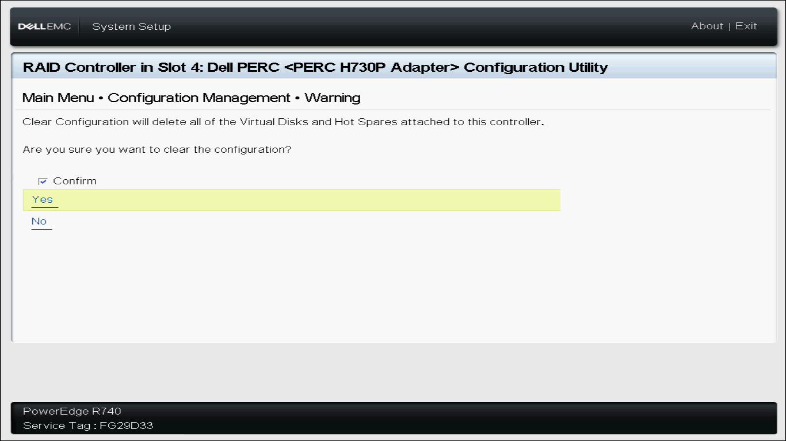

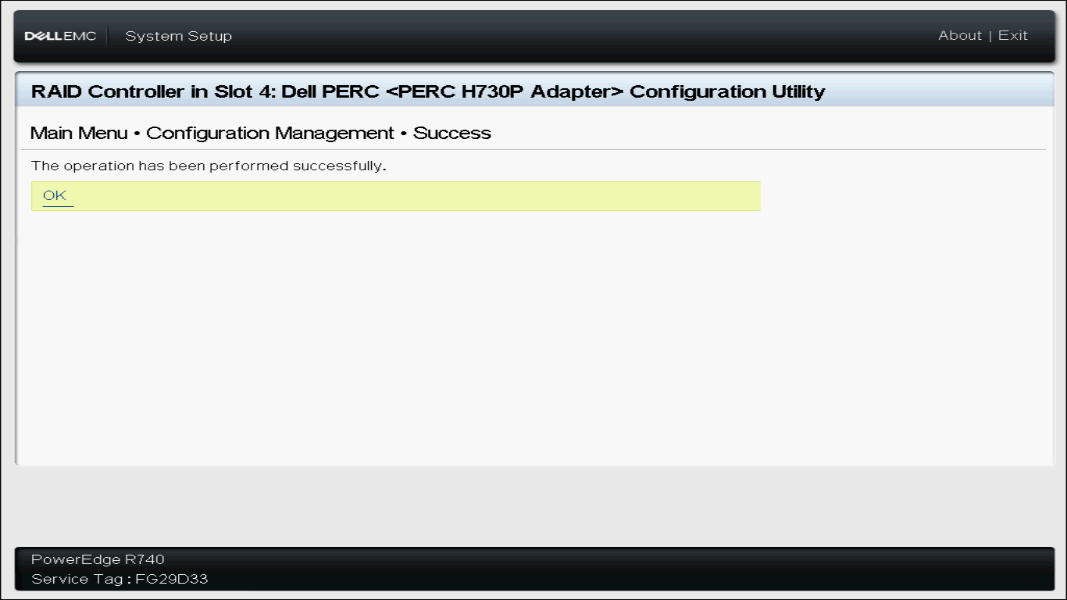

Verify Disk Health & Physical Availability
  - Navigate back to the Controller's Main Menu.
  - Click on Physical Disk Management.
  - Check the status of all your connected drives. For an empty clean setup, you should verify
7 × SAS HDD drives (listed from 00:01:00 through 00:01:06 ), each showing: Capacity: 2.182TB
Status: Ready
Sector Size: 512B

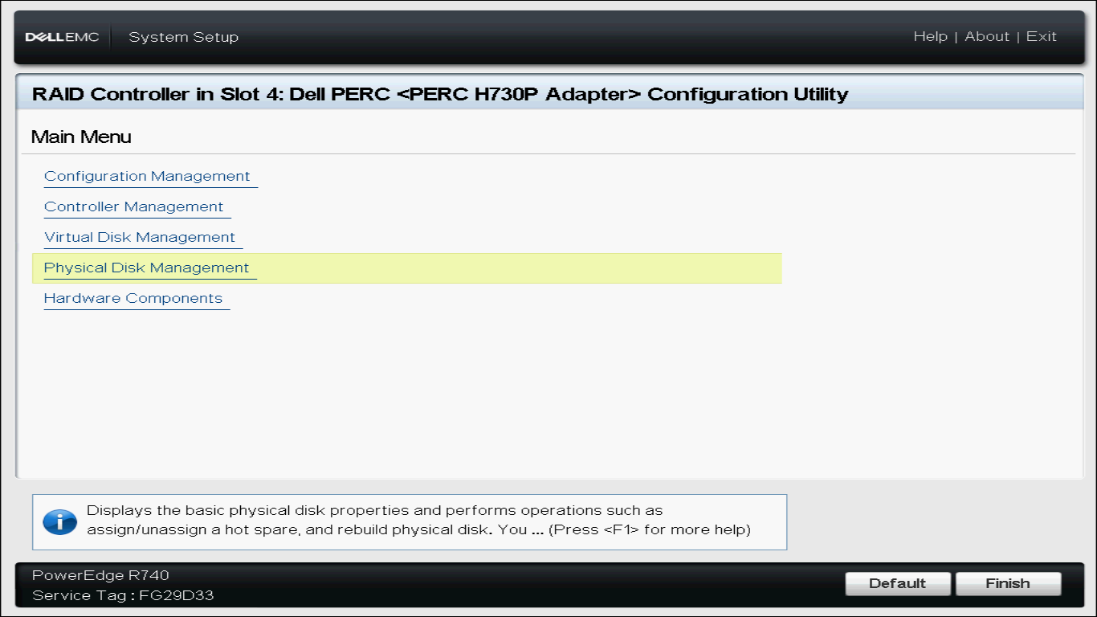

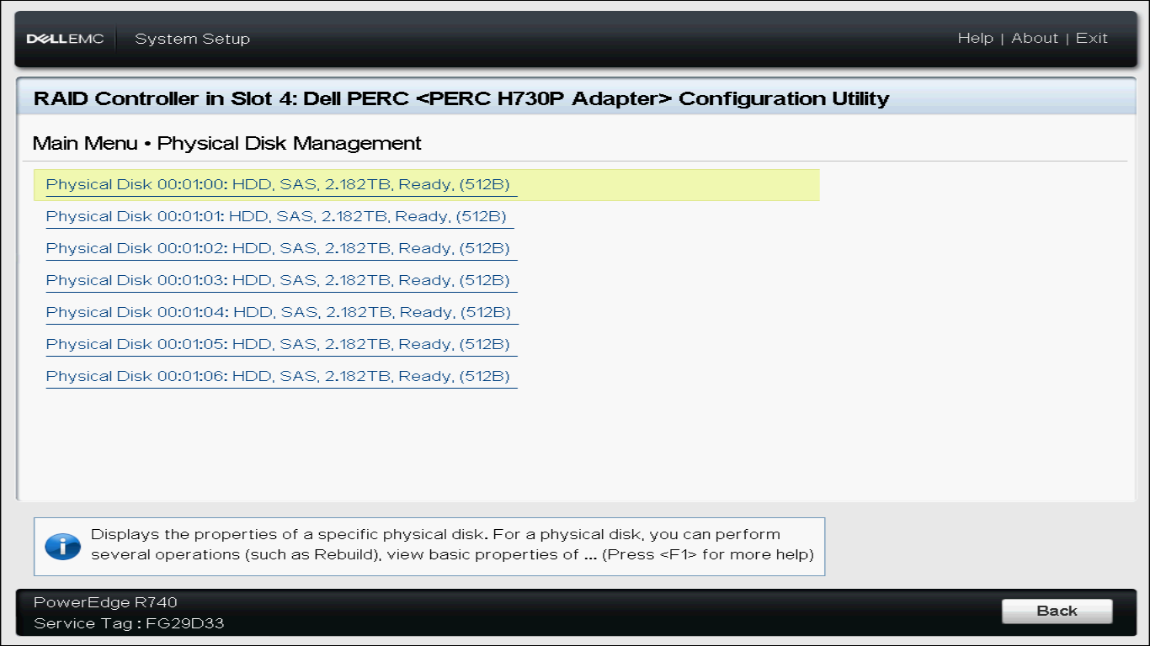

Step-by-Step: Building the RAID Virtual Disks
To balance reliability and performance, we split our 7 physical disks into two separate virtual disks (RAID arrays):
Virtual Disk 0 (OS Partition): Constructed with RAID 1 (Mirrored) using 2 disks. Highly fault- tolerant for system stability.

Virtual Disk 1 (Data Volume): Constructed with RAID 5 (Distributed Parity) using the remaining 5 disks. Optimizes speed and raw disk capacity.

Step 4A: Configure Virtual Disk 0 ( OS )
  - Go to Main Menu → Configuration Management → Create Virtual Disk.
  - Set Select RAID Level to RAID1.
  - Click on the Select Physical Disks link. Under filter configurations, select:
Select Media Type: HDD
Select Interface Type: Both
Logical Sector Size: Both
Under CHOOSE UNCONFIGURED PHYSICAL DISKS, check the boxes for:
Physical Disk

Physical Disk
Click Apply Changes. Click OK on the success screen.

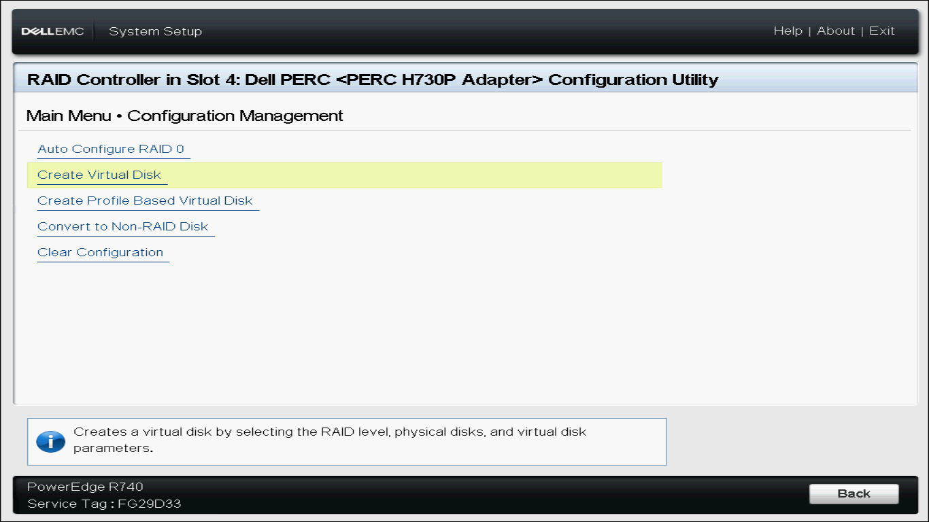
  - Now, configure the parameters of the virtual disk: Virtual Disk Name: OS
Virtual Disk Size: 2.182 (Will auto-calculate to maximum safe capacity)
Virtual Disk Size Unit: TB
Strip Element Size: 256 KB (PERC default optimized for modern filesystems) Read Policy: Read Ahead
Write Policy: Write Through (Safest writing protocol, protects logs/system config) Disk Cache: Default
Default Initialization: No

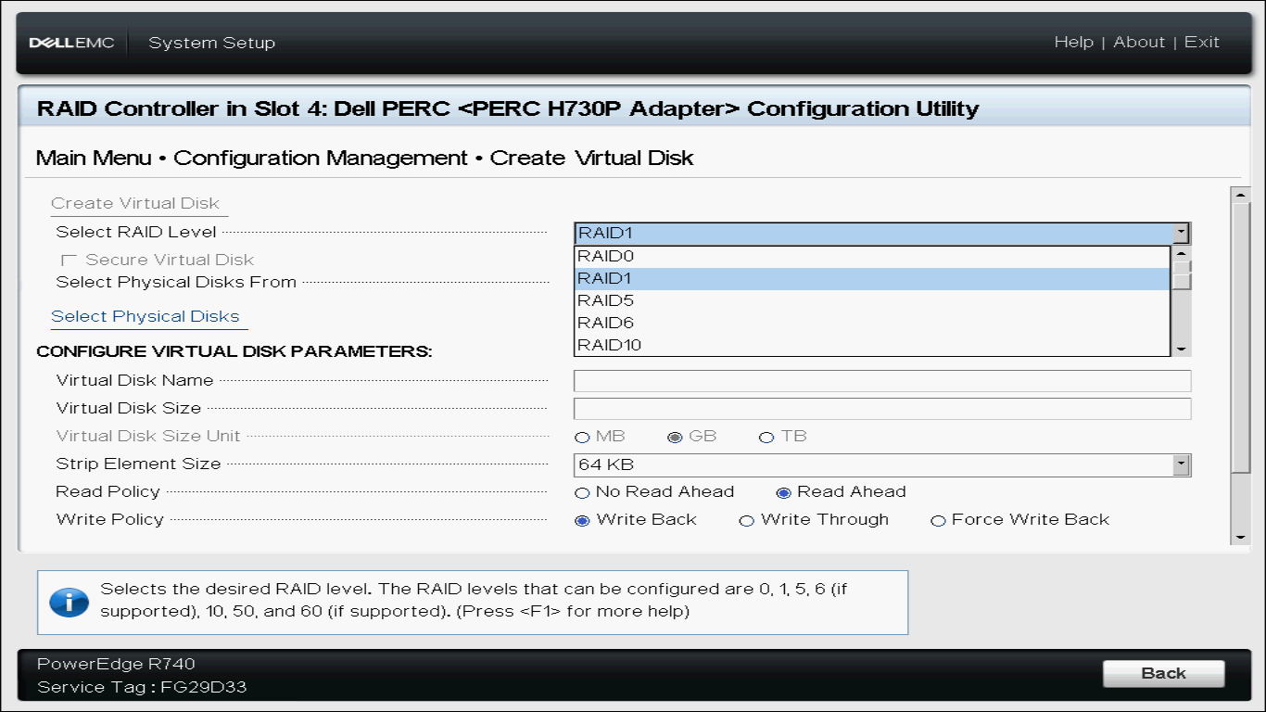
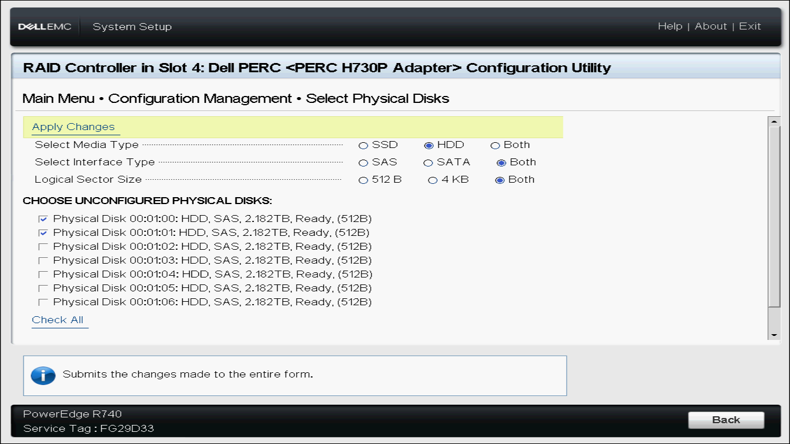

  - Scroll down to the bottom and click Create Virtual Disk.
  - Check Confirm, click Yes, and click OK to acknowledge the successful creation.

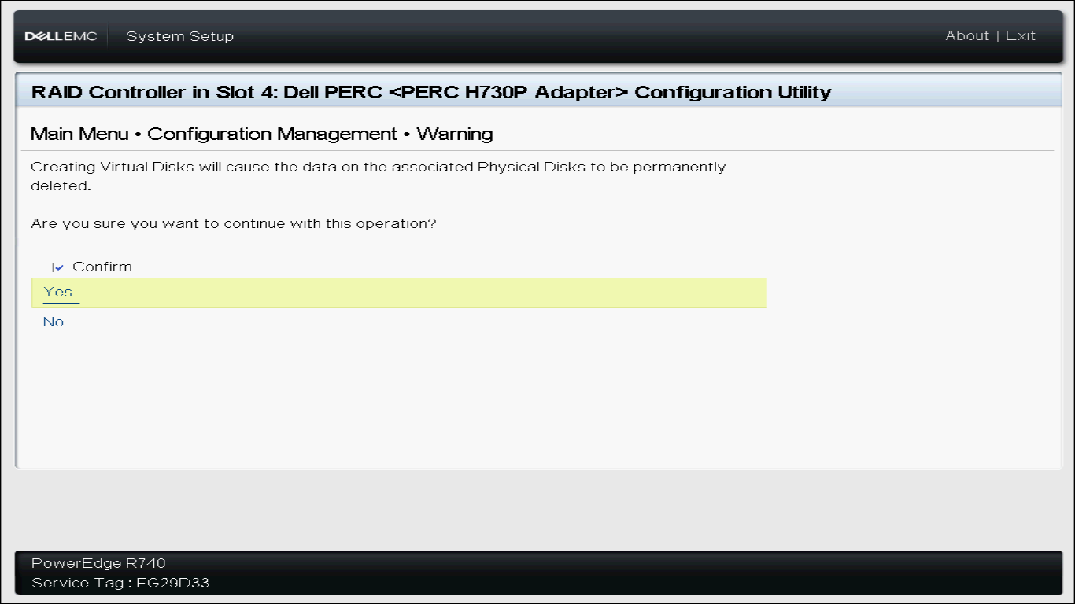



Step 4B: Configure Virtual Disk 1 ( Datastore )
- From the same menu, click Create Virtual Disk once more.
- Change Select RAID Level to RAID5.
- Click Select Physical Disks.
Under CHOOSE UNCONFIGURED PHYSICAL DISKS, check the remaining 5 boxes:
Physical Disk 00:01:02

Physical Disk 00:01:04

Physical Disk 00:01:05

Physical Disk 00:01:06
Click Apply Changes and then click OK.

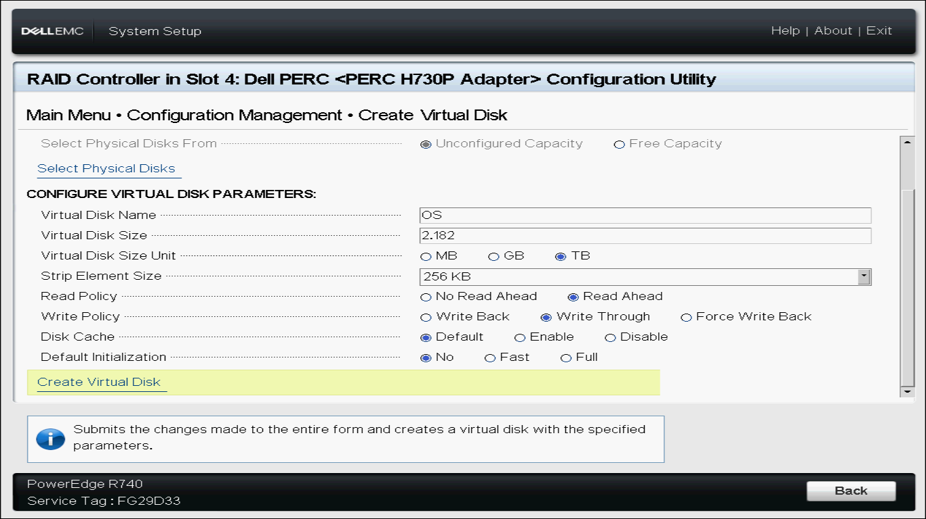

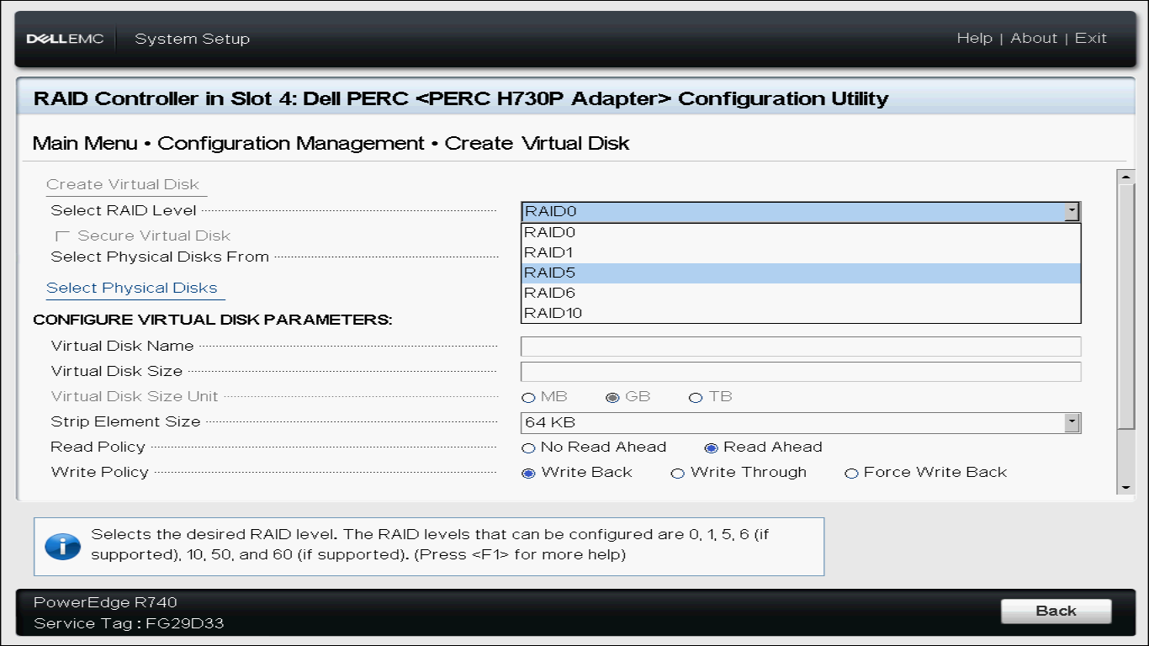

- Configure the parameters of this secondary volume: Virtual Disk Name: Datastore
Virtual Disk Size: 8.730 (Calculated using 4 × 2.182 TB usable storage with 1 TB
reserved for parity storage blocks) Virtual Disk Size Unit: TB
Strip Element Size: 256 KB
Read Policy: Read Ahead
Write Policy: Write Through
- Scroll down to the bottom and click Create Virtual Disk.
- Check Confirm, click Yes, and click OK.

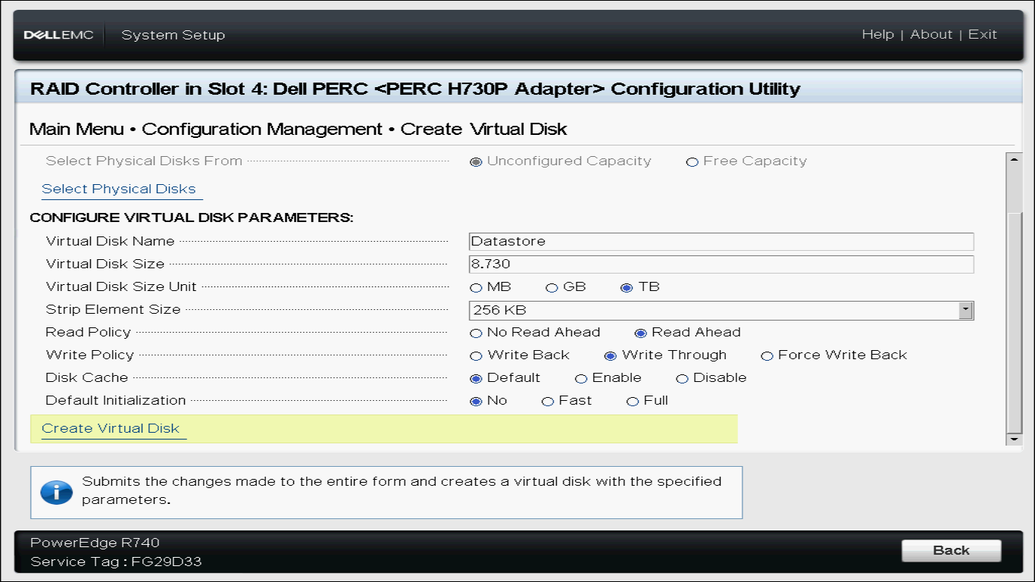





Final Hardware Storage Verification
  - Navigate to Main Menu → Virtual Disk Management.
  - Verify that your screen displays exactly two ready virtual disk arrays:
Virtual Disk 0: OS, RAID1, 2.182TB, Ready, Background Initialization 2%

Virtual Disk 1: Datastore, RAID5, 8.730TB, Ready
  - Click Finish on the bottom right corner of the screens.
  - Under the prompt "Confirm Exit", click Yes to reboot the server chassis.
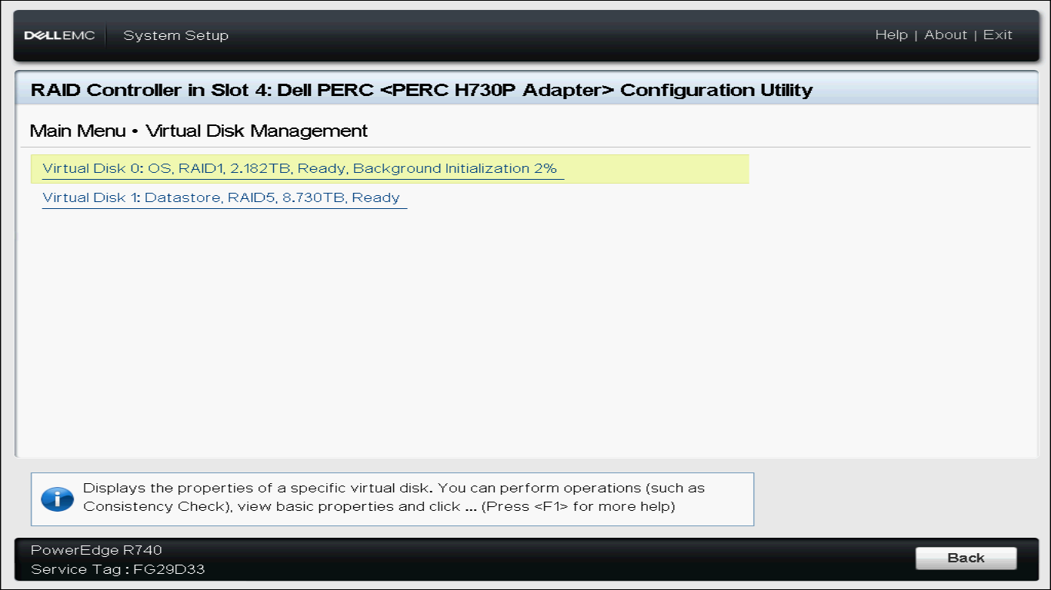

Phase 3: Creating the Bootable Installation Media
While the physical server reboots, prepare your installation media using an external PC workstation.

Download Your Target Operating System (OS) ISO
Choose and download the clean LTS enterprise version of your target operating system: Linux (RHEL Base): Rocky Linux / AlmaLinux Minimal
Linux (Debian Base): Ubuntu Server LTS
Windows Ecosystem: Windows Server Standard Edition

Write the ISO using Rufus
  - Insert a blank USB flash drive (minimum size 16 GB) into your workstation.
  - Download and run Rufus (utility software).
  - Under Device, select your USB flash drive.
  - Click Select, browse, and open your downloaded OS ISO file.
  - Apply these configuration properties:
Partition Scheme: GPT (Mandatory for modern UEFI boot modes) Target System: UEFI (non-CSM)

  - Click Start. Wait until the process finishes completely, then safely eject your USB device.

Phase 4: ESXI Installation

