**This document provides important information regarding the case data provided in the downloaded spreadsheet. This document will be updated periodically when new information arises that is important for researchers to consider when analyzing FADAMA data.**

1. For column with header “FA Report: Ancestry” this column provides information on what the forensic anthropology case report provided as its estimate of ancestry for a given case. However, cases entered *prior to* the year 2020 had a different submission format.

Prior to 2020, FADAMA users were prompted to fill in the FA Report ancestry with options identical to those used for the Actual Bio Profile Ancestry information:

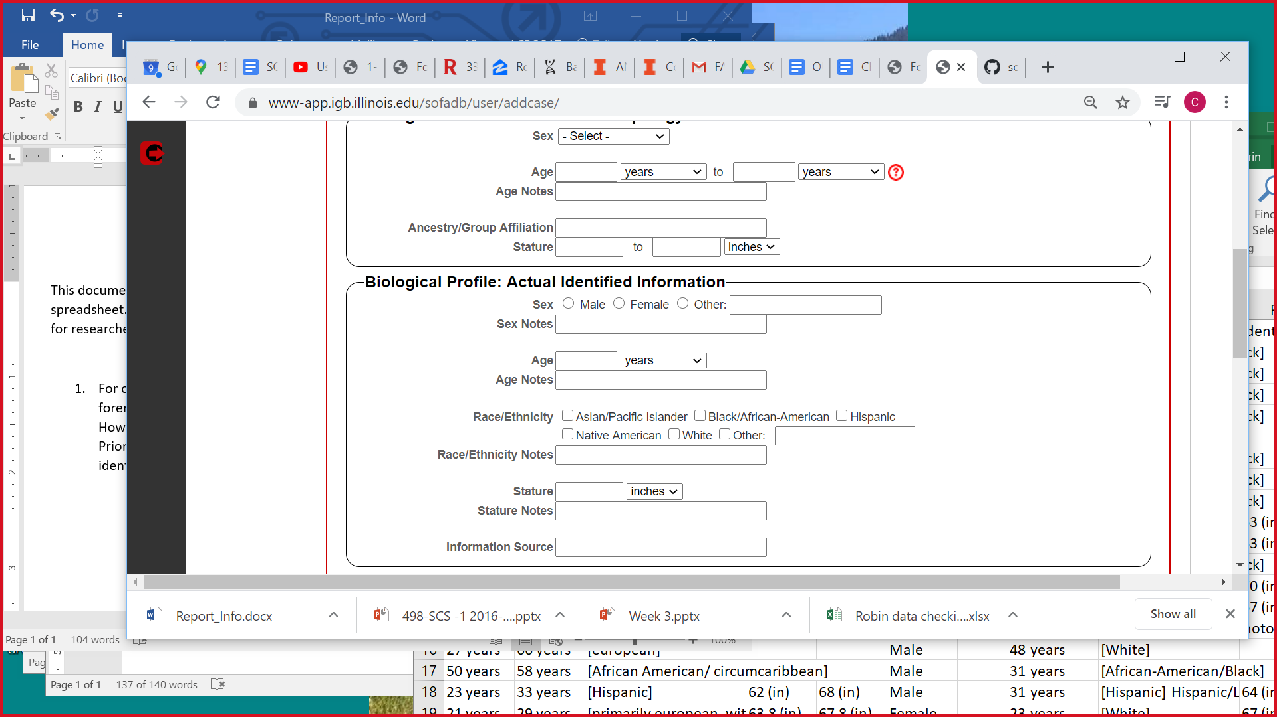

Cases submitted to FADAMA in 2020 and afterward are prompted with the current format for entering information about the FA ancestry report, which is simply an open-ended prompt to provide information on the “Ancestry/Group Affiliation.” These differences in formatting for inputting data may have influenced this data submitted to FADAMA, and should be taken into account when analyzing FADAMA data. For example, if a research were to examine ancestry group descriptors used on case reports, they may find that cases entered prior to 2020 have more uniform phrases when compared to those cases submitted from 2020 onward.

1. On February 24, 2021, the option “ambiguous” was added for the Phenice 1969 sex estimation method. Cases submitted to FADAMA prior to this date did not have this submission option.
2. On February 24, 2021, the reference samples for Mincer et at. 1993 for age estimation were expanded to include Black female, Black male, White female, and White male. Cases submitted to FADAMA prior to this date did not have these options, instead only had the options “male” and “female.”
3. On February 19, 2021 the ancestry estimation method rASUDAS was added. Cases submitted to FADAMA prior to this date did not have the option to indicate use of this method.
4. On August 25, 202, added TA3 as a Age estimation method option.