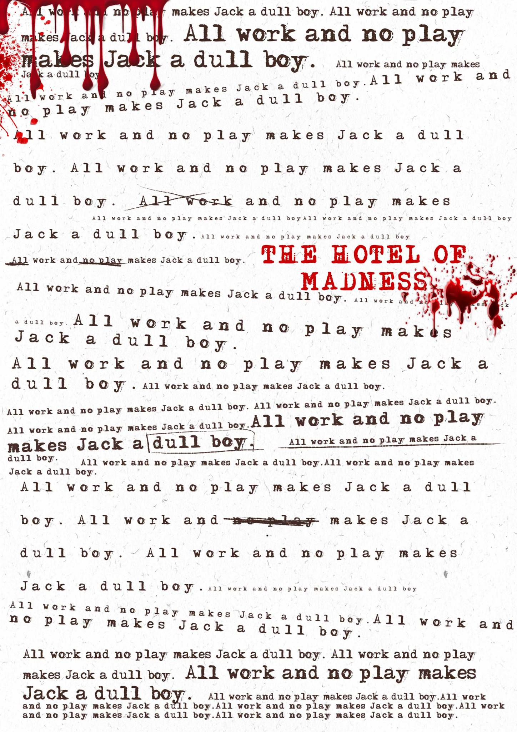

An original game by Matthew Nedelhalf and Alain Dellepiane

An original game by Matthew Nedelhalf and Alain Dellepiane

The hotel of madness

## TABLE OF CONTENTS

3

3

3

4

4

4

5

5

5

5

6

6

6

7

7

7

## Goal of the game

The Human player must remove all phantoms, decoys, and statues from play in order to win, while the Hotel player must either kill or possess all members of the Torrent family.

The game is declared a draw when 10 turns have passed or the Human player flees (see the *End-game* chapter for details.)

## Game Overview

The Hotel of Madness is a two-player game inspired by classic horror stories of the 1980s.

One player controls a sentient and evil Hotel while the other guides its luckless caretakers.

The game is played on two maps, representing the Hotel and its surroundings, using counters to represent Human units (Manny, Jake and Sandy Torrent and their psychic ally Andrew Hann), Hotel units (statues, phantoms and decoys) and objects.

The values of each unit is printed on its counter. (See the tab below.)  
Use a sheet of paper for tracking individual damages.

Set Up

Sequence of Play

Movement and activities

The elevator

Snowfall

Snowmobile

Stacking

Statue

Discovery

Physical combat

Psychic Combat

The Agent

The boiler

Andrew Hann

End-game

Draw endings and victory points.

|  |  |  |  |
| --- | --- | --- | --- |
| **Humans** | **Phantoms** | **Statues** . | |
| Psychic strength► Activity points► | Psychic ATT strength ► Psychic DEF strength► Activity Points ► | ►  Combat  strength | ◄  Movement allowance |

## Set Up

The Hotel player sets-up first, placing phantom and decoy counters, face down, throughout the Hotel and grounds. At least one unit must be placed in the starred areas: the Bar, Room 207 and the Playground. No Hotel units may be placed in the Torrent’s suite, Room 224. The statues are placed in any order, face up, on the triangle-marked grounds hexes.

Then the Humans can be placed: Jake may begin the game in the Office, the Bar, the Basement or the Garage; Sandy in the Pantry, Kitchen, Lobby or Room 224, and Manny in the Game room or Playground. Andrew Hann must be placed on his arrival track.

Objects are placed as follows: the mallets, two gasoline counters and the axe go in the Garage. The knife goes in the Pantry or Kitchen at the discretion of the Human player. One snowmobile goes in the Garage and the other on the “enter map” square of the Andrew Hann arrival track.

## Sequence of Play

The game is played in turns (as opposed to being played in prison, or in a tuxedo), divided in 8 successive phases - identical for both players.

1. Movement and activities
2. Discovery
3. Physical combat
4. Mental combat

## Movement and Activities

During the movement and activity phase, each counter can only use the number of activity points written on it. ("Storing" points from previous phases or "sharing" them across units is not allowed.)

AT THE END OF EACH TURN, ONLY UNITS WITH AT LEAST ONE ACTIVITY POINT LEFT ARE ALLOWED TO ATTACK.

All main actions cost 1 activity point:

Moving through 1 square or hex

Opening a closed door

Closing an open door

Picking up a weapon

Calling the elevator

Boarding the elevator

Starting up a snowmobile

Except:

Changing the direction a Human is facing: 0 points

Dropping weapons:

0 points (unless you drop it in somebody’s skull)

Dragging a snowmobile out of the Garage:

**1 point *plus* movement costs**

Dumping the boiler:

**2 points**

Moving through garage and basement squares:

**2 points**

Outdoor squares *after* snowfall:

**2-3 points**

*Diagonal movement is prohibited within the Hotel. Squares are considered adjacent where they share some length of common border.  
All doors in the Hotel are initially closed; when a door is opened, place a “door open” marker over it.  
Doors can be opened, closed and passed through from any adjacent square or hex*.

## The Elevator

Once called, the elevator immediately moves towards the caller at a rate of two levels per movement phase. When the elevator arrives it will immediately open, and can be boarded for one activity point.

Whichever unit called the elevator chooses a destination floor by selecting the appropriate destination marker and placing it face down while the elevator ascends/descends to the desired level at the same rate. Once summoned or sent to a destination floor, the elevator will not reverse its movement until it has reached that floor and allowed its passengers to get in or out, but will stop at any intervening floor, provided it is called or ordered to do so before it has passed that floor.

The elevator moves in the phase of the player controlling it. When it reaches its destination the marker is revealed and units in the elevator may disembark. Counters riding in the elevator are placed in the elevator square of the level on which they boarded the elevator. Place an “elevator up” or “elevator down” counter atop the stack to show the elevator’s direction, and move the stack to the appropriate level each turn. There is no limit to the number of units which may occupy the elevator.

## Snowfall

Starting on turn four, there is a chance of snow. The Human player rolls one six-sided die (1d6) at the beginning of movement and consults the turn track.

If the number rolled is within the range indicated, the snowfall has begun and the number of activity points necessary for a Human to enter an outdoor hex will increase by one each turn, to a maximum of three points per hex - except for units riding snowmobiles.

## Snowmobile

Up to three units may occupy a snowmobile: stack them on the snowmobile counter.

The turn after it is started, a snowmobile can travel up to 20 hexes per turn (minus two for each unit after the first one that it carries.)

A snowmobile can move into any of the three hexes in front of it, and may change ‘facing’ any number of hex-sides by using one point of its movement allowance PER UNIT RIDING THE SNOWMOBILE.

Needless to say, the snowmobiles cannot be used inside the Hotel or if snow hasn't descended yet.

The snowmobile has enough gasoline to move freely within the map, but will require extra fuel in order to escape.  
Any Human in the same square with the snowmobile and a can of gasoline for one full movement phase is considered to have filled the snowmobile’s tank. Alternately, if an escaping character is carrying a full can of gasoline, the snowmobile can be fueled off the map.

## Stacking

There is no limit to the number of units that may occupy one hex or square.

Phantoms and decoys may not use weapons, but they can move them around. They may only carry one weapon at a time and must drop the weapon counter before ending their movement.

## Statues

Statues may not enter the Hotel or the garage. For the first four turns of the game, they can only move outside any of the hexes that form a 60° "sight cone" from the top and top-side hexes of a Human-controlled unit. After turn four the statues dispense with stealth entirely.

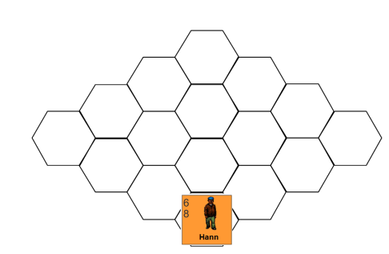

In the above diagram, a statue could not move if it were in any of the hexes depicted and in any hexes beyond, unless such “line of sight” is blocked (a straight line from the center of the Human hex to the center of the statue hex intersects a wall of the Hotel.)

## Discovery

At the end of movement, any inverted unit that is in the same square as, or within one hex of, a Human, is flipped face up. Flipped up decoys get removed from play, while face up phantoms remain until dispelled.

## Physical Combat

## To conduct melee combat, the attacker must be in the same square or hex as the defender. Combat is always voluntary; no unit may make more than one physical attack per turn.

## *Attacks to control*

## When a Human or phantom attacks, one die is rolled. If the die roll is equal to or less than the unit’s NUMBER OF SAVED ACTIVITY POINTS, it has attacked successfully. While phantoms can attack physically, they cannot be attacked physically. Nor can they use weapons. Manny cannot use the ax.

## Damage is equal to one die with the following modifiers:

## • knife: +1

## • mallet: +2

## • ax: +3

## The total comes out of the target’s activity points. If the target is a statue, damage is divided, at the owner’s discretion, between movement allowance and combat strength.

## When any attribute reaches 0, a unit is dead or destroyed, and is removed from play. Any weapon carried by a killed Human remains in the square or hex in which they were killed.

## *Statues*

## To determine if a statue hits, roll two dice. If the resulting number is equal to or less than the unit’s combat strength, it has hit.

## To determine the amount of damage done by a statue strike, roll two dice. Subtract the total rolled from the number of the current turn, and add a modifier for the particular statue:

## • lion: +2

## • bison: +1

## • dog: 0

## • rabbit: -2

## Any damage scored by a statue is subtracted from the target’s activity points. Statue attacks can also inflict no damage, especially in the early game, but may not do "negative damage".

## Psychic Combat

To conduct a psychic attack, a unit must be in the *same area* as its target. “Area” is defined as one room or hallway.

Outside the Hotel, a unit must be adjacent to or stacked with a target in order to attack it. Attack strengths cannot be split or combined; all attacks are individual.

The Human player uses psychic attacks to destroy or dispel phantoms; the Hotel player uses them to possess a Human first and then to scare others units to death.

Until the Hotel has an Agent, it may only make one psychic attack per turn. If two or more phantoms can carry out such attack, the Hotel player must choose which to use. After securing an Agent, the Hotel may attack with all of its phantoms on all subsequent turns.

A psychic attack is successful if the attacking player rolls less than or equal to the attacker’s psychic strength or psychic attack strength on two six-sided dice (2d6). What happens next depends on the objective of the attacker.

***Attacks to dispel***

Subtract the phantom’s psychic defense strength from the attacker’s psychic strength to get a target number. If a second die roll is equal to or less than the target number, the phantom is destroyed and removed from play. If the die roll is higher than the target number, the phantom has been dispelled temporarily.

The Hotel player removes it from play and replaces it at its *original starting spot* during the Hotel movement and activity phase the *second turn* after the unit was dispelled.

***Attacks to control***

A target number is calculated in the same manner. If the Hotel player rolls equal to or less than the target number, *the victim is possessed and becomes an Agent of the Hotel*.

***Attacks to kill***

After securing an Agent, the Hotel may begin terrifying the other Humans to death using all of its phantoms.

Any time a psychic attack performed by the Hotel is successful, the “target number” is simply the number of points of psychic damage done to the defender.

This damage comes out of psychic strength, and when a unit’s psychic strength reaches zero it dies of heart failure.

## The Agent

When the Hotel successfully possesses a member of the Torrent family, flip the counter. From that point on it is an Agent controlled by the Hotel, although they have a short chance of breaking free.

The Human player rolls a die once per turn during the Human psychic combat phase, for a number of turns equal to the Agent’s psychic strength, adding one - cumulative - for each turn that the unit has been under Hotel control.

If the modified die roll is less than the Agent’s psychic strength, the unit breaks free of the Hotel's control and returns to the control of the Human player.

The die roll can be further modified by subtracting the psychic strength of any Human adjacent to the Agent, and by adding the psychic strength of any phantom adjacent to the Agent.

The Agent can dump the boiler and use weapons like any other Human. However, it cannot be attacked until it has conducted a physical attack against another Human.

## The Boiler

At the start of the game, place the boiler pressure marker on the square marked “50" of its track.

Every turn thereafter, if the boiler has not been dumped, the pressure marker will rise at a rate of TWO SQUARES PER TURN at the end of the turn.

The boiler can only be dumped if a Human is placed in the boiler square and spends two activity points for it. On a turn in which the boiler is dumped the pressure level will drop by three squares and will not advance at the end of the turn.

If the boiler reaches 310, it will explode at the end of the next turn, regardless of whether or not it is dumped. One turn after the boiler explodes, the elevator ceases to function. Any units still in the Hotel the turn after that are toast.

The Human player *may not* let the boiler pressure advance past 210 until the Hotel player has initiated hostilities with at least one psychic combat.

## Andrew Hann

On any turn after the first combat - psychic or physical - takes place, Manny - and only Manny - may attempt to call Andrew Hann instead of executing a psychic attack. Only one such attempt may be made per turn. Manny successfully contacts Andrew Hann by rolling under his current psychic strength on two dice. When Andrew Hann is contacted, begin his voyage to the Hotel by placing his counter on the first square of the arrival track.

Each turn thereafter, the Human player rolls one die to determine the progress of Andrew Hann: a roll of a 1-4 advances the counter by 3 squares; a roll of 5-6 advances him by four.

When Andrew Hann reaches the square marked four, the Hotel player may elect to intercept him by removing one statue or phantom from the map, losing it for the rest of the game. Place the counter above Andrew Hann and resolve one round of combat between the two.

Andrew Hann has a number of activity points equal to his total minus the number of squares he advanced before being intercepted. If the Hotel unit succeeds in wounding him without being wounded, the ambush is successful and Andrew Hann is removed from the game. If Andrew Hann either escapes unwounded *or* successfully wounds his attacker, he continues on.

If Andrew Hann runs into snow (the snowfall has started while he is in the second half of his arrival track) he is limited to movement of three squares per turn.

When Andrew Hann reaches the “enter map” square of the arrival track, move him on any hex along the bottom edge of the main map together with the snowmobile. Andrew Hann arrives at the end of movement and may move normally the next turn.

## 

## End-game

The game continues until reaching one of the following conditions:

* All phantoms, decoys and statues have been removed from play (Human wins)

**or**

* The entire Torrent family is either dead or under Hotel's control (Hotel wins)

**or**

* 10 turns have passed (draw)

**or**

* Manny and another Human escape from the Hotel (draw)

## Draw Endings and Victory Points

If the game reaches its 10th turn without reaching a winning condition, it gets decided through points.

***Human***

Each decoy removed:

5 points

Each statue destroyed:

10 points

Each phantom destroyed:

15 points

***Hotel***

Each Human killed:

15 points

Each Human controlled at end of game:

20 points

After at least five turns, the Human player can also opt to flee the Hotel. To do so, they must take Manny and another Human off the bottom edge of the map using the snowmobile.

However, this is not a successful outcome, as the Torrent's will be blamed for the damages to the Hotel (notably by the explosion of the boiler.)

Therefore, this ending too is decided through victory points, with a -20 penalty for the Human player if they flee BEFORE the Hotel player has an “Agent.”