Devan Tilly

02/28/2018

Enabled Citrix USB Redirection Policy inside Citrix Studio

In IGEL we created USB redirection policies, since we deny USB redirection

In our image we installed the latest Canon driver and the latest Capture Perfect software. The Capture Perfect software may not be necessary, additional testing is needed to determine whether or not it is necessary, but we installed it as we had seen in multiple articles say that not having it installed caused various issues. Capture Perfect also provides a GUI for settings that are not normally accessible, and that is how we found what settings we needed to change in the registry to improve scan times.

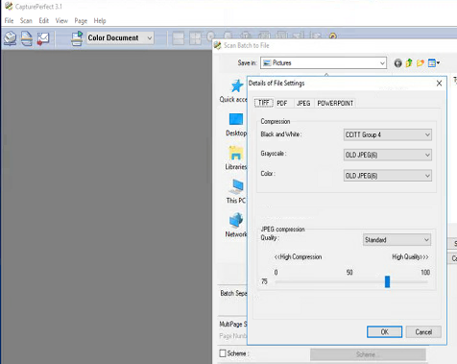

Inside Capture Perfect if you select Scan>Scan Batch to File, you will be able to select scan settings that are not usually accessible from the driver’s GUI as seen above. In the above screenshot you can see the section labeled JPEG Compression. This section is what enabled us to improve our scan times. Changing the location of that slider changes the compression level of the images scanned when transferred from the scanner to the computer/thin client. Moving the slider to the left will increase the compression level, and for us we noticed that it sped up the scanning process, but this came at a cost of poorer image quality. You will want to move the slider to various positions to determine what provides the fastest scan times while providing an acceptable image quality. After finding an acceptable level, I copied down the number to the left of the slider, which will be needed later.

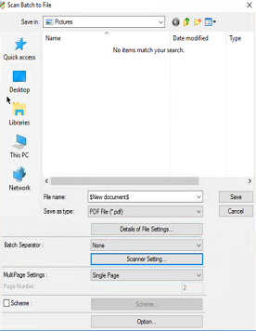

Closing the “Details of File Settings” window, will allow you to select the “Scanner Setting …” button, which opens the window below.

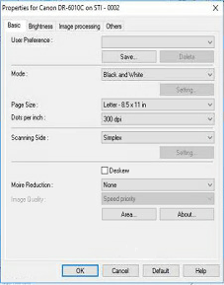

This is the GUI that we would normally see when trying to scan inside our other software. Here we MUST set the JPEG TRANSFER option under the Others section. By default, the Canon scanner we used sends images from the scanner to the computer as raw uncompressed data. Using JPEG TRANSFER converts the scanned image into compressed JPEGs, minimizing the amount of data needing to be transferred from the scanner to the computer. See below for additional information.

s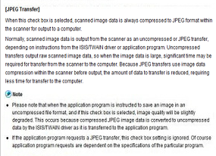

Once you have selected JPEG TRANSFER and the other settings you desire, save these settings as a User Preference.

Now, launch a Run box from the Windows Start Menu and type in Regedit.

Navigating to HKEY_USERS\*user*\Canon Electronics Inc.\ you will find the various models of Canon scanners installed. For my situation I am looking at the Canon DR6010-C, and beneath that model I found a directory called UserPreference.

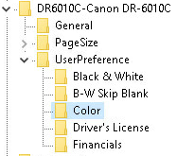

Under the UserPreference directory you will find the User Preference profile you created earlier, selecting that profile will bring up the settings that were specified in the GUI. Here we can find additional settings that were not available in the driver GUI. Not all settings are available when using different color modes, so make changes at your own risk.

The settings I checked to make sure were set were as follows:

TranferMode=1 This means that the checkbox was checked for JPEG Transfer.

TransferHighJpegQuality sets the compression/quality level we tested with earlier. Here we will add the number we copied down earlier that was to the left of the slider. I believe this setting can only be used with color mode, but I have not tested this.

After setting these values try scanning inside the program you would scan with, while selecting the profile we just modified. To do this start scanning in the program you desire and the Canon scanner’s GUI should appear and you will be able to select the profile we modified.

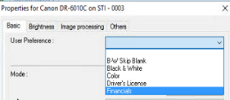

We apply these Canon User Preferences to user’s at login, by adding the registry settings. We utilize Ivanti Environment Manager to do this, other software maybe utilized to add these settings such as group policy or Citrix WorkSpace Environment Manger.