Abstract

Acknowledgements

Figures and Tables

Introduction

Background and Motivation

Research Objective

Project Plan

Literature Review

FSP:

FSP simulation

FSP’s previous visualization research

Satellite:

Orbit type and Height distribution

Kepler element

Coordinate system

Visualization:

Information Visualization

User centered design

Current Space Object Visualizers

Web technology:

Cesium.JS

HTML&CSS&JS

User Research

User research method

Useful

Public Awareness

Methodology

Results

Discussion

Conclusion

# Introduction

## Background and Motivation

Since the late 1990s, technological advancements have facilitated the design of smaller and lighter satellites with improved capabilities. Concurrent improvements in launch technology have broadened access to the space industry, allowing a diverse array of operators to deploy an increasing number of satellites into orbit (Peterson, Sorge and Ailor, 2018). Especially in recent years, commercial investment in space has increased, with multiple commercial companies proposing or funding the deployment of very large constellations of small to medium-sized satellites, leading to a surge in the space population (Muelhaupt *et al.*, 2019).

An analysis of the global number of space objects—including satellites, probes, landers, crewed spacecraft, and space station flight elements launched into Earth's orbit or beyond—reveals a surge from 1810 to 2163 between 2021 and 2022. This increase is noteworthy, considering the average annual number of objects launched into space remained relatively constant at approximately 110 until 2012 (Figure 1).

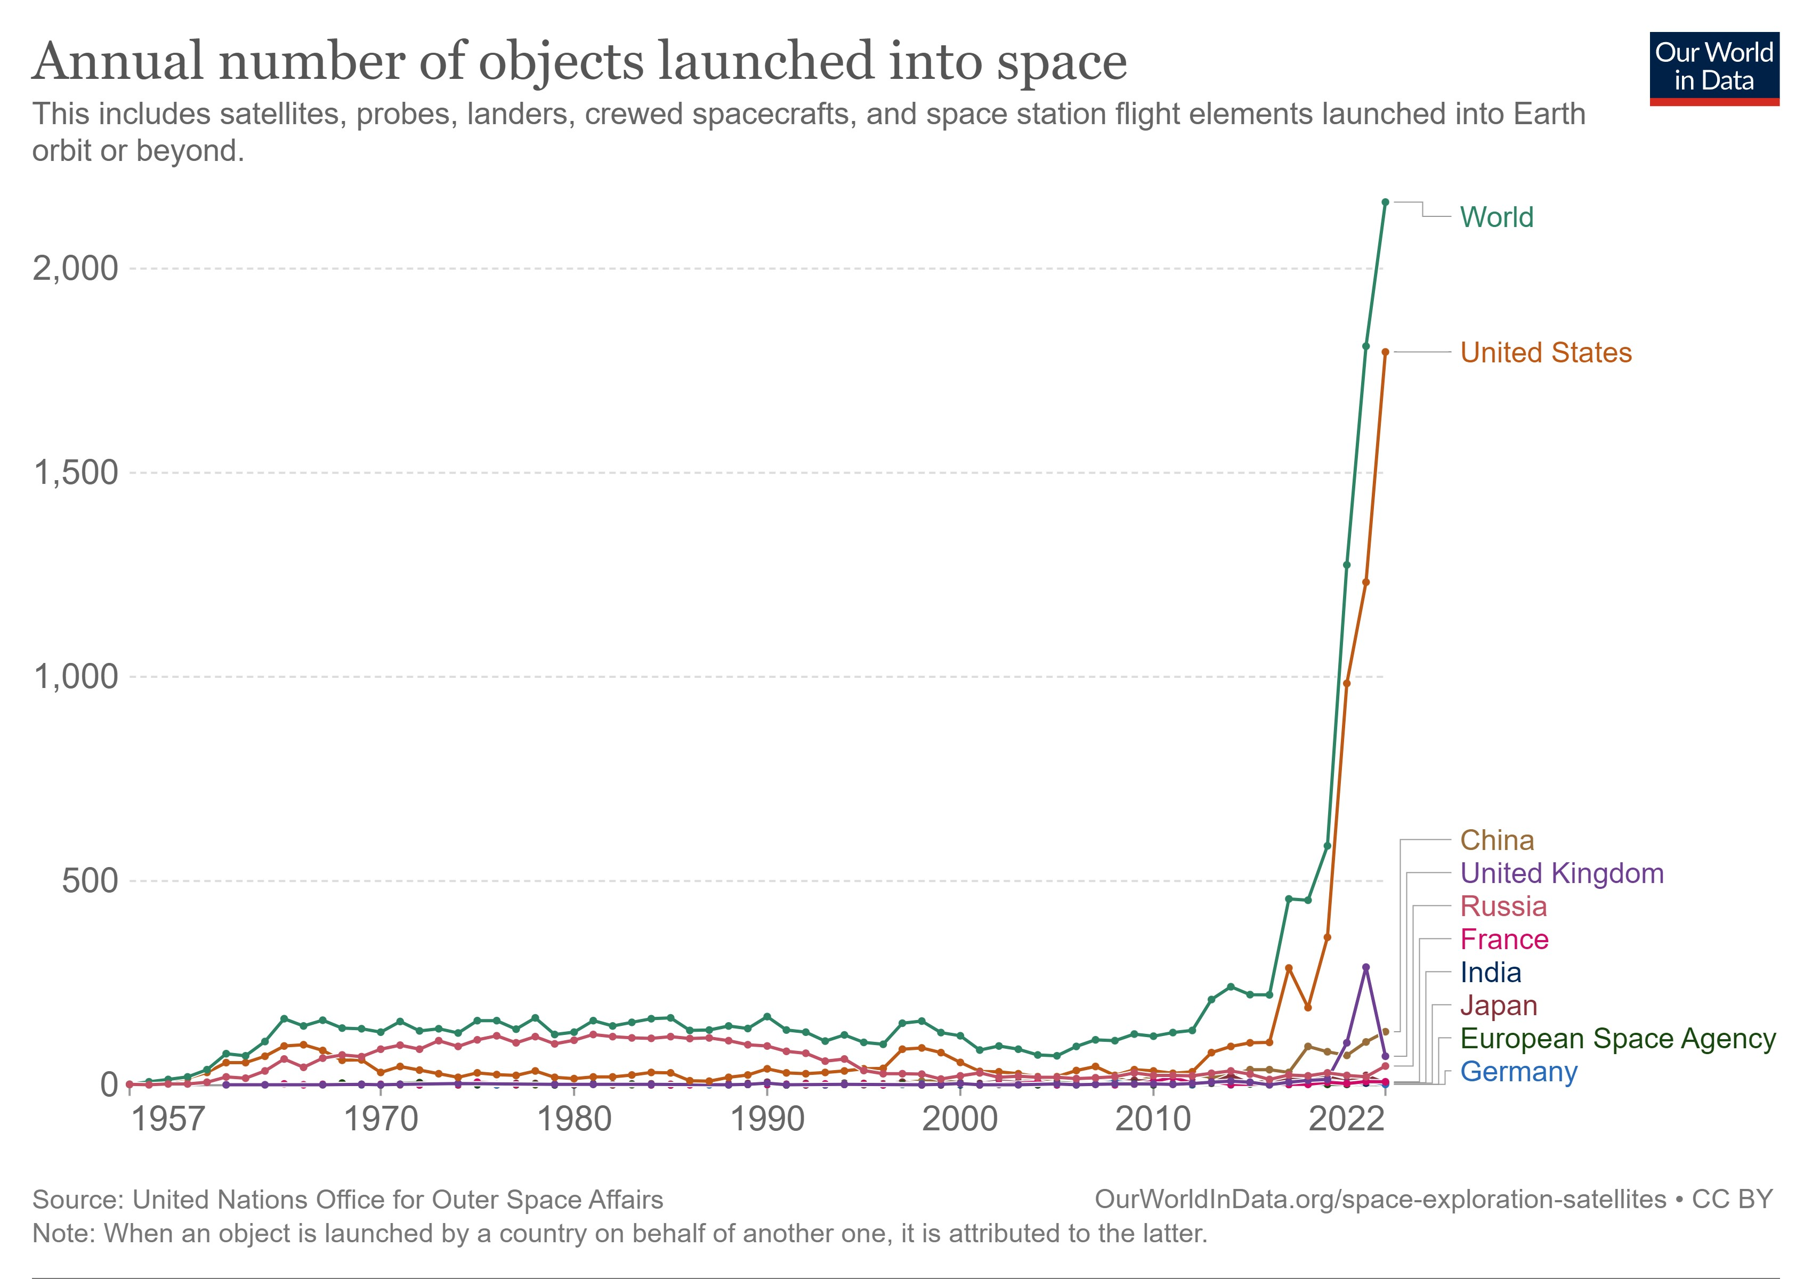

**Figure 1** The annual number of objects launched into space(Our World In Data, 2023).

The exponential increase in the space population has introduced complexities in space operations and amplified the risk of collisions, instigating concerns regarding possible space crowding. Despite International treaties affirming that space should be used for the benefit of all, with nations cooperating to leverage space technology in achieving global development goals, there seems to be a lapse in stringent regulations and management (Kopal, 1966). Countries such as the United States, China, Russia, and Japan have expressed increasing concerns about potential conflict in space, simultaneously escalating their investment in both military and commercial activities in outer space (ZURICH, 2022). The attitude towards the rapidly growing space population is reflected by Elon Musk's remark, "A couple of thousand satellites is nothing. It's like, hey, here's a couple of thousands of cars on Earth, it's nothing" (*BBC News*, 2021).

The evident absence of comprehensive global regulation underscores the urgent need for increased public awareness and international governance, directing the race for space towards collaboration rather than conflict. The visualization of spatial populations can play a crucial role in this effort by translating abstract concepts into tangible, easy-to-understand forms that are accessible to a wider audience, thereby inspiring greater public participation and support for responsible space management (Chen, 2010; Interaction Design Foundation, 2023).

Numerous space object visualizers already exist, such as Leolab's Low Earth Orbit Visualizer and SpaceAware.io, providing insight into past and current space objects, but there is still a gap in the visualization of future space populations.

However, the UCL Future Space Population Study has begun to address this gap. Utilizing the UCL Orbit Dynamics Library (UCL-ODL) (Bhattarai *et al.*, 2019)—a codebase with associated programs and datasets originally designed to study force modelling strategies—the researchers have been able to calculate the positions of space objects for the next +5, +10, +25 years, incorporating both historical satellite data and future launch plans(Bhattarai and Ziebart, 2021).

This research aims to build upon the results of UCL's existing model for future space populations, addressing a gap in space object visualization with a specific focus on future projections. There is already a base visualization tool for future space population (FSP) results, but there is still potential for improvement in the visualization methodology. Therefore, this study will build on the existing base visualization tool to refine and enhance it to provide a more accurate and intuitive representation of future spatial population (FSP) projection data.

## Research Objectives

As stated in the chapter of background and motivation, this research project focuses on the visualization development of FSP results. Therefore, the research objectives are:

* To design a further enhanced FSP Visualizer
  + Identify and rectify the primary limitations and deficiencies in the existing Future Space Population (FSP) visualizer.

*RQ1: What are the main limitations or deficiencies in the existing FSP visualizer?*

*RQ2: How can these limitations or deficiencies be effectively corrected?*

* + Develop an enhanced FSP visualizer tailored for users with no or little knowledge of space objects, aiming to effectively transmit the main results of the FSP simulations.

*RQ3: What are the essential data and information that need to be visualized for users with no or little knowledge of space objects?*

*RQ4: How to implement the principle of visualization to the visualizer to enhance the usability of the FSP visualizer.*

* Evaluate the usefulness of the Design Visualizer by implementing user research.

RQ5: What are the key components and criteria that should be evaluated to assess how useful the newly designed FSP visualizer is?

## Report structure

Chapter 1: This chapter provides an overview of the research project, outlining the primary problem statement and the motivation behind the research.

Chapter 2: This chapter delves into the foundational literature that shapes the project, structured into six critical sections, which are future space population, satellites, visualization, web technology, useful, and the public awareness.

Chapter 3: This chapter offers a concise overview of the methodology employed for the study. The initial section delves into the design and preparation of the prototype, detailing its data structure and anticipated results. Subsequently, the second section outlines the approaches adopted for the user study.

Chapter 4: This chapter reveals the results of the prototype design and user research.

Chapter 5: This chapter will provide a comprehensive analysis and discussion of the findings of the study, incorporating the research objectives and insights from the literature review. In addition, the limitations of the study are discussed in this chapter and directions for future work are suggested.

Chapter 6: The final chapter summarizes the findings in a comprehensive manner by distilling the previous discussion.

# Literature Review

This literature review section provides an overview of the core areas covered. First, it will focus on the future space population (Chapter 2.1) and its related simulation and visualization research. Following this, within the satellite field (Chapter 2.2), this review will explore in depth the orbit elements, orbit types, and coordinate reference systems. Within the visualization section (Chapter 2.3), user-centered design, visualization principles, and current space object visualization tools will be covered. The web technologies section (Chapter 2.4) covers Cesium.js technologies and modern web development techniques. It then explores the definition of the useful for a website (Chapter 2.5) and highlights the importance of public awareness (Chapter 2.6).

## Future space population

### Future Space Population Simulation

University College London (UCL) has made significant progress in the field of space research with the development of the 'UCL FSP Model (v2019)' for Future Space Population (FSP) research. This advanced computational model utilizes current orbital and metadata sources to predict the trajectories, locations and metadata of future artificial resident space objects (RSOs). The model provides a visual snapshot of the potential space landscape under different scenarios in the next +5, +10 and +25 year timeframes, using 2019 as the starting time. The future Space Population Catalog (FSPCAT) file was developed using methods from the UCL Orbital Dynamics Library in this project(Bhattarai and Ziebart, 2021). The detailed file generation process is shown in Figure 2.

**Figure 2**. Diagram of the UCL Future Spatial Population Model (v2019) highlighting the essential elements of the spatial object catalogue propagation algorithm (Bhattarai and Ziebart, 2021)

### Future Space Population Visualization

Based on UCL's base FPS baseline visualizer in 2021, two postgraduate students at UCL undertook a project to enhance its visualization capabilities. Luyang's modifications included several features: an advanced user input module tailored for radar views; a radar window to display radar cross sections of space objects; improved clock and timeline controllers; and a comprehensive statistical analysis module that allows for deeper exploration of the space object data by ownership and orbital type using pie charts and bar charts. For future endeavours, Luyang envisions the integration of custom classifications centred on operational status, interactive click events paired with relevant information pop-ups, and a real-time formula to compute and represent the RCS values of space objects (Luyang, 2021).

On the other hand, Indigo's improvements focus on the diversification of visualization styles. Through user research, Indigo has introduced a 'One Year View', a 'Two Year View' (for comparative analysis) and a 'Hot Spot Aspect Chart'. Notably, user research showed that the One Year View was more effective in enhancing user understanding compared to the other two, suggested that adding a default loading of FSP files may help avoid confusion. As a prospective proposal, Indigo emphasizes the value of click events that are triggered by user interaction, including displaying more details of spatial objects and displaying relative orbits (Indigo, 2021).

## Satellites

### Kepler Element (Orbit Element)

An orbit denotes the trajectory that a space object, whether a planet, moon, star, asteroid, or spacecraft, follows around another larger space object due to gravitational force (The European Space Agency, 2020). These gravitational forces not only define the path but also dictate its shape and dynamics. Notably, most orbits observed in our solar system exhibit an elliptical shape, as proposed by Johannes Kepler in the early 17th century (Pickover, 2008).

Through Kepler's extensive observations, he proposed three basic rules for describing planetary motion. Of these, the first rule emphasized that the planets moved along elliptical paths in which the central star (e.g., the Sun) was located at one of the focal points of the ellipse. Given the elliptical shape of the orbit, detailed parameters were needed to specify the exact motion of the object.

This need introduced the Keplerian elements or orbital parameters, which consist of six key elements that are used to describe an orbit in three dimensions. Figure 3 explains the Keplerian elements: (1) Semi-major axis, (2) eccentricity, (3) Inclination, (4) Longitude of ascending node, (5) argument of perigee(periapsis), and (6) True anomaly. Each of these elements is briefly described below (Amateur Radio In Space, 2023).

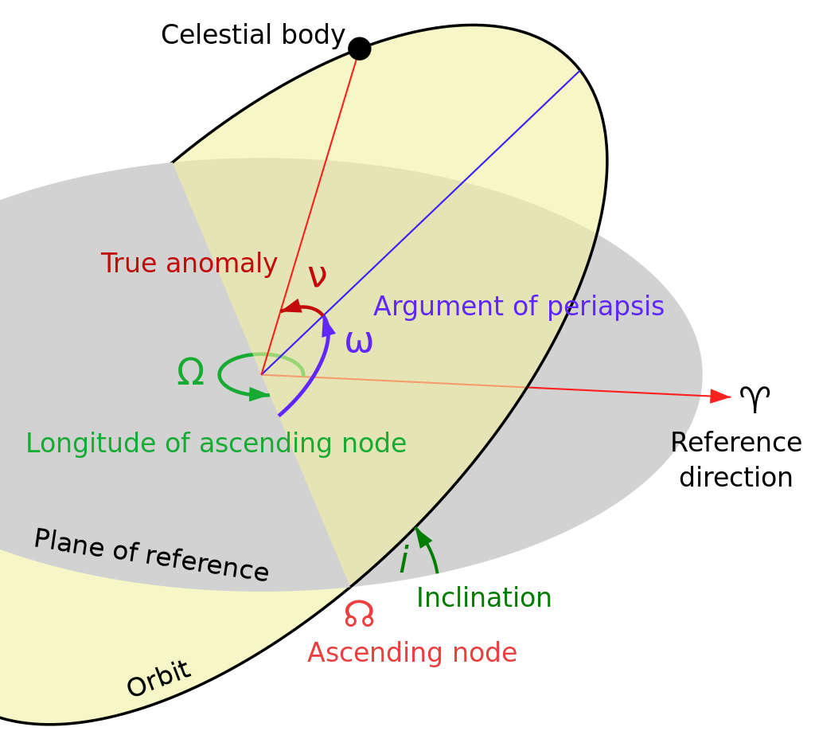

Figure . Kepler element of an orbit (‘Orbital elements’, 2023).

**Semi-major Axis (Unit: km):**

This is the longest radius of an ellipse, which describes the size of the orbit.

**Eccentricity (0-1):**

This measures the shape of the orbit, specifically how much it deviates from a perfect circle. A circular orbit has an eccentricity of 0, and an elliptical orbit has an eccentricity between 0 and 1.

**Inclination (Unit: radians, Range: 0-):**

The inclination of an orbit represents the angle between its plane and a reference plane. For objects orbiting Earth, this reference plane is typically the Earth's equatorial plane. Satellites with orbits closely aligned to the equator have an inclination near 0 degrees. Conversely, orbits with inclinations approaching 90° pass over both the North and South poles.

**Longitude of the ascending node (Unit: degrees, Range: 0-2)**

The ascending node is indeed the point where an orbit crosses a reference plane from south to north or in an upward direction. The longitude of the ascending node (often symbolized by Ω) is the angle measured from a reference direction (typically the direction of the vernal equinox for objects orbiting the Sun, such as planets) to the ascending node.

**Argument of periapsis (Unit: degrees, Range: 0-360)**

The Argument of Periapsis (ω), depicted as a purple angle in Figure 3, determines the ellipse's orientation within the orbital plane. It's the angular measure from the ascending node to the periapsis, the point of closest approach to the primary object.

**True Anomaly (Unit: degrees, Range: 0-360)**

The true anomaly is the angle from the periapsis to the object's current position.

### Orbit type

With the rapid development of space technology, the classification of space objects has become particularly important. Among them, orbital altitude is the most basic and critical classification criterion, which is essential for understanding and predicting the performance and functions of satellites. For a deeper understanding of this categorization, several main orbital height categories and their associated applications are described as follows:

**Low Earth Orbit (LEO)**

A significant proportion of satellites, accounting for fifty-five percent of all operational ones, are located within what's termed as the low Earth orbit (LEO). Positioned at altitudes ranging from 160 to 2,000 kilometers, these satellites have the advantage of being relatively close to the Earth. As a result, they complete an orbit around the earth in a time span of roughly 90 minutes to 2 hours. This combination of proximity and rapid orbital periods positions LEO satellites as prime choice for tasks requiring frequent revisits or high-resolution data, such as science, imaging, and low-bandwidth telecommunications (Roberts, 2017; Via Satellite, 2021).

**Middle Earth Orbit (MEO)**

Satellites in medium Earth orbit (MEO) operate within an altitude range of 2,000 km to 35,586 km, positioned strategically between the widely recognized low Earth orbit (LEO) and the geosynchronous equatorial orbit (GEO), providing a unique operational advantage (The United States Government, 2019). MEO satellites provide a broader view of Earth than LEO satellites and faster transmission times than those in GEO due to their closer proximity. This makes MEO particularly advantageous for navigation systems, where broad coverage and quick signal transmission are pivotal.

However, the fewer number of satellites in MEO can be attributed to the challenges presented by the Van Allen belts—regions of high radiation that can adversely affect satellite operations. Located between 500 km to 5,500 km and 12,000 km to 22,000 km, these belts mean that satellites in MEO require protective shielding to ensure their longevity and functionality (Roberts, 2017; Via Satellite, 2021).

**Geosynchronous Equatorial Orbit (GEO)**

Geosynchronous Earth orbit (GEO) satellites occupy a unique altitude band ranging from 35,586 to 35,986 kilometres. The orbital period of these satellites coincides with Earth’s Day to the nearest 23 hours, 56 minutes and 4 seconds. This synchronization allows them to hover over the same point on the Earth's surface, making them ideal for continuous communications and continuous weather monitoring missions. Communications satellites at this altitude provide stable connectivity, while meteorological satellites provide real-time regional weather forecasts. Both GEO and LEO are favoured for the deployment of satellites, with GEO accounting for about 35 per cent of all operational satellites (Roberts, 2017; The European Space Agency, 2020).

**Highly Elliptical Orbit (HEO)**

A Highly Elliptical Orbit (HEO) is characterized by its significant eccentricity, which differentiates it from more traditional circular orbits. For an HEO, the perigee, or the point closest to Earth, can be just hundreds of miles above the surface, while the apogee, or the farthest point, can extend tens of thousands of miles into space.(Campbell, 2017)**.**

**Graveyard Orbit**

Graveyard orbit is a designated orbit to which satellites are moved at the end of their operational life to reduce the risk of collision with operational satellites and minimize space debris in commonly used orbital regions, such as LEO and GEO(Scott, 2019; The United States Government, 2019).

### Coordinate Reference System

**ECEF (Earth-Centered, Earth-Fixed):**

The ECEF coordinate system is a three-dimensional Cartesian reference frame with its origin situated at the Earth's center of mass. This reference frame rotates with the surface of the Earth, ensuring that any point on the Earth's surface has a fixed coordinate in this system(Rizzi and Ruggiero, 2003). The x-axis extends through the intersection of the Greenwich prime meridian (0° longitude) and the equator (0° latitude). The z-axis aligns with the Earth's rotational axis, passing through the true north and south poles. The y-axis is orthogonal to both, extending through the equator at 90° East longitude, near the Maldives in the Indian Ocean(Holmes, 2023).

**ECI (Earth-Centered Inertial):**

The ECI coordinate system also has its origin at the Earth's center but is designed to be nearly inertial, with its axes fixed relative to distant stars(Rizzi and Ruggiero, 2003). This means it doesn't rotate with the Earth like the ECEF does. While the term "inertial" suggests an ideally fixed frame where Newton's laws of motion apply without corrections, in reality, the ECI frame isn't perfectly inertial. Gravitational effects from celestial bodies, such as the Moon and Sun, cause minor accelerations in this frame. Despite this, for many Earth-centered applications, the ECI provides a close approximation to an inertial frame, though some precision tasks may require accounting for its slight non-inertial nature(Holmes, 2023).

## Visualization

Information visualization is a method of transforming abstract data and information into an intuitive, graphical form that makes it easier to understand, parse and remember that data. At the heart of this technique is the transformation of numbers, text, and other raw data into charts, graphs, and other visual forms that provide viewers with deeper insights and a better interactive experience with the data (Chen, 2010). Cartography belongs to the field of information visualization, which is primarily concerned with the cartographic representation and cartographic interaction.

### Cartography Representation

Central to the field of representation in cartography are key principles that ensure effective and coherent map design. According to Buckley(2012), there are five basic core principles of successful cartographic representation: legibility, visual contrast, site organization, hierarchical organization and balance. Among these, legibility and visual contrast ensure that map elements are clear and distinct; site organization, hierarchy and balance help to determine the importance of content and identify patterns. These principles are fundamental and complementary. The following section provides an in-depth discussion of these five design principles and their key role in communicating geographic information.

**Visual Contrast:**  
visual contrast is used to delineates map elements from their background. High contrast ensures clarity and prominence of specific features, while low contrast merges feature for a subdued impression.

**Legibility:**

Legibility refers to the clarity and comprehensibility of map elements. Proper symbol selection, familiar shapes, and appropriate sizes can enhance legibility. While geometric symbols perform well at smaller sizes, complex symbols require more space to visualize.

**Figure-ground organization:**

Figure-ground organization differentiates the main subject (figure) from the background. This design principle aids readers in concentrating on specific map areas. Techniques like adding map details or employing whitewash, drop shadows, or feathering enhance this separation.

**Hierarchical organization:**

Hierarchical organization refers to the visual structuring of information, allowing for the differentiation of features based on their significance. As described in "Elements of Cartography, Sixth Edition," a primary objective in mapmaking is to "separate meaningful characteristics and to portray likenesses, differences, and interrelationships." This layering technique helps map readers to concentrate on key details and discern patterns. For instance, Reference maps, displaying various physical and cultural features, maintain a more balanced visual representation of elements, with no singular feature outweighing another. In contrast, thematic maps prioritize the primary theme over the foundational geographic details, emphasizing the distribution of specific attributes.

**Balance:**

Balance in map design refers to the harmonious arrangement of map elements, which ensuring stability and equilibrium in the composition. Elements such as the relative location, shape, size, and thematic content of element on the page play pivotal roles in achieving this balance. A well-balanced composition not only appears aesthetically pleasing but also can guide the viewer's emotions and perceptions.

However, in the era of digital transformation and the increasing emphasis on user-centered design, the Ordnance Survey has expanded upon this foundation by introducing additional principles that are attuned to the contemporary challenges and possibilities of map design(Ordnance Survey, 2022).

**Understanding user needs:**

Understanding user needs is critical for a map's efficacy. The clarity of a map's message depends on its projected use. Two guiding queries during the design phase are:

1. Which information do users seek?
2. How will they engage with the map?

Maintaining focus on these aspects prevents the inclusion of irrelevant elements that might detract or confuse.

**Consideration of display format**

To ensure optimal clarity in cartography, the intended display medium is paramount. Decisions on medium dictate design elements like colour mode (RGB for digital; CMYK for print), text sizing for legibility, and potential interactivity. Thus, a map's design intricacies are intrinsically linked to its display context.

**Simplicity**

Including irrelevant details in cartography can hinder the efficiency of translating spatial data into knowledge. It is critical to weigh the utility of the information against the risk of map clutter and the ensuing confusion.

**Consistency**

Consistency in cartography promotes a sense of familiarity and coherence, thereby facilitating effective communication. Organizing features in a consistent manner enhances a sense of grouping and solidifies the identity of the map within the product family. Repeated use of the same symbols improves user recognition, while inconsistent symbols can obscure the map's message and cause confusion.

**Accessibility**

Ensuring the accessibility of maps is critical to their successful utilization. This includes considerations such as user-friendly distribution formats, addressing disability issues, affordability and intuitive design. With the popularity of digital maps, it is critical to prioritize accessible file formats and compatible software. In addition, designs should take into account the abilities of users, including considerations for persons with color vision impairments.

### Cartography Interaction

Interactive cartography has been defined as a form of dialog between a person and a map, via a computing device (Roth, 2012).Its core objective is to ensure that users can easily access and manipulate task information at the right time (Rosson and Carroll, 2002). For successful interactive cartography, understanding the process of interactive realization is essential. In this context, Norman's stages of (inter)action model offer a systematic explanation of this process, encompassing seven distinct steps:

* Forming an open-ended goal
* Specifying a concrete intent toward that goal
* Designating an action or system function in line with the intent
* Executing that action via an input device
* Observing the system's current state
* Analyzing and deciphering the implications of system changes
* Evaluating the outcome to ascertain if the primary goal was met (Roth, 2013b, as depicted in Figure 4)

Central to interactive cartography are cartographic interaction primitives - the fundamental units of interactivity. These primitives often work in concert with other primitives to enhance the user's experience of interacting with an interactive map (Roth, 2012). Extant taxonomies categorize interaction primitives in three different ways:

* Objective-based, which aligns interactions with the "Forming the Intention" stage, emphasizing the objectives users might have within a cartographic interface. Key primitives in this category are “identification” and “comparison”.
* Operator-based, associating interactions with the “Specifying an action” phase, pinpointing the specific tools or actions that might be utilized to meet objectives. Central primitives in this category include “brushing”, “focusing”, “linking”, and “zooming”.
* Operand-based, which classifies interaction primitives based on the characteristics of the recipient of the interaction operators, with prime interactions “temporal”, “data”, and “object”(Roth, 2012, 2013a, 2013b).

While all three approaches are considered to be helpful in designing interactive maps, the focus of this chapter stays on the operator-based approach because of its relevance to the components of map interface design. For operator based approaches, interaction primitives can be categorized into "working operators" that contribute to the achievement of goals and "enabling operators" that contribute to the preparation and completion of the phases of working operators. Table 1 presents a detailed list with descriptions of the complete set of operator-based interaction primitives.

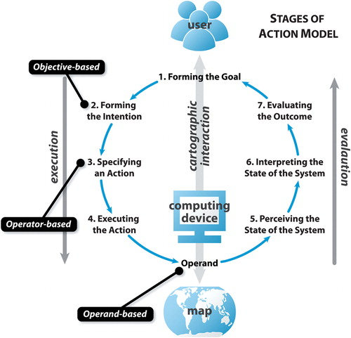

Figure ． Stages of Interaction based on Norman's stages of (inter)action model(Acharya, 2021)

|  |  |  |  |
| --- | --- | --- | --- |
|  | Interaction operator primitives | | Description |
| Work Operator Primitives | | Reexpress | Changes how data is visually represented on a map, such as altering the map type or switching between linear and logarithmic displays. |
| Arrange | Manipulates the layout of views in a coordinated visualization |
| Sequence | Generates a series of related maps that display subsets of geographic information, such as animations that show changes over time. |
| Resymbolize | Adjusts design parameters of a map without changing the map type itself, like altering the color scheme or dot value. |
| Overlay | Modifies the features shown on the map, either by adding/removing layers or changing mapped attributes. |
| Reproject | Alters the map projection, translating the Earth's curved coordinates onto a flat plane. |
| Pan | Changes the geographic center of the map. Some view this operator as also encompassing changes to viewing angles. |
| Zoom | Adjusts the map's scale and/or resolution, magnifying or reducing its detail. |
| Filter | Identifies map features based on user-defined conditions. It can lead to emphasizing or de-emphasizing certain map features. |
| Search | Helps locate specific map features based on direct identifiers like name or address. Different from "filter", as it seeks a direct match. |
| Retrieve | Requests detailed information about specific map features through direct manipulation (e.g. click on features) |
| Calculate | Generates new information or statistics about map features, emphasizing the need for a closer relationship between visualization and computation in cartography. |
| Enabling Operator | | Import | Allows users to load datasets or pre-made maps into the visualization, with potential for dynamic real-time data feeds from online sources. |
| Export | Extracts created maps or the underlying geographic data for use outside the current visualization environment. This could be for tasks like printing the map or producing a report. |
| Save | Preserves the map, its underlying data, or the system status for future use within the same visualization system. Supports undo and redo functionalities and is distinguished from export based on the future use setting (internal vs. external). |
| Edit | Alters the actual geographic data underpinning the map, impacting all future visual representations of that data. This operator encompasses actions like adding, deleting, and manipulating objects. |
| Annotate | Allows users to enhance visualizations with added graphics and textual notes. This aids in externalizing insights directly on the map and supports the analytical and cognitive processes during interaction. |

Among these interaction primitives, pan, zoom, retrieve, filter and search are fundamental primitives to the interface design. Other primitives can be added depending on the purpose of the map design and the goals of the user. However, it is important to keep the design simple to ensure that the interface is user-friendly

### Existing Space Object Visualizer

## User Design

### User Centered Design

1. Definition
2. Stages –
3. Need assessment study
4. Conceptual development (based on the principle of design)-
5. Alpha version released
6. Usability and Unitality survey
7. Implementation
8. debugging
9. Evaluation Of the Visualizer
10. 10 ways evaluating visualizer.
11. Usability

Different users use maps with unique perspectives and goals. To ensure that the interface is effectively represented, it must be adapted to those different needs (Ordnance Survey, 2022). Therefore, establishing well-defined "personas" is a critical step to design a useful interface (Faller, 2019).

Personas are fictional characters based on actual user prototypes, whose goals and characteristics are the "average" representation of a large group of actual users (Faller, 2019, 2019; Zerlinda, 2019). To build up one or more effective personas, the first step is to collect the information from the users, then summarize the characteristics of users in detail, such as age, literacy, and goals etc. If there is multiple personas, priority of personas is needed to clarify the theme of the design. Finally, binding the personas with an imagined situation that describes how a persona would interact with a product in a particular context to achieve its end goal(s) to make the persona valuable(Faller, 2019).

## Web technology

### HTML, CSS and JavaScript

In the field of web building, three main languages are often used at the forefront: HyperText Markup Language (HTML), Cascading Style Sheets (CSS), and JavaScript (JS). HTML lays the foundational structure of a webpage, structuring the content by encapsulating different elements such as text, images, and links. On the other hand, CSS is responsible for the visual appeal, dictating the design, colors, fonts, and layout. JavaScript then brings interactivity to the table, introducing features like animations, real-time data updates, and interactive forms. Together, these technologies empower developers to create dynamic, visually appealing, and user-friendly web pages and applications(Cox, 2021).

### Cesium JS

CesiumJS is an open-source JavaScript library, birthed from a project at Analytical Graphics, Inc. in 2011, that stands at the forefront of 3D globe and map visualization. Renowned as the world's most accurate, performant, and time-dynamic virtual globe, it provides a versatile platform for developers across various sectors, from aerospace to smart cities. Developers use CesiumJS to craft interactive web applications that disseminate dynamic geospatial data. Built on open standards, it champions interoperability and scalability. With its Apache 2.0 licensing, it's available for both commercial and non-commercial endeavors, and its robustness is evident with over a million downloads(Cesium, 2023; SourceForge, 2023).

///////////////////////////////////////////////////////////////////////////////////////////////////////////////////////////////////////

Delving deeper into cartography, it can be segmented into two core domains: Representation and Interaction.(Roth, 2013a).

Cartographic representations effectively communicate geographic data through perception, cognition, and semiotics, providing structure for the visual, cognitive, and symbolic interpretation of maps. Central to this task is the identification and articulation of visual variables and relative design and adaptation based on five principles of design(Roth, 2012).

**Visual variables:** Initially articulated by Bertin, these variables are the building blocks of cartographic representation. They refer to the diverse graphic techniques utilized to convey information. Fundamental variables include:

Location:

Size:

Shape:

Orientation:  
Color hue:

Principle of design

Over time, cartography has not been limited to traditional paper maps. Modern geographic information systems (GIS) and other digital mapping tools have made map production more accurate and dynamic, allowing for more complex data integration and interaction.

///////////////////////////////////////////////////////////////////////////////////////////////////////////////////////////////////////

# Reference

Acharya, S. (2021) ‘Interactive cartographic visualization of real-time satellite data and their orbits’, *Abstracts of the ICA*, 3, pp. 1–2. Available at: https://doi.org/10.5194/ica-abs-3-1-2021.

Amateur Radio In Space (2023) ‘Keplerian Elements Tutorial – AMSAT’. Available at: https://www.amsat.org/keplerian-elements-tutorial/ (Accessed: 10 August 2023).

*BBC News* (2021) ‘Elon Musk rejects claims that his satellites are hogging space’, 30 December. Available at: https://www.bbc.com/news/business-59824404 (Accessed: 10 August 2023).

Bhattarai, S. *et al.* (2019) ‘Demonstrating developments in high-fidelity analytical radiation force modelling methods for spacecraft with a new model for GPS IIR/IIR-M’, *Journal of Geodesy*, 93(9), pp. 1515–1528. Available at: https://doi.org/10.1007/s00190-019-01265-7.

Bhattarai, S. and Ziebart, M. (2021) *The university college london future space population model (v2019) – overview*. Space Geodesy Navigation Laboratory (SGNL), UCL.

Buckley, A. (2012) *Make Maps People Want to Look At*. Available at: https://www.esri.com/news/arcuser/0112/make-maps-people-want-to-look-at.html (Accessed: 13 August 2023).

Campbell, A. (2017) *H is for Highly Elliptical Orbit.*, *NASA*. Available at: http://www.nasa.gov/directorates/heo/scan/communications/outreach/a_to_z/h (Accessed: 10 August 2023).

Cesium (2023) *About Cesium*, *Cesium*. Available at: https://cesium.com/about/ (Accessed: 15 August 2023).

Chen, C. (2010) ‘Information visualization’, *WIREs Computational Statistics*, 2(4), pp. 387–403. Available at: https://doi.org/10.1002/wics.89.

Cox, L.K. (2021) *Coding for Web Design 101: How HTML, CSS, and JavaScript Work*. Available at: https://blog.hubspot.com/marketing/web-design-html-css-javascript (Accessed: 15 August 2023).

Faller, P. (2019) ‘What Are User Personas and Why Are They Important? | Adobe XD Ideas’, *Ideas*. Available at: https://xd.adobe.com/ideas/process/user-research/putting-personas-to-work-in-ux-design/ (Accessed: 15 August 2023).

Holmes, M.W. (2023) ‘Frames of Reference,Orbits and Ellipses’. Available at: https://web.aeromech.usyd.edu.au/AERO2705/2017_course_notes/AERO2705_Wk2_2017_Orbits_Elipses.pdf.

Indigo, B. (2021) *Democratising Data: Future Satellite Populations*. University College London.

Interaction Design Foundation (2023) *What is Information Visualization?*, *The Interaction Design Foundation*. Available at: https://www.interaction-design.org/literature/topics/information-visualization (Accessed: 10 August 2023).

Kopal, V. (1966) ‘Treaty on principles governing the activities of states in the exploration and use of outer space, including the Moon and other celestial bodies’, *YB Air & Space L.*, p. 463.

Luyang, H. (2021) *An Enhanced Visualizer for Future Space Population*. University College London.

Muelhaupt, T.J. *et al.* (2019) ‘Space traffic management in the new space era’, *Journal of Space Safety Engineering*, 6(2), pp. 80–87. Available at: https://doi.org/10.1016/j.jsse.2019.05.007.

‘Orbital elements’ (2023) *Wikipedia*. Available at: https://en.wikipedia.org/w/index.php?title=Orbital_elements&oldid=1155075030 (Accessed: 10 August 2023).

Ordnance Survey (2022) *What is Cartography? | Blog*, *Ordnance Survey*. Available at: https://www.ordnancesurvey.co.uk/blog/what-is-cartography (Accessed: 13 August 2023).

Our World In Data (2023) *Annual number of objects launched into space*, *Our World in Data*. Available at: https://ourworldindata.org/grapher/yearly-number-of-objects-launched-into-outer-space (Accessed: 10 August 2023).

Peterson, G., Sorge, M. and Ailor, W. (2018) ‘Space traffic management in the age of new space’, *Center for Space Policy and Strategy, the Aerospace Corporation. Accessed on*, pp. 2018–05.

Pickover, C. (2008) *Archimedes to Hawking: laws of science and the great minds behind them*. Oxford University Press.

Rizzi, G. and Ruggiero, M.L. (2003) *Relativity in Rotating Frames: Relativistic Physics in Rotating Reference Frames*. Springer Science & Business Media.

Roberts, T.G. (2017) *Popular Orbits 101*, *Aerospace Security*. Available at: https://aerospace.csis.org/aerospace101/earth-orbit-101/ (Accessed: 10 August 2023).

Rosson, M.B. and Carroll, J.M. (2002) ‘Scenario-based usability engineering’, in *Proceedings of the 4th conference on Designing interactive systems: processes, practices, methods, and techniques*. New York, NY, USA: Association for Computing Machinery (DIS ’02), p. 413. Available at: https://doi.org/10.1145/778712.778776.

Roth, R.E. (2012) ‘Cartographic Interaction Primitives: Framework and Synthesis’, *The Cartographic Journal*, 49(4), pp. 376–395. Available at: https://doi.org/10.1179/1743277412Y.0000000019.

Roth, R.E. (2013a) ‘An Empirically-Derived Taxonomy of Interaction Primitives for Interactive Cartography and Geovisualization’, *IEEE Transactions on Visualization and Computer Graphics*, 19(12), pp. 2356–2365. Available at: https://doi.org/10.1109/TVCG.2013.130.

Roth, R.E. (2013b) ‘Interactive maps: What we know and what we need to know’, *Journal of Spatial Information Science*, (6), pp. 59–115.

Scott W. (2019) *Preserving the space environment for future generations*, *Maxar Blog*. Available at: https://blog.maxar.com/tech-and-tradecraft/2019/preserving-the-space-environment-for-future-generations (Accessed: 11 August 2023).

SourceForge (2023) *Cesium*, *SourceForge*. Available at: https://sourceforge.net/projects/cesium.mirror/ (Accessed: 15 August 2023).

The European Space Agency (2020) *Types of orbits*. Available at: https://www.esa.int/Enabling_Support/Space_Transportation/Types_of_orbits (Accessed: 10 August 2023).

The United States Government (2019) *The United States Government Orbital Debris Mitigation Standard Practices (2019)*. Available at: https://orbitaldebris.jsc.nasa.gov/library/usg_orbital_debris_mitigation_standard_practices_november_2019.pdf (Accessed: 10 August 2023).

Via Satellite (2021) *GEO, MEO, and LEO*, *Via Satellite*. Available at: https://www.satellitetoday.com/content-collection/ses-hub-geo-meo-and-leo/ (Accessed: 10 August 2023).

Zerlinda (2019) ‘User Centered Design — Persona’, *Moodah POS*, 26 December. Available at: https://medium.com/moodah-pos/user-centered-design-persona-5cce0dce0833 (Accessed: 15 August 2023).

ZURICH (2022) *Space congestion: An increasingly contested and crowded frontier*. Available at: https://www.zurich.com/en/media/magazine/2022/from-moonshot-to-musk-how-the-rules-of-the-game-are-changing-in-space (Accessed: 10 August 2023).