

Development of an Ensemble Learning Model for Pathogenicity Prediction of Genetic Variants
Final Project Design Report
Team RUVEGO | ID 995380 / 5293783 | ITMO University

Team member | Primary responsibility
Igor Kartashov | Team coordination, ML pipeline architecture, reproducibility, repository integration
Matvey Murtazaliev | Software engineering, model implementation, optimization, debugging
Ruslan Zhemlikhanov | Bioinformatics review, statistical analysis, experiment design, scientific validation

This report follows the requested PDR template: Introduction, Methodology, Findings, Conclusion, and Bibliography.

1. Introduction
Clinical interpretation of missense genetic variants is a high-impact binary classification problem: a model must separate variants with pathogenic evidence from variants that are likely benign. In a diagnostic workflow, false negatives are particularly costly because a pathogenic variant classified as benign may delay diagnosis or risk assessment, while false positives may create avoidable follow-up work and anxiety. The competition setting adds two realistic constraints: feature names and genomic coordinates are anonymized, and the disease-specific panels are much smaller than the general training cohort.
Our solution implements the approach proposed in the PDR as a reproducible ensemble-learning pipeline. The final system combines robust tabular preprocessing, gradient-boosted decision-tree models, sklearn tree ensembles, transfer-style panel adaptation through a global foundation probability, threshold tuning, and post-hoc explainability with SHAP. The main objective is not only to maximize Macro F1, but also to report clinically relevant precision-recall behavior and subgroup performance for MASTER, KANSER, PAH, and CFTR.
Dataset | Rows | Feat. | Path. | Benign | Miss. | Cat. | Num.
MASTER | 2931 | 351 | 2149 | 782 | 54.9% | 8 | 343
KANSER | 388 | 351 | 268 | 120 | 57.2% | 8 | 343
PAH | 372 | 351 | 310 | 62 | 54.3% | 7 | 344
CFTR | 111 | 351 | 90 | 21 | 30.3% | 8 | 343

2. Methodology

2.1 Data Processing and Leakage Controls
The raw tables contain an anonymized Variant_ID, a binary Label, and 351 encrypted or anonymized biological features. Variant_ID and Label are never passed into model features. Numeric columns are imputed by training-fold medians, augmented with missingness indicators, and scaled using RobustScaler to limit the influence of outliers. Categorical columns are imputed with a constant category and one-hot encoded with rare-category handling.
The preprocessing design intentionally treats the dataset as a heterogeneous tabular biomedical dataset rather than a sequence dataset. Because genomic coordinates and exact feature semantics are hidden, the pipeline avoids any external lookup, annotation service, or gene-coordinate reconstruction. Every transformation is local to the provided matrices and is executed inside cross-validation folds.
- All preprocessing is fitted only on the training fold inside a sklearn Pipeline/ColumnTransformer.
- Variant_ID and Label are removed before model fitting.
- For panel adaptation, MASTER rows overlapping with the target panel by Variant_ID are removed before the foundation model is trained.
- Near-duplicate scans and adversarial validation are exported as quality-control reports.
Feature engineering consists of three controlled additions. First, missingness indicators are added for numeric features because the pattern of missing values may itself encode measurement availability or biological assay coverage. Second, categorical anonymized features are converted to sparse indicator features through one-hot encoding with rare-category handling. Third, for disease-specific panels only, a global transfer feature named GLOBAL_FOUNDATION_PROBA is added as described below.
Pair | Overlap | Interpretation
MASTER vs KANSER | 246 | Removed from MASTER before panel foundation training
MASTER vs PAH | 255 | Removed from MASTER before panel foundation training
MASTER vs CFTR | 77 | Removed from MASTER before panel foundation training
KANSER vs PAH | 0 | No cross-panel overlap detected
KANSER vs CFTR | 0 | No cross-panel overlap detected
PAH vs CFTR | 0 | No cross-panel overlap detected

2.2 Model Architecture
The final architecture is a soft-voting ensemble. When optional libraries are available, LightGBM and CatBoost are included because they are strong choices for heterogeneous tabular data with missingness, non-linear feature interactions, and small-to-medium sample sizes. The ensemble also includes HistGradientBoosting, ExtraTrees, and RandomForest as stable sklearn components.
GLOBAL_FOUNDATION_PROBA is the key panel-adaptation feature. For each panel, a separate foundation model is trained on MASTER after removing all MASTER rows whose Variant_ID appears in that panel. The trained foundation model then predicts a pathogenicity probability for each panel row. This probability is appended as a single meta-feature and gives the small panel model a global pathogenicity prior learned from the larger dataset. Because overlapping IDs are removed before the foundation model is fitted, this feature is not a direct label lookup for panel rows.
Component | Role in the ensemble
LightGBM | High-capacity gradient boosting for sparse/encoded tabular features.
CatBoost | Robust boosted trees with strong regularization behavior on small panels.
HistGradientBoosting | Native sklearn gradient boosting baseline and diversity source.
ExtraTrees | High-variance randomized trees that improve ensemble diversity.
RandomForest | Stable bagged-tree component for variance reduction.
GLOBAL_FOUNDATION_PROBA | Panel-only meta-feature produced by a MASTER model trained after removing overlapping panel Variant_IDs.

2.3 Validation, Thresholding, and Hyperparameter Search
The main reported experiment uses repeated stratified cross-validation. MASTER, KANSER, and PAH use 5 folds and 3 repeats; CFTR uses 5 folds and 5 repeats because the cohort has only 111 rows. The operating threshold is selected on out-of-fold probabilities by maximizing Macro F1 over a threshold grid. This is more appropriate than a fixed 0.5 threshold because panels are class-imbalanced and clinical risks differ by error type.
A second experiment performs Optuna TPE search with 20 trials per dataset on fixed CV splits. The search optimizes LightGBM parameters, CatBoost parameters, and the soft-voting weights of all five ensemble members. After the best trial, CV is rerun for the best configuration and final tuned models are trained. SHAP reports are then generated for the tuned LightGBM and CatBoost components.

2.4 Explainability
Explainability is implemented at two levels. First, tree feature-importance summaries are produced for the final full-CV models. Second, SHAP TreeExplainer is applied to the tuned LightGBM and CatBoost components. SHAP is used as a leakage sanity check and as an interpretability tool: dominant features should be biological/anonymized feature groups or the explicitly generated foundation probability, not labels, identifiers, or dataset markers.

3. Findings

3.1 Main Full-CV Results
Dataset | Rows | CV | Threshold | Macro F1 | MCC | AUPRC | ROC-AUC | Path. Prec. | Path. Rec.
MASTER | 2931 | 5x3 | 0.57 | 0.772 | 0.546 | 0.929 | 0.853 | 0.885 | 0.864
KANSER | 388 | 5x3 | 0.47 | 0.872 | 0.747 | 0.936 | 0.905 | 0.901 | 0.951
PAH | 372 | 5x3 | 0.54 | 0.731 | 0.483 | 0.944 | 0.806 | 0.895 | 0.961
CFTR | 111 | 5x5 | 0.48 | 0.878 | 0.758 | 0.976 | 0.913 | 0.946 | 0.967

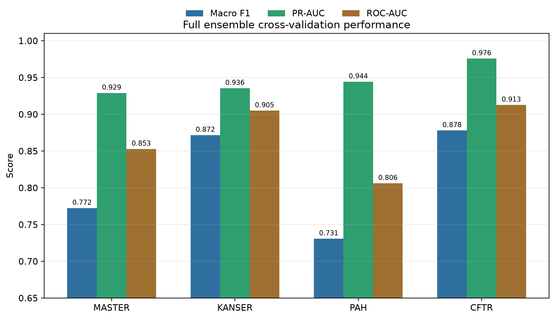
Figure 1. Main full-CV performance overview.
Interpretation: the full repeated-CV protocol shows stable performance across all four subsets. CFTR and KANSER are strongest by Macro F1, while PAH remains harder because the benign class is small.
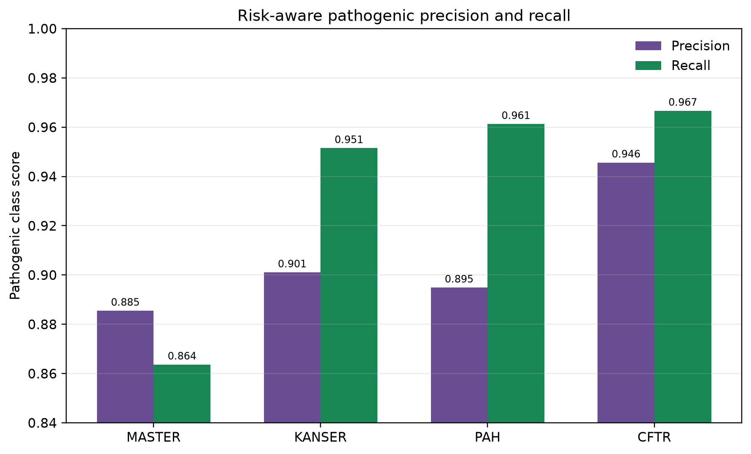
Figure 2. Pathogenic-class precision and recall by dataset.
Interpretation: the selected thresholds keep pathogenic recall high, which is clinically important because false negatives represent missed pathogenic variants.

3.2 Confusion Matrices and Threshold Selection
Dataset | TN | FP | FN | TP | Uncertain 0.40-0.60 | Mean label confidence
MASTER | 542 | 240 | 293 | 1856 | 316 | 0.733
KANSER | 92 | 28 | 13 | 255 | 21 | 0.800
PAH | 27 | 35 | 12 | 298 | 20 | 0.778
CFTR | 16 | 5 | 3 | 87 | 3 | 0.817

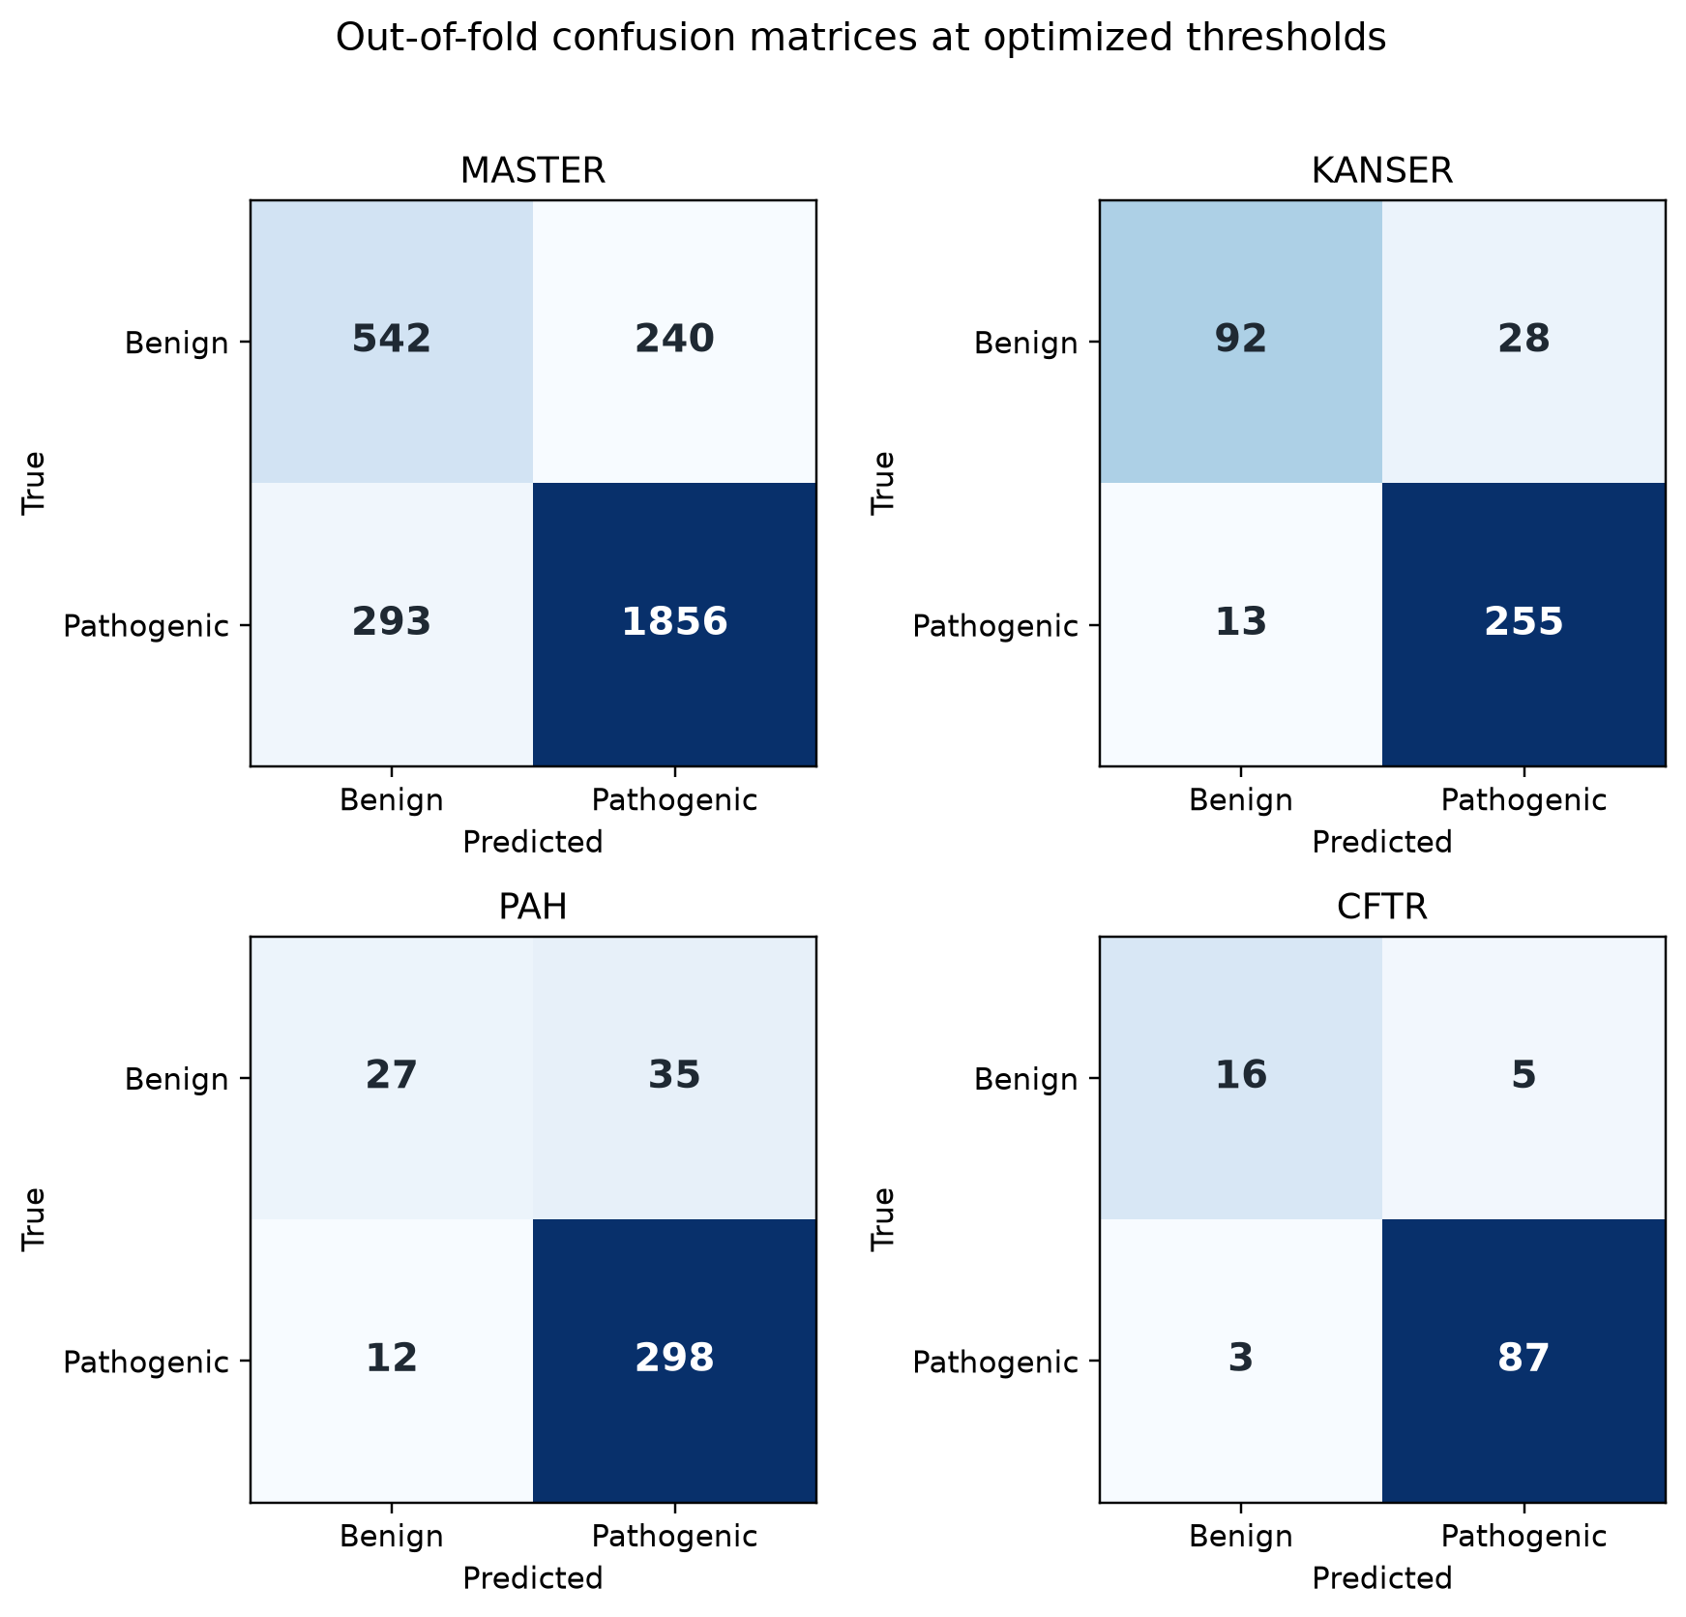
Figure 3. Out-of-fold confusion matrices at selected thresholds.
Interpretation: errors are shown separately for each subset. PAH has the largest benign-class weakness, while CFTR has very few false negatives.
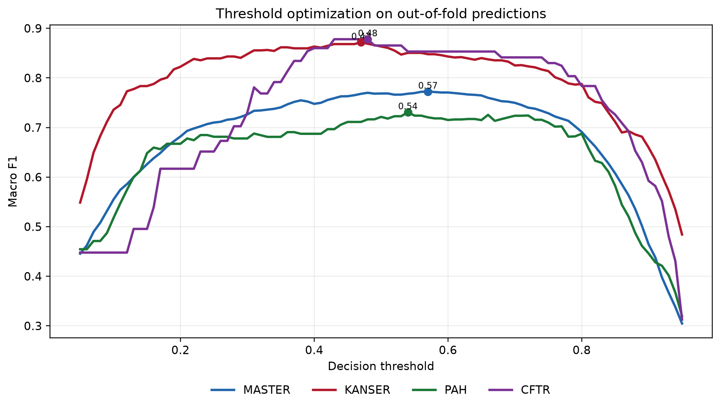
Figure 4. Threshold tuning curves for Macro F1.
Interpretation: the operating threshold is not fixed at 0.5; it is selected from out-of-fold predictions to maximize Macro F1 under class imbalance.

3.3 Optuna Tuning Study
Dataset | Best trial | Threshold | Macro F1 | MCC | AUPRC | ROC-AUC | Path. Prec. | Path. Rec.
MASTER | 12 | 0.55 | 0.773 | 0.546 | 0.922 | 0.845 | 0.884 | 0.868
KANSER | 15 | 0.47 | 0.865 | 0.730 | 0.948 | 0.910 | 0.906 | 0.933
PAH | 14 | 0.39 | 0.758 | 0.522 | 0.923 | 0.777 | 0.910 | 0.945
CFTR | 8 | 0.61 | 0.878 | 0.758 | 0.977 | 0.915 | 0.946 | 0.967

Dataset | LightGBM | CatBoost | HistGBDT | ExtraTrees | RandomForest
MASTER | 0.95 | 2.85 | 0.12 | 0.10 | 0.15
KANSER | 0.13 | 0.12 | 1.00 | 0.39 | 0.80
PAH | 1.27 | 0.46 | 1.18 | 0.16 | 0.05
CFTR | 0.92 | 2.32 | 0.23 | 0.16 | 0.33

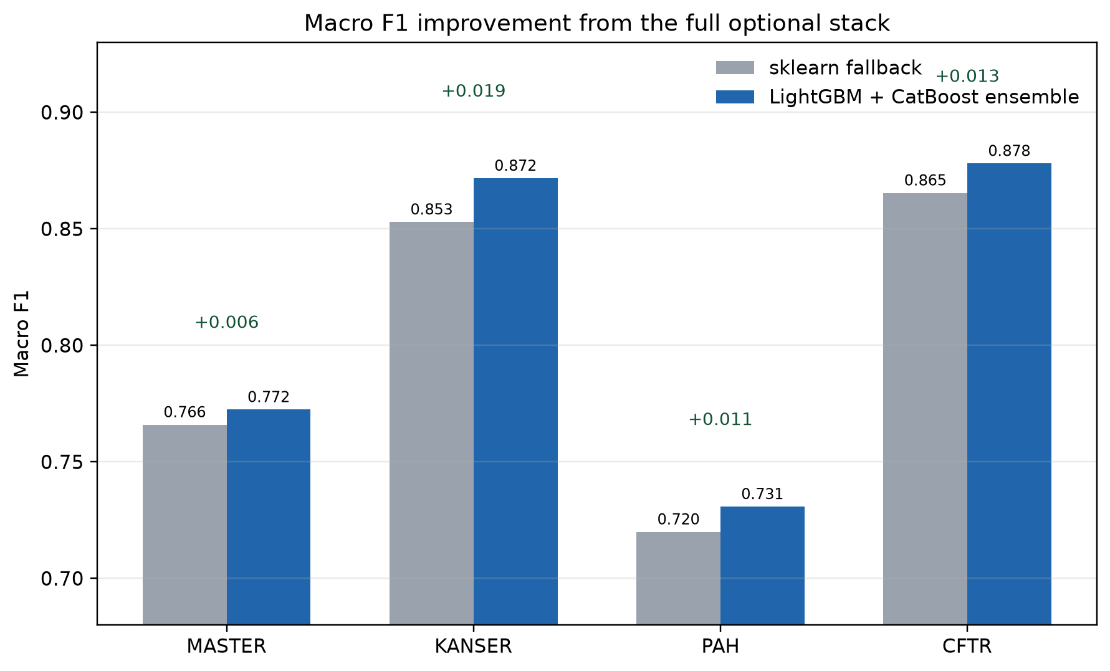
Figure 5. Baseline versus full ensemble Macro F1.
Interpretation: this figure supports the ensemble design choice by comparing the simpler baseline against the richer final configuration.
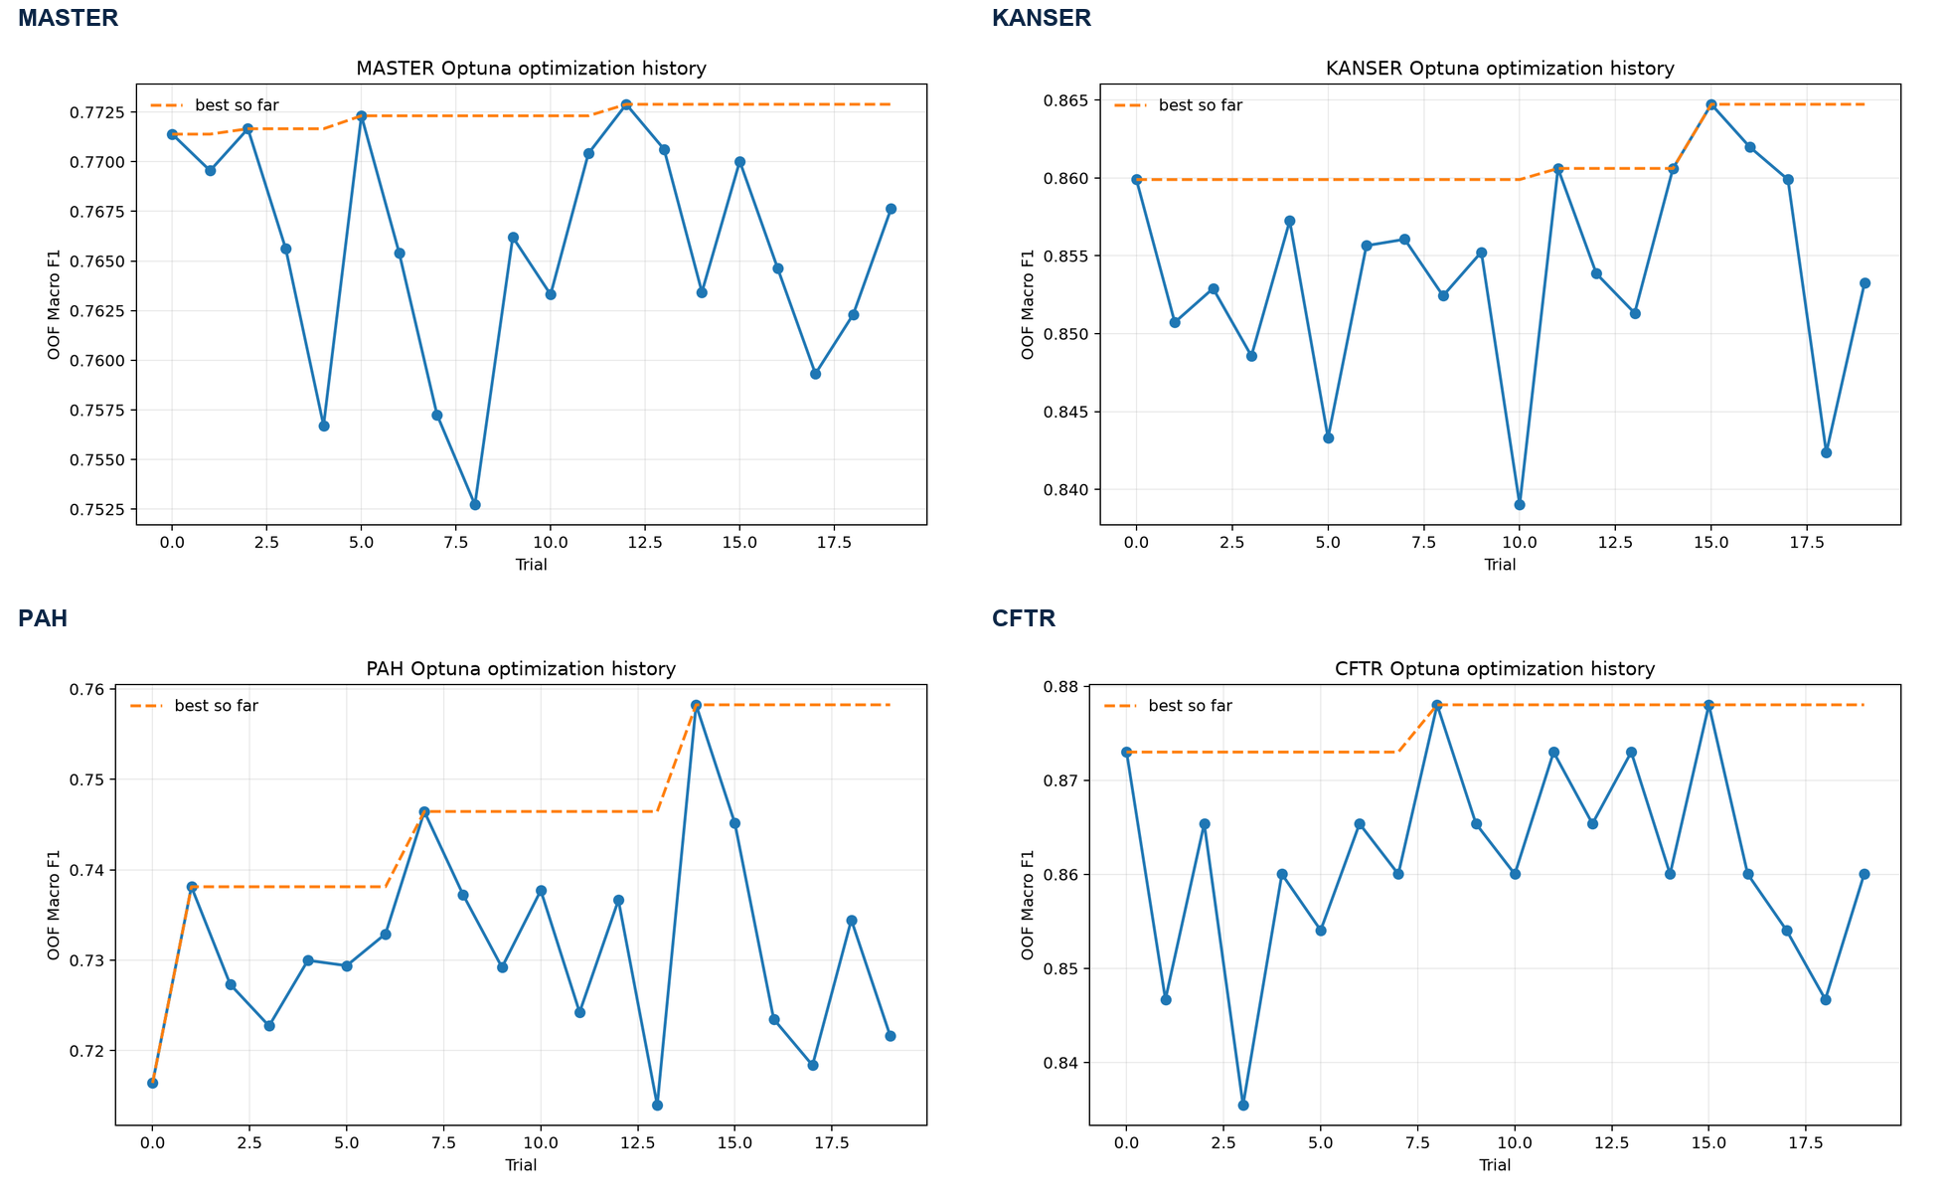
Figure 6. Optuna trial histories grouped by dataset.
Interpretation: Optuna is included as a compact tuning study rather than as the main validation result. Each panel shows trial-level Macro F1 and the best-so-far trajectory on fixed CV splits, so improvements reflect parameter and ensemble-weight choices rather than changing random splits.

3.4 Explainability and Feature Behavior
Dataset | Top LightGBM SHAP features | Top CatBoost SHAP features
MASTER | EK_7 (0.475), missingindicator_AL_295 (0.279), AA_1_R (0.213), AL_327 (0.128), EK_5 (0.116) | EK_7 (0.438), AA_1_R (0.182), missingindicator_AL_186 (0.132), EK_9 (0.131), EK_2 (0.105)
KANSER | GLOBAL_FOUNDATION_PROBA (2.655), EK_5 (0.868), AL_8 (0.746), EK_9 (0.615), EK_7 (0.606) | GLOBAL_FOUNDATION_PROBA (0.754), EK_9 (0.274), EK_7 (0.199), EK_5 (0.121), EK_4 (0.111)
PAH | GLOBAL_FOUNDATION_PROBA (1.160), AL_306 (0.254), AL_7 (0.235), AL_171 (0.212), AL_300 (0.161) | GLOBAL_FOUNDATION_PROBA (2.384), AL_171 (0.299), AL_300 (0.295), AL_12 (0.232), EK_7 (0.176)
CFTR | GLOBAL_FOUNDATION_PROBA (2.547), AL_7 (0.932), AL_145 (0.694), EK_7 (0.672), AL_327 (0.551) | GLOBAL_FOUNDATION_PROBA (3.421), EK_7 (0.563), EK_9 (0.418), AL_76 (0.370), AL_7 (0.283)

SHAP values are interpreted as local contributions to the model output. The report uses mean absolute SHAP value for global feature significance: a higher value means that the feature changes the model decision more strongly on average. Beeswarm plots additionally show whether high or low feature values tend to push predictions toward the pathogenic or benign class.
The main pattern is consistent with the intended architecture. In MASTER, the dominant features are anonymized original predictors such as EK_7, EK_9, AA_1_R, AL_* variables, and missingness indicators. In disease-specific panels, GLOBAL_FOUNDATION_PROBA often becomes the strongest feature because it carries the global pathogenicity signal learned from MASTER. This is expected and methodologically justified because overlapping Variant_ID values were removed before the foundation model was trained.
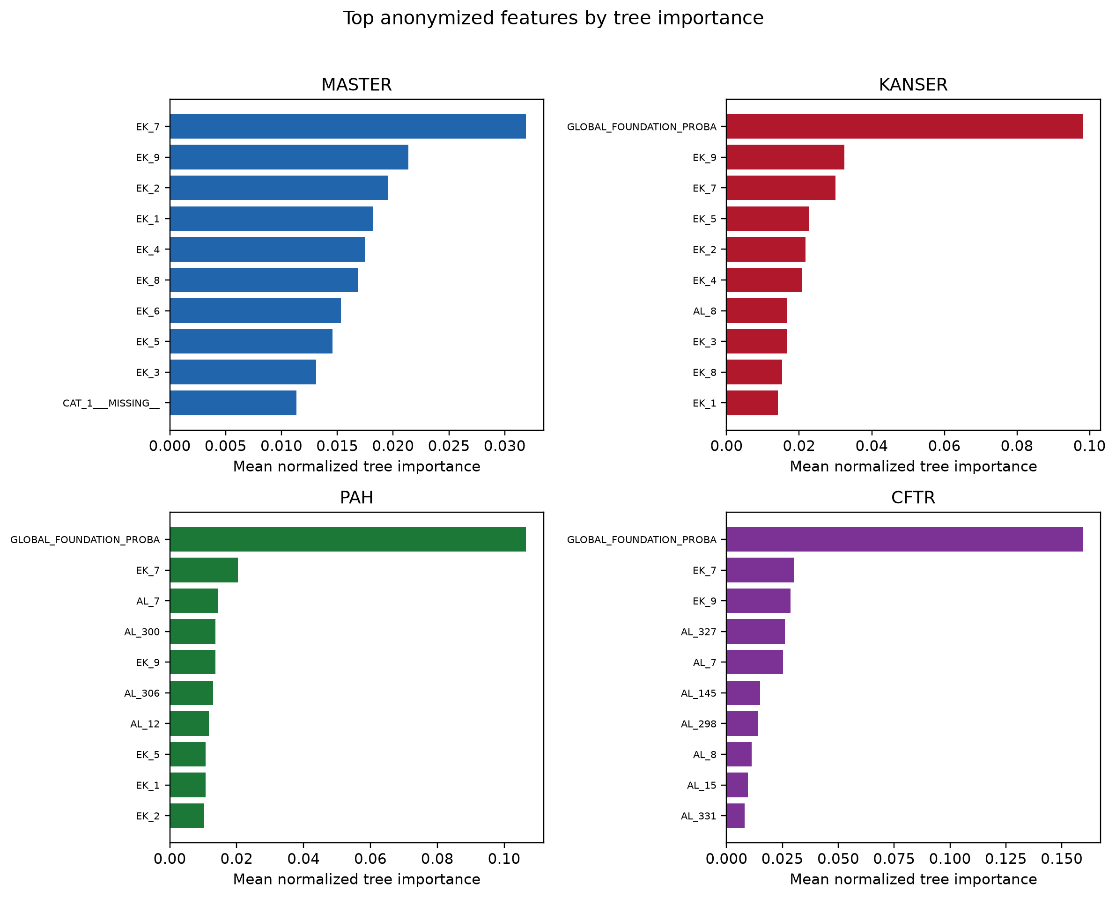
Figure 7. Top feature importance from the full final models.
Interpretation: model-level importance confirms that decisions are driven by anonymized biological feature groups and the intentionally engineered foundation probability, not by identifiers or labels.
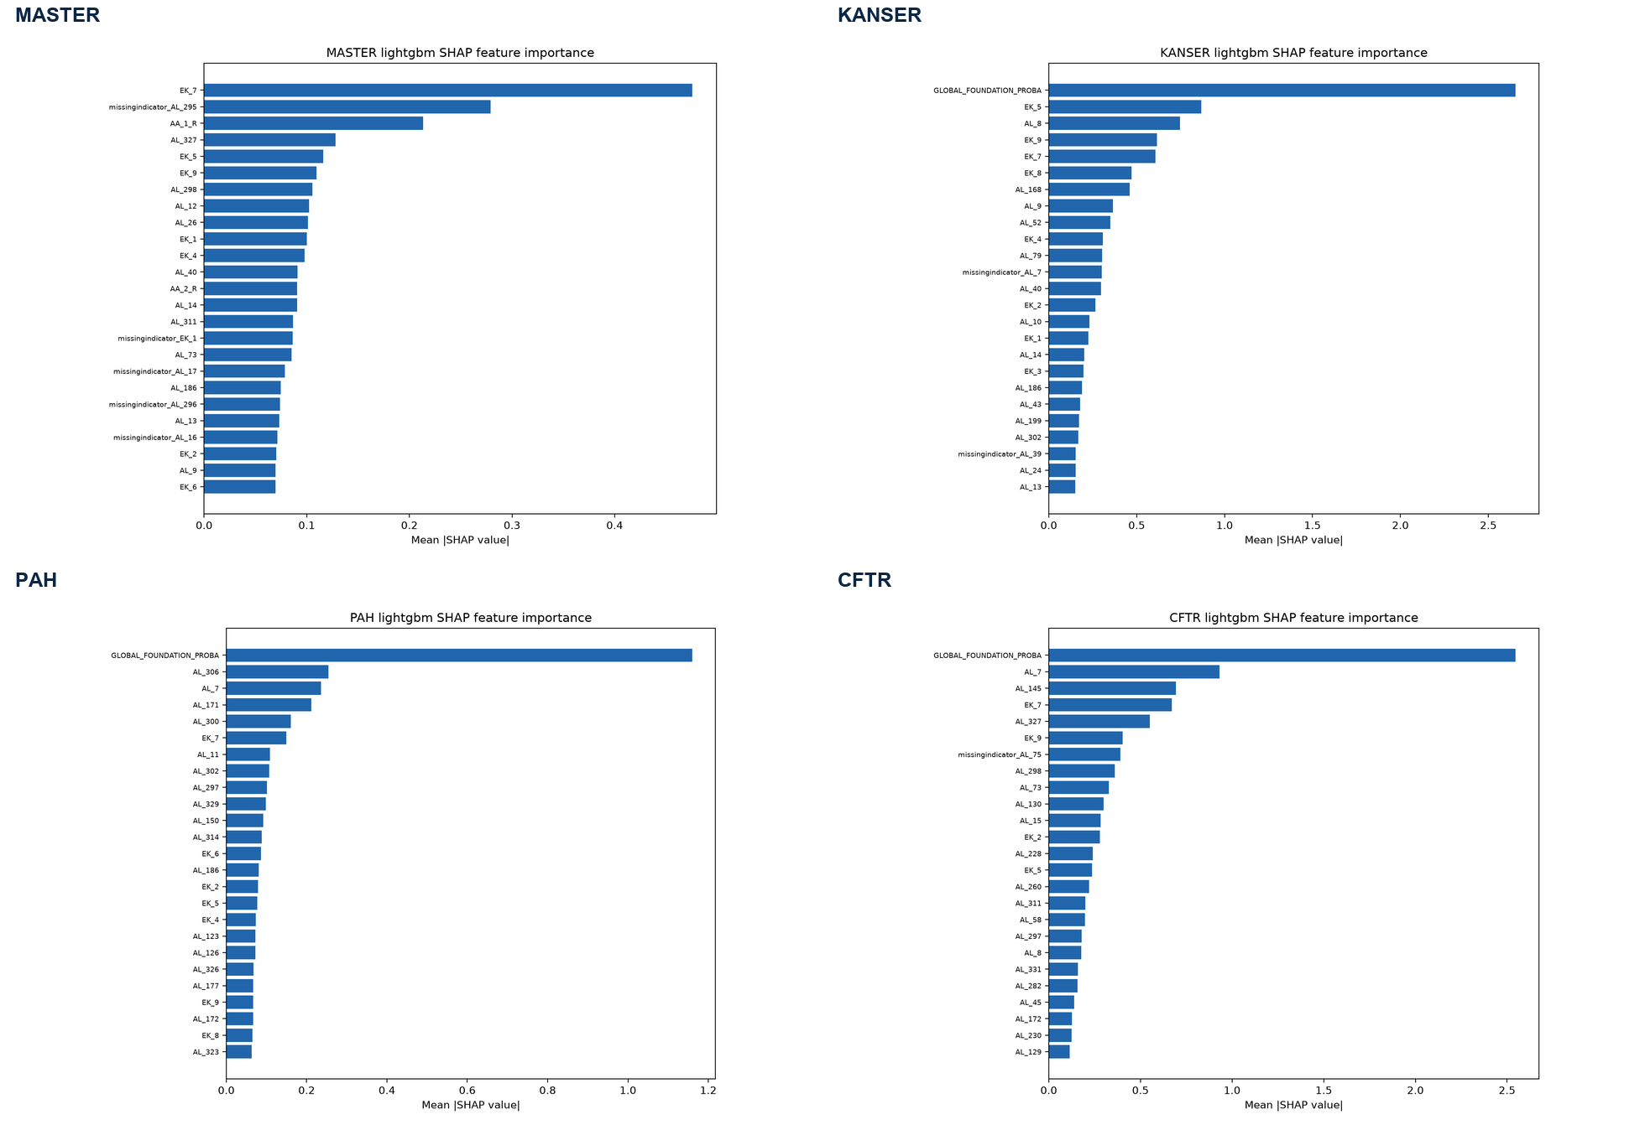
Figure 8. SHAP global feature importance for tuned LightGBM components.
Interpretation: LightGBM uses GLOBAL_FOUNDATION_PROBA strongly in panel models, while MASTER relies only on original anonymized predictors because no panel-transfer feature is added to MASTER.
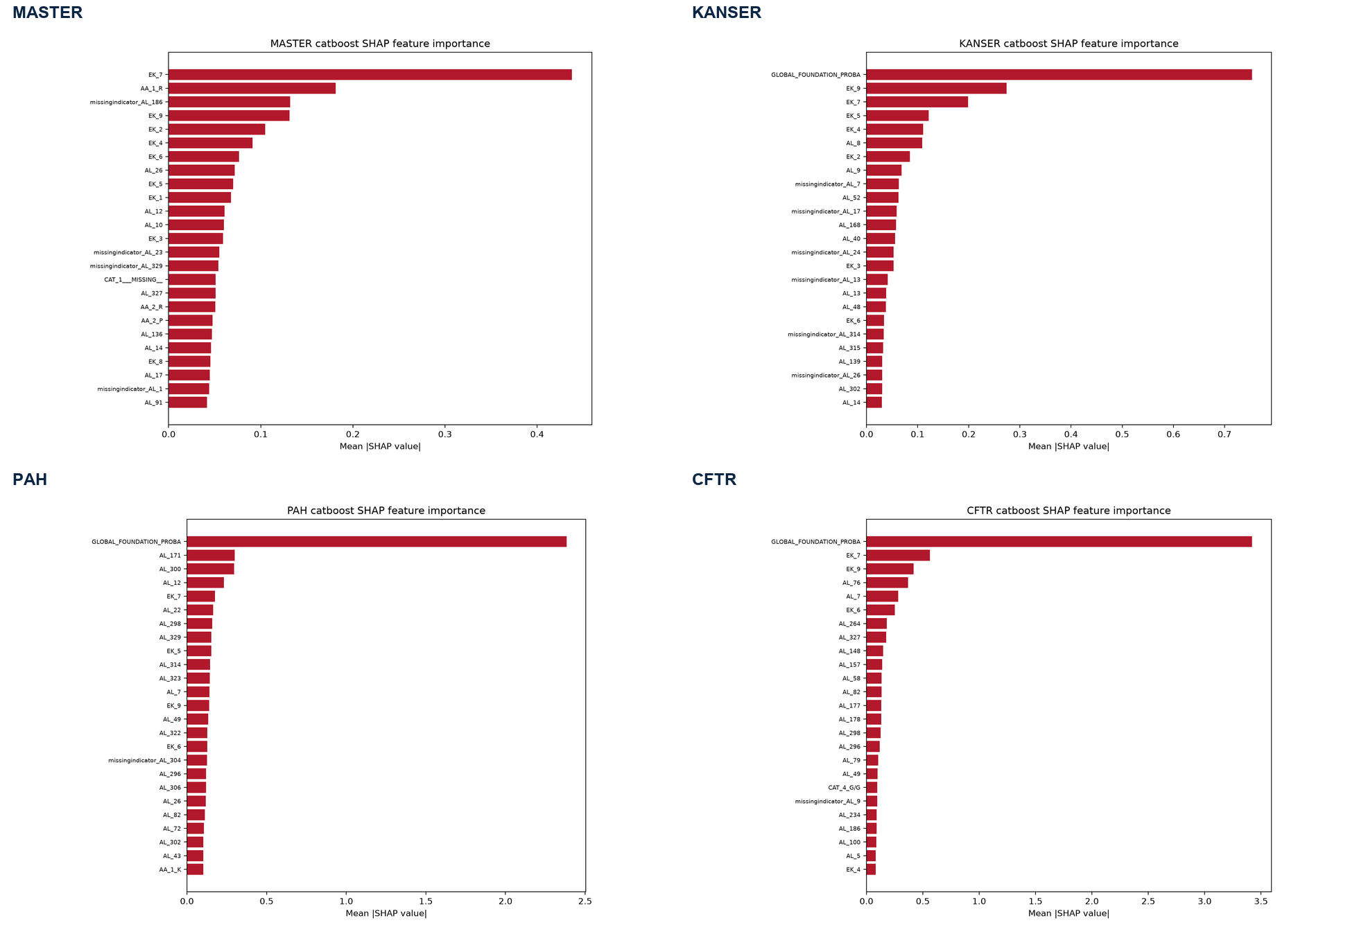
Figure 9. SHAP global feature importance for tuned CatBoost components.
Interpretation: CatBoost shows the same broad feature-significance pattern, which increases confidence that the signal is not an artifact of a single model family.
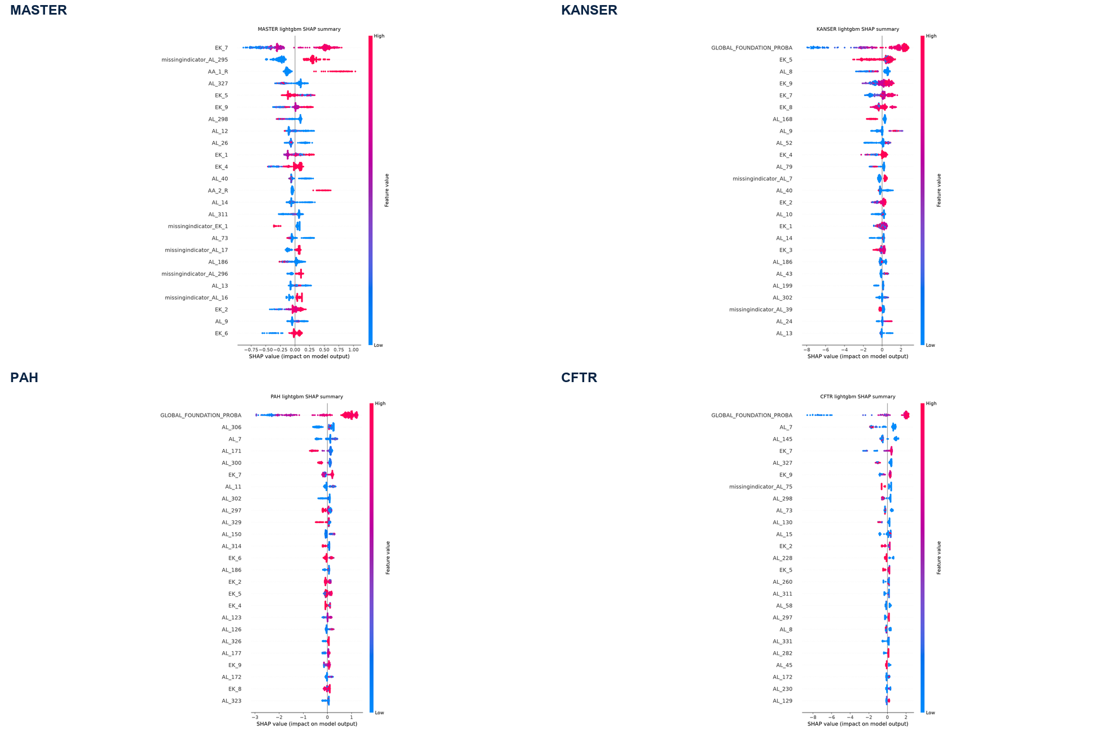
Figure 10. SHAP beeswarm plots for tuned LightGBM components.
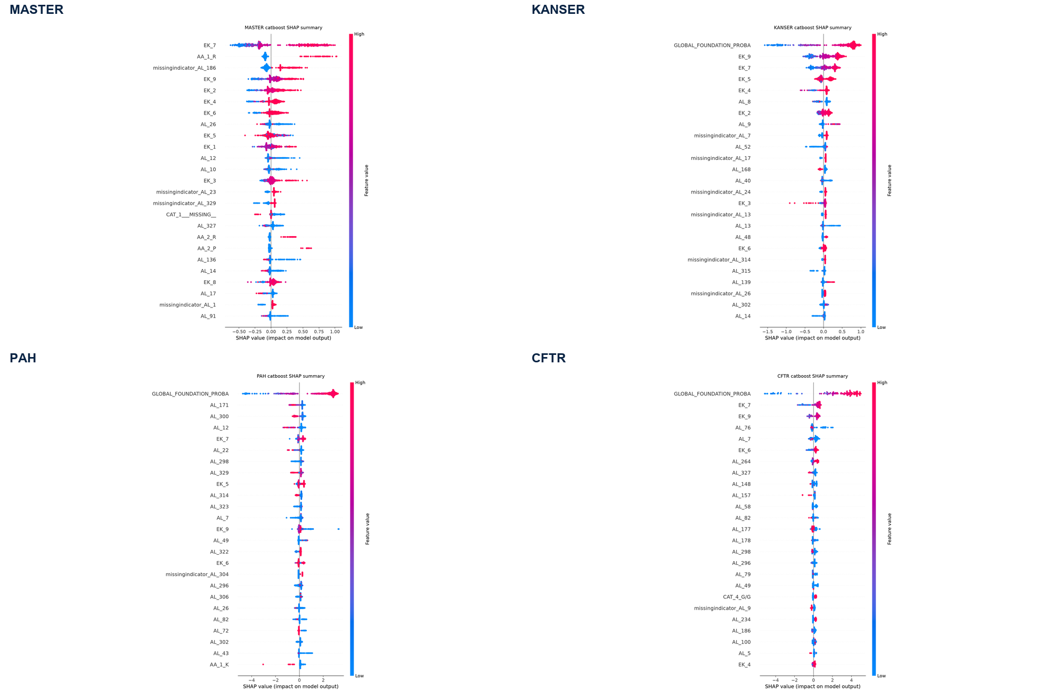
Figure 11. SHAP beeswarm plots for tuned CatBoost components.
Interpretation: beeswarm plots provide instance-level directionality. Wide horizontal spread means the feature has strong decision impact; compact spread means lower decision impact. The absence of Label, Variant_ID, dataset name, or panel-name features among high-impact SHAP features supports the leakage-control design.

3.5 Data Quality and Shift Diagnostics
Panel | MASTER reference rows | Panel rows | Overlap removed | Adversarial AUC | Shift flag
KANSER | 2685 | 388 | 246 | 0.732 | Yes
PAH | 2676 | 372 | 255 | 0.983 | Yes
CFTR | 2854 | 111 | 77 | 0.963 | Yes

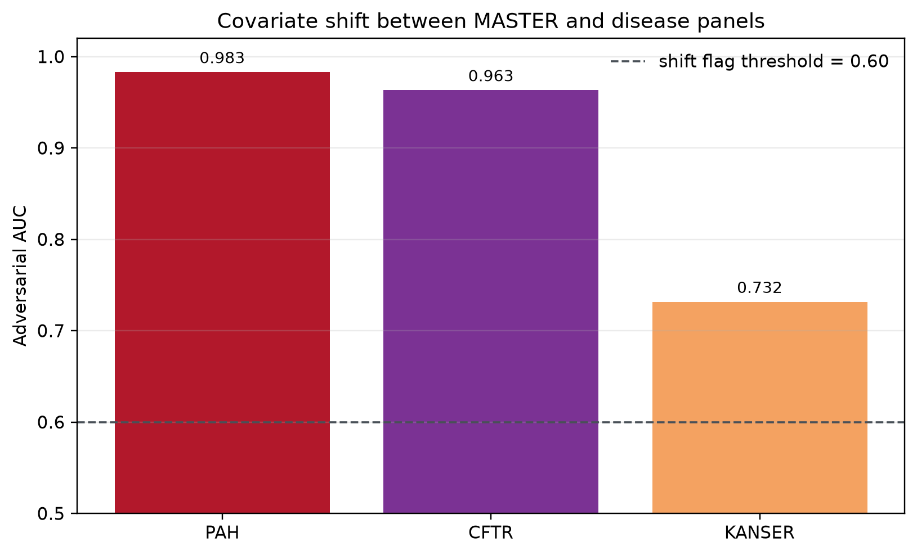
Figure 12. Adversarial validation results: panel shift relative to MASTER.
Interpretation: high adversarial AUC for PAH and CFTR indicates covariate shift between MASTER and the panel distributions. This is a domain-adaptation risk, not evidence of direct label leakage.
The adversarial AUC values indicate substantial domain shift between MASTER and PAH/CFTR and moderate shift for KANSER. This is reported as covariate shift, not label leakage. SHAP summaries did not identify direct label, Variant_ID, dataset, or panel-marker features among dominant predictors.

4. Conclusion
The implemented system successfully reproduces and extends the submitted PDR concept. It is a complete, reproducible, CPU-deployable pipeline for anonymized pathogenicity prediction, including preprocessing, panel adaptation, repeated cross-validation, threshold tuning, Optuna search, SHAP explainability, and diagnostic reporting.
- Strongest results are obtained on CFTR and KANSER, where panel adaptation and threshold tuning produce Macro F1 of 0.878 and 0.872 in the main full-CV run.
- MASTER reaches stable general performance despite the largest heterogeneity, with Macro F1 0.772 and AUPRC 0.929.
- PAH remains the most difficult panel for the benign class because only 62 benign examples are available; Optuna improves the tuned-study Macro F1 to 0.758.
- False negatives are explicitly monitored: the final thresholds keep pathogenic recall high across panels, especially PAH 0.961 and CFTR 0.967 in the main run.
- The main residual risk is domain shift between MASTER and panels, not direct target leakage.
For the final competition stage, the most important operational safeguards are to freeze preprocessing inside pipelines, retain the overlap-removal rule for foundation modeling, avoid fitting any transformations on test data, and submit predictions with the dataset-specific thresholds learned from out-of-fold validation.

5. Bibliography and Report Layout
- Brandes, N. et al. Genome-wide prediction of disease variant effects with a deep protein language model. Nature Genetics, 55, 1512-1522, 2023.
- Kang, M. et al. Gene-specific machine learning for pathogenicity prediction of rare BRCA1 and BRCA2 missense variants. Scientific Reports, 13, 10478, 2023.
- Evans, P. et al. Genetic variant pathogenicity prediction trained using disease-specific clinical sequencing data sets. Genome Research, 29, 1144-1151, 2019.
- Bonetti, E. et al. RENOVO-NF1 accurately predicts NF1 missense variant pathogenicity. Human Genomics, 19, 106, 2025.
- Lundberg, S. M. and Lee, S.-I. A unified approach to interpreting model predictions. Advances in Neural Information Processing Systems, 2017.
- Akiba, T. et al. Optuna: A next-generation hyperparameter optimization framework. KDD, 2019.
- Ke, G. et al. LightGBM: A highly efficient gradient boosting decision tree. NeurIPS, 2017.
- Prokhorenkova, L. et al. CatBoost: unbiased boosting with categorical features. NeurIPS, 2018.
All numerical results in this report are generated from local reproducible artifacts under outputs_full/ and outputs_optuna_fixed/. Figures are inserted from the generated report_figures, Optuna, and SHAP output directories.

