# What your site does and what its purpose

PayYaLator is a basic personal finances/budget program. You can enter your expenses and the program gives you a summary of money spent per category, as well as total expenses.

The program has an entries and profile page. In the profile page you can check/uncheck the subscribed option, which would allow you to enter more than 10 entries in your budget. The subscribed status is being updated in the database, however the limits of 10 entries has not yet been implemented.

# How are you using React? What is it being used to show?

On the Entries page, Budget Breakdown and Budget Summary are two tables that are updated with React. If you add or delete an entry, the items are added and removed from the tables (which is also created using react) and the totals are updated accordingly. The summary page filters items by category type and gives totals per category which are also dynamically updated. The profile page, subscribed checkbox state is also updated using react.

# What (if any) React components do you plan to add?

If there is time I would like to make the ComboBoxes non-static (have a table with values that can also be updated based on subscription), that would however depend on time available.

# What type of data are you currently storing in Mongo?

User profile and budget information in two separate models.

# Do you plan to store any more information?

If time allows, I would like to create a new model that would contain random information. It would be a relational database concept, however I’m not sure what the complications of such an endeavor would be. An example is included below:

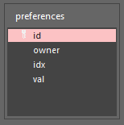 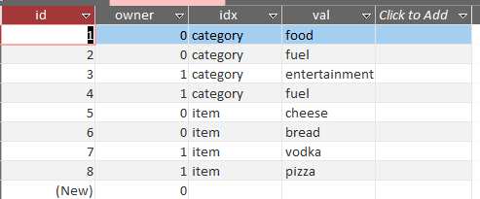

Using this design I can use a single model to hold random data for all users. When populating the comboboxes, I would have a query that references the owner, and return a dictionary that would contain the category and value item information for each individual user. If the user is subscribed, they would be able to add their own custom categories, where if they are not subscribed, they can only add 10 entries and are stuck with 3 or 4 predefined categories

# How are you making use of Handlebars?

I have 4 handlebars files. The base and login which were copied from domomaker, the main which is a variation from domomaker and a new file, profile.handlebars which is a completely new file used to edit the user profile.

# What are your next steps moving forward with the application?

I need to implement the limitations for when a person is not a subscriber by only allowing them to enter 10 items and then giving them a message stating they need to subscribe to add more entries. Then I need to format the site… this will probably take me the most amount of time because I have no skill in formatting… I don’t have any art skills whatsoever.

Once the subscriber/non-subscriber limitations are in, and I’ve managed to get the site to look like something, if there is time left I’ll look at the user-customized drop-down menus.

## I worked solo so there is no group info.