Please put our program, ContinuousGeneralizer, under the path “C:\MyWork\DailyWork\ContinuousGeneralisation”; see the following picture. We insist on the path because we may use some absolute paths in the program. If ContinuousGeneralizer is put somewhere else, errors may occur.

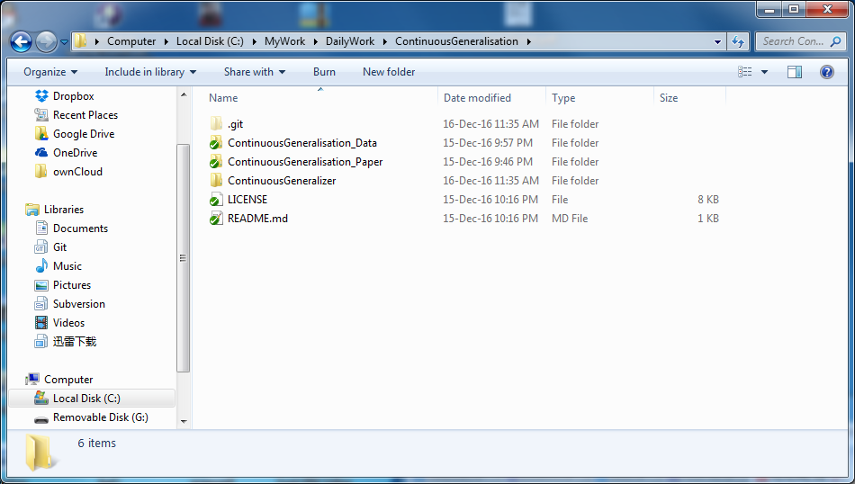

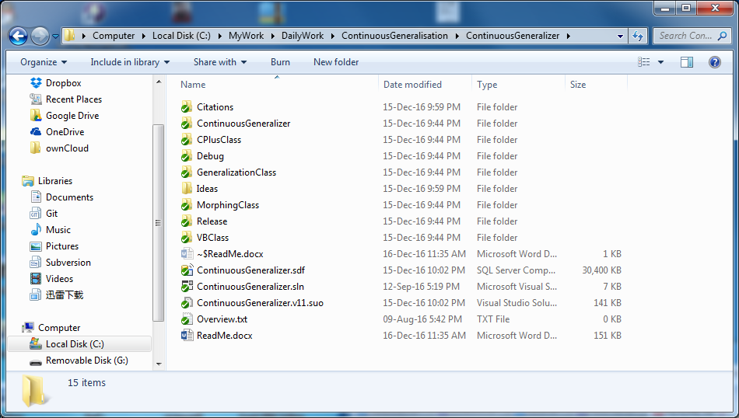

**An instruction of our program ‘ContinuousGeneralizer’**

The main window (form) of our program is ‘FrmContinuousGeneralizer’

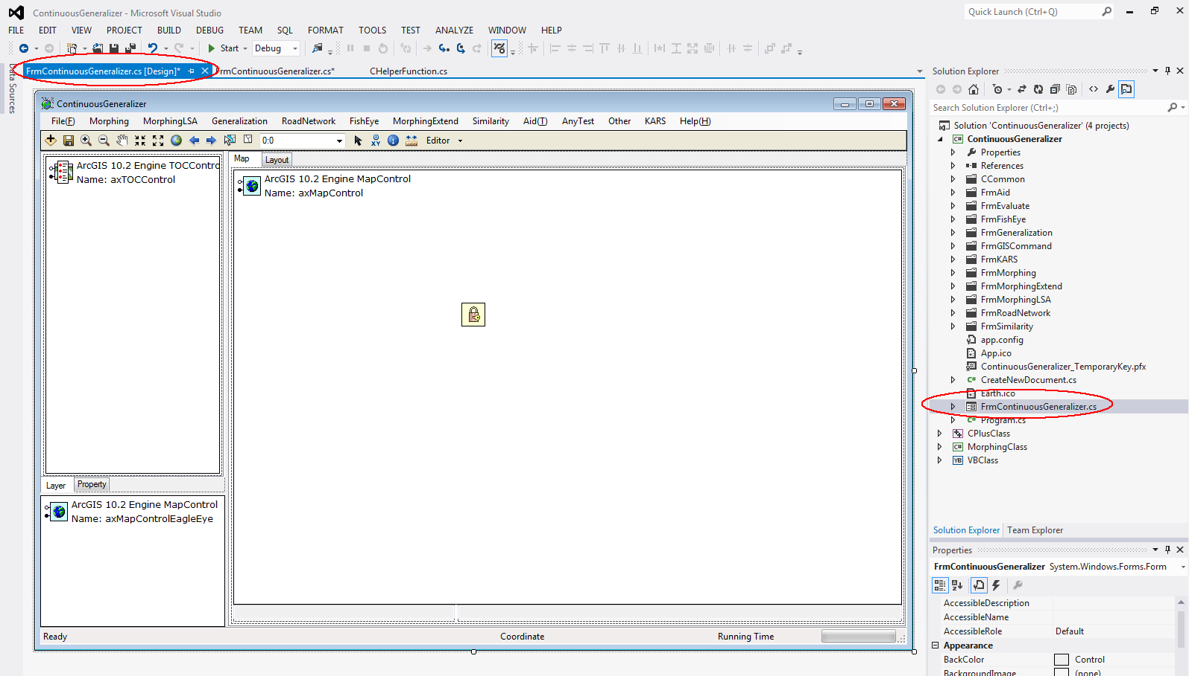

You may work on at most one application (open one Microsoft Visual Studio) if you have a key of ‘Single Use’. You may need to set the licenses. Right click the icon of ‘the lock and key’, go to properties, then check the licenses as following.

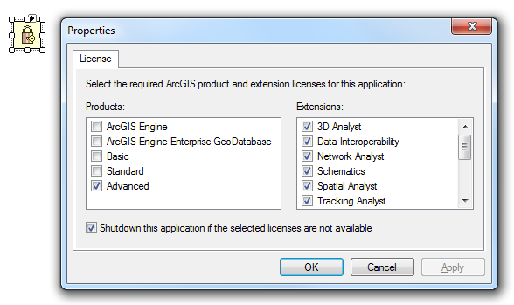

If you launch our program, you should see the “software” ‘ContinuousGeneralizer’ popping up. Then you can call the form ‘FrmBuildingGrowing’ under menu ‘Generalization’. From form ‘FrmBuildingGrowing’, you can run the approach of generalizing buildings.

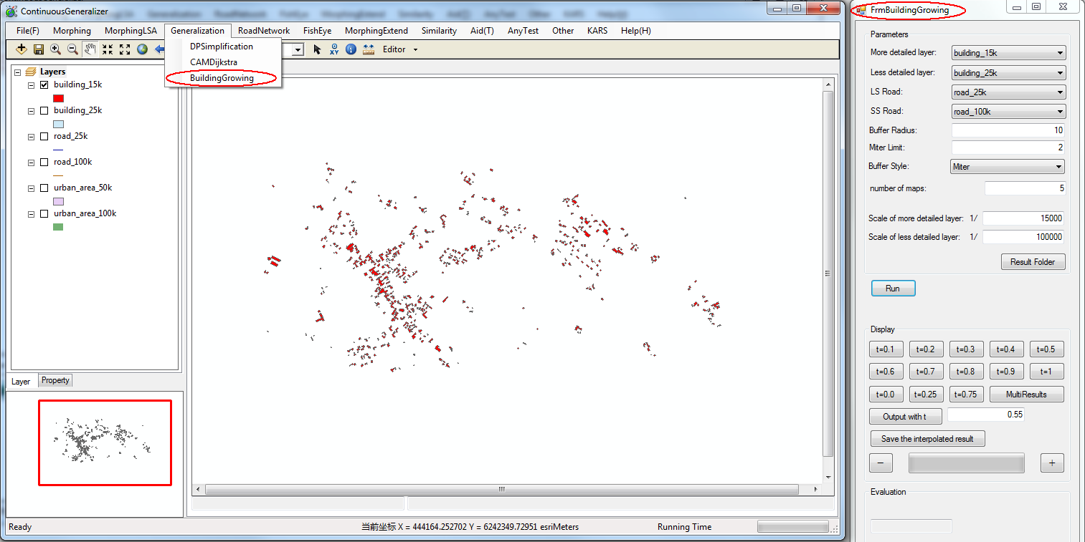

The codes of our approach are in file ‘BuildingGrowing.cs’, which are called in form ‘FrmBuildingGrowing’.

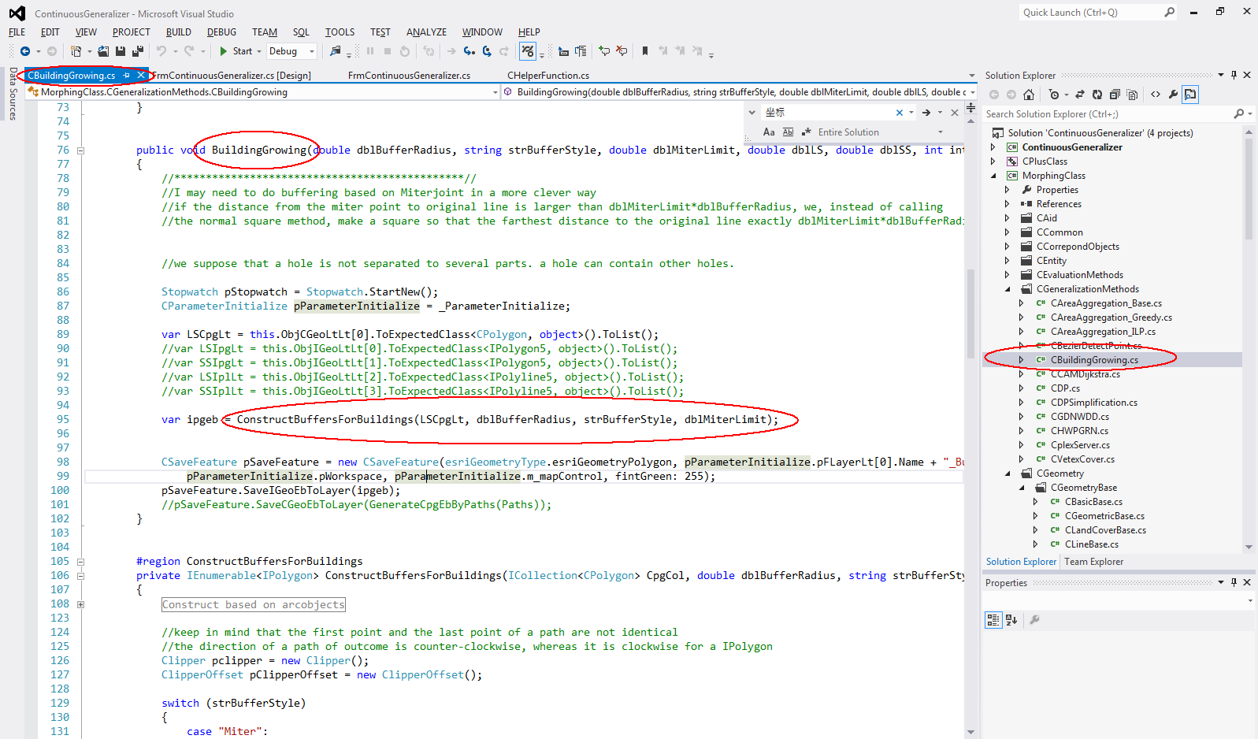

The data for experiment is automatically loaded using codes in file ‘CHelpFunc.cs’.

