Add-In Maplex Engine Configuration – USER GUIDE

# Step 1:

Download the Add-In installer “*MaplexEngineConfig.esriAddinX*” from the official web site of releases and install it.

# Step 2:

Open ArcGIS Pro. You should find the Maplex Engine Configuration Add-In in a new ArcGIS Pro tab called “*IGN Add-Ins*”, like this:

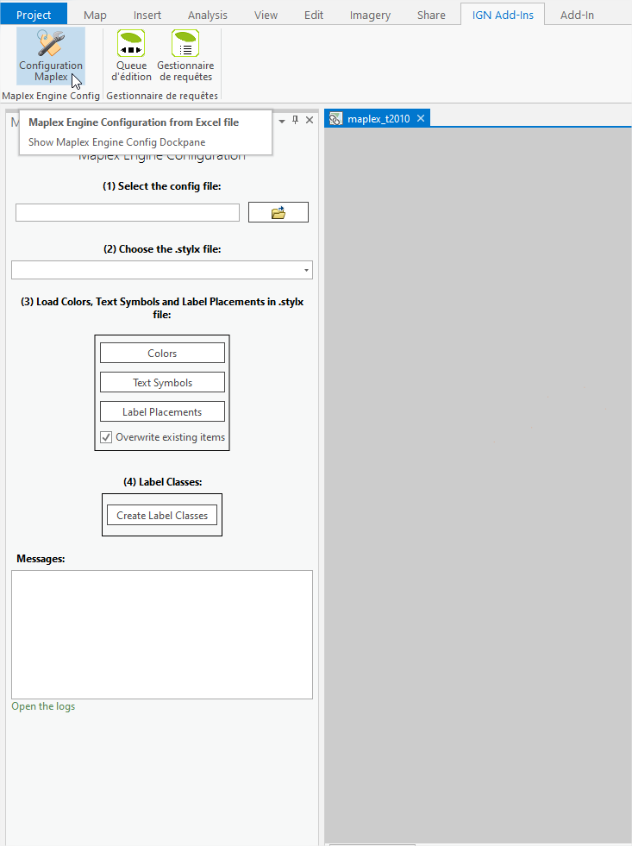

# Step 3:

Select your configuration Excel file:

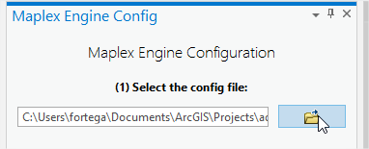

# Step 4:

Select the .stylx file where you want to work and write your Colors, Text Symbols and Label Placements, generally you create a new .stylx file inside your .aprx project, but you can also use an existing .stylx file from outside of the project

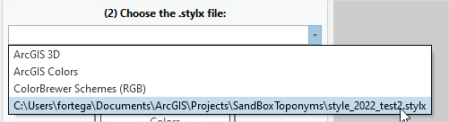

# Step 5:

Then you create your Colors, Text Symbols and Label Placements defined in the tabs of your configuration Excel file:

*Config Excel file*



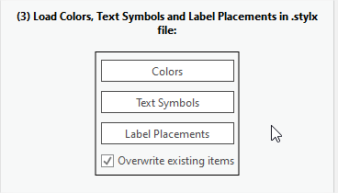

The order of creation is important only for the Text Symbols since they make reference to the Colors, so in order to create the Text Symbols you’ll need to create the Colors first. The creation of the Label Placements doesn’t depend on the Colors or the Text Symbols.

If the process goes well, then you’ll see “*OK*” messages in the messages textbox:

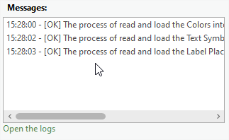

And if something went wrong, you’ll see “*Warning*” messages instead and you’ll be able to take a look into the logs file for more details by clicking on the “*Open the logs*” control.

# Step 6:

And finally, create the Label Classes and associate them with the Layers:

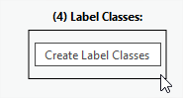

***Note***: it’s important that you open and select a map in your ArcGIS Pro project; this map must contain the Layers where you want to apply your configuration.