Add-In Query Manager –  
USER GUIDE

# Installation:

Download the Add-In installer “QueryManager.esriAddinX” from the official web site of releases and install it.

Open ArcGIS Pro. You should find the Query Manager Add-In in a new ArcGIS Pro tab called “IGN Add-Ins”, with two tabs "Edit queue" and "Query manager", like this:

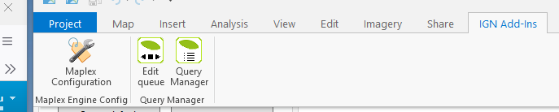

# Query Manager :

The query manager allows you to create a table with references to objects from several layers, in order to store the result of a selection in memory. Either using pre-saved queries or keeping the current selection.

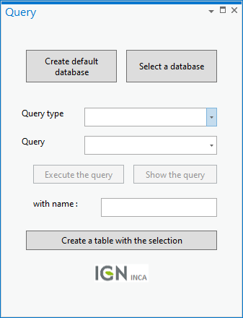

|  |  |
| --- | --- |
|  | Create the gdb query (REQ.gdb), It’s a prerequisite for using the tool. If this gdb already exists, it checks that it is compliant, updates it if necessary. |
|  | Import a gdb whose tables are already filled. |
|  | Choice of query type: attribute or spatial.  Choose the predefined query, if there are any defined in the associated table. |
|  | Execute the chosen query  or  View the query in the Geoprocessing window. Ability to check the query, modify it, before executing it. |
|  | Choose a name for the table to save.  If the table is from a named list, the default name is : result_"list_name"  If saving a table after a selection without a query, the default name is : result_ "Table_Selection"  Creates a selection table that is saved in the query database. |

# Edit Queue :

The edit queue is used to browse one by one the objects of a pre-recorded table that may contain references to several layers. To use the tools, you must have loaded a list, either saved or created with the current selection (result_Table_Selection)

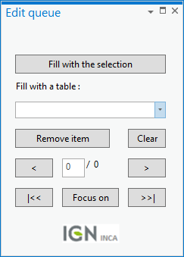

|  |  |
| --- | --- |
|  | Populate a list of features by interactive selection. |
|  | Load a named table listing the selection of pre-saved entities. |
|  | Remove item from list (removed in array but not in functionality)  Empty the tool from the list being processed. (deleting the result_Table_Selection table, if any) |
|  | Navigation to the previous entity, jump directly to the element to be processed or navigate to the next entity. |
|  | Return at the beginning of the list  Refocus the map on the entity  Go to the end of the list |