gEAR Uploader Output - H5AD format

AnnData object consisting of AnnData.X, .var, and .obs.

**.X** - array of expression values

* XLSX-based datasets yield a numpy array as the uploader uses pandas to read in the expression sheet.

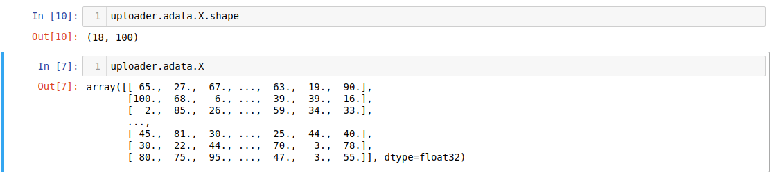

* MEX datasets yield a sparse matrix as the uploader uses scanpy to read in the matrix.mtx. For example:

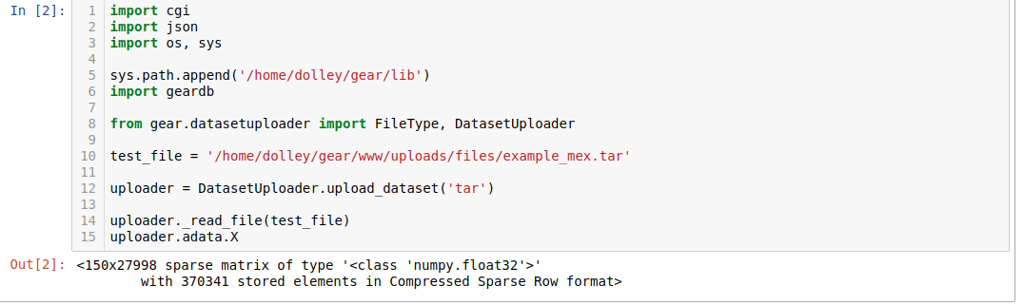

**.var** - holds gene information

* Pandas dataframe where the index (‘genes’) is gene Ensembl IDs and column 1 is ‘gene_symbol’.
* Column ‘gene_symbol’ is optional. Some datasets may only have Ensembl IDs, and no gene symbols. In these cases, .var is an index with no columns.

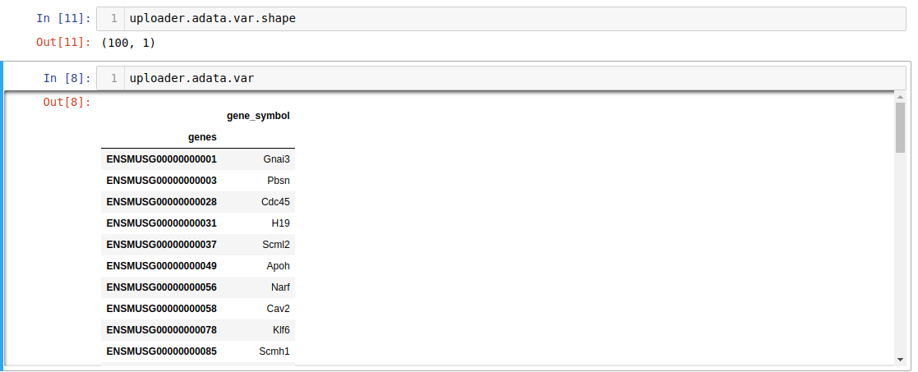

**.obs** - holds the observation information

* Pandas dataframe where the index (‘observations’) is the observation ‘headers’ or barcodes. No specific column is required, but the presence of certain columns will determine how the dataset can be graphically displayed.

