**gEAR Manual – Dataset Comparison Tool**

The gEAR’s comparison tool allows you to dive into datasets by comparing conditions within a dataset (condition A vs condition B in dataset X) or compare conditions across two datasets (condition A of dataset X vs condition B of dataset Y). These comparisons are drawn in an interactive X-Y scatterplot and allow you to resolve specific genes.To get to the comparison tool, simple click on the scatterplot underneath the comparison tool description. **Screenshot needs to be changed after front page revamp.**



To choose the dataset(s) that you would like to compare, use the drop-down menus on the left to select a dataset and condition for the X axis and Y axis. Then click plot to generate the scatterplot. For an example, we will be comparing the inner hair cells to the outer hair cells using a RNA-seq dataset. Hover over a dot to see its coordinates and gene it represents.

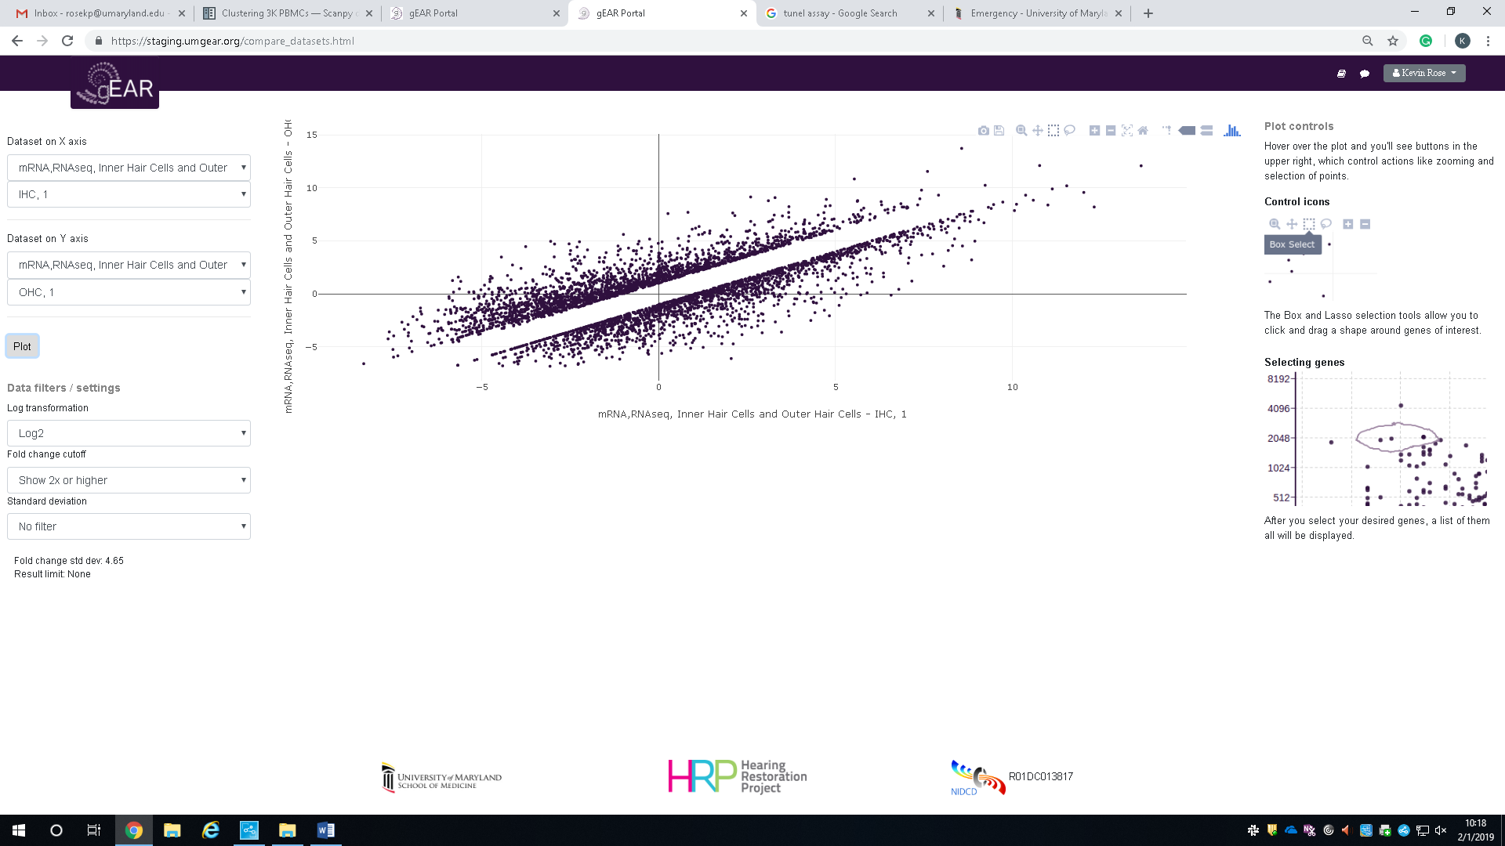

There are multiple settings that can be changed by the drop-down menus on the lower left hand side of the comparison tool. These settings include: log transformation, fold change cutoff, and standard deviation cutoff.

**Log Transformation:** When you have a highly skewed distribution (such as RNA-seq data), using log transformation can be valuable for making patterns in the data more interpretable. The comparison tool allows for no log transformation (raw values), log2 and log 10.

Log2

Raw Values

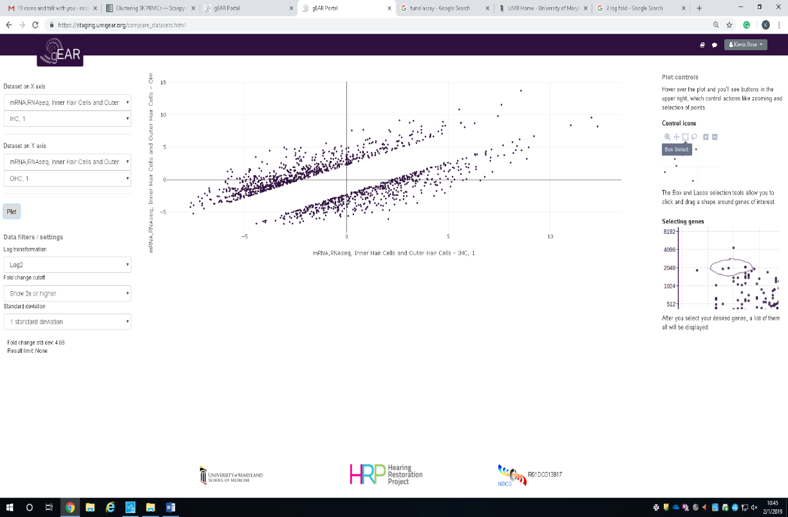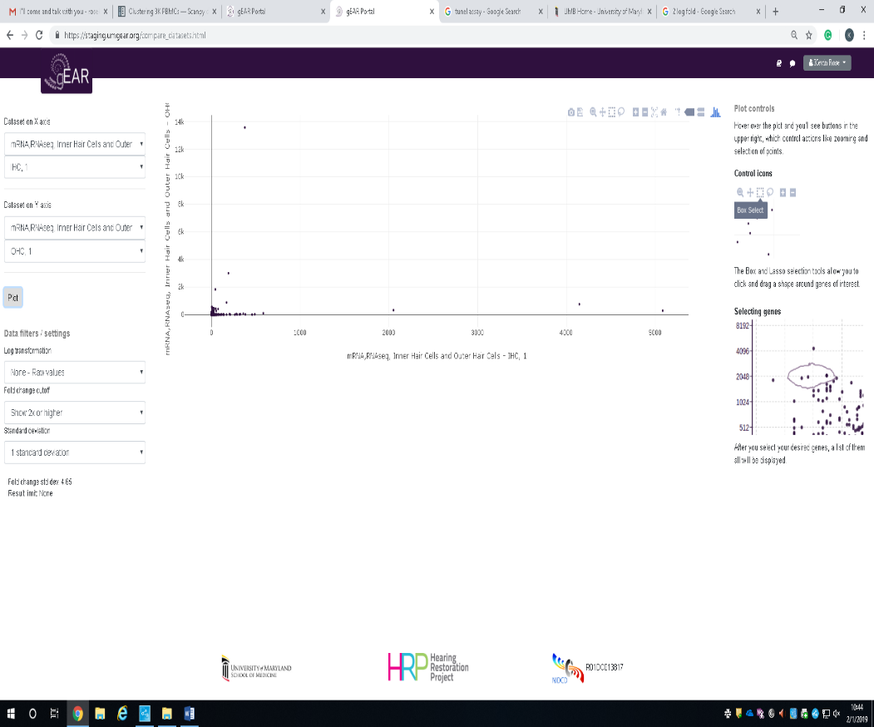

**Fold Change Cutoff:**  This is the cut off value for gene expression fold change between the two conditions being plotted. Options: No filter, 2x or higher fold change, 3x or higher fold change.

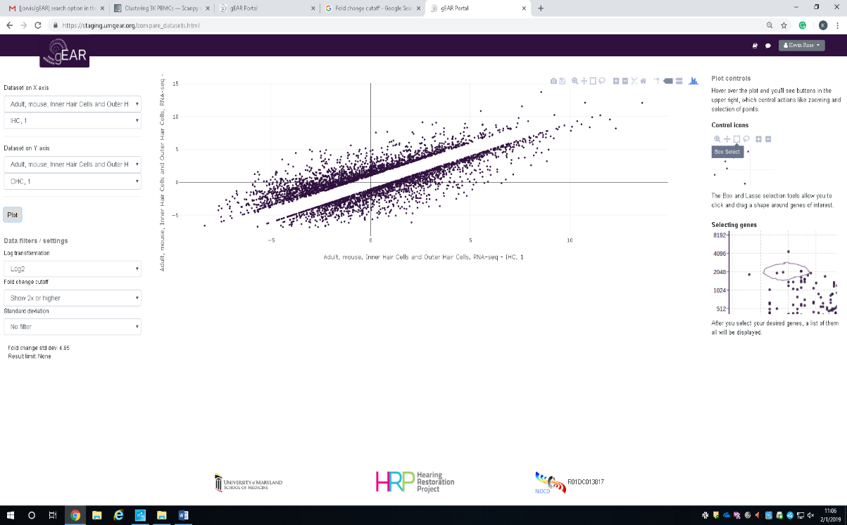

2x or higher

No Filter

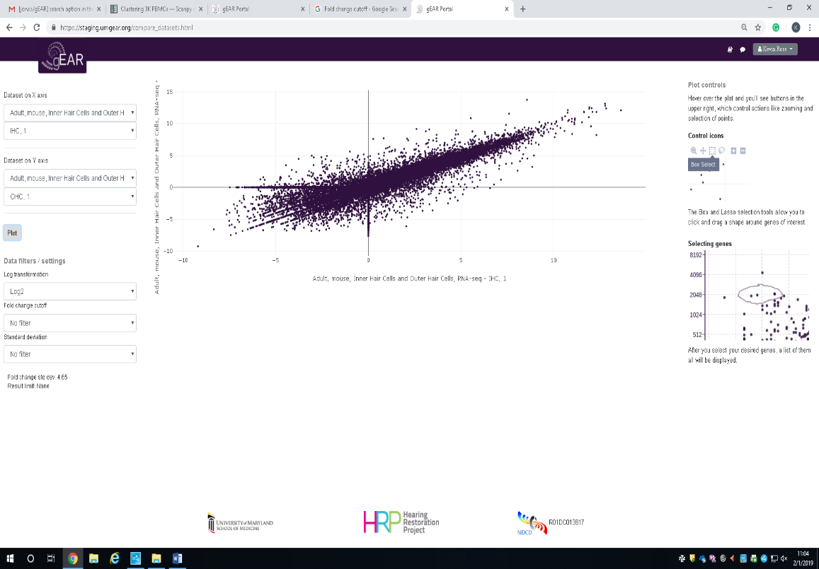

**Standard Deviation Cutoff:** We can also filter by standard deviation. Options: No filter, 1 standard deviation, 2 standard deviations.

2 Standard Deviations

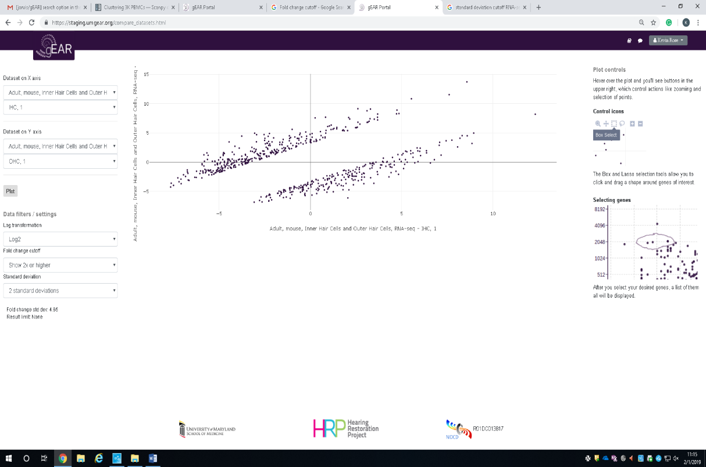

No Filter

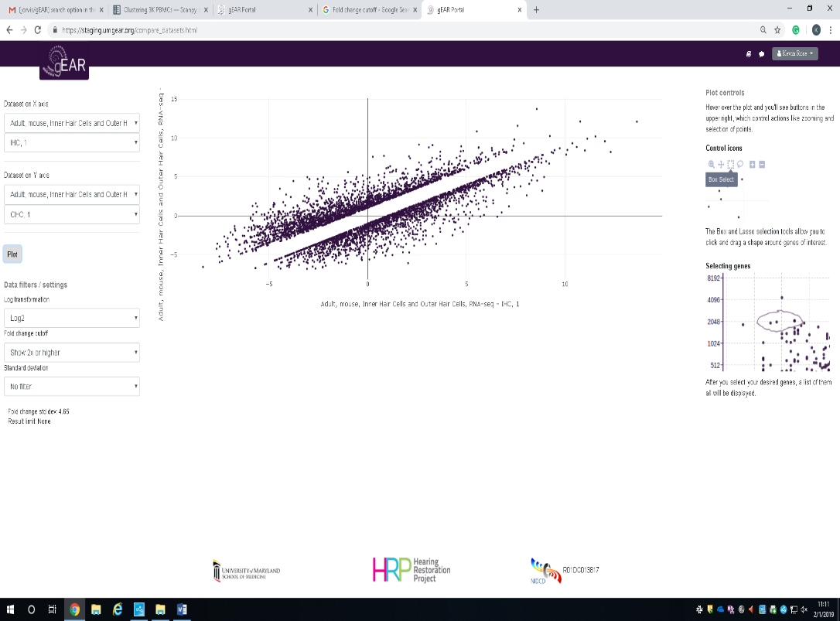

**Selecting Genes of Interest:**

The comparison tool allows you to select genes of interest and save them in an excel file or a gene cart. A gene cart will allow you to search these genes using the gEAR’s search option after your analysis is done. To select genes of interest, use the box or lasso selection tool that is available in the upper right of the scatterplot.

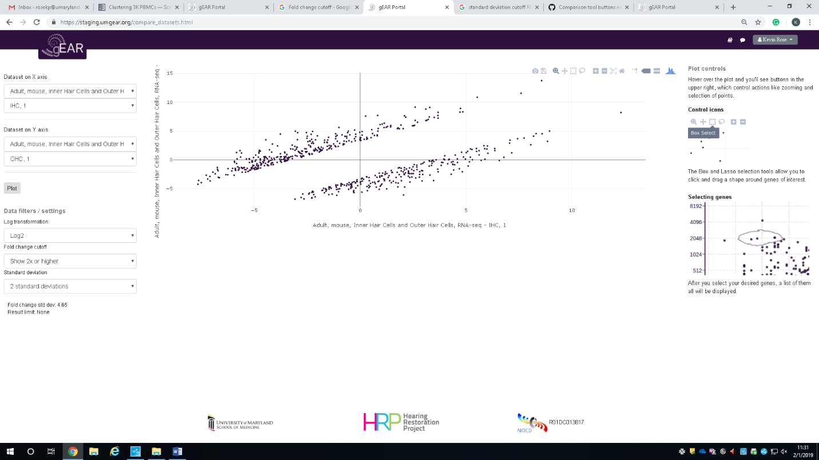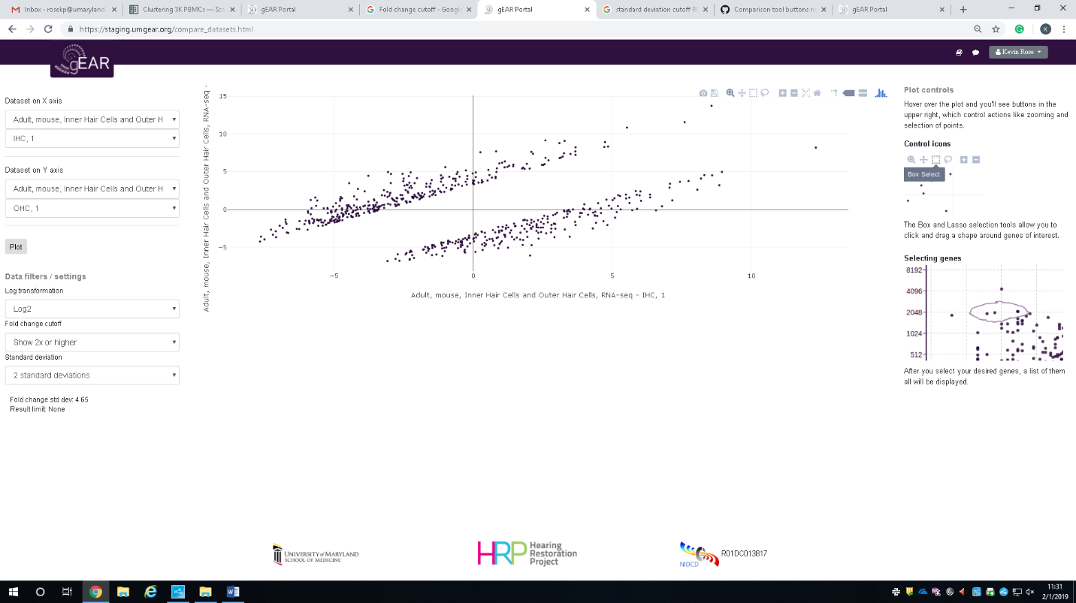

After you have selected the box or lasso tool, draw around the genes you are interested in. This will bring up these genes in a table on the right showing the gene names as well as the fold change at each condition. These genes can be saved as an excel sheet or saved as a gene cart by clicking on the appropriate button above the table.

