*This is to certify that*

*IGUH CHUKWUBUIKE INNOCENT*

*YUSUF FAIZAH OMOBOLANLE*

*AFOLAYAN SHIFAU OMOLABAKE*

*APOKWUEZE FAMOUS UCHE*

*AJADI YUSUF OLADIMEJI*

*Successfully**designed and developed the*

***CLARINS WEBSITE.***

**Table of Contents Page**

**1.0 ACKNOWLEDGEMENT 3**

**2.0 E-PROJECT SYNOPSIS 4**

**3.0 E-PROJECT ANALYSIS 5-6**

**4.0 E-PROJECT DESIGN 7-8**

**5.0 USER GUIDE 9-11**

1. **DEVELOPER’S GUIDE 12**

**7.0 SCREENSHOT 13-16**

**1.0 Acknowledgement**

All thanks to the Almighty God for the gift of life, knowledge and insights. We would like to express our special thanks to our Faculty/Instructor, Mr. Idris, for his able guidance and support towards the completion of this project.

1. e-Project Synopsis

This platform was created to offer high quality skin care products. It provides and guarantees exceptional quality, ensuring every client enjoys a seamless and memorable experience using our products.

This platform is reachable and reliable anytime, anywhere provided with good network stability. We ensure seamless transactions while delivering our products to our customers worldwide. Our dedication to quality is reflected in the glowing testimonials from our satisfied clients, who trust us to provide quality skincare products.

3.0 e- Project Analysis

The purpose of this project is to deliver exceptional Skincare products and cosmetics to our clients through our extensive network.

Clarins is a platform that was created to offer high quality skin care products. It provides and guarantees exceptional quality, ensuring every client enjoys a seamless and memorable experience using our products.

This document explains the purpose and features of the website, the interface of the website, what the website will do and the constraints under which it must operate. This document is intended for both stakeholders and developers of the website and will be proposed to the client for approval.

Contents of the website include a ‘home page’ (index.html) consisting if the following navigation menu:

1. HOME
2. PRODUCT
3. ABOUT US
4. BLOG
5. CONTACT US.

NAVIGATION MENU

1. **Home:**  The home page consists of our products such as the double serum, eyelift serum, Sun screen, contact us, sign up and so on. It also a brief history of our company.
2. **Products:** Which contains various products available to our clients for purchase. Here our clients are free to choose any Product of their choice.
3. **About Us:** The about us page gives a summary of what **Clarins** is all about and our services. It also displays a brief history of how **Clarins** started.
4. **Contact Us:** The contact us page displays the Name**, Phone Number, E-mail and a Message Box.** Here, users can contact us if they have any requests, suggestions or complain.

4.0 e-Project design(Data flow diagram)

Home

Blog

Contact Us

About Us

Products

Home

FAQ

About

Name

Innovative formula

Double serum

Email ID

Videos

Feedback

What we Offer

Eye lift serum

Message

Address

Men’s after shave

Contact Number

Lipstick

4.0 e-Project design(Flowchart)

Home

About Us

No

View products

Choose a Service

Track your Shipment?

No

Yes

What says our client?

No

Cosmetics

Skin Care

Products

No

Yes

Yes

5.0 User Guide

Table of Contents

* Introduction to **CLARINS**
* Home
* products
* About us
* Contact us
* Blogs
* Links
* Info
* Feedback

Introduction to Clarins

Clarins is a platform that was created to offer high quality skin care products. It provides and guarantees exceptional quality, ensuring every client enjoys a seamless and memorable experience using our products.

The purpose of this project is to build an interactive website where our clients can have access to quality skincare products.

We specialize in the provision of quality and affordable skincare products for your ultimate satisfaction.

* A slideshow of pictures and comments that shows our aim, purpose and objectives to our clients.
* It is accessible and functions seamlessly on all devices, including smartphones and tablets.
* Uses high resolution images and videos to showcase our various products.
* Displays testimonials and reviews from satisfied clients and credibility.
* Footer at the bottom of each page containing several links / information such as Email, Contact number and Address of office location.

**Home Page**

**The home page** is the first page displayed on the website. It consists of a Navigation menu at the very top of the home page. The navigation menu contains the following:

1. Products
2. About us
3. Blog
4. Contact us

The home page also contains:

* A slideshow of products.
* A footer section containing website information and links.

**About Page**

The **About** page describes the website and gives details about the web contents.

**Contact Page**

The contact page link takes the user to a page within the website where users can send their comments via email, make enquiries and share their observations about the website with the developers. This page also displays a Google map of the operational station of the development team (Aptech building) and the address. It is important to note that the Google map facility is only available within the website when the user is connected to the internet.

**6.0 Developer’s Guide**

**Clarins is a platform that was created to offer high quality skin care products. It provides and guarantees exceptional quality, ensuring every client enjoys a seamless and memorable experience using our products.**

**If a developer wants to change any content of the website, the developer can access the index page and other html pages within the website.**

**The source code has been commented in detail in order for any developer going through the code to easily understand and modify.**

**The project was created using HTML5, CSS, and JavaScript.**

**Visual Studio Code was used as the HTML text editor, and it has been tested across all leading browser and various screen sizes.**

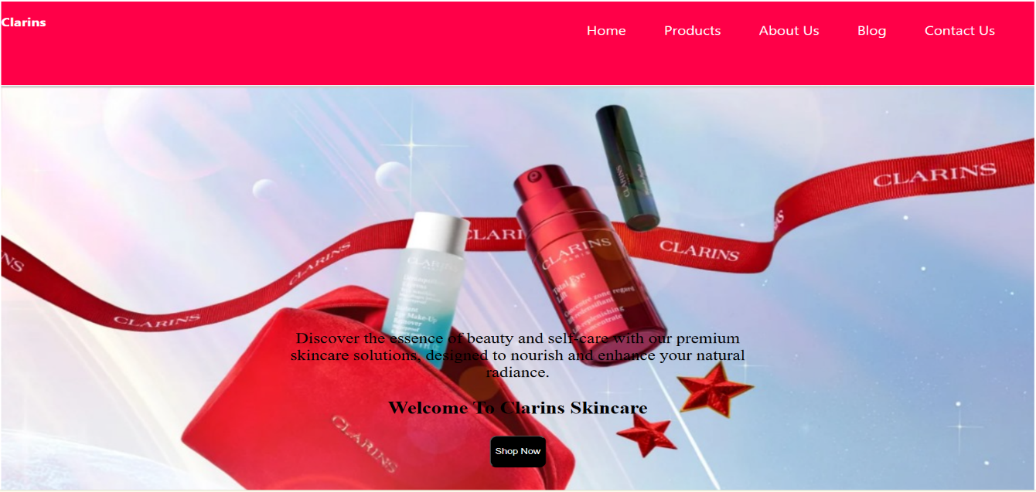

**SCREENSHOTS**

