***PROTOCOL TITLE***

**Project Acronym or Short Study Title:**

**Principal Investigator**

**Co-Investigators***:*

**Institutions:** *Island Health (Vancouver Island Health Authority); Cerner Math (Cerner Corporation)*

**Protocol version number/version date:**

# Protocol Synopsis

# Background & Rationale

# Objectives

Related to problems

Related to questions

Practical/pragmatic – applied components (where does the knowledge fit within a Target Information Architecture)

# Major Research Hypothesis and Associated Research Questions

# Study Approach, Design

## [[If the study has a practical intent and an envisioned context in which the results will be applied, you might want to think in terms of phases, e.g,.

## Phase 1 - Develop models;

## Phase 2 - Validate models;

## Phase 3 - Field trial the tools that use the research knowledge to support whatever functions that knowledge is intended to support;

## Phase 4 - Deploy a production version of the tools (e.g,. ready for full deployment in some context);

## Phase 5 - Validation that the production versions are working as expected;

## Phase 6 – Implement strategy for ‘care and feeding’ of the tools, e.g., refreshing prediction models at XX intervals. ]]

Include –

1. Design, methodology
2. Defining the cohort
   1. Conceptually – who
   2. Operationally – what are the inclusion/exclusion criteria? How will you know whether they have been met/not met?
3. Sample size, power considerations
4. Statistical approach
5. Data elements – broken out by source system (e.g., X, Y, Z from Island Health data warehouse; A, B, C supplied by researcher)
6. Products – [for ‘pure’ research the product is answers. For applied research, the product will be evidence-based tools that relate to cohorts and/or programs and or functions performed by programs or professionals.

# Data management

1. What are the technologies, sources of the data (e.g, X, Y and Z from the data warehouse; A, B & C supplied directly by subjects using web-based tools that store data in the Island Health instance of REDCap; etc)
2. Where will the data be housed – where researchers interact with the data, e.g, inside the Island Health Secure Research Environment; inside the Microsoft Azure Cloud environment; on a laptop (not likely to be viewed favourably!!)
3. Data flow diagram
4. Steps involved in preparing the data – who does what, in which environments
5. What are the activities that are performed to access the data, de-identify the data and locate the data in the environment where the data will be accessed
   1. Data flow diagram
   2. Steps involved in preparing the data – who does what, in which environments
   3. Protection of Privacy

# Consent, Protection of Privacy

1. Consent
2. What are the activities that are performed to de-identify the data

# Data retention

# Publication of Results

# References

# Sample data flow diagram

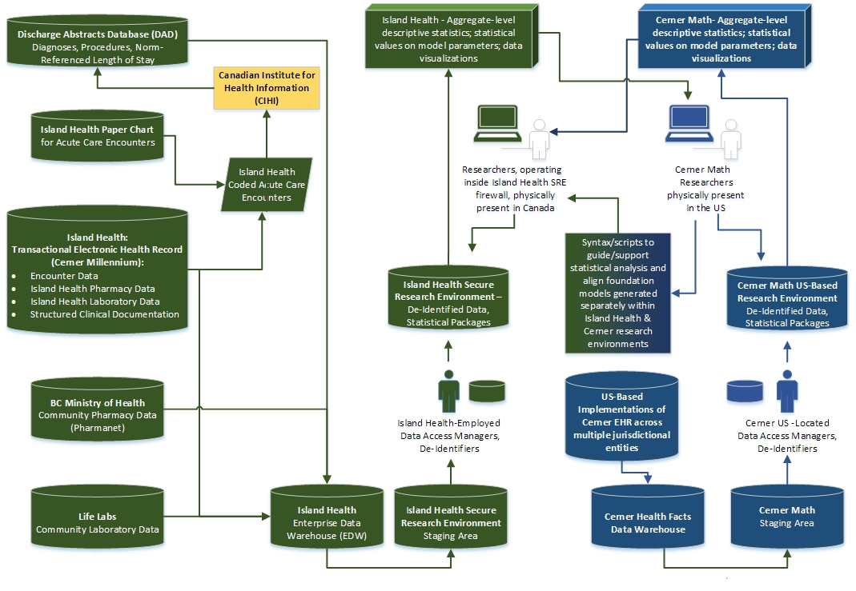

**Table I.** Creation of Analysis-Ready De-Identified Research Data Set in Island Health Data Disclosure Environment

|  |  |  |
| --- | --- | --- |
| **Step** | **Activity** | **Parties Involved** |

|  |  |  |  |  |  |  |  |
| --- | --- | --- | --- | --- | --- | --- | --- |
|  |  | **IH DW Staff** | **IH Dir ACR** | **HI Res** | **UVIC Res** | **Cerner Res** | **O’sight Group** |

|  |  |  |  |  |  |  |  |
| --- | --- | --- | --- | --- | --- | --- | --- |
| 1 | EDW attaches fully anonymized identifier to information coming into the data warehouse from Island Health source data systems and removes Direct Identifiers. EDW retains the key to enable re-identification of data but never discloses to Researchers. Research data are drawn from this larger body of anonymized data in the EDW. | Perf |  |  |  |  |  |
| 2 | Supply EDW team with detailed data requirements for research, reflecting research questions, proposed analyses and data requirements as delineated in research protocol. |  | Perf | Perf | Perf | Perf |  |
| 3 | Generate SQL queries to create a delimited body of data elements that are required to address the research questions & carry out research modeling activities. | Perf | C/A | C/A | C/A | C/A |  |
| 4 | Validate that SQL queries have correctly translated documented data requirements with holdings in the EDW. | Perf | Perf | Perf | Perf | Perf |  |
| 5 | Execute SQL queries to create a copy of required data elements in a secure database inside the Island Health firewall. | Perf |  |  |  |  |  |
| 6 | Replace anonymized EDW identifier with a fully anonymized study-specific ID. EDW retains the key to enable linking of research data with other contents in the EDW. | Perf |  |  |  |  |  |
| 7 | Bring BC provincial PharmaNet data into Island Health DDE as per protocol detailed in Table II | See Table II (Linking Island Health Data with Externally-Supplied Pharmacy and Lab Data Inside the Island Health Data Disclosure Environment) | | | | | |
| 8 | Bring BC community Lab data into Island Health DDE as per protocol detailed in Table II. |
| 9 | Employing meta-data associated with research data elements, partition research data into two sub-sets, using the following scheme:   * 1. Indirect Identifiers (Quasi-Identifiers)   2. Attribute Values that could conceivably be linked to Unique Identifiers via the intermediary of actual knowledge that is either held by members of the Research Team or could be acquired by members of the research team. |  | Perf | Perf | Perf | Perf |  |
| 10 | Apply random transformation to dates in the body of Research Information in the DDE in such a way that sequence and duration are preserved at an individual case level. The protocol routinely employed by the Cerner Math group will be followed by the Island Health parties performing these activities | Perf | C/A | C/A | C/A | C/A |  |
| 11 | Employ Statistical Disclosure Control (SDC) methods to evaluate risks for Re-Identification:   1. Risks associated with Indirect Identifiers 2. Risks associated with subset of Attribute Values that have been deemed to hold some potential to function as Indirect Identifiers. | Perf | Perf | C/A | C/A | C/A | C/A |
| 12 | Apply transformations to the body of Research Information research data file to address quantified risks for Re-Identification. Options include Perturbative and Non-Perturbative changes, with Non-Perturbative changes regarded as the preferred option | Perf | Perf | C/A | C/A | C/A |  |
| 13 | Generate document detailing: (a) all of the transformations that have been applied to the research data in order to achieve acceptable levels of risk for Re-Identification, and (b) all of the analyses conducted to quantify risk for Re-Identification | Perf | Perf | C/A | C/A | C/A | C/A |
| 14 | Circulate documentation of results to the Smart Antibiogram project Analytics Oversight Group to adjudicate on whether an adequate level of residual risk for Re-Identification has met island Health and Cerner Math standards. Minutes generated by the Island Health Director, Applied Clinical Research.  If the data are not approved for disclosure to Researchers – GOTO Step 12.  If the data are approved for disclosure to Researchers – GOTO Step 15. |  | Perf |  |  |  | Adj/ App |
| 15 | Authorize Island Health Information Management/Information Technology to activate accounts for Cerner Math Researchers. This enables these Researchers to interact with the Smart Antibiogram Research Information through a VPN tunnel into the DDE in the Island Health firewall |  | Perf |  |  |  |  |
| 16 | Island Health Data Warehouse Staff add Researchers to the authorization groups associated with contents and locations of the Smart Antibiogram data) | Perf |  |  |  |  |  |

**Table 2.** Linking Island Health Data with Externally-Supplied Pharmacy and Lab Data inside the Island Health Data Disclosure Environment

|  |  |  |  |  |  |  |  |  |
| --- | --- | --- | --- | --- | --- | --- | --- | --- |
| **Step** | **Activity** |  | **Parties Involved** | | | | | |
| **IH DW Staff** | **IH Dir ACR** | **IH Res** | **MoH** | **Com’ty**  **Labs** | **Cerner Res** | **O’sight Group** |
| 1 | Island Health creates the REB-approved study population and a list of anonymized Study ID’s associated with that population. | Perf |  |  |  |  |  |  |
| 2 | Island Health creates temporary anonymized Study ID’s that map onto the Island Health Study ID’s used inside the Smart Antibiogram data holding. | Perf |  |  |  |  |  |  |
| 3 | Island Health maps temporary Study ID’s onto PHN’s. | Perf |  |  |  |  |  |  |
| 4 | Island Health provides MoH or holder of Community Lab data with a linkage file consisting of a list of temporary Study ID’s and PHNs. | Perf |  |  | Perf |  | Perf |  |
| 5 | MoH or holder of Community Lab data attaches Pharmacy/Lab data to PHN’s and then substitutes temporary Study ID’s for PHN’s, deleting the PHN’s from the files to be returned to Island Health. |  |  |  | Perf | Perf | Perf |  |
| 6 | MoH or holder of Community Lab data sends Island Health data warehouse staff the requested, REB-approved data, with temporary Study ID’s associated with the Records. A Secure File Transfer protocol approved by all parties involved in the disclosure is employed. |  |  |  | Perf | Perf |  |  |
| 7 | Island Health attaches MoH or holder of Community Lab data to Smart Antibiogram study population using the Island Health key that links temporary Study ID’s to the Study ID’s employed in Smart Antibiogram data holding. | Perf |  |  |  |  |  |  |
| 8 | Island Health notifies MoH or holder of Community Lab data that the linkage has been completed. | Perf |  |  |  |  | Perf |  |
| 9 | MoH or holder of the Community Lab data destroys the linkage key that associates temporary Study ID’s with PHN’s. |  |  |  | Perf | Perf | C/A |  |
| 10 | MoH or holder of the Community Lab data notifies Island Health that the linkage keys have been destroyed | Perf |  |  | Perf | Perf |  |  |
| 11 | Island Health data warehouse retains a copy of the linkage key for the data retention period associated with the research. This key is never disclosed to Researchers. | Perf |  |  |  |  |  |  |
| 12 | Review, sign-off on implementation of the protocol followed to bring MoH or holder of Community Lab data into the Island Health Smart Antibiogram data holding. |  | Perf | C/A | C/A | C/A | C/A | Perf |