***Long Term Health Risks Associated with Substance Use in Adolescence and Young Adulthood***

**Project Acronym or Short Study Title: Substance Use and Health Outcomes**

**Principal Investigator** *Bonnie J. Leadbeater*

**Co-Investigators***: Gabriel J. Merrin, Clea M. B. Sturgess*

**Institutions:** *University of Victoria & Island Health (Vancouver Island Health Authority)*

**Protocol version number/version date: Version 1, June 16, 2017**

# Protocol Synopsis

We propose to link Island Health data to the existing Healthy Youth Survey cohort to explore their encounters with health services and long-term health outcomes.

# Background & Rationale

The Victoria Healthy Youth Survey

The Victoria Healthy Youth Survey is a 10-year prospective study of a random community sample of 662 (48% male; *M*age = 15.5) Canadian youth followed biennially for six assessments from 2003 to 2013. The sample was representative of the population surveyed (Victoria, BC). In 2003, participants were recruited from a random sample of 9,500 telephone listings; 1,036 households with an eligible youth (ages 12 to 18 years) were identified. Of these, 662 agreed to participate in the study. Youth and the parent or guardian for youth under age 18 gave written consent for participation at each wave and youth received a gift certificate at each interview. A trained interviewer administered the V-HYS individually in the youth’s home or another private place. To enhance privacy, the portion of the V-HYS questionnaire dealing with private topics (i.e., marijuana use, problem behaviors etc.) was self-administered and placed in a sealed envelope not accessible to the interviewer. The university’s research ethics board approved the research protocol.

The Victoria Healthy Youth Survey collected detailed data on many variables, including demographics, academic achievement, victimization, physical health, mental health, behavioral problems, and substance use.

Substance Use in Canada

Research on the long-term health effects of substance use in general, and of marijuana use in particular, is especially pertinent due to the imminent legalization and regulation of cannabis in Canada. Very little is known about the long-term health effects of cannabis use, which is needed to inform policy decisions, programs, practices, and prevention efforts. The current federal cannabis policy “lacks comprehensive, high-quality research in many areas, and that evidence is often non-existent, incomplete and inconclusive on many issues associated with cannabis consumption.” (The Canadian Task Force on Cannabis Legalization and Regulation, 2016).

Island Health Data

Linking the participants’ Island Health data (e.g., encounters with emergency department and acute care units and use of specific services and programs) to the existing longitudinal data in the Victoria Health Youth Study provides an extraordinary opportunity to examine longitudinal health outcomes for myriad of predictors. For the proposed study, it affords the opportunity to understand the way adolescent substance users access Island Health services and the long-term risks to their physical and mental health.

# Objectives

The proposed study has four primary objectives:

* 1. To examine associations between early adolescent substance use and longitudinal patterns of service and program utilization (e.g., Mental Health and Substance Use programs).
  2. To identify differential patterns of service and program utilization and their associations with long-term health outcomes (e.g., Cardio Vascular Disease, Lung failure, Depression, Comorbidities).
  3. To develop a screening tool that identifies and flags adolescents that are on substance use trajectories associated with long term health risks.
  4. Through targeted and individualized early intervention, help reduce health care costs by mitigating the long-term health effects associated with early adolescent patterns of substance use.

# Major Research Hypothesis and Associated Research Questions

1. **Research Questions:**
2. Do early adolescent trajectories of substance use predict differential patterns of service and program utilization (e.g., Mental Health and Substance Use programs)?
3. What are the longitudinal patterns of intensity, severity, and length of service and program utilization?
4. How are long-term health outcomes associated with differential patterns (intensity, severity, and length) of service and program utilization (e.g., Emergency Department Visits, Cardio Vascular Disease, Lung failure, Comorbidities)?
5. What are the associated costs to the health care system?

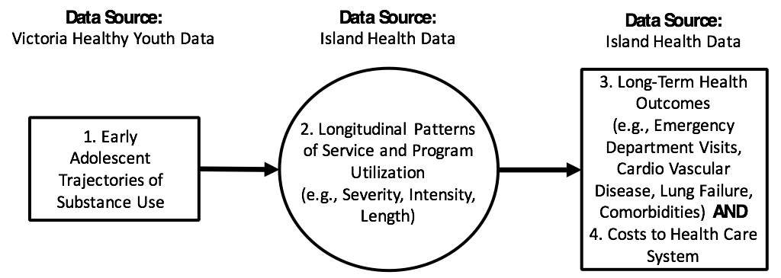

# **Study Approach, Design**

## Phase 1 - Obtain consent from HYS participants and link data

## Phase 2 - Exploratory Analysis: Descriptive statistics of service/program types and utilization amounts. Compare uses by demographic and substance use information.

## Phase 3 - Develop models: (1) Longitudinal trajectories of Substance use; (2) Profiles/patterns of program utilization and predictors of program utilization; (3) Longitudinal health outcomes; (4) Associated health care costs to province.

## Phase 4 - Leverage empirical evidence to develop a screening tool that identifies and flags problematic patterns of substance use during adolescence.

## Phase 5 - Testing and updating screening tool to ensure utility. Continue to learn more about health outcomes over time.

## Design, methodology

1. Defining the cohort: HYS Participants
   1. Ages 12 - 18 in 2003; Ages 22 - 28 in 2013
2. Sample size, power considerations: N = 662. Are there enough of the HYS sample utilizing Island Health programs and services.
3. Statistical approach
   1. Use Latent Class Analysis (LCA) and Growth Modeling strategies to identify early patterns and longitudinal trajectories of polysubstance use.
   2. Use Growth Mixture Modeling (GMM) to identify patterns of severity and intensity of service and program utilization.
   3. Use survival analysis to predict time to first adverse health outcomes (e.g., Cardio Vascular Disease), and use growth modeling to examine longitudinal patterns of reoccurring health complications (e.g., Commodities).
   4. Other considerations: Use propensity weighting (not matching) to adjust for age cohort differences (T1: 12 – 18). Multiple imputation to address missing data. Use accelerated longitudinal designs to use age as the measurement for time.
4. Mental Health and Substance Use programs, Acute Care, Emergency Department Encounters
5. Products – Develop early substance use screening tool that identifies adolescent risk for adverse long-term health outcomes. Create a prescription model to help doctors identify which children are at risk for adverse long-term health outcomes and that may need specific care

# Data management

1. Clinical Encounter Data to be provided by the Island Health Data warehouse. To be linked with existing V-HYS data.
2. Any physical records, including an encrypted USB stick, will be stored in a locked filing cabinet at Cornett A241 (University of Victoria) when not in use. The principal researcher will store the electronic data on 3 password-protected computers, which will be located at 3 locations (Cornett A241, Cornett A204, and Cornett A209). Only the researchers identified will have access to these computers.
3. We are requesting information to enable record linkage of 662 youth from the Victoria Healthy Youth Survey. We are requesting linkage using data available from the V-HYS: V-HYS ID, student first name, student last name, and date of birth. These data were collected during the first wave of the survey, in 2003. We will provide the V-HYS ID, names, and dates of birth for data linkage. The record linkage will yield the Linkage File of PHNs and the V-HYS ID that will then be used to link to the requested Island Health variables. The linkage file will not be provided to the researcher. In the final data files, the PHN will be deleted and the V-HYS ID retained to enable the researcher to link Island Health files with V-HYS survey files.
4. Linkage Steps:  
   Step 1: Researcher will provide Island Health with a secure file containing: V-HYS ID, student first name, student last name and date of birth from the Victoria Healthy Youth Survey data.

Step 2: Island Health will conduct the linkage using requested variables: Date of Birth, First Name, Last Name, and PHN. This linkage will yield a Linkage File containing PHNs and V-HYS IDs all other variables will be deleted.

Step 3: Island Health will use the Linkage File (PHN and V-HYS ID) to prepare approved Island Health data. The PHN will be removed and the V-HYS ID retained in final Island Health data files to be provided to the researcher.

Step 4: The researcher will use the V-HYS ID to link Island Health data to the Healthy Youth Survey data.

# Consent, Protection of Privacy

1. Consent: HYS participants will be contacted to provide consent for their de-identified Island Health information to be linked to their survey responses
2. In the Healthy Youth Survey dataset, each participant has a unique ID. We used this ID, instead of name, to store and analyse the data. This means that the data are stored and analysed in de-identified form. Analysts do not have access to the identifying key. Once we have received the requested variables along with V-HYS ID, we will link the requested variables to the existing six waves of Healthy Youth Survey data using our Healthy Youth Survey ID. We will also store the requested variables with Healthy Youth Survey ID only, not participant name. This ensures that participants cannot be identified from either the requested education records, or the Healthy Youth Survey data.
3. The benefits of linking the requested health records to the existing V-HYS data on an individual level are that we will be able to use these records to examine their links to later outcomes. Without linking on an individual level, we would not be able to carry out the proposed research. The data matching will not be harmful to the individuals because we will not publish or disclose individual-level data. All our data are analysed in de-identified form, and our results are published in the form of aggregate or summary statistics (e.g., means, regression coefficients). Therefore, it is impossible to identify individuals from the data or the published results, or to look up data for a particular individual.

# Data Retention

Data retention to comply with University of Victoria policy, Island Health policy, and TCP2 guidelines.

# Publication of Results

The results will be submitted to academic journals for publication.

# Reference

The Canadian Task Force on Cannabis Legalization and Regulation. (2016). *A Framework for the Legalization and Regulation of Cannabis in Canada*. Canada. Retrieved from http:// healthycanadians.gc.ca/task-force-marijuana-groupe-etude/framework-cadre/index-eng.php