**SWITCHING:**

Switching means forwarding of data. There are three switching techniques:

1. Circuit switching
2. Packet switching
3. Message switching

These methods of switching are used to connect multiple communicating devices with one another. The key difference between circuit switching and packet switching is that packet switching is connectionless, whereas circuit switching is connection-oriented.

1. **Circuit Switching**

Circuit switching is defined as the method of switching which is used for establishing a dedicated communication path between the sender and the receiver. The link which is established between the sender and the receiver is in the physical form. An analog telephone network is a well-known example of circuit switching. Bandwidth is fixed in this type of switching.

**Advantages and Disadvantages of Circuit Switching**

**Advantages**

* The bandwidth used is fixed.
* The quality of communication is increased as a dedicated communication channel is used.
* The rate at which the data is transmitted is fixed.
* While switching, no time is wasted in waiting.
* It is preferred when communication is long and continuous.

**Disadvantages**

* Since dedicated channels are used, the bandwidth required is more.
* The utilization of resources is not full.
* Since a dedicated channel has been used, the transmission of other data becomes impossible.
* The time taken by the two stations for the establishment of the physical link is too long.
* Circuit switching is expensive because every connection uses a dedicated path establishment.
* The link between the sender and the receiver will be maintained until and unless the user terminates the link. This will also continue if there is no transfer of data taking place.

1. **Packet Switching**

Packet switching is defined as the connectionless network where the messages are divided and grouped together and this is known as a packet. Each packet is routed from the source to the destination as individual packets. The actual data in these packets are carried by the payload. When the packet arrives at the destination, it is the responsibility of the destination to put these packets in the right order.  Let us know in detail about the advantages and disadvantages of packet switching.

**Advantages and Disadvantages of Packet Switching**

**Advantages**

* There is no delay in the delivery of the packets as they are sent to the destination as soon as they are available.
* There is no requirement for massive storage space as the information is passed on to the destination as soon as they are received.
* Failure in the links does not stop the delivery of the data as these packets can be routed from other paths too.
* Multiple users can use the same channel while transferring their packets.
* The usage of bandwidth is better in case of packet switching as multiple sources can transfer packets from the same source link.

**Disadvantages**

* Installation costs of packet switching are expensive.
* The delivery of these packets becomes easy when complicated protocols are used.
* High-quality voice calls cannot use packet switching as there is a lot of delay in this type of communication.
* Connectivity issues may lead to loss of information and delay in the delivery of the information.

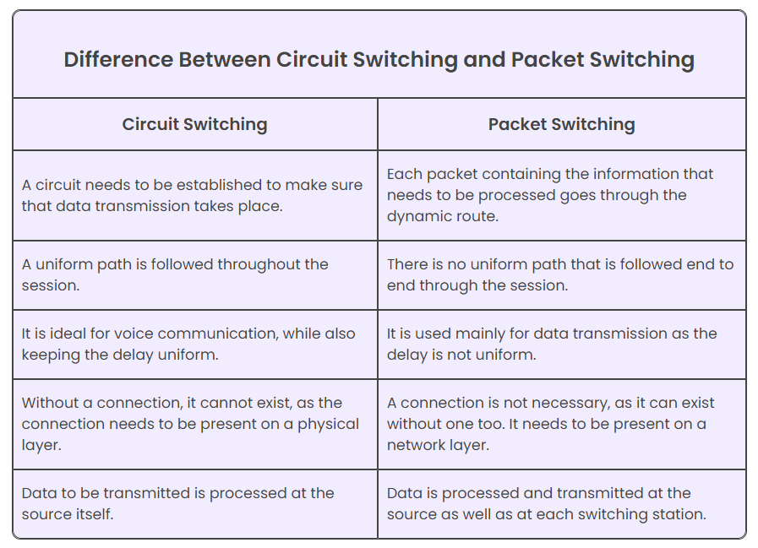

1. **Message Switching**

Message switching is a connectionless network switching technique where the entire message is routed from the source node to the destination node, one hop at a time. It was a precursor of packet switching. Message switching treats each message as an individual unit. Before sending the message, the sender node adds the destination address to the message. It is then delivered entirely to the next intermediate switching node. The intermediate node stores the message in its entirety, checks for transmission errors, inspects the destination address and then delivers it to the next node. The process continues till the message reaches the destination.

In the switching node, the incoming message is not discarded if the required outgoing circuit is busy. Instead, it is stored in a queue for that route and retransmitted when the required route is available. This is called store and forward network.

The following diagram represents routing of two separate messages from the same source to same destination via different routes, using message switching.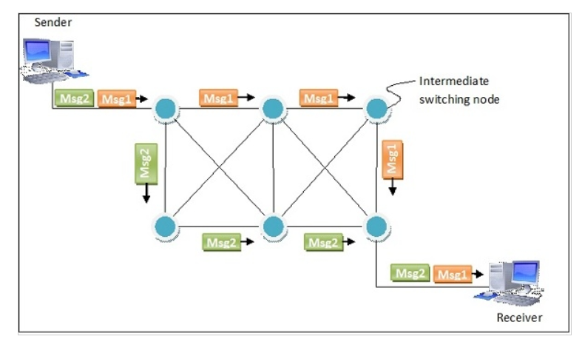

## Advantages and Disadvantages of Message Switching

## Advantages

* Sharing of communication channels ensures better bandwidth usage.
* It reduces network congestion due to store and forward method. Any switching node can store the messages till the network is available.
* Broadcasting messages requires much less bandwidth than circuit switching.
* Messages of unlimited sizes can be sent.
* It does not have to deal with out of order packets or lost packets as in packet switching.

## Disadvantages

* In order to store many messages of unlimited sizes, each intermediate switching node requires large storage capacity.
* Store and forward method introduces delay at each switching node. This renders it unsuitable for real time applications.

| **Basics** | **Circuit Switching** | **Message Switching** | **Packet Switching** |
| --- | --- | --- | --- |
| Connection Creation | Connection is created between the source and destination by establishing a dedicated path between source and destination. | Links are created independently one by one between the nodes on the way. | Links are created independently one by one between the nodes on the way. |
| Queuing | No queue is formed. | Queue is formed. | Queue is formed. |
| Message and Packets | There is one big entire data stream called a message. | There is one big entire data stream called a message. | The big message is divided into a small number of packets. |
| Routing | One single dedicated path exists between the source and destination. | Messages follow the independent route to reach a destination. | Packets follow the independent path to hold the destination. |
| Addressing and sequencing | Messages need not be addressed as there is one dedicated path. | Messages are addressed as independent routes are established. | Packets are addressed, and sequencing is done as all the packets follow the independent route. |
| Propagation Delay | No | Yes | Yes |
| Transmission Capacity | Low | Maximum | Maximum |
| Sequence Order | Message arrives in Sequence. | Message arrives in Sequence. | Packets do not appear in sequence at the destination. |
| Use Bandwidth | Wastage | Bandwidth is used to its maximum extent. | Bandwidth is used to its maximum extent. |