LAN Architectures
The LAN architecture is what determines how the network is connected and how its components communicate with each other. Its primary purpose is to ensure that the LAN functions properly and efficiently.

Wired LANs: Some popular LAN architectures are discussed below:

- Ethernet Architecture
- Ethernet is the most popular LAN technology.
-large installed base (500 million Ethernet nodes)
-more than 95% of LAN traffic is Ethernet based
- Ethernet supports 10 Mb/s, 100 Mb/s (Fast Ethernet), 1 Gb/s (Gigabit Ethernet) and 10 Gb/s(10GbE)
- Ethernet standardized by IEEE (802.3 standard series)
- Ethernet uses CSMA/CD as a medium access protocol
- Widespread popularity
-Specifications and rights to build and install Ethernet made easily available to everyone
-Design goals: create a simple network topology with efficient shared resources, easy to configure and maintain, compatible across many manufacturers and systems
-Ethernet is competitively priced

Standardization of Ethernet
  - In 1983, IEEE released first Ethernet standard (10 Mb/s) based on 50Ω thick coaxial cable in bus topology
  - In 1990, major advancement with unshielded twisted pair (UTP) copper transmission medium (IEEE 802.3 10BASE-T)
  - Only point-to-point connections allowed in 10BASE-T
  - Repeater regenerates data received from one cable and retransmit signal at all output cables to all users

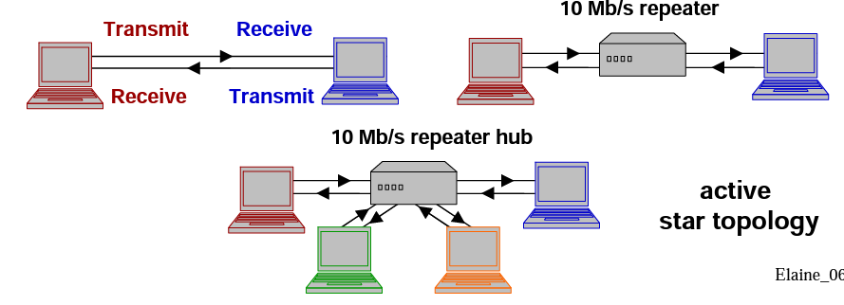

Carrier Sense Multiple Access with Collision Detection (CSMA/CD)

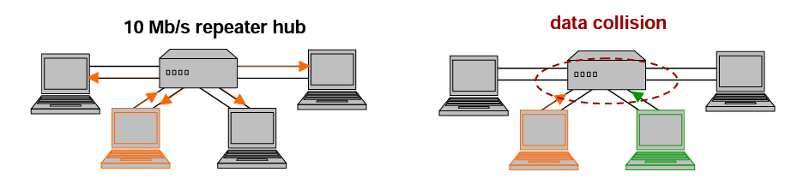

- CSMA/CD protocol minimizes data collision.
- Working of CSMA/CD:
1. Listen for activity on medium (carrier-sense)
2. If no activity, send data frame immediately (multiple access)
3. While transmitting, listen to medium for collision (collision detect)
4. If collision is detected, stop transmission and send jamming signal
5. After random time period, retransmit data by repeating step1.

IEEE STANDARDS
IEEE 802.2 (topology independent), IEEE 802.3 (based on Ethernet), and IEEE 802.5 (based on token ring) are the most commonly used IEEE 802 standards.
The IEEE 802.3 Physical layer definition describes signaling methods (both baseband and broadband), data rates, media, and topologies. Several Physical layer variants also have been defined. Each variant is named following a convention that states the signaling rate (10, 100 or 1000) in Mbps, baseband (BASE) or broadband (BROAD) mode, and a designation of the media characteristics.
The following list details the IEEE 802.3 variants of transmission media:

- 10Mb/s Ethernet (Simple Ethernet)
- 10 BASE 5: Typically called Thick Ethernet, or Thicknet, this variant uses a large diameter (10mm) “thick” coaxial cable with a 50-ohm impedance. A data rate of 10Mbps is supported with a signaling range of 500 meters per cable segment on a physical bus topology.
- 10 BASE 2: Similar to Thicknet, this variant uses a thinner coaxial cable that can support cable runs of 185 meters. (In this case, the “2” indicates only an approximate cable range.)
- The transmission rate remains at 10Mbps, and the physical topology is a bus. This variant typically is called Thin Ethernet, or Thinnet.
- 10 BASE-T: This variant uses UTP cable in a star physical topology. The signaling rate remains at 10Mbps, and devices can be up to 100 meters from a wiring hub.
- 10 BROAD 36: This broadband standard supports channel signal rates of 10Mbps. A 75-ohm coaxial cable supports cable runs of 1,800 meters (up to 3,600 meters in a dual-cable configuration) using a physical bus topology.
- 10 BASE-F: This variant uses fiber-optic cables to support 10Mbps signaling with a range of 4 kilometers. Three subcategories include 10BASE-FL (fiber link), 10BASE-FB (fiber backbone), and 10BASE-FP (fiber passive).

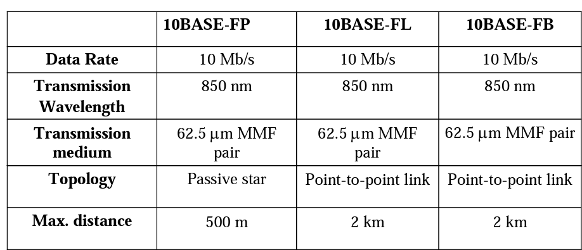

- 100 Mb/s Ethernet (Fast Ethernet)
- In 1995, IEEE improved performance of Ethernet by a factor of 10 with 100 Mb/s standard (Fast Ethernet)
- 100 BASE T: This proposed standard is similar to 10BASE-T but supports 100Mbps data rates.
- 100 BASE 5: This proposed standard is similar to 10BASE5 but supports 100Mbps data rates.
- 100 BASE 2: This proposed standard is similar to 10BASE2 but supports 100Mbps data rates.
- 100 BASE-X: This proposed standard is similar to 10BASE-T but supports 100Mbps data rates. One physical layer specification for the optical fiber transmission medium: 100BASE-FX
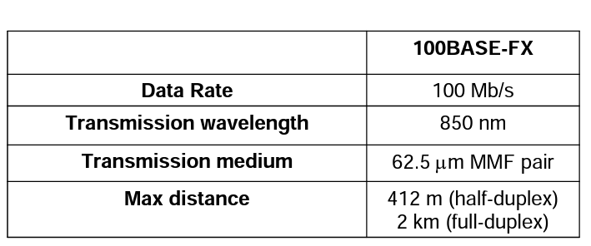

- 1 Gb/s Ethernet (Gigabit Ethernet)
- In 1998, IEEE improved performance of Ethernet by a factor of 10 with 1 Gb/s standard (Gigabit Ethernet, GbE)
- Target application: backbone LAN
- Half-duplex and full-duplex operation
- 1000 BASE T: This proposed standard is similar to 10BASE-T but supports 1000Mbps data rates.
- 1000 BASE 5: This proposed standard is similar to 10BASE5 but supports 1000Mbps data rates.
- 1000 BASE 2: This proposed standard is similar to 10BASE2 but supports 1000Mbps data rates.
- 1000 BASE-X: This proposed standard is similar to 10BASE-F but supports 1000Mbps data rates. Two GbE physical layer specifications for optical fiber transmission: 1000BASE-SX, 1000BASE-LX
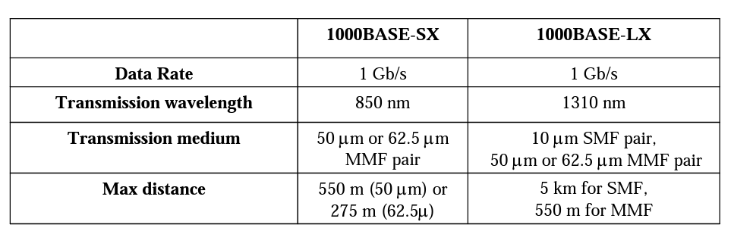

- Token Ring Archiecture
- The Token Ring architecture was developed in the mid-1980s by IBM.
- Token Ring specifications are governed by the IEEE 802.5 standards.
- It use the token-passing access method.
- It can be implemented with a physical ring, or can be a logical ring with a physical star topology.
- The logical ring represents the token's path between computers. The actual physical ring of cable is in the hub.
- A Token Ring network includes the following features:
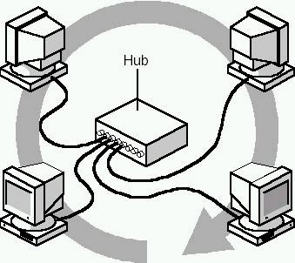
    - Star-wired ring topology
    - Token-passing access method
    - Shielded and unshielded twisted-pair cabling
    - Transfer rates of 4 and 16 Mbps
    - Baseband transmission
- In a pure token-passing network (with ring topology), a computer that fails, stops the token from continuing. This in turn brings down the network.
- In the logical ring , a hub is designed to detect a failed NIC, and to disconnect from it.
- This procedure bypasses the failed computer so that the token can continue on.
- Therefore, a faulty computer or connection will not affect the rest of the Token Ring network.
- The hub in the Token Ring networks does not function like a shared Ethernet hub.
- The Token Ring method is more deterministic and ensures that all users get regular turns at transmitting their data.
- With Ethernet, all users compete to get onto the network.
- Working of Token Ring Network:
  - When the first Token Ring computer comes online, the network generates a token.
  - The token is a predetermined formation of bits (a stream of data) that permits a computer to put data on the cables.
  - The token travels around the ring polling each computer until one of the computers signals that it wants to transmit data and takes control of the token.
  - A computer cannot transmit unless it has possession of the token; while the token is in use by a computer, no other computer can transmit data.
  - After the computer captures the token, it sends a data out on the network.
  - The frame proceeds around the ring until it reaches the computer with the address that matches the destination address in the frame.
  - The destination computer copies the frame into its receive buffer and marks the frame in the frame status field to indicate that the information was received.
  - The frame continues around the ring until it arrives at the sending computer, where the transmission is acknowledged as successful.
  - The sending computer then removes the frame from the ring and transmits a new token back on the ring.
  - Only one token at a time can be active on the network, and the token can travel in only one direction around the ring.

Monitoring the System
- The first computer to come online is assigned by the Token Ring system to monitor network activity.
- The monitoring computer makes sure that frames are being delivered and received correctly. It does this by checking for frames that have circulated the ring more than once and ensuring that only one token is on the network at a time.
- Also the process of monitoring called beaconing. The active monitor sends out a beacon announcement every seven seconds. The beacon is passed from computer to computer throughout the entire ring.
- If a station does not receive an expected announcement from its upstream neighbor, it attempts to notify the network of the lack of contact.
- It sends a message that includes its address, the address of the neighbor that did not announce, and the type of beacon.
- From this information, the ring attempts to diagnose the problem and make a repair without disrupting the entire network.
- If it is unable to complete the reconfiguration automatically, manual intervention is required.

- Fiber Distributed Data Interface (FDDI) Architecture
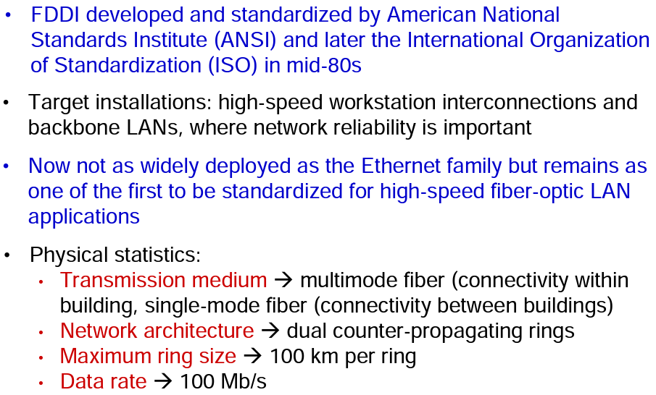
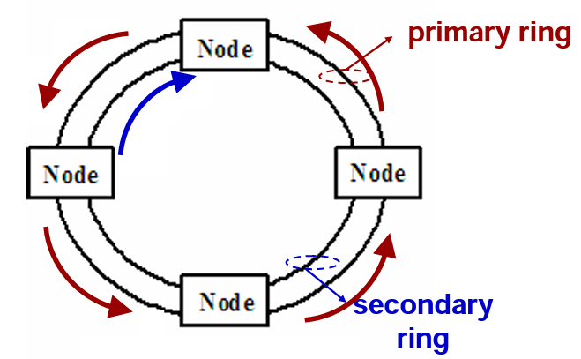

- Each node connected to two rings via four fibers
- During normal operation, data transmitted and received on primary ring
- Data frames passed from one node to another
- FDDI uses token passing as a medium access protocol.
FDDI: Self-Healing Network
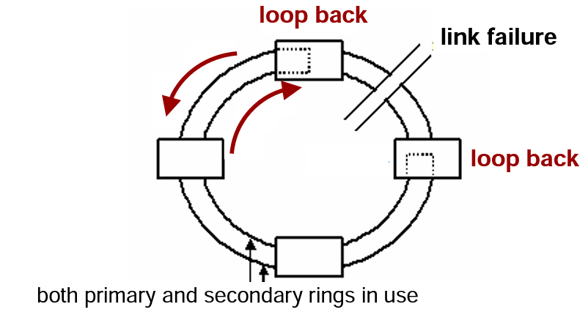

- During node or link failure, secondary ring closes loop to restore all traffic transport
- Self-healing network is fault tolerate and increases network reliability

*****************************************************************************

