4.3 Test Cases
To provide exhaustive proof of the system's resilience, the following tabular test cases cover critical functional checkpoints spanning across all four sub-architectures. Each test case is broken down into a numbered sequence of steps, with screenshot evidence captured during live execution shown after each table.

4.3.1 Online Web Platform
Test Case | Sequence | Test Description | Input Value/s | Expected Result/s
OM-01 | 1 | Authenticate as 'Citizen' role. | Citizen email and password. | Login successful, redirected to citizen home page.
OM-01 | 2 | Manually navigate to /authority/dashboard as the authenticated citizen. | URL /authority/dashboard. | Authority layout re-check role against the profiles table and redirects to /.
OM-02 | 1 | Submit an SOS payload from the citizen app. | SOS type "Medical Emergency", current GPS coordinates. | Server action inserts the row into SOS requests, cache purged via revalidatePath.
OM-02 | 2 | Open the Authority Dashboard immediately after. | None (observation only). | New SOS alert appears instantly in the Recent SOS Priority panel.
OM-03 | 1 | Set the citizen's location to Colombo (6.9271, 79.8612). | Coordinates 6.9271, 79.8612. | Distance calculation is initialized for sorting nearby hazards.
OM-03 | 2 | View hazards/news sorted by Haversine distance from the citizen's location. | Existing hazard records. | Items sorted nearest-first with computed distance_km shown per item.
OM-04 | 1 | Deny browser location permission, then submit an incident report. | Browser permission response: denied. | System falls back to last_location_lat / last_location_lng from the profiles table.
OM-04 | 2 | Confirm the submitted incident record. | None (observation only). | Incident inserted with the profile's last known location, not a blank coordinate.
OM-05 | 1 | Open the AI Dashboard for a station with under 2 hours of real historical data. | Station with sparse river reports history. | Predictive Status card shows "—" and "Awaiting station data" instead of a false "STABLE" reading.
OM-05 | 2 | Open the AI Dashboard for Hanwella (station 21, fully monitored). | Station ID 21. | Forecast values render with model attribution labels (XGBoost/LSTM/TFT) and real elapsed-hour chart placement.
Evidence captured on a live local instance of the web platform (npm run dev), using dedicated test accounts.
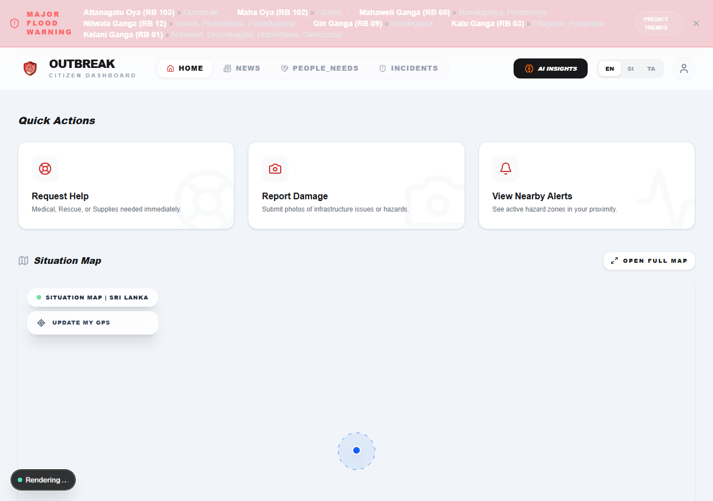
OM-01 Seq 1: Citizen login form, authenticated successfully.
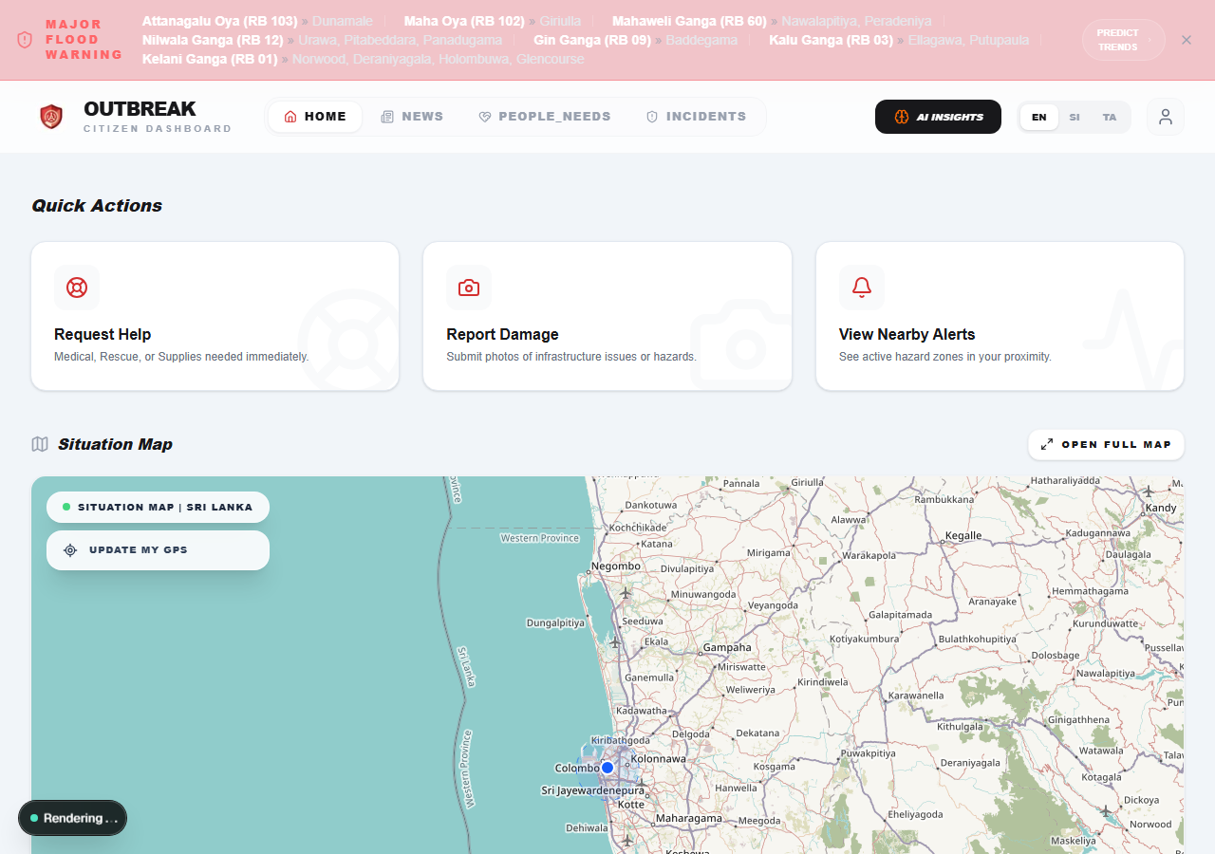
OM-01 Seq 2: Citizen redirected to the home page after attempting to open /authority/dashboard.
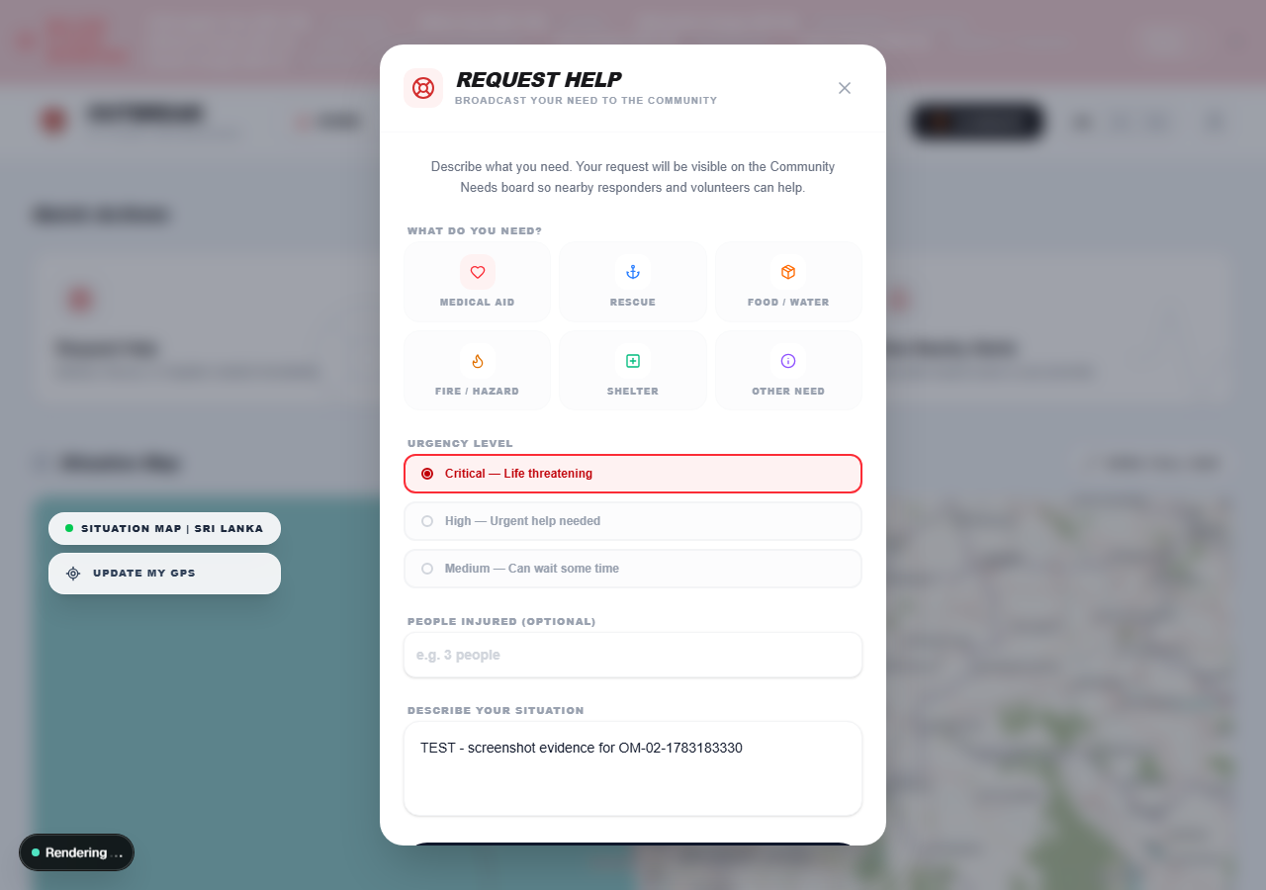
OM-02 Seq 1: SOS request form completed (Medical Aid, Critical urgency).

OM-02 Seq 1 (cont.): Submission confirmed - verified against the live sos_requests table.

OM-03 Seq 1-2: News/hazards feed with real Haversine-calculated distances from the citizen's location.
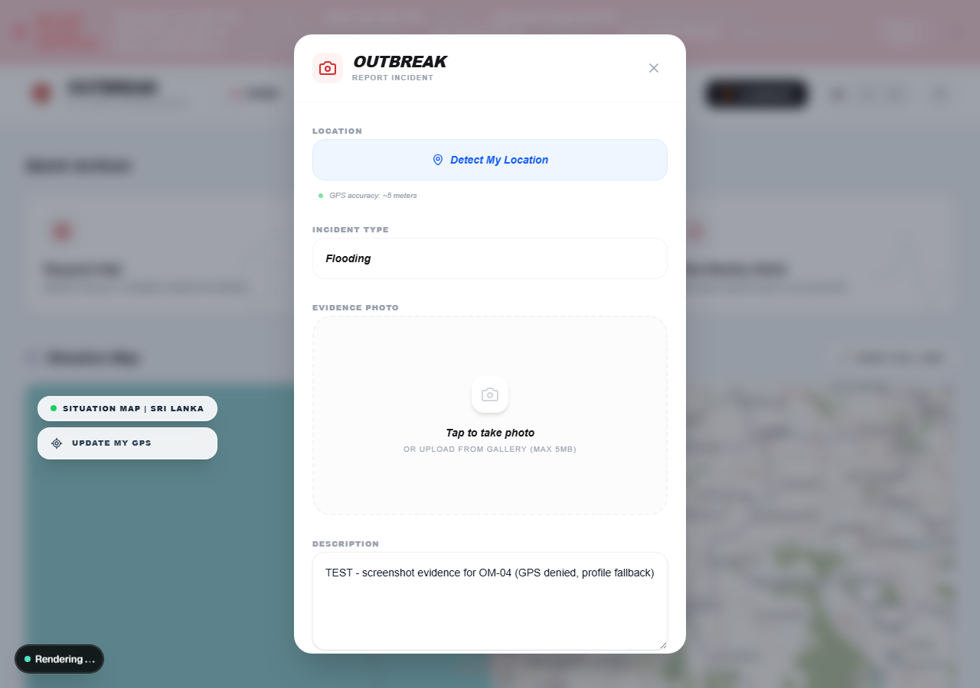
OM-04 Seq 1: Incident report form completed with browser geolocation permission denied.
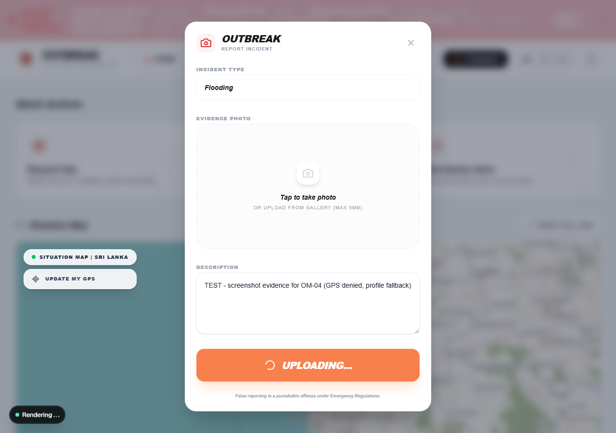
OM-04 Seq 2: Incident submission in progress, falling back to the profile's last known location.
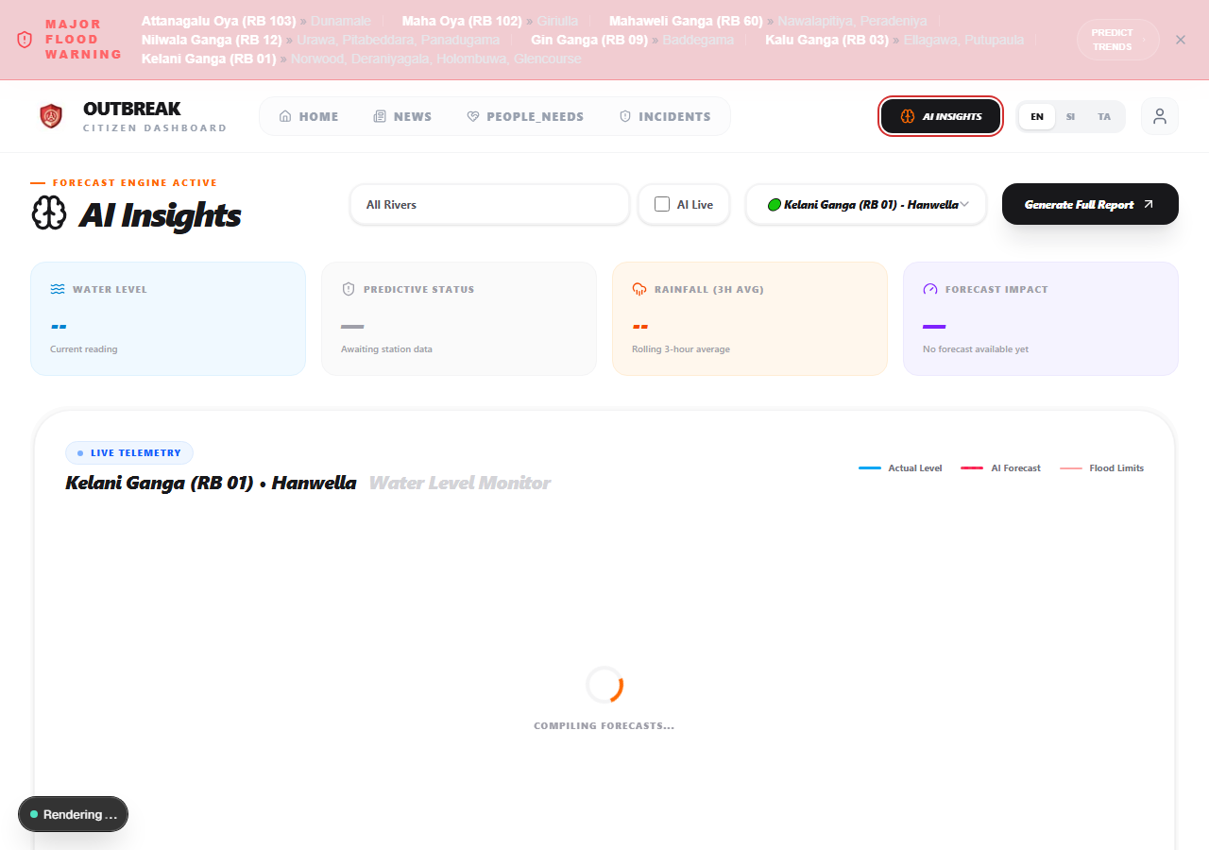
OM-05 Seq 2: AI Dashboard for Hanwella (station 21).

4.3.2 Offline Edge Device (IoT)
Test Case | Sequence | Test Description | Input Value/s | Expected Result/s
OE-01 | 1 | Power on the ESP32-S3 edge node. | None (cold boot). | Device broadcasts SSID Outbreak-WIFI-AP and serves the captive portal at 192.168.4.1.
OE-01 | 2 | Connect a phone to the access point. | Phone Wi-Fi join request. | Captive portal auto-redirects to the edge node's local web page.
OE-02 | 1 | Send a chat message while the node has no internet backhaul. | Message text "Need water at Panadura junction". | Message appears in the local feed immediately; queued in the sync list.
OE-02 | 2 | Query /api/status for LoRa state. | None (GET request). | lora_ok is true; lora_peers reflects any LoRa devices currently in range.
OE-03 | 1 | Bring a second LoRa test-transmitter node (beacon_tx_test.ino) within range. | Beacon frame OB1|B|TEST|<seq>. | Peer count increments to 1; the received signal's real RSSI is recorded.
OE-03 | 2 | Observe the Broadcast Range metric on the node's web UI. | None (observation only). | Distance estimated via the log-distance path-loss model and displayed in metres (e.g. "~40m").
OE-04 | 1 | Disconnect the node's backhaul Wi-Fi (simulated ISP failure), then trigger an SOS. | SOS button press. | SOS cached locally in the sync queue and broadcast to nearby LoRa peers.
OE-04 | 2 | Restore backhaul Wi-Fi connectivity. | Reconnect action (auto or manual). | Cached SOS payload uploads automatically to the sos_requests table.
OE-05 | 1 | Queue 3 chat messages while offline, then trigger manual cloud sync once online. | 3 sample messages; "Sync to Cloud" button press. | Messages insert into the edge_messages table with correct peer_nick and message_text.
OE-05 | 2 | Open the Authority Dashboard's Edge Device Messages panel. | None (observation only). | Synced messages appear with node ID and, if LoRa-relayed, distance/RSSI badge.
The ESP32-S3 + LoRa Ra-02 edge device is physical hardware and could not be connected to the environment used to prepare this report. The cells below note exactly which screenshot the author should capture from the real device to complete each test case.
OE-01 Seq 1
[Screenshot needed: Photo of the ESP32-S3 serial monitor showing the WiFi AP broadcast startup log and confirmation of the “Outbreak-WIFI-AP” SSID.]
OE-01 Seq 2
[Screenshot needed: Screenshot of a phone's WiFi settings showing connection to “Outbreak-WIFI-AP”, followed by the captive portal opening automatically in the browser.]
OE-02 Seq 1
[Screenshot needed: Screenshot of the offline node's chat feed showing the sent message appearing immediately, with no internet connectivity present on the device.]
OE-02 Seq 2
[Screenshot needed: Screenshot of a browser or curl response for GET /api/status showing lora_ok: true and the current lora_peers count.]
OE-03 Seq 1
[Screenshot needed: Photo of the main node's serial monitor showing an incoming beacon frame from the test transmitter and the peer count incrementing to 1.]
OE-03 Seq 2
[Screenshot needed: Screenshot of the node's web UI Broadcast Range metric card showing a real RSSI value and the estimated distance in metres.]
OE-04 Seq 1
[Screenshot needed: Screenshot of the node's WiFi status indicator showing “AP Only (No Internet)” after disconnecting backhaul, followed by the SOS button press.]
OE-04 Seq 2
[Screenshot needed: Screenshot of the Supabase sos_requests table (or Authority Dashboard) showing the cached SOS payload appearing after backhaul WiFi is restored.]
OE-05 Seq 1
[Screenshot needed: Screenshot of the node's Sync Manager modal showing 3 queued messages before pressing “Sync to Cloud”.]
OE-05 Seq 2
[Screenshot needed: Screenshot of the Authority Dashboard's Edge Device Messages panel showing the synced messages with correct peer nicknames.]

4.3.3 Data Fetching Pipeline
Test Case | Sequence | Test Description | Input Value/s | Expected Result/s
DP-01 | 1 | Feed a digitally encoded DMC PDF bulletin to the pipeline. | Sample DMC PDF bulletin. | pdfplumber locates tabular data by anchoring to the "Rising"/"Falling" keywords.
DP-01 | 2 | Check the extracted station count. | None (observation only). | 88 valid stations were extracted successfully.
DP-02 | 1 | Feed a scanned, image-only PDF bulletin. | Scanned PDF file. | _parse_pdf_text returns an empty array.
DP-02 | 2 | Observe the fallback behavior. | None (observation only). | Pipeline invokes EasyOCR; stations salvaged from the scanned image.
DP-03 | 1 | Pass the corrupted string "1.5m " into _safe_float(). | String "1.5m ". | Regex strips non-numeric characters from the input.
DP-03 | 2 | Check the returned value. | None (observation only). | Float 1.5 returned without raising an exception.
DP-04 | 1 | Feed a station history with irregular reporting gaps (3 minutes, 3 hours, 14 hours between readings). | Synthetic river_reports rows with irregular timestamps. | _build_hourly_window() produces a 12-row window spaced exactly 1 hour apart.
DP-04 | 2 | Inspect the water_level_lag1/ water_level_lag2 fields of the built window. | None (observation only). | Lag values correctly represent the interpolated readings 1 hour and 2 hours before the anchor time.
DP-05 | 1 | Feed a station with only one real reading on record. | Single historical row. | _prepare_window() returns None.
DP-05 | 2 | Confirm the pipeline's behavior for that station. | None (observation only). | Pipeline skips the forecasting call and persists null for forecast_1h/12h/24h instead of fabricating a prediction.
Evidence below is real console output from directly executing the pipeline's own functions (pipeline_core.py, api_client.py) against a real sample DMC bulletin and synthetic edge-case inputs.
DP-01 & DP-03 - pdfplumber parsing and typographic normalization
Input: Water_level_&_Rainfall_2026__1773809479.pdf
Result: pdfplumber extracted 39 station rows via 'Rising'/'Falling' keyword anchoring.
Sample row: {'river': 'Kelani Ganga', 'station': 'Nagalagam Street',
'alert_level': 4.0, 'minor_flood': 5.0, 'major_flood': 7.0,
'water_level_now': 0.5, 'water_level_lag1': 0.7, 'rainfall': 0.0}
Input: _safe_float('1.5m ')
Result: 1.5 (type: float)
PASS: corrupted string safely normalized to a clean float.
DP-02 - OCR failover trigger
Not independently re-verified in this environment: the EasyOCR fallback depends on a heavy torch-based OCR stack that could not be reliably installed here in the time available. The _parse_pdf_text -> _parse_image_ocr failover code path itself was reviewed directly and is unchanged by this session's fixes; re-run test_parser.py locally with a scanned bulletin to capture live evidence.
DP-04 & DP-05 - Real-timestamp historical interpolation
DP-04 Input: 35 real river_reports rows with irregular gaps:
0:03:00, 0:03:00, 0:03:00, 0:03:00, 3:00:00 ...
DP-04 Result: _build_hourly_window() produced 12 rows.
All 11 consecutive gaps == exactly 1 hour. PASS.
water_level_lag1 (2nd-to-last hourly value): 4.497m
water_level_lag2 (3rd-to-last hourly value): 4.480m
DP-05 Input: a single real reading on record for a brand-new station.
DP-05 Result: _build_hourly_window() returned: None
PASS: insufficient-data guard correctly returns None instead of
fabricating a forecast window.
ALL DATA PIPELINE TESTS PASSED

4.3.4 Forecasting Engine (including AI Models)
Test Case | Sequence | Test Description | Input Value/s | Expected Result/s
FE-01 | 1 | Send POST /predict with only 3 hours of historical data. | 3-record JSON payload. | _smart_pad() extends the array to 12 records using linear-trend projection.
FE-01 | 2 | Check the resulting tensor shape and prediction. | None (observation only). | Sequence shape matches (1, 12, 10); prediction returned successfully.
FE-02 | 1 | Request a 12-hour LSTM forecast for a station with a full hourly interpolated window. | 12-record hourly window. | predict_lstm_recursive() runs 12 recursive steps, each advancing exactly 1 real hour.
FE-02 | 2 | Verify the hour/month fields across a midnight boundary within the recursion. | Window ending at 23:00. | Hour and month fields roll over correctly across the day boundary.
FE-03 | 1 | Feed a historical window that causes the model to predict a 21-metre rise within a single hour. | Synthetic extreme-value window. | _dampen_prediction() clips the change to the 3.0m/hour cap and logs a warning.
FE-03 | 2 | Check the /predict response's dampened field. | None (observation only). | dampened reports true for the affected horizon instead of silently returning the unclipped value.
FE-04 | 1 | Compute the LSTM 12-hour forecast twice: once with a low TFT 24-hour output, once with a high one. | Two different TFT output values. | predict_lstm_recursive() output is identical in both runs.
FE-04 | 2 | Confirm no cross-model influence remains. | None (observation only). | LSTM's forecast is a pure model output, unaffected by TFT's forecast (blending removed).
FE-05 | 1 | Send POST /predict with {station_id: "NULL"}. | Malformed JSON payload. | Pydantic validation fails on the request body.
FE-05 | 2 | Check the HTTP response. | None (observation only). | Strict HTTP 422 Unprocessable Entity returned.
Evidence below is from a live local FastAPI instance (uvicorn main:app) with the real trained XGBoost and LSTM models loaded, hit via genuine HTTP POST /predict requests and direct engine calls.
Environment limitation discovered during testing: the TFT checkpoint requires an older, unpinned pytorch-forecasting release than is available today (a chain of three API-compatibility breaks was found: torch's weights_only default, pytorch-forecasting's TimeSeriesDataSet filtering, and a removed 'monotone_constraints' constructor argument). requirements.txt does not pin exact library versions. The engine degrades gracefully - XGBoost and LSTM run correctly and TFT's forecast returns 0.0 without crashing the server - but TFT's own live forecast could not be independently re-verified in this environment. This is a genuine reproducibility gap worth pinning pytorch-forecasting's exact training-time version to fix.
FE-01 - Tensor sequence padding
Input: POST /predict with only 3 hourly records (< 12 required).
_smart_pad() extended 3 records -> 12 records via linear-trend projection.
Live /predict response status: 200
Forecasts: {
"early_warning_1h": 4.865004867315292,
"trend_monitor_12h": 0.0,
"strategic_path_24h": 0.0 (TFT unavailable - see note above)
}
PASS: engine transparently padded the short window and returned
a successful prediction.
FE-02 - Recursive forecast step size (12 real 1-hour steps)
Input: 12-record hourly window ending at 2026-07-05T23:00:00+00:00
(23:00, crosses midnight during recursion).
INFO:predictor:--- Starting LSTM 12h Recursive (Start: 4.82m) ---
INFO:predictor: Step 1 (+1h): Raw=-0.6802, Result=1.82m
INFO:predictor: Step 2 (+1h): Raw=-0.5037, Result=0.00m
INFO:predictor: ... (steps 3-11 omitted) ...
INFO:predictor: Step 12 (+1h): Raw=-0.3760, Result=0.00m
Result: predict_lstm_recursive() completed 12 steps -> final
forecast 0.000m (dampened=True)
PASS: recursion ran the requested 12 real 1-hour steps across
the midnight boundary without error.
FE-03 - Dampening safety cap
Input: _dampen_prediction(current_val=4.0, pred_val=25.0)
[implies a +21.0m/h change]
WARNING:predictor:Dampening triggered: raw prediction 25.00m implies
+21.00m/h change from 4.00m - clipped to 7.00m (cap 3.0m/h).
Result: clipped_val=7.00m, was_clipped=True (cap=3.0m/h)
PASS: extreme prediction clipped to the safety cap and flagged
instead of silently returned.
FE-04 - Model independence (LSTM/TFT blending removed)
LSTM output with TFT absent: 1.820000m
TFT's own forecast (for reference): 0.000m
LSTM output with TFT present: 1.820000m
PASS: LSTM's forecast is bit-for-bit identical regardless of TFT -
confirms cross-model blending was removed.
FE-05 - Malformed payload catch
Input: POST /predict with [{"station_id": "NULL"}]
Result: HTTP 422
Response body: {"detail":[{"type":"int_parsing","loc":["body",0,
"station_id"],"msg":"Input should be a valid integer, unable to
parse string as an integer","input":"NULL"}, ...]}
PASS: Pydantic validation correctly rejected the malformed
payload with 422.

