Theory under potential flow equations for free surface problems
Title 2
Title 3
Sergio Fernández Ruano
02/11/2022

Abstract
Lorem ipsum.

Content
1 Simbols 4
2 Definitions 4
3 Description of the problem 4
4 Goberning equations 4
4.1 Derivation of potential flow equation. 4
4.2 Boundary conditions 7
4.2.1 Kinematic boundary condition 7
4.2.2 Bottom boundary condition 8
4.2.3 Kinematic free surface boundary condition 9
4.2.4 Dynamic free surface boundary condition 10
4.2.5 Radiation condition 10
4.3 Linear boundary conditions 11
5 Frequency domain 13
5.1 Linearized BVP 13
5.1.1 Free surface 13
5.1.2 Body boundary condition 14
5.1.3 Seabed boundary condition 14
5.1.4 Radiation condition 14
5.1.5 Summary 14
5.2 Pulsating source 15
5.2.1 Derivation of the pulsating source 15
5.2.2 Source term 16
5.2.3 Image source term 16
5.2.4 Wave term 17
6 Greens Identity 18
6.1 Source term. 19

Simbols
BVP: boundary value problem
$f$: external force field
$ρ$ : fluid density
$\overset{⃑}{u}$ : velocity vector field. $\overset{⃑}{u}(x,y,z,t)= u\left(x, y, z,t\right)\overset{⃑}{i}+v\left(x, y,z,t\right)\overset{⃑}{j}+w(x,y,z,t)\overset{⃑}{k}$
$u$: velocity in x direction $u(x, y, z,t)=\frac{dx}{dt}$
$v$: velocity in x direction. $v(x, y,z,t)=\frac{dy}{dt}$
$w$: velocity in x direction. $w(x,y,z,t)=\frac{dz}{dt}$

Definitions
Definition 1. Divergence theorem
The divergence theorem states that the surface integral over a closed surface is equal to the volume integral of the vector field divergence in the volume.

$$\iiint_{V}{\left(∇·\overset{⃑}{F}\right) dV}= ∯_{S}{\overset{⃑}{F}·\overset{⃑}{n} dS}$$ | (1)

Definition 2. Newtonian Fluid:
A fluid is Newtonian only if the tensors that describe the viscous stress and the strain rate are related by a constant viscosity tensor that does not depend on the stress state and velocity of the flow.

Description of the problem
Introduce the problem to resolved.

Seakeeping of offshore structures and waves propagation…

Goberning equations

Derivation of potential flow equation.
The Navier-Stokes equations are one of the most accurate description of the Newtonian fluids (see Definition 2). Navier-Stokes equations relate the intertial and viscous forces of the fluid with the external forces acting into the fluid. The Navier-Stokes equations describe mathematically the conservation of mass (see Equation (2)) and conservation of the momentum (see Equation (3)).

$$ρ·\frac{∂ρ}{∂t}+\frac{∂\left(ρ·u\right)}{∂x}+\frac{∂\left(ρ·v\right)}{∂y}+\frac{∂\left(ρ·w\right)}{∂y}$$ | (2)

$$ρ·\frac{D\overset{⃑}{u}}{Dt}=ρ·\frac{∂\overset{⃑}{u}}{∂t}+ρ·\overset{⃑}{u}·∇\overset{⃑}{u}= -∇p+μ·∆\overset{⃑}{u}+f$$ | (3)

If the flow is assumed to be isotropic and incompressible the continuity equation can be simplified to
$$\frac{∂u}{∂x}+\frac{∂v}{∂y}+\frac{∂w}{∂z}=0→∇\overset{⃑}{u}=0$$ | (4)

The result is that divergence of the vector field $\overset{⃑}{u}$ is equal to zero. In some applications the influence of the viscous forces is limited and comparatively lower than the interial forces. Therefore, it is possible to remove the influence of the viscous forces obtaining the Euler equation. (see (5))
$$ρ·\frac{∂\overset{⃑}{u}}{∂t}+ρ·\overset{⃑}{u}·∇\overset{⃑}{u}= -∇p+f$$ | (5)

Even for the Euler equation where there is no viscosity, the vorticity might appear due to non-conservative forces and it may be propagated in 3D due the vortex-stretching. The difference with NS is that the vorticity is not convected due to viscous accion and that there is no vorticity appearing due to
The last assumption it can be done is to assume that the velocity might derive from a potential function (see equation (6)).

$$u=\frac{∂Φ}{∂x} ;v=\frac{∂Φ}{∂y} ;w=\frac{∂Φ}{∂z} → \overset{⃑}{u}=∇Φ$$ | (6)

This will lead to the so call irrotational condition. The reason is that the curl of a gradient is zero. Therefore, there is no possible way to propagate the vorticity across the fluid.

$$∇×\overset{⃑}{u}=∇× \left(∇Φ\right)=0$$ | (7)

Equation (6) can be inserted into Equation (4) to obtain the Laplace equation, which will model the potential flow

$$∇\overset{⃑}{u}=∇\left(∇Φ\right)=∆Φ=0$$ | (8)

In order to relate the velocity and the pressure across the fluid the Bernoulli equation will be used. To derive the Bernouilly equation, the Euler equation (5) will be employed. First the vector identity shown in equation XXX will be used

$$\overset{⃑}{u}·∇\overset{⃑}{u}=\frac{∇{\overset{⃑}{u}}^{2}}{2}- \overset{⃑}{u}×\left(∇× \overset{⃑}{u}\right)$$ | (9)
Taking into account that the flow field derives from a potential function, equation (9) can be written as

$$\overset{⃑}{u}·∇\overset{⃑}{u}=\frac{∇{\overset{⃑}{u}}^{2}}{2}$$ | (10)

Therefore the Euler equation (5) can be written as

$$\frac{∂\overset{⃑}{u}}{∂t}+\frac{∇{\overset{⃑}{u}}^{2}}{2}= -\frac{1}{ρ}∇p+\frac{f}{ρ}$$ | (11)
By assuming that the body force $f$ can be expressed as a conservative force of the potential $E$
$$f= -∇E$$ | (12)

And also using the velocity potential (see (6)) for the velocity time derivative term, the Euler equation can be written as:

$$∇\left(\frac{∂Φ}{∂t}\right)+\frac{∇{\overset{⃑}{u}}^{2}}{2}= -\frac{1}{ρ}∇p+\frac{-∇E}{ρ}$$ | (13)

Rewriting the equation (13) in terms of the gradient

$$∇\left(\frac{∂Φ}{∂t}+\frac{{\overset{⃑}{u}}^{2}}{2}+\frac{p}{ρ}+\frac{E}{ρ}\right)=0$$ | (14)

Equation (14) is only true if the the quantity in between the parenthesis is a function of time only

$$\frac{∂Φ}{∂t}+\frac{{\overset{⃑}{u}}^{2}}{2}+\frac{p}{ρ}+\frac{E}{ρ}=C(t)$$ | (15)

This is because $∇C\left(t\right)=0$, there is no spatial dependence of $C(t)$ term. In our case the potential $E$ can be described as

$$E=ρ·g·z$$ | (16)

Therefore, the final form of the Bernouilly equation can be expressed as

$$\frac{∂Φ}{∂t}+\frac{{\overset{⃑}{u}}^{2}}{2}+\frac{p}{ρ}+g·z=C(t)$$ | (17)

If the flow is steady, equation (17) can be simplied to

$$\frac{{\overset{⃑}{u}}^{2}}{2}+\frac{p}{ρ}+g·z=C$$ | (18)

In this case $C=constant$.

Boundary conditions

Kinematic boundary condition
In order to close the problem there will be necessary to impose boundary conditions. This boundary conditions will be of the type “impermeable”. That means that the flow cannot cross the boundary, all the flow must be parallel to it. If the flow could go through the boundary that would mean that there is no boundary surface there.

To impose this boundary condition is necessary to use a robust and general way to impose that. The mathematical expression for the boundary condition may be derived from the mathematical expression of the surface. This mathematical expression may be of the form $F\left(x,y,z,t\right)=0$.

If the surface changes with time, the total derivative of the surface with respect to time would be zero on the surface. This is a consecuence of the “impermeability” condition.

$$\frac{DF(x,y,z,t)}{Dt}=0={\left.\frac{∂F}{∂t}+u·\frac{∂F}{∂x}+v·\frac{∂F}{∂y}+w·\frac{∂F}{∂z}\right|}_{on F\left(x,y,z,t\right)=0}$$ | (19)

Rearranging equation (19) and using vector notation:

$$-\frac{∂F}{∂t}=\overset{⃑}{u}·∇F$$ | (20)

The gradient of the surface function can be expressed in function of the normal vector to the surface and the modulus of the gradient

$$\overset{⃑}{n}= \frac{∇F}{\left|∇F\right|}$$ | (21)

Where the gradient modulus can be expressed as:
$$\left|∇F\right|= \sqrt{{\left(\frac{∂F}{∂x}\right)}^{2}+{\left(\frac{∂F}{∂y}\right)}^{2}+{\left(\frac{∂F}{∂z}\right)}^{2}}$$ | (22)

Therefore, by combining equations (20), (21) and (22) and rearranging:

$$\frac{-\frac{∂F}{∂t}}{\left|∇F\right|}=\overset{⃑}{u}·\overset{⃑}{n}$$ | (23)

Bottom boundary condition
The seafloor is an impermeable boundary where the flow cannot penetrate though it. The reference system is located in the free surface (see Figure 1, therefore the seafloor will be located at negative $z$ values.

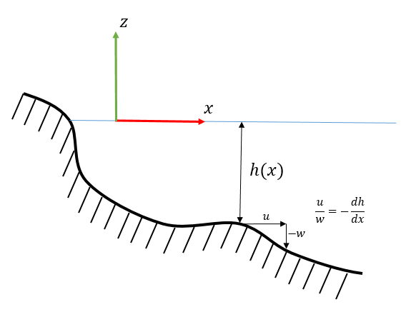

Figure 1. Bottom boundary condition
The seafloor surface function will be expressed as:

$$F\left(x,y,z,t\right)=z+h\left(x, y\right)=0$$ | (24)

And its gradient as

$$∇F=\frac{∂h\left(x,y\right)}{∂x}·\overset{⃑}{i}+\frac{∂h\left(x,y\right)}{∂y}·\overset{⃑}{j}+\overset{⃑}{k}$$ | (25)
By combining equations (23) and (25); and taking into account that the bottom is threated as a solid steady boundary (earthquake influence is disregarded)

$$u·\frac{∂h\left(x,y\right)}{∂x}+v·\frac{∂h\left(x,y\right)}{∂y}+w=0$$ | (26)

In the case were the seafloor can be modelled as a horizontal and flat surface, equation (26) simplifies to

$$w=0$$ | (27)

Kinematic free surface boundary condition
The free surface can be described in terms of a function $F\left(x,y,z,t\right)=z-η\left(x,y,t\right)=0$.
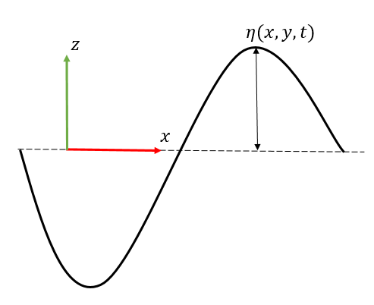
Figure 2. Free surface function description

The gradient of the free surface function can be expressed as

$$∇F=-\frac{∂η}{∂x}·\overset{⃑}{i}- \frac{∂η}{∂y}·\overset{⃑}{j}+ ·\overset{⃑}{k}$$ | (28)

By inserting equation (28) on equation (23) it yields to

$${\left.\frac{∂η}{∂t}= -u·\frac{∂η}{∂x}- v·\frac{∂η}{∂y}+ w\right|}_{on z=η(x,y,t)}$$ | (29)

Dynamic free surface boundary condition
Free surface is modelled as a surface but as a differenc of the bottom surface or the floating bodies surface, it can be deformed due to pressure oscillations. The surface of the floating ship is modelled as a rigid surface, it cannot be deformed by the action of the water pressure. In the case of the free surface, it must be modelled as an interface affected by the pressure changes at both sides in order to have a good representation of it.

This requierement can be satisfied by modelling the pressure as uniform along all the wave form. This can be modelled by using Bernouilli equation (17).

$$\frac{∂Φ_{η}}{∂t}+\frac{1}{2}·\left[{\left(\frac{∂Φ_{η}}{∂x}\right)}^{2}+{\left(\frac{∂Φ_{η}}{∂y}\right)}^{2}+{\left(\frac{∂Φ_{η}}{∂z}\right)}^{2}\right]+\frac{p_{η}}{ρ}+g·η=C(t)$$ | (30)

The pressure along all the wave form must be constant, so it is possible to select the gauge pressure $p_{η}=0$ in order to simplify the equations.

Radiation condition
In some cases it is necessary to have the waves going out of the domain to avoid energy concentration. The radiaton condition imposes that the waves at the lateral boundaries must be propagating waves going out of the domain. This boundary conditions can be expressed as:

$$\lim_{R→∞}{\sqrt{R}}·\left(\frac{∂Φ}{∂R}+k·Φ\right)$$ | (31)
Where:
- $R=\sqrt{x^{2}+y^{2}+z^{2}}$
- $k$: is the wave number
- $Φ$: flow potential function

Linear boundary conditions
In section 4.2 the non-linear free surface kinematic and dynamic boundary conditons were developed. In this section this boundary conditions will be linearized in order to simplify the equations. This will allow to derive theoretical functions in future sections that will be very usefull.

The linearization process will start with the kinematic free surface boundary conditions. Equation (29) can be expanded as a Taylor series around $z=0$.

$${\left(KBC\right)}_{z=η(x,y,t)}= {\left(KBC\right)}_{z=0}+η·\frac{∂}{∂z}{\left(KBC\right)}_{z=0}+…=0$$ | (32)
Where KBC is defined in equation (33) in order to show clearly the Taylor expansion series.
$$KBC= -\frac{∂η}{∂t} -u·\frac{∂η}{∂x}- v·\frac{∂η}{∂y}+ w$$ | (33)

Retaining only those terms that are linear with the small parameters of $u$, $w$ and $η$.

$$w={\left.\frac{∂η}{∂t}\right|}_{z=0}$$ | (34)

Or by expressing the $w$ velocity in terms of the flow potential

$$-\frac{∂Φ}{∂z}= {\left.\frac{∂η}{∂t}\right|}_{z=0}$$ | (35)

The linearization of the dynamical boundary conditions may be performed in a similar way of the kinematic boundary conditions. Equation (30) will be expanded as a Taylor expansion series around $z=0$.

$${\left.BE\right|}_{z=η}= {\left.BE\right|}_{z=0}+η·\frac{∂}{∂z}{\left(BE\right)}_{z=0}+…=C(t)$$ | (36)
Where BE is defined as:

$$BE= \frac{∂Φ_{η}}{∂t}+\frac{1}{2}·\left[{\left(\frac{∂Φ_{η}}{∂x}\right)}^{2}+{\left(\frac{∂Φ_{η}}{∂y}\right)}^{2}+{\left(\frac{∂Φ_{η}}{∂z}\right)}^{2}\right]+\frac{p_{η}}{ρ}+g·η=C(t)$$ | (37)

Retaining only those terms that are linear and disregarding those ones dependent on small parameters of $η$

$${\left(\frac{∂Φ}{∂t}+gη\right)}_{z=0}=C(t)$$ | (38)

Rearraning last equation and takin $C\left(t\right)=0$ ($η$ will have a zero spatial and temporal mean).

$$η= -{\left.\frac{1}{g}\frac{∂Φ}{∂t}\right|}_{z=0}$$ | (39)

If equations (35) and (39) are combined together, the expression for the linear free surface boundary condition can be expressed in one single equation

$$\frac{∂Φ}{∂z}-\frac{1}{g}\frac{∂^{2}Φ}{{∂t}^{2}}=0$$ | (40)

Frequency domain
The wave-structure interaction problem can be described as a function of the interacting frequency. This will allow to recover the properties of the system in function of the diferent modes of vibration of the incoming waves. This methodology is quite advantageous because after the calculation of the properties of the system the total response of the structure can be recovered by combing the information for the different interacting frequencies. The frequency domain approach is conceptually similar to the eigenmode approach in structural analysis.

To perform such calculations is combient to work with the linearized problem. In this way, the summation of solutions will be also a solution to the problem. This will allow to obtain complex solution from the most simple ones.

Linearized BVP
The linearlized boundary value problem is comprised of the Laplace equation (see section 4.1)Derivation of potential flow equation. and the corresponding boundary conditions. In the wave-structure interaction problem the boundary conditions must be imposed over different boundaries of the domain, see Figure 3.
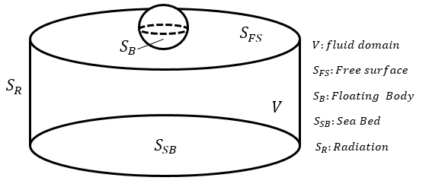
Figure 3. Frequency domain. Linearized BVP. Boundaries description.

Free surface
The free surface boundary condition applied to the linearized problem is described in section 4.3. This boundary condition imposes kinematic restricions, the fluid particles cannot cross the boundary, and also dynamic equilibrium over the surface, the pressure must be constant along it. Its final linearized form is shown in equation (40).

Body boundary condition
The body boundary condition is imposed over the surface of the floating body. The floating body is impermeable so the flow velocity cannot be perpendicular to the body surface. This boundary condition can be expressed as:

$$∇Φ·\overset{⃑}{n}=0$$ | (41)
Where $\overset{⃑}{n}$ is the local normal vector at the body surface point of evaluation.

Seabed boundary condition
Seabed boundary condition can be imposed in a similar way as the body boundary conditions. In section 4.2.2, the seabed boundary condition was derived for a general form seabed. In the linearized frequency domain calculations the seabed will be assumed to be flat. Therefore, the seabed boundary condition can be expressed as

$$\lim_{z→ -h}{∇Φ}$$ | (42)

Radiation condition
The radiation condition imposes that the waves far away from the floating body are always progressive outgoing waves. This condition prevents from having energy concentration on the fluid domain. The radiation boundary condition was first proposed by Sommerfeld in the field of electromagnetic waves. The mathematical expression for this condition is shown in equation (31).

Summary

- $∆Φ=0$  $$2. ∇Φ·\overset{⃑}{n}=0, on S_{b}$$  $$3. \frac{∂Φ}{∂z}-\frac{1}{g}\frac{∂^{2}Φ}{{∂t}^{2}}=0, on S_{FS}$$  $$4. \lim_{z→ -h}{∇Φ}, on S_{SB}$$  $$5. \lim_{R→∞}{\sqrt{R}}·\left(\frac{∂Φ}{∂R}+k·Φ\right)$$ | (43)

Pulsating source
Laplace equation is a second order linear equation. This means that the sum of solutions is also a solution. This property of Laplace equation is used conveniently in the formulation of the pulsating source. This kind of source may be expressed in a general form as as the sum of three independent terms

$$PS=\frac{1}{R}+\frac{1}{R_{1}}+FS_{r}+iFS_{i}$$ | (44)

The pulsating source is composed of three terms. Each term has been designed to fullfill some of the conditions imposed by the linear BVP. Therefore, the sum of all of them gives the solution to the BVP. The three terms will be classified below and be described along this section:
- Soure term: $\frac{1}{R}$
- Image source term: $\frac{1}{R_{1}}$
- Wave term: $FS_{r}+i FS_{i}$

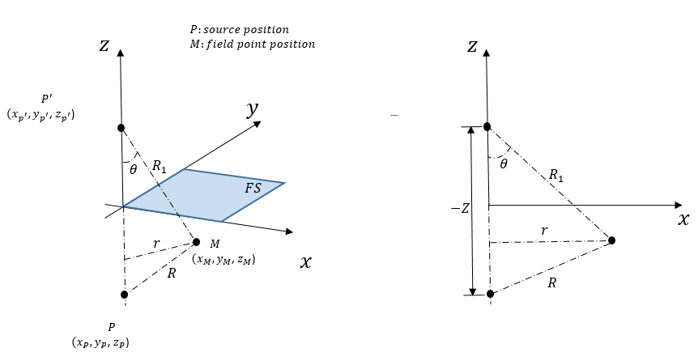
Figure 4. Source and field points positions.

Derivation of the pulsating source
The pulsating source is derived from the BVP definied at

Source term
The source term is a basic solution of the Laplace equation and it is also refered as a Rankine source. The mathematical definition of it is shown in equation (45). It is the inverse of the distance between the source and the field point.
$$ϕ= \frac{1}{R}=\frac{1}{\sqrt{{\left(x_{M}-x_{P}\right)}^{2}+{\left(y_{M}-y_{P}\right)}^{2}+{\left(z_{M}-z_{P}\right)}^{2}}}$$ | (45)

The source term generates a flow field that is going out of the point where the source is located.

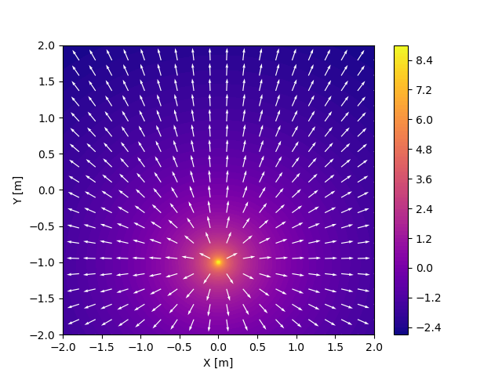
Figure 5. Flow field. Rankine source.

Image source term
The image source term behaviour is similar to the behaviour of the image term, it can be idealized as a point where the flow is going out. It is also a basic solution of the Laplace equation. The difference comes in the position of the source. The image source is located above the water line as an specular image (see Figure 4). The role of the image source term is to prevent to have vertical velocities on the free surface. This is achieved by summing up the source and the image terms. As they have the same intensity and are at the same distance of the free surface the vertical velocities are cancelled out (see Figure 6).

$$ϕ_{1}= \frac{1}{R_{1}}=\frac{1}{\sqrt{{\left(x_{M}-{x_{P}}^{'}\right)}^{2}+{\left(y_{M}-{y_{P}}^{'}\right)}^{2}+{\left(z_{M}-{z_{P}}^{'}\right)}^{2}}}$$ | (46)

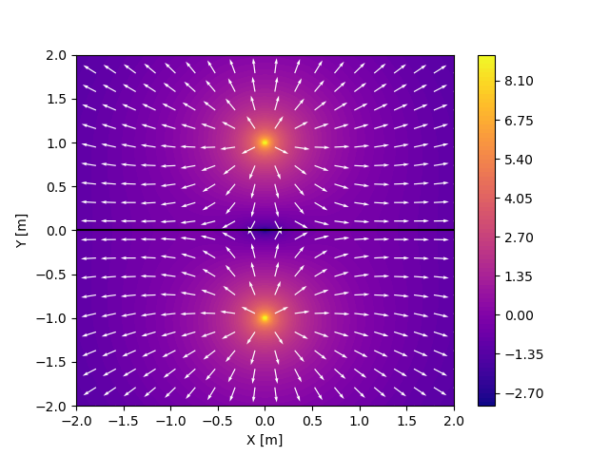
Figure 6. Flow field. Rankine source and its specular image (black line is the waterline).

Wave term
The wave term may be expressed in serveral forms. This different representations of the wave terms comes from the formulations obtained by several authors during the 50’ and 60’. The most convenient formulation depends on the application and use of the pulsating source.
The wave term is obtained from the solution of the following boundary value problem (43) (see

Greens Identity
The BVP defined at (44) can be solved by means of analytical methos (form very simple geometries) or by means numerical methods for more complex geometries. In the case of numerical methods, there exists three main fields methods that can be used to solve the problem: Finite Difference Method, Finte Volume Method or Finite Element Method. Field methods are quiete powefull but they have the drawback that it is necessary to mesh all the domain in order to solve the BVP.

In order to reduce the computational cost it is possible to reduce the field problem to a problem restricted to the boundary. This conversion can be performed through the Green’s identity (referencia Kellog). The Green’s identity can be derived from the divegerce theorem (see Definition 1). The vector $\overset{⃑}{F}$ can be replaced by the vector

$$\overset{⃑}{F}= Φ_{1}·∇Φ_{2}-Φ_{2}·∇Φ_{1}$$ | (47)

Where $Φ_{1}$ and $Φ_{2}$ are two scalar functions of position. Inserting equation (47) into equation (1)

$$\iiint_{V}{Φ_{1}·∆Φ_{2}-Φ_{2}·∆Φ_{1} dV}= ∯_{S}{\left(Φ_{1}·∇Φ_{2}-Φ_{2}·∇Φ_{1}\right)·\overset{⃑}{n} dS}$$ | (48)

Equation (48) is one of the Green’s identities. Here the surface integral is taken over all boundaries of the problem. $Φ_{1}$ and $Φ_{2}$ are two scalar functions that are solutions of the Laplace equation.

If $Φ_{1}$ and $Φ_{2}$are solution of the Laplace equation, the left hand side of the equation (48) is zero because $∆Φ_{1}=0$ and $∆Φ_{2}=0$. Therefore, equation (48) can be expressed as:

$$∯_{S}{\left(Φ_{1}·∇Φ_{2}-Φ_{2}·∇Φ_{1}\right)·\overset{⃑}{n} dS}=0$$ | (49)

The pulsating source is composed of three componets (see section 5.2). Each of the components satisfy the Laplace equation, so it is possible to use equation (49) with them. In the following, sub-sections it will be studied how is obtained the contribution of each component to the Green’s function expression. To obtain the contribution of each pulsating source term to Green’s function the function $Φ_{1}$ will be assumed as the potential of each term of the pulsating source. The function $Φ_{2}$ will assumed to be the potential of the flow in the region of interest $V$.

The boundary surface of the enclosed volume in Figure 3 is composed of four contributions

$$S=S_{B}+S_{FS}+S_{SB}+S_{R}$$ | (50)

The pulsating source expression satisfies the boundary conditions at the free surface, at the seabed and at infinity when the waves shall be outgoing. Therefore, there is still one boundary condition to satisfy. It is on the body surface.

$$S=S_{B}$$ | (51)

Source term.
The potential due to the source term is given by equation (46). Inserting it in equation (49) the following expression is obtained

$$∯_{S_{B}}{\left(\frac{1}{R}·∇Φ_{2}-Φ_{2}·∇\left(\frac{1}{R}\right)\right)·\overset{⃑}{n} dS}=0$$ | (52)

$R$ is the distance from the source to field point. Therefore, if the field point is over the source point the surface integral defined in equation (52) could not be defined due to the singularity of the integrand.

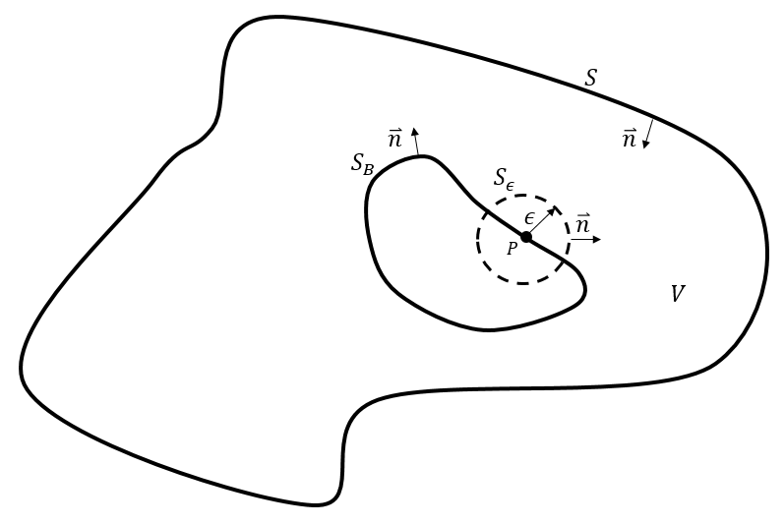
Figure 7. Simplified domain
Imagine the simplified case described in Figure 7. The fluid domain is enclosed by a surface $S$ where the boundary conditions are satisfied by the source $P$. The fluid domain $V$ has a body fully immersed on it. The body has a source $P$ over its surface. To check if its possible to locally remove the singularity created by the source point $P$, a small sphere of radius $ϵ$ is created around it. In this case the equation (52) gets the form

$$∯_{S_{B}+S_{ϵ}}{\left(\frac{1}{R}·∇Φ_{2}-Φ_{2}·∇\left(\frac{1}{R}\right)\right)·\overset{⃑}{n} dS}=0$$ | (53)

Breaking the surface integral into two integrals

$$∯_{S_{B}}{\left(\frac{1}{R}·∇Φ_{2}-Φ_{2}·∇\left(\frac{1}{R}\right)\right)·\overset{⃑}{n} dS}+ ∯_{S_{ϵ}}{\left(\frac{1}{ϵ}·∇Φ_{2}-Φ_{2}·∇\left(\frac{1}{ϵ}\right)\right)·\overset{⃑}{n} dS}=0$$ | (54)

To evaluate the right term of the equation (54) is better to use spherical coordinates, where
- $\overset{⃑}{n}=e_{r}$
- $∇Φ_{2}=\frac{∂Φ_{2}}{∂r}$
- $∇\left(\frac{1}{ϵ}\right)=\frac{1}{ϵ^{2}}e_{r}$
- $dS=R^{2}\sin\left(θ\right)dθ dϕ$
Substituting these identities into the right term of equation (54)

$$∯_{S_{ϵ}}{\left(\frac{1}{ϵ}·∇Φ_{2}-Φ_{2}·∇\left(\frac{1}{ϵ}\right)\right)·\overset{⃑}{n} dS}= ∯_{S_{ϵ}}{\left(\frac{1}{ϵ}·\frac{∂Φ_{2}}{∂r}-Φ_{2}·\frac{1}{ϵ^{2}}\right)·ϵ^{2}\sin\left(θ\right)dθ dϕ}= ∯_{S_{ϵ}}{\left(ϵ·\frac{∂Φ_{2}}{∂r}-Φ_{2}\right)·\sin\left(θ\right)dθ dϕ}$$ | (55)
When the radius of the small sphere surrounding the singularity goes to zero $ϵ→0$, the first term in the third equality of equation (55) goes to zero. Therefore, the integral is performed over the second term in the third equality

$$∯_{S_{ϵ}}{{-Φ}_{2}·\sin\left(θ\right)dθ dϕ}= -4πΦ_{2}$$ | (56)

By combining equation (56) with equation (54)

$$Φ_{2}= ∯_{S_{B}}{\left(\frac{1}{R}·∇Φ_{2}-Φ_{2}·∇\left(\frac{1}{R}\right)\right)·\overset{⃑}{n} dS}$$ | (57)

