QUICK USER GUIDE

NAACCR LRI validator
  - Local validation for one HL7 v2.5.1 cancer-pathology message, with an optional online registry-content check.
Browser workflow | September 2026
Scope: This validator is an implementation aid, not an HL7 or NIST certification service. Local syntax validation is offline. The SEER registry-content check is optional and online.

Prerequisites

Download and open
The hosted validator at ihe-sdc-wg.github.io/LRI-Validator is the simplest option. It opens in a browser without a download or local server.
To download a local copy from GitHub:
- Open the LRI-Validator repository.
- Select the green Code button, then select Download ZIP. You can also use the direct main.zip download.
- Find LRI-Validator-main.zip in the folder where your browser saves downloads.
- Extract LRI-Validator-main.zip.
- Open the extracted LRI-Validator-main folder, then open its dist subfolder.
- Open naaccr-lri-validator.html in a current version of Safari, Chrome, Firefox, or Edge.
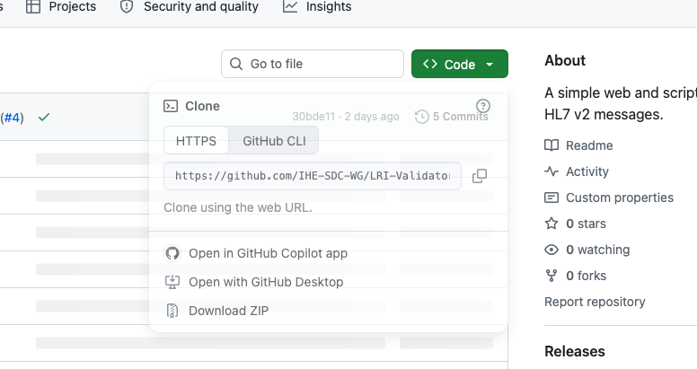
Figure 1. On GitHub, open Code and choose Download ZIP.
File type: The .html extension is intentional. The validator is a local browser application, not a Windows .exe, and it does not require installation. The final path is LRI-Validator-main/dist/naaccr-lri-validator.html.

SEER registry check
The optional registry-content check sends only the message-derived codes and reference identifiers listed before you run it. These codes are sensitive clinical metadata. You need a free SEER API key from api.seer.cancer.gov/login. The full HL7 message and direct identifiers are never sent.

Step 1: Add one message
Open the validator HTML file in a browser. Paste one HL7 message into the editor, or choose one .hl7, .er7, or .txt file. CR, LF, and CRLF line endings are accepted. Complete MLLP framing is removed. Batches and multiple messages are rejected.
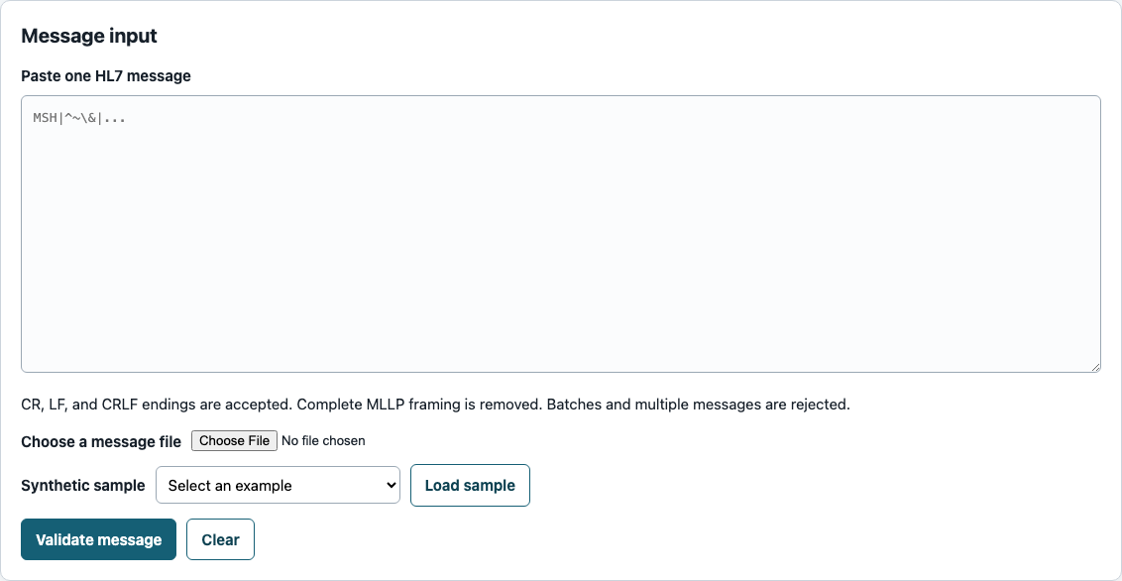
Figure 2. Paste one HL7 message, choose a message file, or load a synthetic sample.

Use a synthetic sample
To learn the interface, choose a report style under Synthetic sample, then select Load sample. The bundled examples use independently synthetic data.
Figure 3. Choose a bundled example, then select Load sample.

Step 2: Validate the message
Select Validate message. A FAIL means that one or more error-level findings require correction. The example below shows Errors first, followed by Warnings.
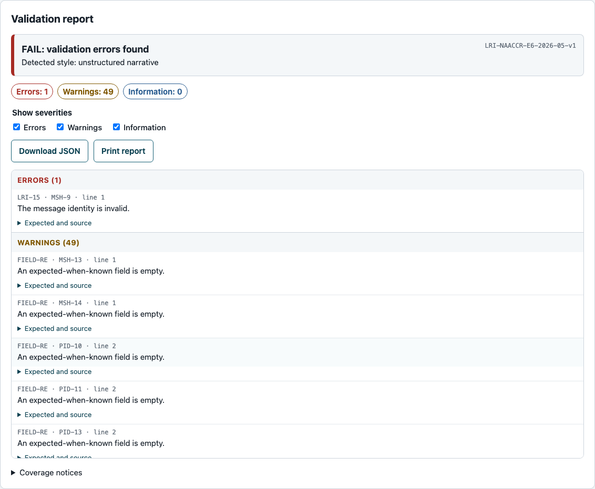
Figure 4. The report groups Errors before Warnings and lists findings by message line within each group.

Step 3: Review and export the local report
The on-screen report groups findings as Errors, Warnings, then Information. Within each group, message-level findings without a line number appear first and line-based findings follow message-line order. Missing required (R) fields are errors. Empty required-but-may-be-empty (RE) fields produce warnings when values are not known. Other rule-specific errors and warnings may also appear.
Use the severity checkboxes to filter findings. Select a compact row to focus its message line. Open Expected and source to read the complete requirement and source section.
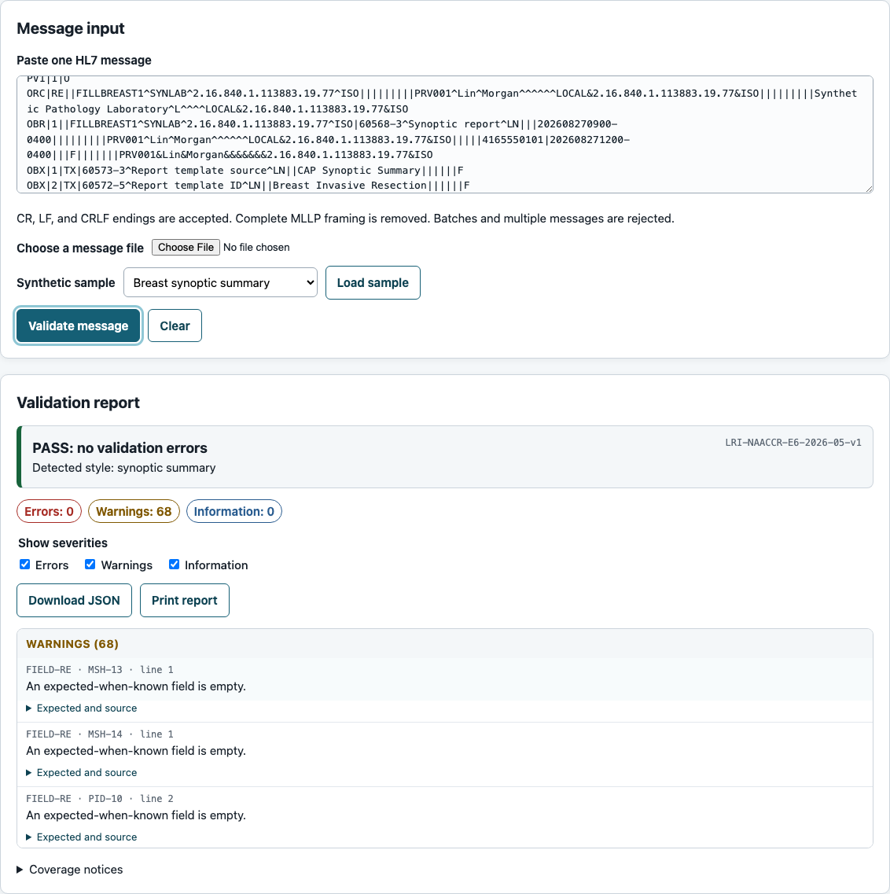
Figure 5. Message input appears above the full-width Validation report.
PASS: No error-level findings were reported. A passing report can still contain warnings.
Download JSON: Save the structured local report. The download omits the raw message and arbitrary clinical text.
Print report: Open the browser print flow. The printed report also omits the message editor.

Step 4: Run the optional registry-content check
After a syntax-valid message yields registry codes, the online panel lists every message-derived item proposed for transmission. Review the values and message lines, enter a SEER API key, then select Check registry content.
Privacy: Only the listed normalized codes and reference identifiers are sent. Grade is checked locally and is not sent. The full HL7 message and direct identifiers are never sent. The codes remain sensitive clinical metadata, and SEER and network operators can observe the API account and source IP address.
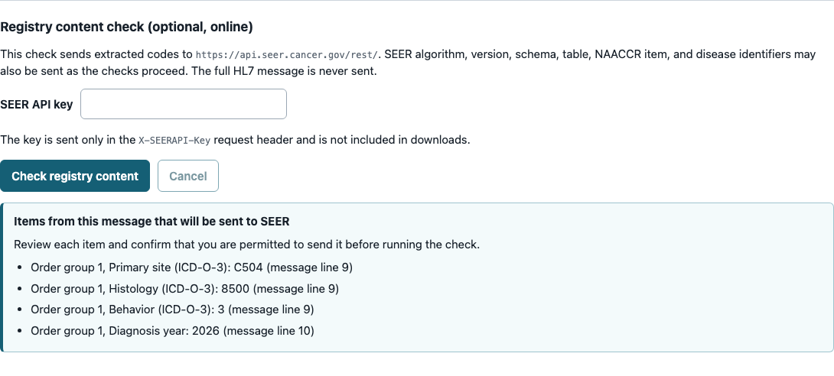
Figure 6. Review every proposed outbound item before starting the online check.
API key: The key stays in memory in the current tab, is sent only in the X-SEERAPI-Key header, and is excluded from downloads. Close the tab on a shared workstation.

Step 5: Review the registry-content result
Review the status and grouped finding counts. Open Expected and source for finding details. Expand a request to inspect its description, method, URL, body, cache state, and HTTP status. Coverage notices describe checks that did not apply or could not run.
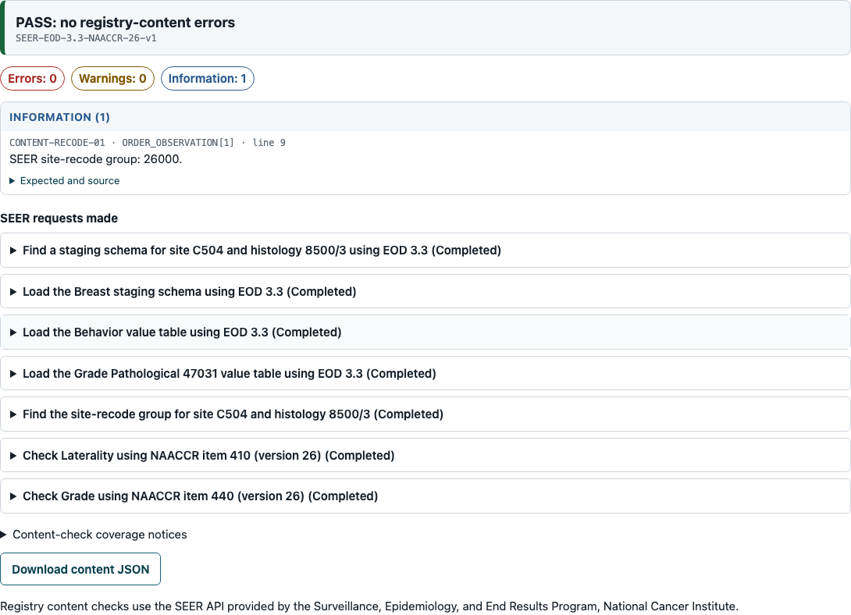
Figure 7. A completed registry-content report groups findings and lists the SEER requests made.
PASS: Every applicable online check finished and no error-level findings were reported.
INCOMPLETE: One or more checks were skipped or failed. This label can appear even when Errors is 0.
Download content JSON: Save the report, normalized registry codes, public SEER response data, and request metadata. The raw message and API key are not included.

