IHE Work Item Proposal (Detailed)

# Proposed Work Item: International Patient Summary (IPS) Profile

Proposal Editor: Michael Nusbaum

Work item co-editors: Michael Nusbaum; *Content Expert from CEN/TC251* (TBA)

xSDO Project Team:

IHE: Lori Fourquet, Andrea Fourquet, Karima Bourguard, Charles Parisot, Tone Southerland, Didi Davis, John Donnelly, Derek Ritz

CEN/TC251 and ISO/TC215: Robert Stegwee, Stephen Kay

HL7: Giorgio Cangioli

SNOMED: Jane Millar

Others, as required

Date: June 25, 2019

Version: 1

Domain: Patient Care Coordination (PCC)

**Summary**

This IPS Profile proposal directly follows a joint project between HL7 and CEN, that has produced a content specification (CEN) and two Implementation Guides (HL7) for CDA and FHIR. The CEN IPS specification is in the final stages of ballot approval, and has been accepted as an ISO/TC215 work item. The HL7 CDA IG has been completed and published as STU, the HL7 FHIR IG, already positively balloted, will be submitted to a new ballot cycle in September 2019 and likely published as STU by the end of 2019.

The IPS Implementation Guide (IG) will greatly benefit from IHE’s profile and testing cycle. The ability to provide a test plan and national extensions can help progress the testability and further development of the IPS. Participation of HL7 and IHE members and a process guide will be necessary for this cycle, to assure that IHE will not be replicating HL7 work. If any gaps are found during this process, they will be submitted to HL7 and CEN as the owners of the underlying IPS IG so that the IPS IG can be updated to incorporate recommended updates.

# The Problem

An **International Patient Summary (IPS) document** is an electronic health record extract containing essential healthcare information about a subject of care. It is specifically aimed at supporting the use case scenario for ‘unplanned, cross border care’. While this is the main use case, the IG is not limited to this. It is intended to be international, i.e., to provide generic solutions for global application beyond a particular region or country.

The IPS dataset is a minimal and non-exhaustive patient summary dataset, specialty-agnostic, condition-independent, but readily usable by clinicians for the cross-border unscheduled care of a patient.

The IPS profile is comprised of a set of robust, well-defined and reusable core data items and a series of workflow steps to facilitate the access to this data at the point of care. Its tight focus on unplanned care is not a limitation, but, on the contrary, enables the IPS profile to be used as common minimal ‘core’ set beyond its initial scope.

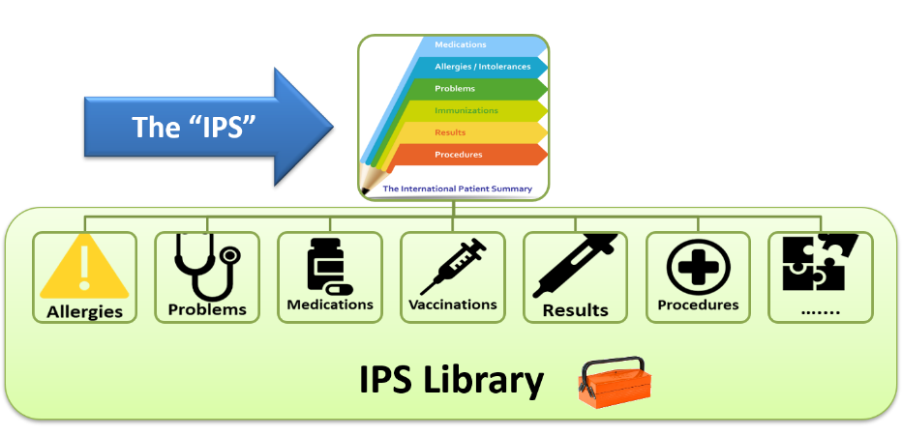

Figure 1 - The IPS product

The goal is to leverage the established clinical data, vocabulary, value sets and implementation guides for the International Patient Summary, in order to profile the entire IPS workflow process with the objective of fostering global vendor adoption.

Profiling the IPS specification will serve to support:

* Cross-jurisdictional patient summaries (through adaptation/extension for multi-language and realm scenarios, including translation).
* Emergency and unplanned care in any country, regardless of language.
* Value sets based on international vocabularies that are usable and understandable in any country.
* Data and metadata for document-level provenance.

**Use cases:**

1. **Unscheduled Care**

A 19-year old college student is attending University is in a study abroad program and is taking a semester abroad. He had fallen off of his bike on his way to class, breaking his left arm. He is transported to a hospital for car. Since this is his first time being treated in this area the hospital needs to access his international patient summary so that they can provide informed care. They find that the patient is mildly allergic to NSAIDs and find an alternative method of pain management for the patient after his arm was splinted.

1. **Scheduled Care**

A 68 year old man schedules a procedure in another country for medical services that are unavailable in their own country. Prior to the surgery the patient met with physician for a checkup and the pre operation process. Since the patient lives outside of this country the physician needed access to the patient’s medical summary so that they can be informed before going into the surgery about and additional issues that this patient has that may affect the surgical process. With this information available the surgery was successful, and the patient carried out his rehab back in his home country.

1. **Cross-border Care**

A 43 year old woman is working with an engineering company is assigned a job for 8 months to train personnel in another country to demonstrate use of polyurethane foam product in hospitals. She has a health examination before she leaves where her new job tasks and potential exposures are noted in her medical record. Four months after starting in this new location she develops respiratory symptoms and is found to have new-onset asthma. The physician at the new location reviews her work history in her Occupational Data for Health and sees that she started a new job 4 months earlier and is exposed to polyurethane foam, components of which are known to cause asthma. The woman is given inhalers to treat these symptoms and provides training to others without engaging in direct demonstration of foam production. The engineering company provides portable ventilation exhaust systems to reduce exposures to other workers. The new diagnosis of asthma related to this occupational hazard is added to her international patient summary.

1. **Within-border Care**

An elderly woman and her husband are visiting their new grandchild in another part of the country. During their visit, the woman had a stroke and was taken to the hospital. When she arrives at a hospital that is able to give her the appropriate care, they are able to access her international patient summary. Based on her history of heart disease and one previous stroke, the providers care for the current stroke and adjust her current medication dosages. After a successful discharge she is able to go back home.

**Additional Candidate use cases:**

Lower income country IPS use

Infectious disease outbreak a vacation destination (e.g. curse ship, hotel)

A 23 year old American woman is travels to Germany with her friends for vacation. A few days into this vacation she was exposed to cigarette smoke. She is allergic to this smoke and developed bronchitis and asthmatic symptoms. Her friends recommended that she go to a clinic where she can get some medication to help her manage the symptoms for the rest of the vacation. When she arrived at the clinic the clinician was able to access her international patient summary, indicating her smoke allergy and history of asthma. With this information the clinician provides informed care to the patient and prescribed her with an albuterol inhaler.

# Standards & Systems

* CEN/TC251 – International Patient Summary Project <http://www.ehealth-standards.eu/en/projects/international-patient-summary-ips-project/>
* Draft European Standard CEN/17269 IPS <http://www.ehealth-standards.eu/wp-content/uploads/2019/01/17269_CEN-ENQ_25-10-2018_WM.pdf>
* HL7 International Patient Summary Implementation Guide – FHIR version :
* <http://hl7.org/fhir/uv/ips/2018Sep/> <https://build.fhir.org/ig/HL7/fhir-ips/>
* HL7 CDA® R2 Implementation Guide International Patient Summary, Release 1 <https://www.hl7.org/implement/standards/product_brief.cfm?product_id=483>
* HL7 FHIR® STU 3: <http://hl7.org/fhir/uv/ips/2018May/profiles.html>
* Trillium II IPS-related Deliverables: <https://trillium2.eu/deliverables/>
* SNOMED International Global Patient Set (to be published in September 2019)
* Joint Initiative Council (JIC) Patient Summary Standards Set (PSSS) <http://www.jointinitiativecouncil.org/registry/standards.set.patient.summary.asp>

# Technical Approach

This would be a content profile for HL7’s IPS using CDA and FHIR transactions. IHE will review any international requirements. Review IHE’s XPHR and MS for any additional content requirements needed for international use, including concept domains and vocabulary that may be appropriate. Leveraging input from JIC member organizations. Any updates that are needed to the underlying IPS standards will be collaboratively reviewed with HL7 Patient Care workgroup. Requirement for National Extensions will be established and documented in the Volume 4.

IHE will develop a Test plan, Test Procedures, and Test Tooling for the IPS IG that will go through IHE’s public commenting process. The Test plan Specification testing will take place at the IHE Europe Connecathon, IHE North AmericaConnecathon, and other IHE Connecathons as appropriate.

**New actors**

None anticipated

**Existing actors**

Content Creator and Content Consumer actors will be used [as well as Hl7 FHIR actors].

**New transactions (standards used)**

No new transactions anticipated.

**Impact on existing integration profiles**

* Medical Summary
* XPHR

**New integration profiles needed**

None anticipated.

**Breakdown of tasks that need to be accomplished**

* Detailed Profile Proposal (Final vote 9/13/2019)
* HL7 [Sept 14-10] - Update Patient Care; Joint HL7/IHE meeting
* FHIR North [October]
* ISO TC215 [Nov 4-8] - JIC meeting
* IHE [11/11/2019] - Volume 1 meeting
* IHE Connectathon [1/1/2020] - Test current HL7 IPS
* IHE [February] - Volume 2 meeting
* HL7 Australia [Feb 1-7 2020]
* HIMSS 2020 [March 9-10] - Session at Interop showcase
* European Connectathon 2020 [Apr-20] - Test current HL7 IPS
* ISO TC215 [April/May]

# Risks

* Determining the aspects of the IHE profile should be done within HL7.
* Potential of taking more than a year cycle to accomplish all of the goals for this project.

# Open Issues

* Timeline may not
* Scoping how much the work item is in scope of the project
* Project goals aligning with the goals of the STOs on the project

# Effort Estimates

Medium