IHE Change Proposal

Tracking information:
IHE Domain | PCC
Change Proposal ID: | CP-DOM-0052
Change Proposal Status: | Submitted
Date of last update: | 05/27/2009
Person assigned: | Tone Southerland

Change Proposal Summary information:
Header Information
Submitter’s Name(s) and e-mail address(es): | Mike Jolley mjolley@uhin.com
Submission Date: | 04/10/2009
Integration Profile(s) affected: | APR
Actor(s) affected: | If known at time of submission; enter "None" for purely editorial changes.
IHE Technical Framework or Supplement modified: | Version 1.0 2009/03/23
Volume(s) and Section(s) affected: | Volume 2
Rationale for Change:
2009/03/23 version line# 2385 paragraph.
The APR History and Physical 1.3.6.1.4.1.19376.1.5.3.1.1.16.1.1 needs to include “Need to include Language, Ethnicity, Husband/Domestic Partner, Father of Baby”; in the comment column.

05/27/2009
Add this verbiage to the comments column in the Header row in the Data Element Specification in table 5.3.1.z.4 (in public comment version dated 06-01-2009):

Spouse, Domestic Partner, Father of Baby, Ethnicity (as permitted), Primary Language and Religion (as permitted) should be included in the Header as needed.

June documentation
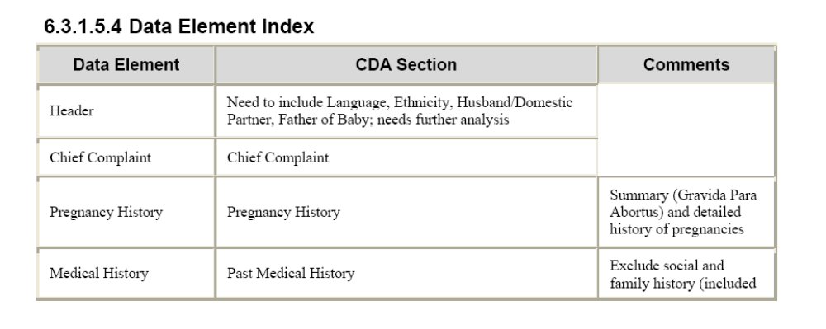

Current documentation
