Integrating the Healthcare Enterprise



IHE Patient Care Coordination (PCC)

Technical Framework Supplement

<Profile Name
(Profile Acronym)>

< Public Comment or
Trial Implementation>

Date: <June XX, 20XX>
Author: <Author Name>
Email: <ihe@himss.org>
Foreword?
This is a supplement to the IHE PCC Technical Framework <VX.X>.

It is submitted for Public Comment between <June XX, 20XX and July XX, 20XX>.
Comments shall be submitted within that period to http://forums.rsna.org:
- Select the “IHE” forum
- Select <Domain Name> Technical Framework
- Select <20XX-20XX> Supplements for Public Comment
- Select <Supplement Name>
Please use the Public Comment Template provided there when starting your New Thread.

Details about IHE may be found at: www.ihe.net

Details about the IHE PCC Domain may be found at: http://www.ihe.net/Domains/index.cfm

Details about the structure of IHE Technical Frameworks and Supplements may be found at: http://www.ihe.net/About/process.cfm and http://www.ihe.net/profiles/index.cfm

The current version of the IHE <Domain Name> Technical Framework may be found at:. http://www.ihe.net/Technical_Framework/index.cfm

These ”boxed” instructions are for the author to indicate to the Volume Editor how to integrate the relevant section(s) into the overall Technical Framework
Replace Section X.X by the following:

Introduction
<provide a brief overview of the volumes/ sections of the Technical Framework that get changed/ added by this profile>

Open Issues and Questions
< List of open issues/ questions that need to be addressed prior to publishing of the Technical Framework>

Closed Issues
< List of closed issues/ questions with their resolutions that have been addressed prior to publishing of the Technical Framework>
TABLE OF CONTENTS

Volume 1 – Profiles 4
1.1.5 Copyright Permissions 4
2.5 Dependencies of the PCC Integration Profiles 4
2.7 History of Annual Changes 4
X <Profile Name Content/Integration> Profile 4
X.1 Scope and Purpose 4
X.2 Use Cases 4
X.3 Actors/ Transactions 5
X.4 Options 6
X.5 Groupings 6
X.6 Security Considerations 6
X.7 Requirements of Actors 6
X.8 Content Modules 7
X.9 Process Flow 7
<Appendix A> Actor Summary Definitions 8
<Appendix B> Transaction Summary Definitions 8
Glossary 9
Volume 2 – Transactions and Content Modules 9
3.0 IHE Transactions 9
3.Y <Transaction Name> 9
3.Y.1 Scope 9
3.Y.2 Use Case Roles 9
3.Y.3 Referenced Standard 10
3.Y.4 Interaction Diagram 10
3.Y.4.1 <Message_1 Name> 10
3.Y.4.1.1 Trigger Events 10
3.Y.4.1.2 Message Semantics 10
3.Y.4.1.3 Expected Actions 10
3.Y.4.2 <Message_2 Name> 11
3.Y.4.2.1 Trigger Events 11
3.Y.4.2.2 Message Semantics 11
3.Y.4.2.3 Expected Actions 11
3.Y.5 Security Considerations 11
3.Y.5.1 Security Audit Considerations 11
3.Y.5.1.(z) Actor Specific Security Considerations 11
6.0 PCC Content Modules 11
6.2 Folder Content Modules 11
6.2.Y <Folder Specification Name> 11
6.3 HL7 Version 3.0 Content Modules 12
6.3.1 CDA Document Content Modules 12
6.3.1.A <Document Content Module Specification Name> 12
6.3.2 CDA Header Content Modules 12
6.3.2.B <Header Content Module Specification Name> 12
6.3.3 CDA Section Content Modules 12
6.3.3.C <Section Content Module Specification Name> 12
6.3.4 CDA Entry Content Modules 12
6.3.4.D <Entry Content Module Specification Name> 12
6.5 PCC Value Sets 13
6.5.A <Value Set Name> 13
<Appendix letter> Appendix_Name 13

Volume 1 – Profiles
Add the following to section 1.1.5
1.1.5 Copyright Permissions

Add the following to section 2.5
2.5 Dependencies of the PCC Integration Profiles
<Profile Name> | <?> | <?> | <->

Add the following to section 2.7
2.7 History of Annual Changes

Add Section X
X <Profile Name Content/Integration> Profile
<200 words or less describing this profile – this is the Profile Abstract that goes in the Executive Summary document>
X.1 Scope and Purpose
<This section contains an expanded version of the Profile Abstract as well as any applicable diagrams that add to the understanding of the scope and purpose of the profile.>

X.2 Use Cases
<One or more use cases that this profile addresses>

X.3 Actors/ Transactions
<Actor/ Transaction diagram and Actor/ Transaction table. >
Figure X.1-1 shows the actors directly involved in the <Profile Name> Integration Profile and the relevant transactions between them. Other actors that may be indirectly involved due to their participation in <other related profiles>, etc. are not necessarily shown.

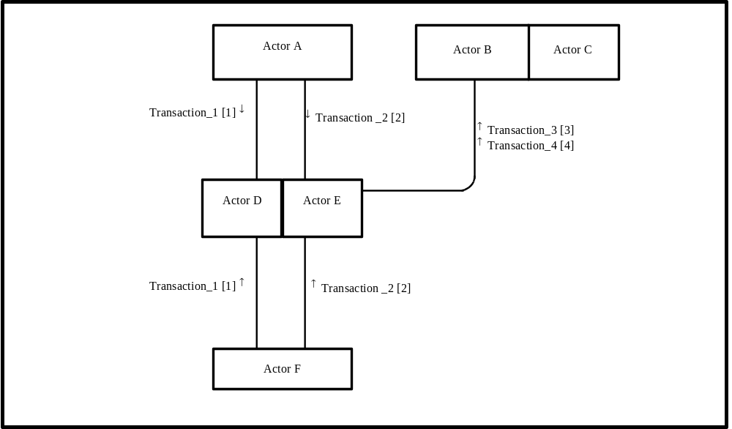
Figure X.1-1. <Profile Name> Actor Diagram
Table X.1-1 lists the transactions for each actor directly involved in the <Profile Name> Profile. In order to claim support of this Integration Profile, an implementation must perform the required transactions (labeled “R”). Transactions labeled “O” are optional. A complete list of options defined by this Profile and that implementations may choose to support is listed in Volume I, Section X.2.

Table X.1-1. <Profile Name> Integration Profile - Actors and Transactions
Actors | Transactions | Optionality | Section in Vol. 2
Actor A | Transaction_1 | R | Z.1
Actor A | Transaction_2 | R | Z.2
Actor F | Transaction_1 | R | Z.1
Actor F | Transaction_2 | R | Z.2
Actor D/ Actor E | Transaction_1 | R | Z.1
Actor D/ Actor E | Transaction_2 | R | Z.2
Actor D/ Actor E | Transaction_3 | R | Z.3
Actor D/ Actor E | Transaction_4 | R | Z.4
Actor B (Actor C) | Transaction_3 | R | Z.3
Actor B (Actor C) | Transaction_4 | R | Z.4
Note: This is a note

X.4 Options
<Table describing the options available for this integration profile and references to all sections that state requirements for compliance to the Option.>
Options that may be selected for this Profile are listed in the table X.2-1 along with the Actors to which they apply. Dependencies between options when applicable are specified in notes.
Table X.2-1 <Profile Name> - Actors and Options
Actor | Options | Vol & Section
Actor A | No options defined | - -
Actor F | No options defined | - -
Actor D/ Actor E | No options defined | - -
Actor D/ Actor E | No options defined | - -
Actor B (Actor C) | No options defined | - -
Actor B (Actor C) | No options defined | - -

X.5 Groupings

<Actors from other profiles, possibly in other domains, that this profile shall, may or should be grouped with.>

X.6 Security Considerations
<Description of the Profile specific security considerations. This should include the outcomes of a risk assessment. This likely will include profile groupings, and residual risks that need to be assigned to the product design, system administration, or policy.>

X.7 Requirements of Actors
<Specific requirements for each Actor defined within this profile>

X.8 Content Modules
<Define which document content module(s) shall be used. Not all profiles will have content in this section.>

X.9 Process Flow
<Description of the process flow(s) and sequence diagram(s) covered by this profile in order to satisfy the use cases. This often will include a brief description of the use cases as well. If there are detailed behavioral rules that apply to a specific process flow or multiple process flows or descriptions then an appendix may be added as needed>

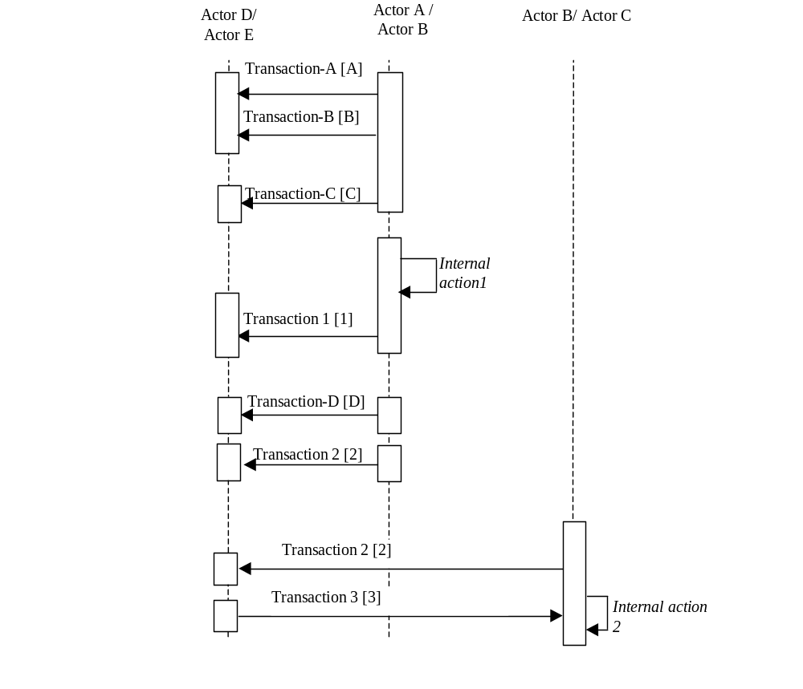
Figure X.10-1. Basic Process Flow in <Profile Name> Profile

<Appendix A> Actor Summary Definitions
<add any actor definitions for new actors defined specifically for this profile>

<Appendix B> Transaction Summary Definitions
<add any transaction definitions for new transactions defined specifically for this profile>

Glossary
Add the following terms to the Glossary:
<any glossary additions associated with the profile draft go here>

Volume 2 – Transactions and Content Modules
<A PCC Profile will have sometimes have Transactions, will sometimes have Content Modules, and sometime may have both. Following are guidelines on the content needed in sections for both Transactions and Content Modules.>

3.0 IHE Transactions

Add section 3.Y
3.Y <Transaction Name>
<This section corresponds to Transaction Y of the IHE Technical Framework. Transaction Y is used by the <ABC> and <DEF> actors. This section may or may not be present depending on the issues the profile addresses.>

3.Y.1 Scope

3.Y.2 Use Case Roles
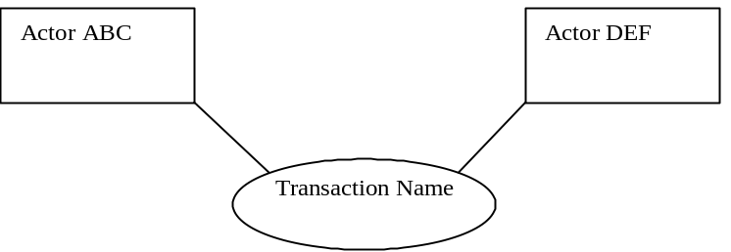

Actor:
Role:
Actor:
Role:
Actor:
Role: .

3.Y.3 Referenced Standard
<e.g., HL7 2.3.1 Chapters 2, 3>
<e.g. DICOM 2008 PS 3.3: A.35.8 X-Ray Radiation Dose SR IOD>

3.Y.4 Interaction Diagram
<the interaction diagram shows the detailed standards-based message exchange that makes up the IHE transaction>
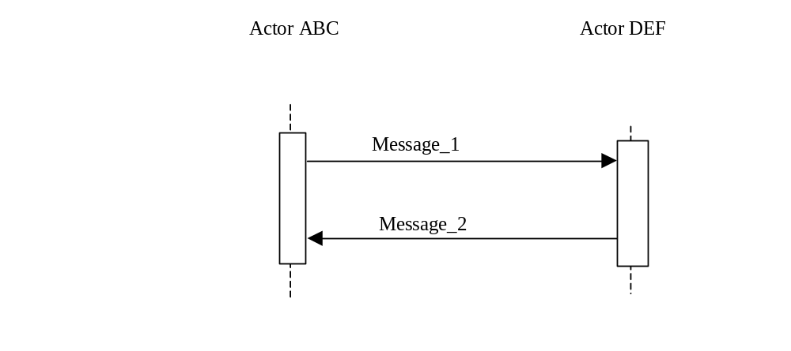
3.Y.4.1 <Message_1 Name>
<One or two sentence description of the first message of the above interaction diagram, typically relating the message to the relevant standard>

3.Y.4.1.1 Trigger Events
<description of the real world events that cause the initiation of the first message>

3.Y.4.1.2 Message Semantics
<detailed description of the meaning, structure and contents of the first message including any IHE specific clarifications of the message format, attributes, etc.>

3.Y.4.1.3 Expected Actions
<description of the actions expected to be taken as a result of sending or receiving this message>

3.Y.4.2 <Message_2 Name>
<One or two sentence description of the the next message in the above interaction diagram, typically relating the message to the relevant standard. Note, repeat this section as necessary based on the number of messages in the interaction diagram>

3.Y.4.2.1 Trigger Events
<description of the real world events that cause the initiation of the next message>

3.Y.4.2.2 Message Semantics
<detailed description of the meaning, structure and contents of the next message including any IHE specific clarifications of the message format, attributes, etc.>

3.Y.4.2.3 Expected Actions
<description of the actions expected to be taken as a result of sending or receiving this message>

3.Y.5 Security Considerations
<description of the transaction specific security consideration. Such as use of security profiles. >

3.Y.5.1 Security Audit Considerations
<This section should specifiy any specific ATNA security audit event that is associated with this transaction and requirements on the encoding of that audit event. >

3.Y.5.1.(z) Actor Specific Security Considerations
<This section should specifiy any specific security considerations on an Actor by Actor basis.>

6.0 PCC Content Modules

6.2 Folder Content Modules

Add section 6.2.Y
6.2.Y <Folder Specification Name>
<This section corresponds to Folder Specification Y of the IHE Technical Framework. Folders are typically used to manage content profiles. This section may or may not be present depending on the issues the profile addresses.>

6.3 HL7 Version 3.0 Content Modules

6.3.1 CDA Document Content Modules

Add section 6.3.1.A
6.3.1.A <Document Content Module Specification Name>
<This section corresponds to Document Content Module Specification A of the IHE Technical Framework. This section may or may not be present depending on the issues the profile addresses.>

6.3.2 CDA Header Content Modules
Add section 6.3.2.B
6.3.2.B <Header Content Module Specification Name>
<This section corresponds to Header Content Module Specification B of the IHE Technical Framework. This section may or may not be present depending on the issues the profile addresses.>

6.3.3 CDA Section Content Modules
Add section 6.3.3.C
6.3.3.C <Section Content Module Specification Name>
<This section corresponds to Section Content Module Specification C of the IHE Technical Framework. This section may or may not be present depending on the issues the profile addresses.>

6.3.4 CDA Entry Content Modules
Add section 6.3.4.D
6.3.4.D <Entry Content Module Specification Name>
<This section corresponds to Entry Content Module Specification D of the IHE Technical Framework. This section may or may not be present depending on the issues the profile addresses.>

6.5 PCC Value Sets
Add section 6.5.A
6.5.A <Value Set Name>
<This section corresponds to Value Set A of the IHE Technical Framework. This section may or may not be present depending on the issues the profile addresses.>

<Appendix letter> Appendix_Name
<Detailed cross transaction relationships or mapping details are described in an appendix in Volume 2>

