Integrating the Healthcare Enterprise



IHE Patient Care Coordination (PCC)

Technical Framework Supplement

<Profile Name
(Profile Acronym)>

< Public Comment or
Trial Implementation>

Date: <June XX, 20XX>
Author: <Author Name>
Email: <ihe@himss.org>
Foreword
This page is standard language for all IHE supplements. The Introduction section following will list all other IHE documents that are modified by this supplement. This document is a supplement to the IHE <Domain Name> Technical Framework <VX.X>. The technical framework can be found at http://www.ihe.net/Technical_Framework/index.cfm#pcc.
This and all IHE supplements are written as changes to a base document. The base document is normally one or more IHE Final Text documents. Supplements tell a technical editor and the reader how to modify the final text (additions, deletions, changes in wording). In order to understand this supplement, the reader needs to read and understand all of the base documents that are modified by this supplement.
In this supplement you will see “boxed” instructions similar to the following:
Replace Section X.X by the following:
These “boxed” instructions are for the author to indicate to the Volume Editor how to integrate the relevant section(s) into the overall Technical Framework.
This format means the reader has to integrate the base documents and the supplement. When the material in the supplement is considered ready for incorporation into the final text of the Technical Framework, the IHE committees will update the technical framework documents with the final text. Supplements are written in this format to avoid duplication material. This means that two IHE documents (one possibly final text, and the other a supplement) should not contain contradictory material.
Text in this document is not considered final for the Technical Framework. It becomes Final Text only after the IHE <Domain Name> Technical Committee ballots the supplement (after testing) and agrees that the material is ready for integration with the existing Technical Framework documents.

It is submitted for Trial Implementation starting August XX, 20XX.
Comments on this supplement may be submitted http://forums.rsna.org:
- Select the “IHE” forum
- Select <Domain Name> Technical Framework
- Select <20XX-20XX> Supplements for Public Comment
- Select <Profile Name>

Please use the Public Comment Template provided there when starting your New Thread.

Details about IHE may be found at: www.ihe.net
Details about the IHE Patient Care Coordination may be found at: http://www.ihe.net/Domains/index.cfm
Details about the structure of IHE Technical Frameworks and Supplements may be found at: http://www.ihe.net/About/process.cfm and http://www.ihe.net/profiles/index.cfm

TABLE OF CONTENTS

Introduction 5
Open Issues and Questions 5
Closed Issues 5
Volume 1 – Profiles 5
1.1.5 Copyright Permissions 5
2.5 Dependencies of the PCC Integration Profiles 5
2.7 History of Annual Changes 5
X <Profile Name Content/Integration> Profile 5
X.1 Purpose and Scope 5
X.2 Process Flow 6
X.2.1 Use Cases 6
X.2.2 Diagrams 6
X.3 Actors/Transactions 7
X.3.1 Requirements of Actors 9
X.4 Options 9
X.5 Groupings 10
X.6 Security Considerations 10
X.7 Content Modules 11
<Appendix A> Actor Summary Definitions 11
<Appendix B> Transaction Summary Definitions 11
Glossary 11
Volume 2 – Transactions and Content Modules 12
3.0 IHE Transactions 12
3.Y <Transaction Name> 12
3.Y.1 Scope 12
3.Y.2 Use Case Roles 12
3.Y.3 Referenced Standard 13
3.Y.4 Interaction Diagram 13
3.Y.4.1 <Message_1 Name> 13
3.Y.4.1.1 Trigger Events 13
3.Y.4.1.2 Message Semantics 13
3.Y.4.1.3 Expected Actions 13
3.Y.4.2 <Message_2 Name> 13
3.Y.4.2.1 Trigger Events 14
3.Y.4.2.2 Message Semantics 14
3.Y.4.2.3 Expected Actions 14
3.Y.5 Security Considerations 14
3.Y.5.1 Security Audit Considerations 14
3.Y.5.1.(z) Actor Specific Security Considerations 14
5.0 Namespaces and Vocabularies 14
5.1 IHE Format Codes 15
6.0 PCC Content Modules 15
6.2 Folder Content Modules 15
6.2.Y <Folder Specification Name> 15
6.3 HL7 Version 3.0 Content Modules 15
6.3.1 CDA Document Content Modules 15
6.3.1.A <Document Content Module Specification Name> 15
6.3.2 CDA Header Content Modules 15
6.3.2.B <Header Content Module Specification Name> 16
6.3.3 CDA Section Content Modules 16
6.3.3.C <Section Content Module Specification Name> 16
6.3.4 CDA Entry Content Modules 16
6.3.4.D <Entry Content Module Specification Name> 16
6.5 PCC Value Sets 16
6.5.A <Value Set Name> 16
<Appendix letter> Appendix_Name 16

Introduction
<provide a brief overview of the volumes/ sections of the Technical Framework that get changed/ added by this profile>
Open Issues and Questions
< List of open issues/ questions that need to be addressed prior to publishing of the Technical Framework>
Closed Issues
< List of closed issues/ questions with their resolutions that have been addressed prior to publishing of the Technical Framework>

Volume 1 – Profiles
Add the following to section 1.1.5
1.1.5 Copyright Permissions

Add the following to section 2.5
2.5 Dependencies of the PCC Integration Profiles
<Profile Name> | <?> | <?> | <->

Add the following to section 2.7
2.7 History of Annual Changes

Add Section X
X <Profile Name Content/Integration> Profile
<200 words or less describing this profile – this is the Profile Abstract that goes in the Executive Summary document. >

X.1 Purpose and Scope
<This section focuses on purpose and scope by starting with a clear statement of the problem being addressed. It expands on this with statements of specific inclusions and exclusions of scope, value statements to represent why this problem is being solved and diagrams (if applicable) to represent the problem being addressed (and not the solution to the problem).>

X.2 Process Flow

X.2.1 Use Cases
<One or more use cases in the form of user stories that this profile addresses.>

X.2.2 Diagrams

<Description of the process flow(s) and sequence diagram(s) covered by this profile in order to satisfy the use cases. If there are detailed behavioral rules that apply to a specific process flow or multiple process flows or descriptions then an appendix may be added as needed>
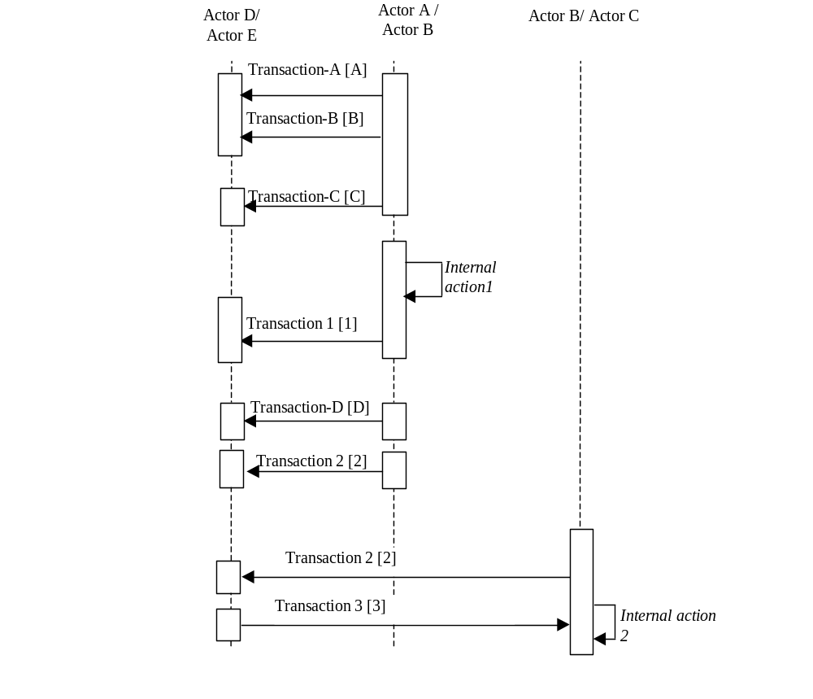
Figure X.2.2-1. Basic Process Flow in <Profile Name> Profile

X.3 Actors/Transactions
<Actors are roles that are played by a system. A system may have multiple actors. This section shall contain Actor/Transaction diagrams and an Actor/Transaction table. See below for general guidelines for Actors/Transactions>
Figure X.3-1 shows the actors directly involved in the <Profile Name> Integration Profile and the relevant transactions between them. Other actors that may be indirectly involved due to their participation in <other related profiles>, etc. are not necessarily shown.

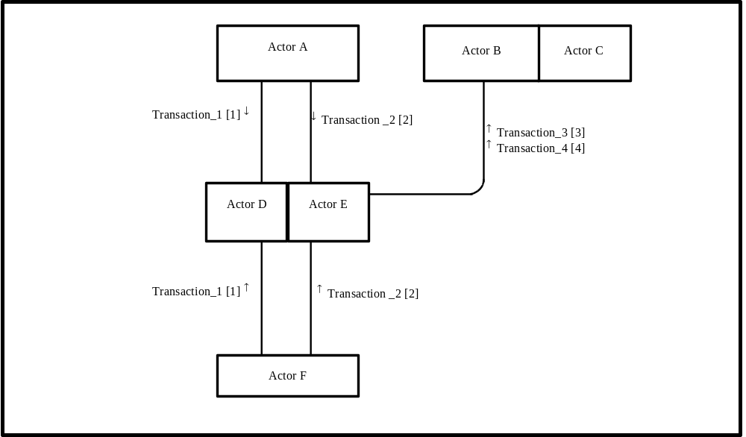
Figure X.3-1. <Profile Name> Actor Diagram
Table X.3-1 lists the transactions for each actor directly involved in the <Profile Name> Profile. In order to claim support of this Integration Profile, an implementation must perform the required transactions (labeled “R”). Transactions labeled “O” are optional. A complete list of options defined by this Profile and that implementations may choose to support is listed in Volume I, Section X.4.

Table X.3-1. <Profile Name> Integration Profile - Actors and Transactions
Actors | Transactions | Optionality | Section in Vol. 2
Actor A | Transaction_1 | R | Z.1
Actor A | Transaction_2 | R | Z.2
Actor F | Transaction_1 | R | Z.1
Actor F | Transaction_2 | R | Z.2
Actor D/ Actor E | Transaction_1 | R | Z.1
Actor D/ Actor E | Transaction_2 | R | Z.2
Actor D/ Actor E | Transaction_3 | R | Z.3
Actor D/ Actor E | Transaction_4 | R | Z.4
Actor B (Actor C) | Transaction_3 | R | Z.3
Actor B (Actor C) | Transaction_4 | R | Z.4
Note: This is a note

<Actors and Transactions are usually the same across PCC Content Profiles, below is an example of what should be used for these types of profiles. In future work these will likely be moved into a common section that can be referenced.>

There are two actors in this profile, the Content Creator and the Content Consumer. Content is created by a Content Creator and is to be consumed by a Content Consumer. The sharing or transmission of content from one actor to the other is addressed by the appropriate use of IHE profiles described below, and is out of scope of this profile. A Document Source or a Portable Media Creator may embody the Content Creator Actor. A Document Consumer, a Document Recipient or a Portable Media Importer may embody the Content Consumer Actor. The sharing or transmission of content or updates from one actor to the other is addressed by the use of appropriate IHE profiles described in the section on Content Bindings with XDS, XDM and XDR. in PCC TF_2:4.1

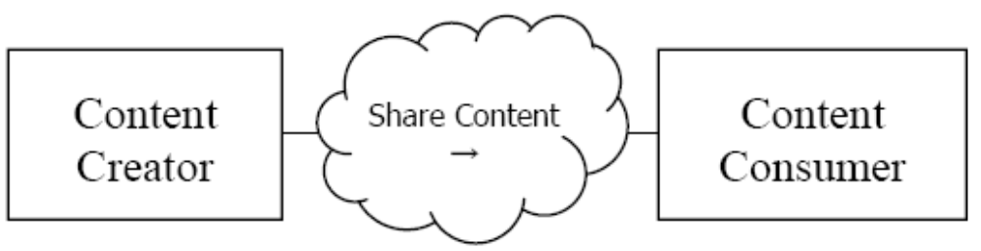
Figure X.3-1 Actor Diagram

X.3.1 Requirements of Actors
<Specific requirements for each Actor defined within this profile. The intent of this section is to summarize any requirements that have been laid out in previous sections. This section is included for testing purposes.>

X.4 Options
<This section contains a table describing the additional capabilities available for this profile and references to all sections that state requirements for compliance to the Option. Options in a Profile are synonomous with options on an automobile in that the purchaser of the automobile may choose the sunroof and upgraded stereo options, but is not required to do so in order to purchase and use the automobile. In another example the purchaser may have the option of an automatic transmission or a manual transmission. In this case the purchaser must choose one option or the other as a car cannot be driven without a transmission.>
Options that may be selected for this Profile are listed in the table X.4-1 along with the Actors to which they apply. Dependencies between options when applicable are specified in notes.
Table X.4-1 <Profile Name> - Actors and Options
Actor | Options | Vol & Section
Actor A | No options defined | - -
Actor F | No options defined | - -
Actor D/ Actor E | No options defined | - -
Actor D/ Actor E | No options defined | - -
Actor B (Actor C) | No options defined | - -
Actor B (Actor C) | No options defined | - -

<Options are usually the same across PCC Content Profiles, below is an example of what should be used for these types of profiles. In future work these may be moved into a yet to be created PCC Technical Framework Volume 0.>

Actor | Option | Section
Content Consumer | View Option (See Note 1)  Document Import Option (See Note 1)  Section Import Option (See Note 1)  Discrete Data Import Option (See Note 1) | PCC TF-2: 3.0.1  PCC TF-2: 3.0.2  PCC TF-2: 3.0.3  PCC TF-2: 3.0.4
Content Creator | No options defined
Note 1: The Actor shall support at least one of these options.

X.5 Groupings

<This section specifies Actors from other profiles, possibly in other domains, that this profile shall, may or should be grouped with; including any additional requirements placed upon them when grouped with actors of this profile (and vice versa).>

X.6 Security Considerations
<Description of the Profile specific security considerations. This should include the outcomes of a risk assessment. This likely will include profile groupings, and residual risks that need to be assigned to the product design, system administration, or policy.>

X.7 Content Modules
<This section defines which document and/or section content module(s) shall be used. Not all profiles will have content in this section. Tables should be used to show data element mappings between different standards. See below for an example from the Antepartum Summary profile mapping ACOG data elements to PCC section templates.>

ACOG Antepartum Record Datum | CDA Section
Drug Allergy/Latex Allergy | Allergies and Other Adverse Reactions
Is Blood Transfusion Acceptable | Advance Directives
Antepartum Anesthesia Consult Planned | Plan of Care
Problems/Plans | Problems
Medication List | Active Medications
EDD Confirmation/18-20 Week EDD Update | Estimated Delivery Dates
Prepregnancy Weight | Visit Summary Flowsheet
Visit Flowsheet | Visit Summary Flowsheet

<Appendix A> Actor Summary Definitions
<add any actor definitions for new actors defined specifically for this profile>

<Appendix B> Transaction Summary Definitions
<add any transaction definitions for new transactions defined specifically for this profile>

Glossary
Add the following terms to the Glossary:
<any glossary additions associated with the profile draft go here>

Volume 2 – Transactions and Content Modules
<A PCC Profile will have sometimes have Transactions, will sometimes have Content Modules, and sometime may have both. Following are guidelines on the content needed in sections for both Transactions and Content Modules.>

3.0 IHE Transactions

Add section 3.Y
3.Y <Transaction Name>
<This section corresponds to Transaction Y of the IHE Technical Framework. Transaction Y is used by the <ABC> and <DEF> actors. This section may or may not be present depending on the issues the profile addresses.>

3.Y.1 Scope

3.Y.2 Use Case Roles
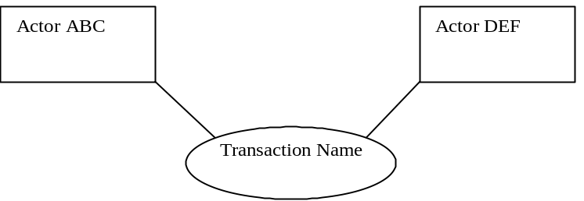

Actor:
Role:
Actor:
Role:
Actor:
Role: .

3.Y.3 Referenced Standard
<e.g., HL7 2.3.1 Chapters 2, 3>
<e.g. DICOM 2008 PS 3.3: A.35.8 X-Ray Radiation Dose SR IOD>

3.Y.4 Interaction Diagram
<the interaction diagram shows the detailed standards-based message exchange that makes up the IHE transaction>
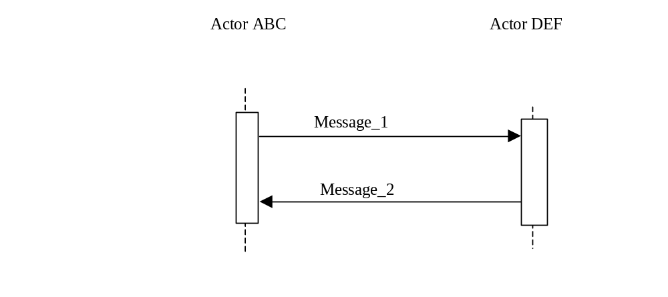
3.Y.4.1 <Message_1 Name>
<One or two sentence description of the first message of the above interaction diagram, typically relating the message to the relevant standard>

3.Y.4.1.1 Trigger Events
<description of the real world events that cause the initiation of the first message>

3.Y.4.1.2 Message Semantics
<detailed description of the meaning, structure and contents of the first message including any IHE specific clarifications of the message format, attributes, etc.>

3.Y.4.1.3 Expected Actions
<description of the actions expected to be taken as a result of sending or receiving this message>

3.Y.4.2 <Message_2 Name>
<One or two sentence description of the the next message in the above interaction diagram, typically relating the message to the relevant standard. Note, repeat this section as necessary based on the number of messages in the interaction diagram>

3.Y.4.2.1 Trigger Events
<description of the real world events that cause the initiation of the next message>

3.Y.4.2.2 Message Semantics
<detailed description of the meaning, structure and contents of the next message including any IHE specific clarifications of the message format, attributes, etc.>

3.Y.4.2.3 Expected Actions
<description of the actions expected to be taken as a result of sending or receiving this message>

3.Y.5 Security Considerations
<description of the transaction specific security consideration. Such as use of security profiles. >

3.Y.5.1 Security Audit Considerations
<This section should specifiy any specific ATNA security audit event that is associated with this transaction and requirements on the encoding of that audit event. >

3.Y.5.1.(z) Actor Specific Security Considerations
<This section should specifiy any specific security considerations on an Actor by Actor basis.>

5.0 Namespaces and Vocabularies
<This section lists the namespaces and identifiers defined or referenced by the IHE PCC Technical Framework, and the vocabularies defined or referenced therein. Additional namespaces and vocabularies shall be added to the table in the following format. For specific examples see PCC TF-2:5.0>
codeSystem | codeSystemName | Description

5.1 IHE Format Codes
<This section contains a table that lists the format codes, template identifiers and media types used by the IHE Profiles specified in the PCC Technical Framework, and also lists, for reference purposes the same values for other selected IHE Profiles from other committees. For specific examples see PCC TF-2:5.1>

Profile | Format Code | Media Type | Template ID
2010 Profiles

6.0 PCC Content Modules

6.2 Folder Content Modules

Add section 6.2.Y
6.2.Y <Folder Specification Name>
<This section corresponds to Folder Specification Y of the IHE Technical Framework. Folders are typically used to manage content profiles. This section may or may not be present depending on the issues the profile addresses.>

6.3 HL7 Version 3.0 Content Modules

6.3.1 CDA Document Content Modules

Add section 6.3.1.A
6.3.1.A <Document Content Module Specification Name>
<This section corresponds to Document Content Module Specification A of the IHE Technical Framework. This section may or may not be present depending on the issues the profile addresses.>

6.3.2 CDA Header Content Modules
Add section 6.3.2.B
6.3.2.B <Header Content Module Specification Name>
<This section corresponds to Header Content Module Specification B of the IHE Technical Framework. This section may or may not be present depending on the issues the profile addresses.>

6.3.3 CDA Section Content Modules
Add section 6.3.3.C
6.3.3.C <Section Content Module Specification Name>
<This section corresponds to Section Content Module Specification C of the IHE Technical Framework. This section may or may not be present depending on the issues the profile addresses.>

6.3.4 CDA Entry Content Modules
Add section 6.3.4.D
6.3.4.D <Entry Content Module Specification Name>
<This section corresponds to Entry Content Module Specification D of the IHE Technical Framework. This section may or may not be present depending on the issues the profile addresses.>

6.5 PCC Value Sets
Add section 6.5.A
6.5.A <Value Set Name>
<This section corresponds to Value Set A of the IHE Technical Framework. This section may or may not be present depending on the issues the profile addresses.>

<Appendix letter> Appendix_Name
<Detailed cross transaction relationships or mapping details are described in an appendix in Volume 2>

