ACC, HIMSS and RSNA
Integrating the Healthcare Enterprise

IHE Patient Care Coordination Technical Framework

Supplement 2005-2006

Basic Patient Privacy Consents (BPPC)

Draft for Public Comment Version

Comments due July 15, 2006

Foreword
Integrating the Healthcare Enterprise (IHE) is an initiative designed to stimulate the integration of the information systems that support modern healthcare institutions. Its fundamental objective is to ensure that in the care of patients all required information for medical decisions is both correct and available to healthcare professionals. The IHE initiative is both a process and a forum for encouraging integration efforts. It defines a technical framework for the implementation of established messaging standards to achieve specific clinical goals. It includes a rigorous testing process for the implementation of this framework. And it organizes educational sessions and exhibits at major meetings of medical professionals to demonstrate the benefits of this framework and encourage its adoption by industry and users.
The approach employed in the IHE initiative is not to define new integration standards, but rather to support the use of existing standards, HL7, DICOM, IETF, and others, as appropriate in their respective domains in an integrated manner, defining configuration choices when necessary. IHE maintain formal relationships with several standards bodies including HL7, DICOM and refers recommendations to them when clarifications or extensions to existing standards are necessary.
This initiative has numerous sponsors and supporting organizations in different medical specialty domains and geographical regions. In North America the primary sponsors are the American College of Cardiology (ACC), the Healthcare Information and Management Systems Society (HIMSS) and the Radiological Society of North America (RSNA). IHE Canada has also been formed. IHE Europe (IHE-EUR) is supported by a large coalition of organizations including the European Association of Radiology (EAR) and European Congress of Radiologists (ECR), the Coordination Committee of the Radiological and Electromedical Industries (COCIR), Deutsche Röntgengesellschaft (DRG), the EuroPACS Association, Groupement pour la Modernisation du Système d'Information Hospitalier (GMSIH), Société Francaise de Radiologie (SFR), Società Italiana di Radiologia Medica (SIRM), the European Institute for health Records (EuroRec), and the European Society of Cardiology (ESC). In Japan IHE-J is sponsored by the Ministry of Economy, Trade, and Industry (METI); the Ministry of Health, Labor, and Welfare; and MEDIS-DC; cooperating organizations include the Japan Industries Association of Radiological Systems (JIRA), the Japan Association of Healthcare Information Systems Industry (JAHIS), Japan Radiological Society (JRS), Japan Society of Radiological Technology (JSRT), and the Japan Association of Medical Informatics (JAMI). Other organizations representing healthcare professionals are invited to join in the expansion of the IHE process across disciplinary and geographic boundaries.
The IHE Technical Frameworks for the various domains (IT Infrastructure, Cardiology, Laboratory, Radiology, etc.) defines specific implementations of established standards to achieve integration goals that promote appropriate sharing of medical information to support optimal patient care. It is expanded annually, after a period of public review, and maintained regularly through the identification and correction of errata. The current version for these Technical Frameworks may be found at www.ihe.net/Technical_Framework.
The IHE Technical Framework identifies a subset of the functional components of the healthcare enterprise, called IHE Actors, and specifies their interactions in terms of a set of coordinated, standards-based transactions. It describes this body of transactions in progressively greater depth. The volume I provides a high-level view of IHE functionality, showing the transactions organized into functional units called Integration Profiles that highlight their capacity to address specific clinical needs. The subsequent volumes provide detailed technical descriptions of each IHE transaction.
This supplement to the IHE Patient Care Coordination Technical Framework V1.0 is submitted for Public Comment between June 15, 2006 and July 15, 2006, per the schedule announced in February 2006

Comments shall be submitted before July 15, 2006 to:
http://forums.rsna.org under the “IHE” forum
Select the “IHE Patient Care Coordination Supplements for Public Review” sub-forum.

The IHE Patient Care Coordination Technical Committee will address these comments and publish the Trial Implementation version in August of 2006.

Date: May 19, 2006
Author: Keith W. Boone, John Moehrke, Lori Fourquet, Robert Horn
These ”boxed” instructions for the author to indicate to the Volume Editor how to integrate the relevant section(s) into the overall Technical Framework

Volume I – Integration Profiles
<This section describes the changes required in Volume I of the Technical Framework that result form including this Integration Profile.>

Changes to Sections 1 – 1.X
<Include a subsection for each section/ subsection changed>

1.7 History of Annual Changes
<Brief description of what to add to Volume I, section 1.7 which gives a brief overview of “what’s new” in the given year of the Technical Framework.>
Add the following bullet to the end of the bullet list in section 1.7
- Added the Basic Patient Privacy Consents (BPPC) which does…

Introduction
This Supplement provides a mechanism to record the patient privacy consent(s), a method to mark documents published to XDS with the patient privacy consent that was used to authorize the publication, and a method for XDS Consumers to use to enforce the privacy consent appropriate to the use.

Open Issues and Questions
- Not clear how we handle the case where a patient changes their mind on a consent. How does this affect the documents that are already published, already consumed by other enterprises in the Affinity Domain under the previous consent. The proposal is to handle all of these issues as manualy.
- This method does not try to communicate the meaning of the patient consent. This is expected to be a safe thing to communicate through manual configurations.

Closed Issues
< List of closed issues/ questions with their resolutions that have been addressed prior to publishing of the Technical Framework>

Profile Abstract
This Supplement provides a mechanism to record the patient privacy consent(s), a method to mark documents published to XDS with the patient privacy consent that was used to authorize the publication, and a method for XDS Consumers to use to enforce the privacy consent appropriate to the use.

GLOSSARY
Privacy Consent – This is where a patient gives up all pretense that he/she has any control over their healthcare data.

Volume I – Integration Profiles
<This section describes the changes required in Volume I of the Technical Framework that result form including this Integration Profile.>

Changes to Sections 1 – 1.X
<Include a subsection for each section/ subsection changed>

1.7 History of Annual Changes
<Brief description of what to add to Volume I, section 1.7 which gives a brief overview of “what’s new” in the given year of the Technical Framework.>
Add the following bullet to the end of the bullet list in section 1.7
- Added the BPPC Profile that provides for multiple privacy consents to be managed and acted upon.

Y <XYZ> Integration Profile Dependencies
Add the following section to Table 2-1 Integration Profiles Dependencies in section 2.1

Basic Patient Privacy Consents | XDS | Required to hold consent act and consent used to publish document | holds the patient consent act, and has metadata for each registered document indicating the ConfidentialityCode
Basic Patient Privacy Consents | XDP | Required to hold consent act and consent used to publish document | holds the patient consent act, and has metadata for each registered document indicating the ConfidentialityCode
Basic Patient Privacy Consents | XDS-SD | Required when patient uses wet signature | When the patient uses wet signatures (ink on paper), XDS-SD is used to capture the actual copy of the consent that the patient signs.

Add the following section to section 2.2

2.2.11 Basic Patient Privacy Consents (BPPC)
This Supplement provides a mechanism to record the patient privacy consent(s), a method to mark documents published to XDS with the patient privacy consent that was used to authorize the publication, and a method for XDS Consumers to use to enforce the privacy consent appropriate to the use.

The section shall be added to Vol 1

X BPPC Integration Profile
The document sharing infrastructure provided by XDS and XDP allow for the publication and use of clinical documents associated with a patient. This system requires that the Affinity Domain create and agree to a single policy (See IHE-ITI Vol 1:Appendix L). Today this means that much of the useful data is not entered into the XDS, or that the access to this data is too liberly allowed. This profile allows for the Affinity domain to have a small number of privacy consents. This allows for more flexibility to support some patient concerns, while providing an important and useful dataset to the healthcare provider.
Healthcare providers utalize many different sets of data to carry out the treatment, billing, and normal operations. When a patient presents, often the patient must fill out volumns of information used for patient demographics, contacts, and insurance. This information could be captured in XDS using a form of coded clinical document with an scanned image of the patient’s insurance card. This information is very useful to the administrative staff at the healthcare provider.
The patient when staying for a few days might have special dietary needs based on their conditions. This diatary needs could be documented in the XDS and marked as for clinical support staff. This document could be accessed by the diatition when preparing the meals.
The patient has other clinical data that is generally available for the patient’s direct care givers. This is the typical document that is found in the XDS today under the single policy.

X.1 Actors/ Transactions
<Actor/ Transaction diagram and Actor/ Transaction table. >
Figure X.1-1 shows the actors directly involved in the <XYZ> Integration Profile and the relevant transactions between them. Other actors that may be indirectly involved due to their participation in <other related profiles>, etc. are not necessarily shown.

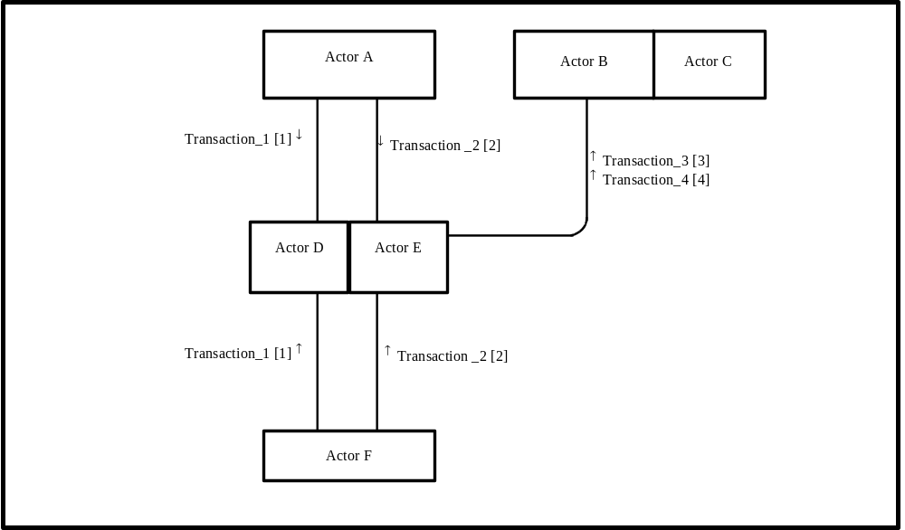
Figure X.1-1. <XYZ Profile> Actor Diagram
Table X.1-1 lists the transactions for each actor directly involved in the <XYZ> Profile. In order to claim support of this Integration Profile, an implementation must perform the required transactions (labeled “R”). Transactions labeled “O” are optional. A complete list of options defined by this Integration Profile and that implementations may choose to support is listed in Volume I, Section X.2.

Table X.1-1. <XYZ> Integration Profile - Actors and Transactions
Actors | Transactions | Optionality | Section in Vol. 2
Actor A | Transaction_1 | R | Z.1
Actor A | Transaction_2 | R | Z.2
Actor F | Transaction_1 | R | Z.1
Actor F | Transaction_2 | R | Z.2
Actor D/ Actor E | Transaction_1 | R | Z.1
Actor D/ Actor E | Transaction_2 | R | Z.2
Actor D/ Actor E | Transaction_3 | R | Z.3
Actor D/ Actor E | Transaction_4 | R | Z.4
Actor B (Actor C) | Transaction_3 | R | Z.3
Actor B (Actor C) | Transaction_4 | R | Z.4
Note: This is a note

4.? CSI Bindings
Content bindings describe how the payload used in the transactions of an IHE profile is related to and/or constrains the data elements sent or received in those transactions. This section is where any specific dependencies between the content and transaction are defined. The Patient Care Coordination Technical Framework defines one content binding, to the ITI Cross Enterprise Sharing profile.
?? describes the content that may be used with each transaction.
Transaction | Content | Optionality | Binding
Provide and Register Document Set [ITI-15]  ITI TF-2: 3.15  Query Registry [ITI-16]  ITI TF-2: 3.16  Retrieve Document [ITI-17]  ITI TF-2: 3.17 | Consent to Share Information | R | Medical Documents  PCC TF-1: 3.4.1.1
Portable Media Creator [ITI-??]
ITI TF-2: 3.??
Portable Media Importer [ITI-??]
ITI TF-2: 3.??
Table 0-1 Transactions and Content
Note 1: At least one type of content from this table must be used with the specified transaction (from the sender or receiver side) in order for the transaction to meet the requirements of the XDS-MS profile.

5.? CSI Content Modules
<Content profiles describe the content of a payload found in an IHE transaction. Content profiles are transaction neutral. They do not have dependencies upon the transaction that they appear in. These dependencies are reflected in the Bindings listed above.>

X.3.1.1 Consent
A consent document is a kind of medical document, and shall conform to the requirements of the Consent content module specified in PCC TF-2: 5.??. The content of a consent document shall include a text description of what the patient has consented to, the effective time of the consent, coded vocabulary identifying the policies consented to, and either a faximile of a wet signature, or a digital signature by the patient (or legal representative).

X.2 <XYZ> Integration Profile Options
<Table describing the options available for this integration profile>

X.2 <XYZ> Integration Profile Options
<Table describing the options available for this integration profile>
Options that may be selected for this Integration Profile are listed in the table X.2-1 along with the Actors to which they apply. Dependencies between options when applicable are specified in notes.
Table X.2-1 Evidence Documents - Actors and Options
Actor | Options | Vol & Section
Repository | BASIC Patient Privacy Consents | - -
Registry | BASIC Patient Privacy Consents | - -
Document Source | BASIC Patient Privacy Consents | - -
Actor B | BASIC Patient Privacy Consents | - -

X.3 <XYZ Integration Profile> Process Flow
<Description of the process flow(s) and sequence diagram(s) covered by this profile in order to satisfy the use cases. This often will include a brief description of the use cases as well. If there are detailed behavioral rules that apply to a specific process flow or multiple process flows or descriptions then an appendix may be added as needed>

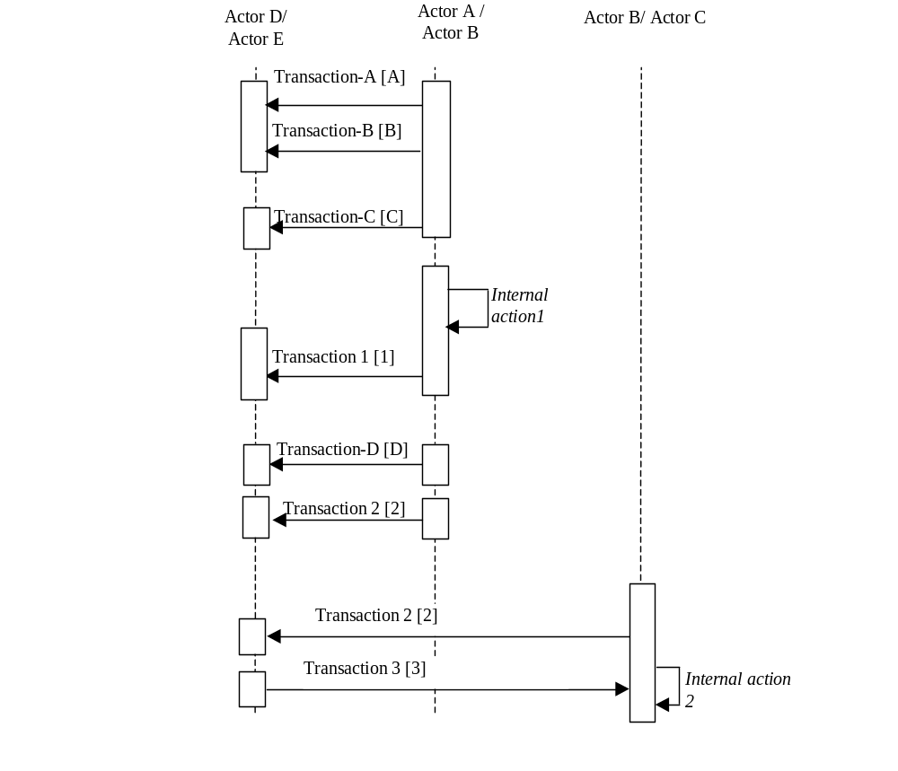
Figure X.2-1. Basic Process Flow in XYZ Profile
<Appendix A> Actor Summary Definitions
<add any actor definitions for new actors defined specifically for this profile>

X.3 <CSI Integration Profile> Process Flow
<Description of the process flow(s) and sequence diagram(s) covered by this profile in order to satisfy the use cases. This often will include a brief description of the use cases as well. If there are detailed behavioral rules that apply to a specific process flow or multiple process flows or descriptions then an appendix may be added as needed>

<Appendix A> Actor Summary Definitions
<add any actor definitions for new actors defined specifically for this profile>
<Appendix B> Transaction Summary Definitions
<add any transaction definitions for new transactions defined specifically for this profile>

<Describe changes to volume II below>

IHE Transactions

X.Y Provide and Register
Add the following section on the Basic Privacy Consents

X.Y.4.1.1 Trigger Events
If the basic privacy option is implemented:
- The Document Source actor shall populate the confidentiality code in the document metadata with the list of OID values that identify the disclosure policies that apply to the associated document. All documents submitted shall have confidentiality codes. The confidentiality codes for different documents in the same submission may be different.
The Document Source actor will need to be configured with the OIDs and associated information for this particular affinity domain. The details of this is product specific and not specified by IHE.
The Document Source actor may have user interface options or business rule options to determine the appropriate confidentiality codes for each document. The details of this are product specific and not specified by IHE.

X.Y Register
Add the following section on the Basic Privacy Consents

X.Y.4.1.1 Trigger Events
If the basic privacy consents option is implemented:
- The Registry actor shall verify tat the confidentiality code in the document metadata are OID values that match the disclosure policies that have been defined for this affinity domain. All documents submitted shall have confidentiality codes. The confidentiality codes for different documents in the same submission may be different.
The Registry actor will need to be configured with the OIDs and associated information for this particular affinity domain. The details of this is product specific and not specified by IHE.
The Registry actor may have user interface options or business rule options to determine the appropriate confidentiality codes for each document. The details of this are product specific and not specified by IHE.

X.Y Query
Add the following section on the Basic Privacy Consents

X.Y.4.1.1 Trigger Events
If the basic privacy option is implemented:
- The Document Consumer actor shall populate the confidentiality code in every query with the list of OID values that identify the disclosure policies that should apply to the documents that are returned in the query results. All documents submitted have confidentiality codes.
The Document Consumer actor will need to be configured with the OIDs and associated information for this particular affinity domain. The details of this is product specific and not specified by IHE.
The Document Consumer actor is expected have user access control options or business rule options to determine the details of how confidentiality codes apply to query results. For example, many EHR systems have complex role based access control (RBAC) systems that determine what information is displayed to a user. The RBAC configuration will need to know the user, the user’s role, the patient, and the confidentiality code to know whether all or only selected portions of the document are visible to the user. The details of this are product specific and not specified by IHE. These rules shall reduce the query results to only those that are appropriate to the current situation for that actor and user.
- The Registry shall return only documents that match the query according to the following rules:
- If the query code is empty, return all document metadata.
- If the query contains one or more confidentiality code, the Registry shall perform a equals comparison where if any of the confidentiality codes on the query match any of the codes that apply to a particular document.

X.Y Retrieve Document

X.Y.4.1 Retrieve Document
Add the following section on the Basic Privacy Consents

X.Y.4.1.1 Trigger Events
If the basic privacy option is implemented:
- The Document Consumer actor honor the confidentiality code in the metadata associated with the document. Not all documents have confidentiality codes.
The Document Consumer actor will need to be configured with the OIDs and associated information for this particular affinity domain. The details of this is product specific and not specified by IHE.
The Document Consumer actor is expected have user access control options or business rule options to determine the details of how confidentiality codes apply to query results. For example, many EHR systems have complex role based access control (RBAC) systems that determine what information is displayed to a user. The RBAC configuration will need to know the user, the user’s role, the patient, and the confidentiality code to know whether all or only selected portions of the document are visible to the user. The details of this are product specific and not specified by IHE. These rules shall reduce the document display results to only those that are appropriate to the current situation for that actor and user.

X.Y Distribute Document Set on Media
Add the following section on the Basic Privacy Consents

X.Y.4.1.1 Trigger Events
If the basic privacy option is implemented:
- The Portable Media Creator actor shall populate the confidentiality code in the document metadata with the list of OID values that identify the disclosure policies that apply to the associated document. All documents submitted shall have confidentiality codes. The confidentiality codes for different documents in the same submission may be different.
The Document Source actor will need to be configured with the OIDs and associated information for this particular affinity domain. The details of this is product specific and not specified by IHE.
The Document Source actor may have user interface options or business rule options to determine the appropriate confidentiality codes for each document. The details of this are product specific and not specified by IHE.
The Portable Media Importer actor shall have the ability to coerce the confidentiality code in the metadata associated with the document from the codes used by the source to the codes used by the Importer.
The Portable Media Importer actor will need to be configured with the OIDs and associated information for its particular affinity domain. The meanings of the codes on the media must be provided out of band, e.g., by telephone, fax, or email. The details of this is product specific and not specified by IHE. If the documents are transferred internally within the organization or to other members of the recipients afinity domain, appropriate internal confidentiality codes shall be applied.
The Portable Media Importer actor is expected have user access control options or business rule options to determine the details of how confidentiality codes apply to query results. For example, many EHR systems have complex role based access control (RBAC) systems that determine what information is displayed to a user. The RBAC configuration will need to know the user, the user’s role, the patient, and the confidentiality code to know whether all or only selected portions of the document are visible to the user. The details of this are product specific and not specified by IHE. These rules shall reduce the document display results to only those that are appropriate to the current situation for that actor and user.

Bindings
Add the following section to the list of bindings in Section 4.

Consent Binding to XDS-MS
The consent binding to XDS is the same as the Medical Document Binding to XDS described in section 4.1, with the exception of the following XDSDocumentEntry metadata fields highlighted in the table below.

XDSDocumentEntry  Attribute | Optional? | Constrained? | Extended Discussion? | Source Type | Source/ Value
authorPerson | R |  | 4.1.1.1
classCode | R |  | 4.1.1.2 | FAD | Consent
classCodeDisplayName | R |  | 4.1.1.2 | FAD | Consent
confidentialityCode | R |  | 4.1.1.3
eventCodeList | R |  | 4.1.1.4 | CADT | /ClinicalDocument/authorization  /consent/code/@code
eventCodeDisplay  NameList | R |  | 4.1.1.4 | CADT | /ClinicalDocument/authorization  /consent/code/@displayName
legalAuthenticator | R |  | 4.1.1.5 | SAT | $person <= /ClinicalDocument/  legalAuthenticator
serviceStartTime | R |  | 4.1.1.6 | SA | /ClinicalDocument  /documentationOf/serviceEvent  /effectiveTime/low/@value
serviceStopTime | R2 |  | 4.1.1.6 | SA | /ClinicalDocument  /documentationOf/serviceEvent  /effectiveTime/high/@value

Extended Discussion

author
The author is a required element, and is the person issuing the consent.

classCode and classCodeDisplayName
These attributes are fixed to the value "Consent" by this binding.

confidentialityCode
The binding has not changed from XDS, however, note that a consent document may also be assigned a confidentialityCode, because the content of the document may be restricted to users in specific functional roles due to the possibly sensitive nature of the content of the consent document.

eventCodeList and eventCodeDisplayNameList
The eventCodeList shall be populated using the codes identifying the policies that have been consented to within the document. The eventCodeDisplayNameList shall be populated using the display names for those policies.

legalAuthenticator
The legalAuthenticator of a consent document shall be present, and shall be one of the persons whose digital signature attests to the content of the consent document.

serviceStartTime and serviceStopTime
The serviceStartTime shall be present and indicates the effective start time of the consent. The serviceStopTime may be present, and if it is present, indicates the effective time at which the consent is no longer effective. If it is not present, the effectiveStopTime is assumed to be controlled by Affinity Domain policy.

Content Modules

IHE PCC Template Identifiers
Add the following row to the list of IHE PCC Template Identifiers

extension | Description
XDS-CSI-2006 | The template identifier used to indicate that a CDA document conforms to the Consent to Share Information Module.

Add the following section to the IHE Content Profiles Section of Volume II of the Patient Care Coordination Technical Framework.

Consent to Share Information

Dependencies
A Consent is a type of medical document, and incorporates the constraints defined for medical summaries found in section 5.3 Medical Documents above.

Standards
CDAR2 Clinical Document Architecture, Release 2.0, 2005, HL7
XDS-SD Scanned Documents

Conformance
CDA Release 2.0 documents that conform to the requirements of this content shall indicate their conformance by the inclusion of the appropriate <templateId> element in the header of the document. This is shown below in Figure 5.7-1.
<ClinicalDocument xmlns='urn:hl7-org:v3'>
<typeId extension="POCD_HD000040" root="2.16.840.1.113883.1.3"/>
<templateId extension="XDS-CSI-2006" root="1.3.6.1.4.1.19376.1.5.3.1"/>
:
Figure 5.7-1: Declaring Conformance
A CDA Document may conform to more than one template, and can therefore have more that one <templateId> element. One of those <templateId> elements must appear exactly as shown above in Figure 5.7-1.

Constraints
A consent shall contain a text description of what the patient consented to, a list of codes indicating the policy(s) agreed to, a time range indicating the effective time of the consent, and shall contain a signature signifying the patient agreement to those policy(s) stated in the text description. Finally, consents must be attested to using an electronic digital signature, conforming to the ITI Digital Signature Profile.
The text description and signature may shall appear as a scanned image, in which case and it shall also conform to the constraints of the ITI Scanned Document profile.
The consent may instead appear in text sections within an XMLBody, in which case it shall conform to the CDA Release 2.0 standard with respect to the content of the XMLBody element. In this case, at least one of the digital signatures on the document must use a digital certificate assigned to the patient or his/her legal representative.
A consent shall have one or more <authorization> elements in the header identifying the policies authorized by the document (see Section 4.2.3.4 of CDAR2). Each <authorization> element indicates informed consent to one and only one XDS Affinity Domain policy. More than one policy may be agreed to within a given consent document.
A consent shall have a documentationOf element describing a consent serviceEvent. This
Consent documents shall be attested to by either the patient and/or legal guardian, or a third party assigned by the XDS Affinity Domain or its member organizations. The attestation shall be performed using the ITI Digital Signature profile. The signer may be the patient, or a third party. When signed by a third party, the consent document shall contain an image of the paper document actually signed by the patient or his/her legal guardian.

Authorization
Each authorization element in the CDA Header represents informed consent to one policy expressed by the XDS Affinity Domain. The consent shall have a unique identifier contained in the <id> element, representing the patient consent to that policy. The policy being consented to shall be represented in the <code> element.
<authorization typeCode='AUTH'>
<consent classCode='CONS' moodCode='EVN'>
<id root='' extension=''/>
<code code='' codeSystem='' codeSystemName='' displayName=''/>
<statusCode code='completed'/>
</consent>
</authorization>
Policies are identified using an Affinity Domain specified coding system. Each coded value in that vocabulary represents one affinity domain specific policy.

<authorization typeCode='AUTH'>
At least one <authorization> element must be present in a consent document. The typeCode attribute shall be present and be valued with AUTH, indicating that this is an authorization act related to the document.

<consent classCode='CONS' moodCode='EVN'>
Each authorization element shall have one <consent> element. The classCode shall be present and be valued with CONS, indicating that the related act is an informed consent. The moodCode shall be EVN, indicating that this element represents and act that has occurred.

<id root='' extension=''/>
The <consent> element shall have one identifier that is used to uniquely identify the consent act. This identifier shall contain a root attribute, and may contain an extension attribute.

<code code='' codeSystem=''
codeSystemName='' displayName=''/>
The <consent> element shall have one <code> element that is used to identify the consent policy that was agreed to by the patient.

Effective Time
Within a consent document, the effective time of the consent shall be specified within the documentationOf/serviceEvent element.
<documentationOf typeCode='DOC'>
<serviceEvent classCode='ACT' moodCode='EVN'>
<id root='' extension=''/>
<code code='CONS' codeSystem='2.16.840.1.113883.5.6'
codeSystemName='ActClass' displayName='Consent'/>
<effectiveTime>
<low value=''/>
<high value=''/>
</effectiveTime>
</serviceEvent>
</documentationOf>

<documentationOf typeCode='DOC'>
Only one <documentationOf> element shall exist, describing the service event of provision of consent. This element shall have a typeCode attribute with the value DOC.

<serviceEvent classCode='ACT' moodCode='EVN'>
Only one <serviceEvent> shall exist, describing the duration of the provision of consent. This element shall have a classCode attribute set to ACT, and a moodCode attribute of EVN.

<id root='' extension=''/>
The service event shall have one <id> element, providing an identifier for the service event.
The root attribute of this element shall be present, and shall be a GUID or OID. The extension attribute may be present.

<code code='CONS' codeSystem='2.16.840.1.113883.5.6' codeSystemName='ActClass' displayName='Consent'/>
The service event shall have one <code> element, identifying the type of service event as being the provision of consent. This element shall appear exactly as specified above.
Note: The ActCode vocabulary is extensible, and so I have used CONS from the HL7 ActClass vocabulary to represent that the service event is an informed consent. Normally, this would be identified and implied by serviceEvent/@classCode, however, that value is fixed to ACT by CDA Release 2.0. As code is used to refine Act.classCode, and "CONS" is a refinement of ACT, this is technically legal, but somewhat edgy. Another alternative would be to propose additions to the HL7 ActCode vocabulary to include codes to describe Consents to share information, consents for procedures, et cetera, which might be a better way to handle this problem. Another possibility would be to specify the use of a specific coding system (SNOMED-CT or other vocabulary) that represents this concept.

<effectiveTime><low value=''/><high value=''/></effectiveTime>
The <effectiveTime> element shall be present, and shall indicated the effective time range over which consent is given. The low value must be provided. The high value may be present. If present, is shall indicate the maximum effective time of the consent.
<Appendix ???> Patient Consents Examples (Informative)
The document sharing infrastructure provided by XDS and XDP allow for the publication and use of clinical documents associated with a patient. This system requires that the Affinity Domain create and agree to a single policy (See IHE-ITI Vol 1:Appendix L). Today this means that much of the useful data is not entered into the XDS, or that the access to this data is too liberly allowed. This profile allows for the Affinity domain to have a small number of privacy consents. This allows for more flexibility to support some patient concerns, while providing an important and useful dataset to the healthcare provider.
This section gives examples of some possible patient privacy consent policies and how the systems publishing documents and using documents might act. This is an informative section and should not be interpreted as the only way to implement the BPPC profile.
The sprit of the privacy consents usecase would be captured in one or more legal documents that are vetted by the legal departments of all of the Affinity Domain enterprises. This legal document would be made available to all patients and systems involved in the Affinity Domain. The mechanism used to configure the systems (e.g. EHR, PACS) to meet this Policy is not defined in this profile. This symantic interoperability will likely be the subject of future IHE profiles as the standards and their implementations become available.
A.???.1 Administrative Use
Healthcare providers utalize many different sets of data to carry out the treatment, billing, and normal operations. When a patient presents, often the patient must fill out volumns of information used for patient demographics, contacts, and insurance.
For this example we might illustrate a registration system that captures a scanned image of the patient’s insurance card. This scanned image can be submitted to the XDS using the confidentiality code indicating that it is available for administrative uses. This registration system could additionally capture the typical demographics and such in a form of coded clinical document that is also published as available for administrative use. Both of these documents don’t have clinical information and thus wouldn’t need to be restricted to direct care providers.
Now that we have shown how this information can be captured. We can see cases where the patient presents at a different clinic in the same Affinity Domain. The administrative staff can now query the XDS and simply confirm that the information is the same.
A.???.2 Clinical Support Staff Use
The patient when staying for a few days might have special dietary needs based on their conditions. This diatary needs could be documented in the XDS and marked as for clinical support staff. This document could be accessed by the diatition when preparing the meals.
A.???.3 Direct Care Provider Use
The patient has other clinical data that is generally available for the patient’s direct care givers. This is the typical document that is found in the XDS today under the single policy.

A consent-authoring environment might assume that the low value is the creation time of the document providing consent.

