Integrating the Healthcare Enterprise



IHE Patient Care Coordination (PCC)

Technical Framework Supplement

XDW Based Workflow Definition Profile
Templating

< Public Comment or
Trial Implementation>

Date:

Email:

Introduction
< No specific guidance>

Open Issues and Questions
< No specific guidance>

Closed Issues
< No specific guidance>

Volume 1 – Profiles

X Volume 1 - Workflow Definition Profile
< No specific guidance>

X.1 Purpose and Scope
< Vocabulary:The concept of Workflow Step does not exist in XDW. It assumes a linera model for workflows which is not adequate. Its use should be avoided, except in the early part of this Purpose and Scope section. The use of the term “workflow step” needs to be used in a loose sense, and need to be entirely replaced by the end of this section by the more genric XDW concept of Task with a Status.>
< Suggestion: present the broader workflow context within which this Workflow Definition Profile fits in a simplified primary path workflow, with an expanded view of the priamry path of this workflow description. It provides in addition to the textual scope and purpose description text, a visual presentation. This avoids the reader expect the broader workflow context to be adressed. See below example form the tumor board workflow and the overall encolongy treatment workflow.>
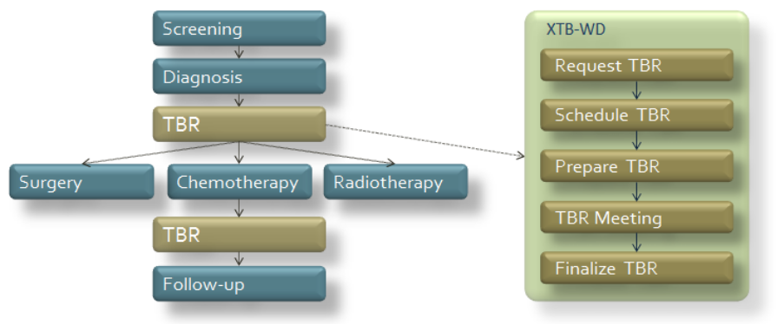
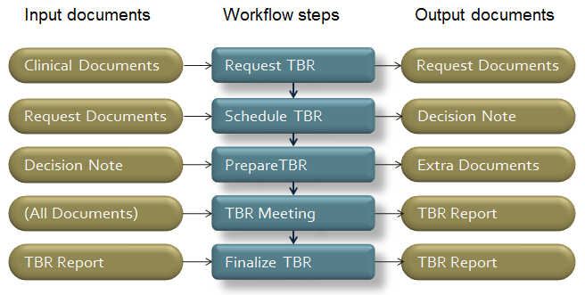
< Suggestion: If possible, introduce a graphical overview description that this is showing the main input and output documents referenced by each one of the workflow steps of the primary workflow path. See below example form the tumor board workflow and the overall encolongy treatment workflow. Note that the workflow steps should be using the same brown color as above and the input/output documents a different color (e.g. blue).>

X.2 Process Flow

< Requirement: a consistent approach to the process flow diagrams is required so that the tasks are visible and not confused with the informal definition of the steps that may be used in the scoping section. A state diagram, as formatted below shall be used for the Workflow Descritpion Process Flow, with the following requirments:
- no inclusion of input and output documents (reduces clutter. Will use the table below)
- Ensure that there is one box for each task/status defined in the workflow. The name of the task with the status in brackets underneath.
- Try to place the same task with different status around the same line, so alternative status can be easily seen.
- Keep the primary workflowpath vertical, so that more complex workflows can better fit the page.
- Label the event that drives the workflow transition as one way arrows (no bidrectional arrows allowed)
- Dotted line arrows represents event transitions external to the workflow definition>

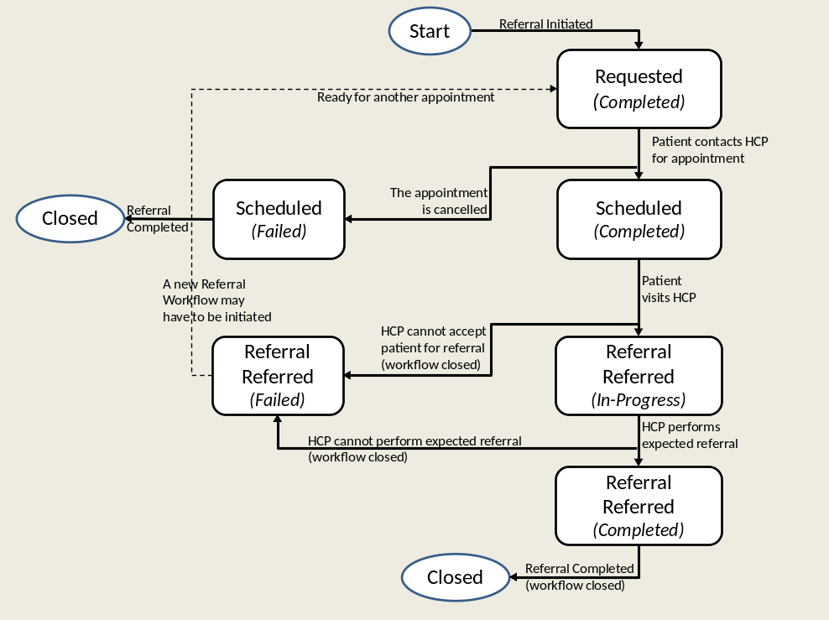
<Figure X.2-1. Functional Workflow Definition sample process flow>
➔Use UML drawing styles

< Requirement: include a different table in Volume 1 that lists the various documents that shall, or may be referenced as either input or output documents for each task/status pair defoned by the Profile. Document the optionality for each referenced document>.

Task Name | Task Status | Input Docs |  | Option | Output Docs | Option
Requested | Completed | Doc Label 1  Doc Label 2 | Creator  Consumer | R  R2 | Doc Label 6 | R
Scheduled | Completed | Doc 3 | Creator/Consumer | C | N/A
Scheduled | Failled | Doc 4 |  | O | N/A
Referral Referred | In progress | N/A |  |  | N/A
Referral Referred | Completed | Doc 5 |  | R | Doc 6 | R
Referral Referred | Failed | N/A |  |  | N/A
- Doc labels needed

X.3 Workflow Actors

< Requirement: describe the workflow Actors (Abstracts the systems that supports the workflow participants involved in a workflow description profile). Use the following table at the beginning of the use case to introduce these actor names>

Workflow  Actors | Description
Referral Requester | Health Professional (e.g. GP) that initiates the referral workflow. Produces the eReferral and the related supporting document.
Referral Scheduler | Actor responsible for the scheduling of the referral, by providing an appointment for the patient
Referral Performer | Actor responsible for execution of the visit. This workflow actor encapsulate many entities within the enterprise that responds to the referral request and produce the clinical report of the visit ending the eReferral process
Referral Monitor | Actor that tracks progress of the workflow and reacts to certain exception conditions. This actor can be satndalone or grouped with one of the above Workflow Actors

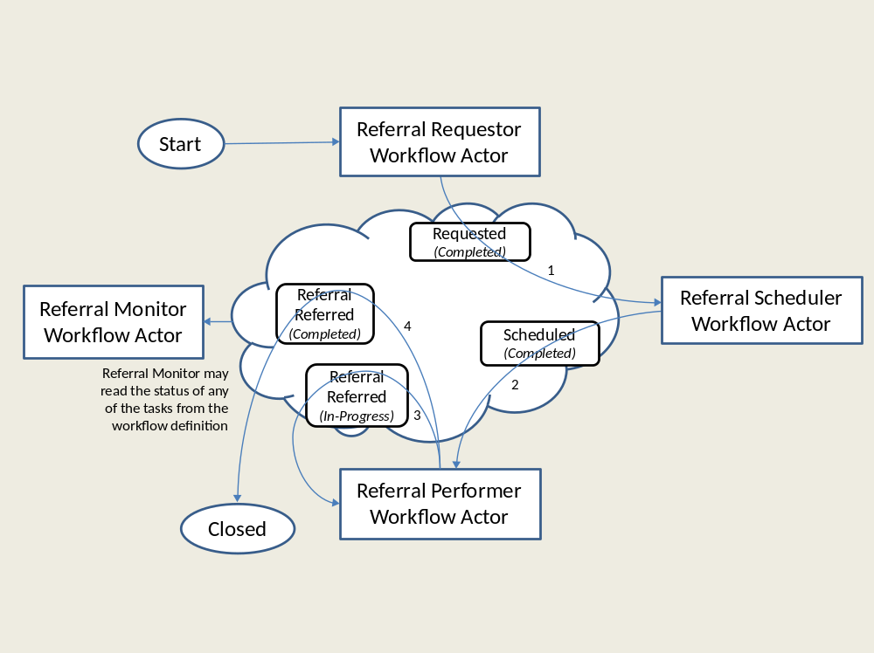

Monitor ➔ Dashboard or tracker ?

X.3.1 Use Cases

< Requirement: The Use Cases in Volume 1 should be described at the non-technical level, as Workflow descriptions in Volume 1 shall be understood by health professionals. The Use Cases should described using the above task/status by using relevant subsets(one or more as needed) of the workflow state diagram and discussing the input/ouput documents associated with every taks/status.

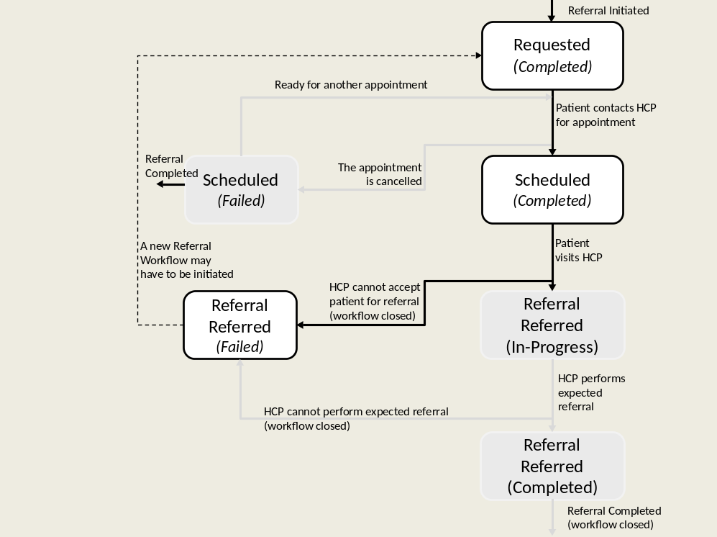
<Figure X.2.2.2-5 Process Flow- Use Case Subset A: Sample >

➔Task Cases Versus Workflow Actor ases

<Requirement: The evolution of the XDW Workflow document across the transitions of the workflow should be shown with a semi-simplified diagrams where only some of the attributes of the XDW workflow document are shown (Task Name, Task Status, Author, Time, Inputs, Outputs and Task Event History)
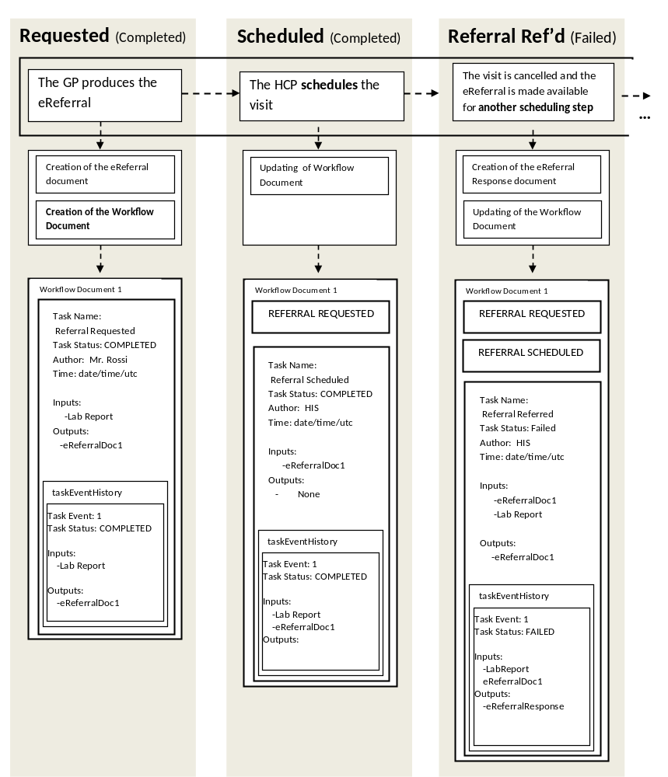
<Figure X.2.2.2-6 Evolution of the XDW workflow document: Sample >

<Requirement: The transation process flow that demonstrates how the various actors using the XDS transactions to shared XDW workflow documents and referenced input and output douments, should be in Volume 2. This is too technical from a workflow definition point of view.>

X.5 Groupings
<The Workflow Actors need to be grouped with XDW Actors for the creating, updating and consuming of the XDW Workflow Document as specified in the table X.5.vvvv. The Workflow Actors need to be grouped with one of the XDS, XDR, XDM Actors for the submission or consumption of Documents that are referenced by the XDW Workflow Document, as specified in the tableX.5.uuu .>

Workflow Definition  Actor | Shall be grouped by XDW actors
Referral Requester | XDW Content Creator  XDW Content Consumer
Referral Scheduler | XDW Content Updater
Referral Performer | XDW Content Updater
Workflow Monitor | XDW Content Updater
Table X.5.vvvv Workflow Actor grouping with XDW Actors

Workflow Definition  Actor | Shall be grouped with the following actors | Input and Output Documents to be supported
Referral Requester | Content Profiles for the documents shown in table X.2 specific Document Creator Actors grouped with one of : XDS Document Source, XDR Document Source, XDM Media Creator
Referral Scheduler | N/A
Referral Performer | Content Profiles specific Document Creator Actors grouped with one of : XDS Document Source, XDR Document Source, XDM Media Creator  and  Content Profiles specific Document Consumer Actors grouped with one of : XDS Document Consumer, or XDR Document Recipient, or XDM Media Reader
Workflow Monitor | Content Profiles specific Document Consumer Actors grouped with one of : XDS Document Consumer, or XDR Document Recipient, or XDM Media Reader

Table X.5.vvvv Workflow Actors grouping for sharing of referenced documents

X.4 Options
Options that may be selected for this Profile are listed in the table 30.2-1 along with the Actors to which they apply.

Table X.4-1 <Profile Name> Actors and Options
Workflow Actor | Workflow Definition Options | Vol & Section
Referral Requester | No options | - -
Referral Scheduler | Document Import Option | ITI TF-1: 30.2.2
Referral Performer | Document Import Option | ITI TF-1: 30.2.1
Workflow Monitor | View Option
Workflow Monitor | Document Import Option | ITI TF-1: 30.2.1

Volume 2 – Content Modules

5.1 XXX Workflow Definition - XDW Workflow Document – Common Attributes
The XXX-WD Workflow Definition does not introduce new metadata and all the metadata elements used are the common XDS document metadata specified in ITI TF-3:4.1.5 and in ITI TF-3:5.4.6. In this section only the use of some specific metadata for the use of XDW in the XXX-WD context is specified.

XDS Metadata Attribute | Definition
typeCode | For the Workflow Document which tracks the XXX-WD process the code for the typeCode shall be:  To be assigned by LOINC
classCode | For the Workflow Document which tracks the XXX-WD process the code for the classCode is defined by the XDW profile.  See XDW Supplement Section YYYYYY.
eventCodeList | Rule 1:  An XXX-WD workflow shall be created with code OPEN and shall remain in this status until it is set to CLOSED.  Rule 2:  An XXX-WD workflow should be set to CLOSED when:  - one of the tasks has the status FAILED; or  - when you complete the workflow with the YYY task in status COMPLETED.  See ITI TF-3: 5.4.5.7 for a general description of this attribute.
serviceStartTime | It is the time at which work began on the first task for this workflow.
serviceStopTime | It is the time at which the status of the overall Workflow is changed from OPEN to CLOSED.  It shall be empty when the workflow is still in OPEN state.

6.0 Tasks Specifications

Workflow Description Overview

Task Name | Requirement  For task initiation | Task Statuses  *valid when task initiated | Task  Property | Input Docs | Option | Output Docs | Option
TaskA | At XDW doc creation | Ready*  Completed*  Failled | Cardinality: 1  Removable: no
TaskB | When TaskA completed | In progress*  Completed  Failled | Cardinality: 1  Removable: no
Task C | Optional | Completed | Cardinality: 1  Removable: no

      - Task: Approved

Task attributes | Rules for the task “Approved”
Task id | Unique id of the instance of the task
Task type | Approved
Task name | Approved Request
Task description | Approving of the request of activation for the telemonitoring service.
Task dependencies | Ancestors: Requested  Successors: Telemonitoring
Status allowed | IN-PROGRESS: if the the enrollment of the patient is pending and need more informations or time to be completed  COMPLETED: if the enrollment is completed
Status transactions | If the task born in status IN_PROGRESS, it shall be a transaction of status into status COMPLETED when the approving process is completed.
Input | - Required  - Request activation Document  - Optional  - Report of laboratory exam
Output | None
Owner | Data Centre Manager (Approver of the request activation)
owner changes | No
<taskEvent> | Only one
Task Removal allowed | May workflow participants remove a task when updating a XDW Workflow Document): No
Task duplication | May the task appear more than once in the Workflow Definition: No

6.3.3.2.1 Encoding Example of XDW Task: Approved

<ns3:XDWTask>
<ns3:taskData>
<ns2:taskDetails>
<ns2:id>urn:oid:1.1.1.1.1</ns2:id>
<ns2:taskType>Approved</ns2:taskType>
<ns2:name>Approved Request</ns2:name>
<ns2:status>COMPLETED</ns2:status>
<ns2:createdTime>2011-01-02T10:10:51.0Z</ns2:createdTime>
<ns2:lastModifiedTime>2011-01-02T10:10:51.0Z</ns2:lastModifiedTime>
<ns2:renderingMethodExists>false</ns2:renderingMethodExists>
<ns2:actualOwner>Mr. Smith</ns2:actualOwner>
<ns2:createdBy>Mr. Smith</ns2createdBy>
</ns2:taskDetails>
<ns2:description>Request for activation of a telehealth service</ns2:description>
<ns2:taskInput>
<ns2:documentReference> <!--RequestActivationDoc-->
<ns2:identifier>urn:oid:1.2.3.4.2</ns2:identifier>
<ns2:name>RequestActivationDoc</ns2:name>
<ns2:accessType>urn:IHE:iti:2011:xdw:XDSregistered</ns2:accessType>
<ns2:contentCategory>URI of the document</ns2:contentCategory>
<ns2:contentType>XDSDocumentEntry.classCode</ns2:contentType>
<ns2:attachedTime>2011-01-02T10:10:51.0Z</ns2:attachedTime>
<ns2:attachedBy>Mr. Smith</ns2:attachedBy>
</ns2:documentReference>
</ns2:taskInput>
</ns3:taskData>
<ns3:taskEventHistory>
<ns3:taskEvent>
<ns3:id>1</ns3:id>
<ns3:eventTime>2011-01-02T10:10:51.0Z</ns3:eventTime>
<ns3:identifier>urn:oid:1.1.1.1.1</ns3:identifier>
<ns3:eventType>create</ns3:eventType>
<ns3:status>COMPLETED</ns3:status>
</ns3:taskEvent>
</ns3:taskEventHistory>
<ns3:XDWTask>

  - Transaction Flow in Support of the XXX-WD Workflow

The following diagrams proviode an informational depiction of the combined use of the XXX-WD Workflow Definition Profile along with the XDW Content Profile and the underlying XDS Intergation Profile.
