Integrating the Healthcare Enterprise



IHE PCC Technical Framework
Supplement 2008-2009

Cancer Registry Pathology Report (CPR)

Public Comment Version 1.0
Comments due July 18 2008

Forward
Integrating the Healthcare Enterprise (IHE) is an initiative designed to stimulate the integration of the information systems that support modern healthcare institutions. Its fundamental objective is to ensure that in the care of patients all required information for medical decisions is both correct and available to healthcare professionals. The IHE initiative is both a process and a forum for encouraging integration efforts. It defines a technical framework for the implementation of established messaging standards to achieve specific clinical goals. It includes a rigorous testing process for the implementation of this framework. And it organizes educational sessions and exhibits at major meetings of medical professionals to demonstrate the benefits of this framework and encourage its adoption by industry and users.
The approach employed in the IHE initiative is not to define new integration standards, but rather to support the use of existing standards, HL7, DICOM, IETF, and others, as appropriate in their respective domains in an integrated manner, defining configuration choices when necessary. When clarifications or extensions to existing standards are necessary, IHE refers recommendations to the relevant standards bodies.
This initiative has numerous sponsors and supporting organizations in different medical specialty domains and geographical regions. In North America the primary sponsors are the Healthcare Information and Management Systems Society (HIMSS) and the Radiological Society of North America (RSNA). IHE Canada has also been formed. IHE Europe (IHE-EUR) is supported by a large coalition of organizations including the European Association of Radiology (EAR) and European Congress of Radiologists (ECR), the Coordination Committee of the Radiological and Electromedical Industries (COCIR), Deutsche Röntgengesellschaft (DRG), the EuroPACS Association, Groupement pour la Modernisation du Système d'Information Hospitalier (GMSIH), Société Francaise de Radiologie ([www.sfr-radiologie.asso.fr SFR]), and Società Italiana di Radiologia Medica (SIRM). In Japan IHE-J is sponsored by the Ministry of Economy, Trade, and Industry (METI); the Ministry of Health, Labor, and Welfare; and [www.medis.or.jp MEDIS-DC]; cooperating organizations include the Japan Industries Association of Radiological Systems (JIRA), the Japan Association of Healthcare Information Systems Industry (JAHIS), Japan Radiological Society (JRS), Japan Society of Radiological Technology (JSRT), and the Japan Association of Medical Informatics (JAMI). Other organizations representing healthcare professionals are actively involved and others are invited to join in the expansion of the IHE process across disciplinary and geographic boundaries.
The IHE Technical Frameworks for the various domains (Patient Care Coordination, IT Infrastructure, Cardiology, Laboratory, Radiology, etc.) define specific implementations of established standards to achieve integration goals that promote appropriate sharing of medical information to support optimal patient care. These are expanded annually, after a period of public review, and maintained regularly through the identification and correction of errata. The current version for these Technical Frameworks may be found at www.ihe.net.
The IHE Technical Framework identifies a subset of the functional components of the healthcare enterprise, called IHE Actors, and specifies their interactions in terms of a set of coordinated, standards-based transactions. It describes this body of transactions in progressively greater depth. Volume I provides a high-level view of IHE functionality, showing the transactions organized into functional units called Integration Profiles that highlight their capacity to address specific clinical needs. Subsequent volumes provide detailed technical descriptions of each IHE transaction.
This supplement to the IHE PCC Technical Framework is submitted for Public Comment between June 18 2008 and July 18 2008, per the schedule announced in December 2007.
Comments shall be submitted before July 18 2008 to:
http://forums.rsna.org under the “IHE” forum
Select the “PCC Profiles for Public Review” sub-forum.

The IHE PCC Technical Committee will address these comments and publish the Trial Implementation version in August 2008.

Table of Contents
Forward 2
1.1 Preface to Volume 1 of the PCC Technical Framework 7
1.1.1 Intended Audience 7
1.1.2 Related Information for the Reader 7
1.1.3 How this Volume is Organized 7
1.1.4 Conventions Used in this Document 8
1.1.5 Copyright Permissions 9
2 Introduction 11
2.1 Relationship to Standards 11
2.2 Relationship to Product Implementations 12
2.3 Framework Development and Maintenance 12
2.4 About the Patient Care Coordination Integration Profiles 13
2.5 Dependencies of the PCC Integration Profiles 14
2.6 PCC Integration Profiles Overview 15
2.6.1 Unplanned Access to past Content 17
2.7 History of Annual Changes 18
2.8 Product Implementations 20
3 Cancer Registry Pathology Report Content 21
3.1 Profile Abstract 21
3.2 Glossary 21
3.3 Issue Log 21
3.3.1 Open Issues 21
3.3.2 Closed Issues 21
3.4 Dependencies 22
3.5 Overview 22
3.6 Use Cases 23
3.7 Scope 25
3.8 Actors/Transaction 27
3.9 Grouping 27
3.9.1 Care Management (CM) 27
3.9.2 Basic Patient Privacy Consents (BCCP) 28
3.10 Policy Considerations 28
3.11 Security Considerations 28
3.12 Requirements/Capabilities 28
Actor Definitions 28
Transaction Definitions 29
How to Prepare an IHE Integration Statement 30
Volume 2 33
1 Preface to Volume 2 34
1.1 Intended Audience 34
1.2 Related Information for the Reader 34
1.2.1 How this Document is Organized 34
1.2.2 Conventions Used in this Volume 35
1.3 Copyright Permissions 36
1.4 How to Contact Us 36
2 Introduction 37
2.1 Relationship to Standards 37
2.2 Relationship to Product Implementations 38
2.3 Relation of this Volume to the Technical Framework 38
2.3.1 Content Modules 39
3 PCC Content Modules 47
3.1 Conventions 47
3.2 CDA Release 2.0 Content Modules 48
3.3 HL7 Version 2 Content Modules 48
3.3.1 Cancer Registry Pathology Report Content 1.3.6.1.4.1.19376.1.5.3.1.1.19.1.1 48

Content of the Technical Framework
This technical framework defines relevant standards and constraints on those standards in order to implement a specific use cases for the transfer of information between systems. This document is organized into 2 volumes as follows:
Volume 1 - Overview
This volume is provided as a high level overview of the profiles including descriptions of the use case, the actors involved, the process flow, and dependencies on other standards and IHE profiles. It is of interest to care providers, vendors' management and technical architects and to all users of the profile
Volume 2 – Transactions and Content Profiles
This volume is intended as a technical reference for the implementation of specific transactions in the use case including references to the relevant standards, constraints, and interaction diagrams. It is intended for the technical implementers of the profile.
How to Contact Us
IHE Sponsors welcome comments on this document and the IHE initiative. They should be directed to the discussion server at http://forums.rsna.org or to:
Didi Davis
Director of Integrating the Healthcare Enterprise
HIMSS
230 East Ohio St., Suite 500
Chicago, IL 60611
Email: ihe@himss.org

Preface to Volume 1 of the PCC Technical Framework

Intended Audience
The intended audience of this document is:
- Healthcare professionals involved in informatics
- IT departments of healthcare institutions
- Technical staff of vendors participating in the IHE initiative
- Experts involved in standards development
- Those interested in integrating healthcare information systems and workflows

Related Information for the Reader
The reader of volume 1 should read or be familiar with the following documents:
- Volume 1 of the Cross-Enterprise Document Sharing (XDS) Integration Profile documented in the ITI Infrastructure Technical Framework
- Volume 1 of the Notification of Document Availability (NAV) Integration Profile documented in the ITI Infrastructure Technical Framework
- Volume 1 of the Audit Trail and Node Authentication (ATNA) Integration Profile documented in the ITI Infrastructure Technical Framework
(See http://www.ihe.net/Technical_Framework/index.cfm ).
- HL7 Clinical Document Architecture Release 2: Section 1, CDA Overview.
- Care Record Summary – Implementation Guide for CDA Release 2 (US Realm): Section 1
- Presentations from IHE Workshop: Effective Integration of the Enterprise and the Health System - June 28–29, 2005: http://www.ihe.net/Participation/workshop_2005.cfm, June 2005:
- Leveraging IHE to Build RHIO Interoperability
- Cross-Enterprise Document Sharing (XDS)
- Notification of Document Availability (NAV)
- Patient Care Coordination
- Use Cases for Medical Summaries
- Patient Care Coordination - Overview of Profiles

How this Volume is Organized
Section 2 describes the general nature, structure, purpose and function of the Technical Framework. Section 3 and the subsequent sections of this volume provide detailed documentation on each integration profile, including the Patient Care Coordination problem it is intended to address and the IHE actors and transactions it comprises.
The appendices following the main body of the document provide a summary list of the actors and transactions, detailed discussion of specific issues related to the integration profiles and a glossary of terms and acronyms used.

Conventions Used in this Document
This document has adopted the following conventions for representing the framework concepts and specifying how the standards upon which the IHE Technical Framework is based should be applied.

Technical Framework Cross-references
When references are made to another section within a Technical Framework volume, a section number is used by itself. When references are made to other volumes or to a Technical Framework in another domain, the following format is used:
<domain designator> TF-<volume number>: <section number>
where:
<domain designator>
is a short designator for the IHE domain (PCC= Patient Care Coordination, ITI = IT Infrastructure, RAD = Radiology)
<volume number>
is the applicable volume within the given Domain Technical Framework (e.g., 1, 2, 3), and
<section number>
is the applicable section number.
For example: PCC TF-1: 3.1 refers to Section 3.1 in volume 1 of the IHE Patient Care Coordination Technical Framework, ITI TF-2: 4.33 refers to Section 4.33 in volume 2 of the IHE IT Infrastructure Technical Framework.

IHE Actor and Transaction Diagrams and Tables
Each integration profile is a representation of a real-world capability that is supported by a set of actors that interact through transactions. Actors are information systems or components of information systems that produce, manage, or act on categories of information required by operational activities in the enterprise. Transactions are interactions between actors that communicate the required information through standards-based messages.
The diagrams and tables of actors and transactions in subsequent sections indicate which transactions each actor in a given profile must support.
The transactions shown on the diagrams are identified both by their name and the transaction number as defined in PCC TF-2 (Volume 2 of the PCC Technical framework). The transaction numbers are shown on the diagrams as bracketed numbers prefixed with the specific Technical Framework domain.
In some cases, a profile is dependent on a prerequisite profile in order to function properly and be useful. For example, Cross-Enterprise Sharing of Medical Summaries depends on Audit Trail and Node Authentication (ATNA). These dependencies can be found by locating the desired profile in the dependencies section of this document to determine which profile(s) are listed as prerequisites. An actor must implement all required transactions in the prerequisite profiles in addition to those in the desired profile.

Process Flow Diagrams
The descriptions of integration profiles that follow include process flow diagrams that illustrate how the profile functions as a sequence of transactions between relevant actors.
These diagrams are intended to provide an overview so the transactions can be seen in the context of an institution’s or cross-institutions’ workflow. Certain transactions and activities not defined in detail by IHE are shown in these diagrams in italics to provide additional context on where the relevant IHE transactions fit into the broader scheme of healthcare information systems. These diagrams are not intended to present the only possible scenario. Often other actor groupings are possible, and transactions from other profiles may be interspersed.
In some cases the sequence of transactions may be flexible. Where this is the case there will generally be a note pointing out the possibility of variations. Transactions are shown as arrows oriented according to the flow of the primary information handled by the transaction and not necessarily the initiator.

Copyright Permissions
Health Level Seven, Inc., has granted permission to the IHE to reproduce tables from the HL7 standard. The HL7 tables in this document are copyrighted by Health Level Seven, Inc. All rights reserved. Material drawn from these documents is credited where used.
IHE has been very fortunate in having the American College of Obstetricians and Gynecologists (ACOG) help us in the definition of the data found in the Antepartum Summary Profile (APS).
The Antepartum Summary Profile (APS) describes the content structures and specifications the American College of Obstetricians and Gynecologists (ACOG) views are necessary in an antepartum record. ACOG encourages the use of the content structures contained in the Antepartum Summary Profile of the Patient Care Coordination Technical Framework. ACOG does not endorse any EMR products. Companies or individuals that use these content structures in EMR product or service are prohibited from using ACOG's name and/or its logo on any promotional material, packaging, advertisement, website or in any other context related to the EMR product or service.
Braden Scale For Predicting Pressure Sore Risk, Copyright © Barbara Braden and Nancy Bergstrom, 1988. Reprinted with permission. Barabara Braden and Nancy Bergstrom have granted permission to use the Braden Scale in the IHE Functional Status Assessment Integration Profile to be provided to vendors for demonstration purposes only. Should a vendor chose to include the Braden Scale in their product, they must seek permission to do so from the copyright holders. More information is available from http://www.bradenscale.com/

Introduction
This document, the IHE Patient Care Coordination Technical Framework (PCC TF), defines specific implementations of established standards. These are intended to achieve integration goals that promote appropriate exchange of medical information to coordinate the optimal patient care among care providers in different care settings. It is expanded annually, after a period of public review, and maintained regularly through the identification and correction of errata. The latest version of the document is always available via the Internet at http://www.ihe.net/Technical_Framework/ , where the technical framework volumes specific to the various healthcare domains addressed by IHE may be found.
The IHE Patient Care Coordination Technical Framework identifies a subset of the functional components of the healthcare enterprises and health information networks, called IHE actors, and specifies their interactions in terms of a set of coordinated, standards-based transactions. The other domains within the IHE initiative also produce Technical Frameworks within their respective areas that together form the IHE Technical Framework. Currently, the following IHE Technical Framework(s) are available:
- IHE IT Infrastructure Technical Framework
- IHE Cardiology Technical Framework
- IHE Laboratory Technical framework
- IHE Radiology Technical Framework
- IHE Patient Care Coordination Technical Framework
Where applicable, references are made to other technical frameworks. For the conventions on referencing other frameworks, see the preface of this volume.

Relationship to Standards
The IHE Technical Framework identifies functional components of a distributed healthcare environment (referred to as IHE actors), solely from the point of view of their interactions in the healthcare enterprise. It further defines a coordinated set of transactions based on standards (such as HL7, IETF, ASTM, DICOM, ISO, OASIS, etc.) in order to accomplish a particular use case. As the scope of the IHE initiative expands, transactions based on other standards may be included as required.
At its current level of development, IHE has also created Content Integration Profiles to further specify the payloads of these transactions, again based on standards. This has become necessary as the healthcare industry moves towards the use of transaction standards that have been used in more traditional computing environments.
In some cases, IHE recommends selection of specific options supported by these standards. However, IHE does not introduce technical choices that contradict conformance to these standards. If errors in or extensions to existing standards are identified, IHE’s policy is to report them to the appropriate standards bodies for resolution within their conformance and standards evolution strategy.
IHE is therefore an implementation framework, not a standard. Conformance claims for products must still be made in direct reference to specific standards. In addition, vendors who have implemented IHE integration capabilities in their products may publish IHE Integration Statements to communicate their products’ capabilities. Vendors publishing IHE Integration Statements accept full responsibility for their content. By comparing the IHE Integration Statements from different products, a user familiar with the IHE concepts of actors and integration profiles can determine the level of integration between them. See PCC TF-1: Appendix C for the format of IHE Integration Statements.

Relationship to Product Implementations
The IHE actors and transactions described in the IHE Technical Framework are abstractions of the real-world healthcare information system environment. While some of the transactions are traditionally performed by specific product categories (e.g. HIS, Clinical Data Repository, Electronic Health record systems, Radiology Information Systems, Clinical Information Systems or Cardiology Information Systems), the IHE Technical Framework intentionally avoids associating functions or actors with such product categories. For each actor, the IHE Technical Framework defines only those functions associated with integrating information systems. The IHE definition of an actor should therefore not be taken as the complete definition of any product that might implement it, nor should the framework itself be taken to comprehensively describe the architecture of a healthcare information system.
The reason for defining actors and transactions is to provide a basis for defining the interactions among functional components of the healthcare information system environment. In situations where a single physical product implements multiple functions, only the interfaces between the product and external functions in the environment are considered to be significant by the IHE initiative. Therefore, the IHE initiative takes no position as to the relative merits of an integrated environment based on a single, all-encompassing information system versus one based on multiple systems that together achieve the same end.

Framework Development and Maintenance
The IHE Patient Care Coordination Technical Framework is continuously maintained and expanded on an annual basis by the IHE Patient Care Coordination Technical Committee. The development and maintenance process of the Framework follows a number of principles to ensure stability of the specification so that both vendors and users may use it reliably in specifying, developing and acquiring systems with IHE integration capabilities.
The first of these principles is that any extensions or clarifications to the Technical Framework must maintain backward compatibility with previous versions of the framework (except in rare cases for corrections) in order to maintain interoperability with systems that have implemented IHE Actors and Integration Profiles defined there. The IHE Patient Care Coordination Technical Framework is developed and re-published annually following a three-step process:
- The Patient Care Coordination Technical Committee develops supplements to the current stable version of the Technical Framework to support new functionality identified by the IHE Strategic and PCC Planning Committees and issues them for public comment.
- The Committee addresses all comments received during the public comment period and publishes an updated version of the Technical Framework for “Trial Implementation.” This version contains both the stable body of the Technical Framework from the preceding cycle and the newly developed supplements. It is this version of the Technical Framework that is used by vendors in developing trial implementation software for the IHE Connectathons.
- The Committee regularly considers change proposals to the Trial Implementation version of the Technical Framework, including those from implementers who participate in the Connectathon. After resolution of all change proposals received within 60 days of the Connectathon, the Technical Framework version is published as “Final Text”.
As part of the Technical framework maintenance the Committee will consider change proposals received after the publication to the “Final Text”.

About the Patient Care Coordination Integration Profiles
IHE Integration Profiles offer a common language that healthcare professionals and vendors can use to discuss integration needs of healthcare enterprises and the integration capabilities of information systems in precise terms. Integration Profiles specify implementations of standards that are designed to meet identified clinical needs. They enable users and vendors to state which IHE capabilities they require or provide, by reference to the detailed specifications of the IHE Patient Care Coordination Technical Framework.
Integration profiles are defined in terms of IHE Actors, transactions and their content. Actors (listed in PCC TF-1: Appendix A) are information systems or components of information systems that produce, manage, or act on information associated with clinical and operational activities. Transactions (listed in PCC TF-1: Appendix B) are interactions between actors that communicate the required information through standards-based messages. Content is what is exchanged in these transactions, and are defined by Content Profiles.
Vendor products support an Integration Profile by implementing the appropriate actor(s) and transactions. A given product may implement more than one actor and more than one integration profile.
Content Profiles define how the content used in a transaction is structured. Each transaction is viewed as having two components, a payload, which is the bulk of the information being carried, and metadata that describes that payload. The binding of the Content to an IHE transaction specifies how this payload influences the metadata of the transaction. Content modules within the Content Profile then define the payloads. Content modules are transaction neutral, in that what they describe is independent of the transaction in which they are used, whereas content bindings explain how the payload influences the transaction metadata.
The figure below shows the relations between the Content Integration Profiles of the Patient Care Coordination Domain.
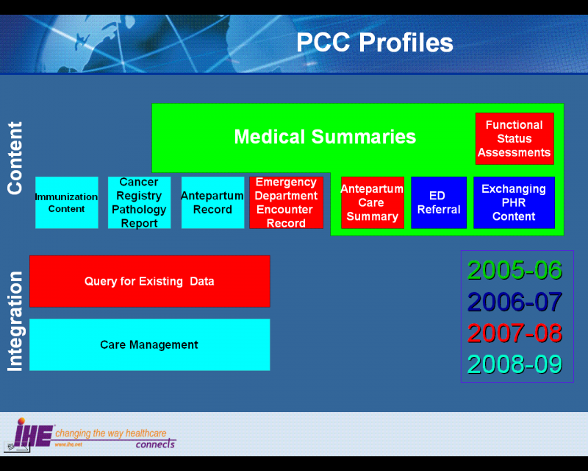
Figure 2.4-1 IHE Patient Care Coordination Content Integration Profiles

Dependencies of the PCC Integration Profiles
Dependencies among IHE Integration Profiles exist when implementation of one integration profile is a prerequisite for achieving the functionality defined in another integration profile. The table below defines these dependencies. Some dependencies require that an actor supporting one profile be grouped with one or more actors supporting other integration profiles. For example, Cross-Enterprise Sharing of Medical Summaries (XDS-MS) requires that its actors be grouped with a Secured Node Actor of the Audit Trail and Node Authentication (ATNA) Integration Profile. The dependency exists because XDS-MS and XDS actors must support a secured communication channel with proper auditing of the exchange of patient identified information in order to function properly in an environment where protection of patient privacy is critical.
Integration Profile | Depends on | Dependency Type | Purpose
All PCC Content Profiles | Audit Trail and Node Authentication (ATNA) | Each Content Creator and Content Consumer actor shall be grouped with the ATNA Secured Node Actor | Required to manage audit trail of exported PHI, node authentication, and transport encryption.
All PCC Content Profiles | Consistent Time (CT) | Each Content Creator and Content Consumer actor shall be grouped with the Time Client Actor | Required to manage and resolve conflicts in multiple updates.
Functional Status Assessments (FSA) | Cross Enterprise Document Exchange of Medical Summaries (XDS-MS)  OR  Exchange of Personal Health Record Content (XPHR)  OR  Emergency Department Referral (EDR) | Content Consumers implementing the Functional Status Assessments profile shall be grouped with either the XDS-MS, XPHR or EDR Content Consumer. Content Creators implementing the Functional Status Assessments profile shall be grouped with either the XDS-MS, XPHR or EDR Content Creator. | Ensures that the Functional Status Assessment is communicated as part of an exchange of medical summary information.
Functional Status Assessments (QED) | Audit Trail and Node Authentication (ATNA) | Each actor in this profile shall be grouped with the ATNA Secure Node or Secure Application actor. | Required to manage audit trail of exported PHI, node authentication, and transport encryption.
Functional Status Assessments (QED) | Consistent Time (CT) | Each actor in this profile shall be grouped with the Time Client Actor | Required to manage and resolve conflicts in multiple updates.
Table 2.5-1 PCC Profile Dependencies
To support a dependent profile, an actor must implement all required transactions in the prerequisite profiles in addition to those in the dependent profile. In some cases, the prerequisite is that the actor selects any one of a given set of profiles.

PCC Integration Profiles Overview
In this document, each IHE Integration Profile is defined by:
- The IHE actors involved
- The specific set of IHE transactions exchanged by each IHE actor.
- The content of the IHE transactions
These requirements are presented in the form of a table of transactions required for each actor supporting the Integration Profile. Actors supporting multiple Integration Profiles are required to support all the required transactions of each Integration Profile supported. When an Integration Profile depends upon another Integration Profile, the transactions required for the dependent Integration Profile have not been included in the table.
The content of the transactions are presented as Content Integration Profiles. These are specification of the content to be exchange, along with explanations (called bindings) of how the content affects the transactions in which it is exchanged. It is expected that Content Integration Profiles will be used environments where the physician offices and hospitals have a coordinated infrastructure that serves the information sharing needs of this community of care. Several mechanisms are supported by IHE profiles:
- A registry/repository-based infrastructure is defined by the IHE Cross-Enterprise Document Sharing (XDS) and other IHE Integration Profiles such as patient identification (PIX & PDQ), and notification of availability of documents (NAV).
- A media-based infrastructure is defined by the IHE Cross-Enterprise Document Media Interchange (XDM) profile.
- A reliable messaging-based infrastructure is defined by the IHE Cross-Enterprise Document Reliable Interchange (XDR) profile.
- All of these infrastructures support Security and privacy through the use of the Consistent Time (CT) and Audit Trail and Node Authentication (ATNA) profiles.
For more details on these profiles, see the IHE IT Infrastructure Technical Framework, found here: http://www.ihe.net/Technical_Framework/.
Such an infrastructure is assumed by the use cases that focus on the context for defining the specific clinical information content for this profile. These content integration profiles use similar transactions and differ only in the content exchanged. A process flow for these use cases using Cross Enterprise Document Sharing (XDS) and Notification of Document Availability (NAV) is shown in the figure below. Other process flows are possible using XDM and/or XDR.
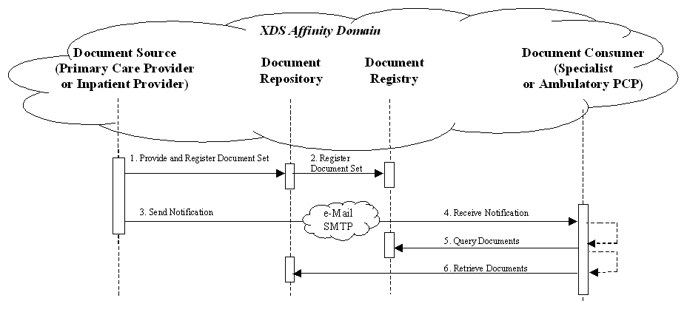
Figure 2.6-2 Use Case Process Flow Diagram
These steps are:
- Extract/capture a collection of records into a set of documents packaged as an XDS Submission Set. This submission contains at least one clinical document, and may contain a number of other related clinical documents. For example, Medical Summaries are clinical documents (already known in the paper world), which often serve the dual purpose of documenting an encounter and providing the rationale for sending the information to another provider. This step utilizes the transactions provided by the ITI XDS profile to place the records in an XDS Repository (local or shared).
- The Repository ensures that the documents of the submission set are registered with the XDS Registry of the Affinity Domain (set of cooperating care delivery institutions).
- Notify the other provider that documents are now available for review. This step utilizes the transactions provided by the ITI NAV profile to perform the e-mail notification.
- The e-mail notification that contains no patient identified information is received by the specialist EMR system.
- The receiving provider can then utilize existing query transactions from the XDS profile to find the URL of the Documents.
- Finally, the receiving provider may choose to display the document, or import relevant information from these records into their own EMR system.

Unplanned Access to past Content
In many cases, a provider may need to assess information from the patient care history, and patients may have content in the XDS repository from prior visits to other providers. For example, Medical Summaries, as well as other documents such as laboratory and radiology reports are critical for emergency physicians and nurses to provide the best care to patient in acute conditions. The figure below shows the transactions required for this use case, again, using XDS. Other process flows are possible using XDM and/or XDR.
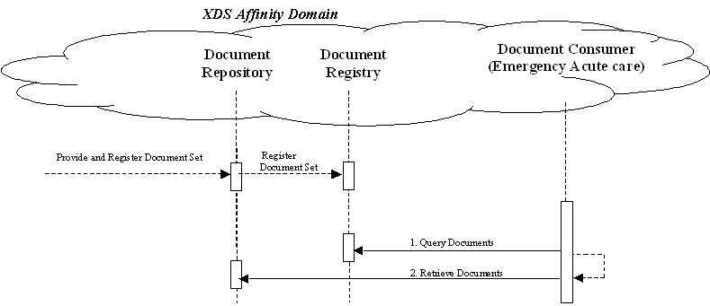
Figure 2.6-3 Unplanned Access Process Flow Diagram
Note that IHE Integration Profiles are not statements of conformance to standards, and IHE is not a certifying body. Users should continue to request that vendors provide statements of their conformance to standards issued by relevant standards bodies, such as HL7 and DICOM. Standards conformance is a prerequisite for vendors adopting IHE Integration Profiles.
Also note that there are critical requirements for any successful integration project that IHE cannot address. Successfully integrating systems still requires a project plan that minimizes disruptions and describes fail-safe strategies, specific and mutually understood performance expectations, well-defined user interface requirements, clearly identified systems limitations, detailed cost objectives, plans for maintenance and support, etc.

History of Annual Changes
In the 2005-2006 cycle of the IHE Patient Care Coordination initiative, the first release of the IHE PCC Technical Framework introduced the following integration profile:
- Cross-Enterprise Sharing of Medical Summaries (XDS-MS) – a mechanism to automate the sharing process between care providers of Medical Summaries, a class of clinical documents that contain the most relevant portions of information about the patient intended for a specific provider or a broad range of potential providers in different settings. Medical Summaries are commonly created and consumed at points in time of transfers of care such as referrals or discharge.
In the 2006-2007 cycle of the IHE Patient Care Coordination initiative, the following integration profiles were added to the technical framework.
- Exchange of Personal Health Record Content (XPHR) – provides a standards-based specification for managing the interchange of documents between a Personal Health Record used by a patient and systems used by other healthcare providers to enable better interoperability between these systems.
- Basic Patient Privacy Consents (BPPC) – enables XDS Affinity Domains to be more flexible in the privacy policies that they support, by providing mechanisms to record patient privacy consents, enforce these consents, and create Affinity Domain defined consent vocabularies that identify information sharing policies.
Please Note: This profile was transfered to the ITI Domain in the Fall of 2007, and can be found here http://www.ihe.net/Technical_Framework/index.cfm#IT
- Preprocedure History and Physical Content Profile (PPHP) – supports the exchange of information allowing for the assessment and amelioration of risks related to a procedure. Please Note: This profile has been withdrawn.
- Emergency Department Referral Profile (EDR) – provides a means to communicate medical summary data from an EHR System to an EDIS System.
In the 2007-2008 cycle of the IHE Patient Care Coordination initiative, the following integration profiles were added to the technical framework.
- Antepartum Care Summary (APS) - describes the content and format of summary documents used during antepartum care.
- Emergency Department Encounter Summary (EDES) - describes the content and format of records created during an emergency department visit.
- Functional Status Assessment Profile (FSA) - supports the handoff of assessment information between practictioners during transfers of care by defining the Functional Status Assessment option on the XDS-MS and XPHR profiles.
- Query for Existing Data (QED) - allows information systems to query data repositories for clinical information on vital signs, problems, medications, immunizations, and diagnostic results.
- Public Health Laboratory Report(PHLAB) - extends the XD*-LAB profile to support reporting from public health laboratories for disease surviellance activities. Please Note: This profile has been subsequently moved to the XD-LAB specification, and van be found here http://www.ihe.net/Technical_Framework/index.cfm#LAB
In addition, all content within the technical framework was revised in the 2007-2008 cycle to encourage compatibility with the ASTM/HL7 Continuity of Care Document Implementation Guide.
In the 2008-2009 cycle of the IHE Patient Care Coordination initiative, the following integration profiles were added to the technical framework.
- Antepartum Record (APR) - describes the content and format of summary documents used during antepartum care.
- Care Management (CM) - describes the content and format of summary documents used during antepartum care.
- Immunization Content (IC) - describes the content and format of summary documents used during antepartum care.
- Cancer Registry Pathology Report (CPR) - describes the content and format of summary documents used during antepartum care.

Product Implementations
Developers have a number of options in implementing IHE actors and transactions in product implementations. The decisions cover three classes of optionality:
- For a system, select which actors it will incorporate (multiple actors per system are acceptable).
- For each actor, select the integration profiles in which it will participate.
- For each actor and profile, select which options will be implemented.
All required transactions must be implemented for the profile to be supported (for XDS-MS, refer to the transaction descriptions for XDS in ITI TF-2).
Implementers should provide a statement describing which IHE actors, IHE integration profiles and options are incorporated in a given product. The recommended form for such a statement is defined in PCC TF-1: Appendix C.
In general, a product implementation may incorporate any single actor or combination of actors. When two or more actors are grouped together, internal communication between actors is assumed to be sufficient to allow the necessary information flow to support their functionality; for example, the Document Source Actor of XDS-MS may use the Patient Identifier Cross-reference Consumer Actor to obtain the necessary patient identifier mapping information from its local patient id to that used in the document sharing domain. The exact mechanisms of such internal communication are outside the scope of the IHE Technical Framework.
When multiple actors are grouped in a single product implementation, all transactions originating or terminating with each of the supported actors shall be supported (i.e., the IHE transactions shall be offered on an external product interface).
The following examples describe which actors typical systems might be expected to support. This is not intended to be a requirement, but rather to provide illustrative examples.
An acute care EMR serving a hospital might include a Document Source Actor, Document Consumer Actor, a Document Repository Actor, a Patient Identification Consumer Actor, as well as a Secured Node Actor. An Ambulatory EMR serving a physician practice might include a Document Source Actor, Document Consumer Actor, a Patient Demographics Client Actor, as well as a Secured Node Actor.

Cancer Registry Pathology Report Content

Profile Abstract
The Cancer Registry Pathology Report Content Profile (CRPR) defines the the content used in the PCC-11 to send a completed pathology report to a Cancer Registry using an HL7 Version 2.3.1 ORU message.

Glossary
International Classification of Diseases for Oncology, 3rd Edition (ICD-O-3)
Classification system for reporting incidences of malignant diseases.
NAACCR
The North American Association of Central Cancer Registries. A collaborative umbrella organization for cancer registries, governmental agencies, professional organizations, and private groups in North America interested in enhancing the quality and use of cancer registry data.
Pathology Report
The written description of the microscopic examination of a tissue. The gross description reports the physical characteristics of the tissue: size, color, and abnormalities visible with the unaided eye. The microscopic description reports the cellular characteristics aided by the use of a microscope: what cells are involved, the behavior, and the aggressiveness or grade of any abnormality. The final diagnosis is a summary of the findings and indicates the pathologist’s impression of what was found in concise terms.

Issue Log

Open Issues

Closed Issues
- Issue: Glossary: Use MERP glossary document or consolidated glossary tool?
  - Refer to the existing document
- Issue: Options: need help understanding this component
  - Won't have any
  - Added options based on discussion at May f2f meeting.
- Issue: Transaction Definitions: need help understanding this component
  - Not relevant to this profile
- Issue: What information do we need to include in 3.1.2, 3.1.3, 3.2, 3.3, 3.4?
  - Just reference the NAACCR Documentation on this section
- Should we include a sample message?
  - include a link to a webpage of a sample message. There are ways to convert a document to a webpage....
Add the following bullet to the list of profiles
- The Cancer Registry Pathology Report Content Profile (CPR) defines the the content used in the PCC-11 to send a completed pathology report to a Cancer Registry using an HL7 Version 2.3.1 ORU message.

Dependencies
Add the following row(s) to the list of dependencies
Integration Profile | Dependency | Dependency Type | Purpose
Cancer Registry Pathology Report (CPR) | Care Management (CM) | The Content Creator actor of the CPR profile must be grouped with the Clinical Data Source Actor of the CM profile | The CPR profile defines the content sent in the PCC-11 transaction specified in the CM profile
Cancer Registry Pathology Report (CPR) | Care Management (CM) | The Content Consumer actor of the CPR profile must be grouped with the Care Manager Actor of the CM profile | The CPR profile defines the content recieved in the PCC-11 transaction specified in the CM profile
Cancer Registry Pathology Report (CPR) | ATNA | Actors the CPR profile shall implement the Secure Node Actor of the ATNA profile | Ensures that transmissions and changes to patient health information are logged in an audit repository, and that communication is secured between nodes.
Cancer Registry Pathology Report (CPR) | ATNA | Actors the CPR profile shall implement the Time Client Actor of the CT profile | Ensures that concistent time is used in all messages.

Overview
The Cancer Registry Pathology Report Content Profile (CRPR) defines the the content used in the PCC-11 to send a completed pathology report to a Cancer Registry using an HL7 Version 2.3.1 ORU message.
Monitoring the occurence of cancer is a cornerstone of cancer control decision making. this monitoring, referred to as cancer surveillance, can be used to trigger case investigations, follow trends, evaluate the effectiveness of prevention measures such as screening and early detection programs and suggest public health priorities. It is vital to identify and registrar all cancer cases. By not identifying all of the cancer cases, cancer incidence will be underestimated, giving a false impression of the magnitude of the cancer problem in the registry’s population area. Inaccurate incidence rates can misdirect cancer control efforts, and provide a false picture of the effectiveness of treatment efforts.
Because most cancers are definitively diagnosed by microscopic examination of tissue, cancer surveillance programs rely on pathology reports to identify new cases and collect further information on cases previously reported.
Two challenges relate to pathology laboratory reporting of cancer cases. Laboratories may photocopy selected pathology reports and mail them to the cancer registry. This method is labor intensive and prone to missing cases because the laboratory staff is not aware of the full case definition for identifying a cancer case. Additionally, the cancer registry staff must re-enter the information into the cancer registry with a risk of data entry errors.
Alternately, laboratories may choose not to actively report cases, but allow cancer registry personnel to identify and photocopy appropriate pathology reports on site. This is very costly for the registry and has the same risk of data entry errors when the reports are manually entered into the registry database.
Further information on the benefits, challenges and the cancer registry's uses of electronic pathology reporting can be found in the:
[4] : North American Association of Central Cancer Registries (NAACCR) Electronic Pathology (E-Path) Reporting Guidelines, Dec 2006.

Use Cases
Pre-condition
A woman goes in for a routine mammogram and a suspicious area is noted. The woman is referred by her family physician to a surgeon who does a biopsy and sends the tissue sample to the pathology laboratory for review and diagnosis.
The pathology laboratory receives the specimen, logs it into the laboratory information system (LIS) and prepares the specimen for analysis. The pathologist analyzes the specimen and dictates his/her findings, which are then transcribed into the LIS. The pathologist verifies the accuracy of the report and signs the transcribed report. The LIS marks the pathology report as "Final", triggering the use case events.
Events
1. Pathology Laboratory Creates Message
The LIS identifies that the report matches submission criteria because it is a histopathology test (biopsy) and the diagnosis relates to cancer ("carcinoma"). The LIS gathers information from its database and other appropriate databases to create a message that contains all of the required data elements. The LIS validates the data to ensure it conforms to the HL7 2.3.1 ORU-RO1 specification and transmits it to the Cancer Registry using a secure connection.
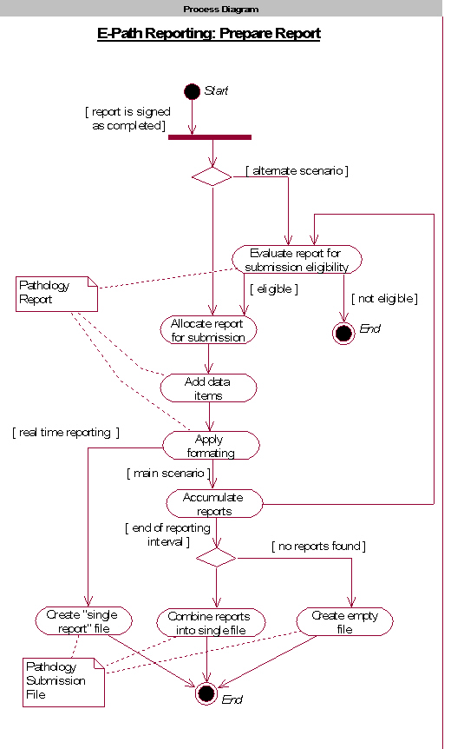
Figure 4 Pathology Laboratory Process Flow :
[1] : North American Association of Central Cancer Registries (NAACCR) Electronic Pathology (E-Path) Reporting Guidelines, Dec 2006.
1. Cancer Registry Processes Registration
The Cancer Registry receives the HL7 messages, parses it into the processing database and determines that a cancer diagnosis has been documented. The Cancer Registry staff codes the medical information. The pathology data and coded information is exported to the Cancer Registry Database and the message is archived.
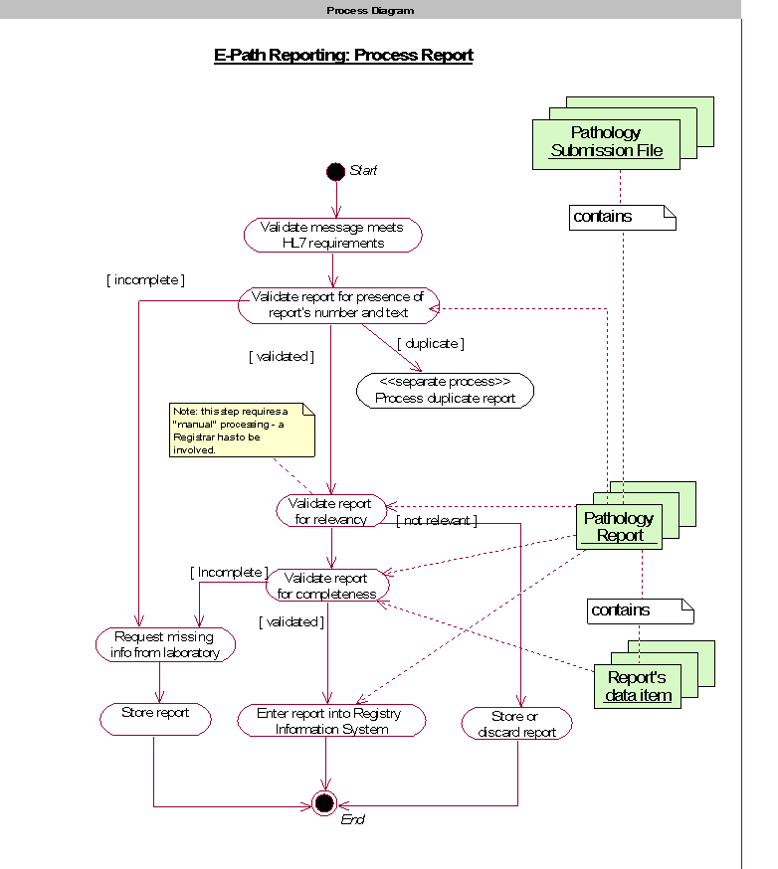
Figure 5 Cancer Registry Process Flow:
[2] : North American Association of Central Cancer Registries (NAACCR) Electronic Pathology (E-Path) Reporting Guidelines, Dec 2006.
Post-condition
Pathology information has been added to the Cancer Registry Database.
The message is available for future use as needed.

Scope
The following diagram constrains the scope of the Cancer Registry Pathology Report Content Profile.
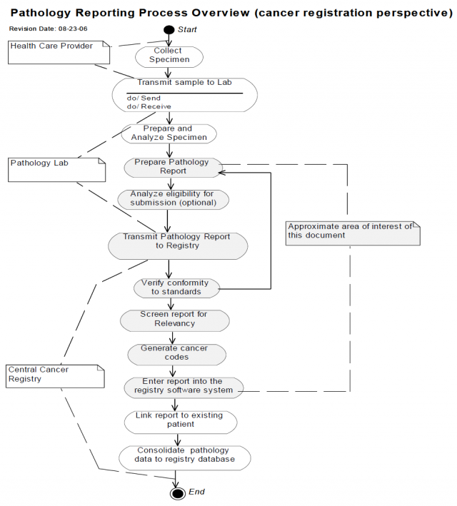
Cancer Registry Pathology Report Content Profile Scope of Action Diagram:
[3] : North American Association of Central Cancer Registries (NAACCR) Electronic Pathology (E-Path) Reporting Guidelines, Dec 2006.

Actors/Transaction
There are two actors in this profile, the Content Creator and the Content Consumer. Content is created by a Content Creator and is to be consumed by a Content Consumer. The sharing or transmission of content from one actor to the other is addressed by the appropriate use of IHE profiles described below, and is out of scope of this profile.

Figure 6Cancer Registry Pathology Report Content Actor Diagram

Grouping

Care Management (CM)
The Content Creator of this profile must be grouped with the Clinical Data Source of the Care Management profile. The Clinical Data Source actor must implement the V2 Care Management Update Option.
The Content Consumer Actor of this profile must be grouped with the Care Manager actor of the Care Management profile.

Basic Patient Privacy Consents (BCCP)
When patient consent is required (for example, as in the case of Quebec), the Content Creator may be grouped with the Content Consumer Actor of the BPPC profile. When grouped with that actor, the Content Creator shall verify that an appropriate consent has been registered for the patient to share the pathology data prior to sending the message.

Policy Considerations
Batch or Real Time Reporting
Because the Cancer Registry Pathology Report Content Profile relates to secondary use of data, Batch Reporting with a frequency of every 24 hours is recommended.
Case Selection
A Content Consumer may require that all reports be transmitted, regardless of relevance to cancer, or it may require transmission to be restricted based on specific selection criteria. This is a policy decision made by the Content Receiver based on state, provincial and fedreal legislations and/or regulations, rules or by operating policy.

Security Considerations

Requirements/Capabilities
Case selection
Provide option to select all reports or only those that meet selection criteria. Refer to Volume II for:
- List of anatomic pathology reports
- Standards for Identifying Pathology Reports
Message Conformance
Message can be validated using:
[5] : NAACCR Volume V Messaging Workbench Profile.

Actor Definitions
Actors are information systems or components of information systems that produce, manage, or act on information associated with operational activities in the enterprise.
Content Creator
The Content Creator Actor is responsible for the creation of content and transmission to a Content Consumer.
Content Consumer
A Content Consumer Actor is responsible for viewing, import, or other processing of content created by a Content Creator Actor.
Clinical Data Consumer
A clinical data consumer makes use of clinical patient data.
Clinical Data Source
A Clinical Data Sources maintains patient information about vital signs, problem and allergies, results from diagnostic tests (e.g., Lab, Imaging, or other test results), medications, immunizations or historical or planned visits and procedures.
Guideline Manager
The guideline manager actor is responsible for managing the guidelines used to create care plans, and for communicating those guidelines to other systems.
Care Manager
The care manager actor is responsible for supporting the management of the care of patients with respect to a specific health condition. It gathers information about the care provided and current health status of the patient. A Care Manager actor may be designed for management of a single condition, such as management of Diabetes, or may be a general purpose system supporting management of multiple conditions.

Transaction Definitions
Query Existing Data
Request information about recent patient information, used to obtain vital signs measurements, problems and allergies, diagnostic results, medications, immunizations, or procedures or visits relevant for a patient. The query may request information about some or all of the above topics, or may request information on a specific topic, or one entered for a specific encounter or date range.
Guideline Notification
The Guideline Notification transaction reports a the content of new and/or updated guidelines to interested parties. The purpose of this transaction is to alert systems that need to act on clinical guidelines of the availability of new guidelines.
Request Guideline Data
The Request Guideline Data transaction supports the capability of systems to query for the contents of an identified guideline.

Care Management Data Query
The Care Management Data Query transaction supports the capability for systems responsible for monitoring the health status and care provided to one or more patients to request that information from systems that may have it.
V3 Care Management Update
The V3 Care Management Update transaction supports the capability for systems that have information about the health status and care provided to one or more patients to share that information with external systems that need to monitor that information using profiles of HL7 V3 Care Record standard messages.
V2 Care Management Update
The Care Management Updagte transaction supports the capability for systems that have information about the health status and care provided to one or more patients to share that information with external systems that need to monitor that information using specific profiles of HL7 V2 standard messages.

How to Prepare an IHE Integration Statement
IHE Integration Statements are documents prepared and published by vendors to describe the conformance of their products with the IHE Technical Framework. They identify the specific IHE capabilities a given product supports in terms of IHE actors and integration profiles described in the technical frameworks of each domain.
Users familiar with these concepts can use Integration Statements to determine what level of integration a vendor asserts a product supports with complementary systems and what clinical and operational benefits such integration might provide. Integration Statements are intended to be used in conjunction with statements of conformance to specific standards (e.g. HL7, IETF, DICOM, W3C, etc.).
IHE provides a process for vendors to test their implementations of IHE actors and integration profiles. The IHE testing process, culminating in a multi-party interactive testing event called the Connect-a-thon, provides vendors with valuable feedback and provides a baseline indication of the conformance of their implementations. The process is not intended to independently evaluate, or ensure, product compliance. In publishing the results of the Connect-a-thon and facilitating access to vendors' IHE Integration Statements, IHE and its sponsoring organizations are in no way attesting to the accuracy or validity of any vendor's IHE Integration Statements or any other claims by vendors regarding their products.
IMPORTANT -- PLEASE NOTE: Vendors have sole responsibility for the accuracy and validity of their IHE Integration Statements. Vendors' Integration Statements are made available through IHE simply for consideration by parties seeking information about the integration capabilities of particular products. IHE and its sponsoring organizations have not evaluated or approved any IHE Integration Statement or any related product, and IHE and its sponsoring organizations shall have no liability or responsibility to any party for any claims or damages, whether direct, indirect, incidental or consequential, including but not limited to business interruption and loss of revenue, arising from any use of, or reliance upon, any IHE Integration Statement.
  - Structure and Content of an IHE Integration Statement
An IHE Integration Statement for a product shall include:
- The Vendor Name
- The Product Name (as used in the commercial context) to which the IHE Integration Statement applies.
- The Product Version to which the IHE Integration Statement applies.
- A publication date and optionally a revision designation for the IHE Integration Statement.
- The following statement: "This product implements all transactions required in the IHE Technical Framework to support the IHE Integration Profiles, Actors and Options listed below:"
- A list of IHE Integration Profiles supported by the product and, for each Integration Profile, a list of IHE Actors supported. For each integration profile/actor combination, one or more of the options defined in the IHE Technical Framework may also be stated. Profiles, Actors and Options shall use the names defined by the IHE Technical Framework Volume I. (Note: The vendor may also elect to indicate the version number of the Technical Framework referenced for each Integration Profile.)
Note that implementation of the integration profile implies implementation of all required transactions for an actor as well as selected options.
The statement shall also include references and/or internet links to the following information:
- Specific internet address (or universal resource locator [URL]) where the vendor's Integration Statements are posted
- URL where the vendor's standards conformance statements (e.g., HL7, DICOM, etc.) relevant to the IHE transactions implemented by the product are posted.
- URL of the IHE Initiative's web page for general IHE information www.himss.org/ihe.
An IHE Integration Statement is not intended to promote or advertise aspects of a product not directly related to its implementation of IHE capabilities.
  - Format of an IHE Integration Statement
Each Integration Statement shall follow the format shown below. Vendors may add a cover page and any necessary additional information in accordance with their product documentation policies.
IHE Integration Statement | Date | 12 Oct 2005
Vendor | Product Name | Version
Any Medical Systems Co. | IntegrateRecord | V2.3
This product implements all transactions required in the IHE Technical Framework to support the IHE Integration Profiles, Actors and Options listed below:
Integration Profiles Implemented | Actors Implemented | Options Implemented
Cross-Enterprise Sharing of Medical Summaries | Document Consumer | View Option
Audit Trail and Node Authentication | Secure Node | none
Patient Identity Cross-referencing | Patient Identifier Cross-reference Consumer | PIX Update Notification
Internet address for vendor's IHE information:www.anymedicalsystemsco.com/ihe
Links to Standards Conformance Statements for the Implementation
HL7 | www.anymedicalsystemsco.com/hl7
Links to general information on IHE
In North America: www.ihe.het | In Europe: www.ihe-europe.org | In Japan: www.jira-net.or.jp/ihe-j
The assumption of an integration statement is that all actors listed are functionally grouped and conform to any profile specifications for such groupings. In case of exceptions the vendor must explicitly describe the functional groupings.

Volume 2

Preface to Volume 2

Intended Audience
The intended audience of this document is:
- Technical staff of vendors planning to participate in the IHE initiative
- IT departments of healthcare institutions
- Experts involved in standards development
- Anyone interested in the technical aspects of integrating healthcare information systems

Related Information for the Reader
The reader of volume 2 should read or be familiar with the following documents:
- Volume 1 of the Cross-Enterprise Document Sharing (XDS) Integration Profile documented in the ITI Infrastructure Technical Framework
(See http://www.ihe.net/Technical_Framework/index.cfm ).
- Volume 1 of the Notification of Document Availability (NAV) Integration Profile documented in the ITI Infrastructure Technical Framework
(See http://www.ihe.net/Technical_Framework/index.cfm ).
- Volume 1 of the Audit Trail and Node Authentication (ATNA) Integration Profile documented in the ITI Infrastructure Technical Framework
(See http://www.ihe.net/Technical_Framework/index.cfm ).
- HL7 Clinical Document Architecture Release 2: Section 1, CDA Overview.
- Care Record Summary – Implementation Guide for CDA Release 2 (US Realm): Section 1
- Presentations from IHE Workshop: Effective Integration of the Enterprise and the Health System - June 28–29, 2005: http://www.ihe.net/Participation/workshop_2005.cfm, June 2005:
- for a RHIO-3.ppt Leveraging IHE to Build RHIO Interoperability
- Cross-Enterprise Document Sharing (XDS)
- Notification of Document Availability (NAV)
- Educ.ppt Patient Care Coordination
- Use Cases for Medical Summaries
- Ovrw.ppt Patient Care Coordination - Overview of Profiles

How this Document is Organized
Section 1 is the preface, describing the intended audience, related resources, and organizations and conventions used within this document.
Section 2 provides an overview of the concepts of IHE actors and transactions used in IHE to define the functional components of a distributed healthcare environment.
Section 3 defines transactions in detail, specifying the roles for each actor, the standards employed, the information exchanged, and in some cases, implementation options for the transaction.
Section 4 defines a set of payload bindings with transactions.
Section 5 defines the content modules that may be used in transactions.

Conventions Used in this Volume
This document has adopted the following conventions for representing the framework concepts and specifying how the standards upon which the IHE Technical Framework is based should be applied.

The Generic IHE Transaction Model
Transaction descriptions are provided in section 4. In each transaction description, the actors, the roles they play, and the transactions between them are presented as use cases.
The generic IHE transaction description includes the following components:
- Scope: a brief description of the transaction.
- Use case roles: textual definitions of the actors and their roles, with a simple diagram relating them, e.g.:
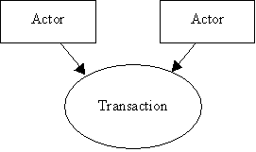
Figure 1.2-7 Use Case Role Diagram
- Referenced Standards: the standards (stating the specific parts, chapters or sections thereof) to be used for the transaction.
- Interaction Diagram: a graphical depiction of the actors and transactions, with related processing within an actor shown as a rectangle and time progressing downward, similar to:
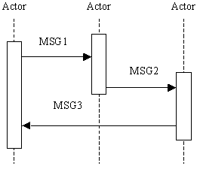
Figure 1.2-8 Interaction Diagram
The interaction diagrams used in the IHE Technical Framework are modeled after those described in Grady Booch, James Rumbaugh, and Ivar Jacobson, The Unified Modeling Language User Guide, ISBN 0-201-57168-4. Simple acknowledgment messages are omitted from the diagrams for brevity.
- Message definitions: descriptions of each message involved in the transaction, the events that trigger the message, its semantics, and the actions that the message triggers in the receiver.

Copyright Permissions
Health Level Seven, Inc., has granted permission to the IHE to reproduce tables from the HL7 standard. The HL7 tables in this document are copyrighted by Health Level Seven, Inc. All rights reserved.
Material drawn from these documents is credited where used.

How to Contact Us
IHE Sponsors welcome comments on this document and the IHE initiative. They should be directed to the discussion server at http://forums.rsna.org or to:
Didi Davis
Senior Director of Integrating the Healthcare Enterprise
230 East Ohio St., Suite 500
Chicago, IL 60611
Email: ihe@himss.org

Introduction
This document, the IHE Patient Care Coordination Technical Framework (PCC TF), defines specific implementations of established standards. These are intended to achieve integration goals that promote appropriate exchange of medical information to coordinate the optimal patient care among care providers in different care settings. It is expanded annually, after a period of public review, and maintained regularly through the identification and correction of errata. The latest version of the document is always available via the Internet at http://www.ihe.net/Technical_Framework/index.cfm , where the technical framework volumes specific to the various healthcare domains addressed by IHE may be found.
The IHE Patient Care Coordination Technical Framework identifies a subset of the functional components of the healthcare enterprises and health information networks, called IHE actors, and specifies their interactions in terms of a set of coordinated, standards-based transactions.
The other domains within the IHE initiative also produce Technical Frameworks within their respective areas that together form the IHE Technical Framework. Currently, the following IHE Technical Framework(s) are available:
- IHE IT Infrastructure Technical Framework
- IHE Cardiology Technical Framework
- IHE Laboratory Technical framework
- IHE Radiology Technical Framework
- IHE Patient Care Coordination Technical Framework
Where applicable, references are made to other technical frameworks. For the conventions on referencing other frameworks, see the preface of this volume.

Relationship to Standards
The IHE Technical Framework identifies functional components of a distributed healthcare environment (referred to as IHE actors), solely from the point of view of their interactions in the healthcare enterprise. At its current level of development, it defines a coordinated set of transactions based on standards (such as HL7, IETF, ASTM, DICOM, ISO, OASIS, etc.) in order to accomplish a particular use case. As the scope of the IHE initiative expands, transactions based on other standards may be included as required.
Each transaction may have as its payload one or more forms of content, as well as specific metadata describing that content within the transaction. The specification of the payload and metadata about it are the components of a Content Integration Profile. The payload is specified in a Content Module, and the impacts of any particular payload on a transaction are described within a content binding. The payloads of each transaction are also based on standards (such as HL7, IETF, ASTM, DICOM, ISO, OASIS, etc.), again, in order to meet the needs of a specific use case.
In some cases, IHE recommends selection of specific options supported by these standards. However, IHE does not introduce technical choices that contradict conformance to these standards. If errors in or extensions to existing standards are identified, IHE's policy is to report them to the appropriate standards bodies for resolution within their conformance and standards evolution strategy.
IHE is therefore an implementation framework, not a standard. Conformance claims for products must still be made in direct reference to specific standards. In addition, vendors who have implemented IHE integration capabilities in their products may publish IHE Integration Statements to communicate their products' capabilities. Vendors publishing IHE Integration Statements accept full responsibility for their content. By comparing the IHE Integration Statements from different products, a user familiar with the IHE concepts of actors and integration profiles can determine the level of integration between them. See PCC TF-1: Appendix C for the format of IHE Integration Statements.

Relationship to Product Implementations
The IHE actors and transactions described in the IHE Technical Framework are abstractions of the real-world healthcare information system environment. While some of the transactions are traditionally performed by specific product categories (e.g. HIS, Clinical Data Repository, Electronic Health record systems, Radiology Information Systems, Clinical Information Systems or Cardiology Information Systems), the IHE Technical Framework intentionally avoids associating functions or actors with such product categories. For each actor, the IHE Technical Framework defines only those functions associated with integrating information systems. The IHE definition of an actor should therefore not be taken as the complete definition of any product that might implement it, nor should the framework itself be taken to comprehensively describe the architecture of a healthcare information system.
The reason for defining actors and transactions is to provide a basis for defining the interactions among functional components of the healthcare information system environment. In situations where a single physical product implements multiple functions, only the interfaces between the product and external functions in the environment are considered to be significant by the IHE initiative. Therefore, the IHE initiative takes no position as to the relative merits of an integrated environment based on a single, all-encompassing information system versus one based on multiple systems that together achieve the same end.

Relation of this Volume to the Technical Framework
The IHE Technical Framework is based on actors that interact through transactions using some form of content.
Actors are information systems or components of information systems that produce, manage, or act on information associated with operational activities in the enterprise.
Transactions are interactions between actors that transfer the required information through standards-based messages.
The implementation of the transactions described in this PCC TF-2 support the specification of Integration Profiles defined in PCC TF-1. The role and implementation of these transactions require the understanding of the Integration profile they support.
There is often a very clear distinction between the transactions in a messaging framework used to package and transmit information, and the information content actually transmitted in those messages. This is especially true when the messaging framework begins to move towards mainstream computing infrastructures being adopted by the healthcare industry.
In these cases, the same transactions may be used to support a wide variety of use cases in healthcare, and so more and more the content and use of the message also needs to be profiled, sometimes separately from the transaction itself. Towards this end IHE has developed the concept of a Content Integration Profile.
Content Integration Profiles specify how the payload of a transaction fits into a specific use of that transaction. A content integration profile has three main parts. The first part describes the use case. The second part is binding to a specific IHE transaction, which describes how the content affects the transaction. The third part is a Content Module, which describes the payload of the transaction. A content module is specified so as to be independent of the transaction in which it appears.

Content Modules
The Patient Care Coordination Technical Framework organizes content modules categorically by the base standard. At present, the PCC Technical Framework uses only one base standard, CDA Release 2.0, but this is expected to change over time. Underneath each standard, the content modules are organized using a very coarse hierarchy inherent to the standard. So for CDA Release 2.0 the modules are organized by document, section, entry, and header elements.
Each content module can be viewed as the definition of a "class" in software design terms, and has associated with it a name. Like "class" definitions in software design, a content module is a "contract", and the PCC Technical Framework defines that contract in terms of constraints that must be obeyed by instances of that content module. Each content module has a name, also known as its template identifier. The template identifiers are used to identify the contract agreed to by the content module. The PCC Technical Committee is responsible for assigning the template identifiers to each content module.
Like classes, content modules may inherit features of other content modules of the same type (Document, Section or Entry) by defining the parent content module that they inherit from. They may not inherit features from a different type. Although information in the CDA Header is in a different location that information in a CDA Entry, these two content modules are considered to be of the same type, and so may inherit from each other when necessary.
The PCC Technical Framework uses the convention that a content module cannot have more than one parent (although it may have several ancestors). This is similar to the constraint in the Java™ programming language, where classes can derive from only one parent. This convention is not due to any specific technical limitation of the technical framework, but does make it easier for software developers to implement content modules.
Each content module has a list of data elements that are required (R), required if known (R2), and optional (O). The presentation of this information varies with the type of content module, and is described in more detail below. Additional data elements may be provided by the sender that are not defined by a specific content module, but the receiver is not required to interpret them.
Required data elements must always be sent. Data elements that are required may under exceptional circumstances have an unknown value (e.g., the name of an unconscious patient). In these cases the sending application is required to indicate the reason that the data is not available.
Data elements that are marked required if known (R2) must be sent when the sending application has that data available. The sending application must be able to demonstrate that it can send all required if known elements, unless it does not in fact gather that data. When the information is not available, the sending application may indicate the reason that the data is not available.
Data elements that are marked optional (O) may be sent at the choice of the sending application. Since a content module may include data elements not specified by the profile, some might ask why these are specified in a content module. The reason for specifying the optional data elements is to ensure that both sender and receiver use the appropriate semantic interpretation of these elements. Thus, an optional element need not be sent, but when it is sent, the content module defines the meaning of that data element, and a receiver can always be assured of what that data element represents when it is present. Senders should not send an optional data element with an unknown value. If the value is not known, simply do not send the data element.
Other data elements may be included in an instance of a content module over what is defined by the PCC Technical Framework. Receivers are not required to process these elements, and if they do not understand them, must ignore them. Thus, it is not an error to include more than is asked for, but it is an error to reject a content module because it contains more than is defined by the framework. This allows value to be added to the content modules delivered in this framework, through extensions to it that are not defined or profiled by IHE. It further allows content modules to be defined later by IHE that are refinements or improvements over previous content modules.
For example, there is a Referral Summary content module defined in this framework. In later years an ED Referral content module can be created that inherits the constraints of the Referral Summary content module, with a few more use case specific constraints added. Systems that do not understand the ED Referral content module but do understand the Referral Summary content module will be able to interoperate with systems that send instances of documents that conform to the ED Referral content module. This interoperability, albeit at a reduced level of functionality, is by virtue of the fact that ED Referrals are simply a refinement of the Referral Summary.
In order to retain this capability, there are a few rules about how the PCC Technical Committee creates constraints. Constraints that apply to any content module will always apply to any content modules that inherit from it. Thus, the "contracts" are always valid down the inheritance hierarchy. Secondly, data elements of a content module will rarely be deprecated. This will usually occur only in the cases where they have been deprecated by the base standard. While any specific content module has a limited scope and set of use cases, deprecating the data element prevents any future content module from taking advantage of what has already been defined when a particular data element has been deprecated simply because it was not necessary in the original use case.

Document Content Module Constraints
Each document content module will define the appropriate codes used to classify the document, and will also describe the specific data elements that are included. The code used to classify it is specified using an external vocabulary, typically LOINC in the case of CDA Release 2.0 documents. The set of data elements that make up the document are defined, including the whether these data elements must, should or may be included in the document. Each data element is typically a section within the document, but may also describe information that is contained elsewhere within of the document (e.g., in the header). Each data element is mapped into a content module via a template identifier, and the document content module will further indicate whether these are data elements are required, required if known or optional.
Thus, a document content module shall contain as constraints:
- The template identifier of the parent content module when there is one.
- The LOINC code or codes that shall be used to classify the document.
- A possibly empty set of required, required if known, and optional section content modules, and their template identifiers.
- A possibly empty set of required, required if known, and optional header content modules, and their template identifiers.
- Other constraints as necessary.
The template identifier for the document will be provided in the narrative, as will the legal LOINC document type codes and if present, any parent template identifier.
The remaining constraints are presented in two tables. The first table identifies the relevant data elements as determined during the technical analysis, and maps these data elements to one or more standards. The second table actually provides the constraints, wherein each data element identified in the first table is repeated, along with whether it is required, required if known, or optional. Following this column is a reference to the specification for the content module that encodes that data element, and the template identifier assigned to it. The simple example below completes the content specification described above. A simplified example is shown below.
Sample Document Specification SampleDocumentOID
Sample Document has one required section, and one entry that is required if known
Specification
Data Element Name | Opt | Template ID
Sample Section  Comment on section | R | SampleSectionOID
Sample Entry  Comment on entry | R2 | SampleEntryOID
Table 2.3-2
Conformance
CDA Release 2.0 documents that conform to the requirements of this content module shall indicate their conformance by the inclusion of the appropriate <templateId> elements in the header of the document. This is shown in the sample document below.
<ClinicalDocument xmlns='urn:hl7-org:v3'>
<typeId extension="POCD_HD000040" root="2.16.840.1.113883.1.3"/>
<templateId root='SampleDocumentOID'/>
<id root=' ' extension=' '/>
<code code=' ' displayName=' '
codeSystem='2.16.840.1.113883.6.1' codeSystemName='LOINC'/>
<title>Sample Document</title>
<effectiveTime value='20080601012005'/>
<confidentialityCode code='N' displayName='Normal'
codeSystem='2.16.840.1.113883.5.25' codeSystemName='Confidentiality' />
<languageCode code='en-US'/>
:
<component><structuredBody>
<component>
<section>
<templateId root='SampleSectionOID'/>
<!-- Required Sample Section Section content -->
</section>
</component>

</strucuredBody></component>
</ClinicalDocument>

Schematron
<pattern name='Template_SampleDocumentOID'>
<rule context='*[cda:templateId/@root="SampleDocumentOID"]'>
<!-- Verify that the template id is used on the appropriate type of object -->
<assert test='../cda:ClinicalDocument'>
Error: The Sample Document can only be used on Clinical Documents.
</assert>
<!-- Verify the document type code -->
<assert test='cda:code[@code = "{{{LOINC}}}"]'>
Error: The document type code of a Sample Document must be {{{LOINC}}}
</assert>
<assert test='cda:code[@codeSystem = "2.16.840.1.113883.6.1"]'>
Error: The document type code must come from the LOINC code
system (2.16.840.1.113883.6.1).
</assert>
<assert test='.//cda:templateId[@root = "SampleSectionOID"]'>
<!-- Verify that all required data elements are present -->
Error: A(n) Sample Document must contain Sample Section.
See http://wiki.ihe.net/index.php?title=SampleDocumentOID
</assert>
<assert test='.//cda:templateId[@root = "SampleEntryOID"]'>
<!-- Alert on any missing required if known elements -->
Warning: A(n) Sample Document should contain Sample Entry.
See http://wiki.ihe.net/index.php?title=SampleDocumentOID
</assert>
</rule>
</pattern>

Section Content Module Constraints
Section content modules will define the content of a section of a clinical document. Sections will usually contain narrative text, and so this definition will often describe the information present in the narrative, although sections may be wholly comprised of subsections.
Sections may contain various subsections, and these may be required, required if known or optional. Sections may also contain various entries, and again, these may be required, required if known, or optional. A section may not contain just entries; it must have at least some narrative text or subsections to be considered to be valid content.
Again, sections can inherit features from other section content modules. Once again, sections are classified using an external vocabulary (again typically this would be LOINC), and so the list of possible section codes is also specified. Sections that inherit from other sections will not specify a LOINC code unless it is to restrict the type of section to smaller set of LOINC codes specified by one of its ancestors.
Thus, a section content module will contain as constraints:
- The template identifier of the parent content module when there is one.
- The LOINC code or codes that shall be used to classify the section.
- A possibly empty set of required, required if known, and optional section content modules, and their template identifiers for the subsections of this section.
- A possibly empty set of required, required if known, and optional entry content modules, and their template identifiers.
- Other constraints as necessary.
These constraints are presented in this document using a table for each section content module, as shown below.
Sample Section
Template ID | SampleSectionOID
Parent Template | foo (SampleParentOID)
General Description | Desription of this section
LOINC Codes | Opt | Description
XXXXX-X | R | SECTION NAME
Entries | Opt | Description
OID | R | Sample Entry
Subsections | Opt | Description
OID | R | Sample Subsection
Parent Template
The parent of this template is foo.
<component>
<section>
<templateId root='SampleParentOID'/>
<templateId root='SampleSectionOID'/>
<id root=' ' extension=' '/>
<code code=' ' displayName=' '
codeSystem='2.16.840.1.113883.6.1' codeSystemName='LOINC'/>
<text>
Text as described above
</text>
<entry>
Required and optional entries as described above
</entry>
<component>
Required and optional subsections as described above
</component>

</section>

Entry and Header Content Modules Constraints
Entry and Header content modules are the lowest level of content for which content modules are defined. These content modules are associated with classes from the HL7 Reference Information Model (RIM). These "RIM" content modules will constrain a single RIM class. Entry content modules typically constrain an "Act" class or one of its subtypes, while header content modules will normally constrain "Participation", "Role" or "Entity" classes, but may also constrain an "Act" class.
Entry and Header content modules will describe the required, required if known, and optional XML elements and attributes that are present in the CDA Release 2.0 instance. Header and Entry content modules may also be built up using other Header and Entry content modules.
An entry or header content module may also specify constraints on the vocabularies used for codes found in the entry, or data types for the values found in the entry.
Thus, an entry or header content module will contain as constraints:
- The template identifier of the parent content module when there is one.
- A description of the XML elements and attributes used in the entry, along with explanations of their meaning.
- An indication of those XML elements or attributes that are required, required if known, or optional.
- Vocabulary domains to use when coding the entry.
- Data types used to specify the value of the entry.
- Other constraints as necessary.
An example is shown below:
Sample Entry
Some text describing the entry.
<observation classCode='OBS' moodCode='EVN'>
<templateId root='foo'/>
</observation>

<observation classCode='OBS' moodCode='EVN'>
Some details about the observation element

<templateId root='foo'/>
Some details about the template id element

PCC Content Modules
This chapter contains the various content modules and value sets that are used with IHE Patient Care Coordintation profiles and transactions.

Conventions
Various tables used in this section will further constrain the content. Within this volume, the follow conventions are used.
R
A "Required" data element is one that shall always be provided. If there is information available, the data element must be present. If there is no information available, or it cannot be transmitted, the data element must contain a value indicating the reason for omission of the data. (See PCC TF-2: 5.3.4.2 for a list of appropriate statements).
R2
A "Required if data present" data element is one that shall be provided when a value exists. If the information cannot be transmitted, the data element shall contain a value indicating the reason for omission of the data. If no such information is available to the creator or if such information is not available in a well identified manner (e.g. buried in a free form narrative that contains additional information relevant to other sections) or if the creator requires that information be absent, the R2 section shall be entirely absent. (See section PCC TF-2: 5.3.4.2 for a list of appropriate statements).
O
An optional data element is one that may be provided, irrespective of whether the information is available or not. If the implementation elects to support this optional section, then its support shall meet the requirement set forth for the "Required if data present" or R2.
C
A conditional data element is one that is required, required if known or optional depending upon other conditions. These will have further notes explaining when the data element is required, et cetera.

Note: | The definitions of R, R2, and O differ slightly from other IHE profiles. This is due in part to the fact that local regulations and policies may in fact prohibit the transmission of certain information, and that a human decision to transmit the information may be required in many cases.

CDA Release 2.0 Content Modules
This section contains content modules based upon the HL7 CDA Release 2.0 Standard, and related standards and/or implementation guides.

HL7 Version 2 Content Modules
This section contains content modules based upon the HL7 Version 2 Standard, and related standards and/or implementation guides.

Cancer Registry Pathology Report Content 1.3.6.1.4.1.19376.1.5.3.1.1.19.1.1
This message is sent by a Clinical Data Source actor that implements the V2 Care Management Update option after the completion of any of the following anatomic pathology reports:
- histopathology
- flow cytometry
- cytology
- autopsy
- bone marrow
- peripheral smear

Standards
NAACCR | North American Association of Central Cancer Registries Standards for Cancer Registries Volume V: Pathology Laboratory Electronic Reporting; Version 2.1
NAACCRMWP | NAACCR Volume V Messaging Workbench Profile
NAACCRSTL | NAACCR Search Term List
&nbsp | Chapter III. Standards for Tumor Inclusion and Reportability. NAACCR Standards for Cancer Registries Volume II: Data Standards and Data Dictionary. Twelfth Edition; Record Layout Version 11.2.
IDC-O | World Health Organization : International Classification of Diseases for Oncology (ICD-0) Third Edition

Data Element Index
[1] : Refer to NAACCR Standards for Cancer Registries Volume V: Pathology Laboratory Electronic Reporting Verison 2.1, Chapter 2.6

Message Specification
The message to send to a Cancer Registry upon completion of a qualifying pathology report is fully specified in NAACCR Standards for Cancer Registries Volume V: Pathology Laboratory Electronic Reporting Verison 2.1, Chapter 2.6. A summary of this message is listed below.
HL7 Version
HL7 2.3.1
Event Type
R01
Message Structure
ORU_R01 Unsolicited Observation Message
Conformance Profile
1.3.6.1.4.1.19376.1.5.3.1.1.19.1.1

HL7 Example of a Pathology Report HL7 Message to a Cancer Registry
Note: | Lines in the example below have been wrapped to support display of the example.

MSH|^~\&|TESTLAB1|INDEPENDENT LAB SERVICES^LABCLIANUM^CLIA|||200404281339|
|ORU^R01|2004042813390045|P|2.3.1|||||||||2.0
PID|1||123456789^^^^SS|000039^^^^LR|McMuffin^Candy^^^Ms.||19570706|F||2106-3
|495 East Overshoot Drive^^Delmar^NY^12054||^^^^^518^5559999|||M||
|4442331235
ORC|RE||||||||||||||||||||General Hospital^^123456^^^AHA
|857 Facility Lane^^Albany^NY^12205|^^^^^518^3334444
|100 Provider St^^Albany^NY^12205
OBR|1||S91-1700|22049-1^cancer identification battery^LN|||20040720|||||||
|^left breast mass|1234567^Myeolmus^John^^MD|(518)424-4243||||||||F|||||
||99999&Glance&Justin&A&MD
OBX|1|TX|22636-5^clinical history^LN|
|47-year old white female with (L) UOQ breast mass||||||F|||20040720
OBX|2|ST|22633-2^nature of specimen^LN|1|left breast biopsy||||||F||
|20040720
OBX|3|ST|22633-2^nature of specimen^LN|2|apical axillary tissue||||||F||
|20040720
OBX|4|ST|22633-2^nature of specimen^LN|3
|contents of left radical mastectomy||||||F|||20040720
OBX|5|TX|22634-0^gross pathology^LN|1
|Part #1 is labeled "left breast biopsy" and is received fresh after frozen
section preparation. It consists of a single firm nodule measuring 3cm in
circular diameter and 1.5cm in thickness surrounded by adherent fibrofatty
tissue. On section a pale gray, slightly mottled appearance is revealed.
Numerous sections are submitted for permanent processing.||||||F|||20040720
OBX|6|TX|22634-0^gross pathology^LN|2
|Part #2 is labeled "apical left axillary tissue" and is received fresh. It
consists of two amorphous fibrofatty tissue masses without grossly
discernible lymph nodes therein. Both pieces are rendered into numerous
sections and submitted in their entirety for history.||||||F|||20040720
OBX|7|TX|22634-0^gross pathology^LN|3
|Part #3 is labeled "contents of left radical mastectomy" and is received
flesh. It consists of a large ellipse of skin overlying breast tissue, the
ellipse measuring 20cm in length and 14 cm in height. A freshly sutured
incision extends 3cm directly lateral from the areola, corresponding to the
closure for removal of part #1. Abundant amounts of fibrofatty connective
tissue surround the entire beast and the deep aspect includes and 8cm length
of pectoralis minor and a generous mass of overlying pectoralis major muscle.
Incision from the deepest aspect of the specimen beneath the tumor mass
reveals tumor extension gross to within 0.5cm of muscle. Sections are
submitted according to the following code: DE- deep surgical resection
margins; SU, LA, INF, ME -- full thickness radila samplings from the center
of the tumor superiorly, laterally, inferiorly and medially, respectively:
NI- nipple and subjacent tissue. Lymph nodes dissected free from axillary
fibrofatty tissue from levels I, II, and III will be labeled accordingly.
||||||F|||20040720
OBX|8|TX|22635-7^microscopic pathology^LN|1
|Sections of part #1 confirm frozen section diagnosis of infiltrating duct
carcinoma. It is to be noted that the tumor cells show considerable
pleomorphism, and mitotic figures are frequent (as many as 4 per high power
field). Many foci of calcification are present within the tumor.
||||||F|||20040720
OBX|9|TX|22635-7^microscopic pathology^LN|2
|Part #2 consists of fibrofatty tissue and single tiny lymph node free of
disease.||||||F|||20040720
OBX|10|TX|22635-7^microscopic pathology^LN|3
|Part #3 includes 18 lymph nodes, three from Level III, two from Level II and
thirteen from Level I. All lymph nodes are free of disease with the exception
of one Level I lymph node, which contains several masses of metastatic
carcinoma. All sections taken radially from the superficial center of the
resection site fail to include tumor, indicating the tumor to have originated
deep within the breast parenchyma. Similarly, there is no malignancy in the
nipple region, or in the lactiferous sinuses. Sections of deep surgical
margin demonstrate diffuse tumor infiltration of deep fatty tissues, however,
there is no invasion of muscle. Total size of primary tumor is estimated to
be 4cm in greatest dimension.||||||F|||20040720
OBX|11|TX|22637-3^final diagnosis^LN|1
|1. Infiltrating duct carcinoma, left breast. ||||||F|||20040720
OBX|12|TX|22637-3^final diagnosis^LN|2
|2. Lymph node, no pathologic diagnosis, left axilla.||||||F|||20040720
OBX|13|TX|22637-3^final diagnosis^LN|3
|3. Ext. of tumor into deep fatty tissue. Metastatic carcinoma, left axillary
lymph node (1) Level I. Free of disease 17 of 18 lymph nodes - Level I (12),
Level II (2) and Level III (3). ||||||F|||20040720
OBX|14|TX|22638-1^comments^LN||Clinical diagnosis: carcinoma of breast.
Post-operative diagnosis: same.||||||F|||20040720

