IHE Change Proposal

Tracking information:
IHE Domain | PCD
Change Proposal ID: | CP-PCD-098
Change Proposal Status: | Submitted
Date of last update: | 4/8/2014
Person assigned:

Change Proposal Summary information:
ACM Profile Alert Consumer Actor Addition
Submitter’s Name(s) and e-mail address(es): | Jeff McGeath  Jeff.mcgeath@iatric.com
Submission Date: | 4/8/2014
Integration Profile(s) affected: | ACM
Actor(s) affected: | New Actor - ACON
IHE Technical Framework or Supplement modified: | Rev 1.4 7/11/2013
Volume(s) and Section(s) affected:
Rationale for Change:
A new actor is being proposed to expose the Alert Receiver functional behaviour that is assumed inside of the Alert Manager actor, and make it a separate functional actor that can consume alerts from an Alert Reporter. This will allow systems who elect to implement this actor to have the ability to consume alerts without the additional overhead of all of the other functionality required by an Alert Manager actor.
This new actor addition does not propose any new PCD transactions, nor does it change any of the behaviour that exists today between an AR and an AM or an AM and an AC.

Add the following row to table X.1-1:
Alert Consumer (ACON) | Report Alert [PCD-04] | Inbound | R | 3.Y

Replace the diagram in Figure X.1-1 with the following:
PCD-06
Alert
Reporter
(AR)
Alert
Reporter
(AR)
Alert
Reporter
(AR)
PCD-04

PCD-07

PCD-04

Alert
Reporter
(AR)

Add the following row to table X.2-1:

Alert Consumer (ACON)

Add the following text to <Appendix A> Actor Summary Definitions:

Alert Consumer – The Alert Consumer (ACON) actor receives the alert from the Alert Reporter (AR) and uses the alert information strictly as a consumer of the alert being raised. There is no implementation requirement for how the ACON ultimately uses the alert information.

Replace the diagram in Figure X.2-1 with the following:

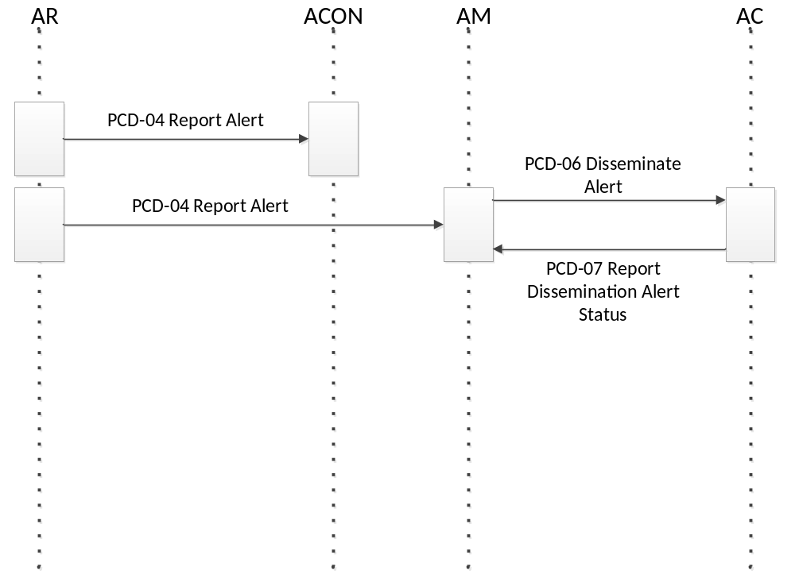

Add the following text to <Appendix A> Actor Summary Definitions, at Line 436 (just before the expanded Alert Manager (AM) definition:

Alert Consumer (ACON) Actor
This actor receives alerts from the AR. The actor may elect to use the alert for internal application usage, reporting purposes, or storage/caching for future reporting capabilities. There is no implementation requirement defined by the ACM profile in regards to how the ACON actor may elect to use the alert data, but it is assumed that display of the alert in some form takes place in an application implementing the ACON actor.

Add the following text to Section 3.Y PCD-04 Report Alert:

This section corresponds to Transaction PCD-04 of the IHE Technical Framework. Transaction
PCD-04 is used by the Alert Reporter, Alert Consumer and the Alert Manager (AM) actor.

Add the following text to Section 3.Y.1 Scope:

This transaction is used by the Alert Reporter to report alerts to the Alert Manager (AM) and/or the Alert Consumer. The Alert Reporter (AR) sends alerts to the Alert Manager (AM) and/or the Alert Consumer actor in an unsolicited manner.

Replace the diagram in 3.Y.2 Use Case Roles with the following:

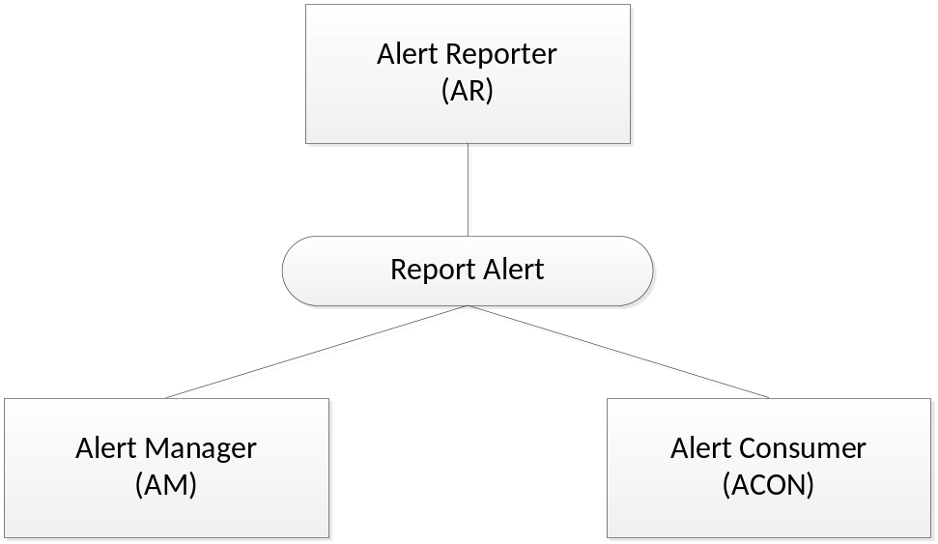

Add the following text to Section 3.Y.2 Use Case Roles:

Actor: Alert Consumer
Role: Receives Report Alert from Alert Reporter

Change section title text of 3.Y.4.1:
AR reports to AM and/or ACON

Change diagram and accompanying text in section 3.Y.4.1:

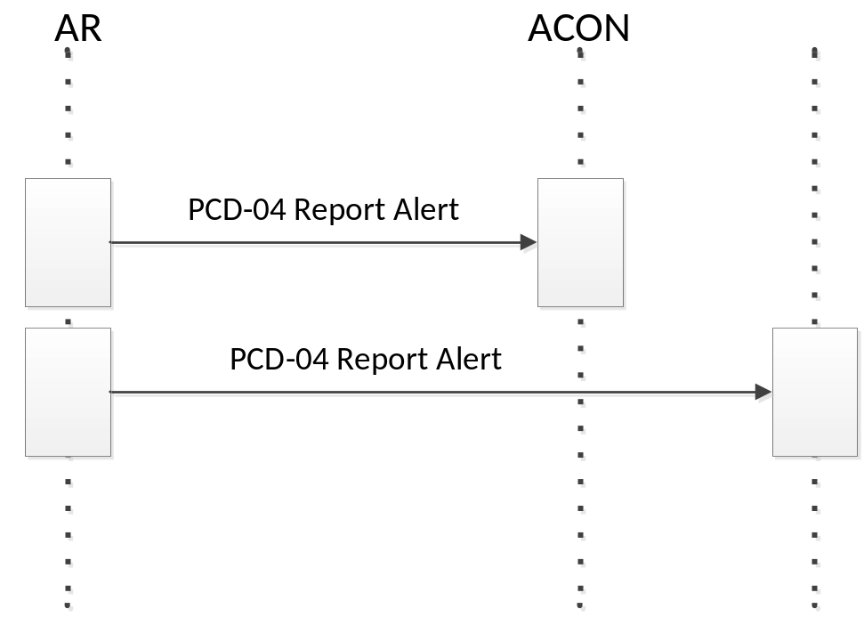

AR sends Report Alert to AM and/or ACON as an HL7 ORU message.

Change table 3.Y.4.1.1: PCD-04 Transaction Conformance text:
<On the row describing purpose, change the description text as follows:>
Report Alert from AR to AM and/or ACON

Change text of section 3.Y.4.1.2 PCD-04 Report Alert (ORU^R40^ORU_R40) static definition

The PCD-04 Report Alert message is used to communicate ACM data
From an Alert Reporter (AR) to Alert Manager (AM) and/or Alert Consumer (ACON)

Change text of section 3.Y.4.1.3 Trigger Events
The AR has arrived at the onset, continuation of, or conclusion an event which may be an alert
and sends it to the AM and/or the ACON.

Change text of section 3.Y.4.1.4 Message Semantics

This message is meant to convey from the AR actor to the AM and/or ACON actor the fact that an alert is occurring, is still occurring, or has ended along with the data related to the alert to identify the patient and/or location, the alerting condition, and any observations associated with the alert.

Change text of section 3.Y.4.1.5 Expected Actions

HL7 ACK from the Alert Manager (AM) and/or Alert Consumer (ACON) actor back to the Alert Reporter (AR) actor is used to communicate that the Alert Manager (AM) and/or Alert Consumer (ACON) actor has received the Report Alert [PCD-04] transaction from the Alert Reporter (AR) actor. The Report Alert [PCD-04] is asynchronous to Report Dissemination Alert Status [PCD-07] transactions by an indeterminate amount of time. HL7 ACK is therefore not used to report dissemination status of the alert as it would leave the Alert Reporter (AR) actor awaiting HL7 ACK receipt for an indeterminate amount of time.

While the AR to AM and/or ACON message [PCD-04] is one message it is likely to result in the potential for many messages from AM to AC and many messages from AC back to AM and from AM back to AR. Communication device operator response delays may result in delays of AC to AM and AM back to AR message delays.

